JavaScript Number Methods

The toString() method converts a number to a string.

## Converting Variables to Numbers

There are 3 JavaScript methods that can be used to convert variables to numbers:

* The Number() method
* The parseInt() method
* The parseFloat() method

# Arrays in JavaScript

In JavaScript, array is a single variable that is used to store different elements. It is often used when we want to store list of elements and access them by a single variable. Unlike most languages where array is a reference to the multiple variable, in JavaScript array is a single variable that stores multiple elements.

**There are 3 ways to construct array in JavaScript**

1. **By array literal**
2. **By creating instance of Array directly (using new keyword)**
3. **By using an Array constructor (using new keyword)**

## 1) JavaScript array literal

The syntax of creating array using array literal is given below:

var arrayname=[value1,value2.....valueN];

var fruits = [ "apple", "orange", "mango" ];

## 2) JavaScript Array directly (new keyword)

The syntax of creating array directly is given below:

var arrayname=new Array();

**<script>**

var i;

var emp = new Array();

emp[0] = "Arun";

emp[1] = "Deepak";

emp[2] = "Vijay";

for (i=0;i**<emp.length**;i++){

document.write(emp[i] + "**<br>**");

}

**</script>**

var fruits = new Array(5);

**<!DOCTYPE html>**

**<html>**

**<body>**

**<h2>JavaScript Arrays</h2>**

**<script>**

**var num = new Array(5);**

**var i,ln;**

**for(i=0;i<num.length;i++)**

**{**

**num[i]=i+1;**

**}**

**for(i=0;i<num.length;i++)**

**{**

**document.write(num[i]+"<br>") ;**

**}**

**</script>**

**</body>**

**</html>**

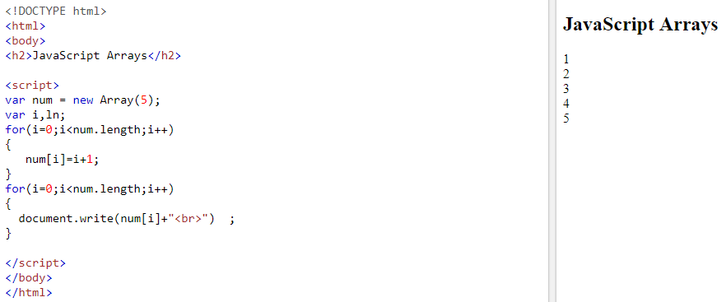

## 3) JavaScript array constructor (new keyword)

**<script>**

var emp=new Array("Sandeep","Hardeep","Mandeep");

for (i=0;i**<emp.length**;i++){

document.write(emp[i] + "**<br>**");

}

**</script>**

## Array Properties and Methods

The real strength of JavaScript arrays are the built-in array properties and methods:

## 1.The length Property

The length property of an array returns the length of an array (the number of array elements).

### Example

var fruits = ["Banana", "Orange", "Apple", "Mango"];  
fruits.length;   // the length of fruits is 4

2.JavaScript Array reverse() method

**<!DOCTYPE html>**

**<html>**

**<body>**

**<script>**

**var arr=["sandeep","mandeep","hardeep"];**

**var rev=arr.reverse();**

**var i;**

**for(i=0;i<rev.length;i++)**

**{**

**document.write(rev[i]+"<br>");**

**}**

**</script>**

**</body>**

**</html>**

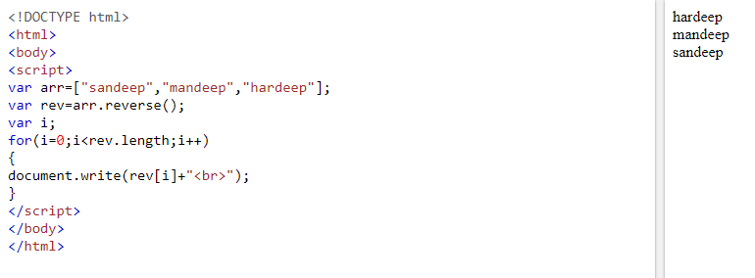

## 3.Sorting an Array

The sort() method sorts an array alphabetically:

**<!DOCTYPE html>**

**<html>**

**<body>**

**<script>**

**var arr=["san","deep","amit","geu"];**

**var myarry=arr.sort();**

**var i;**

**for(i=0;i<myarry.length;i++)**

**{**

**document.write(myarry[i]+"<br>");**

**}**

**</script>**

**</body>**

**</html>**

## 4.Merging (Concatenating) Arrays

The concat() method creates a new array by merging (concatenating) existing arrays:

**<!DOCTYPE html>**

**<html>**

**<body>**

**<script>**

**var arr1=["C","C++","Python"];**

**var arr2=["Java","JavaScript","Android"];**

**var arr3=arr1.concat(arr2);**

**var i;**

**for(i=0;i<arr3.length;i++)**

**{**

**document.write(arr3[i]+"<br>");**

**}**

**</script>**

**</body>**

**</html>**

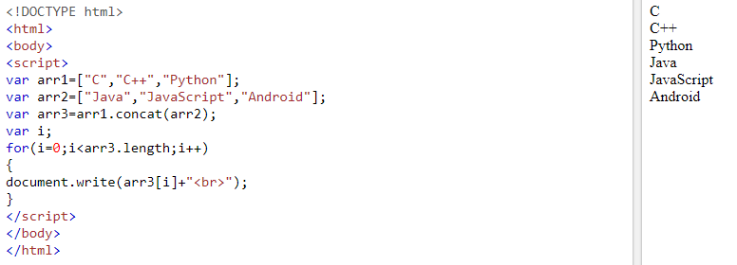

## Popping

The pop() method removes the last element from an array:

The pop() method returns the value that was "popped out":

### Example

var fruits = ["Banana", "Orange", "Apple", "Mango"];  
fruits.pop(); // Removes the last element ("Mango") from fruits

**<!DOCTYPE html>**

**<html>**

**<body>**

**<script>**

**var arr=["Java","JavaScript","Android"];**

**var i;**

**for(i=0;i<arr.length;i++)**

**{**

**document.write(arr[i]+"<br>");**

**}**

**arr.pop();**

**document.write("<h2>New Values are</h2>");**

**for(i=0;i<arr.length;i++)**

**{**

**document.write(arr[i]+"<br>");**

**}**

**</script>**

**</body>**

**</html>**

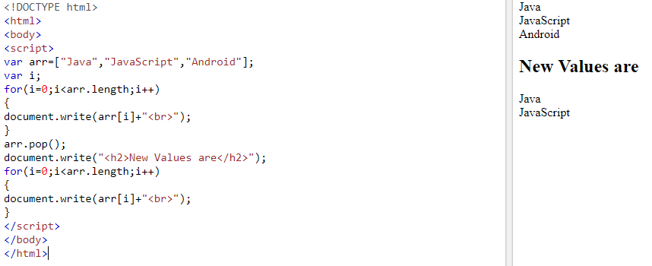

## Pushing

The push() method adds a new element to an array (at the end):

### Example

var fruits = ["Banana", "Orange", "Apple", "Mango"];  
fruits.push("Kiwi");       //  Adds a new element ("Kiwi") to fruits

The push() method returns the new array length:

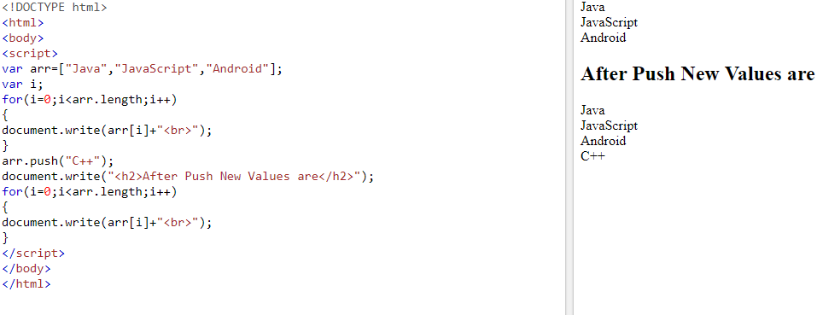

**<!DOCTYPE html>**

**<html>**

**<body>**

**<p>The push() method returns the new array length.</p>**

**<button onclick="myFunction()">Try it</button>**

**<p id="demo1"></p>**

**<p id="demo2"></p>**

**<script>**

**var fruits = ["Banana", "Orange", "Apple", "Mango"];**

**document.getElementById("demo1").innerHTML = fruits;**

**function myFunction() {**

**document.getElementById("demo2").innerHTML = fruits.push("Kiwi");**

**document.getElementById("demo1").innerHTML = fruits;**

**}**

**</script>**

**</body>**

**</html>**

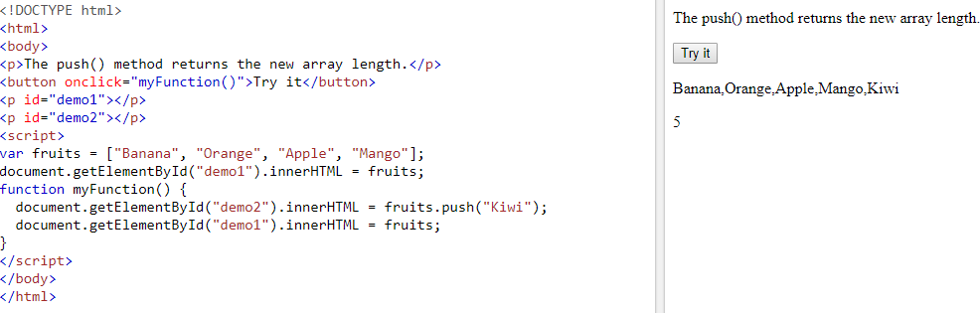

## Shifting Elements

Shifting is equivalent to popping, working on the first element instead of the last.

The shift() method removes the first array element and "shifts" all other elements to a lower index.

The shift() method returns the string that was "shifted out":

**<!DOCTYPE html>**

**<html>**

**<body>**

**<p id="demo1"></p>**

**<p id="demo2"></p>**

**<script>**

**var fruits = ["Banana", "Orange", "Apple", "Mango"];**

**document.getElementById("demo1").innerHTML = fruits;**

**fruits.shift();**

**document.getElementById("demo2").innerHTML = fruits;**

**</script>**

**</body>**

**</html>**

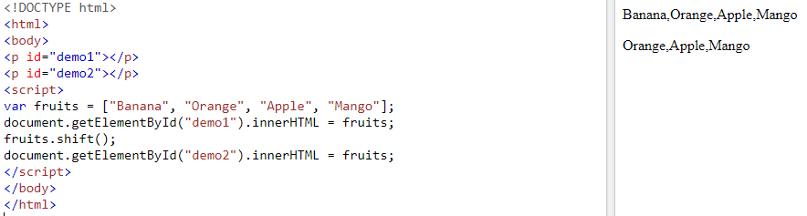

The unshift() method adds a new element to an array (at the beginning), and "unshifts" older elements:

**<!DOCTYPE html>**

**<html>**

**<body>**

**<button onclick="myFunction()">Try it</button>**

**<p id="demo"></p>**

**<hr>**

**<p id="demo2"></p>**

**<script>**

**var fruits = ["Banana", "Orange", "Apple", "Mango"];**

**document.getElementById("demo").innerHTML = fruits;**

**function myFunction() {**

**fruits.unshift("Lemon");**

**document.getElementById("demo2").innerHTML = fruits;**

**}**

**</script>**

**</body>**

**</html>**

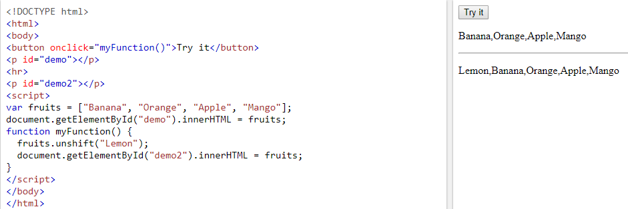

## Splicing an Array

The splice() method can be used to add new items to an array:

The first parameter (2) defines the position **where** new elements should be **added** (spliced in).

The second parameter (0) defines **how many** elements should be **removed**.

The rest of the parameters ("Lemon" , "Kiwi") define the new elements to be **added**.

The splice() method returns an array with the deleted items:

**<!DOCTYPE html>**

**<html>**

**<body>**

**<p>The splice() method adds new elements to an array.</p>**

**<button onclick="myFunction()">Try it</button>**

**<p id="demo1"></p>**

**<p id="demo2"></p>**

**<script>**

**var fruits = ["Banana", "Orange", "Apple", "Mango"];**

**document.getElementById("demo1").innerHTML = "Original Array:<br>" + fruits;**

**function myFunction() {**

**fruits.splice(2, 0, "Lemon", "Kiwi");**

**document.getElementById("demo2").innerHTML = "New Array:<br>" + fruits;**

**}**

**</script>**

**</body>**

**</html>**

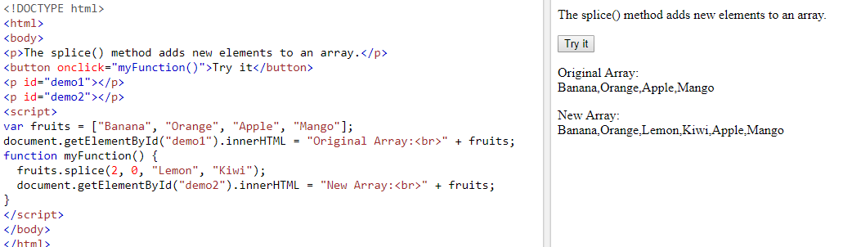

## Using splice() to Remove Elements

With clever parameter setting, you can use splice() to remove elements without leaving "holes" in the array:

### Example

var fruits = ["Banana", "Orange", "Apple", "Mango"];  
fruits.splice(0, 1);        // Removes the first element of fruits

The first parameter (0) defines the position where new elements should be **added** (spliced in).

The second parameter (1) defines **how many** elements should be **removed**.

The rest of the parameters are omitted. No new elements will be added.

**<!DOCTYPE html>**

**<html>**

**<body>**

**<p>The splice() methods can be used to remove array elements.</p>**

**<button onclick="myFunction()">Try it</button>**

**<p id="demo"></p>**

**<script>**

**var fruits = ["Banana", "Orange", "Apple", "Mango"];**

**document.getElementById("demo").innerHTML = fruits;**

**function myFunction() {**

**fruits.splice(1, 1);**

**document.getElementById("demo").innerHTML = fruits;**

**}**

**</script>**

**</body>**

**</html>**

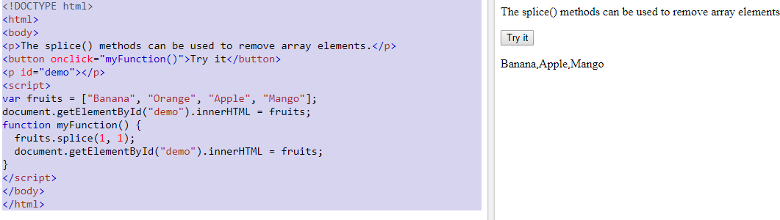

## Slicing an Array

The slice() method slices out a piece of an array into a new array.

**<!DOCTYPE html>**

**<html>**

**<body>**

**<p id="demo"></p>**

**<script>**

**var fruits = ["Banana", "Orange", "Lemon", "Apple", "Mango"];**

**var citrus = fruits.slice(3);**

**document.getElementById("demo").innerHTML = fruits + "<br><br>" + citrus;**

**</script>**

**</body>**

**</html>**

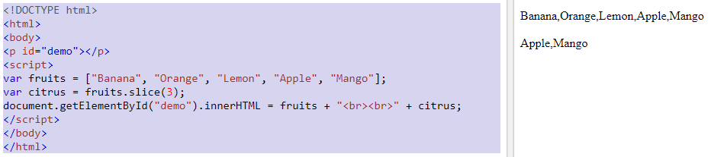

**This example slices out a part of an array starting from array element 3 ("Apple"):**

**When the slice() method is given two arguments, it selects array elements from the start argument, and up to (but not included) the end argument:**

**<!DOCTYPE html>**

**<html>**

**<body>**

**<p id="demo"></p>**

**<script>**

**var fruits = ["Banana", "Orange", "Lemon", "Apple", "Mango"];**

**var citrus = fruits.slice(1,3);**

**document.getElementById("demo").innerHTML = fruits + "<br><br>" + citrus;**

**</script>**

**</body>**

**</html>**

