Q1: Write a html code for following frame.



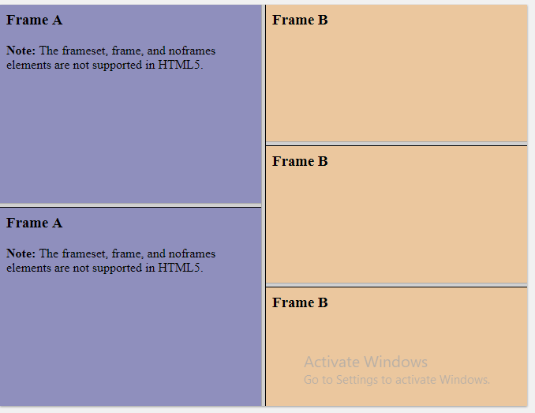



Q2: Write a JavaScript program to convert temperatures to and from Celsius, Fahrenheit.   
[ Formula : c/5 = (f-32)/9 [ where c = temperature in Celsius and f = temperature in Fahrenheit ]  
*Expected Output*:  
60°C is 140 °F  
45°F is 7.222222222222222°C

Q3. Write a JavaScript conditional statement to find the largest of five numbers. Display an alert box to show the result.

Q4: Write a JavaScript program which iterates the integers from 1 to 100. But for multiples of three print "Fizz" instead of the number and for the multiples of five print "Buzz". For numbers which are multiples of both three and five print "FizzBuzz".