## Q-1: ProblemStatement: [TODO]

Create a registration form for XYZ University. The form should look as shown in the image below.

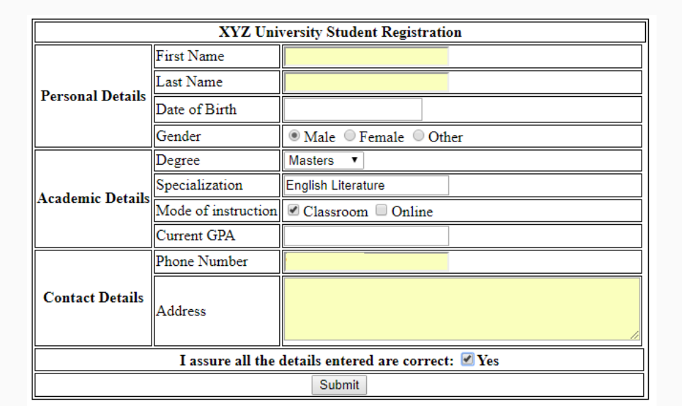

The validations for each field are described below:

* **First Name**: Required, max 10 characters
* **Last Name**: Required, max 10 characters
* **Date of birth**: Required
* **Gender**: Only one option must be selected
* **Degree**: Dropdown should contain "Bachelors", "Masters" and "Doctorate"
* **Specialization**: Required, max 40 characters
* **Current GPA**: Required, max value 5, increment in steps of 0.1
* **Phone Number**: Required
* **Address**: Required, max 4 rows of 40 characters each.

**All required fields should be marked with a red asterisk (*)**

## Q-2: ProblemStatement: [TODO]

Create the below table for Destiny Tours & Travels price list.

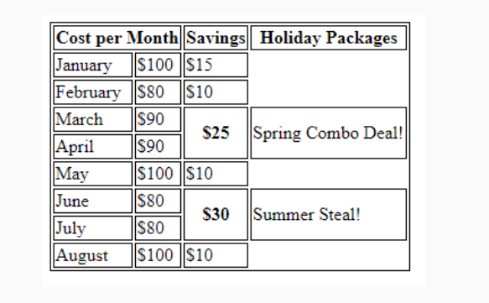

## Q-6: ProblemStatement: [TODO]

– Create the below layout using Flexbox and Media Query. Depending upon the screen size defined you need to apply the media rules.

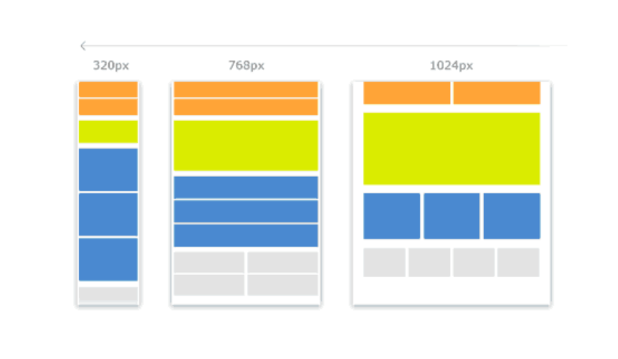

## Q-8: ProblemStatement: [TODO]

Create the Contact Us page as shown below. Use HTML5,CSS3,SASS.Define SASS variables, function , mixins, nesting to create the page.

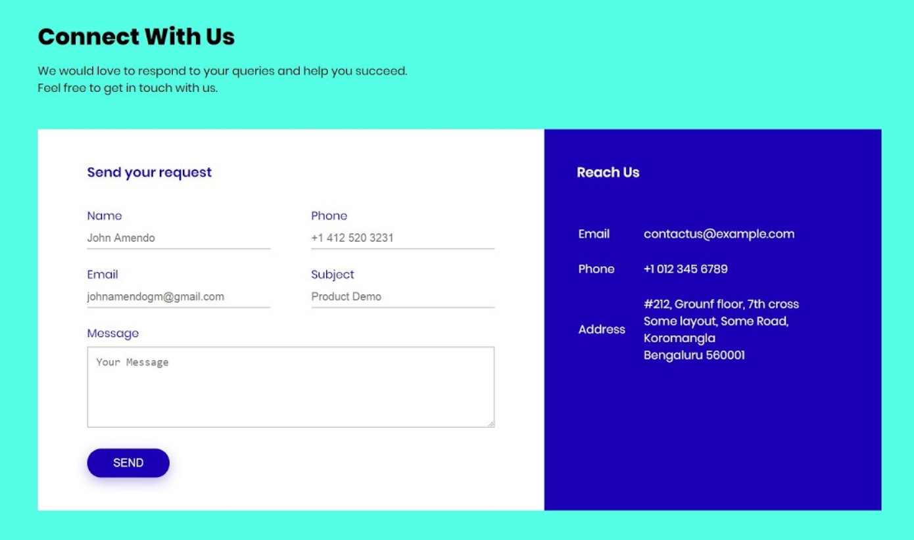

## Q-10: ProblemStatement: Create this page using HTML5 Semantic Elements and CSS3 Flexbox, Layout, Compositors, SASS,Gradient. [TODO]

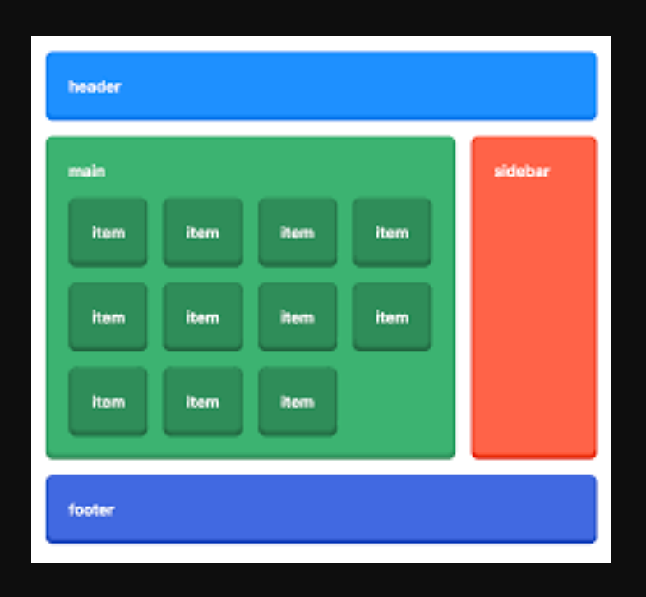

12. Create the table using Delete functionality. **Note: Use JavaScript Array Method and DOM API to implement this, Apply transition effect while deleting .** [TODO]

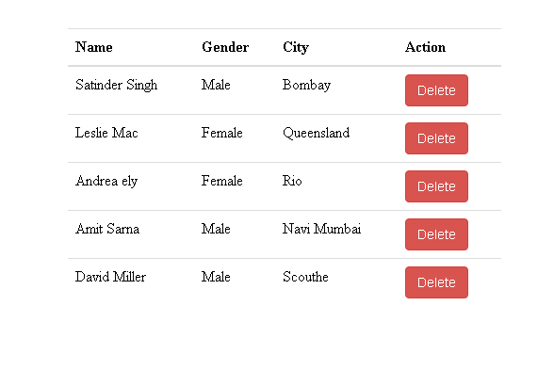

13. Create an UI with **HTML5,CSS3,SASS and Add functionality using JavaScript. Here use JavaScript Array of Objects and array functions.** [TODO]

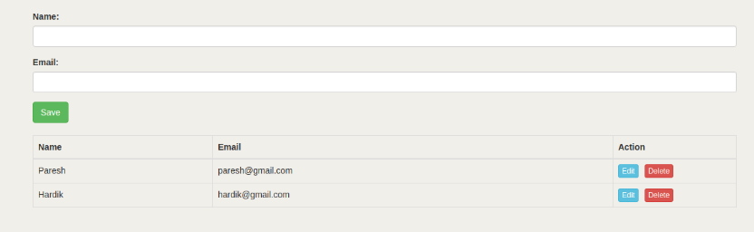

If you click on delete button then the row should deleted from the table. Using Edit button we can update the respective row.

21. Here we have to create a web page where we can add element to an array , remove element from an array, Remove all element from an array. **Use Array methods like push(),pop(),shift(),unshift()** . To display all the elements use array function like **forEach**. Add **two more buttons in this form so that we can display all the fruit name in either captal letter or small letter by clicking on the respective buttons**. Use **map()** function of an array and other string functions. [TODO]

