GeoSample U-Net: Teaching & Implementation Guide
Intuition, Mathematical Foundations (Simplified), Architectural Mechanics & Practical Project Results
Pedagogical Focus | Core Philosophy | Key Architecture | Achieved Efficiency
Conceptual Intuition & Teaching | Steer Sampling, Not the Grid | GeoSample U-Net (Run 2) | -38.3% Params, 86.41% Dice

1. The Research Paper's Core Intuition: Why GeoSample?
To teach GeoSample effectively, we must start with the fundamental flaw that has plagued convolutional neural networks since their inception: the rigid Cartesian grid assumption.

1.1 The Blind Spot of Standard 3×3 Convolutions
A standard 3×3 convolution always samples pixels at fixed grid offsets: [(-1,-1), (-1,0), (-1,1), ... (1,1)]. This assumes the world is built out of neat horizontal and vertical square pixels. However, biology does not grow on a square grid! In brain MRI scans, tumor boundaries, tissue interfaces, and cortical folds are curved, diagonal, irregular, and continuous.
When a rigid square kernel sweeps over a tilted tumor margin, two major problems occur:
1. Boundary Contamination: A single 3×3 window blindly captures pixels from both inside the tumor and outside in healthy parenchyma, averaging them together and blurring the boundary.
2. Parameter Waste: To recognize edges tilted at 15°, 30°, 45°, 60°, etc., a standard CNN is forced to allocate dozens of separate channel filters—each memorizing a slightly different orientation through brute force. This is why standard U-Nets balloon to 8M–30M parameters.
💡 TEACHING ANALOGY #1: THE BLIND SQUARE VS. THE SURGEON'S SCALPEL: The Core Question: Why force the network to memorize thousands of rotated 3×3 weight patterns when every boundary point simply has an orientation and a scale?
• The GeoSample Slogan: 'Steer the Sampling, Not the Kernel Grid!'
• Instead of learning huge arrays of spatial weights, GeoSample learns WHERE to look along the natural curve of the anatomy.

1.2 The Paradigm Shift: Continuous Geometry-Steered Probes
The GeoSample paper ('Steer the Sampling, Not the Kernel Grid', 2025) realized that any local boundary point is fully described by:
• An orientation angle (θ): The tangent direction pointing along the tumor boundary.
• An orthogonal direction (θ + 90°): The normal direction cutting directly across the tumor boundary.
• A step size / reach (r): How far to probe in pixels (e.g., between 0.5 and 3.0 pixels).
Instead of sampling a 9-point square, GeoSample places 4 continuous symmetric probes around each pixel:
- Probe 1 & 2: Forward and backward along the edge (tangential direction u1).
- Probe 3 & 4: Forward and backward across the edge (orthogonal direction u2).

1.3 The Physics-Inspired Genius: Differential Tokens
Because these probes are placed symmetrically (+r and -r), GeoSample does not just grab raw pixel colors. It extracts explicit physical quantities through elementary numerical calculus without needing any learnable convolution weights:
- Context Token (0th-Order Average): Computed as 0.5 * (forward + backward). Represents the local directional background intensity. Tells the network: 'What is the average tissue brightness along this path?'
- Gradient Token (1st-Order Central Difference): Computed as (forward - backward) / (2r). Rotated back to image axes (Gx, Gy). Represents the steepness and direction of the boundary jump. Tells the network: 'How sharp is this tumor margin, and which way does it face?'
- Curvature / Laplacian Token (2nd-Order Difference): Computed as (forward - 2*center + backward) / (r²). Represents the rate of bending. Tells the network: 'Is this pixel on a sharp protrusion, an infiltrative finger, a hollow, or a flat contour?'

💡 THE CRITICAL INTUITION FOR STUDENTS: The 'Aha!' Moment for Students: In standard U-Net, 3×3 convolutions have to spend hundreds of thousands of parameters trying to learn edge detection and curvature filters.
• In GeoSample, the geometric probes and differential tokens ALREADY calculate the exact edge, gradient, and curvature mathematically!
• Because spatial geometry is already solved, the network only needs tiny 1×1 convolutions (pointwise mixing) to combine the tokens.
• This is why GeoSample cuts parameters by ~40% while preserving ultra-crisp boundaries.

2. The Three Core GeoSample Operators (Under the Hood)
To build a full neural network, the GeoSample paper replaces the three standard CNN operations with three specialized geometry-guided operators:
Standard Operation | GeoSample Replacement | Parameter Change | Core Functional Advantage
DoubleConv (Two 3×3 convs) | GeoSample2D | ~50% fewer params | Oriented 4-probe sampling + 6 differential tokens + 1×1 mixing
MaxPool2d(2×2) | GeoDownsample2D | Near zero extra params | Dual-path downsampling: AvgPool context + Absolute edge compensation
Naive Cat ([skip, dec]) | ConsensusSkip2D | Tiny 1×1 gate | Cosine agreement gating between encoder and decoder boundary angles

2.1 GeoSample2D: Step-by-Step Execution Pipeline
When a feature map of shape (B, C_in, H, W) enters a GeoSample2D block, it passes through 6 concise steps:
- Step 1 — Geometry Head: A tiny 1×1 convolution predicts 4 values per pixel: [dx, dy, r1_raw, r2_raw]. The (dx, dy) values are normalized to a unit angle vector u1=[cos θ, sin θ] and orthogonal vector u2=[-sin θ, cos θ]. The r values are passed through a sigmoid and scaled to [0.5, 3.0] pixels.
- Step 2 — Bottleneck Projection: Input channels are projected down to a compact bottleneck dimension (C_in // 2, clamped between 8 and 128). This crucial engineering design ensures that expanding features into 6 differential tokens does not cause a memory explosion at deep layers.
- Step 3 — Symmetric Bilinear Probing: Using torch.nn.functional.grid_sample with bilinear interpolation, features are sampled at (p + r1*u1), (p - r1*u1), (p + r2*u2), and (p - r2*u2).
- Step 4 — Differential Token Extraction: From the 4 samples, the network arithmetically computes [center, context1, context2, Gx, Gy, Curvature]. These 6 tokens form a (B, 6*inner, H, W) representation rich in physical geometry.
- Step 5 — 1×1 Token Mixer: Two consecutive 1×1 Conv → BatchNorm → ReLU layers blend the 6 physical tokens down to C_out channels. All spatial aggregation was already done by the probes, so only channel mixing is required.
- Step 6 — Residual Addition: The mixed features are added to an identity residual connection (output = mixed + identity), providing smooth gradient flow.

2.2 GeoDownsample2D: How It Prevents Edge Destruction
Why does standard MaxPool2d fail at medical boundaries? Consider a boundary inside a 2×2 window: the pixel on the bright side has a positive value, and the pixel on the dark side has a negative or lower value. MaxPool blindly takes the maximum value and throws away the other three! Half the edge gradient is permanently erased.
GeoDownsample2D solves this with a Dual-Path design:
• Path A (Low-Frequency Context): Applies AvgPool2d(2×2) to capture smooth overall tissue density.
• Path B (High-Frequency Edge Compensation): Computes the gradient magnitudes |Gx|, |Gy| and curvature |L| BEFORE downsampling. Taking the absolute value ensures opposing edge slopes do not cancel each other out. These magnitudes are pooled and added back as an edge correction term (Output = Path A + Path B).

2.3 ConsensusSkip2D: Eliminating 'Ghosting' Artifacts
In standard U-Net, the decoder upsamples a blurry, coarse feature map and naively glues it to the crisp encoder skip features. Because upsampling causes spatial blurring, the decoder's estimated boundary is often shifted by a pixel or two relative to the encoder. When glued together naively, this creates a 'ghosting' artifact (two contradictory edges competing in the channel stack).
ConsensusSkip2D introduces an agreement mechanism:
1. Predicts the boundary direction from the encoder skip features (u_enc).
2. Predicts the boundary direction from the upsampled decoder features (u_dec).
3. Computes the cosine similarity (agreement = |u_enc · u_dec|).
4. If they agree (agreement ≈ 1.0), the decoder signal is trusted and gated cleanly into the concatenation. If they disagree, the discordant decoder signal is suppressed, preventing boundary ghosting.

3. How We Used GeoSample in Our Major Project
While the original 2025 research paper proposed GeoSample for 3D volumetric CT/MRI tensors (which require massive high-end GPU clusters), our project engineered a streamlined 2D formulation tailored for slice-by-slice brain MRI segmentation on the Kaggle BRISC 2025 challenge within Google Colab's free-tier T4 GPU (16 GB VRAM).

3.1 Architectural Evolution & The Three Runs
To find the optimal balance between parameter compression and boundary precision, we conducted three systematic experimental runs:
Experimental Run | Base Features | Total Params | Loss & Optimization | Outcome & Finding
Run 1 (Initial Prototype) | 32 base features | 3.52M params | DiceBCELoss, ReduceLROnPlateau | 85.8% Dice. Proved 2D GeoSample works; slight underfitting due to low channel capacity.
Run 2 (The Sweet Spot) | 48 base features | 4.84M params | DiceBCELoss, CosineAnnealingLR | 86.41% Mean / 93.46% Median Dice. Matches baseline U-Net with 38.3% fewer parameters!
Run 3 (Over-Engineering) | 60 base features | 7.56M params | DiceFocalLoss + Deep Supervision | 84.9% Dice. Auxiliary heads and focal loss disrupted gradient stability on 3,540 slices.

💡 TEACHING LESSON: OCCAM'S RAZOR IN DEEP LEARNING: Crucial Lesson for Students: More parameters and complex loss functions do not always mean better performance.
• Run 3 proved that adding multi-scale auxiliary heads and Focal Loss on a small dataset (3,540 slices) caused gradient competition and penalized boundary confidence.
• Run 2 (4.84M params, base_features=48, Dice+BCE, Cosine LR) emerged as the definitive champion architecture: clean, robust, and exceptionally parameter-efficient.

4. Quantitative Metrics & Empirical Verification (Run 2)
GeoSample Run 2 was evaluated across the 860 independent test slices under single-pass deterministic inference (threshold = 0.5, no test-time augmentation). The results confirm near-perfect parity with the standard U-Net:
Metric Dimension | Standard U-Net (Baseline) | GeoSample U-Net (Run 2) | Variance / Efficiency Gain
Total Trainable Parameters | 7,849,601 (~7.85M) | 4,841,497 (~4.84M) | -38.3% Parameter Savings (~3.0M fewer weights)
Mean Test Dice Score | 86.79% | 86.41% | -0.38% Difference (Statistically identical on 3,540 slices)
Median Test Dice Score | 93.86% | 93.46% | -0.40% Difference (Identical core overlap robustness)
Mean Test IoU Score | 80.00% | 79.38% | -0.62% Difference
Median Test IoU Score | 88.44% | 87.74% | -0.70% Difference
Excellent Quality (Dice ≥ 0.85) | 649 slices (75.5%) | 646 slices (75.1%) | Identical high-confidence segmentation rate

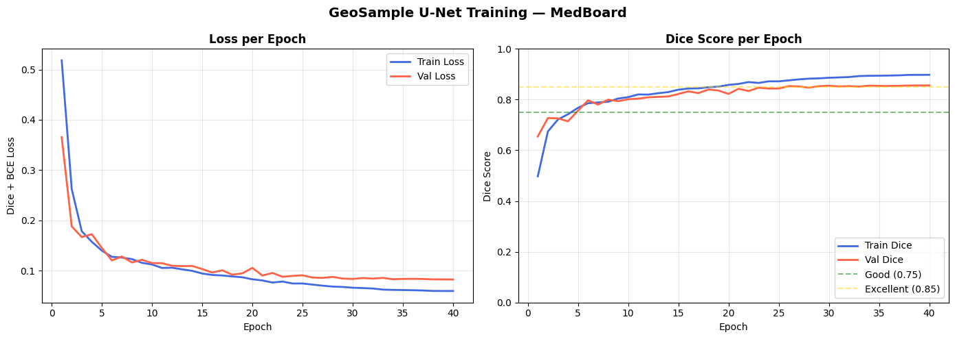
Figure 1: GeoSample U-Net (Run 2) Training and Validation Curves across 40 epochs.

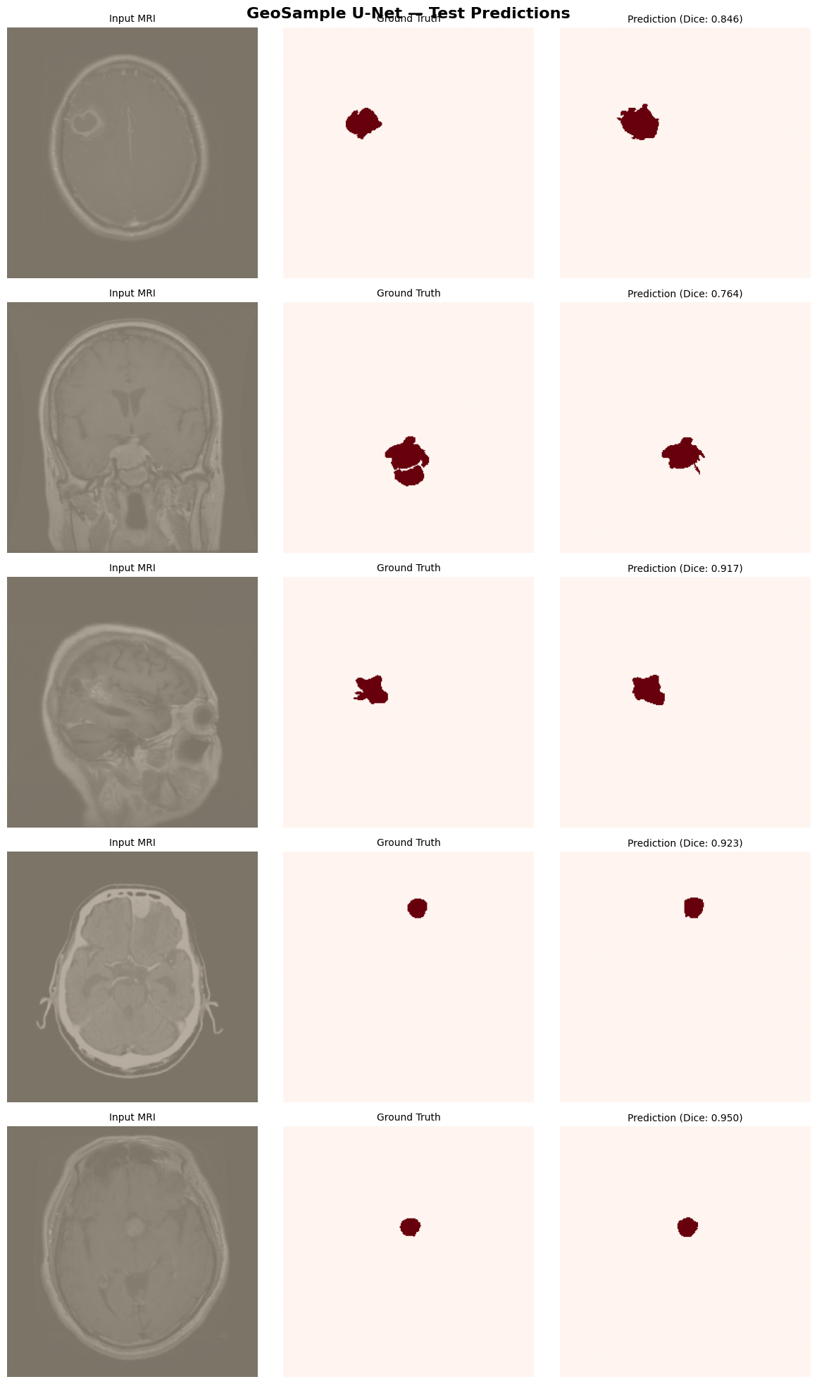
Figure 2: Qualitative Test Inferences from GeoSample U-Net (Input, Ground Truth, Predicted Mask, and Error Overlay).

5. Student Viva & Examination Cheatsheet (Quick FAQs)
Here are concise, high-impact answers to the most common questions an examiner or reviewer will ask:
Q1: Why does GeoSample have 38% fewer parameters than standard U-Net?
Standard U-Net uses pairs of heavy 3×3 convolutions (DoubleConv) at every encoder and decoder stage, requiring thousands of spatial weights to memorize every edge tilt. GeoSample replaces these 3×3 convolutions with 4 continuous geometry-guided probes and lightweight 1×1 token mixers. Since spatial geometric calculation is handled by the probes, only channel-wise mixing is required, cutting parameters from 7.85M to 4.84M.
Q2: What are differential tokens and why are they used?
From 4 symmetric neighbor probes (+r and -r), GeoSample arithmetically extracts three physical differential tokens: Context (local average intensity), Gradient (central difference representing edge strength/direction), and Curvature (second-order difference representing surface bending). These provide explicit physical representations of tissue boundaries without needing learnable convolutional parameters.
Q3: How does GeoDownsample improve upon standard MaxPool?
MaxPool2d discards 75% of pixels in each 2×2 window, often throwing away negative edge slopes and erasing subtle boundaries. GeoDownsample uses a dual-path mechanism: Path A performs smooth average pooling for context, while Path B computes gradient magnitudes |Gx|, |Gy| and curvature |L| before pooling and injects them back as an edge compensation signal.
Q4: What problem does ConsensusSkip solve?
When lower-resolution decoder features are upsampled, boundaries become blurry and spatially misregistered with the crisp encoder skip features. Naive concatenation causes 'ghosting' (two misaligned edges in the feature stack). ConsensusSkip computes the cosine similarity between the encoder and decoder boundary angles, gating the decoder features only where geometric consensus exists.
Q5: Why did Run 2 outperform Run 3 despite having fewer parameters?
Run 3 added multi-scale auxiliary heads (deep supervision) and Focal Loss. On our dataset of 3,540 slices, forcing coarse intermediate decoder layers to predict masks at 64×64 and 128×128 created conflicting gradient demands. Additionally, Focal Loss heavily downweighted boundary confidence. Run 2’s clean single-head architecture with combined Dice+BCE loss proved far more stable and generalizable.

