**TASK : -**

MAKE A LOCAL REPO HAVING TWO BRANCH MASTER AND DEV1

PUSH THE REPO TO THE GITHUB

IN YOU REDHAT SYSTEM YOU MUST HAVE DOCKER JENKINS

**JOB1 :** USING JENKINS MAKE A JOB FOR DEV1 BRANCH TO COPY DATA IN YOUR REDHAT SYSTEM AND DEPLOY IT USING DOCKER IMAGE

**JOB2 :** SAME MAKE THE JOB FOR THE MASTER BRANCH

**JOB3 :** NOW THERE IS A QAT WHO CHECK BOTH DATA OF DEV1 AND MASTER BRANCH AND IF BOTH ARE STABLE THEN MERGE THEM AND LAUNCH WITH A DOCKER IMAGE WHICH IS EXPOSED TO THE PUBLIC WORLD

**SOLUTION :**

.................................................................................

1. FIRSTLY MAKE A LOCAL GIT REPO AND CREATE A NEW BRANCH DEV1 USING COMMAND git branch dev1

2. YOU CAN SWITH BETWEEN BRANCH USING git checkout branchname

3. ENTER THE DATA AND PUSH THE REPO TO THE GITHUB

4. IN YOUR REDHAT SYSTEM START DOCKER AND JENKINS SERVICES

5. NOW LOGIN TO YOUR JENKINS

CREATE JOB 1 AS :

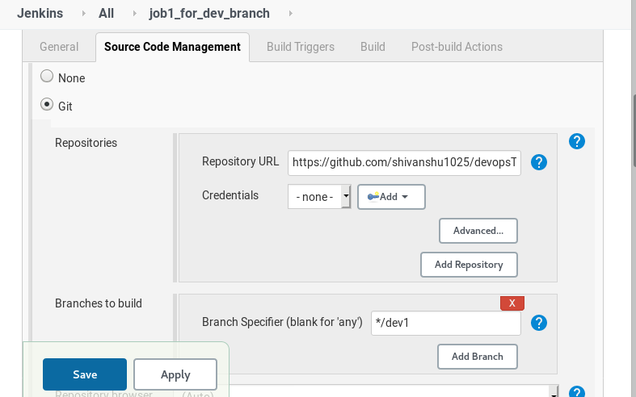

SELECT POLL SCM SO THAT WHEN DEVELOPER DO ANY CHANGE IN GITHUB THEN THE JOB WILL AUTOMATICALLY RUN

WRITE THE CODE TO COPY THE DATA INTO REDHAT MACHINE AND TO LAUNCH AND LINK FILE WITH DOCKER SYSTEM

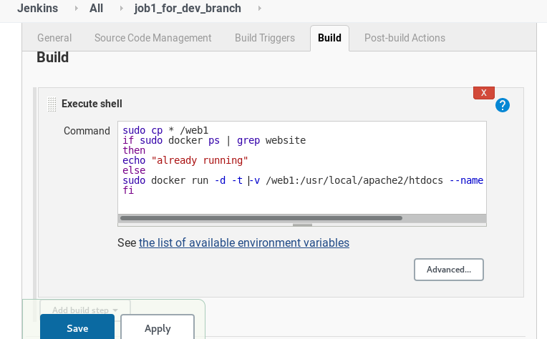

NOW CREATE THE NEW JOB FOR THE MASTER BRANCH IN THE SAME WAY

IN THE THIRD JOB QAT CHECK IF BOTH THE JOBS ARE STABLE THEN THEY WILL MERGE THE DEV1 AND MASTER BRNCH.

TO MERGE THE SAME USING JENKINS WE CAN DO THIS AS :

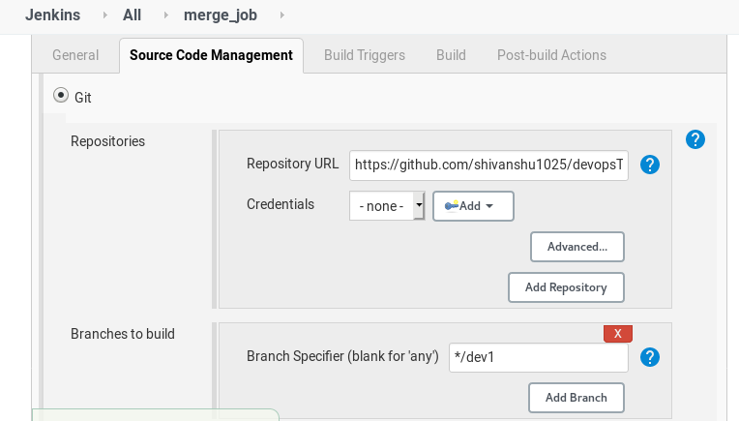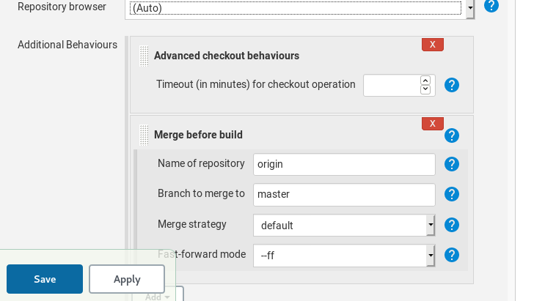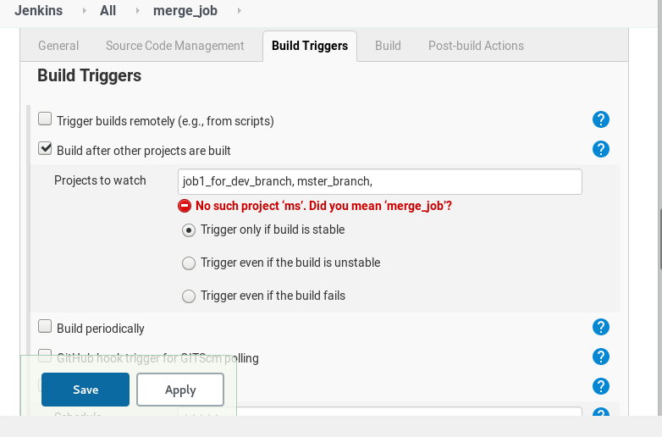

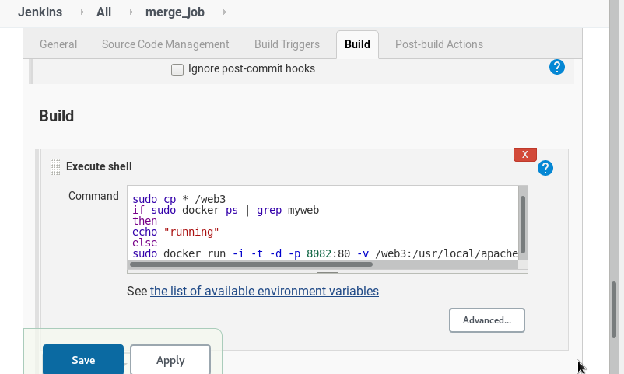

IN THIS WAY YOU WILL ACHIEVE THE TASK.