**Day 17 task**

The database consists of two tables account and t<accountno> for each row in table account there exists a table t<accountno> .

As shown in following diagram

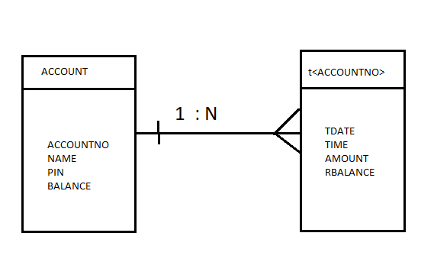

Where N is the no of rows in the table account.

Now elaborating about each table: -

ACCOUNT

This table contains the records of all the account holders in the bank with their pin, account balance, name and account number.

Where Account Number is the primary key as its value will be unique for each account holder and we can identify any account holder by using account number.

The snapshot of the table is shown: -

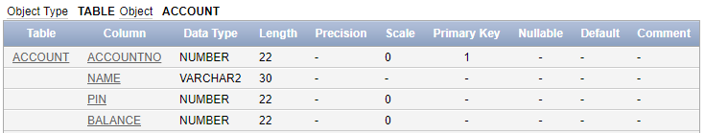

After creating the table, we can insert data as follows: -

*insert into account*

*values(76001,'shivanshu',1234,4500.00)*

The table after inserting the value: -

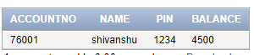

T<ACCOUNTNO>

There are equal number of these tables as there are accounts in the bank, each account has different table to store the transactions as the transaction date, time, amount, remaining balance.

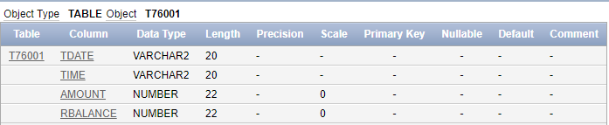

Now inserting values in the table by executing the following query: -

*insert into t76001*

*values ('22/06/2018','15:35:33',500,4000)*

The snapshot of the table is as follows: -

