VendorVerse — Project Deliverables
Consolidated from docs/deliverables (01–10).

01 · Updated Feature Coverage & Gap Analysis
Baseline: mobile mockup (156 screens in `docs/screen-inventory.csv`), spec of 19 Oct 2026. Updated 28 Oct 2026.
Scope: mobile only (Android + iOS). Web is being handled separately by another developer and is not covered in these documents.
How to read "covered". The mockup has no backend. "Covered" means the screen is clickable and the business rule is evaluated in the browser. It does not mean production-ready. Every row below still needs real APIs, persistence and integrations.

1. Summary
Measure | Count
Mobile mockup screens | 156 (146 MVP-tagged, 10 Phase 2)
Roles modelled | Customer, Vendor, Business (company), Sales agent, Admin
Demo journeys clickable end to end | 7 (J1–J7)
Industries in taxonomy | 30 (10 MVP, 9 Phase 2, 11 Phase 3 — see doc 03)

2. Coverage by feature area
Legend: ✅ covered in mockup · 🟡 partial · ❌ missing · 🔮 future (Phase 3)
# | Feature area | Mockup | Notes
1 | Brand, region-aware home, intent tabs | ✅ | EN + HI only.
2 | Dynamic categories + suggest-a-category + taxonomy builder | ✅ | Per-category custom fields drive onboarding, listing, RFQ, filters.
3 | Country → state → city → pincode, waitlist, rollout matrix | ✅ | 4 live cities; country packs exist.
4 | Customer profile (individual/business), vendor public profile | ✅ | Business-team roles are Phase 2.
5 | Business (company) account, vendor-gated | ✅ | Owner-only, 3+ yrs, admin verified, vendors message only.
6 | Scheduled booking | ✅ | Full state machine incl. modify/cancel/conflict.
7 | Instant booking | ✅ | Live availability, atomic slot check.
8 | Structured RFQ (services) | ✅ | Revisions, atomic accept, locked terms.
9 | Goods catalogue + goods RFQ + purchase order | ✅ | MOQ, tiers, PO lifecycle with exception/failed states.
10 | Contract booking (recurring, AMC, supply, milestones) | 🟡 | Propose/counter/sign modelled; no renewal, amendment or termination flows.
11 | Vendor-to-vendor procurement (buyer mode) | ✅
12 | Verification tiers 1–3, expiry, reviewer queue | ✅ | Tier 4 audit is Phase 2.
13 | Publication gates (6) | ✅ | Computed, not stored.
14 | Reviews (verified only), reports, cases, appeals | ✅
15 | Chat (linked, privacy-aware) | 🟡 | Text only. No attachments policy, read receipts, or real-time behaviour defined.
16 | Subscriptions, grace, sponsored visibility | ✅ | Plan values are sample (CFG-01/02).
17 | Checkout, escrow, wallet, refunds, payouts, commission | 🟡 | Screens exist (Phase 2). Contradicts MVP direct-payment model — keep hidden in MVP.
18 | Sales-agent CRM (leads, consent onboarding, tasks) | ✅ | No agent commission (by design).
19 | Admin: queues, RBAC, audit, analytics, config register | ✅ | Analytics are static samples.
20 | Notifications | 🟡 | Inbox + destinations only. No channel/template/preference model for push, SMS, email, WhatsApp.
21 | Multi-language | 🟡 | EN/HI. RTL + 5 languages Phase 2.
22 | Accessibility WCAG 2.2 AA | 🟡 | Target stated; not audited.

3. Gap list
ID | Gap | Impact | Proposed handling
G1 | Withdrawn — web is out of scope for this plan (separate workstream). | — | The API (doc 07) is client-agnostic, so the web developer can consume the same backend.
G2 | README/vision screens quote stale counts (93/111 screens). | Low | Regenerate from inventory.
G3 | No backend, auth, persistence, file storage, search engine. | Foundational | Doc 06, 07, 09.
G4 | Payments conflict: MVP is direct pay, but P2 checkout/escrow screens are in the same build. | Medium — scope confusion | Feature-flag; exclude from MVP navigation.
G5 | Notification system not specified (channels, templates, quiet hours, opt-in/out, DLT for SMS in India). | Medium | Add module N1 in doc 07; spec in MVP.
G6 | Tax/invoicing: GST invoice screen exists; no rules for TCS/TDS, e-invoice, place of supply. | Medium (India legal) | Needs finance/legal input.
G7 | Dispute path for purchase orders (damaged goods, partial delivery) exists as screen only; no settlement outcomes. | Medium | Define outcomes: replace, credit note, partial refund, close.
G8 | Contract lifecycle lacks renewal, amendment, termination, missed-milestone handling. | Medium | Add states to doc 05.
G9 | Search: ranking rules are mocked client-side. Needs geo index, filters, pagination at scale. | High | Search service (doc 07 module S1).
G10 | KYC/KYB provider integrations (GST, PAN, Aadhaar-consented, MCA) not selected. | High | Vendor selection in Phase 0.
G11 | Support/helpdesk tooling for staff (macros, SLA timers, queue assignment) beyond case screens. | Low–Med | Use off-the-shelf helpdesk or build minimal.
G12 | Content moderation for listing images/text (automated pre-screen). | Medium | Third-party moderation API.
G13 | Data lifecycle: retention, export, deletion cascade (DPDP Act alignment). | High (legal) | Policy + jobs; doc 06 notes soft-delete + anonymisation.
G14 | Agent: field/offline tools. | Low | Phase 3.
G15 | Open configuration register (CFG-01…12) still has unresolved values (plan prices, response deadlines, cancellation windows). | High | Business sign-off before build of billing.
G16 | Analytics events/tracking plan not defined. | Medium | Define event taxonomy in Phase 0.
G17 | Observability, rate limiting, abuse prevention (OTP pumping, scraping of contacts). | High | Non-functional list in doc 09/10.

4. Scope conflicts to resolve with the client
1. Payments: confirm MVP = vendors paid directly; platform revenue only from subscriptions + sponsorship.
2. Shared backend with the web workstream: agree the API contract (doc 07) with the web developer so both clients use one backend.
3. Manufacturing industry (i_manu) is tagged Phase 2 while the supplier/manufacturer onboarding path is MVP. Recommendation: allow manufacturers in the Wholesale industry at MVP; open Manufacturing & OEM in Phase 2.
4. Agent commissions: mockup shows conversion metrics only. Confirm agents are paid outside the platform.

02 · Screen-Wise Status — Completed / Partial / Missing / Future
Source: `docs/screen-inventory.csv` (156 screens) plus gaps from doc 01.
Status meaning
- Completed — clickable in the mobile mockup with its business rule evaluated. Needs real backend.
- Partial — mockup exists but a sub-flow, state or rule is absent.
- Missing — required by the spec, no screen yet.
- Future — deliberately Phase 2/3.

1. Totals
Status | Screens
Completed | 141
Partial | 5
Future (Phase 2 mocked) | 10
Missing (new screens needed) | 22 (listed in §4)

2. Per-role breakdown (inventory)
Role | MVP | Phase 2 | Total
Auth | 5 | 0 | 5
Shared | 11 | 0 | 11
Customer (incl. buyer mode) | 51 | 7 | 58
Vendor | 31 | 2 | 33
Business | 7 | 0 | 7
Agent | 11 | 0 | 11
Admin | 30 | 1 | 31
Total | 146 | 10 | 156

3. Non-completed screens in the inventory

Partial
Screen | ID | What is missing
Contract — terms, e-sign, milestones | c_contract, v_contract | Renewal, amendment, termination, missed-milestone
Chat — linked, private | chat | Attachments rule, delivery state, block/mute
Notifications | notifications | Per-channel preferences, templates
Analytics | ad_analytics | Static sample data; no export or date ranges
Purchase order — delivery exception | c_order_exc | Settlement outcomes (replace / credit / refund)

Future (Phase 2 — mocked but not in MVP navigation)
c_pay, c_payments, c_pay_fx, c_refund, c_refund_view, c_wallet, v_payouts, v_refunds, team, ad_commission

4. Missing screens (to add)
# | Screen | Role | Phase | Reason
1 | Notification preferences (channel × event matrix) | All | MVP | G5
2 | Email/SMS/push template manager | Admin | MVP | G5
3 | Contract renewal / amend / terminate | Customer, Vendor | P2 | G8
4 | PO dispute resolution (outcome picker) | Customer, Vendor, Admin | MVP | G7
5 | Credit note view | Customer, Vendor | P2 | G7
6 | Data export / "download my data" | Customer, Vendor | MVP | G13
7 | Deletion confirmation with retention explainer | All | MVP | G13
8 | Analytics date range + export | Admin | MVP
9 | Event/tracking debug view | Admin | P2 | G16
10 | Staff helpdesk macros and SLA timers | Admin | P2 | G11
11 | Image/text moderation review queue | Admin | MVP | G12
12 | Forced app update / maintenance screen | Shared | MVP | Ops
13 | Permission prompts (location, notifications, camera) explainer | Shared | MVP | Store review
14 | Session/device list with revoke (vendor and admin) | Vendor, Admin | MVP | Security
15 | Feature flags console | Admin | P2 | G4
16 | Tier 4 audit scheduling | Admin, Vendor | P2
17 | Sample request (manufacturer) | Customer, Vendor | P2 | Global sourcing
18 | Trade-document vault | Vendor, Customer | P2 | Global sourcing
19 | Arabic/RTL review of key screens | All | P2
20 | Language selection beyond EN/HI | All | P2
21 | Vendor staff accounts | Vendor | P2
22 | Enterprise approvals / cost centres | Customer | P3

5. Phase 3 (not planned in screens yet)
Personalised home, AI search, ML category mapping, fraud-signal ML, trade finance, BNPL, freight bundles, multi-vendor tenders, offline field tools, predictive demand.

6. Platform scope
Mobile only (Android + iOS). Web is a separate workstream and not tracked here.

03 · Complete Category Taxonomy
Source: `src/globaldata.jsx` (`INDUSTRIES`) and `src/mvpdata.jsx` (`SCHEMA`).

1. Structure
Industry → Category → Subcategory → Attribute schema (per category)

- Industry and category are data, not code. The admin taxonomy builder adds them without a release.
- Each category has: booking modes allowed (instant / scheduled / RFQ / contract), verification requirements, response deadline, cancellation policy, and a custom-field schema.
- Anyone can suggest a category; admin approves, merges or rejects.
- Counts shown are the mockup's sample category counts.

2. Industries and subcategories

Launch (MVP)
Industry | Sample subcategories | Categories
Home & household services | Electrician, Plumbing, Cleaning & pest control, Carpentry, Painting, Appliance repair | 84
Construction & infrastructure | Civil contractors, Interior fit-out, Electrical projects, Waterproofing, Roads & bridges | 126
Events & entertainment | Catering, Decoration, Photography, Venues, Artists & DJs | 58
Professional & business services | CA & tax, Legal, Architects, Consultants, Translation | 92
IT, software & digital | Web & app development, IT support, Digital marketing, Cybersecurity, Cloud & DevOps | 110
Wholesale, suppliers & distribution | Electrical supplies, Building materials, Packaging, Industrial machinery, Office supplies | 140
Logistics, freight & shipping | Packers & movers, Freight forwarding, Courier, Customs clearance, Warehousing | 47
Automotive & mobility | Car service, Towing, Driver hire, Vehicle rental, Fleet maintenance | 52
Healthcare, education & wellness | Physiotherapy, Tutors, Yoga & fitness, Home nursing, Diagnostics | 73
Agriculture, energy & environment | Solar installation, Agri equipment, Soil testing, Waste & recycling, Water treatment | 64

Priority launch categories (live at go-live): Home, Construction, Events, Professional, Wholesale.

Phase 2
Industry | Sample subcategories | Categories
Manufacturing & OEM | Electronics & PCB, CNC & machining, Plastics & moulding, Metal fabrication, Auto components | 168
Textiles, apparel & fashion | Garment manufacturing, Fabrics & yarn, Embroidery, Uniforms | 61
Chemicals, plastics & materials | Industrial chemicals, Polymers, Adhesives, Paints & coatings | 55
Food, beverage & agri-processing | Packaged food, Spices, Beverages, Cold storage | 49
Education & training providers | Corporate training, Test prep, Vocational skills | 38
Finance, insurance & real estate | Accounting, Insurance brokers, Property consultants, Valuation | 44
Marketing, media & printing | Branding, Video production, Printing & packaging, Signage | 57
Power, utilities & electrical | Transformers, Switchgear, Generators, EV charging | 41
Packaging & printing | Corrugated boxes, Labels, Custom packaging | 43

Phase 3
Industry | Sample subcategories | Categories
Mining, metals & minerals | Steel & alloys, Aggregates, Industrial minerals | 33
Hospitality, travel & tourism | Hotels, Tour operators, Travel desks | 46
Real estate & property services | Facility management, Interior design, Property inspection | 36
Beauty, salon & personal care | Salon at home, Spa, Makeup artists | 29
Sports, fitness & recreation | Coaches, Equipment, Turf & courts | 27
Security & safety services | Guards, CCTV, Fire safety | 31
Telecom & networking | Network cabling, Telecom towers, ISP services | 35
Aerospace & defence suppliers | Aero components, MRO | 22
Marine & shipbuilding | Ship repair, Marine equipment | 19
Recycling & circular economy | E-waste, Scrap trading, Upcycling | 24
Jewellery, gifts & luxury | Jewellery makers, Corporate gifting | 26

3. Taxonomy clean-up needed
Issue | Recommendation
"Packaging & printing" (P2) overlaps "Marketing, media & printing" and the "Packaging" subcategory in Wholesale | Merge print/packaging into one industry; keep Wholesale→Packaging as a product view of the same categories
"Real estate & property services" (P3) overlaps "Finance, insurance & real estate" (P2) | Keep property services (FM, inspection) separate from property finance/brokerage
"Education & training providers" (P2) overlaps "Healthcare, education & wellness" (MVP) | Tutors stay in MVP; corporate training moves under Professional services
Security & safety icon id is i_print in code | Rename id to i_security
"Healthcare" mixes regulated care with wellness | Split verification rules per category (regulated licence required for nursing/diagnostics)

4. Offer type by category
Type | Examples | Booking modes | Typical verification
Service | Home, Events, Professional, IT, Automotive, Health | Instant / Scheduled / RFQ / Contract | ID + address; licence if regulated
Contractor | Construction | RFQ / Contract (milestones) | GST, contractor licence, insurance
Manufacturer | Manufacturing, Textiles, Chemicals | RFQ / PO / Contract | Factory registration, ISO/CE/BIS, audit
Supplier / distributor | Wholesale, Food, Packaging | Catalogue → RFQ → PO | GST, brand authorisation, warehouse proof

5. Attribute schemas (configurable per category)
Field types: short text, number, single choice, multiple choice, yes/no, file upload, date. Each field has flags: required, filterable, compare operator (min/max), unit.
Schema | Fields (R = required, F = filterable)
Home services | Experience yrs (R,F), Tools provided (F), Service radius km (F), Mode of service (F)
Construction | Project size range (R), Crew size (F), Material included (F), Licence class (F)
Events | Min guests (R,F), Cuisine/style (F), Setup included (F)
Professional | Qualification (R), Registration no. (R), Languages (F), Mode of service (F)
IT | Tech stack (R), Team size (F), Delivery model (F)
Wholesale / products | Brand (F), Material (F), MOQ (R,F), Lead time days (F), Certification (F), Delivery radius
Logistics | Fleet size (R), Insurance cover (F), Coverage
Automotive | Vehicle types (R), Pick-up & drop (F), Warranty on work
Healthcare | Qualification (R), Session length, Home visit (F)
Agriculture / energy | Capacity range (R), Warranty yrs (F), Subsidy support (F)

6. Governance rules
1. A category cannot go live without: at least one booking mode, a verification rule, a response deadline, and a cancellation policy.
2. Changing a schema versions it. Existing listings keep the version they were published under until the vendor edits them.
3. Retiring a category hides it from search and blocks new listings; existing bookings are unaffected.
4. Per-country packs (Phase 2) may override attribute labels and verification evidence but not structure.

04 · Customer, Vendor, Agent and Admin Flowcharts
Diagrams use Mermaid (renders on GitHub, VS Code preview, and most docs tools). Screen IDs in brackets match docs/screen-inventory.csv.

1. Customer
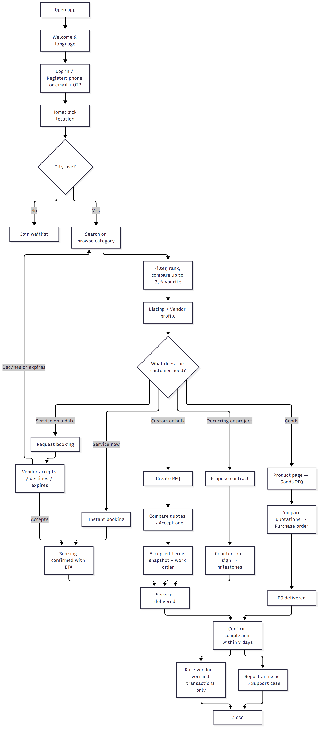
Side flows: suggest a category · modify or cancel a booking · edit RFQ (revision) · profile (individual/business) · notification and privacy settings · delete account request.

2. Vendor
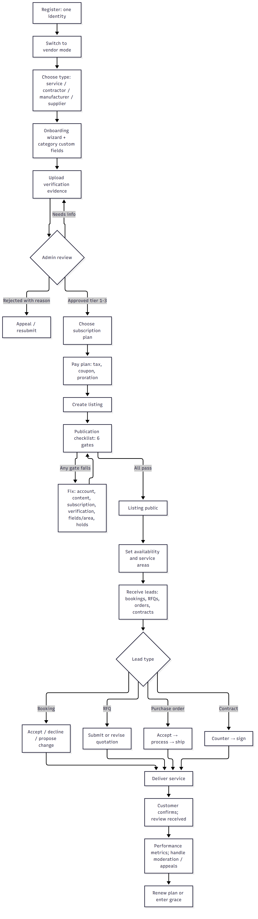
Side flows: sponsored visibility · business network (message a verified company) · buyer mode for vendor-to-vendor procurement · credential expiry reminders.

3. Business (company) account

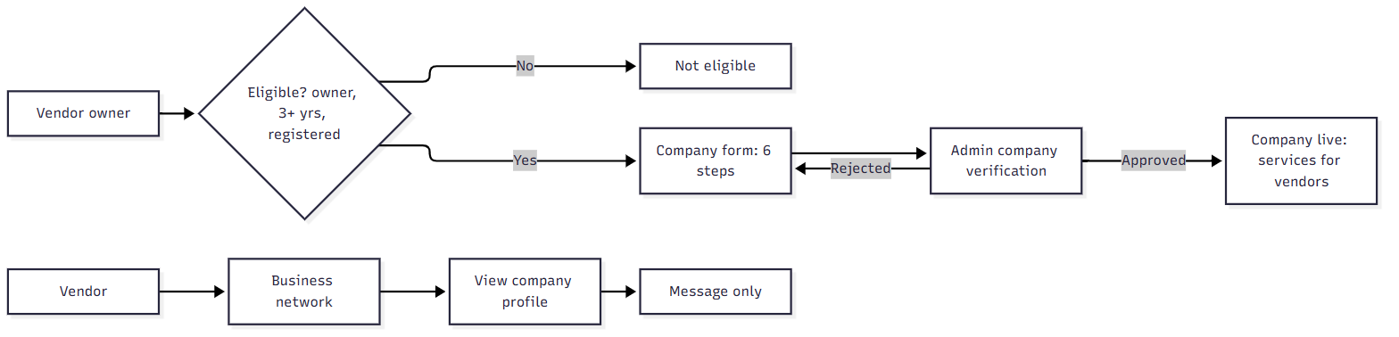

4. Sales agent
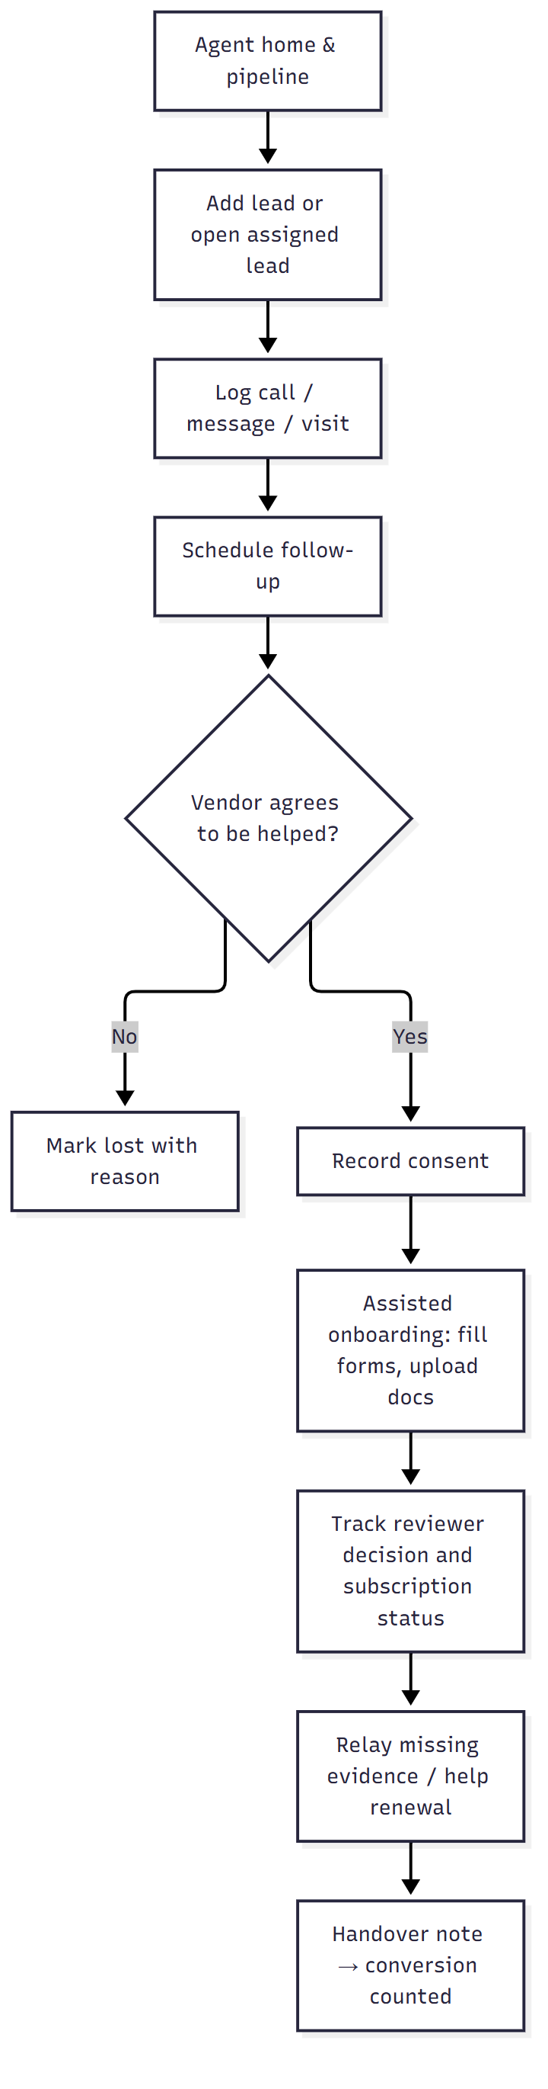
Hard limits: agent cannot approve or reject verification, publish or edit listings, touch billing/refunds, read customer transactions or chats, or see other agents' leads.

5. Admin (staff)
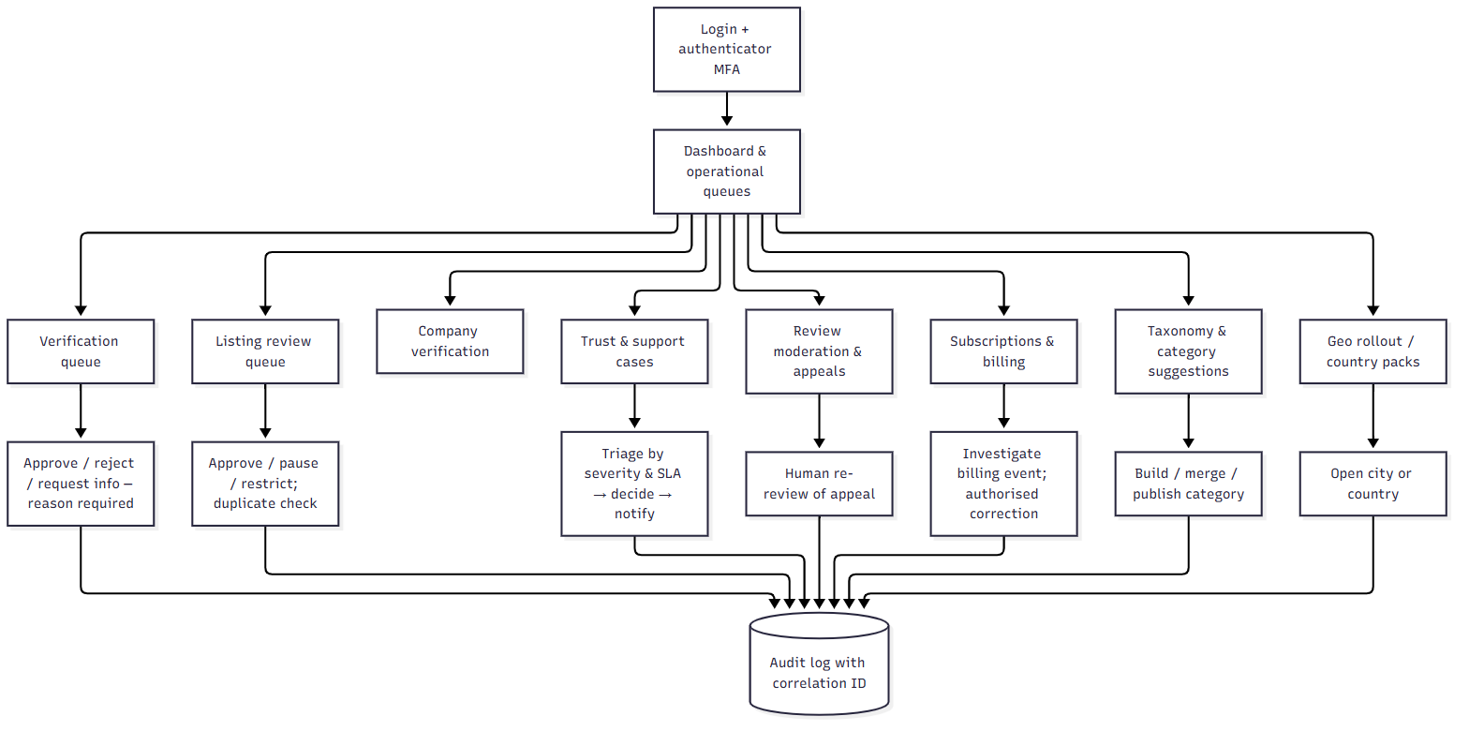

Rules: self-approval blocked (separation of duties); every high-impact action captures a reason; RBAC scopes per staff role; admin sessions require MFA.

05 · Booking, RFQ and Order State Diagrams
States come from the mockup code (BK_LABEL in src/screens/shared.jsx, PO_FLOW/rfqStatus in src/mvpdata.jsx). Items marked (proposed) are not yet in the mockup and are needed for production.

1. Booking
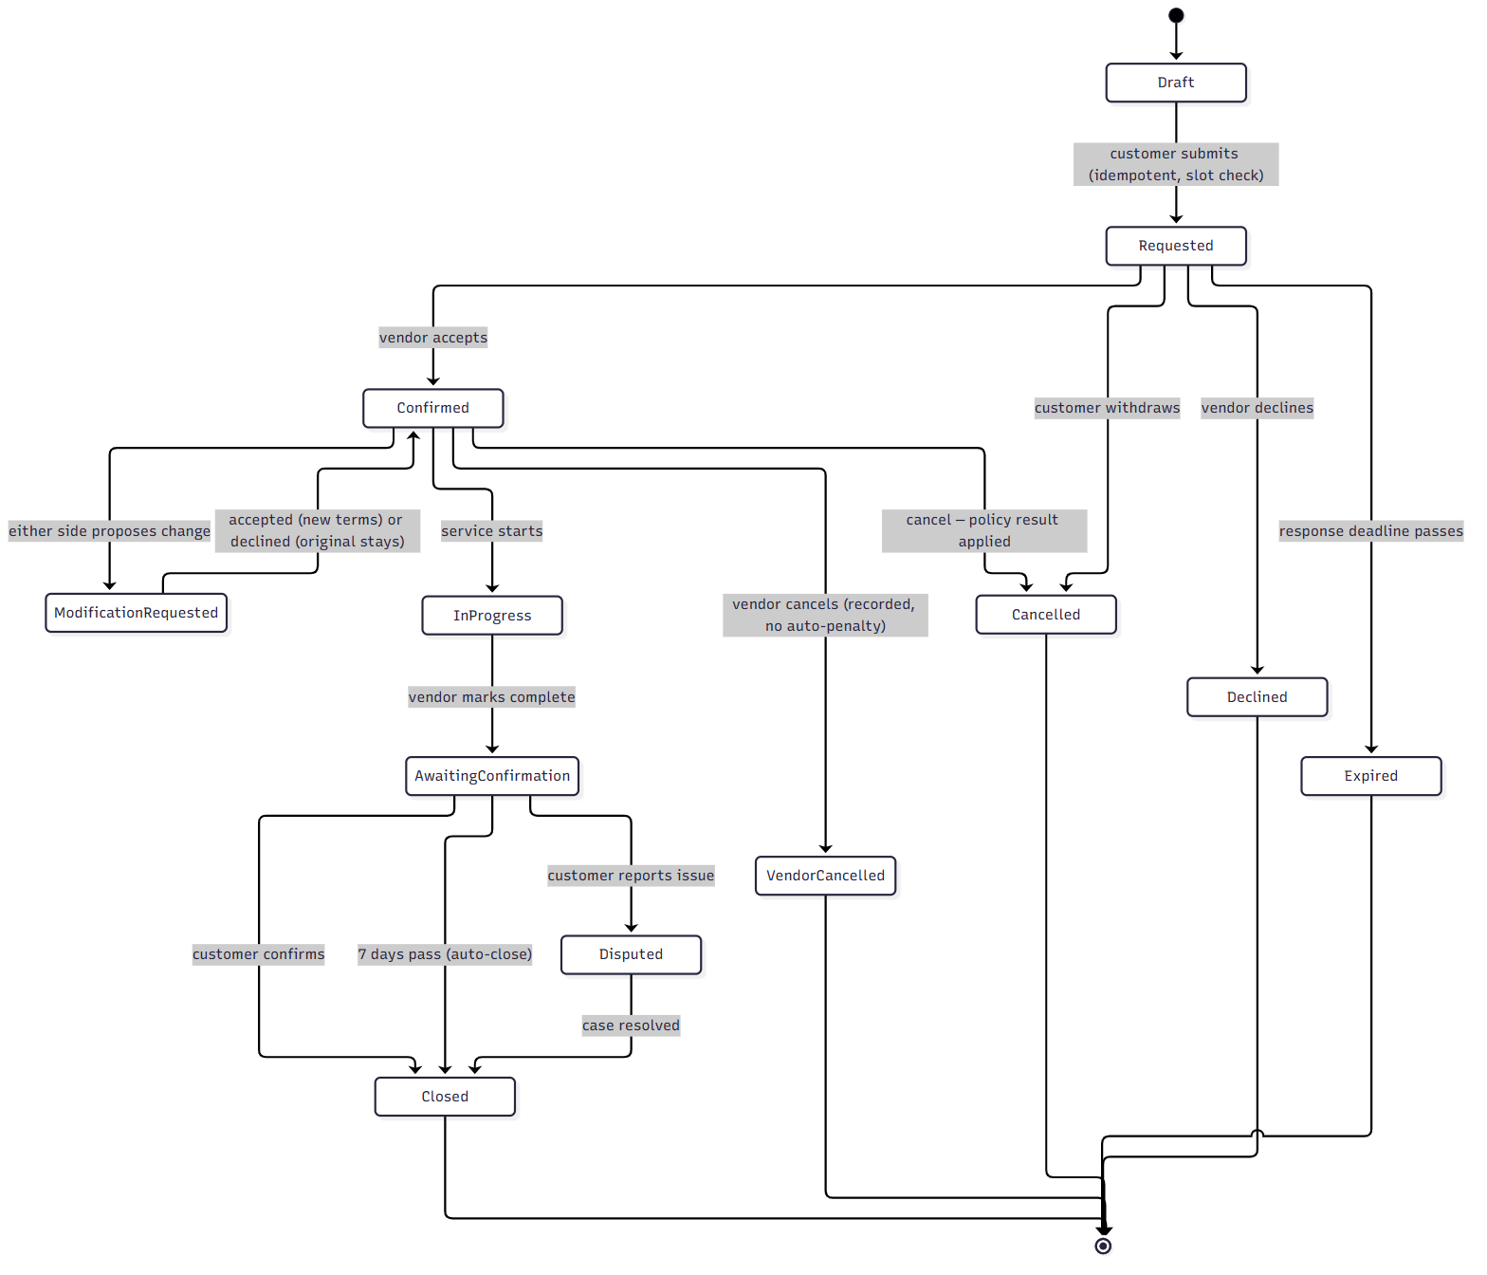
Rules
- Terms are snapshotted at confirmation. A modification never changes them until accepted.
- Two simultaneous confirmations for one slot → "conflicting confirmations" chooser; one wins atomically.
- Instant booking skips Requested: slot is locked and the booking is created as Confirmed with an ETA.
- Reviews are enabled only from Closed with a completed transaction.
- A support case can be linked to a closed booking.

2. RFQ
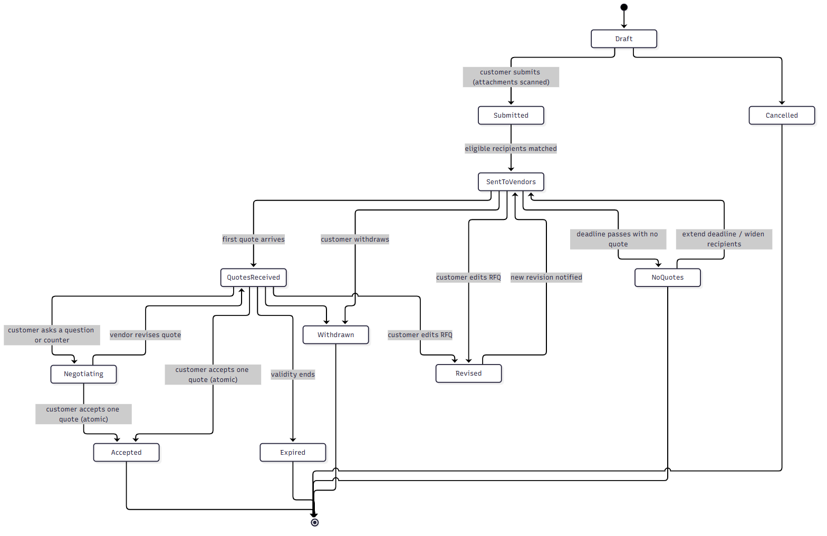
Quote sub-states: submitted → revised → withdrawn | expired | accepted | not_selected.
Rules
- Accept is atomic: if two accepts race, exactly one wins; the others receive "not selected".
- Accepting creates an immutable accepted-terms snapshot plus a downstream record:
  - service RFQ → work order (or booking),
  - goods RFQ → purchase order,
  - recurring/project → contract.
- Editing an RFQ creates a revision; vendors with open quotes are notified and may revise.

3. Purchase order (goods)
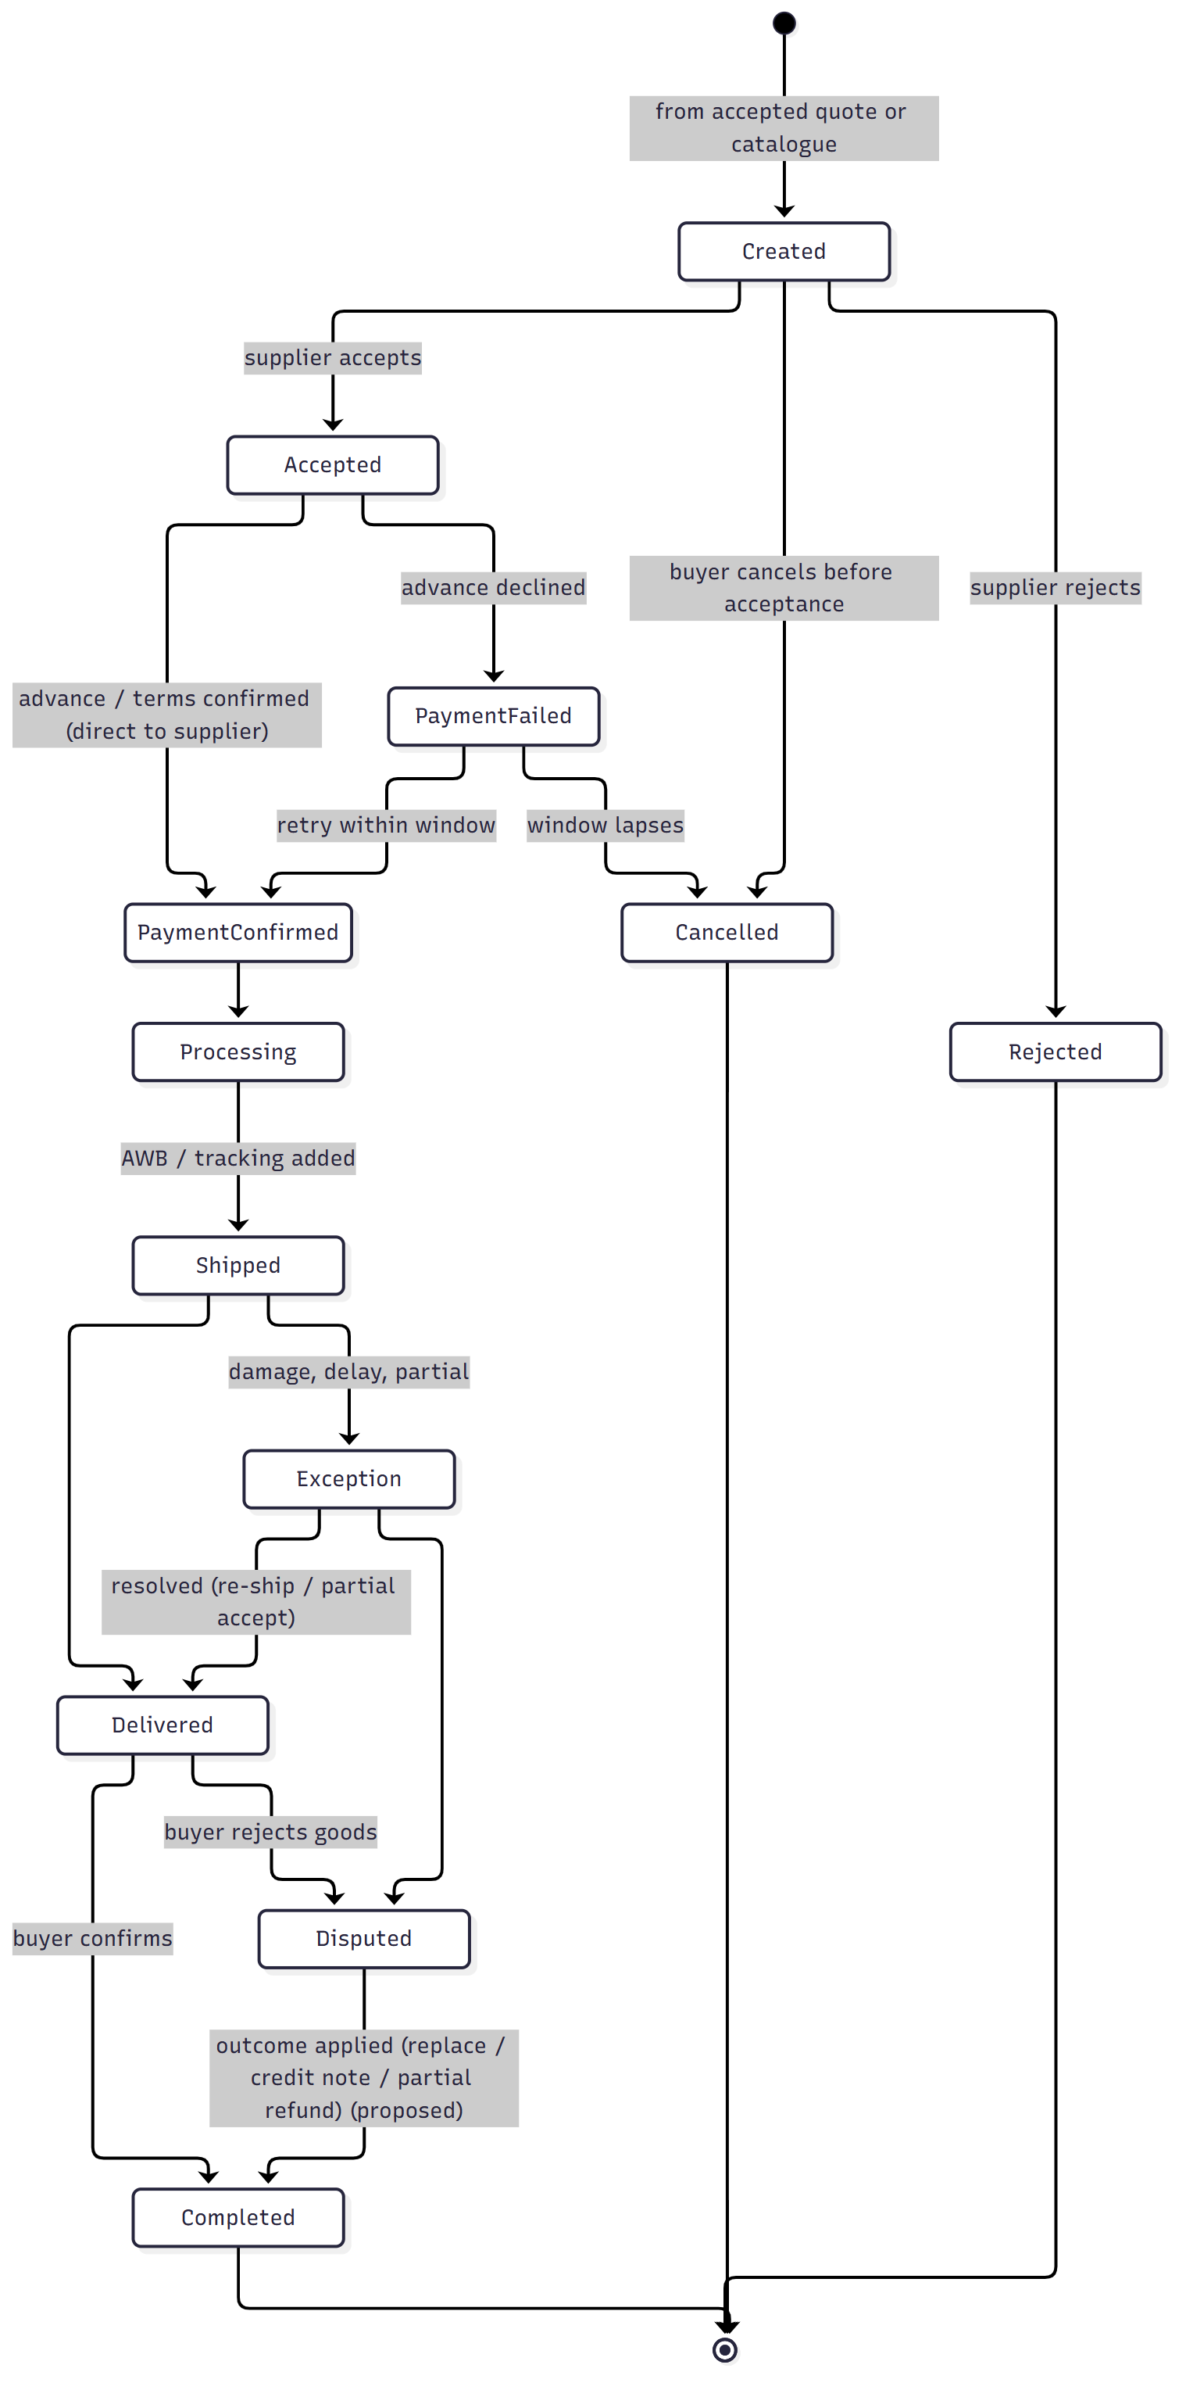

4. Contract (recurring, AMC, supply, project)
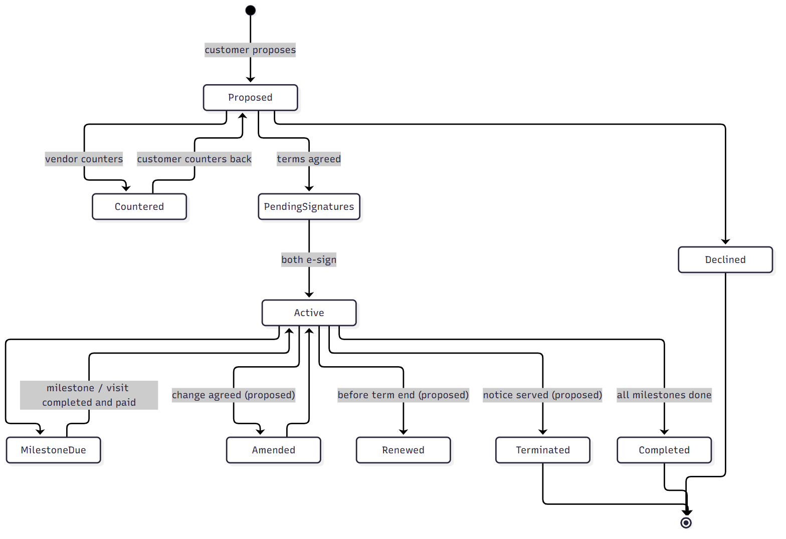

5. Vendor verification and listing publication
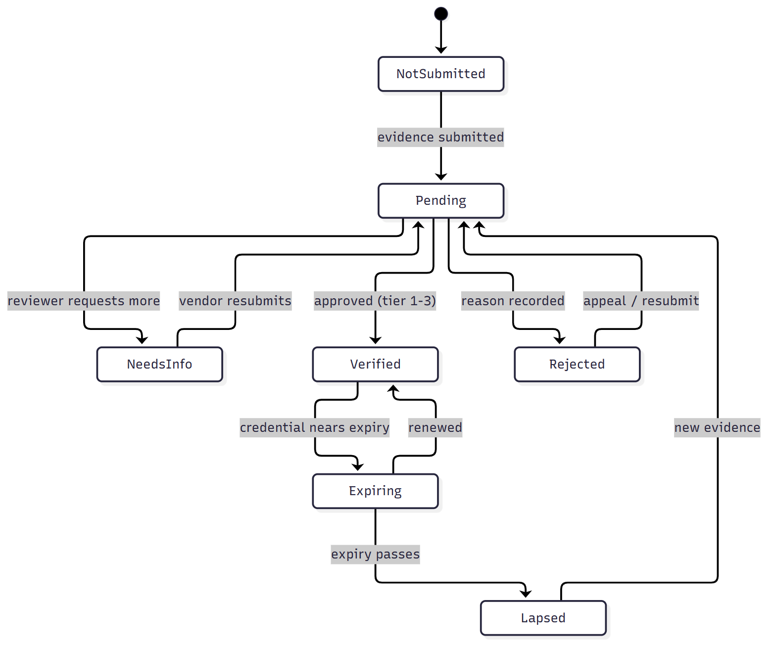
A listing is public only if all six gates pass, computed live: account state · content review · subscription (active/grace/cancelled-in-period) · required verification (per-credential expiry) · required fields + service area · no holds.

6. Subscription
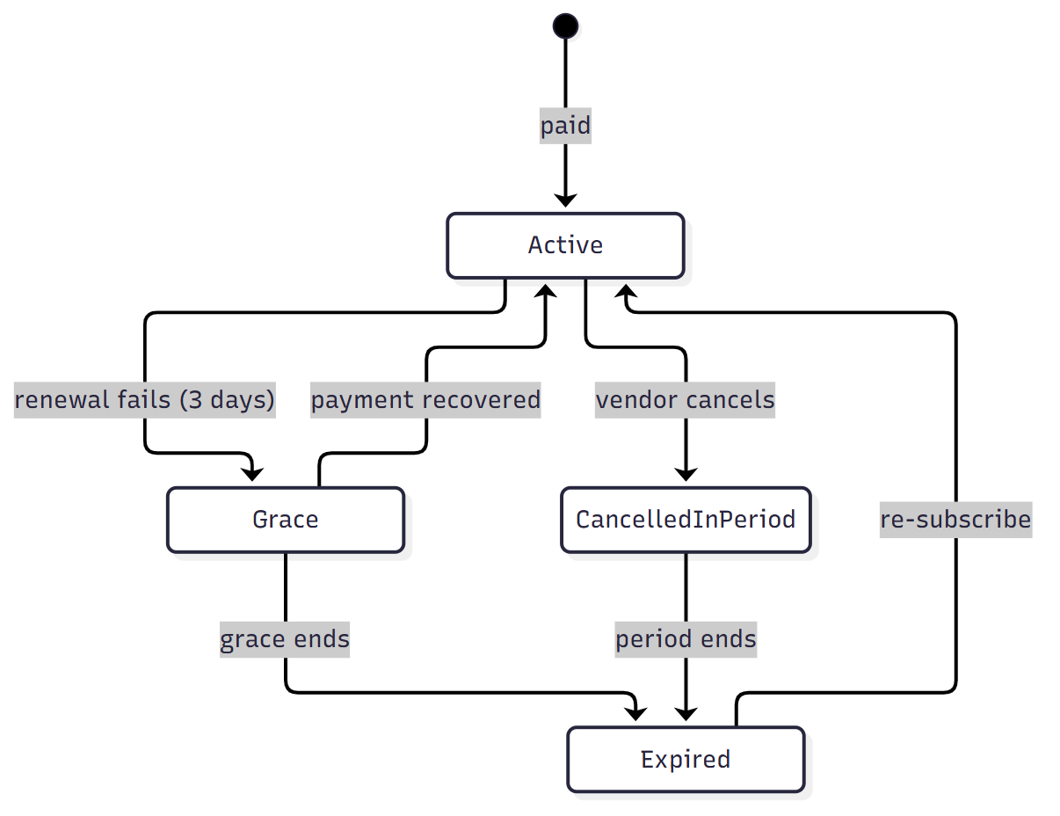

7. Support case
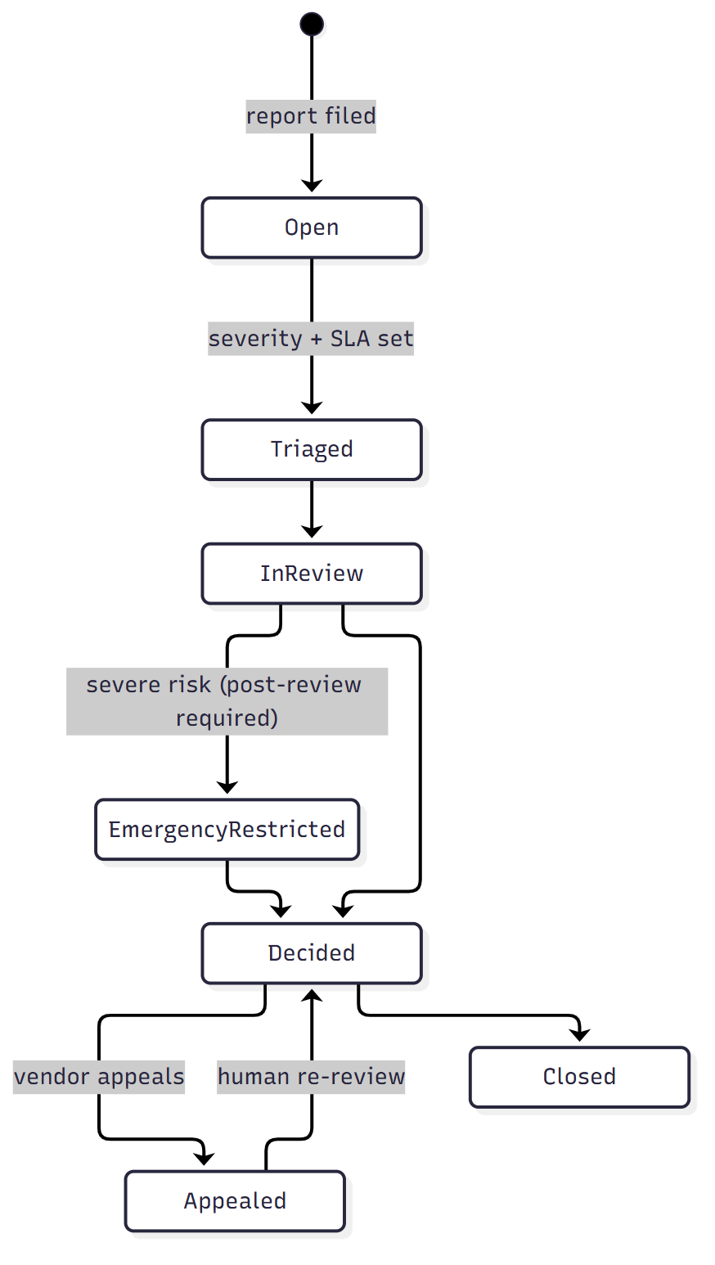

06 · Proposed Database Architecture / ERD

1. Architecture choices
Concern | Choice | Why
Primary store | PostgreSQL 16 | Strong relational integrity for bookings/quotes/billing; JSONB for category attributes; row-level locking for atomic accept and slot booking.
Geo | PostGIS | Service-area and pincode/radius matching.
Search | OpenSearch / Elasticsearch (read model) | Filters on dynamic attributes, geo, ranking. Fed from Postgres via outbox events.
Cache / queues | Redis | OTP, rate limits, sessions, deadline timers, job queues.
Files | S3-compatible object storage + virus scan | Evidence, listing media, RFQ attachments, invoices.
Analytics | Event stream → warehouse (later) | Keeps reporting load off OLTP.
Audit | Append-only table, partitioned monthly | Immutable trail with correlation IDs.

Principles
1. Config over code. Categories, attribute schemas, plans, policies and country packs are versioned rows.
2. Computed publication. listing.is_public is never stored; it is derived from the six gates (use a SQL view / service, plus a denormalised search flag updated by events).
3. Snapshots are immutable. Accepted terms, booking terms and contract versions are copied into snapshot rows.
4. One identity, many modes. A user may have customer, vendor, business and staff profiles; mode is not a privilege.
5. Soft delete + anonymise for DPDP-style deletion; financial and audit records retained per law.
6. Money as integer minor units + ISO currency code. No floats.
7. Every table: id (UUIDv7), created_at, updated_at; tenant-like scoping by country_code where relevant.

2. ERD — identity, vendors and listings
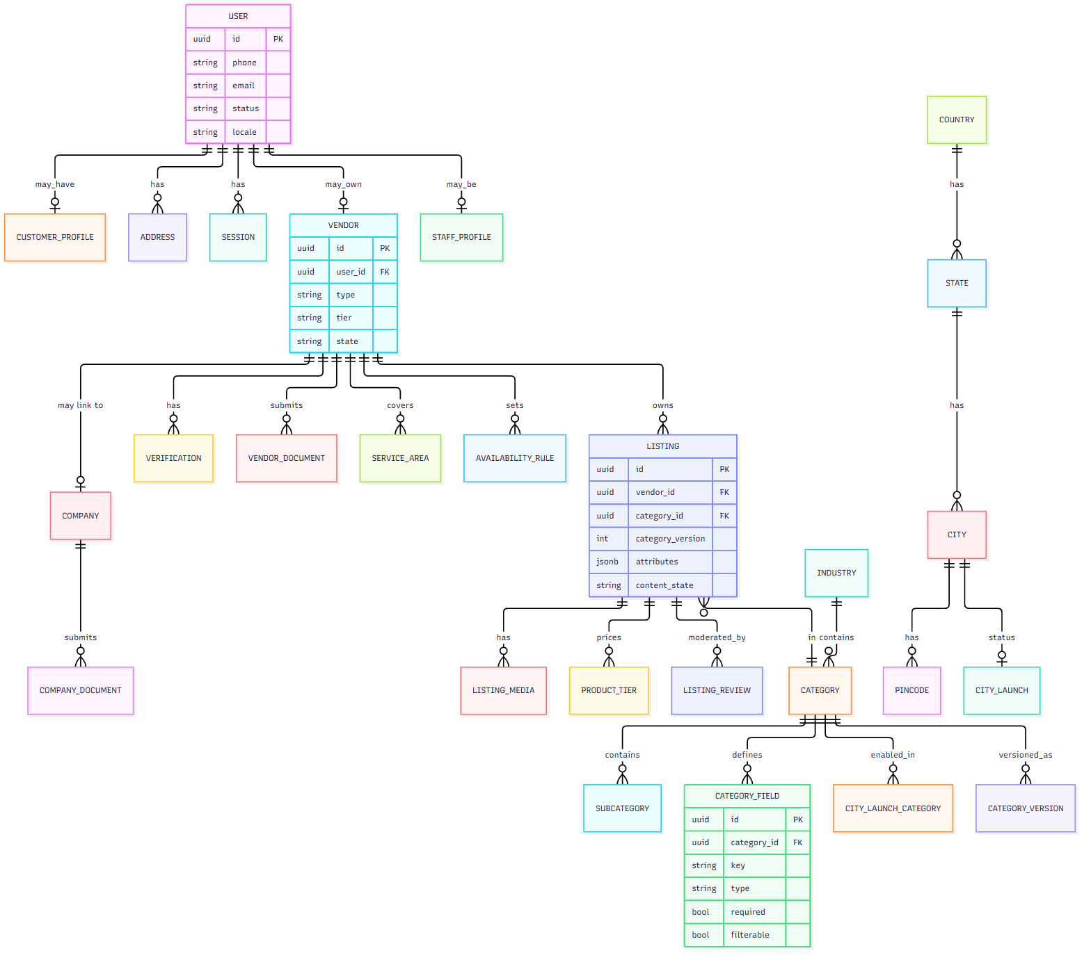

3. ERD — transactions
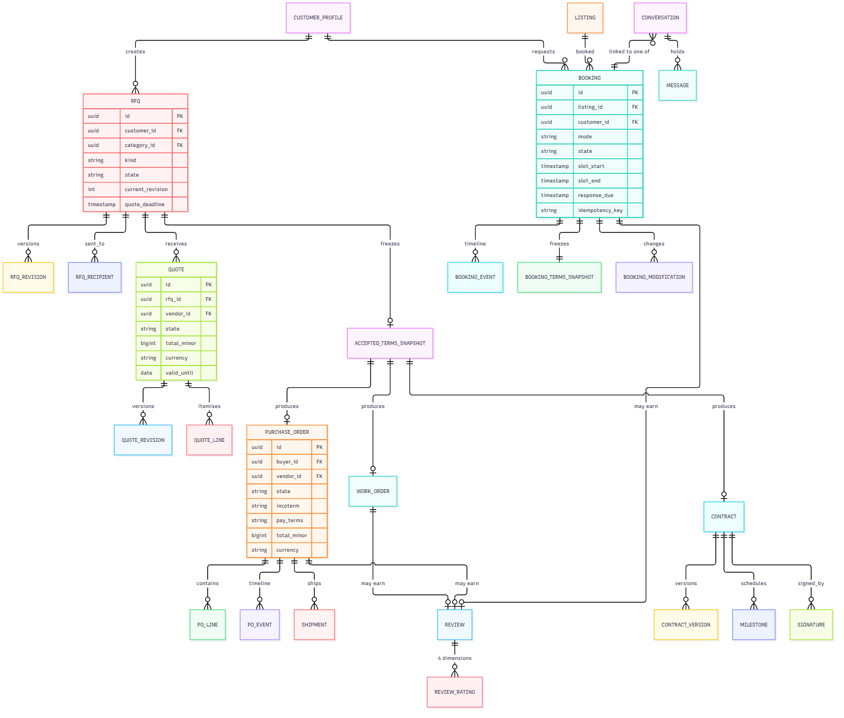

4. ERD — trust, billing and operations
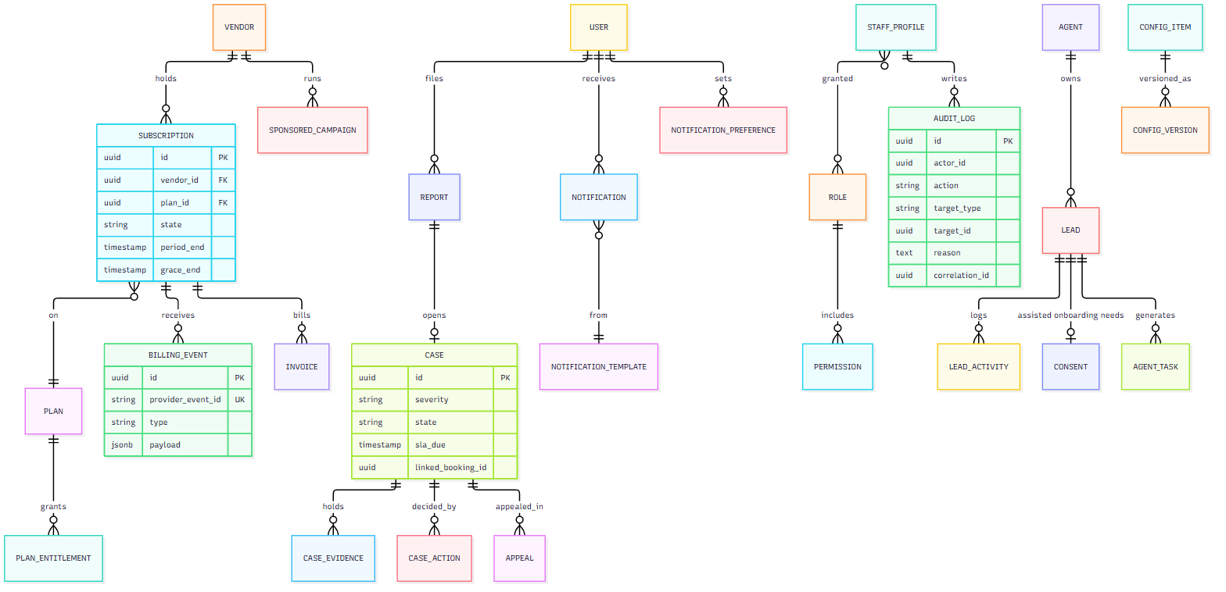

5. Phase 2 additions (not in MVP schema)
PAYMENT, ESCROW_HOLD, PAYOUT, COMMISSION_RULE, WALLET, WALLET_TXN, REFUND, BANK_ACCOUNT, TEAM_MEMBER, SAMPLE_REQUEST, TRADE_DOCUMENT, COUNTRY_PACK, CREDIT_NOTE.

6. Key constraints and invariants
Rule | Mechanism
One winning quote per RFQ | UNIQUE (rfq_id) WHERE state='accepted' + SELECT … FOR UPDATE on RFQ in accept transaction
No double-booked slot | Exclusion constraint on (listing_id, tstzrange(slot_start, slot_end)) where state in (confirmed, in_progress)
Idempotent booking create | UNIQUE (customer_id, idempotency_key)
Idempotent billing webhooks | UNIQUE (provider_event_id)
Review only after eligible transaction | FK to closed booking/PO/work order + unique per transaction per reviewer
Contact details hidden pre-confirmation | Application policy + column-level access; messages scanned
Admin self-approval blocked | Check actor_id <> subject.owner_id and separation-of-duties rule in service
Audit immutability | No UPDATE/DELETE grants on audit_log
Money precision | bigint minor units, char(3) currency

7. Index and scale notes
- Search is served by the search index, not Postgres. Keep Postgres indexes for owner lookups (vendor_id, customer_id, state, created_at).
- Partition audit_log, message, notification, booking_event by month.
- Category attributes in listing.attributes (JSONB) with GIN index for admin tooling; filter queries go to the search index.
- Read replicas for dashboards and exports from MVP+3 months.

8. Retention
Data | Retention
Audit log, invoices, billing events | 8 years (tax)
Messages linked to a case | Until case closed + 2 years
Messages otherwise | 2 years after transaction close
Verification evidence | While vendor active + 1 year
Deleted user PII | Anonymised within 30 days of request unless legal hold

07 · API Module Breakdown
Style: REST/JSON over HTTPS, versioned /v1, OpenAPI-first. Server-sent events or WebSocket for chat and live status. Background jobs for deadlines, billing, search indexing and notifications.
Deployment recommendation: a modular monolith (one deployable, hard module boundaries) for MVP, with search, notifications and file scanning as separate workers. Split further only when a module needs independent scaling.
Auth: JWT access token (15 min) + rotating refresh token. Staff require MFA. Every write endpoint accepts Idempotency-Key. Every response carries a correlation-id that lands in the audit log.

1. Modules
Code | Module | Responsibility | Key endpoints (examples) | Screens served | Phase
A1 | Auth & sessions | OTP login, registration, MFA for staff, device sessions | POST /auth/otp/request, /auth/otp/verify, /auth/refresh, GET/DELETE /me/sessions | auth, c_settings | MVP
A2 | Accounts & modes | One identity, customer/vendor/business modes, account states, deletion | GET/PATCH /me, POST /me/mode, POST /me/delete-request, GET /me/export | cprofile, acctstate, c_delete | MVP
A3 | RBAC & staff | Roles, permissions, scopes, separation of duties | GET/POST /admin/roles, POST /admin/staff/{id}/grant | adroles, adusers | MVP
G1 | Geo | Country/state/city/pincode, launch status, waitlist, rollout matrix, country packs | GET /geo/countries, /geo/cities?state=, POST /geo/waitlist, PUT /admin/geo/rollout | clocation, adgeo, ad_country | MVP
T1 | Taxonomy | Industries, categories, subcategories, field schemas, versions, suggestions | GET /taxonomy, POST /taxonomy/suggestions, POST /admin/categories, POST /admin/categories/{id}/publish | ccategories, adtaxonomy, ad_category | MVP
V1 | Vendors & onboarding | Vendor types, wizard, profile, public profile, company link | POST /vendors, PATCH /vendors/{id}, GET /vendors/{id}/public | vregister*, vprofile, c_vendor | MVP
V2 | Verification | Evidence upload, tiers, expiry, reviewer decisions, appeals | POST /vendors/{id}/documents, GET /admin/verifications, POST /admin/verifications/{id}/decision | vverify, advendors | MVP
B1 | Business accounts | Eligibility, company form, admin verification, network | POST /companies, GET /vendor/network, POST /admin/companies/{id}/decision | b*, adcompany, vbiz* | MVP
L1 | Listings & catalogue | Listings, products, tiers, media, 6-gate publication, duplicates | POST /listings, GET /listings/{id}/gates, POST /listings/{id}/submit, POST /admin/listings/{id}/decision | vlisting*, adlisting | MVP
L2 | Availability & areas | Service areas, availability rules, slot lookup | PUT /vendors/{id}/areas, GET /listings/{id}/slots | vareas, vavail | MVP
S1 | Search & discovery | Query, filter, geo, ranking, sponsored slots, compare, favourites | GET /search, GET /listings/{id}, POST /favorites, GET /compare | cexplore, csaved | MVP
K1 | Bookings | Create (idempotent), accept/decline, modify, cancel, complete, conflict | POST /bookings, POST /bookings/{id}/accept, /modify, /cancel, /complete, /confirm | cbook*, cbooking, v_booking | MVP
R1 | RFQ & quotes | Create/revise RFQ, recipients, quotes, compare, atomic accept | POST /rfqs, PUT /rfqs/{id}, POST /rfqs/{id}/quotes, POST /rfqs/{id}/accept | crfq*, vrfq, crfqgoods | MVP
O1 | Purchase orders | PO from quote/catalogue, accept, ship, deliver, exception | POST /orders, POST /orders/{id}/accept, /ship, /deliver, /exception | corder*, vorder* | MVP
C1 | Contracts | Propose, counter, e-sign, milestones; renewal/termination (P2) | POST /contracts, POST /contracts/{id}/counter, /sign, POST /milestones/{id}/complete | ccontract*, vcontract | MVP (core) / P2
M1 | Messaging | Linked conversations, privacy filter, contact-share consent, report | GET /conversations, POST /conversations/{id}/messages, WebSocket /ws | messages, chat, b_messages | MVP
N1 | Notifications | Templates, channels (push, SMS, email, WhatsApp), preferences, in-app inbox | GET /notifications, PUT /me/notification-preferences, POST /admin/templates | notifications | MVP
Q1 | Reviews | Eligibility, 4 ratings, trust score, moderation | POST /reviews, GET /vendors/{id}/reviews, POST /admin/reviews/{id}/decision | creview*, vreviews | MVP
Q2 | Trust & cases | Reports, cases, severity/SLA, evidence, emergency restriction, appeals | POST /reports, GET /admin/cases, POST /admin/cases/{id}/decision, POST /cases/{id}/appeal | creport, ccase, ad_case, v_cases | MVP
P1 | Plans & subscriptions | Plans, entitlements, checkout, webhooks, grace, corrections | GET /plans, POST /subscriptions, POST /webhooks/billing, POST /admin/subscriptions/{id}/correct | vsub, vplans, vcheckout, adsubs | MVP
P2 | Sponsored visibility | Campaigns, placement rules (cannot bypass gates) | POST /sponsored, GET /admin/sponsored | vsponsor, adsponsored | MVP
I1 | Invoices & tax | Tax invoice generation, GST fields | GET /invoices, GET /invoices/{id}/pdf | invoice | MVP
AG1 | Sales agents | Leads, activities, consent, assisted onboarding, tasks, conversion metrics | POST /agent/leads, POST /agent/leads/{id}/activities, POST /agent/leads/{id}/consent | a_* | MVP
AD1 | Admin ops & analytics | Dashboards, queues, analytics, config register | GET /admin/queues, GET /admin/analytics, GET/PUT /admin/config/{key} | addash, adanalytics, adcfg, adsettings | MVP
AU1 | Audit | Append-only action trail, query, export | GET /admin/audit | ad_audit | MVP
F1 | Files & media | Signed upload URLs, virus scan, image moderation, thumbnails | POST /files/upload-url, GET /files/{id} | all uploads | MVP
PAY1 | Payments & escrow | Checkout, escrow hold/release, refunds, wallet | POST /payments, POST /escrow/{id}/release, POST /refunds | cpay*, cwallet, c_refund* | P2
PAY2 | Payouts & commission | Commission rules, payouts, bank verification | GET /vendor/payouts, PUT /admin/commission-rules | vpayouts, adcommission | P2
TR1 | Trade (global) | Incoterms, multi-currency quotes, samples, trade-doc vault | POST /samples, POST /trade-docs | cpayfx, clistingtrade | P2
TM1 | Business teams | Team members, roles, spending limits, approvals | POST /team/members, POST /approvals/{id}/decision | team | P2

2. Background jobs and events
Job / event | Trigger | Effect
Booking response deadline | timer at response_due | Requested → Expired, notify both
7-day auto-close | timer | Awaiting → Closed, unlock review
RFQ deadline | timer | → No quotes / Expired
Credential expiry scan | daily | Reminders; gate 4 fails on expiry
Subscription renewal / grace | provider webhook + daily | Active → Grace → Expired
Search index sync | outbox events | Upsert/delete listing documents
Notification dispatch | events | Render template → channel provider
Retention / anonymisation | daily | Apply deletion & retention policy
Moderation scan | upload | Virus + image/text pre-screen

3. Third-party integrations
Need | Candidate | Phase
SMS/OTP (India DLT) | MSG91 / Twilio | MVP
Email | SES / SendGrid | MVP
Push | FCM / APNs | MVP
WhatsApp business | Meta Cloud API | MVP (optional)
Subscription billing | Razorpay Subscriptions / Stripe | MVP
KYC/KYB | Karza / Signzy / IDfy (GST, PAN, MCA) | MVP
Maps & geocoding | Google Maps / Mapbox | MVP
E-sign | Leegality / Digio | P2 (contracts core can use click-to-sign in MVP)
Payments + escrow | Razorpay Route / Cashfree | P2
Shipment tracking | Shiprocket / AfterShip | P2
Error / APM | Sentry + OpenTelemetry | MVP

4. Cross-cutting requirements
- Rate limiting: OTP (per phone, IP, device), search, message send, report.
- Authorisation: policy layer per module; ownership checks on every resource; staff scope checks.
- Pagination: cursor-based. Errors: RFC 9457 problem+json.
- Observability: structured logs, metrics, traces, alerting on queue depth and webhook failures.
- Privacy: PII encrypted at column level for ID documents; contact details gated until booking confirmed.
- Contract testing: OpenAPI schema published; mobile client generated from it; the same schema is shared with the separate web workstream.

08 · MVP and Phase 2 Scope
Business model fixed for MVP: customers pay vendors directly. Platform revenue = vendor subscriptions + sponsored visibility. The platform holds no customer funds.

1. MVP (Release 1)

In scope
Area | MVP includes
Platforms | Android and iOS only. Web is a separate workstream and uses the same backend API
Accounts | Phone/email + OTP, one identity with customer / vendor / business modes, account states, deletion request
Languages | English, Hindi
Geography | Country → state → city → pincode picker; live: Jaipur, Ajmer, Sikar, Delhi NCR; waitlist elsewhere
Taxonomy | Admin taxonomy builder, category schemas, suggest-a-category; 10 industries live (launch categories: Home, Construction, Events, Professional, Wholesale)
Vendors | Service provider, contractor, manufacturer, supplier onboarding; verification tiers 1–3 with expiry; 6-gate publication; public profile
Business accounts | Owner-only company profile, admin verification, vendor→company messaging only
Customer buying | Search/filter/rank, compare 3, favourites, vendor and listing detail
Booking modes | Instant, scheduled, structured RFQ (atomic accept, locked terms), goods RFQ → purchase order, basic contract (propose / counter / e-sign / milestones)
Goods | Catalogue with MOQ and volume tiers, domestic RFQ, PO lifecycle
Vendor-to-vendor | Buyer mode (RFQ + PO)
Messaging | Linked, privacy-aware chat; contact-share consent
Trust | Eligible-only reviews with 4 ratings, trust score, reports, cases with SLA, appeals with human re-review
Revenue | Plans, entitlements, checkout (tax, coupon, proration), grace period, sponsored visibility, tax invoice
Sales agents | Leads, consent-based assisted onboarding, tasks, conversion metrics
Admin | Queues, RBAC with separation of duties, MFA, audit log, analytics, geo rollout, country packs, config register
Notifications | Push, SMS, email, in-app; user preferences (new — gap G5)
Compliance | WCAG 2.2 AA target, DPDP-aligned consent/deletion/export

MVP additions required (from gap analysis)
Notification preferences and template manager · PO dispute outcomes · data export / deletion explainer · moderation review queue · session/device list for vendors and admins · maintenance/force-update screen · analytics date ranges and export.

Out of MVP (hidden by feature flag)
Checkout/escrow, wallet, refunds, payouts, commission engine, FX checkout, business team roles, cross-border trade.

2. Phase 2
Pillar | Phase 2 scope
Payments | In-app checkout, escrow with milestone release, wallet, refunds, invoices, bank verification
Commission | Engine by category and country, vendor payouts, tax handling (TCS/TDS), commission analytics
Languages | Arabic (RTL), Spanish, French, German, Chinese
Geography | More Indian metros; UAE, Singapore
Categories | Per-country packs; localised attribute schemas; 9 Phase 2 industries opened (Manufacturing & OEM, Textiles, Chemicals, Food processing, Education providers, Finance/RE, Marketing/media, Power/utilities, Packaging/printing)
Verification | Tier 4 audited partner; third-party KYB / registry integrations per country
Global trade | Incoterms, export markets, multi-currency quotes, samples workflow, trade-document vault, customs
Contracts | Renewal, amendment, termination, e-sign provider integration
Teams | Business team roles, spending limits, approvals; vendor staff accounts
Analytics | Cohort and funnel analytics, commission/payout analytics, event tracking console
Ops | Helpdesk macros and SLA timers, feature-flag console

3. Phase 3 (direction only)
Personalised home and AI search · ML category mapping · fraud-signal ML and continuous monitoring · UK/US/EU/APAC launches with local compliance · enterprise accounts (approval chains, cost centres) · multi-vendor project plans and tenders · trade finance, BNPL, inspection and freight bundles · predictive demand and pricing benchmarks · offline field tools · remaining 11 industries.

4. MVP exit criteria
1. All journeys J1–J7 run end to end against the real backend.
2. A vendor can onboard, be verified, subscribe, publish and receive a booking without engineer help.
3. An admin can add a new category, publish it and see it in search with no release.
4. No P1/P2 defects open; security review and load test passed (doc 10).
5. Configuration register CFG-01…12 fully resolved.

5. Decisions needed before build starts
# | Decision | Owner
1 | Mobile stack: React Native vs Flutter vs native (mockup is React; RN reuses most UI logic) | Tech lead
2 | API contract shared with the web developer (one backend, two clients) | Tech lead
3 | KYC/KYB vendor | Product + Legal
4 | Subscription billing provider | Finance
5 | Plan prices and limits (CFG-01/02), response deadlines, cancellation windows | Business
6 | Hosting region and cloud provider | Tech lead
7 | Whether manufacturers launch under Wholesale at MVP | Product

09 · Estimated Development Timeline
Treat as a planning estimate (±25%), not a quote. It assumes the scope in doc 08, decisions in §5 of doc 08 made in week 0–2, and the staffing below. The mockup already provides validated UI structure, business rules and sample data, which shortens design and discovery.

1. Assumed team
Role | Count
Product manager / BA | 1
UI/UX designer | 1
Backend engineers | 3
Mobile engineers (React Native) | 2
QA (manual + automation) | 2
DevOps / SRE | 1 (part-time → full-time at hardening)
Tech lead / architect | 1

Fewer engineers stretch the timeline roughly in proportion on the build phases.

2. MVP plan — about 30 weeks
Phase | Weeks | Work | Exit
0 · Discovery & setup | 1–3 | Resolve doc 08 decisions · API contracts (OpenAPI) · design system from mockup · CI/CD, environments, observability · provider selection (SMS, KYC, billing) | Signed-off scope, running skeleton
1 · Foundation | 4–7 | Auth/OTP/MFA · accounts and modes · RBAC · geo · taxonomy engine · files · audit · notifications core | Login, location, categories work end to end
2 · Vendor supply | 8–12 | Vendor onboarding (4 types) · verification and reviewer queue · listings and catalogue · 6-gate publication · service areas, availability | Vendor can register, be verified, publish
3 · Discovery | 10–14 (overlaps) | Search service and index · ranking · filters · compare/favourites · vendor profile | Customer finds live listings
4 · Transactions | 13–20 | Bookings (instant + scheduled) · RFQ and quotes with atomic accept · goods RFQ and PO · contracts (core) · chat | J1, J2, J3 pass
5 · Revenue & trust | 19–24 | Plans, billing, webhooks, grace · sponsored · invoices · reviews · reports/cases/appeals · business accounts · buyer mode | Vendors can pay; trust loop works
6 · Admin & agents | 21–25 (overlaps) | Admin queues, analytics, config register, geo rollout · agent CRM and assisted onboarding | J4, J5, J6, J7 pass
7 · Hardening | 26–28 | Performance and load · security review and pen test · accessibility audit · localisation (EN/HI) · data migration/seed · bug bash | Release candidate
8 · UAT & launch | 29–30 | Client UAT · store submission (Play / App Store review) · soft launch in Jaipur · monitoring | Go-live

Critical path: auth → taxonomy → vendor/listing → search → booking/RFQ → billing → hardening.

3. Phase 2 plan — about 18–20 weeks after MVP
Stream | Weeks | Work
Payments & escrow | 1–10 | Payment provider, escrow hold/release, milestones, wallet, refunds, reconciliation
Commission & payouts | 6–14 | Rule engine, payouts, bank verification, tax handling
Global trade | 4–14 | Incoterms, multi-currency, samples, trade-doc vault
Languages & RTL | 2–8 | Arabic RTL, ES/FR/DE/ZH, translation workflow
Verification tier 4 + KYB | 8–14 | Audit scheduling, registry integrations
Teams, contracts v2 | 10–16 | Business roles, approvals, renewal/amend/terminate, e-sign
New industries & cities | continuous | Taxonomy only — no release required
Hardening & launch | 17–20 | Payments security review, compliance, UAT

4. Effort summary
Scope | Calendar | Approx. person-weeks
MVP | ~30 weeks | ~240
Phase 2 | ~18–20 weeks | ~150

5. Milestones
Milestone | Target
M0 Scope & contracts frozen | Week 3
M1 Foundation demo | Week 7
M2 Vendor can publish | Week 12
M3 First booking end to end | Week 18
M4 Feature complete | Week 25
M5 Release candidate | Week 28
M6 Go-live (Jaipur) | Week 30

6. Risks to the timeline
Risk | Effect | Mitigation
Config register (CFG-01…12) unresolved | Billing and policies stall | Business sign-off by week 3
KYC/KYB integration delays | Verification blocked | Manual document review fallback
Web workstream (separate developer) changes shared API needs | Rework on backend contracts | Freeze OpenAPI contract by M0; change control for both clients
App-store review rejections | +1–2 weeks | Early TestFlight/Play internal track from week 14
SMS DLT registration in India | OTP blocked | Start registration in week 1
Search relevance tuning | Quality slips | Seed real listings early; weekly relevance review
Scope creep from Phase 2 screens already in mockup | MVP slips | Feature flags; change control

10 · Acceptance Testing Checklist
Run against the real build (not the mockup). Each item should record: tester, date, build number, pass/fail, defect link.
Format: [ ] = not yet run. Severity on failure: S1 blocks release · S2 must fix before launch · S3 can follow.

A. Journeys (end to end)
- [ ] J1 Customer searches nearby, opens a provider, books a service, sees status updates
- [ ] J2 Business buyer searches suppliers → product with MOQ/tiers → goods RFQ → compares quotes → accepts → PO created
- [ ] J3 Vendor registers, uploads evidence, admin approves, vendor adds listing and receives a lead
- [ ] J4 Admin creates category with fields, publishes, sees it in search; reviews a vendor and approves/rejects with reason
- [ ] J5 Vendor switches to buyer mode, sends bulk RFQ, accepts quote, tracks PO
- [ ] J6 Owner passes eligibility, submits 6-step company form, admin verifies, company is live
- [ ] J7 Vendor opens Business network, views company, can message only (no RFQ/booking)

B. Accounts and security
- [ ] Register and log in with phone OTP and with email OTP
- [ ] Wrong/expired OTP rejected; OTP request rate-limited per phone, IP and device
- [ ] Admin login requires MFA; session expires; device list shows and revokes sessions
- [ ] One identity switches between customer and vendor without gaining privileges
- [ ] Suspended / restricted / deleted account states block the correct actions
- [ ] Account deletion request anonymises PII within the policy window; legal-hold data retained
- [ ] User can export their data
- [ ] A user cannot read another user's bookings, RFQs, orders, chats or documents (test with direct ID access)
- [ ] Staff cannot approve their own submissions (self-approval blocked)
- [ ] Every high-impact admin action requires a reason and appears in the audit log with correlation ID
- [ ] Sales agent cannot approve, publish, change billing, or see customer transactions/chats/other agents' leads
- [ ] Uploaded files are virus-scanned; wrong types and oversize files rejected
- [ ] Contact details are hidden until booking confirmed; contact-sharing needs consent

C. Geography and taxonomy
- [ ] Country → state → city → pincode selection works; unlaunched city shows waitlist and accepts sign-up
- [ ] Admin opens a city and it goes live without a release
- [ ] Admin adds an industry, category, subcategory and custom fields; they drive onboarding, listing form, RFQ form and search filters
- [ ] Category cannot be published without booking mode, verification rule, deadline and cancellation policy
- [ ] Changing a category schema versions it; existing listings keep their version
- [ ] Suggest-a-category reaches admin; approve, merge and reject all notify the requester

D. Vendor onboarding and publication
- [ ] All four vendor types show the correct evidence requirements
- [ ] Reviewer can approve, reject with reason, or request more info; vendor sees the outcome
- [ ] Rejected vendor can appeal/resubmit
- [ ] Credential expiry reminders fire; expiry removes the listing from search (gate 4)
- [ ] Each of the six gates blocks publication independently: account · content review · subscription · verification · required fields + area · holds
- [ ] Publication status is derived live; changing one input flips visibility in search within the agreed delay
- [ ] Duplicate listing detection flags a copy
- [ ] Listing count respects plan limit

E. Discovery
- [ ] Search matches by pincode/city coverage; ineligible listings never appear
- [ ] Filters on category custom fields work; pagination stable
- [ ] Plan tier does not affect organic ranking; sponsored slots are labelled
- [ ] "Outside your area" and missing-data labels shown honestly
- [ ] No-result flow offers broader search / RFQ / waitlist
- [ ] Compare up to 3; favourites persist across devices
- [ ] Search error/offline state allows retry

F. Booking
- [ ] Instant booking confirms with ETA; slot cannot be double-booked under concurrent requests
- [ ] Scheduled request: accept, decline and expiry (deadline) all update both sides
- [ ] Idempotent create: double-tap creates one booking
- [ ] Modification keeps original terms until accepted; decline leaves original in force
- [ ] Customer and vendor cancellation apply the category policy; vendor cancellation recorded, no auto-penalty
- [ ] Conflicting confirmations show the chooser; exactly one wins
- [ ] Completion: vendor marks done; customer confirms or auto-closes after 7 days
- [ ] Review is available only after a closed, eligible transaction

G. RFQ, quotes, orders, contracts
- [ ] RFQ form follows the category schema; attachments scanned
- [ ] Only eligible vendors receive the RFQ
- [ ] Quote contains price, scope, inclusions, exclusions, timeline, validity; revise, withdraw, expire work
- [ ] Edit RFQ creates a revision and notifies quoting vendors
- [ ] No-quote path: extend deadline or widen recipients
- [ ] Two simultaneous accepts: exactly one winner; others see "not selected"
- [ ] Accepted-terms snapshot is immutable and creates the correct next record (work order / PO / contract)
- [ ] PO moves through created → accepted → paid/terms → processing → shipped → delivered → completed
- [ ] PO payment-failed retry window and delivery-exception paths behave as specified; dispute outcome recorded
- [ ] Contract: propose, counter, e-sign by both parties, milestone completion

H. Messaging and notifications
- [ ] Chat is linked to one transaction; non-parties cannot join
- [ ] Phone/email/link sharing is filtered before consent
- [ ] Customers cannot message or RFQ a Business (company) account; vendors can only message
- [ ] Report from chat creates a case with the conversation as evidence
- [ ] Every notification opens the correct destination screen
- [ ] User preferences per channel are honoured; quiet hours respected; opt-out works

I. Trust and safety
- [ ] Report → case with severity and SLA; breach raises an alert
- [ ] Emergency restriction applies immediately and is queued for post-review
- [ ] Appeal is decided by a human other than the original decider
- [ ] Review moderation hides abusive content; reviewer is notified
- [ ] Case-bound conversation access only for staff assigned to the case

J. Subscriptions and revenue
- [ ] Purchase a plan with tax, coupon and proration; invoice generated with correct GST fields
- [ ] Renewal failure → 3-day grace → expiry; listings follow gate 3
- [ ] Downgrade scheduled for period end; upgrade prorates
- [ ] Billing webhooks are idempotent (replay does nothing); out-of-order events handled
- [ ] Admin correction is authorised, reasoned and audited
- [ ] Sponsored campaigns cannot make an ineligible listing visible
- [ ] Lead-usage meter and plan limits enforce correctly

K. Agents and admin
- [ ] Agent assisted onboarding is impossible without recorded consent
- [ ] Conversion metrics match actual onboarding outcomes
- [ ] Admin queues show correct counts; filters and SLA timers work
- [ ] Analytics numbers reconcile with database counts for a known test dataset
- [ ] Config register values change behaviour without a deployment

L. Non-functional
- [ ] Performance: search p95 < 800 ms at 200 concurrent users; booking create p95 < 1 s; page LCP < 2.5 s on mid-range Android over 4G
- [ ] Load: 5× expected launch traffic for 30 minutes without errors
- [ ] Availability: health checks, graceful degradation when SMS/payment/KYC providers are down
- [ ] Security: pen test report with no open critical/high; OWASP ASVS L2 checklist; secrets not in code; dependency scan clean
- [ ] Privacy: consent screens, data export, deletion, retention jobs verified
- [ ] Accessibility: WCAG 2.2 AA audit passed on all MVP screens (screen reader, contrast, touch targets, focus order)
- [ ] Localisation: English and Hindi complete; no truncation; dates, numbers, currency formatted per locale
- [ ] Compatibility: Android 9+ and iOS 15+; phones of small, medium and large screen sizes; tablets render without breakage
- [ ] Resilience: flaky network, app killed mid-booking, double-submit, clock skew
- [ ] Backup & recovery: restore from backup tested; RPO ≤ 15 min, RTO ≤ 4 h
- [ ] Observability: alerts fire for webhook failures, queue backlog, error spike
- [ ] Release: store listings, privacy labels, terms and privacy policy published

M. Sign-off
Role | Name | Date | Decision
Product owner
QA lead
Tech lead
Security
Client sponsor

