VendorVerse — Product Documentation
One consolidated reference for the VendorVerse browser-local prototype: coverage and gaps, screen status, taxonomy, role flows, state machines, data architecture, APIs, scope, timeline and acceptance criteria. It merges the ten product documents with the 24 Oct 2026 PRS v3 gap report and the requirements-coverage map.
Prototype boundary. The app uses Vite, React 19 and Tailwind v4 with in-memory context state and browser-local persistence. It demonstrates product workflows but provides no authoritative backend authorization, production payments, shared database, file storage, notification delivery or immutable audit infrastructure.

Document control
Field | Detail
Document | VendorVerse Product Documentation Pack
Version / status | 1.0, draft for review
Date | 28 October 2026
Basis | Browser-local prototype; PRS v3 gap audit of 24 October 2026
Audience | Product, engineering, QA, security and business stakeholders
Classification | Internal
Owner / approver | To be assigned

Executive summary
VendorVerse is a working browser prototype, not a production system. The updated 28 October 2026 feature audit rates weighted mockup completion at approximately 48/100 and production readiness at 25–30/100. The PRS v3 review covers 29 requirement areas: 24 are partial, 5 are missing, and none is production-complete.
- Updated coverage. The feature matrix now reflects 21 capability rows across discovery, bookings, RFQs, procurement, verification, payments, communications, localization and QA. Screens may be demonstrable locally while the corresponding production capability remains partial or missing.
- Root cause. Identity and permissions, shared persistence, payment execution, uploads, notifications, search indexing and auditability are not authoritative platform services in the browser-local prototype.
- Plan. The current estimate is 16–22 calendar weeks for MVP delivery with parallel workstreams; Phase 2 is estimated at a further 12–20 weeks, subject to payment, logistics and country-compliance decisions.
- Decisions needed first. The payment boundary, the canonical PRS version, and three overlapping taxonomy categories (Appendix C).

Contents
- Updated Feature Coverage & Gap Analysis
- Screen-Wise Status
- Complete Category Taxonomy
- Customer, Vendor, Agent and Admin Flowcharts
- Booking, RFQ and Order State Diagrams
- Proposed Database Architecture / ERD
- API Module Breakdown
- MVP and Phase 2 Scope
- Estimated Development Timeline
- Acceptance Testing Checklist
- Appendices: A Glossary, B Risk register, C Open decisions, D Source register

1. Updated Feature Coverage & Gap Analysis
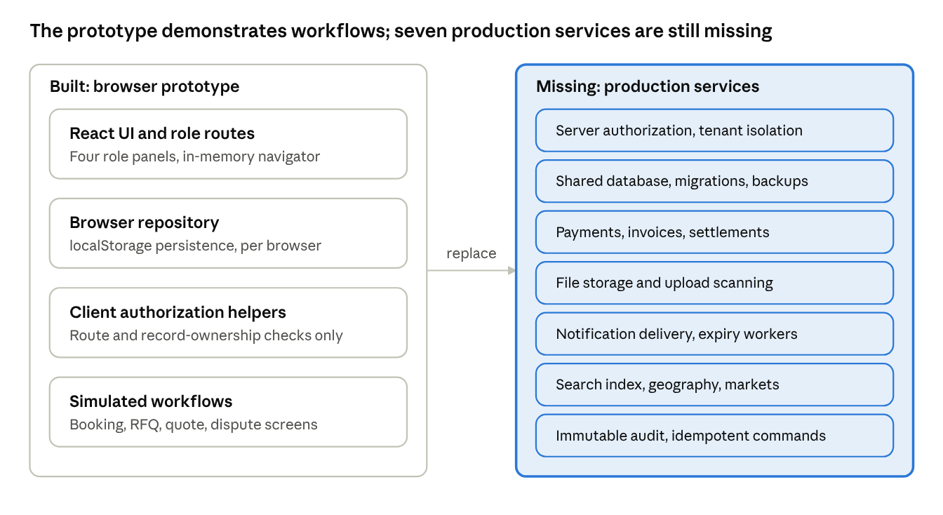
prototype vs production · 2 columns
Updated audit basis: 28 October 2026. Status describes the browser prototype; production readiness is assessed separately. A demonstrable screen is not evidence of secure, shared or durable backend behavior.

1.1 Feature coverage by area
Area | Status | Current implementation | Production gap
Branding, landing and navigation | Complete | Global marketplace landing, coverage and navigation entry points | SEO, content governance, analytics and server-backed navigation state
Explore, vendors, products and services | Complete | Search UI, category browsing, vendor/listing detail and discovery filters | Indexed search, relevance ranking, pagination and authoritative vendor data
Local, nationwide, worldwide and remote discovery | Complete concept | Coverage controls and country/location selection concepts | Normalized geography, service regions, market activation and eligibility rules
Customer profiles, saved items and comparison | Complete | Profiles, saved items and comparison behavior in browser-local state | Cross-device synchronization and server-side record ownership
Scheduled booking | Demonstrable | Booking request, vendor response, progress and completion screens | Capacity locks, reminders, deadlines and durable concurrency controls
Instant booking | Partial | Some booking UI concepts | Real-time availability, reservation workflow and slot locking
Recurring contracts | Partial concept | Recurring/contract concepts only | Contracts, milestones, renewals, SLA rules and billing entities
RFQ creation, quotations and comparison | Demonstrable | RFQ submission, vendor matching concepts, quote revisions and comparison | Matching service, expiry jobs, immutable terms and atomic/idempotent acceptance
Supplier procurement and purchase orders | Demonstrable | MOQ, quantity, lead time, specifications and purchase-order screens | Inventory, payment boundary, fulfilment, returns and trade compliance
Vendor-to-vendor buying | Demonstrable concept | Vendor buyer mode and procurement journey concepts | Organization membership, tenant permissions and transaction isolation
Vendor onboarding and listings | Complete mockup | Registration, business profile, listing management and approval states | Secure document storage, duplicate checks, publication gates and ownership
Evidence-based verification | Complete mockup | Evidence submission and verification status concepts | Evidence expiry, reviewer controls, re-verification and durable audit
Reviews, complaints and moderation | Demonstrable | Review, complaint, issue and dispute screens | Eligible-transaction enforcement, evidence handling, SLA timers and appeals
Customer, vendor, agent and admin workspaces | Complete mockup | Role-specific routes, dashboards and operational screens | Server-side RBAC, tenant isolation and staff-scope enforcement
Payments, refunds, invoices, commissions and subscriptions | Concept screens | Payment/refund/settlement status concepts and subscription/commission views | Payment provider, ledger, tax engine, payouts, billing and signed webhooks
Messages and notifications | Demonstrable | Threads, unread filters, chat and notification UI | Delivery providers, participant authorization, attachment security, receipts and retries
Dynamic taxonomy and custom fields | Admin concept | Category, subcategory, field and filter editor concepts | Versioning, localization, migration strategy and schema-driven rendering
Location and currency | Display concept | Country/currency controls and location labels | Currency conversion rules, tax/settlement logic and normalized geography
Hindi localization | Partial | English/Hindi toggle and partial translated copy | Complete translation catalog, encoding repair and locale regression tests
Loading, empty, error, cancelled, rejected and expired states | Partial | Representative state variants on key screens | Consistent state coverage, retry/offline handling and scheduled transitions
Accessibility and automated QA | Foundation only | Responsive layout and build validation | Keyboard/screen-reader support, contrast review, responsive QA and scenario test suites

1.2 PRS v3 audit (24 Oct 2026)
The audit covers 29 requirement areas: 24 partial, 5 missing, none complete. Missing: 21–25 release gates and configuration, 26.2 dynamic categories, 26.3 geography and global search, 26.9 payments/commission/subscriptions, 26.11 launch market architecture.
PRS area | Status | Main gap to close
1–2 purpose, scope, payment boundary | Partial | Legacy product checkout data and copy remain; release boundaries not enforced
3 accounts and four roles | Partial | One identity cannot switch customer/vendor contexts
4 RBAC | Partial | No deny-by-default service authorization or per-action ownership checks
5 vendor onboarding and publication | Partial | Country-first onboarding, L0–L4 levels, expiry gates, reviewer self-approval protection
6 taxonomy and attributes | Partial | Seed data only; no lifecycle, country scope, merge, aliases, suggestion queue
7 discovery, comparison, favorites | Partial | No geography hierarchy, pagination, result rationale, remote/ships-to logic
8 service bookings | Partial | No full state machine, terms snapshot, deadlines/reminders, recurring/instant modes
9 RFQs and quotations | Partial | No structured schema fields, deadline extension, withdrawal, no-quote outcome
10 messaging and notifications | Partial | No participant authorization, privacy notice, message reports, durable delivery
11 subscriptions and sponsored visibility | Partial | No checkout, invoices, grace/expiry, lead usage, eligibility enforcement
12 reviews, reports, disputes | Partial | No rating dimensions, report/appeal, moderation queue
13 Super Admin operations | Partial | Missing several queues, dual approval, market filters
14–16 data, integrations, privacy, security | Partial | No server authorization, normalized persistence, idempotency, attachment handling
17 non-functional | Partial | No performance/offline instrumentation, RTL, formal accessibility audit
18 analytics | Partial | Metrics mostly fixture-based
19 UX states and screen inventory | Partial | Incomplete loading, retry, offline, expired, permission-denied states
20 scenarios SC-001–SC-046 | Partial | No scenario test suite; SC-041–SC-046 missing
21–25 release gates, configuration | Missing | No release/market configuration registry or phased feature gates
26.1 global branding and homepage | Partial | No market controls, measured trust copy, market status/waitlist, SEO
26.2 global dynamic categories | Missing | No unlimited taxonomy, lifecycle, localized names, scopes, versioning
26.3 geography and global search | Missing | No geography records, coverage model, locale-aware currency, relevance tiers
26.4 profiles | Partial | Missing field-visibility classes, completeness, protected data rules
26.5 bookings and contracts | Partial | Missing instant, recurring, contract modes and lifecycle
26.6 verification and ratings | Partial | No L0–L4 evidence matrix, dated labels, computed trust metrics
26.7 supplier/manufacturer listings | Partial | No price tiers, trade terms, export coverage, compliance controls
26.8 dashboards | Partial | Missing market filters, contracts, subscription usage, booking calendar
26.9 payments, commission, subscriptions | Missing | No payment provider, checkout, tokens, receipts, dual approval
26.10 responsive, i18n, accessibility | Partial | Hard-coded copy, damaged Hindi encoding, no locale selector, not RTL-ready
26.11 launch market architecture | Missing | No market register, activation checklist, noindex status

1.3 Main gaps before production
- Backend authorization and record-ownership enforcement.
- Durable transaction state machines and idempotent commands.
- Real evidence upload, scanning and verification expiry.
- Geography, market activation and a global search index.
- Payment provider, tax invoice, commission and settlement integration.
- Notification delivery and scheduled expiry/reminder workers.
- Automated unit, integration, accessibility and end-to-end tests (the project has a build script only; no lint, type-check or test scripts).

1.4 Latest booking and quote pass (browser-local)
- Customer: service booking request form, booking list/detail, cancellation, progress and completion, booking-linked issue, eligible-review check, occupied-time collision checks, accepted-RFQ term snapshot and quote-expiry guard.
- Vendor: booking and change requests in the Work panel with accept/decline, progress and completion; already-confirmed-slot check; RFQ validity dates cannot be newly set in the past.
- Agent and Admin: no new workflow needed in this pass.
- Still needs platform work: durable booking locks, weekly availability/capacity, subscription billing enforcement, real payouts, atomic transactions, server-side permissions, SLA timers and immutable audit.
- The mock does not collect service payments; customers and vendors arrange terms directly, consistent with the release scope.

1.5 Safe implementation sequence
- Foundation: persistent repository/service layer, authorization boundary, identity and account state, audit, i18n/locale preferences.
- Taxonomy, geography and search: data-driven categories and geography, market-aware search.
- Vendor onboarding and publication: computed gates, verification levels, profile visibility rules.
- Transactions: booking/RFQ state machines, contracts, immutable terms.
- Communications, subscriptions, trust and Super Admin operations.
- QA: responsive review, state/error coverage, accessibility checks, scenario tests.
Phase A progress (in progress): browserRepository.js (resilient localStorage persistence), authorization.js (role permission, vendor and customer ownership, route checks), store.jsx moved to persisted state, persisted country/currency choices added to the header, and user-visible non-production wording removed. npm run build passes.
Wording still to clean: internal names and comments containing demo/mock, and public README wording that describes the deployed product.
Points to reconcile. (1) The MVP scope includes a basic payment intent, while the coverage map states the release does not collect service payments; confirm the payment boundary. (2) Two PRS file names are cited (Global Marketplace v3 and Simplified RBAC v3); confirm which is canonical.

2. Screen-Wise Status
Legend: Completed prototype = route and primary interaction demonstrable locally. Partial = important UI flow exists but production services or edge cases are incomplete. Missing = not implemented as a complete workflow. Future = recommended post-MVP capability.
Area | Completed prototype | Partial | Missing / Future
Auth | Splash, welcome, registration shell | Login, OTP, role entry | Password recovery, secure MFA, session service
Customer | Home, categories, explore, vendor/listing detail, saved/compare | RFQ, booking, orders, messages, reviews, support, settings | Contracts, recurring booking, production checkout
Vendor | Registration shell, listings, profile, work and dashboard routes | Verification, quotations, bookings, orders, reviews, performance | Full inventory, settlement, contracts, organization controls
Agent | Leads, lead detail, activity, follow-ups, profile | Assisted onboarding, commissions | Assignment engine, offline mode, real payouts
Admin | Dashboard, users, categories, vendor/listing queues, disputes, settings | Reports, RFQ consoles, moderation, audit | Market activation, review appeals, SLA operations, immutable audit
Shared | Notifications, chat route, forms, cards, dialogs, responsive shells | Localization, error/loading coverage | Backend delivery, upload scanning, observability
Important future screens
- Contract workspace and milestone management.
- Organization/team member administration.
- Procurement approval center and cost centers.
- Tax invoices, settlements and payout center.
- Review appeals and moderation queue.
- Market activation and country compliance console.
- Notification delivery and integration health monitor.

3. Complete Category Taxonomy
The seed taxonomy has 42 categories. In the prototype, Admin can create custom categories, subcategories, fields and filters.
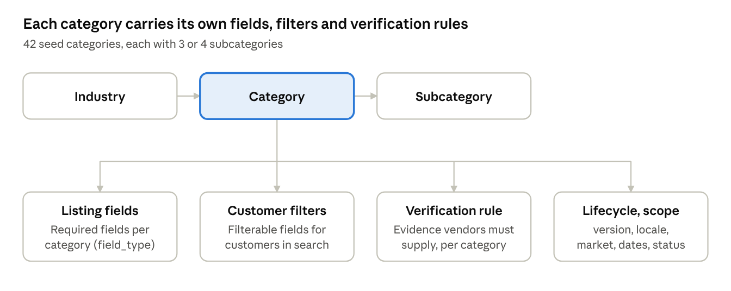
taxonomy hierarchy · industry to subcategory
Admin edits categories; each category defines its listing fields, customer filters, verification requirement and lifecycle.
# | Category | Subcategories
1 | Electrical & Hardware | Wires & Cables, Switches & Sockets, Power Tools, Lighting
2 | Construction Material | Cement, Steel & TMT, Bricks & Blocks, Plywood
3 | Office & IT Supplies | Printers, Computers, Stationery, Furniture
4 | Printing & Packaging | Boxes, Labels, Brochures, Branding
5 | Home Repair Services | Electrician, Plumbing, Carpentry, Painting
6 | Cleaning & Pest Control | Deep Cleaning, Sofa & Carpet, Pest Control
7 | Catering & Events | Wedding, Corporate, Decoration
8 | Facility & Staffing | Security, Housekeeping, Drivers
9 | Agriculture & Farming | Seeds, Irrigation, Farm Equipment
10 | Automotive & Mobility | Vehicle Parts, Repairs, Fleet Services
11 | Beauty & Wellness | Salon, Spa, Makeup
12 | Legal & Compliance | Business Law, Contracts, Tax Advice
13 | Finance & Insurance | Accounting, Loans, Insurance
14 | Healthcare & Medical | Clinics, Diagnostics, Medical Equipment
15 | Logistics & Freight | Road Freight, Warehousing, Customs
16 | Travel & Hospitality | Hotels, Tour Operators, Transport
17 | Real Estate & Property | Property Sales, Rentals, Property Management
18 | Security & Safety | CCTV, Guards, Access Control
19 | Renewable Energy | Solar, Wind Power, Batteries
20 | Water & Sanitation | Water Treatment, Pumps, Wastewater
21 | Fashion & Textiles | Garments, Fabrics, Uniforms
22 | Food & Beverages | Packaged Food, Ingredients, Beverages
23 | Chemicals & Materials | Industrial Chemicals, Adhesives, Coatings
24 | Pharmaceuticals | Medicines, Supplements, Lab Supplies
25 | Machinery & Equipment | Industrial Machines, Components, Maintenance
26 | Consumer Electronics | Mobile Devices, Audio Video, Accessories
27 | Telecom & Networking | Internet, Network Hardware, Telephony
28 | Software & SaaS | Business Software, Cloud Apps, Cybersecurity
29 | Marketing & Advertising | Digital Marketing, Branding, Media Buying
30 | Human Resources | Recruitment, Payroll, Training
31 | Education & Training | Tutoring, Corporate Training, E-learning
32 | Engineering & Design | Civil Design, Mechanical Design, Architecture
33 | Business Consulting | Strategy, Operations, Market Research
34 | Insurance Services | Health Insurance, Business Insurance, Claims
35 | Environmental Services | Recycling, Audits, Pollution Control
36 | Marine & Shipping | Ship Services, Marine Equipment, Freight
37 | Mining & Minerals | Minerals, Mining Equipment, Drilling
38 | Aerospace & Defence | Aviation Parts, Drones, Maintenance
39 | Entertainment & Media | Production, Photography, Events
40 | Sports & Recreation | Fitness, Sports Equipment, Coaching
41 | Household Products | Kitchenware, Home Decor, Storage
42 | Gifts & Crafts | Handicrafts, Corporate Gifts, Artisan Goods
Taxonomy attributes: industry, category and subcategory; product/service type; required listing fields; customer-facing filters; active/inactive status; category merge and custom category creation.
Recommended production fields: parent_id, version, locale, market_scope, vendor_type_scope, field_type, required, filterable, sort_order, effective_from, effective_to, verification_requirement_id, created_by, updated_by.
Overlaps to review before launch: Finance & Insurance (13) vs Insurance Services (34); Logistics & Freight (15) vs Marine & Shipping (36, includes Freight); Facility & Staffing (8, includes Security) vs Security & Safety (18, includes Guards). These are candidates for the merge workflow.

4. Customer, Vendor, Agent and Admin Flowcharts

4.1 Customer
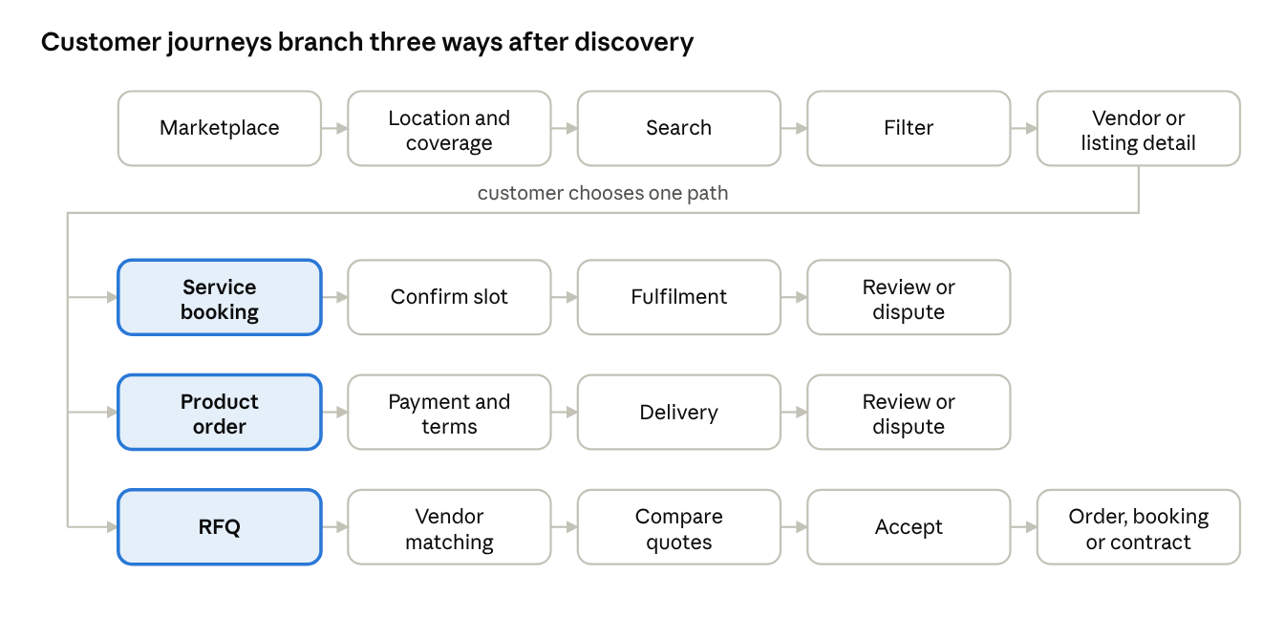
customer flowchart · 3 paths
After discovery the customer takes one of three paths; booking and order paths end in review or dispute, and an accepted quote becomes an order, booking or contract.

4.2 Vendor or supplier
Vendors can also switch to buyer mode: discover supplier, submit RFQ/order, compare terms, approve purchase, receive goods or service, confirm delivery, and dispute if needed.
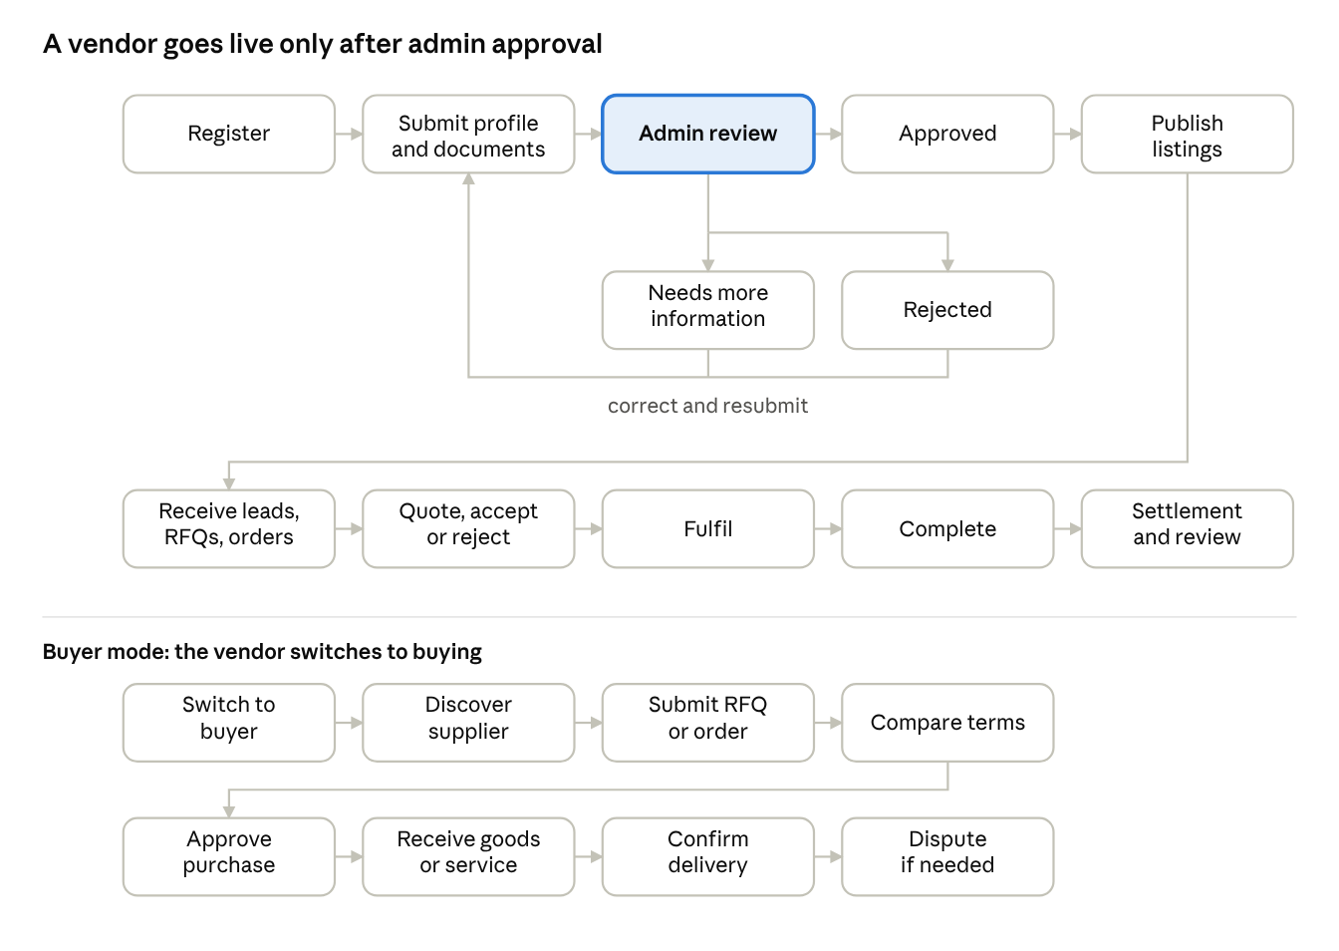
vendor flowchart · onboarding, work, buyer mode
Approval gates publication; incomplete or rejected profiles go back to the vendor for correction. In buyer mode the same vendor procures from other suppliers.

4.3 Sales Agent
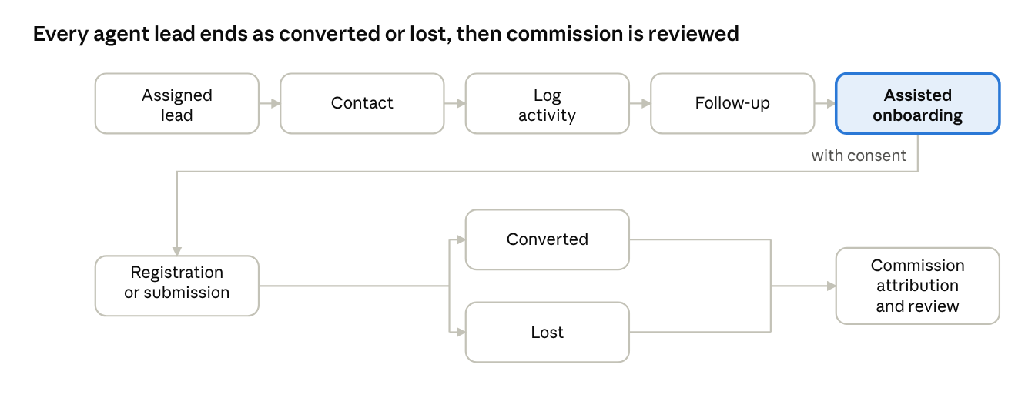
sales agent flowchart · lead to commission
An assigned lead moves through contact and follow-up to assisted onboarding with consent; conversions and losses both feed commission review.

4.4 Admin
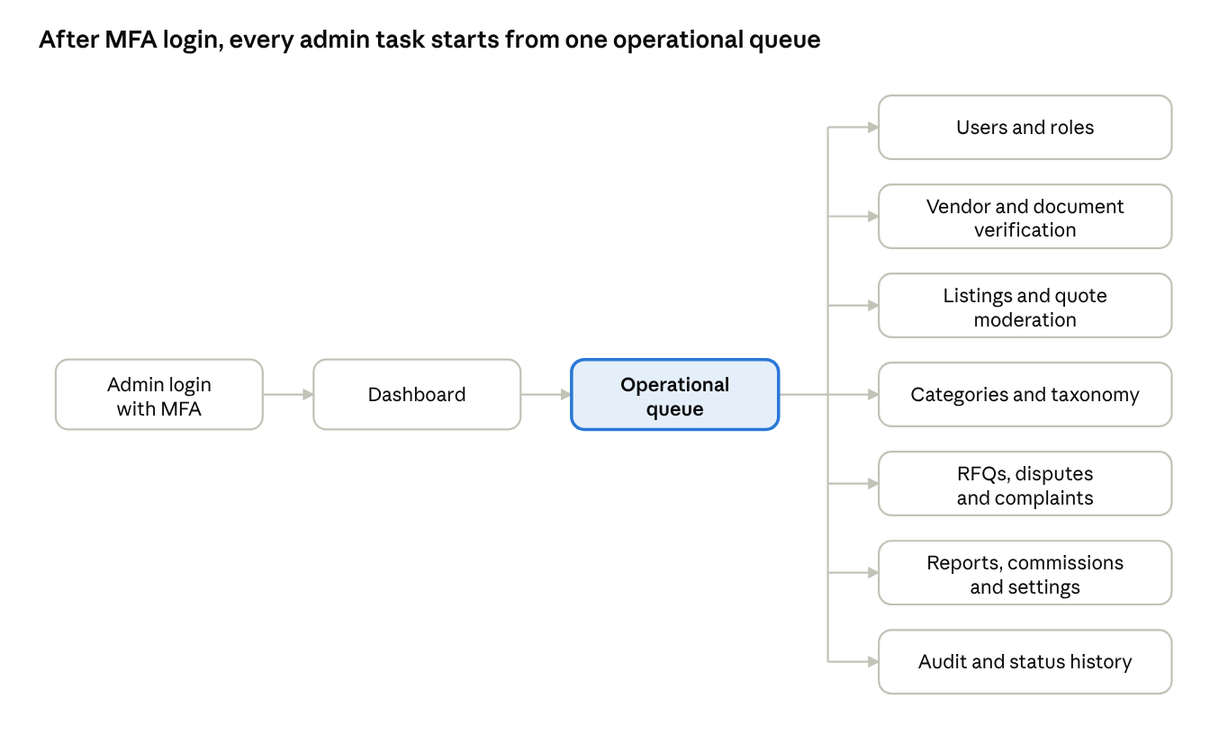
admin flowchart · one queue, seven work areas
Admin work is organized as queues; every critical action should record actor, target, reason and timestamp.

5. Booking, RFQ and Order State Diagrams
Every production transition should record actor, timestamp, reason, source and idempotency key.

5.1 Booking
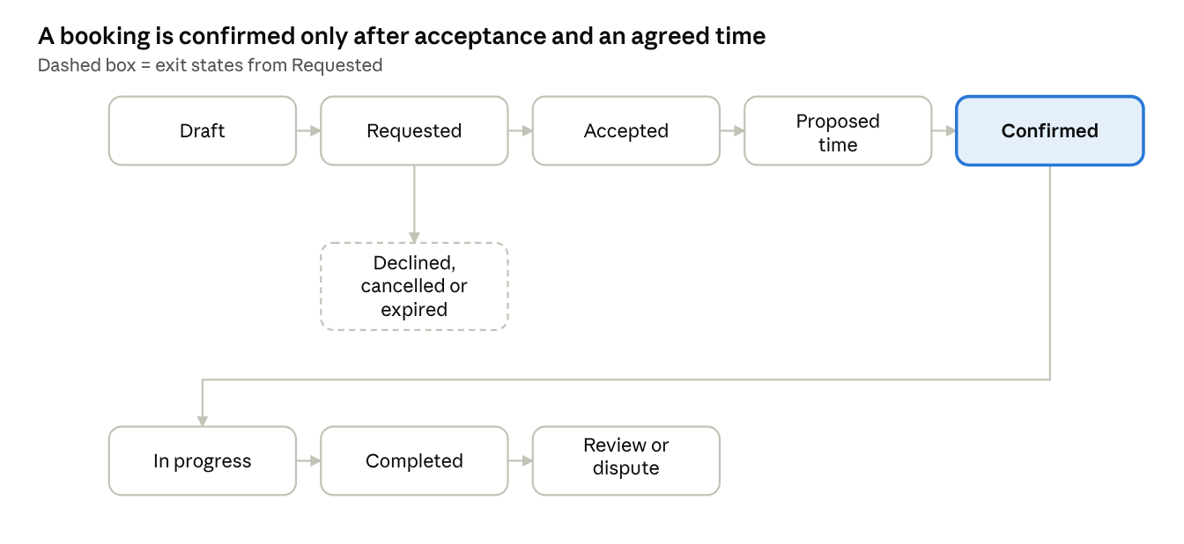
booking state diagram · 8 states
A vendor can accept, decline or propose a new time; only a confirmed booking proceeds to service delivery.
Recommended production states to add: reschedule_requested, vendor_no_show, customer_no_show, payment_pending, refund_pending, refunded.

5.2 RFQ and quotation
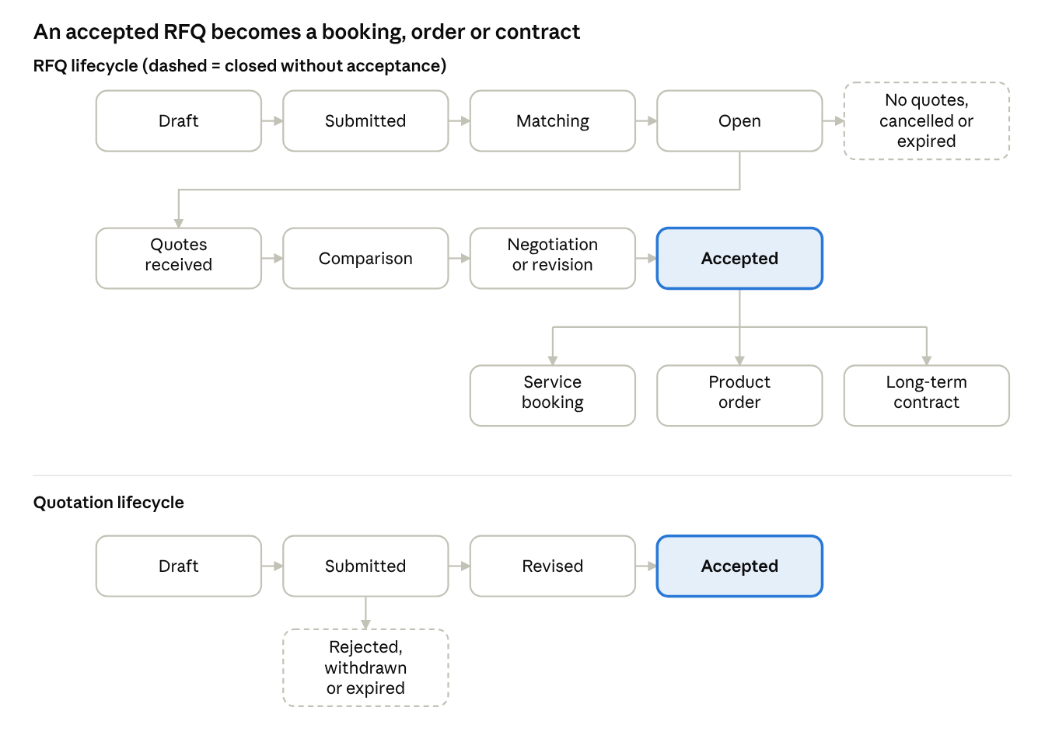
RFQ and quotation state diagrams
Quote acceptance must be atomic and idempotent so that a duplicate acceptance cannot create two outcomes.

5.3 Product order
↗ product order state diagram
Failed payment, cancellation and supplier rejection all stop an order before terms are confirmed; returns and disputes branch from Delivered.

6. Proposed Database Architecture / ERD
↗ ERD by domain · 6 domains
Transactions reference vendors, customers and categories; payments, reviews, disputes, messages and audit records all attach to those transactions.
Key relationships (one-to-many unless noted)
- User ↔ Role through UserRole; Role → Permission. User ↔ Organization through OrganizationMember.
- User → CustomerProfile (1:1) and VendorProfile (1:1). VendorProfile → VendorDocument, Listing, VendorCoverage, VendorAvailability, VendorSubscription, VendorSettlement.
- Listing → ListingAttribute.
- Industry → Category → Subcategory. Category → CategoryField, CategoryFilter, VerificationRequirement.
- CustomerProfile → RFQ, Booking, PurchaseOrder.
- RFQ → RFQItem, RFQVendorMatch, RFQAttachment, Quote. Quote → QuoteRevision.
- Booking → BookingStatusHistory. PurchaseOrder → PurchaseOrderItem, Payment, Shipment. Payment → Refund.
- Booking and PurchaseOrder → Review. Review → ReviewReport.
- Booking, PurchaseOrder or RFQ → Dispute. Dispute → DisputeEvidence.
- MessageThread → Message. User → Notification and AuditLog.
- Organization → Contract → ContractMilestone.
Recommended infrastructure
- PostgreSQL with UUID keys and organization/tenant scope.
- Object storage for vendor documents, listing media and RFQ attachments.
- Search index for vendor, listing, taxonomy and geography discovery.
- Queue workers for notifications, expiry, reminders and settlement jobs.
- Immutable status-history and audit tables.
- Idempotency keys for payment, quote acceptance, order creation and webhooks.
- Soft deletion and data-retention policies.

7. API Module Breakdown
↗ API module map · 10 modules
Transaction endpoints are explicit commands such as accept, confirm and cancel, not generic updates, so each one can enforce its state machine.
Module | Endpoints
Auth and identity | POST /auth/register, /auth/login, /auth/otp/request, /auth/otp/verify, /auth/logout, /auth/refresh; GET /auth/me
Users, roles, organizations | GET/PATCH /users/me; GET/POST /organizations; GET /organizations/:id/members; POST/PATCH /organizations/:id/members/:memberId; GET /roles; GET /permissions
Taxonomy and geography | GET/POST /industries; GET/POST /categories; PATCH /categories/:id; POST /categories/:id/merge; GET/POST /categories/:id/subcategories; GET /countries, /states, /cities, /markets, /currencies
Vendors and verification | GET/POST /vendors; GET/PATCH /vendors/:id; POST /vendors/:id/documents; GET /vendors/:id/verification; POST .../verification/submit, /approve, /reject, /request-info
Listings and search | GET/POST /listings; GET/PATCH /listings/:id; POST /listings/:id/submit, /approve, /reject; GET /search; GET /search/suggestions
Bookings | POST/GET /bookings; GET /bookings/:id; POST /bookings/:id/accept, /decline, /propose-time, /confirm, /cancel, /complete
RFQs and quotes | POST/GET /rfqs; GET /rfqs/:id; POST /rfqs/:id/submit, /match, /quotes; GET /rfqs/:id/quotes; PATCH /quotes/:id; POST /quotes/:id/revise, /accept, /reject, /withdraw
Orders and contracts | POST/GET /orders; GET /orders/:id; POST /orders/:id/confirm, /pack, /ship, /deliver, /cancel; POST/GET /contracts; POST /contracts/:id/approve, /terminate
Communication and finance | GET/POST /threads; GET/POST /threads/:id/messages; POST /messages/:id/report; GET /notifications; POST /notifications/:id/read; PATCH /notification-preferences; POST /payments/intent, /payments/:id/confirm, /payments/webhook, /payments/:id/refund; GET /invoices, /settlements, /commissions
Admin | GET /admin/dashboard, /admin/reports, /admin/audit, /admin/disputes; POST /admin/disputes/:id/resolve; GET /admin/moderation/listings, /reviews, /quotes; POST /admin/notifications

8. MVP and Phase 2 Scope
MVP | Phase 2
Secure authentication and role-based access | Instant and recurring service bookings
Customer, vendor, agent and admin profiles | Long-term contracts and milestones
Vendor registration, evidence submission, admin approval | Vendor-to-vendor procurement approvals, budgets, cost centers
Dynamic taxonomy with categories, fields, filters | Multi-currency settlement and country-specific tax workflows
Vendor listings and customer discovery | Subscription billing and sponsored visibility
Country/state/city location and coverage filters | Advanced search ranking and supplier recommendations
Scheduled service booking | Review appeals and advanced moderation
Product order foundation with status tracking | AI-assisted requirement extraction and matching
RFQ submission, quotations, revision, comparison, acceptance | Logistics, shipment tracking and returns
Customer-vendor messaging and in-app notifications | Sales-agent offline mode
Reviews, complaints, admin disputes | Advanced analytics, forecasting, conversion funnels
Basic payment intent, invoice, transaction records | Market activation and country compliance management
Admin moderation, reports, audit history
Responsive accessibility and automated acceptance tests

9. Estimated Development Timeline
Assumed team: 1 product designer, 2 frontend engineers, 2 backend engineers, 1 QA engineer, part-time DevOps/security support.
↗ MVP workstream estimates · 11 workstreams
Estimates overlap; the 16–22 week MVP duration assumes the workstreams run in parallel.
Workstream | Estimate
Product decisions and architecture | 1–2 weeks
Authentication, accounts and RBAC | 2 weeks
Vendor onboarding and verification | 2–3 weeks
Taxonomy, geography and search | 3–4 weeks
Listings and profiles | 2 weeks
Booking and order foundation | 3 weeks
RFQ and quotation workflow | 3 weeks
Messaging and notifications | 2 weeks
Payments, invoices and settlements foundation | 2–3 weeks
Admin operations and audit | 2 weeks
QA, security review and UAT | 3 weeks
MVP duration: 16–22 calendar weeks with parallel workstreams (the individual estimates add up to more than this, so parallel work is assumed). Phase 2: a further 12–20 calendar weeks, depending on contracts, payment providers, logistics, AI, country compliance and mobile-app requirements. The browser prototype can keep validating workflows while backend work proceeds in parallel.

10. Acceptance Testing Checklist

Authentication and access
- ☐ Customer registration and login work.
- ☐ Vendor registration and onboarding work.
- ☐ Agent sees only permitted screens and leads.
- ☐ Admin-only routes reject unauthorized roles.
- ☐ Logout clears the session.
- ☐ Protected records cannot be accessed by changing route parameters.
- ☐ Production admin actions require MFA.

Taxonomy and discovery
- ☐ Admin can create industries, categories and subcategories.
- ☐ Admin can configure fields, filters and verification requirements.
- ☐ Category activation/deactivation and merge are audited.
- ☐ Search works by vendor, product, service, category and location.
- ☐ Local, nationwide, worldwide and remote filters work.
- ☐ Country change updates valid state, city and currency.
- ☐ Category chips scroll without page-wide horizontal overflow.
- ☐ Empty, loading, error and no-match states are clear.

Vendor and listing workflows
- ☐ Required vendor fields validate.
- ☐ Documents can be submitted and reviewed.
- ☐ Admin can approve, reject or request information.
- ☐ Vendor can resubmit rejected information.
- ☐ Unverified vendors do not display a verified status.
- ☐ Vendor can create, edit and submit listings.
- ☐ Admin can approve, reject, suspend or remove listings.
- ☐ Category-specific listing fields appear correctly.

Bookings and orders
- ☐ Customer can select a service and available time.
- ☐ Conflicting slots are prevented.
- ☐ Vendor can accept, decline or propose another time.
- ☐ Customer can confirm, cancel and report an issue.
- ☐ Product order can be created and tracked.
- ☐ MOQ, lead time, stock and quantity are displayed where applicable.
- ☐ Order statuses progress correctly.
- ☐ Cancellation, refund and dispute states are visible.

RFQ and quotations
- ☐ Category selection is required.
- ☐ Requirement, quantity, budget and deadline validate.
- ☐ Vendors receive eligible RFQs.
- ☐ Vendors can submit and revise quotations.
- ☐ Customer can compare quotations.
- ☐ Negotiation history is retained.
- ☐ Duplicate quote acceptance is prevented.
- ☐ Quote expiry, rejection, cancellation and no-quote states work.
- ☐ Accepted quotes create an order, booking or contract.

Messaging and notifications
- ☐ Customer can search conversations.
- ☐ All, unread and RFQ filters work.
- ☐ Long names do not collide with timestamps or unread badges.
- ☐ Customer can start an enquiry.
- ☐ Opening a thread clears the unread count.
- ☐ Messages persist in the production backend.
- ☐ Participants cannot access unrelated threads.
- ☐ Notification read state and preferences work.

Payments and finance
- ☐ Payment status is visible before and after checkout.
- ☐ Payment failure does not create a successful order.
- ☐ Refund status is visible.
- ☐ Invoice contains correct customer, vendor, tax and commission data.
- ☐ Vendor settlement is calculated correctly.
- ☐ Webhook processing is idempotent.

Admin and audit
- ☐ Dashboard counters reflect current records.
- ☐ Vendor, listing, quote, review and dispute moderation queues work.
- ☐ Admin category changes are logged.
- ☐ Critical financial and approval actions record actor, target, reason and timestamp.
- ☐ Reports support date, category, location and role filters.

Responsive and accessibility
- ☐ Test viewports: 320×568, 375×812, 430×932, 768×1024, 1366×768, 1440×900, 1920×1080.
- ☐ No unintended horizontal page scrolling.
- ☐ Touch targets are usable on mobile.
- ☐ Keyboard focus is visible.
- ☐ Dialogs and drawers are keyboard accessible.
- ☐ Text contrast is acceptable.
- ☐ Reduced-motion mode disables nonessential animations.
Prototype limitation. Backend authorization, real payments, shared persistence, upload scanning, notification delivery, immutable audit logs and concurrency-safe transactions need production services before final acceptance.

Appendix A. Glossary
Term | Meaning
PRS | Product Requirements Specification (v3)
RBAC | Role-based access control
MFA | Multi-factor authentication
OTP | One-time password
RFQ | Request for quotation
MOQ | Minimum order quantity
L0–L4 | Vendor verification evidence levels defined in PRS 5 and 26.6
ERD | Entity-relationship diagram
SLA | Service-level agreement (review and case timers)
UAT | User acceptance testing
SC-001–SC-046 | PRS scenario identifiers; SC-041–SC-046 are the global scenarios
GM-01–GM-27 | PRS global marketplace requirement identifiers (26)
Idempotency key | Token that makes a repeated command (payment, quote acceptance, webhook) take effect once

Appendix B. Risk register
Risk | Where it shows | Mitigation
Client-side authorization can be bypassed by editing routes or parameters | RBAC, record ownership | Deny-by-default server authorization with per-record ownership checks
Double acceptance of quotes or double-booked slots | Bookings, RFQs | Atomic acceptance, durable slot locks, idempotency keys
Data lost or inconsistent between browsers | Persistence | Shared PostgreSQL with migrations and backups
Payment scope unresolved | Payments, MVP scope | Decide the boundary early; use a swappable provider interface
Overlapping categories confuse search and reporting | Taxonomy | Use the merge workflow; version and audit taxonomy changes
Trust claims shown without evidence | Verification, ratings | L0–L4 evidence matrix, expiry gates, dated verification labels
Regressions go unseen | QA | Scenario test suite for SC-001–SC-046 plus accessibility and end-to-end tests
Localization defects | i18n | Fix damaged Hindi encoding, move copy to dictionaries, adopt RTL-ready layout
Phase 2 range of 12–20 weeks widens | Timeline | Settle contracts, payment providers, logistics and compliance scope early

Appendix C. Open decisions
Decision | Why it matters | Owner
Payment boundary: no service payments in the release, or basic payment intent in the MVP | Scope, invoicing and acceptance tests differ | To be assigned
Canonical PRS file (Global Marketplace v3 or Simplified RBAC v3) | Traceability and audit baseline | To be assigned
Merge or keep Finance & Insurance / Insurance Services, Logistics / Marine freight, Facility security / Security & Safety | Taxonomy clarity before launch | To be assigned
Launch markets and activation checklist | PRS 26.11 market architecture | To be assigned
Verification level (L0–L4) required per category | Publication gate and trust labels | To be assigned
Payment provider selection | Phase 2 duration and settlement design | To be assigned

Appendix D. Source register
Source file | Used in section
01-feature-coverage-gap-analysis | 1
GAP_REPORT (audit of 24 Oct 2026) | 1
requirements-coverage | 1.4
02-screen-wise-status | 2
03-category-taxonomy | 3
04-role-flowcharts | 4
05-transaction-state-diagrams | 5
06-database-architecture-erd | 6
07-api-module-breakdown | 7
08-mvp-phase-2-scope | 8
09-development-timeline | 9
10-acceptance-testing-checklist | 10
README | Prototype boundary

Appendix E — Detailed Workflow Diagrams and ERDs
Expanded implementation-oriented diagrams based on the documented VendorVerse roles, feature coverage, state transitions and proposed database relationships.
Reading note: these diagrams formalize the workflows and relationships described in this documentation pack. Where production safeguards or additional states are shown, they are proposed implementation details—not evidence that those services already exist in the browser-local prototype. The payment boundary remains an open product decision: the source document is explicit that service payments are not collected in the current release, while the MVP table mentions a basic payment intent.
Notation: diamonds represent decisions; solid arrows represent primary transitions; dashed arrows indicate audit/event side effects. ERD boxes show key fields and PK/FK relationships; optional references are marked with “?”.

E1. Customer End-to-End Journey
Discovery branches into service booking, product order, or RFQ-led procurement. Accepted quotes preserve an immutable terms snapshot; completion can lead to review or dispute.
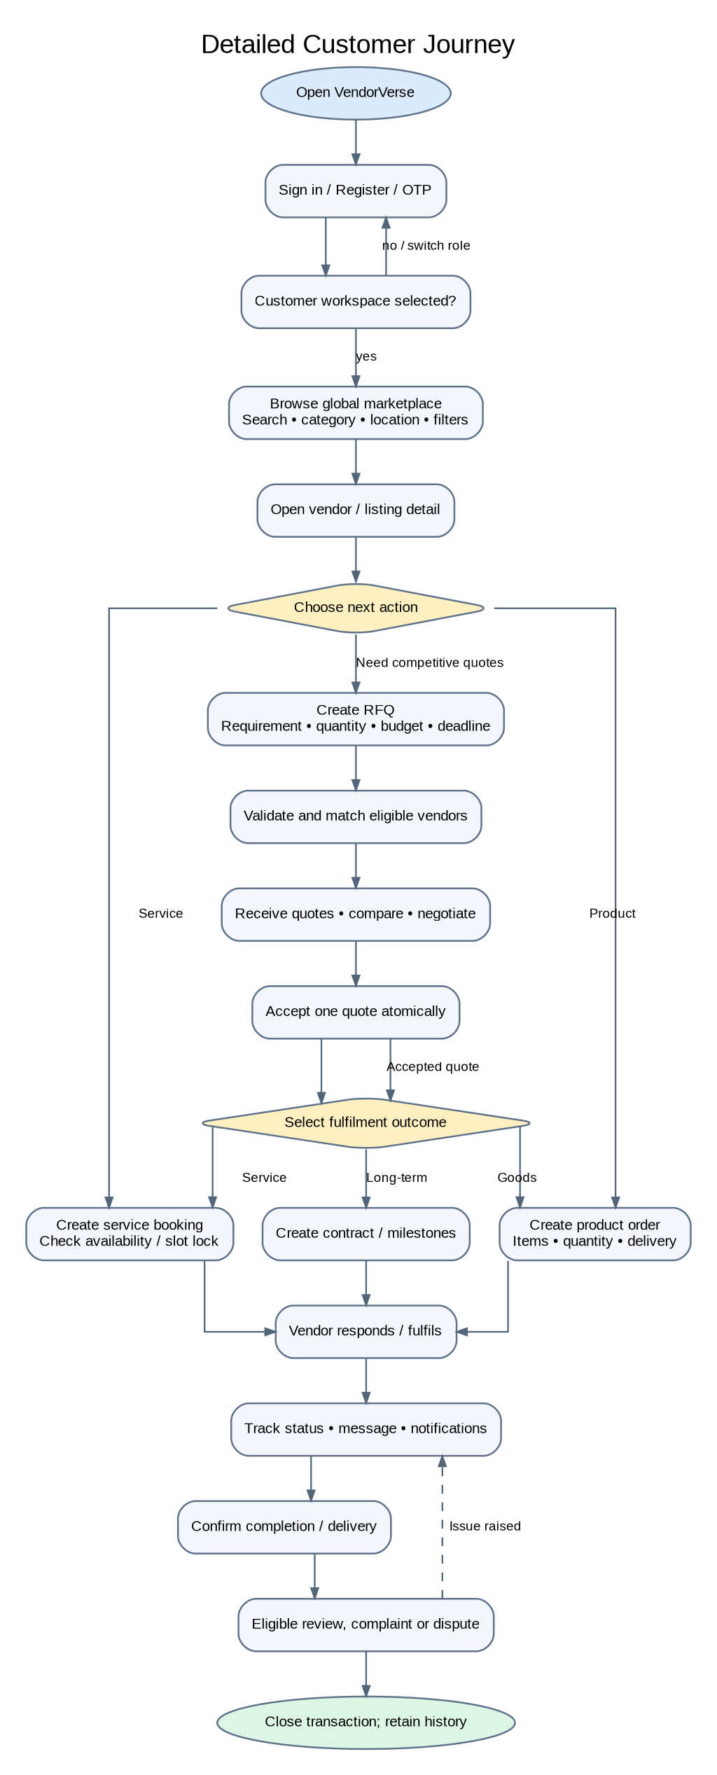

E2. Vendor Onboarding, Publication and Buyer Mode
Publication is gated by evidence review and category rules. Vendors can also switch to buyer mode and procure from other suppliers.
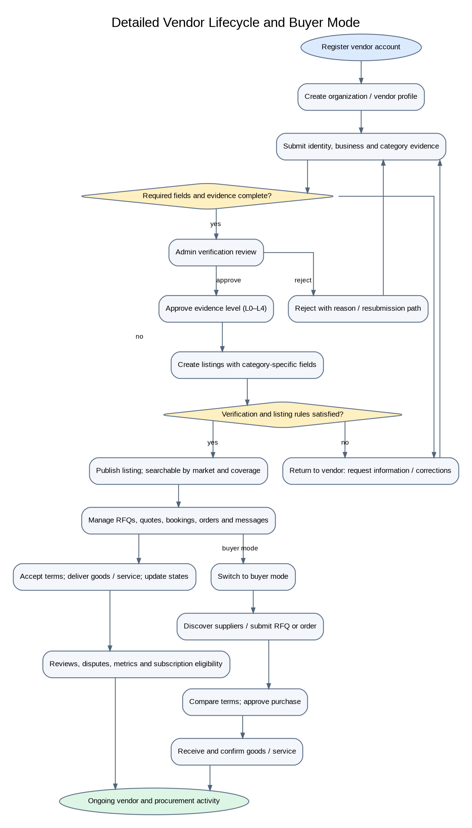

E3. Sales Agent Lead-to-Commission Workflow
Lead assignment, consent-based assisted onboarding, conversion attribution and commission approval are auditable steps.
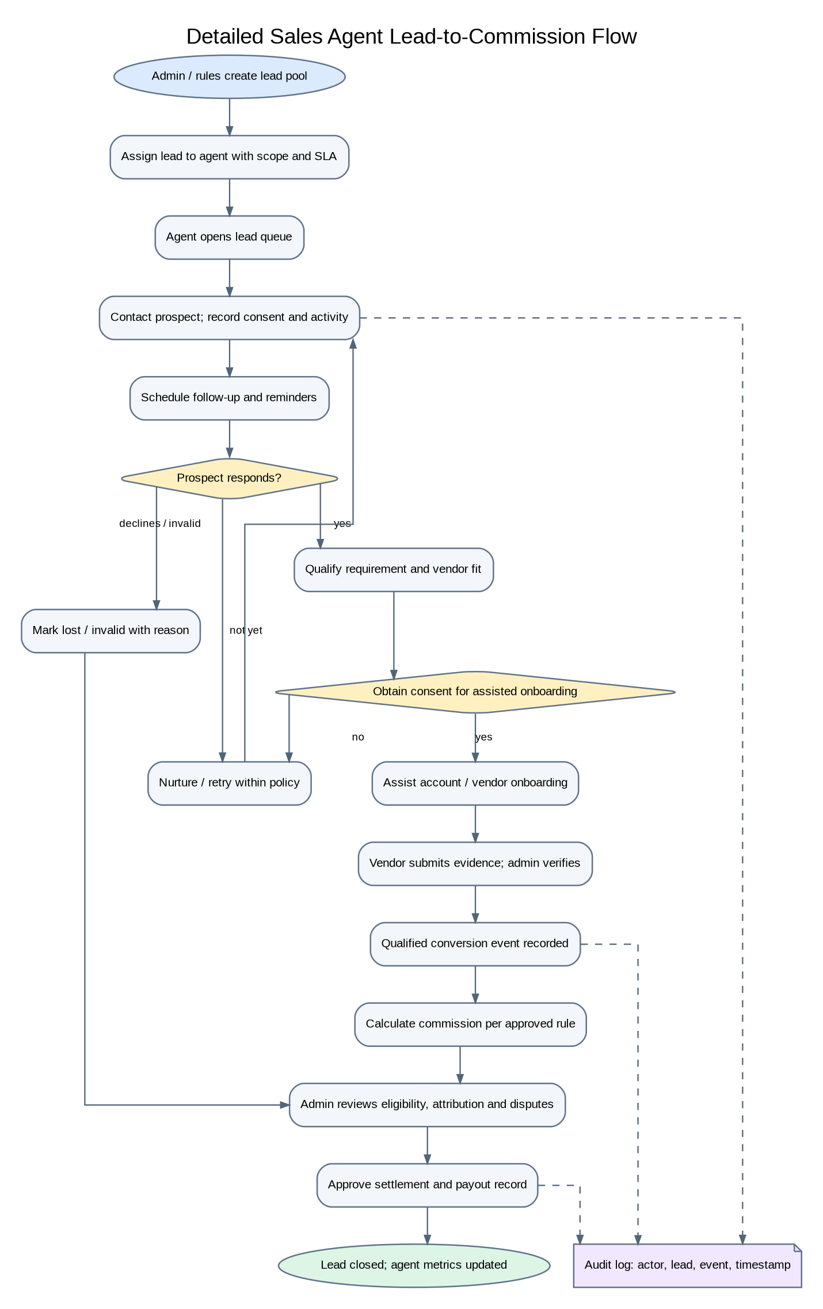

E4. Admin Operations and Governance
All privileged actions require server-side authorization; critical decisions record reason and evidence, with independent second approval where policy requires.
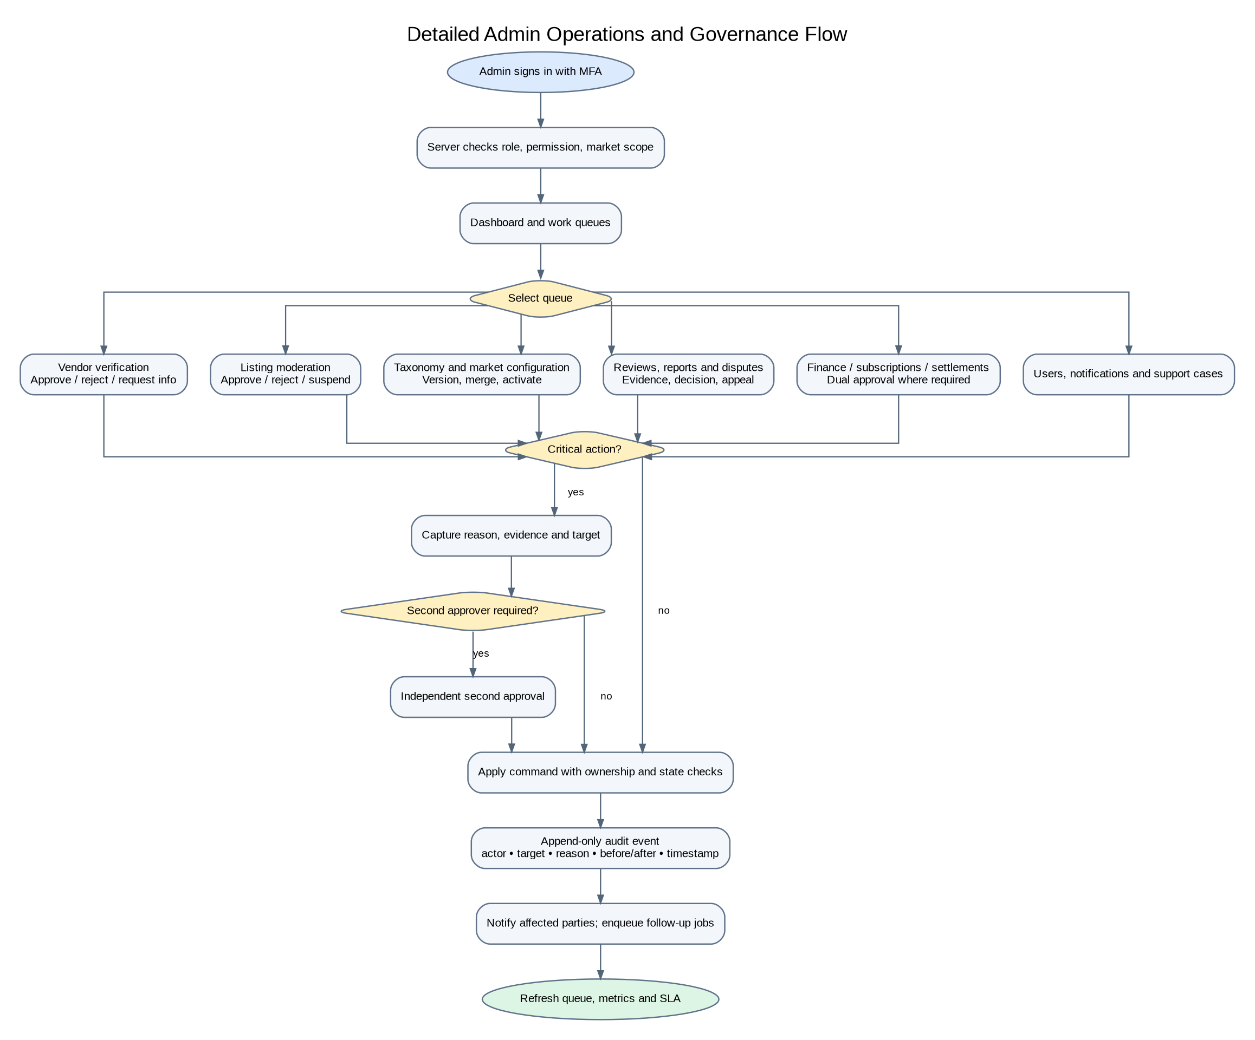

E5. Booking State Machine
Recommended production state machine, including rescheduling, no-show and issue handling. Enforce legal transitions and slot locking transactionally.
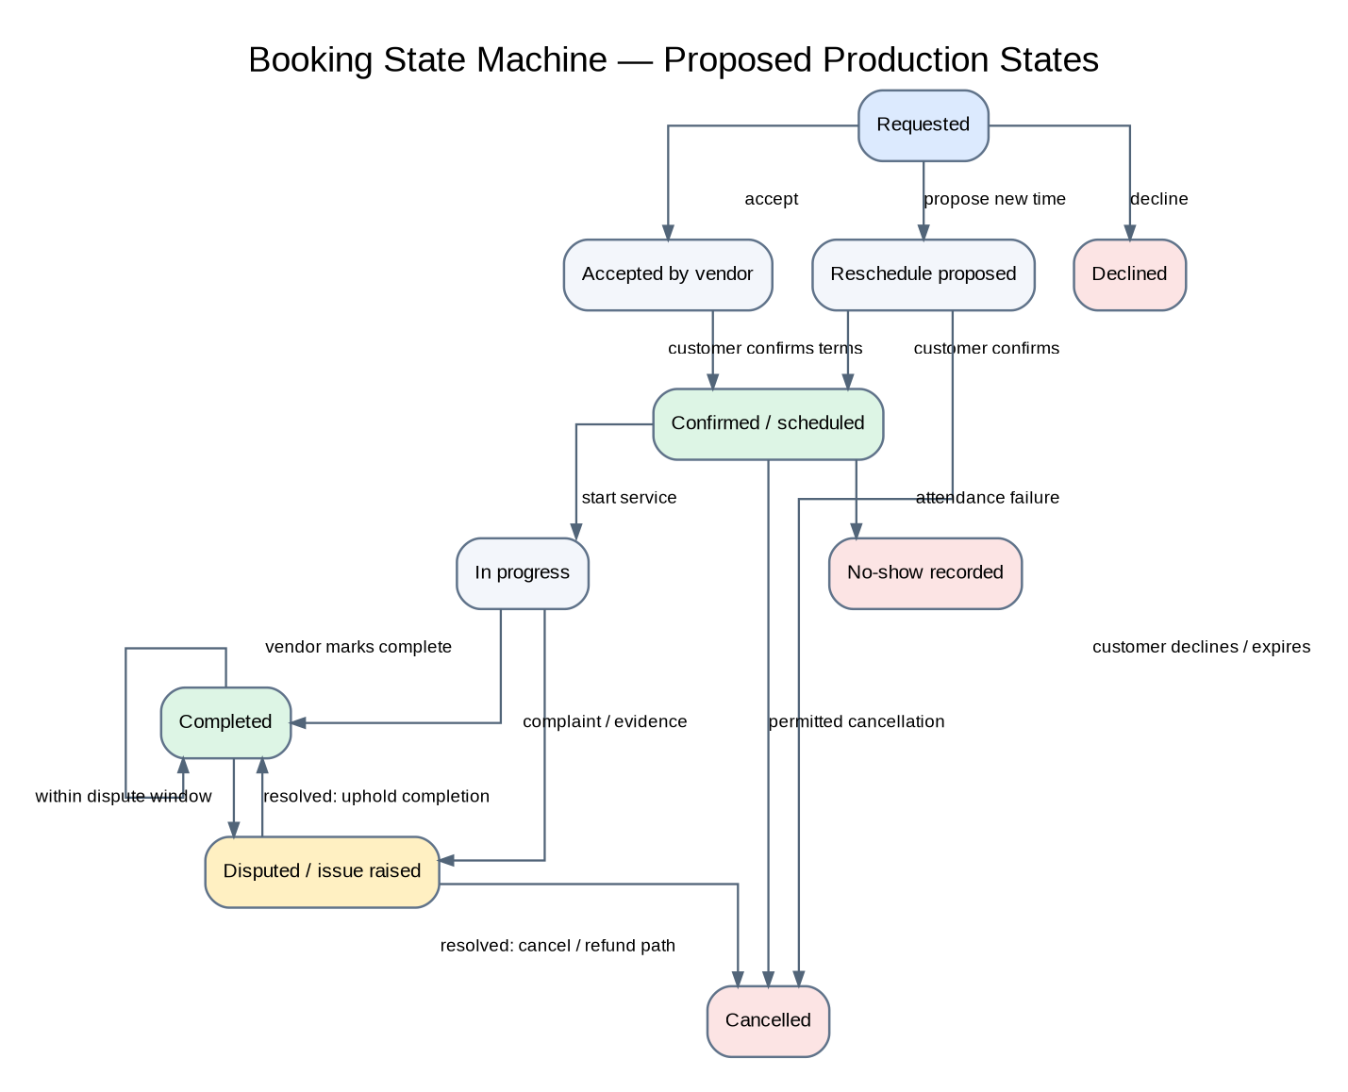

E6. RFQ and Quotation State Machine
Quote acceptance must be atomic and idempotent so one RFQ cannot produce multiple accepted outcomes.
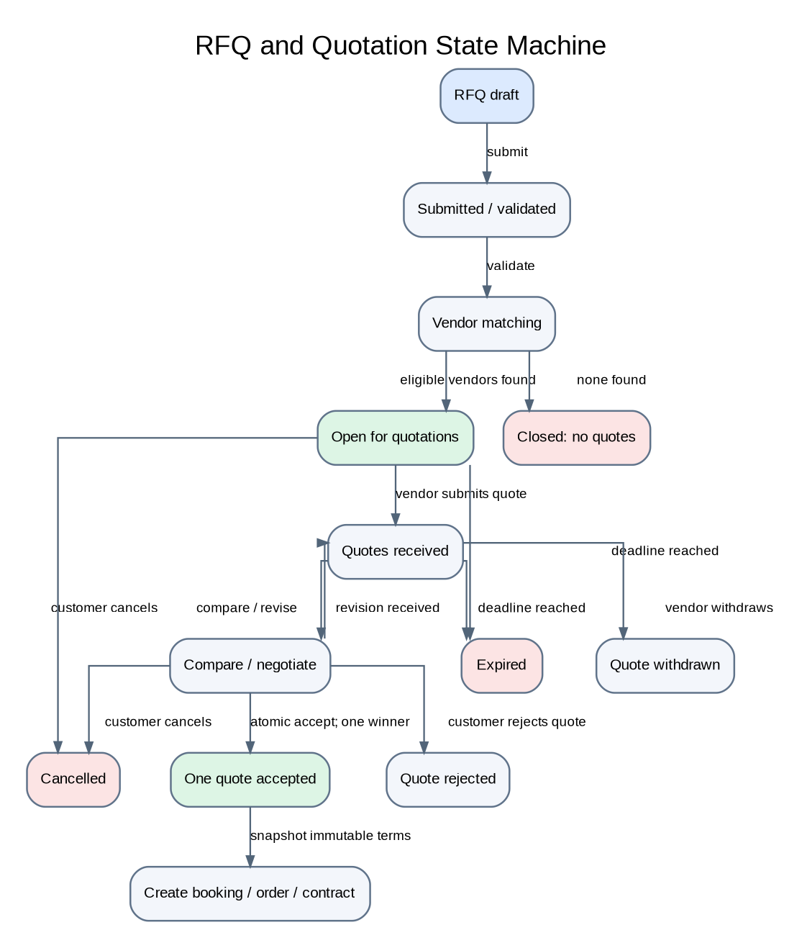

E7. Product Order State Machine
Payment states apply only if the final release scope includes payment collection; otherwise supplier/customer terms remain outside platform checkout.
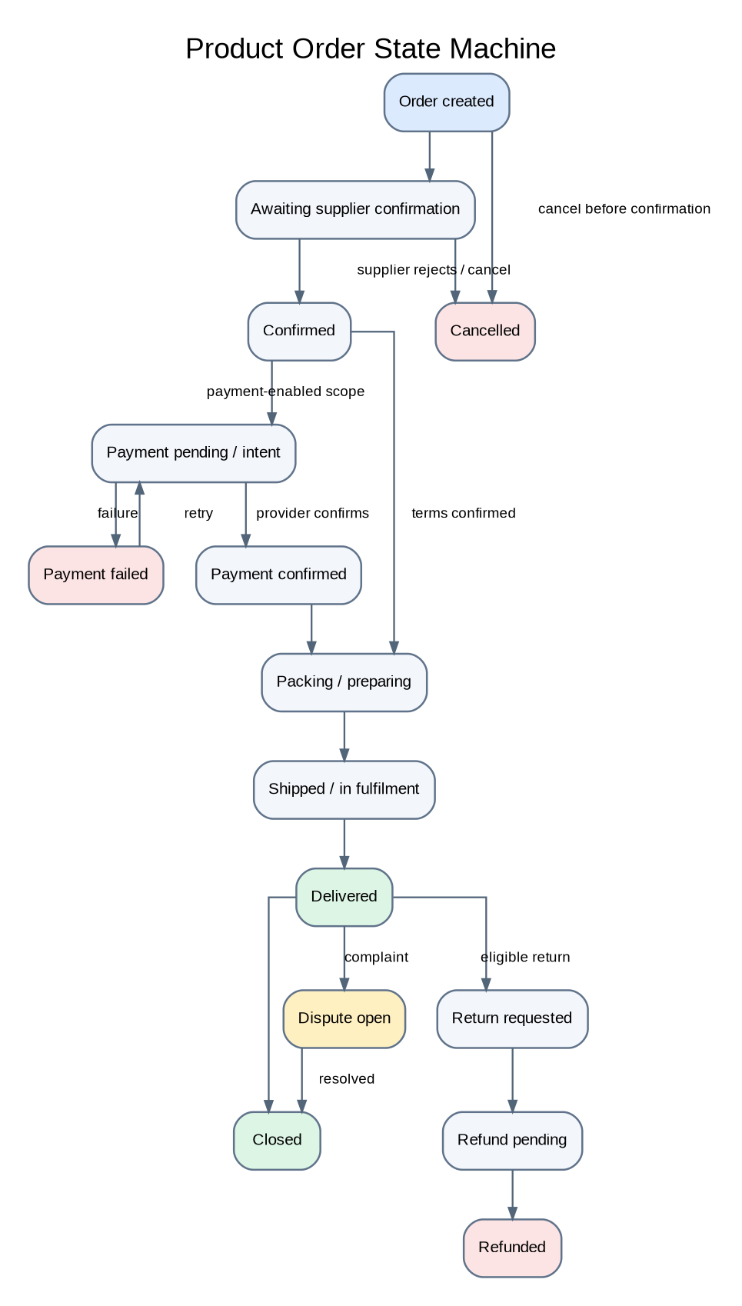

E8. ERD — Identity, Organization, Vendor and Taxonomy
Core identity and catalog domain. User–Role and Role–Permission are many-to-many bridge relationships; category fields drive dynamic listing attributes.
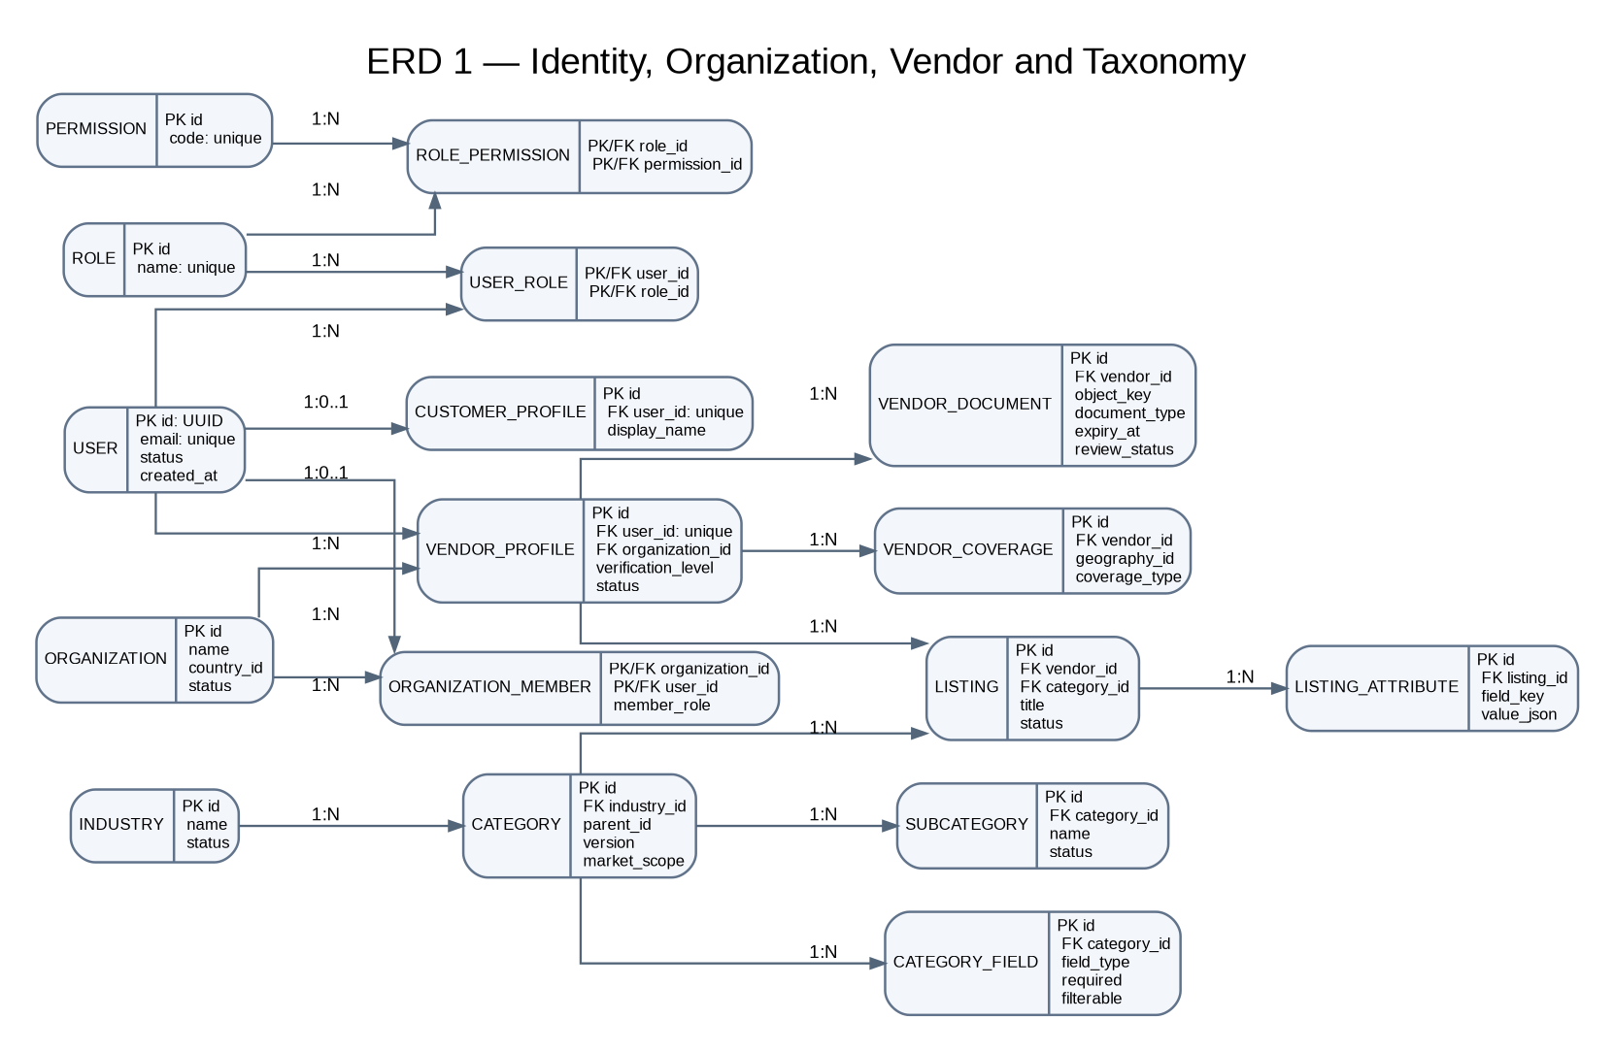

E9. ERD — RFQs, Quotes, Bookings, Orders and Contracts
Transaction domain. Preserve quote revisions and accepted terms; status history should be append-only. Optional accepted_quote_id links depend on the chosen transaction model.
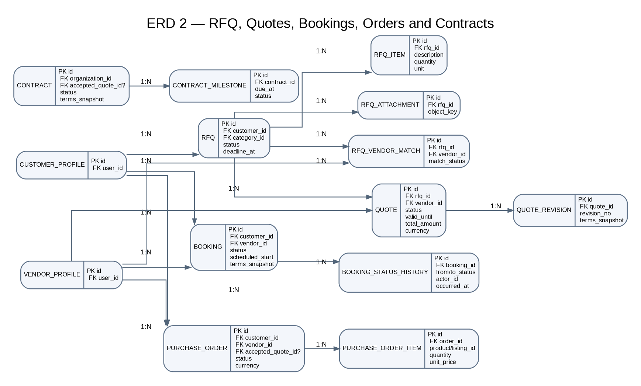

E10. ERD — Payments, Trust, Messaging, Notifications and Audit
Platform services attach to transaction context. In production, enforce participant access, use object storage for evidence, and make audit events append-only.
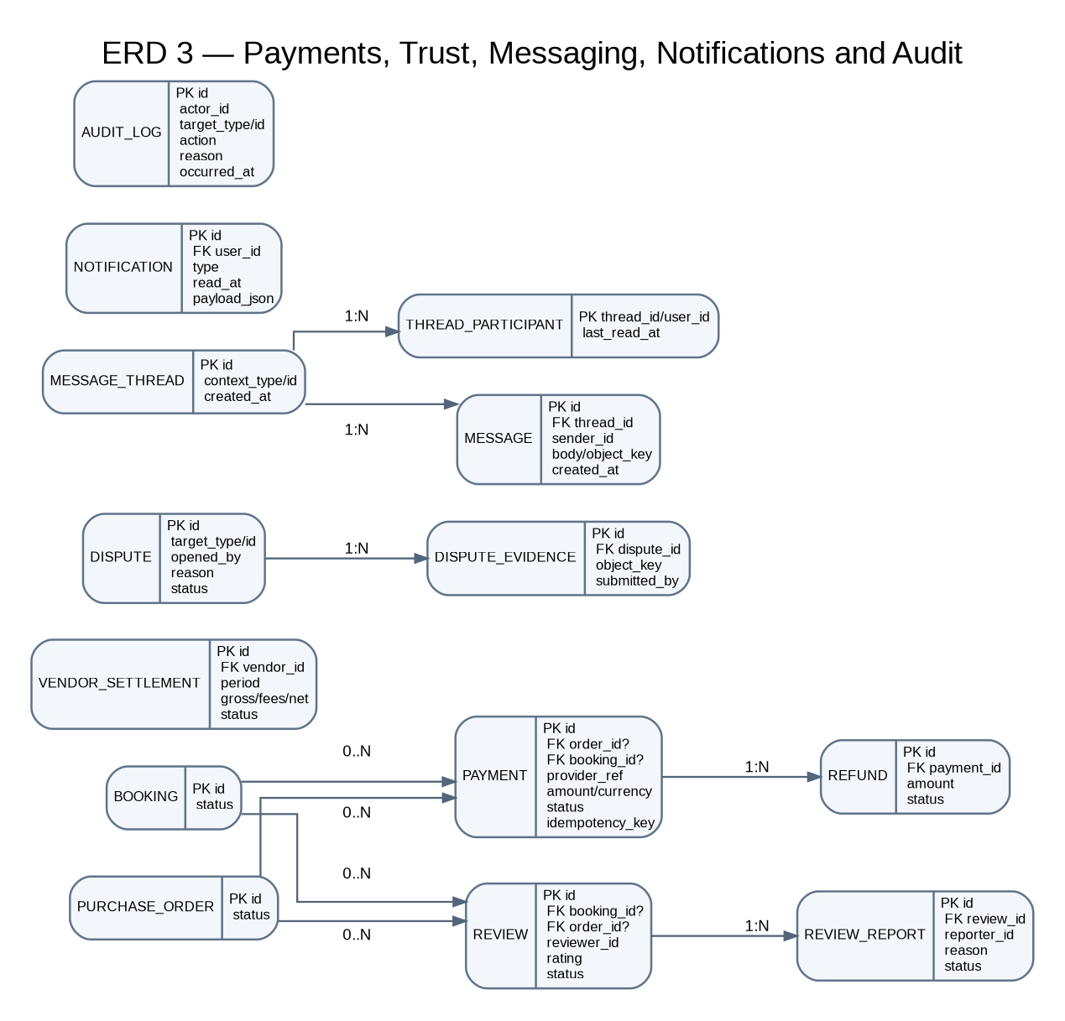

Appendix E — Implementation Rules to Preserve

• Authorization: deny by default; validate role, market scope and record ownership on the server for every command.
• State transitions: expose explicit commands (accept, confirm, cancel, complete, approve) rather than unrestricted status updates.
• Concurrency and idempotency: use database transactions and unique/idempotency keys for quote acceptance, booking slot reservation, order creation, payment events and webhooks.
• Evidence and media: store files in object storage; keep metadata, scan status, expiry and review outcomes in the database.
• Audit: record actor, target, action, reason, timestamp and relevant before/after values for critical actions; prevent normal application users from editing or deleting audit events.
• Global marketplace: scope taxonomy, coverage, currencies, locale and market activation explicitly; do not assume a single country or currency.
• Prototype boundary: current browser-local persistence and simulated workflows are not production authorization, shared persistence, real payment processing, durable notifications or immutable audit.

