Automated Diabetic Retinopathy Prediction System

Minor Project Report

For

B.E. [Computer Science & Engineering]

7th Semester [CS-757]

Submitted By:

Shivanshu Sawan (UEM213119)

Zul Quarnain Azam (UEM213124)

Kshitij Negi (UEM213117)

*Under the guidance of*

Dr. Savita Gupta

Professor, UIET



Department of Computer Science and Engineering

University Institute of Engineering & Technology Panjab University, Chandigarh

CERTIFICATE

I hereby certify that the work which is being submitted in this project work titled

"AUTOMATED DIABETIC RETINOPATHY PREDICTION SYSTEM" in partial fulfilment of the requirement for the award of the degree of "Bachelor of Engineering in Computer Science and Engineering" submitted in UIET, Panjab University, Chandigarh, is an authentic record of my work carried out under the supervision of Dr. Savita Gupta and refers to other researchers work which is duly listed in the reference section. The matter presented in this project work has not been submitted for the award of any other degree of this or any other university.

Shivanshu Sawan (UEM213119)

Zul Quarnain Azam (UEM213124)

Kshitij Negi (UEM213117)

This is to certify that the statements made above by the candidate are correct and true to the best of my knowledge.

Guide Name

Dr. Savita Gupta

Professor, CSE, UIET,

Panjab University,

Chandigarh – 160014

VISION:

To be recognized as an eminent department in Computer Science and Engineering education and research for the benefit of society globally.

MISSION:

* To sustain world-class computing infrastructure for the enhancement of technical knowledge in the field of Computer Science and Engineering.
* To excel in research and innovation for the discovery of new knowledge and technologies.
* To produce technocrats, entrepreneurs, and business leaders of the future.
* To foster human values for national growth and life-long learning amongst all the stakeholders.

PROGRAMME EDUCATIONAL OBJECTIVES (PEOs):

I. Graduates will work as software professional in industry of repute.

II. Graduates will pursue higher studies and research in engineering and management disciplines.

III. Graduates will work as entrepreneurs by establishing startups to take up projects for societal and environmental cause.

PROGRAMME SPECIFIC OBJECTIVES (PSOs):

I. The ability to use software engineering techniques to design and develop software solutions.

II. The ability to employ data science principles to extract insights and knowledge from data.

PROGRAMME OUTCOMES:

1. Engineering Knowledge**:** Apply the knowledge of mathematics, science, engineering fundamentals, and an engineering specialization to the solution of complex engineering problems.

2. Problem Analysis**:** Identify, formulate, review research literature, and analyze complex engineering problems reaching substantiated conclusions using first principles of mathematics, natural sciences, and engineering sciences.

3. Design/development of solution:Design solutions for complex engineering problems and design system components or processes that meet the specified needs with appropriate consideration for the public health and safety, and the cultural, societal, and environmental considerations.

4. Conduct investigation of complex problems**:** Use research-based knowledge and research methods including design of experiments, analysis and interpretation of data, and synthesis of the information to provide valid conclusions.

5. Modern tool usage:Create, select, and apply appropriate techniques, resources, and modern engineering and IT tools including prediction and modeling to complex engineering activities with an understanding of the limitations.

6. The engineer and society:Apply reasoning informed by the contextual knowledge to assess societal, health, safety, legal, and cultural issues and the consequent responsibilities relevant to the professional engineering practice.

7. Environment and sustainability:Understand the impact of the professional engineering solutions in societal and environmental contexts and demonstrate the knowledge of and need for sustainable development.

8. Ethics:Apply ethical principles and commit to professional ethics and responsibilities and norms of the engineering practice.

9. Individual and team work:Function effectively as an individual, and as a member or leader in diverse teams, and in multidisciplinary settings.

10. Communication:Communicate effectively on complex engineering activities with the engineering community and with society at large, such as, being able to comprehend and write effective reports and design documentation, make effective presentations, and give and receive clear infrastructure.

11. Project management and finance:Demonstrate knowledge and understanding of the engineering and management principles and apply these to one’s own work, as a member and leader in a team, to manage projects and in multidisciplinary environments.

12. Life-long learning:Recognition of the need for, and have the preparation and ability to engage in independent and life-long learning in the broadest context of technological change.

COURSE OUTCOMES (CO):

On completion of this course, a student will be able to

1. Apply the knowledge from previous semesters to undertake and solve a real-life problem
2. Illustrate the solution after identifying various objectives of the problem undertaken
3. Devise an organised action plan along with all the team members
4. Develop a solution using appropriate methodology and tools available
5. Communicate and demonstrate the work through structured reports and oral presentation

ABSTRACT

Diabetic retinopathy is a leading problem throughout the world and many people are losing their vision because of this disease. The disease can get severe if it is not treated properly at its early stages. The damage in the retinal blood vessel eventually blocks the light that passes through the optical nerves which makes the patient with Diabetic Retinopathy blind. Therefore, in our research we wanted to find out a way to overcome this problem and thus using the help of ConvolutionalNeural Network (ConvNet), we wereable to detect multiple stages of severity for Diabetic Retinopathy. There are other processes present to detect Diabetic Retinopathy and one such process is manual screening, but this requires a skilled ophthalmologist and takes up a huge amount of time. Thus our automatic diabetic retinopathy detection technique can be used to replace such manual processes and theophthalmologist can spend more time taking proper care of the patient or at least decrease the severity of this disease.

TABLE OF CONTENTS

|  |  |  |  |
| --- | --- | --- | --- |
| Sno. | Title | Pg. No | Remark |
| 1. | Title Page | - |  |
| 2. | Declaration | 1 |  |
| 3. | Vision, Mission, PEO, PO, CO | 2-4 |  |
| 4. | Abstract | 5 |  |
| 5. | Table of Contents | 6 |  |
| 6. | List of Figures | 7 |  |
| 7. | Chapter 1: Planning & Requirement Analysis | 8-9 |  |
| 8. | Chapter2: Defining Requirements | 10 |  |
| 9. | Chapter3: System Design | 11-13 |  |
| 10. | Chapter4: Developement | 14-17 |  |
| 11. | Chapter5: Testing | 18-20 |  |
| 12. | Chapter6: Deployment & Maintenance | 21-22 |  |
| 13. | Reference | 22 |  |
| 14. | Course Exit Survey | 23-25 |  |

LIST OF FIGURES

|  |  |  |  |
| --- | --- | --- | --- |
| Sno. | Figure No. | Figure Name | Page No. |
| 1. | 1.4.1 | Original Dataset | 9 |
| 2. | 1.3.2 | Modified Dataset | 9 |
| 3. | 3.2.1 | Home Page | 11 |
| 4. | 3.2.2 | About Us Page | 12 |
| 5. | 3.2.3 | Diagnosis Page | 12 |
| 6. | 3.3.1 | Low Level Design | 13 |
| 7. | 4.1.1 | Model Training Result | 14 |
| 8. | 4.1.2 | Model Evaluation Result | 15 |
| 9. | 4.1.3 | Accuracy Graph | 15 |
| 10. | 4.2.1 | Directory Structure | 16 |
| 11. | 5.0.1 | Confusion Matrix visualize performance | 18 |
| 12. | 5.0.2 | Metric Evaluation | 18 |
| 13. | 5.1.1 | Prediction Result | 19 |
| 14. | 5.1.2 | Confusion Matrix for DR | 20 |

Chapter 1 : Planning and Requirement Analysis

1.1 Planning

Diabetic retinopathy is a leading cause of vision loss among individuals with diabetes. Early diagnosis is crucial for effective management and treatment. The objective of this project is to develop an AI-powered diagnostic tool to classify and detect the stages of diabetic retinopathy based on retinal images.

1.2 Define Project Scope

* Build a web-based diagnostic tool that allows users to upload retinal images for automatic diagnosis.
* Support classification into different diabetic retinopathy stages: Normal, Mild, Moderate, Severe, Proliferative.
* Provide dataset accessibility for further testing and learning purposes

1.3 Set Objectives and Goals

* High Accuracy: Deliver prediction accuracy exceeding 90%, making it reliable for medical use.
* Real-Time Analysis: Provide results instantly, avoiding delays in decision-making.
* Ease of Use: A minimalistic, intuitive interface accessible on any browser.

1.4 Resource Planning:

* Tools: TensorFlow for model training, Streamlit for building the interface.
* Dataset: Use the publicly available Kaggle DDR dataset , which contains over 13,673 fundus images from 147 hospitals for training and testing.

*Dataset Link : https://www.kaggle.com/datasets/mariaherrerot/ddrdataset*

* Infrastructure: GTX 1650 GPU support during model training.

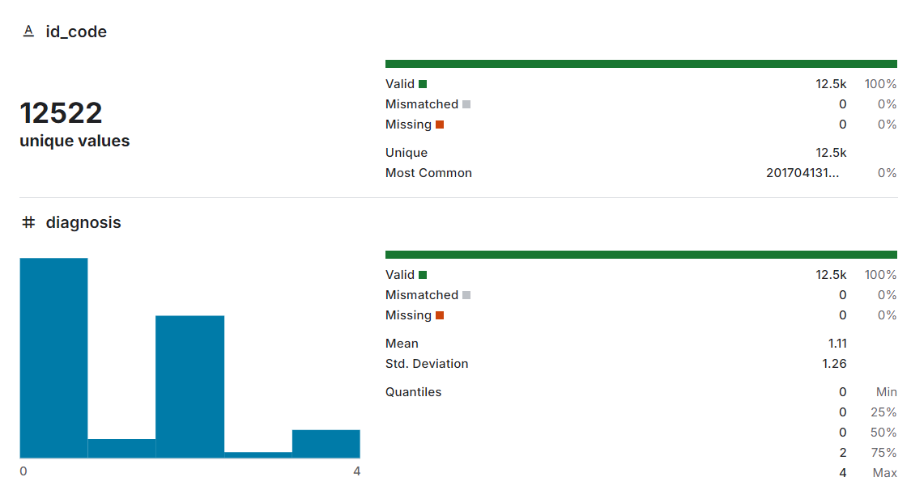 Fig 1.4.1 : Original Dataset

* Dataset is modified to resolve the issue of Data Imbalance.

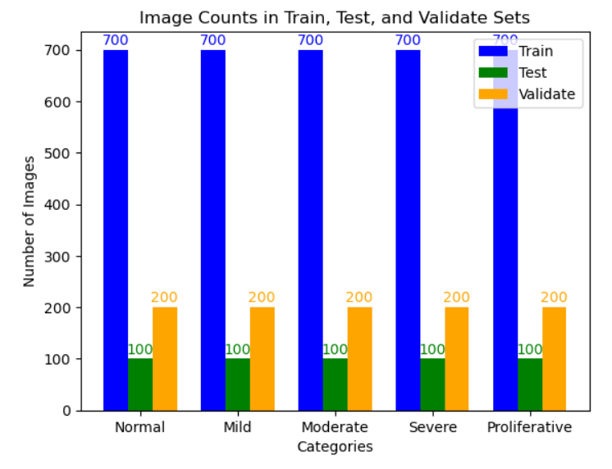

Fig 1.3.2 : Modified dataset

Chapter 2 : Defining Requirements

2.1 Defining

For the successful development of this diagnostic tool, the requirements have been categorized into functional and technical aspects, ensuring that the solution meets both user and system needs.

2.2 Functional Requirements:

* Users should be able to upload retinal images (formats supported: JPEG, JPG, PNG).
* The tool must classify images into one of the diabetic retinopathy stages.
* Downloadable datasets should be made available for practice and further testing.

2.3 Technical Requirements:

* CNN Model: The model, trained using the DDR dataset, must provide an accuracy of over 90% during validation.
* Image Preprocessing: Uploaded images must be resized to 256x256 pixels before prediction to align with the training process.
* File Size Limit: Uploads should not exceed 2MB, ensuring smooth handling of images during prediction.
* Cross-Browser Compatibility: The tool should function seamlessly on all modern browsers (Chrome, Edge, Firefox, etc.).

2.4 Requirement Reviews:

The functional and technical requirements have been validated to ensure alignment with user needs and project objectives. Continuous testing during development ensures these requirements are met.

Chapter 3: System Design

3.1 Design

The design of the diagnostic tool includes both high-level and low-level components, focusing on user interaction, backend processing, and AI integration.

3.2 High Level Design

The tool consists of three primary sections:

* Home Page: Provides an overview of diabetic retinopathy, its stages, and the importance of early detection.

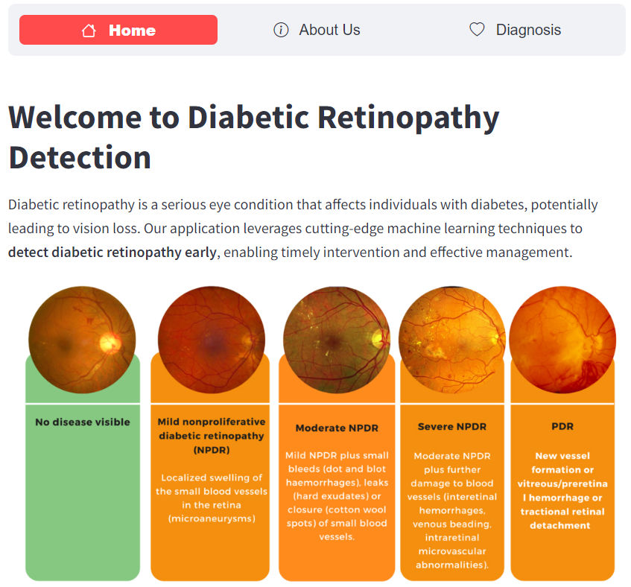

Fig3.2.1: Home Page

* About Us: Shares insights about the development team, the project's vision, and collaboration.

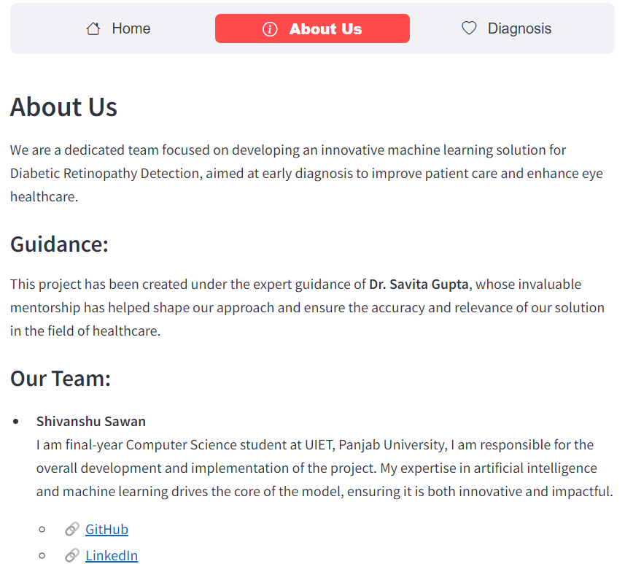

Fig 3.2.2: About Us Page

* Diagnosis Page: Allows users to upload retinal images for prediction and offers access to datasets for further testing.

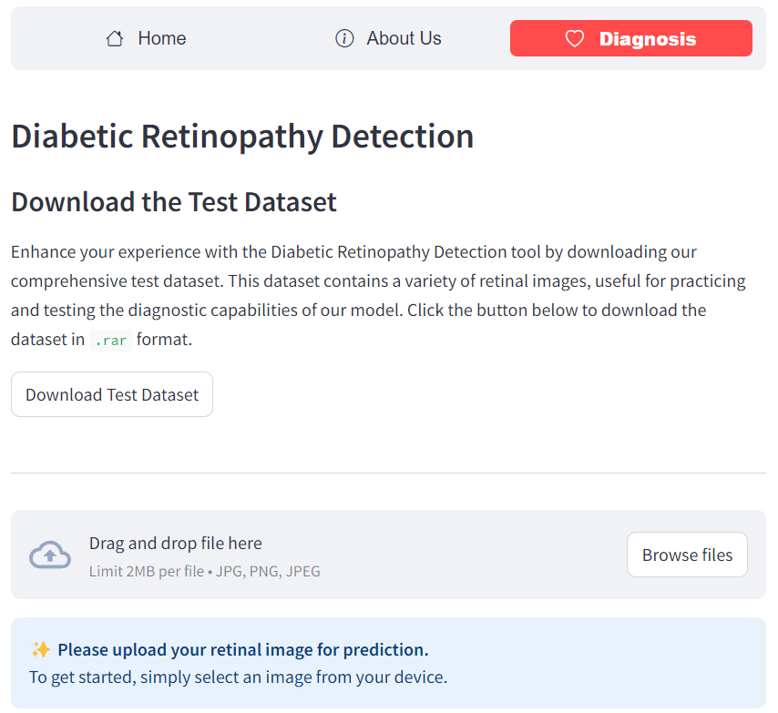

Fig 3.2.3: Diagnosis Page

3.3 Low Level Design

* Backend Model: A custom-trained convolutional neural network (CNN) built from scratch to ensure reliable and accurate predictions.
* Frontend Interface: Streamlit provides an interactive, easy-to-use interface for uploading images, displaying results, and downloading datasets.
* Output Classification: The model predicts one of five stages:
  + Normal
  + Mild
  + Moderate
  + Severe
  + Proliferative

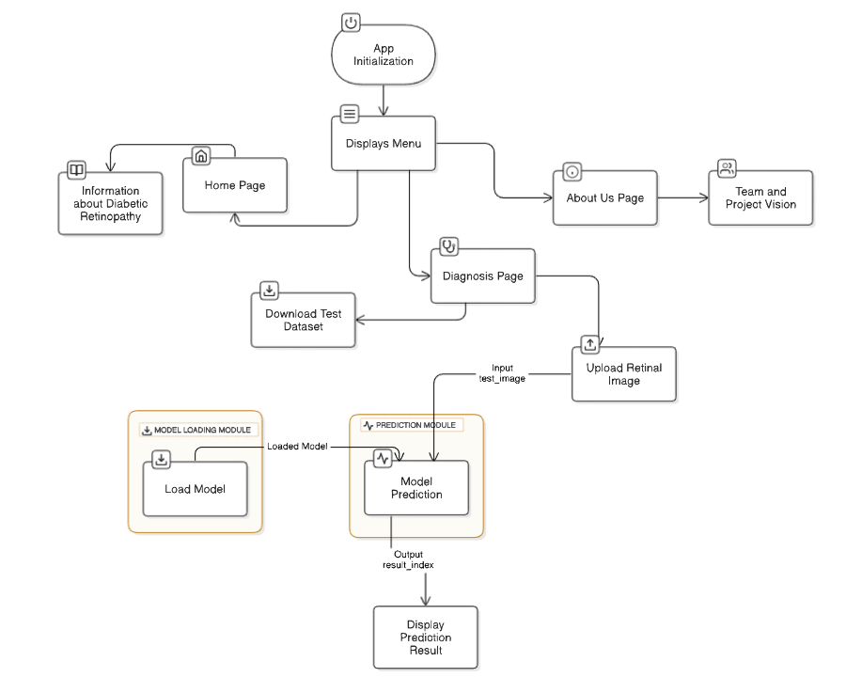

Fig 3.3.1 Low Level Design

Chapter 4: Development

4.1 Development

The project follows a modular approach to ensure scalability and maintainability. Each component has been developed independently and integrated into the final tool.

Model training:  
The core of the diagnostic tool is a Convolutional Neural Network (CNN) trained on the DDR Dataset . The training process involved: 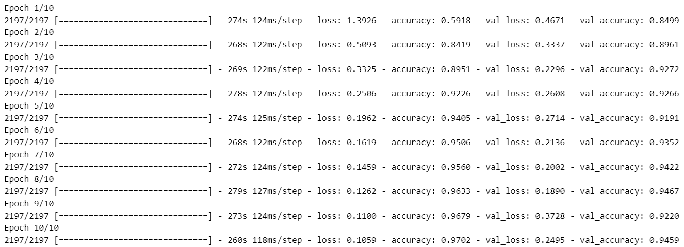

Fig 4.1.1: Model training Result

* Data Augmentation: Techniques like flipping and rotation, were applied to improve the model’s generalization.
* Loss Function: A categorical cross-entropy loss function was used for multi-class classification.
* Optimizer: The Adam optimizer was employed for faster convergence.
* Accuracy Achieved: The model achieved 85% accuracy on the validation set and performed consistently across various test images.

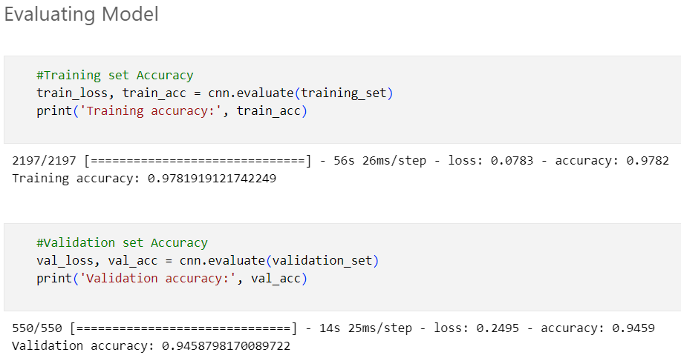

Fig 4.1.2: Model evaluation result

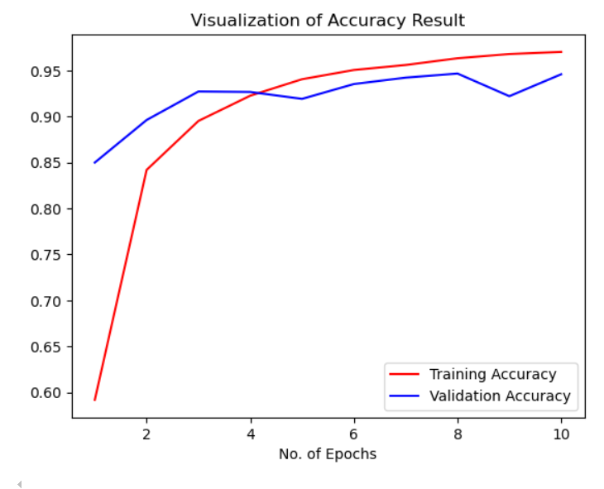

Fig 4.1.3: Accuracy Graph

4.2 Coding Standards

* Code Structure: A modular approach was followed for better readability and maintainability. Each functionality, such as image preprocessing, model loading, and prediction, was developed in separate modules.
* Frameworks Used:
  + TensorFlow/Keras for AI model implementation and training.
  + Streamlit for creating an interactive and user-friendly web interface.

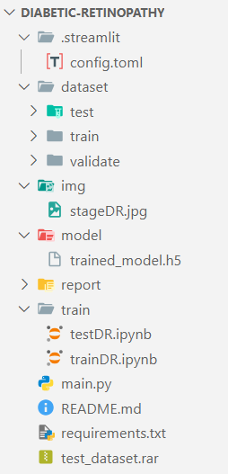

Fig 4.2.1: Directory Structure

4.3 Scalable Code

* The application was designed to handle multiple predictions seamlessly while maintaining responsiveness.
* Batch processing was implemented during model training for scalability, ensuring faster training and validation.
* The tool is capable of handling high-resolution images resized to 256x256 pixels during the preprocessing stage.

4.4 Version Control

* Git was used for version control to track changes during development and ensure collaborative efforts.
* A dedicated GitHub repository was maintained to store and manage code, datasets, and model weights.

4.5 Code Review

* Regular code reviews were conducted by team members to ensure adherence to standards and eliminate bugs.
* Peer reviews improved the overall quality of the codebase and ensured the robustness of the diagnostic tool.

Chapter 5: Testing

Testing is a critical phase in the development process to ensure the reliability, accuracy, and robustness of the Diabetic Retinopathy Diagnostic Tool. Comprehensive testing was conducted to evaluate the system's performance across multiple scenarios, datasets, and conditions. This stage included system testing, manual testing, and automated testing, alongside detailed metric evaluations such as accuracy, precision, recall, F1 score, and confusion matrix analysis.

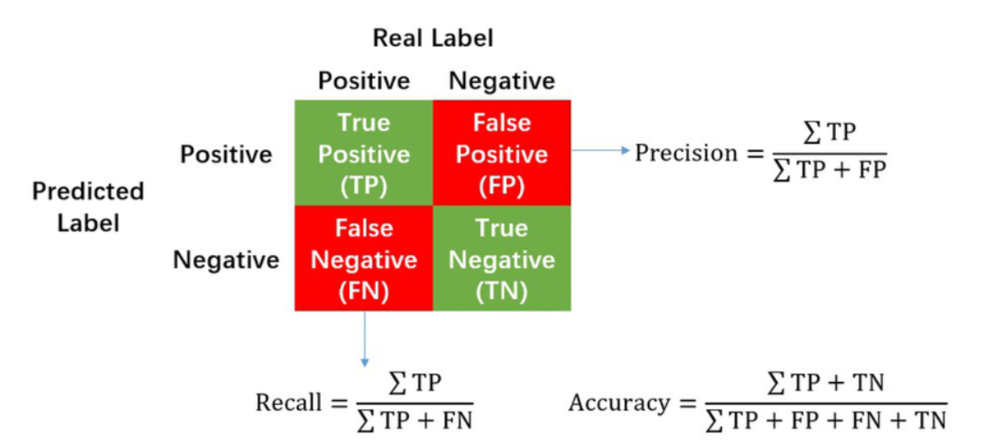

Fig5.0.1: confusion matrix visualizes the performance

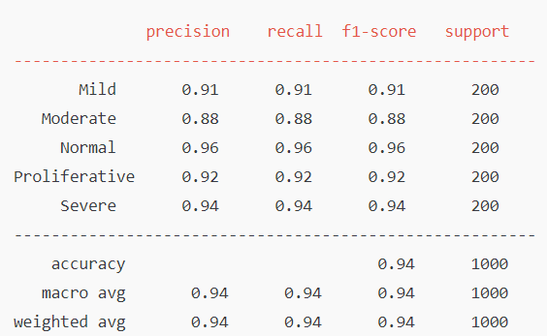

Fig 5.0.2: Metrics Evaluation

5.1 System Testing

* The end-to-end functionality of the tool was tested to ensure smooth workflow, from image upload to prediction generation.
* Cross-browser compatibility was validated, ensuring consistent performance on Chrome, Firefox, and Edge.
* Average prediction latency was recorded as less than 3 seconds per image, providing users with real-time results.

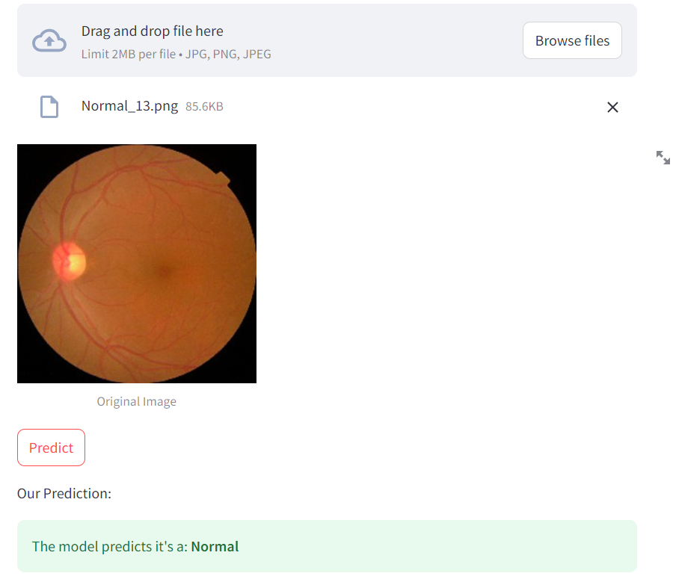

Fig 5.1.1: Prediction Result

Manual Testing

* Dataset Variety: Tested the tool with real-world retinal images of varying resolutions, brightness levels, and noise levels to assess robustness.
* Error Handling: Verified how the system handles invalid inputs, such as incorrect file formats, excessively large files, and corrupted images.

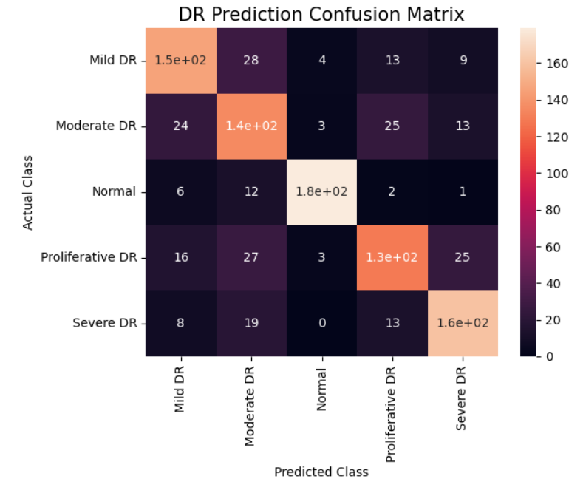

Fig 5.1.2 : Confusion Matrix for DR

Chapter 6: Deployment & Maintenance

*Live Link : https://diabetic-retinopath.streamlit.app/*

The final stage involves deploying the Diabetic Retinopathy Diagnostic Tool for real-world use, ensuring it is accessible, maintainable, and user-friendly.

6.1 Deployment and Maintenance

* Deployment Framework:  
  The tool was deployed using Streamlit, a Python-based web application framework tailored for machine learning projects. Streamlit was chosen for its simplicity, seamless integration with AI models, and ability to create interactive dashboards quickly.
* Hosting Platform:  
  The application was hosted on Streamlit Cloud, ensuring reliable access and minimal setup.

6.2 Release Planning

* Version Control:
  + The initial release was tagged as v1.0, with all core functionalities tested and validated.
  + Future versions will include updates based on user feedback, additional features, and fine-tuned model parameters.
* Documentation: Comprehensive user documentation was included to guide healthcare professionals and researchers in using the tool effectively.

6.3 Deployment Automation

* Deployment pipelines were established to ensure a smooth transition from development to production using tools like GitHub Actions.
* Every code push triggers automated testing and deployment, ensuring that only verified changes are rolled out.

6.4 Maintenance

* Model Updates:
  + The model will periodically be retrained with new datasets to improve accuracy and adapt to new patterns in retinal images.
  + Ongoing fine-tuning ensures robust performance across diverse populations and imaging conditions.

REFERENCES

* This paper explores the application of deep learning in diagnosing diabetic retinopathy, discussing various methodologies.

*Link: https://www.sciencedirect.com/science/article/pii/S2352914820302069*

* A live session discussing the implementation of CNN

*Link :* [*https://www.youtube.com/live/SH8D4WJBhms?si=fDqjtaRBwL0yzZl0*](https://www.youtube.com/live/SH8D4WJBhms?si=fDqjtaRBwL0yzZl0)

****Department of Computer Science and Engineering

UIET, Panjab University, Chandigarh

Course Exit Survey

Dear Student

The attainment of course outcome after the completion of the course is required as it would help in the continuous improvement of Course Outcomes (CO). This course exit survey would enable us to know as to what extend the subject under consideration and the teaching methodology that have been practiced in the institution have contributed towards the attainment of course outcomes. Hence you are asked to provide the attainment level on scale of Very High (5), High (4), Medium(3), Satisfactory (2), Low (1) for the given course outcomes.

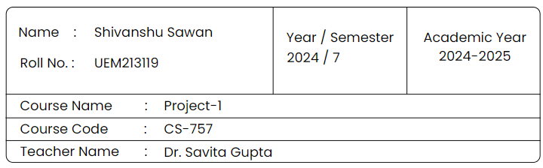

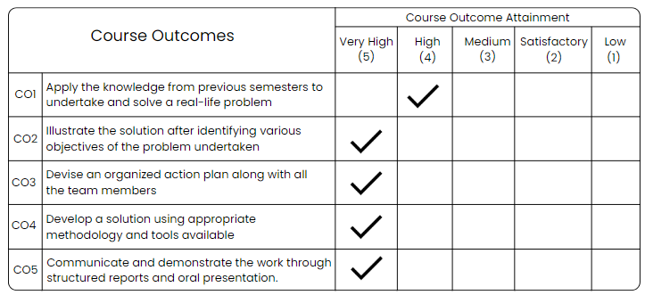

Suggestions for Improvement

Signature of Student

*Shivanshu*

****Department of Computer Science and Engineering

UIET, Panjab University, Chandigarh

Course Exit Survey

Dear Student

The attainment of course outcome after the completion of the course is required as it would help in the continuous improvement of Course Outcomes (CO). This course exit survey would enable us to know as to what extend the subject under consideration and the teaching methodology that have been practiced in the institution have contributed towards the attainment of course outcomes. Hence you are asked to provide the attainment level on scale of Very High (5), High (4), Medium(3), Satisfactory (2), Low (1) for the given course outcomes.

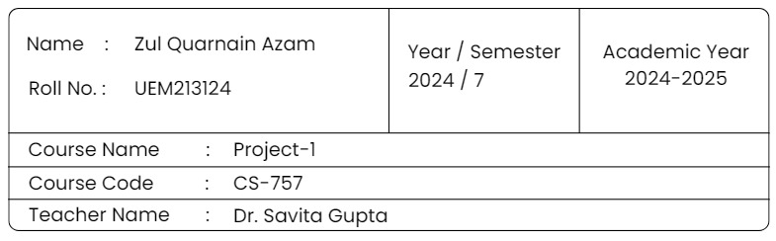

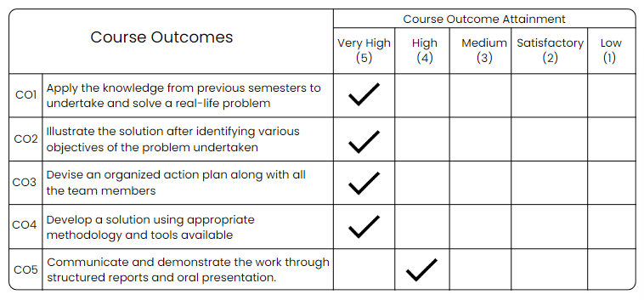

Suggestions for Improvement

Signature of Student

*Zul Quarnain Azam*

****Department of Computer Science and Engineering

UIET, Panjab University, Chandigarh

Course Exit Survey

Dear Student

The attainment of course outcome after the completion of the course is required as it would help in the continuous improvement of Course Outcomes (CO). This course exit survey would enable us to know as to what extend the subject under consideration and the teaching methodology that have been practiced in the institution have contributed towards the attainment of course outcomes. Hence you are asked to provide the attainment level on scale of Very High (5), High (4), Medium(3), Satisfactory (2), Low (1) for the given course outcomes.

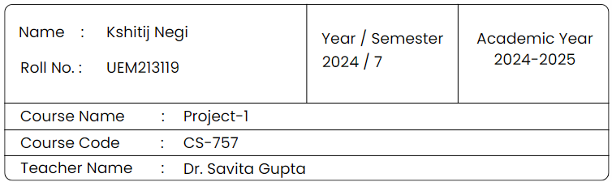

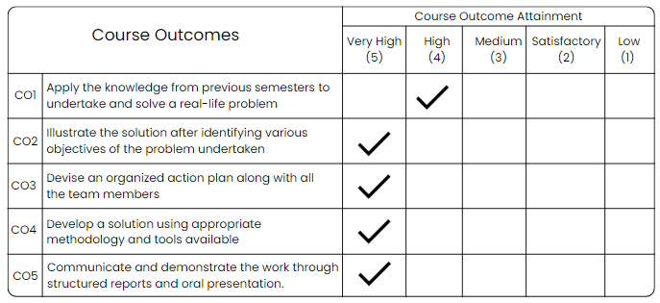

Suggestions for Improvement

Signature of Student

*Kshitij Negi*