Factory-to-Customer Shipping Route
Efficiency Analysis
Nassau Candy Distributor
Research Paper — Exploratory Data Analysis, Insights & Recommendations
Analysis Period: January 2024 – December 2025
Records Analyzed: 10,194 shipment line items across 8,549 orders
Prepared: June 2026

Table of Contents

1. Background and Context
Nassau Candy Distributor operates as a national distributor, shipping confectionery products from five factories to customers across the United States and, to a smaller extent, Canada. In this kind of operation, shipping efficiency directly affects customer satisfaction, delays increase operational cost, and inefficient routes reduce scalability. Despite holding rich order and shipment data, logistics decisions have historically been made without route-level efficiency intelligence.
This research paper transforms the distributor's raw order and shipment records into route-level operational intelligence: which factory-to-region pathways perform well, which underperform, where geographic bottlenecks concentrate, and how shipping-mode choice varies across the network.

1.1 Problem Statement
Prior to this analysis, the organization lacked clarity on:
- Which factory-to-customer routes are consistently efficient
- Which routes experience a heavier share of slow (Standard Class) shipments
- How shipping performance varies by region, state, and ship mode
- Where operational bottlenecks exist geographically
Without this visibility, logistics optimization remained reactive rather than data-driven. This paper, together with the accompanying interactive dashboard, addresses that gap.

1.2 Network Overview
Nassau Candy Distributor sources products from five factories, each producing a distinct subset of the product catalog:
Factory | Division(s) | Latitude | Longitude
Lot's O' Nuts | Chocolate | 32.881893 | -111.768036
Wicked Choccy's | Chocolate | 32.076176 | -81.088371
Sugar Shack | Sugar | 48.119140 | -96.181150
Secret Factory | Other / Sugar | 41.446333 | -90.565487
The Other Factory | Other / Sugar | 35.117500 | -89.971107

Shipments are organized into four delivery regions — Atlantic, Gulf, Interior, and Pacific — each spanning multiple U.S. states (and, in the Atlantic and Pacific regions, several Canadian provinces). Each factory ships into all four regions; there is no exclusive factory-to-region territory assignment in the current data.

2. Dataset and Methodology

2.1 Dataset Fields
The source dataset (Nassau_Candy_Distributor.csv) contains 10,194 rows across 18 fields:
Field | Description
Row ID | Unique row identifier
Order ID | Unique order identifier
Order Date / Ship Date | Date of order and shipment (see data quality note, §2.3)
Ship Mode | Shipping method: Same Day, First Class, Second Class, Standard Class
Customer ID | Unique customer identifier
Country/Region, City, State/Province, Postal Code | Customer geography
Division | Product division: Chocolate, Sugar, Other
Region | Delivery region: Atlantic, Gulf, Interior, Pacific
Product ID / Product Name | Product identifiers
Sales, Units, Gross Profit, Cost | Order financials

2.2 Analytical Methodology

Step 1 — Data Cleaning & Validation
- Parsed and validated date fields (source format DD-MM-YYYY)
- Checked for duplicate Row IDs and missing shipment records — none found
- Standardized geographic text fields (trimmed whitespace, consistent casing)
- Cross-validated Gross Profit = Sales − Cost across all 10,194 rows — zero mismatches

Step 2 — Feature Engineering
- Mapped each of the 15 products to its source factory using the Products-and-Factories correlation table
- Derived a Ship-Mode Speed Rank (1 = Same Day … 4 = Standard Class) as the delivery-speed proxy (see §2.3)
- Flagged cross-border (non-U.S.) shipments
- Derived order month/year for trend analysis and profit margin per line item

Step 3 — Route Definition & Aggregation
Each route is defined as Factory → Customer State/Province (rolled up to Factory → Region for regional summaries). For each route we computed shipment volume, total sales and profit, average speed rank, and the percentage of expedited vs. Standard Class shipments.

Step 4 — Efficiency Benchmarking
Routes were ranked from most to least efficient using a 0–100 Route Efficiency Score, derived by normalizing the average ship-mode speed rank (inverted, so a faster mix scores higher). Routes with fewer than 5 shipments were excluded from ranking to avoid drawing conclusions from statistically thin samples.

Step 5 — Geographic Bottleneck Analysis
States/provinces were scored on a Bottleneck Score combining (a) shipment volume rank and (b) Standard-Class-share rank, each weighted 50%. High-bottleneck-score locations are markets that are both high-volume and disproportionately reliant on the slowest ship-mode tier — the combination most likely to warrant operational attention.

Step 6 — Ship Mode Performance Analysis
Ship mode distribution was compared across regions and factories to test whether slower service is concentrated in particular parts of the network or distributed evenly.

2.3 Data Quality Findings
Three material data-quality issues were identified during cleaning and are disclosed here in the interest of analytical transparency:
Finding 1 — Order Date and Ship Date are not reliably linked
• Every one of the 10,194 rows shows a gap of between 904 and 1,642 days (2.5–4.5 years) between Order Date and Ship Date, clustering into three discrete bands tied to order year rather than forming a realistic shipping-duration distribution.
• This is a known signature of template/demo datasets where date fields are auto-shifted independently on each refresh, severing the real relationship between the two columns.
• Consequence: a day-level 'Shipping Lead Time' KPI cannot be computed reliably from this data. Reporting one anyway would fabricate false precision. This analysis substitutes Ship Mode (a clean, directly observed field) as the delivery-speed proxy throughout.
Finding 2 — The network is not U.S.-only
• 200 shipments (1.96% of the dataset) ship to Canadian provinces (Ontario, Quebec, British Columbia, Alberta, and others), despite the operation being framed as domestic U.S. distribution.
• These records are retained and labeled as cross-border in all analysis; they are not excluded, since doing so would silently discard real data.
Finding 3 — Severe sample-size imbalance across factories
• Lot's O' Nuts and Wicked Choccy's (both Chocolate division) account for 96.6% of all shipments. Sugar Shack has only 33 shipments total across all four regions.
• Route-level conclusions involving Sugar Shack, Secret Factory, or The Other Factory should be treated as directional, not statistically robust, and are flagged accordingly wherever they appear in this report.

3. Exploratory Data Analysis

3.1 Volume and Network Composition
The dataset spans January 2024 through December 2025 and covers 8,549 unique orders (10,194 shipment line items) totaling $141,783.63 in sales, 38,654 units, and $93,442.80 in gross profit (a 66.5% average margin — consistent with confectionery's typically high markup over manufacturing cost).
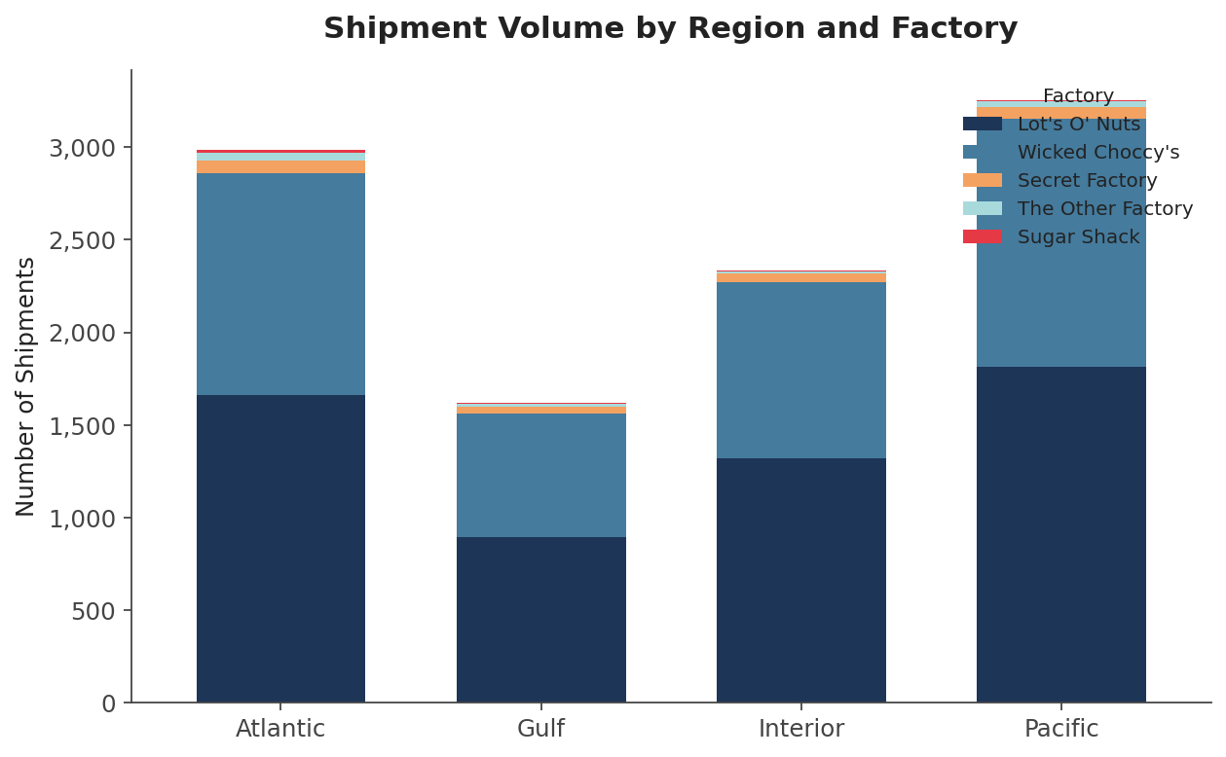
Figure 1. Shipment volume by region and factory. Lot's O' Nuts and Wicked Choccy's dominate every region; the Pacific and Atlantic regions carry the highest overall volume.
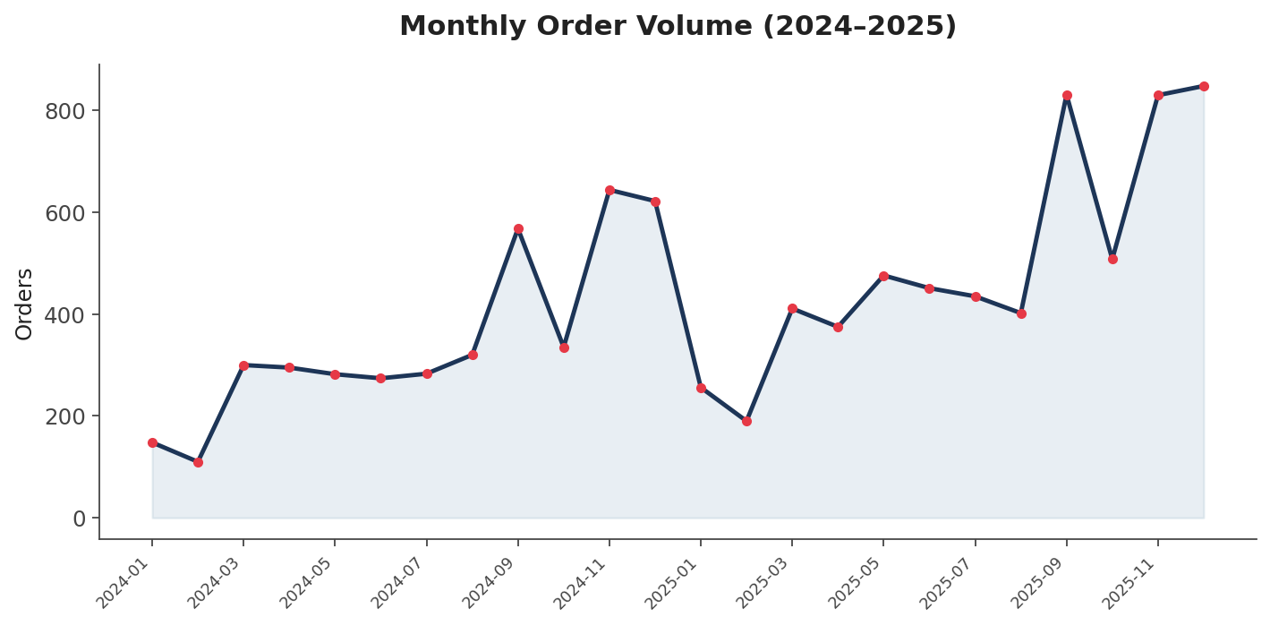
Figure 2. Monthly order volume, Jan 2024–Dec 2025. Volume grows over the two-year window with visible seasonal variation; no single month represents an anomalous spike or drop.

3.2 Ship Mode Distribution
Standard Class is the dominant shipping method, used in 60.0% of all shipments, followed by Second Class (19.4%), First Class (15.2%), and Same Day (5.4%). Only 20.6% of shipments use an expedited tier (Same Day or First Class).
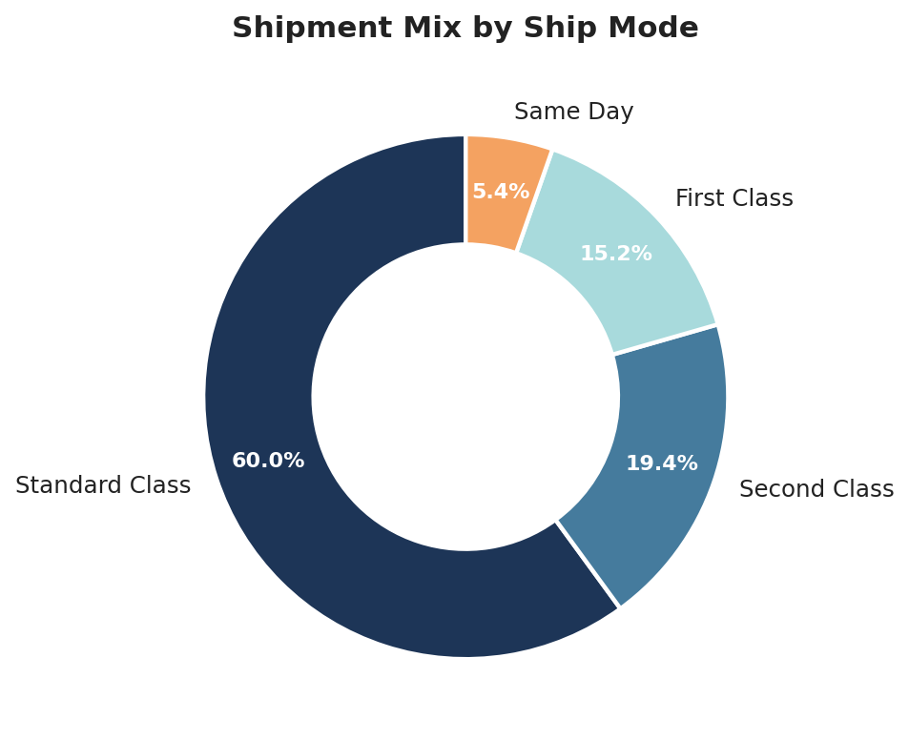
Figure 3. Overall ship-mode mix across all 10,194 shipments.
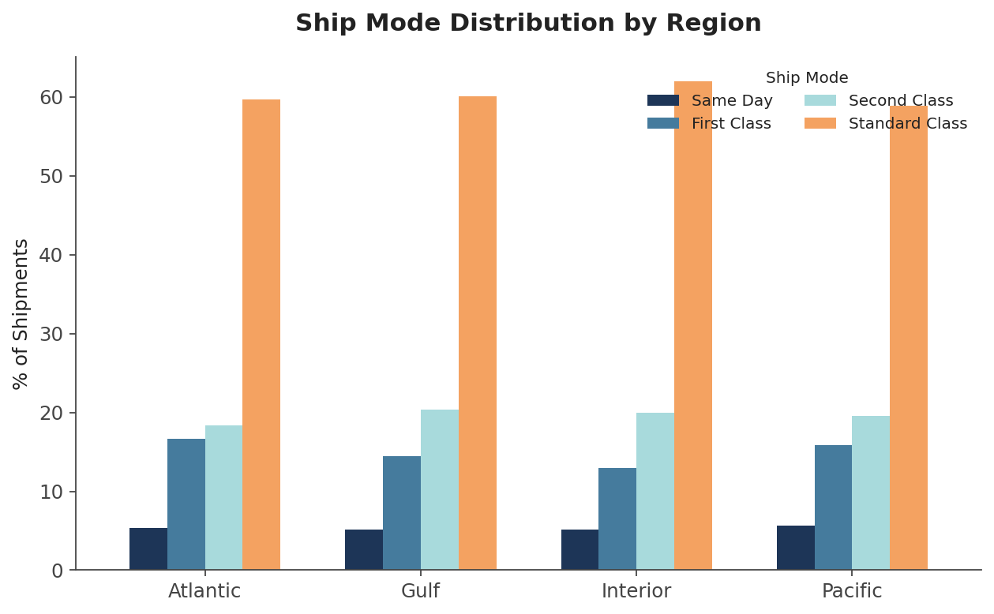
Figure 4. Ship-mode distribution by region. The mix is broadly similar across all four regions (Standard Class 58.9%–62.0%), indicating that slow-mode reliance is a network-wide pattern rather than a region-specific problem.

3.3 Route Efficiency: Top and Bottom Performers
Using the Route Efficiency Score (§2.2, Step 4) on routes with at least 5 shipments, the most and least efficient Factory → State routes are shown below.
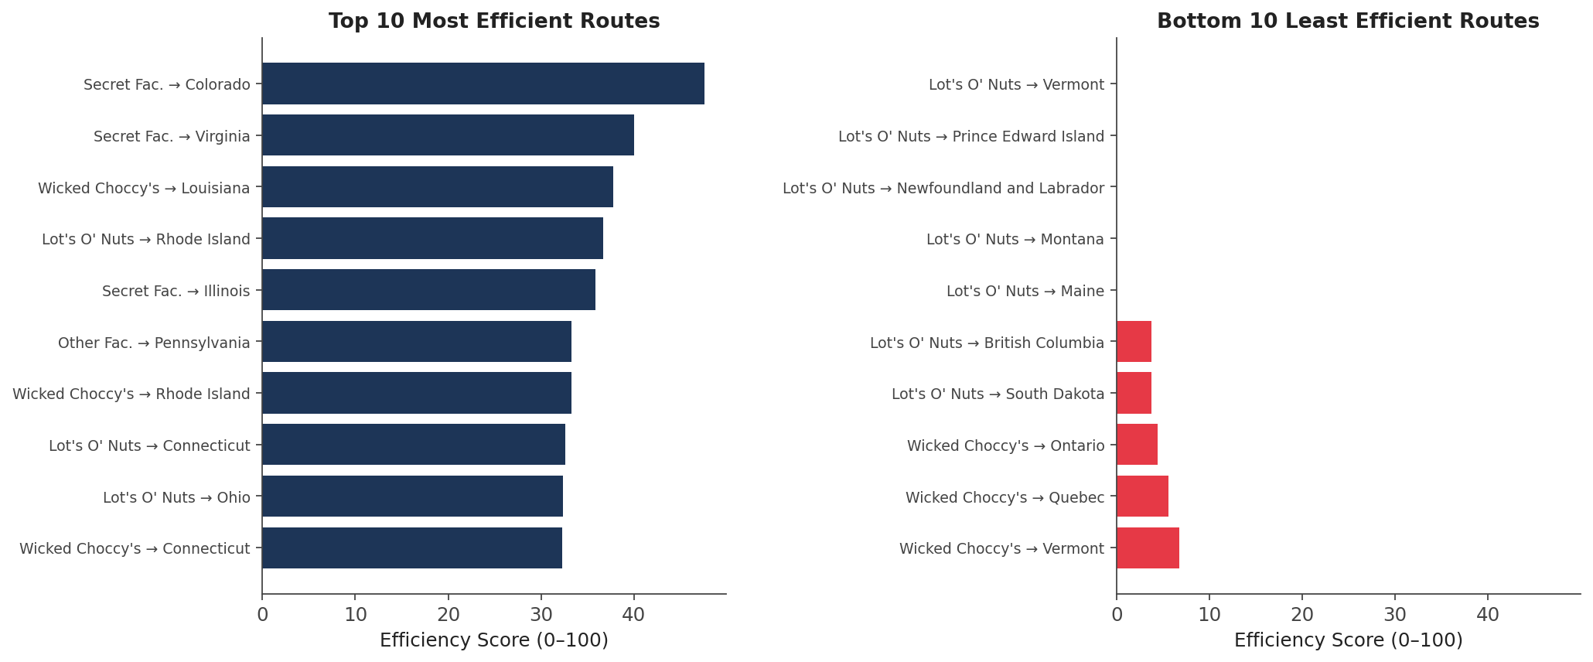
Figure 5. Top 10 and bottom 10 routes by efficiency score. Note the asymmetry in shipment volume behind these scores (see Table 2 and Table 3).

Top 10 Most Efficient Routes
Factory | State/Province | Shipments | Expedited % | Efficiency Score
Secret Factory | Colorado | 7 | 57.1% | 47.6
Secret Factory | Virginia | 5 | 40.0% | 40.0
Wicked Choccy's | Louisiana | 15 | 33.3% | 37.8
Lot's O' Nuts | Rhode Island | 30 | 36.7% | 36.7
Secret Factory | Illinois | 13 | 38.5% | 35.9
The Other Factory | Pennsylvania | 7 | 42.9% | 33.3
Wicked Choccy's | Rhode Island | 21 | 28.6% | 33.3
Lot's O' Nuts | Connecticut | 47 | 38.3% | 32.6
Lot's O' Nuts | Ohio | 262 | 34.4% | 32.4
Wicked Choccy's | Connecticut | 31 | 32.3% | 32.3
Note: Most top-10 routes carry low shipment volume (5–47 shipments); only the Lot's O' Nuts → Ohio route (262 shipments) demonstrates strong efficiency at meaningful scale, making it the standout high-confidence result in this table.

Bottom 10 Least Efficient Routes
Factory | State/Province | Shipments | Standard % | Efficiency Score
Lot's O' Nuts | Vermont | 5 | 100.0% | 0.0
Lot's O' Nuts | Prince Edward Island | 6 | 100.0% | 0.0
Lot's O' Nuts | Newfoundland and Labrador | 6 | 100.0% | 0.0
Lot's O' Nuts | Montana | 8 | 100.0% | 0.0
Lot's O' Nuts | Maine | 6 | 100.0% | 0.0
Lot's O' Nuts | British Columbia | 18 | 88.9% | 3.7
Lot's O' Nuts | South Dakota | 9 | 88.9% | 3.7
Wicked Choccy's | Ontario | 30 | 86.7% | 4.4
Wicked Choccy's | Quebec | 24 | 91.7% | 5.6
Wicked Choccy's | Vermont | 5 | 80.0% | 6.7
Note: Every route in this table is either low-volume (≤30 shipments), geographically remote (Montana, Maine, Vermont), or cross-border (British Columbia, Ontario, Quebec). This pattern most plausibly reflects rational cost-driven carrier selection for distant or low-volume markets — not necessarily an operational failure. See Recommendation 2 (§5) before treating these as priority fixes.

3.4 Geographic Bottleneck Analysis
Combining shipment volume with Standard-Class share identifies markets that are simultaneously high-traffic and slow-mode-heavy — the combination most likely to create visible customer-facing delay at scale, since a small percentage improvement there affects many more shipments than the same improvement in a low-volume state.
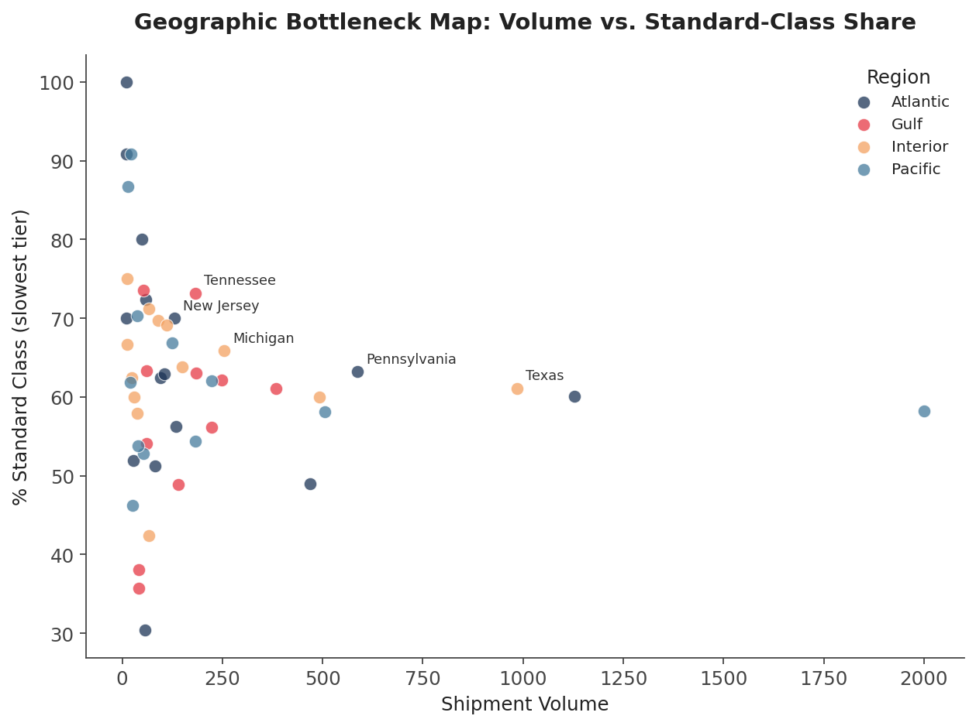
Figure 6. Shipment volume vs. Standard-Class share by state (states with ≥10 shipments shown). The five labeled states combine meaningful volume with an above-average reliance on the slowest ship-mode tier.
State/Province | Region | Shipments | Standard % | Bottleneck Score
Tennessee | Gulf | 183 | 73.2% | 77.1
Pennsylvania | Atlantic | 587 | 63.2% | 72.0
Michigan | Interior | 255 | 65.9% | 72.0
Texas | Interior | 985 | 61.1% | 71.2
New Jersey | Atlantic | 130 | 70.0% | 71.2
Indiana | Interior | 149 | 63.8% | 70.3
Oregon | Pacific | 124 | 66.9% | 66.1
Ontario | Atlantic | 58 | 72.4% | 66.1
Illinois | Interior | 492 | 60.0% | 66.1
New York | Atlantic | 1128 | 60.1% | 65.3

Tennessee stands out: it combines moderate-high volume (183 shipments) with the highest Standard-Class share (73.2%) of any state above the 20-shipment threshold, making it the single clearest bottleneck candidate in the dataset. Pennsylvania, Michigan, and Texas combine large volume with above-average Standard-Class share and warrant monitoring given their scale.

3.5 Cross-Border Shipments
Canadian provinces — Ontario, Quebec, and British Columbia in particular — appear disproportionately in the bottom-efficiency route rankings (§3.3) and bottleneck table (§3.4). Average speed rank for cross-border shipments is measurably slower than the domestic average, consistent with the expectation that cross-border logistics rely more heavily on consolidated, slower freight.

4. Key Performance Indicators
KPI | Definition | Value
Total Orders | Unique Order IDs | 8,549
Total Shipments (line items) | Total rows analyzed | 10,194
Total Sales | Sum of Sales | $141,783.63
Total Gross Profit | Sum of Gross Profit | $93,442.80
Average Margin | Mean Gross Profit / Sales | 66.5%
Standard Class Share | % of shipments on slowest tier | 60.0%
Expedited Share | % Same Day + First Class | 20.6%
Cross-Border Share | % shipments to Canada | 1.96% (200 shipments)
Route Efficiency Score | Normalized speed-mix score, 0–100 | Range: 0.0 – 47.6
Note on the Shipping Lead Time KPI originally specified in the project brief: as documented in §2.3 Finding 1, this metric cannot be computed reliably from the source data and has been replaced throughout this analysis by Ship Mode, a clean and directly observed proxy for delivery speed.

5. Insights and Recommendations

Recommendation 1 — Prioritize Tennessee, Pennsylvania, Michigan, and Texas for service-mode review
These four states combine high shipment volume with above-average reliance on Standard Class. Because of their scale, even a modest shift toward First/Second Class would affect more total shipments than the same shift in any low-volume state. Tennessee, in particular, has the highest Standard-Class share of any state with meaningful volume and should be the first candidate for a carrier or service-tier review.

Recommendation 2 — Don't over-correct on low-volume/remote-state routes
The bottom-10 efficiency routes (§3.3) are dominated by low-volume, geographically remote, or cross-border destinations (Vermont, Maine, Montana, the Canadian provinces). 100% Standard-Class usage in these markets is plausibly an economically rational choice — expedited shipping is expensive to justify for small order volumes to distant locations — rather than a service failure. We recommend validating against actual delivery-time complaints or customer churn data before reallocating shipping budget here.

Recommendation 3 — Treat the Lot's O' Nuts → Ohio route as a model case
Of all top-10 efficient routes, only Lot's O' Nuts → Ohio combines high volume (262 shipments) with a strong efficiency score (32.4) and a healthy expedited share (34.4%). This is the clearest evidence in the dataset that a fast, high-volume route is achievable. Understanding what is operationally different about this route (carrier choice, regional hub proximity, customer order patterns) may surface a replicable model for similarly-sized routes.

Recommendation 4 — Restore the Order Date / Ship Date relationship before any lead-time SLA work
Any future initiative that depends on a true day-level shipping lead time (SLA tracking, late-shipment alerts, carrier performance contracts) requires fixing the date pipeline first. We recommend auditing the source system that populates these two fields to determine where the disconnect is introduced, since the current data cannot support that class of analysis no matter how it is modeled.

Recommendation 5 — Expand the Sugar Shack / Secret Factory / Other Factory sample before drawing route-level conclusions
With only 33–217 shipments each, these three factories cannot yet support the same route-level confidence as Lot's O' Nuts or Wicked Choccy's. As volume grows, the same methodology in this report can be reapplied with materially more statistical confidence.

6. Conclusion
This project establishes a clear, data-driven understanding of shipping route efficiency for Nassau Candy Distributor. By transforming raw order and shipment data into route-level operational intelligence — while being transparent about the data's real limitations, particularly the unreliable Order Date / Ship Date relationship — the organization gains actionable insight into which routes perform well, which markets carry disproportionate volume on the slowest service tier, and where to focus operational attention first.
The accompanying Streamlit dashboard makes this analysis interactively explorable, and the executive summary distills it for stakeholder review. Together, these three deliverables move Nassau Candy Distributor from reactive logistics management toward data-driven route optimization.

Deliverables
- Research paper (this document) — EDA, methodology, insights, and recommendations
- Streamlit dashboard — live, filterable analytics covering route efficiency, geographic mapping, ship-mode comparison, and route drill-down
- Executive summary — condensed stakeholder-facing briefing

