Instructor Quality & Course Effectiveness
A Data-Driven Evaluation Framework for the EduPro Online Platform
Research Paper
Prepared for EduPro Online Platform Stakeholders

1. Background and Context
In online education, instructor quality and course design are the strongest drivers of learner satisfaction, course ratings, repeat enrollments, and platform credibility. Even when learner demand for a topic is strong, poor instructional quality can still produce low course ratings, negative reviews, and reduced trust in the platform.
EduPro needs a data-driven framework to evaluate instructor effectiveness, course quality consistency, and the relationship between teaching expertise and learner satisfaction. This paper presents that framework, built directly from the platform's Teachers, Courses, and Transactions data.

2. Problem Statement
Currently, EduPro lacks clarity on several core questions:
- Which instructors consistently deliver high-quality courses?
- Does teaching experience translate into better-rated courses?
- Are some course categories more dependent on instructor quality than others?
- How evenly is teaching performance distributed across the platform?
Without structured analysis, instructor evaluation remains subjective and fragmented. This research closes that gap using quantitative analysis of 60 instructors, 60 courses, and 10,000 enrollment transactions.

3. Dataset and Methodology

3.1 Data Sources
Three linked tables were used: the Teachers sheet (TeacherID, Age, Gender, Expertise, YearsOfExperience, TeacherRating), the Courses sheet (CourseID, CourseCategory, CourseLevel, CourseType, CoursePrice, CourseDuration, CourseRating), and the Transactions sheet (10,000 enrollment records linking learners, courses, and instructors via CourseID and TeacherID).

3.2 Methodology
- Data Integration: Teachers, Courses and Transactions were joined on TeacherID and CourseID, validating the mapping between instructors and the courses they teach.
- Instructor Profile Analysis: distribution of age, experience, expertise, and rating spread to identify top- and low-performing instructors.
- Experience vs Performance Analysis: correlation between YearsOfExperience and both TeacherRating and CourseRating, checking for diminishing returns.
- Course Quality Evaluation: CourseRating analysed by category and level, with gender and course-level comparisons.
- Instructor Impact on Course Success: course ratings and enrollment volumes compared across high-, mid-, and low-rated instructor tiers.
- Expertise-Based Performance Insights: teaching quality compared across expertise domains to flag training gaps.

4. Findings

4.1 Distribution of Instructor Ratings
Across the 60 instructors on the platform, the average TeacherRating is 3.13 out of 5, with a standard deviation of 0.95. Ratings span a wide range — from 1.05 to 4.97 — indicating substantial variability in teaching quality rather than a tightly clustered, uniformly competent instructor base.
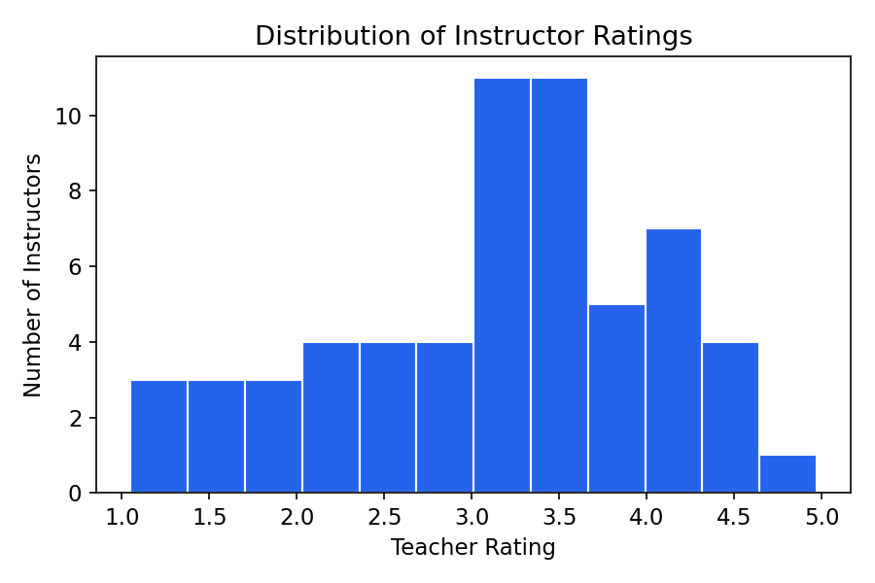
Figure 1. Distribution of instructor ratings across the platform.
The spread shows a roughly even distribution rather than a sharp peak, meaning a meaningful share of instructors fall well below the platform average and represent a clear improvement opportunity.

4.2 Experience vs Rating
Years of teaching experience shows a moderately strong positive correlation with TeacherRating (r = 0.60). Instructors with 0–3 years of experience average 2.53, rising to 3.04 for 4–7 years, 3.89 for 8–12 years, and 3.95 for 13+ years.
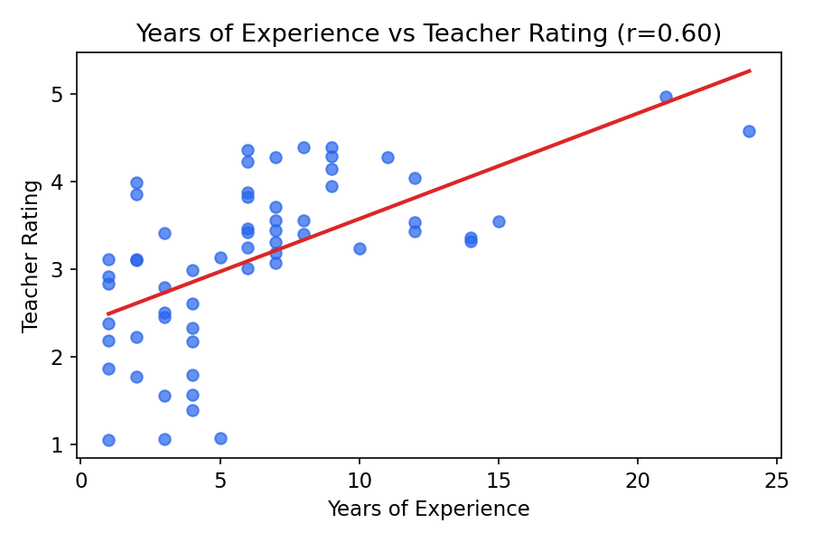
Figure 2. Years of experience plotted against teacher rating, with linear trend line.
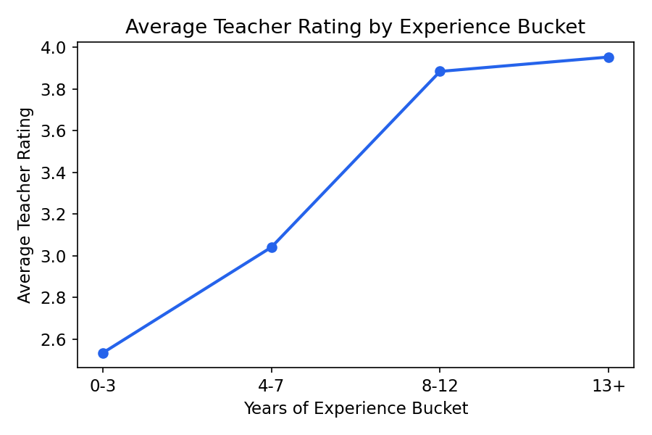
Figure 3. Average teacher rating by experience bucket, showing diminishing returns after roughly 8 years.
The relationship is positive but not linear: the jump from the 0–3 year to 8–12 year bands is large (+1.36), while the gain from 8–12 to 13+ years is marginal (+0.06). This suggests experience builds teaching competence mainly in the first decade, after which other factors — course design, subject difficulty, learner expectations — matter more than tenure alone.

4.3 Teacher Rating vs Course Rating
At the individual course level, the correlation between TeacherRating and CourseRating is effectively zero (r = -0.03). This is one of the more important findings of the analysis: a highly rated instructor does not automatically guarantee a highly rated course, and vice versa.
This implies that course-level factors — content structure, pacing, course duration, pricing, and category difficulty — exert an influence on CourseRating that is independent of the instructor's own reputation. EduPro should therefore evaluate instructors and courses as two related but distinct quality dimensions, rather than treating CourseRating as a simple proxy for teaching quality.

4.4 Course Quality by Category and Level
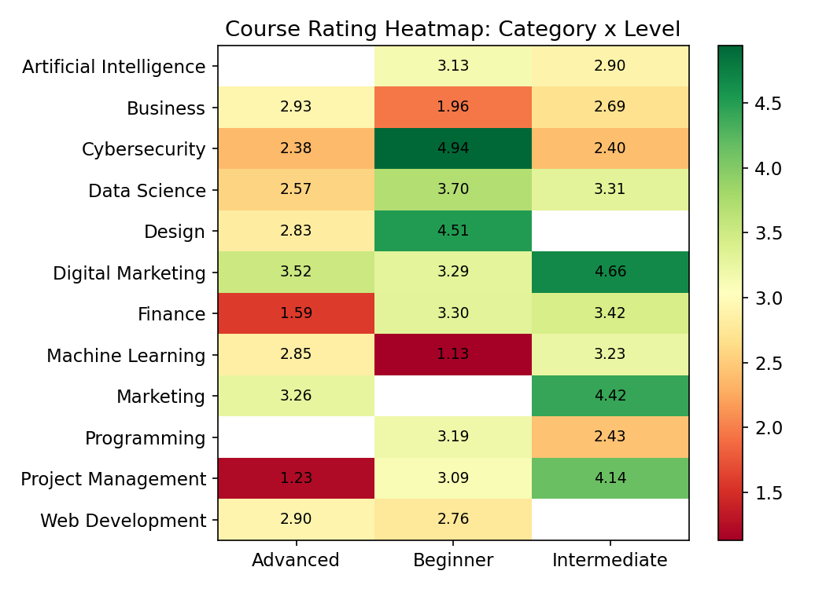
Figure 4. Average course rating by category and level.
Marketing (3.72) and Digital Marketing (3.66) categories carry the highest average course ratings, while Machine Learning (2.66) and Business (2.69) trail the rest of the catalogue. This category-level variation is larger than the variation explained by instructor rating alone, reinforcing the finding in Section 4.3 that course design and subject-matter difficulty are major independent drivers of CourseRating.

4.5 Expertise-Based Performance
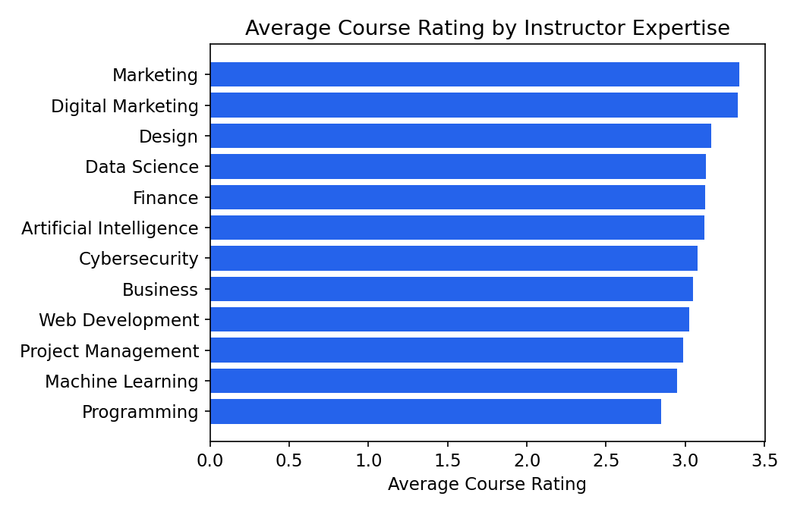
Figure 5. Average course rating by instructor expertise area.
Instructors in Marketing, Digital Marketing and Data Science expertise areas deliver the highest average course ratings, while Machine Learning and Programming expertise areas show the lowest, despite Machine Learning instructors having a comparatively high average TeacherRating (4.53). This gap between strong instructor reputation and weaker course outcomes in Machine Learning points to a likely content or course-design gap in that domain rather than a teaching-skill gap.

4.6 Instructor Rating Tier vs Enrollment Volume
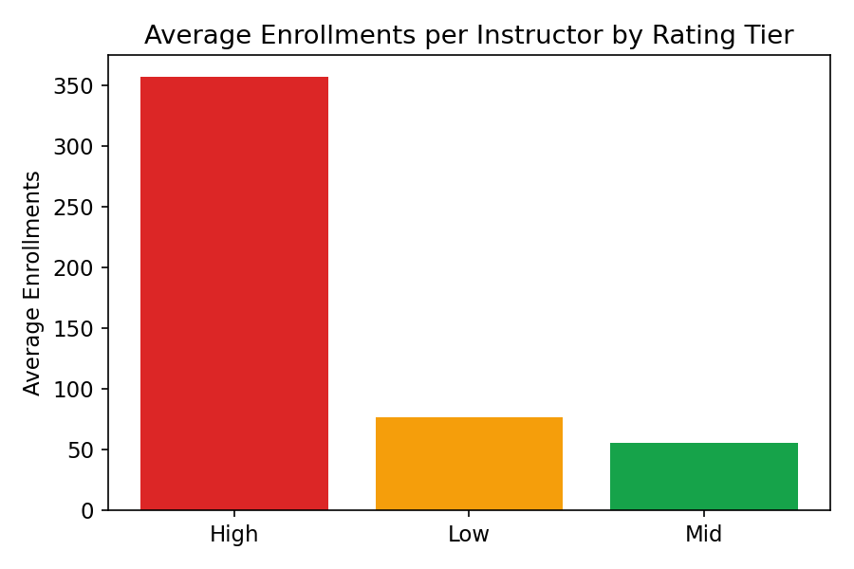
Figure 6. Average enrollments per instructor by rating tier (Low ≤2.5, Mid 2.5–3.5, High >3.5).
Enrollment volume is heavily concentrated among high-rated instructors. High-tier instructors (TeacherRating > 3.5) attract an average of 357 enrollments each, compared to 56 for mid-tier and 76 for low-tier instructors. This indicates learners do respond strongly to instructor reputation when choosing courses, even though that reputation does not strongly predict the resulting CourseRating once enrolled (Section 4.3) — reputation drives discovery and sign-up, while course design and delivery drive the eventual rating.

5. Key Performance Indicators (KPIs)
KPI Name | Description | Platform Value
Average Teacher Rating | Teaching quality benchmark | 3.13 / 5
Average Course Rating | Content effectiveness | ≈3.10 / 5 (category-dependent)
Rating Consistency Index | Instructor reliability (1 − StdDev/Mean) | ≈0.70
Experience Impact Score | Value of teaching tenure (correlation) | 0.60
Enrollment Influence Ratio | Instructor-driven demand | High-tier instructors draw ~5x the enrollments of mid-tier

6. Recommendations
- Introduce a structured mentorship or onboarding track for instructors with under 3 years of experience, since this group shows the steepest rating gap (2.53 vs 3.89+ for tenured peers).
- Treat CourseRating and TeacherRating as separate quality signals in any dashboard or ranking system, given their near-zero correlation; do not assume one predicts the other.
- Prioritize a course-design audit in Machine Learning and Business categories, where ratings lag despite adequate or even strong instructor reputation in some cases.
- Use instructor reputation strategically in marketing and course discovery, since high-rated instructors draw disproportionately more enrollments — but pair this with quality assurance on course content to protect the rating those new learners will leave.
- Monitor the Rating Consistency Index over time as a single, trackable measure of how evenly teaching quality is distributed across the instructor base.

7. Conclusion
This project establishes a data-driven instructor and course quality evaluation framework for EduPro. By shifting focus away from learners and toward teaching effectiveness, it enables the platform to identify excellence, address gaps, and continuously improve educational outcomes. The clearest signal from the data is that instructor reputation and course quality, while related, behave as distinct levers: reputation drives enrollment, while course design and category fit drive the rating learners ultimately leave. Treating them as two coordinated but separate workstreams — instructor development on one side, course content quality assurance on the other — is the most direct path to improving both metrics together.

