

Amazon Web Services

Build VPC With AWS CloudFormation

May 2018

Table of Contents

Overview 3

Explore Initial VPC template 3

Create Stack 4

Lab Objective: 8

References: 9

Update Stack and Solution: 10

Appendix: 13

# Overview

This lab will walk the user through using the AWS CloudFormation to create a VPC with public and private subnets, describe each of the objects created by the AWS CloudFormation, and launch VPC with the public and private VPC subnets, RouteTable, Elastic IP NAT Gateway, and S3 bucket.

The following is a high-level overview of this lab:

* Explore the initial AWS CloudFormation template
* Explore the different VPC objects and what they mean
* Launch AWS CloudFormation by creating Stack from Console.
* Export VPC ID, NAT Gateway ID and S3 bucket URL to output tab

The lab will provide an initial template for users to explore . after creating VPC stack from an initial template, users need to complete provided objective to achieve the final solution.

**Note:** Screenshots are provided to guide you through the steps in the lab. The elements that you will create (e.g. VPC, NAT Gateway, EIP) will be unique to your account, so things such as VPC ID that you see in the console will not necessarily mirror what’s seen in the screenshot.

# Explore Initial VPC template

Please browse the initial AWS CloudFormation Template file, You can use any text editor to explore the different elements of VPC mentioned in the template:

*Lab_Initial_CloudFormation_Module_General_ImmersionDay.json* (Follow instruction in appendix section to get template)

You will notice following resources in Initial AWS CloudFormation Template:

* VPC
* Internet Gateway
* S3 bucket
* Two public subnets with corresponding route tables
* Two private subnets with corresponding route tables
* Two Elastic IP
* Two NAT Gateway

# Create Stack

Log into the **AWS Console**, and click on **CloudFormation** and below screen will open:

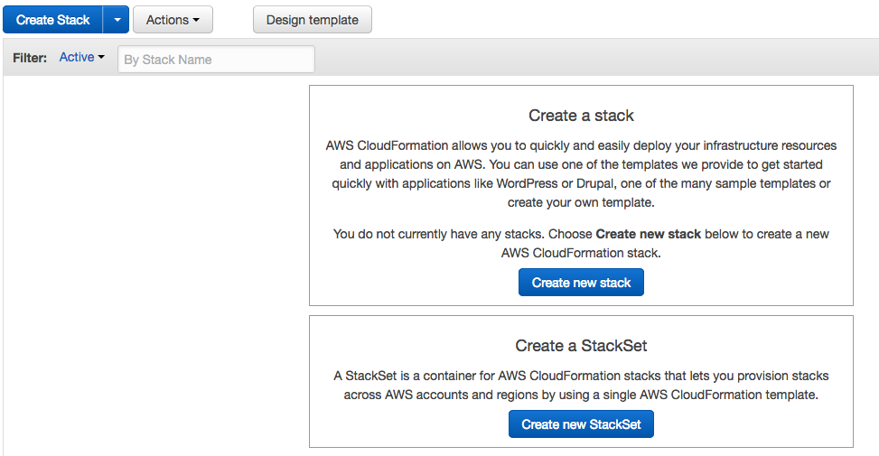

Now click on **Create new stack** and browse your initial template to against choose a template option :

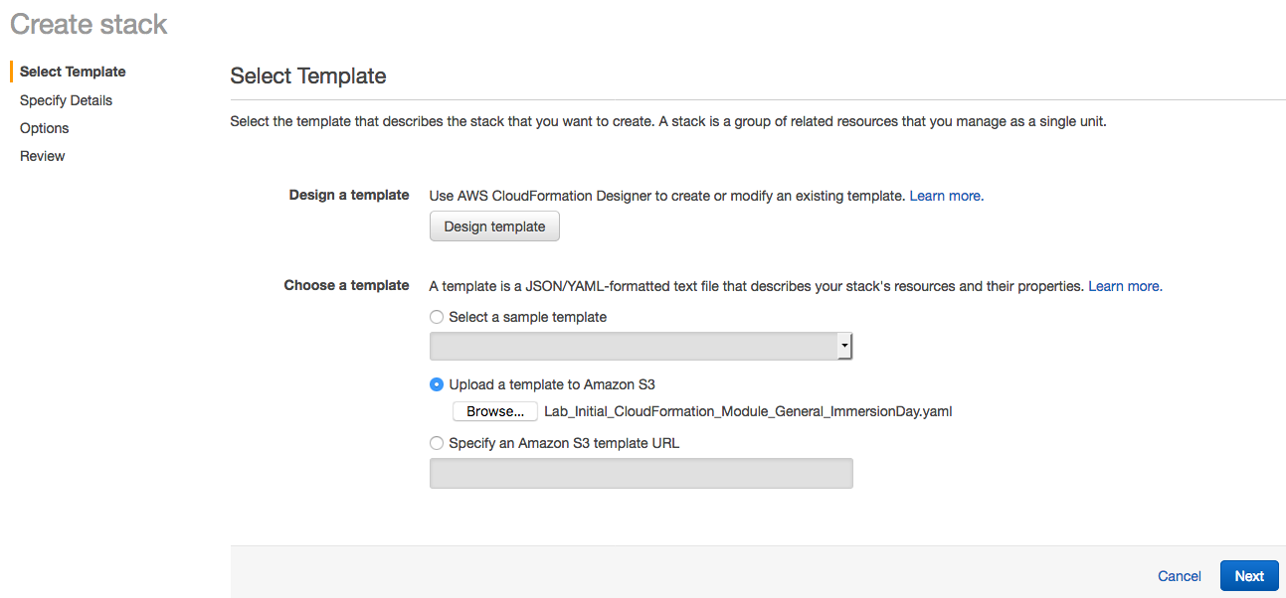

Click **Next** and give stack name. Make sure your stack name should be unique to your account. Leave all other option as default

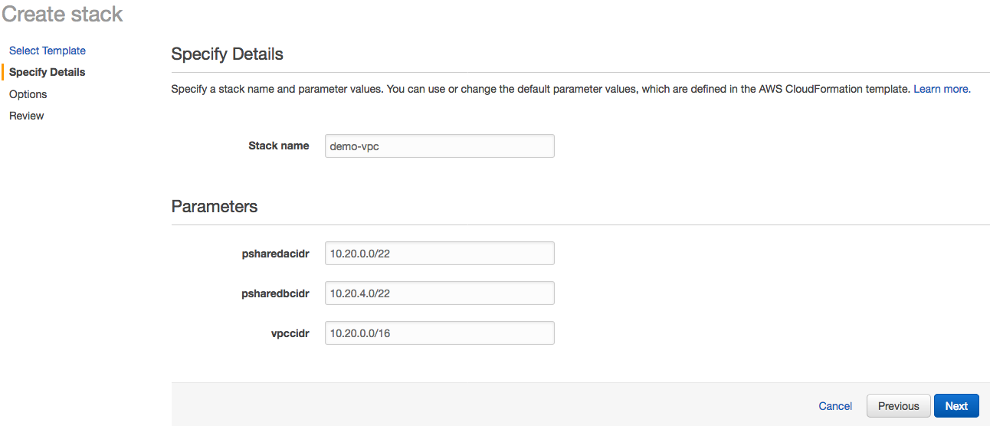

Click **Next**, here you can define a tag for the stack, IAM Role and other advance option like termination protection and rollback trigger. For this lab we will leave this as it and click to **Next** again, where you will have the opportunity to review your stack settings:

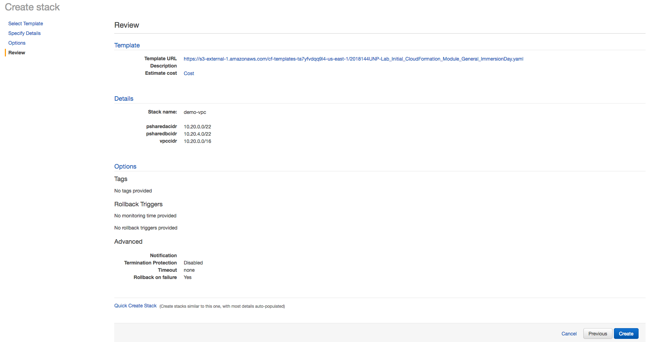

Now Click on **Create** and you will notice your stack creation started with status **CREATE_IN_PROGRESS.** Explore the **Events** tab where you can see the progress as your stack get created.

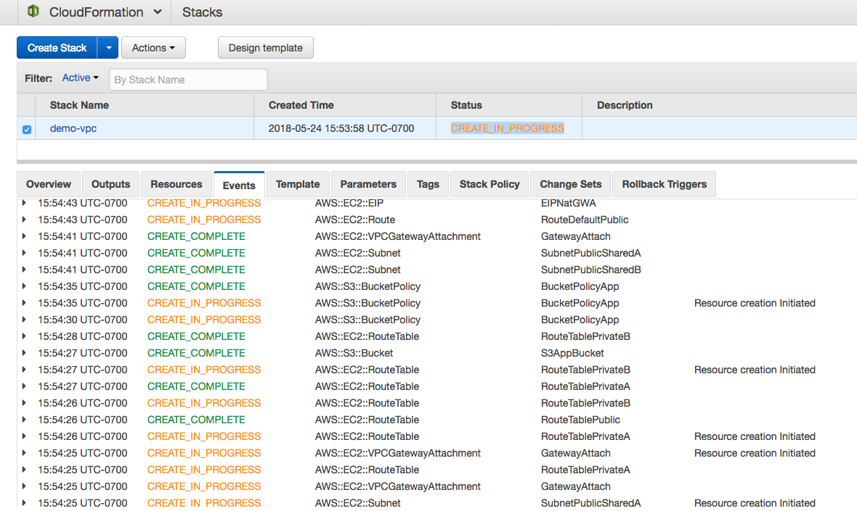

While you are waiting to explore all other tabs like **Template** tab to review your template and **Parameters** tab to see parameter value. You will also notice that **Outputs tab** is empty and you are going to modify your template to show values in Outputs tab.

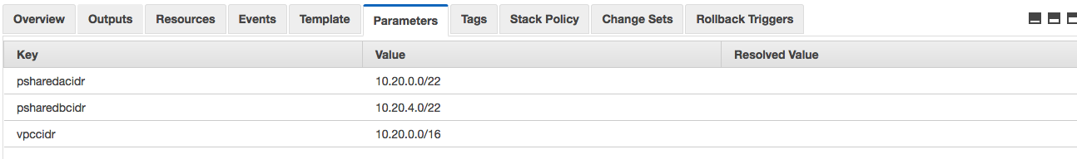

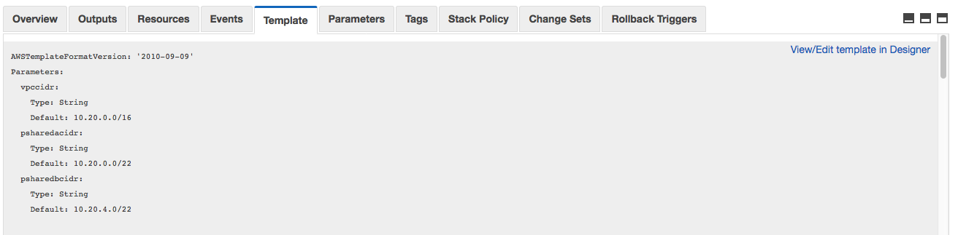

Once stack status changes to **CREATE_COMPLETE,** you can visit **Resources** tab to see all the resources got created by this AWS CloudFormation template.

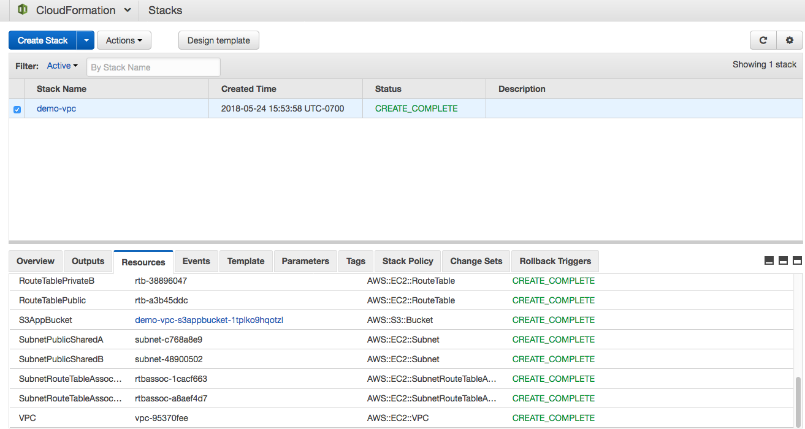

You can click on Amazon S3 bucket link shown in **Resources** tab and explore the bucket.Also, go to VPC from the console and explore different resources got created from AWS CloudFormation stack.

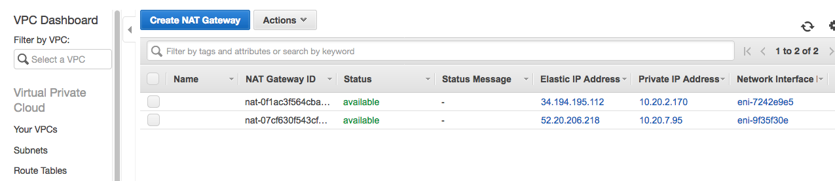

# Lab Objective:

Now you need to modify your template with following objectives:

**Add Parameter Constraint :**

* Vpccidr
  + Minimum length should be set to 9
  + Maximum length should be set to 18
  + Allowed pattern should be: "(\\d{1,3})\\.(\\d{1,3})\\.(\\d{1,3})\\.(\\d{1,3})/(\\d{1,2})"
  + Add a constraint description
* Psharedacidr
  + Minimum length should be set to 9
  + Maximum length should be set to 18
  + Allowed pattern should be: "(\\d{1,3})\\.(\\d{1,3})\\.(\\d{1,3})\\.(\\d{1,3})/(\\d{1,2})"
  + Add a constraint description
* Psharedbcidr
  + Minimum length should be set to 9
  + Maximum length should be set to 18
  + Allowed pattern should be: "(\\d{1,3})\\.(\\d{1,3})\\.(\\d{1,3})\\.(\\d{1,3})/(\\d{1,2})"
  + Add a constraint description

**Add delete policy constraint :**

* Create a Deletion Policy for your S3 bucket to be Retained at deletion

**Add Outputs section to show value in Output tab:**

* Vpc id
  + Create a description of your output
  + Reference your VPC as the value using !Ref
* NATGWA
  + Create a description of your output
  + Reference your NAT gateway A as the value using !Ref
* NATGWB
  + Create a description of your output
  + Reference your NAT gateway B as the value using !Ref
* App bucket URL
  + Create a description of your output
  + Reference your S3 bucket URL as the value using !Ref

**Add export values in Outputs section for Cross-Stack Reference:**

* Vpc id
  + Export your vpcid Name as ‘sharedinf-vpc’
* App bucket URL
  + Export your appbucketurl Name as ‘sharedinf-appbucketurl’

# References:

**Parameters:**

<https://docs.aws.amazon.com/AWSCloudFormation/latest/UserGuide/parameters-section-structure.html>

**Intrinsic functions:**

<https://docs.aws.amazon.com/AWSCloudFormation/latest/UserGuide/intrinsic-function-reference.html>

**Outputs and Export:**

<https://docs.aws.amazon.com/AWSCloudFormation/latest/UserGuide/outputs-section-structure.html>

**Mappings:**

<https://docs.aws.amazon.com/AWSCloudFormation/latest/UserGuide/mappings-section-structure.html>

**Deletion policy:**

<https://docs.aws.amazon.com/AWSCloudFormation/latest/UserGuide/aws-attribute-deletionpolicy.html>

# Update Stack and Solution:

Once you modified your existing template , you can use **Update Stack** option to update your stack. To update select your Stack and click on **Actions drop down and you will find Update Stack** option**.**

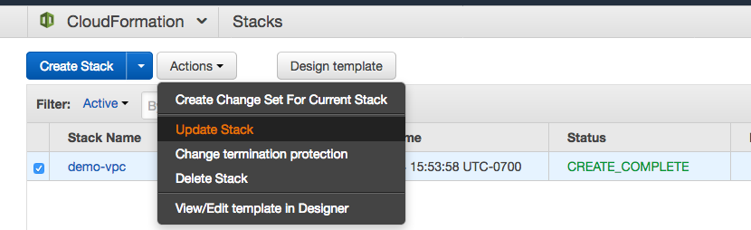

In **Update**, Stack screen select browse your updated template. If you have not figured out a solution yet Follow instruction in appendix section to get template

*Lab_Solution_CloudFormation_Module_General_ImmersionDay.json*.

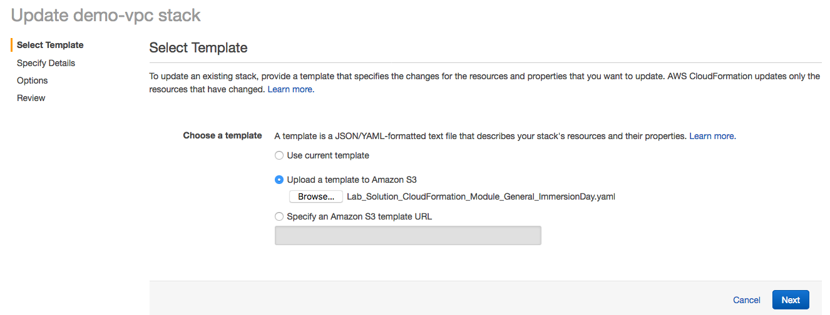

Now remaining steps are same as you followed in Create stack. Click Next couple of time and you will land up to review summary screen, where you need to click on **Update** button :

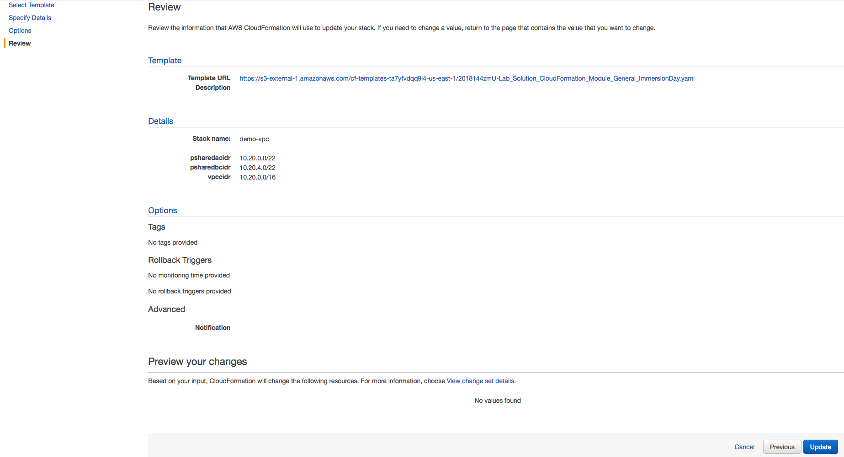

Now you will find your stack status changed to **UPDATE_IN_PROGRESS** and **Events** tab showing the activity performed using update stack.

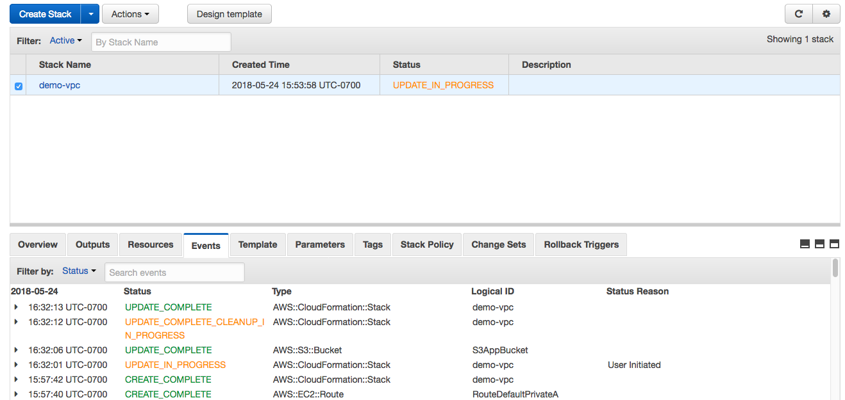

Once stack status changed to UPDATE_COMPLETE status, you can browse to **Outputs** tab and find out our changes has reflected now Outputs tab has four values compare to earlier it was empty :

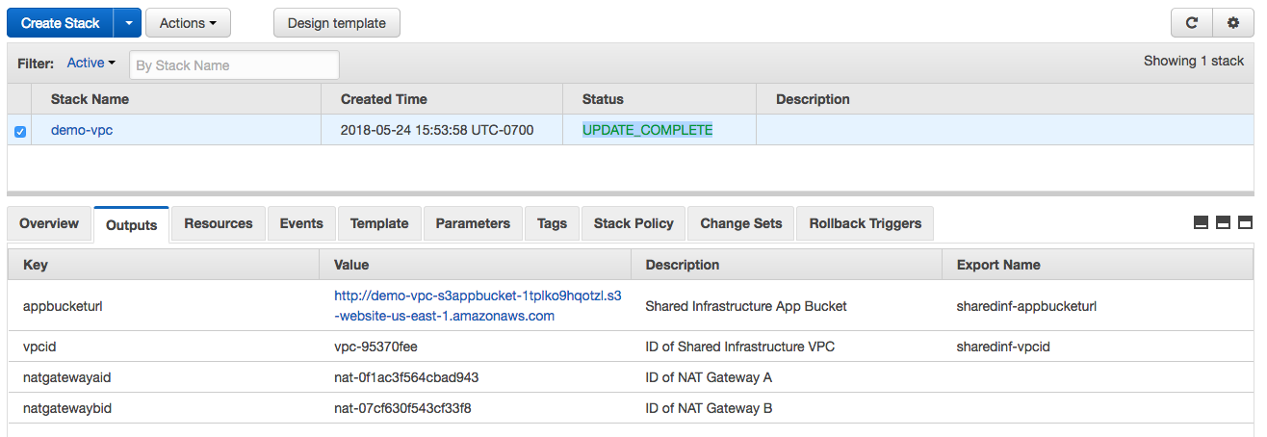

Also, click on **CloudFormation** icon on the right top corner of the screen and select **Exports** option**,** you will find two exported value shown in here which can be utilized for cross-stack reference.

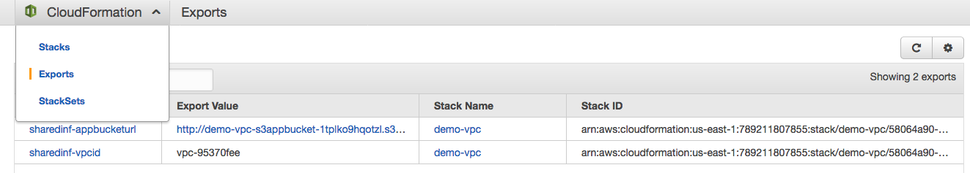

To create a cross-stack reference, use the **Export** output field to flag the value of a resource-output for export. Then, use the **Fn:: ImportValue** intrinsic function to import the value.

# Appendix:

**Initial AWS CloudFormation Template for lab exercise:**

Create a file Lab_Initial_CloudFormation_Module_General_ImmersionDay.yaml and copy paste following code :

AWSTemplateFormatVersion: '2010-09-09'

Parameters:

vpccidr:

Type: String

Default: 10.20.0.0/16

psharedacidr:

Type: String

Default: 10.20.0.0/22

psharedbcidr:

Type: String

Default: 10.20.4.0/22

Resources:

VPC:

Type: "AWS::EC2::VPC"

Properties:

CidrBlock: !Ref vpccidr

IGW:

Type: "AWS::EC2::InternetGateway"

S3AppBucket:

Type: "AWS::S3::Bucket"

Properties:

AccessControl: PublicRead

WebsiteConfiguration:

ErrorDocument: index.html

IndexDocument: index.html

BucketPolicyApp:

Type: "AWS::S3::BucketPolicy"

Properties:

Bucket: !Ref S3AppBucket

PolicyDocument:

Statement:

-

Sid: "ABC123"

Action:

- "s3:GetObject"

Effect: Allow

Resource: !Join ["", ["arn:aws:s3:::", !Ref S3AppBucket, "/*"]]

Principal:

AWS:

- "*"

GatewayAttach:

Type: "AWS::EC2::VPCGatewayAttachment"

Properties:

InternetGatewayId: !Ref IGW

VpcId: !Ref VPC

SubnetPublicSharedA:

Type: "AWS::EC2::Subnet"

Properties:

AvailabilityZone: !Select [0, !GetAZs ]

CidrBlock: !Ref psharedacidr

MapPublicIpOnLaunch: true

VpcId: !Ref VPC

SubnetPublicSharedB:

Type: "AWS::EC2::Subnet"

Properties:

AvailabilityZone: !Select [1, !GetAZs ]

CidrBlock: !Ref psharedbcidr

MapPublicIpOnLaunch: true

VpcId: !Ref VPC

SubnetRouteTableAssociatePublicA:

Type: "AWS::EC2::SubnetRouteTableAssociation"

Properties:

RouteTableId: !Ref RouteTablePublic

SubnetId: !Ref SubnetPublicSharedA

SubnetRouteTableAssociatePublicB:

Type: "AWS::EC2::SubnetRouteTableAssociation"

Properties:

RouteTableId: !Ref RouteTablePublic

SubnetId: !Ref SubnetPublicSharedB

RouteDefaultPublic:

Type: "AWS::EC2::Route"

DependsOn: GatewayAttach

Properties:

DestinationCidrBlock: 0.0.0.0/0

GatewayId: !Ref IGW

RouteTableId: !Ref RouteTablePublic

RouteDefaultPrivateA:

Type: "AWS::EC2::Route"

Properties:

DestinationCidrBlock: 0.0.0.0/0

NatGatewayId: !Ref NatGatewayA

RouteTableId: !Ref RouteTablePrivateA

RouteDefaultPrivateB:

Type: "AWS::EC2::Route"

Properties:

DestinationCidrBlock: 0.0.0.0/0

NatGatewayId: !Ref NatGatewayB

RouteTableId: !Ref RouteTablePrivateB

RouteTablePublic:

Type: "AWS::EC2::RouteTable"

Properties:

VpcId: !Ref VPC

RouteTablePrivateA:

Type: "AWS::EC2::RouteTable"

Properties:

VpcId: !Ref VPC

RouteTablePrivateB:

Type: "AWS::EC2::RouteTable"

Properties:

VpcId: !Ref VPC

EIPNatGWA:

DependsOn: GatewayAttach

Type: "AWS::EC2::EIP"

Properties:

Domain: vpc

EIPNatGWB:

DependsOn: GatewayAttach

Type: "AWS::EC2::EIP"

Properties:

Domain: vpc

NatGatewayA:

Type: "AWS::EC2::NatGateway"

Properties:

AllocationId: !GetAtt EIPNatGWA.AllocationId

SubnetId: !Ref SubnetPublicSharedA

NatGatewayB:

Type: "AWS::EC2::NatGateway"

Properties:

AllocationId: !GetAtt EIPNatGWB.AllocationId

SubnetId: !Ref SubnetPublicSharedB

**Solution AWS CloudFormation Template to review at end of the lab:**

Create a file Lab_Solution_CloudFormation_Module_General_ImmersionDay.yaml and copy paste following code :

AWSTemplateFormatVersion: '2010-09-09'

Parameters:

vpccidr:

Type: String

MinLength: 9

MaxLength: 18

AllowedPattern: "(\\d{1,3})\\.(\\d{1,3})\\.(\\d{1,3})\\.(\\d{1,3})/(\\d{1,2})"

ConstraintDescription: Must be a valid CIDR range in the form x.x.x.x/16

Default: 10.20.0.0/16

psharedacidr:

Type: String

MinLength: 9

MaxLength: 18

AllowedPattern: "(\\d{1,3})\\.(\\d{1,3})\\.(\\d{1,3})\\.(\\d{1,3})/(\\d{1,2})"

ConstraintDescription: Must be a valid CIDR range in the form x.x.x.x/22

Default: 10.20.0.0/22

psharedbcidr:

Type: String

MinLength: 9

MaxLength: 18

AllowedPattern: "(\\d{1,3})\\.(\\d{1,3})\\.(\\d{1,3})\\.(\\d{1,3})/(\\d{1,2})"

ConstraintDescription: Must be a valid CIDR range in the form x.x.x.x/22

Default: 10.20.4.0/22

Resources:

VPC:

Type: "AWS::EC2::VPC"

Properties:

CidrBlock: !Ref vpccidr

IGW:

Type: "AWS::EC2::InternetGateway"

S3AppBucket:

DeletionPolicy: Retain

Type: "AWS::S3::Bucket"

Properties:

AccessControl: PublicRead

WebsiteConfiguration:

ErrorDocument: index.html

IndexDocument: index.html

BucketPolicyApp:

Type: "AWS::S3::BucketPolicy"

Properties:

Bucket: !Ref S3AppBucket

PolicyDocument:

Statement:

-

Sid: "ABC123"

Action:

- "s3:GetObject"

Effect: Allow

Resource: !Join ["", ["arn:aws:s3:::", !Ref S3AppBucket, "/*"]]

Principal:

AWS:

- "*"

GatewayAttach:

Type: "AWS::EC2::VPCGatewayAttachment"

Properties:

InternetGatewayId: !Ref IGW

VpcId: !Ref VPC

SubnetPublicSharedA:

Type: "AWS::EC2::Subnet"

Properties:

AvailabilityZone: !Select [0, !GetAZs ]

CidrBlock: !Ref psharedacidr

MapPublicIpOnLaunch: true

VpcId: !Ref VPC

SubnetPublicSharedB:

Type: "AWS::EC2::Subnet"

Properties:

AvailabilityZone: !Select [1, !GetAZs ]

CidrBlock: !Ref psharedbcidr

MapPublicIpOnLaunch: true

VpcId: !Ref VPC

SubnetRouteTableAssociatePublicA:

Type: "AWS::EC2::SubnetRouteTableAssociation"

Properties:

RouteTableId: !Ref RouteTablePublic

SubnetId: !Ref SubnetPublicSharedA

SubnetRouteTableAssociatePublicB:

Type: "AWS::EC2::SubnetRouteTableAssociation"

Properties:

RouteTableId: !Ref RouteTablePublic

SubnetId: !Ref SubnetPublicSharedB

RouteDefaultPublic:

Type: "AWS::EC2::Route"

DependsOn: GatewayAttach

Properties:

DestinationCidrBlock: 0.0.0.0/0

GatewayId: !Ref IGW

RouteTableId: !Ref RouteTablePublic

RouteDefaultPrivateA:

Type: "AWS::EC2::Route"

Properties:

DestinationCidrBlock: 0.0.0.0/0

NatGatewayId: !Ref NatGatewayA

RouteTableId: !Ref RouteTablePrivateA

RouteDefaultPrivateB:

Type: "AWS::EC2::Route"

Properties:

DestinationCidrBlock: 0.0.0.0/0

NatGatewayId: !Ref NatGatewayB

RouteTableId: !Ref RouteTablePrivateB

RouteTablePublic:

Type: "AWS::EC2::RouteTable"

Properties:

VpcId: !Ref VPC

RouteTablePrivateA:

Type: "AWS::EC2::RouteTable"

Properties:

VpcId: !Ref VPC

RouteTablePrivateB:

Type: "AWS::EC2::RouteTable"

Properties:

VpcId: !Ref VPC

EIPNatGWA:

DependsOn: GatewayAttach

Type: "AWS::EC2::EIP"

Properties:

Domain: vpc

EIPNatGWB:

DependsOn: GatewayAttach

Type: "AWS::EC2::EIP"

Properties:

Domain: vpc

NatGatewayA:

Type: "AWS::EC2::NatGateway"

Properties:

AllocationId: !GetAtt EIPNatGWA.AllocationId

SubnetId: !Ref SubnetPublicSharedA

NatGatewayB:

Type: "AWS::EC2::NatGateway"

Properties:

AllocationId: !GetAtt EIPNatGWB.AllocationId

SubnetId: !Ref SubnetPublicSharedB

Outputs:

vpcid:

Description: ID of Shared Infrastructure VPC

Value: !Ref VPC

Export: # added to export

Name: sharedinf-vpcid

natgatewayaid:

Description: ID of NAT Gateway A

Value: !Ref NatGatewayA

natgatewaybid:

Description: ID of NAT Gateway B

Value: !Ref NatGatewayB

appbucketurl:

Description: Shared Infrastructure App Bucket

Value: !GetAtt S3AppBucket.WebsiteURL

Export: # added to export

Name: sharedinf-appbucketurl