Table selected to find the normalization is **JOB** relation

1nf- decomposition

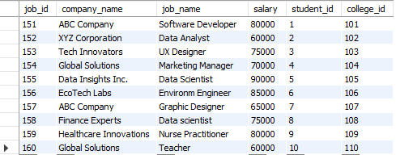

This relation is already in 1-NF form because  no multivalued attribute(atomic)

the key for this table is (job_id,college_id,student_id)

the Fds are F={aef to bcd  }

bcd may have redundant values so they won’t form the key.

Prime attributes are aef

Non- prime bcd

checking for partial dependency

a to d  / e to d / f to d

a to c/ e to c/ f to c

a to d/e to d/ f to d

Non prime attributes are partially dependent of the part of primary key.

 2nf decomposition

a to d  / e to d / f to d

a to c/ e to c/ f to c

a to d/e to d/ f to d

All the above 9 functional dependencies are creating problem because there are  non-prime attributes are in partially dependent on the candidate key.