VISVESVARAYA TECHNOLOGICAL UNIVERSITY, BELAGAVI 590018

Project Report on
“EXPENSE TRACKER”
By
JAYAM SHANMUKHA SHIVANVITHA (1BF24CS127)
KAPPALABANDA KEERTHI (1BF24CS133)
KIRTI KUMARI (1BF24CS140)

Under the Guidance of
MONISHA H M
Assistant Professor, Department of CSE
BMS College of Engineering

Work carried out at

Department of Computer Science and Engineering
BMS College of Engineering
(Autonomous college under VTU)
P.O. Box No.: 1908, Bull Temple Road, Bangalore-560 019
2025-2026

BMS COLLEGE OF ENGINEERING
DEPARTMENT OF COMPUTER SCIENCE AND ENGINEERING



CERTIFICATE

This is to certify that the OOPS with JAVA project titled “Expense Tracker” has been carried out by JAYAM SHANMUKHA SHIVANVITHA (1BF24CS127), KAPPALABANDA KEERTHI (1BF24CS133), KIRTI KUMARI (1BF24CS140) during the academic year 2025-2026.

Signature of the guide
MONISHA H M
Assistant Professor,
Department of Computer Science and Engineering
BMS College of Engineering, Bangalore

BMS COLLEGE OF ENGINEERING
DEPARTMENT OF COMPUTER SCIENCE AND ENGINEERING

DECLARATION

We, JAYAM SHANMUKHA SHIVANVITHA (1BF24CS127), KAPPALABANDA KEERTHI (1BF24CS133), KIRTI KUMARI (1BF24CS140), students of 3rd Semester, B.E, Department of Computer Science and Engineering, BMS College of Engineering, Bangalore, hereby declare that, this project work entitled "Expense Tracker" has been carried out by us under the guidance of MONISHA H M , Assistant Professor, Department of CSE, BMS College of Engineering, Bangalore during the academic semester Sep-Dec 2025. We also declare that to the best of our knowledge and belief, the project reported here is not from part of any other report by any other students.

Signature of the Candidates

JAYAM SHANMUKHA SHIVANVITHA (1BF24CS127)

KAPPALABANDA KEERTHI (1BF24CS133)

KIRTI KUMARI (1BF24CS140)
Tables of Contents

S no. | Contents | Page no.
1 | Problem statement | 5
2 | Introduction | 6
3 | Overview of the project (Block diagram) | 7 - 11
4 | Tools Used | 12
5 | OOPs concept used & its explanation | 13
6 | Implementation/code | 14 - 16
7 | Result /snapshots | 17 - 20
8 | Conclusion | 21
9 | Future improvements | 23
10 | References | 24

Problem Statement

Managing personal expenses manually is difficult and error-prone. People often fail to track daily spending, categorize expenses properly, and understand where their money is going. Traditional methods like notebooks or basic spreadsheets do not provide visual insights or automated summaries. Hence, there is a need for a simple, user-friendly application that helps users record, categorize, and analyze their expenses efficiently.

Introduction

In today’s fast‑paced digital world, effective personal financial management has become essential. Individuals often find it difficult to keep track of their daily expenses, leading to poor financial planning and unnecessary overspending. Traditional methods such as notebooks or spreadsheets are time‑consuming and error‑prone.
The Expense Tracker Application is a desktop‑based software solution developed using Java and JavaFX to address this problem. The application allows users to enter income and expense details, assign categories, and automatically calculate balances. The application also presents expense data visually using charts, making it easier for users to understand their spending patterns.
All transaction data is stored locally, making the application lightweight and suitable for personal use without requiring internet connectivity.
JavaFX is used to build a responsive and interactive graphical user interface, while core Java features handle business logic, data processing, and file management. The project demonstrates practical usage of object‑oriented programming concepts such as inheritance, encapsulation, collections, exception handling, and file I/O.
This application is designed as a single‑user system with minimal setup, making it easy to operate on a local machine.

I. DESCRIPTION OF THE PROJECT

1. OBJECTIVE OF THE PROJECT AND MODULES

Objective of the Project
The objective of the Expense Tracker Application is to design and develop a single‑user desktop application that helps users record, manage, and analyze their daily financial transactions efficiently. The application allows users to track income and expenses, categorize transactions, calculate balances, and store records persistently for future reference.
This project aims to:
- Provide a simple and user‑friendly graphical interface for expense management
- Reduce manual effort in tracking daily expenses
- Help users understand spending patterns through structured data
- Apply core Java concepts and JavaFX GUI programming
- Demonstrate real‑world application development using Java

Modules of the Project
The project is divided into the following major modules:
- User Interface Module
- Transaction Management Module
- Category Management Module
- Data Storage Module
- Calculation & Summary Module

2. DESIGN MODULES

Module Design Overview
The system is designed using a modular architecture, where each module handles a specific responsibility. This improves maintainability, readability, and scalability.

Block Diagram
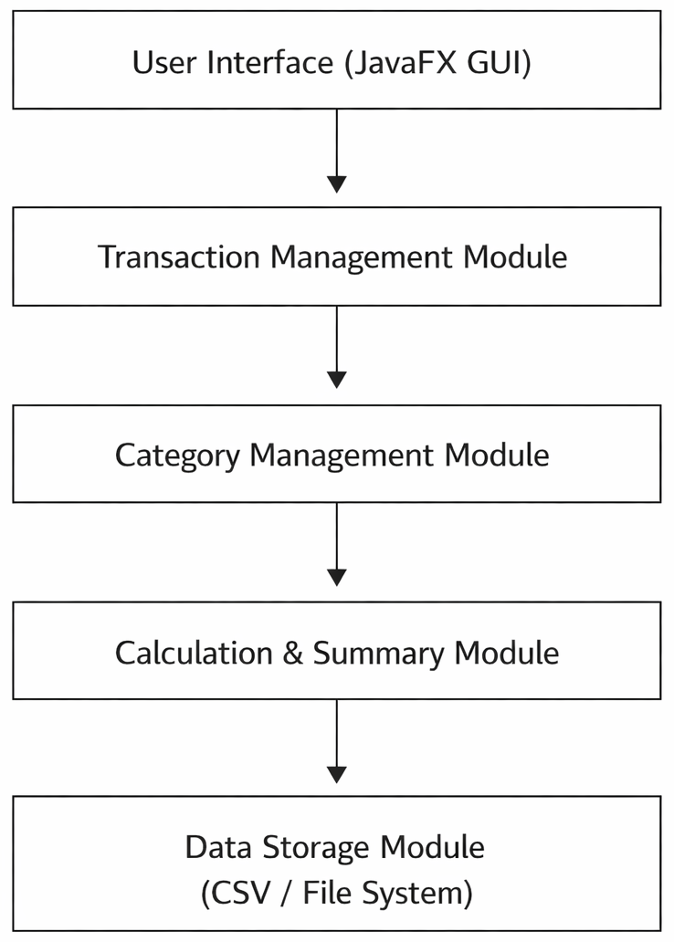

3. DETAILED DESCRIPTION OF MODULES

3.1 User Interface Module

Requirement and Functionality
The User Interface module provides an interactive platform for user interaction. It allows users to:
- Enter transaction amount, date, category, and notes
- Choose transaction type (Income/Expense)
- View transactions in a table format
- Display current balance and summaries
Technologies and Java Concepts Used
- JavaFX for GUI development
- Layout managers such as BorderPane, VBox, and HBox
- UI controls like Label, TextField, DatePicker, ComboBox, RadioButton, and TableView
- Event handling using lambda expressions
Java Mechanisms Used
- Packages (javafx.scene, javafx.stage)
- Event handling
- Object‑oriented design

3.2 Transaction Management Module
Requirement and Functionality
This module manages all financial transactions entered by the user. It:
- Creates transaction objects
- Stores transaction data in memory
- Displays transaction details in tabular form
- Differentiates between income and expense transactions
Technologies and Java Concepts Used
- Custom Transaction class
- ObservableList<Transaction> for dynamic UI updates
- TableView with PropertyValueFactory
Java Mechanisms Used
- Classes and Objects
- Encapsulation (private fields with getters)
- Collections Framework
- Generics

3.3 Category Management Module
Requirement and Functionality
- This module allows categorization of transactions such as:
- Food
- Education
- Transport
- Shopping
- Bills
- General
- It improves expense analysis and readability.
Technologies and Java Concepts Used
- ObservableList<String> for categories
- ComboBox for category selection
- HashMap for remembering previous selections
Java Mechanisms Used
- Collections (List, Map)
- Generics
- Data abstraction

3.4 Calculation and Summary Module
Requirement and Functionality
This module handles:
- Balance calculation
- Addition of income
- Deduction of expenses
- Updating balance dynamically
Technologies and Java Concepts Used
- Arithmetic operations
- Real‑time UI updates
- Conditional logic for income vs expense
Java Mechanisms Used
- Control structures
- Data types
- Encapsulation
- Exception handling (for invalid inputs)

3.5 Data Storage Module
Requirement and Functionality
This module ensures persistence of transaction data. It:
- Saves transactions to a CSV file
- Loads existing data on application startup
- Prevents data loss between sessions
Technologies and Java Concepts Used
- File handling using java.io and java.nio.file
- CSV format for simplicity
- Buffered reading and writing
Java Mechanisms Used
- File I/O
- Exception Handling (try-catch)
- Streams
- Collections

II.TOOLS USED

The following tools and technologies were used to develop the Expense Tracker application:
- Java – Core programming language used for application logic
- JavaFX – Used for building the graphical user interface
- CSV Files – Used for importing transaction data
- VS Code – Development environment
- Google Docs – Documentation and report preparation
- Windows OS – Operating system used for development and testing

III. OOPS CONCEPTS USED & EXPLANATION

1. Classes and Objects
Classes such as ExpenseTrackerApp and Transaction are used to represent real‑world entities. Objects are created to store transaction details.

2. Encapsulation
Data members are declared private and accessed using getter and setter methods to protect data integrity.

3. Inheritance
JavaFX classes such as Application are extended to inherit GUI functionality.

4. Polymorphism
Method overriding is used in JavaFX lifecycle methods like start()

5. Exception Handling
Try‑catch blocks are used to handle invalid inputs and file I/O errors.

6. Collections & Generics
Collections such as ObservableList, Map, FilteredList and ArrayList are used to store transactions dynamically.

7.File handling
Reading and writing CSV files.

8. GUI Implementation (JavaFX)
The user interface is developed using JavaFX components such as Stage, Scene, TableView, Button, TextField, and layout panes.

IV. IMPLEMENTATION / CODE
The Expense Tracker application is implemented using JavaFX for the graphical user interface and core Java for business logic and data handling. The application includes UI, data model, and logic.
Application Entry Point
The application starts by extending the Application class provided by JavaFX. The start() method initializes the main window, loads stored data, and sets up the layout.
Code:
public class ExpenseTrackerApp extends Application {

@Override
public void start(Stage stage) {
loadBudgetFromCSV();
loadTransactionsFromCSV();

BorderPane root = new BorderPane();
root.setTop(createBudgetBox());
root.setCenter(createTable());
root.setRight(createControls());

stage.setScene(new Scene(root, 1000, 600));
stage.setTitle("Expense Tracker");
stage.show();
}
}

Data Model (Transaction Class)
Each expense or income entry is represented using a Transaction class. This class stores details such as date, category, amount, type, payment method, and note.
Code:
public static class Transaction {
LocalDate date;
String category, type, method, note;
double amount;
Transaction(LocalDate d, String c, String t, String m, double a, String n) {
date = d;
category = c;
type = t;
method = m;
amount = a;
note = n;
}

public String getDateStr() {
return date.toString();
}
}

Adding Transactions
Users can add debit or credit transactions through the UI. Input validation is performed before adding data to the observable list.
Code:
private void addManualTransaction() {
double amt = Double.parseDouble(amountField.getText());
String type = ((RadioButton) typeGroup.getSelectedToggle()).getText();

Transaction t = new Transaction(
datePicker.getValue(),
categoryCombo.getValue(),
type,
"Cash",
amt,
noteField.getText()
);

transactions.add(t);
updateBalance();
writeCSVFromMemory();
}

File Handling (CSV Storage)
All data is stored locally using a CSV file. This ensures persistence without requiring a database.
Code:
private void writeCSVFromMemory() {
try (PrintWriter pw = new PrintWriter(new FileWriter(CSV_PATH))) {
pw.println("BUDGET," + balance);
for (Transaction t : transactions) {
pw.println(t.date + "," + t.category + "," +
t.type + "," + t.amount + "," + t.note);
}
} catch (IOException e) {
e.printStackTrace();
}
}

Filtering and Dashboard
JavaFX’s FilteredList is used to filter transactions based on category, date, amount, and notes. Visual analytics are implemented using PieChart and LineChart.
Code:
FilteredList<Transaction> filtered =
new FilteredList<>(transactions, p -> true);

filtered.setPredicate(t ->
t.category.equals(categoryFilter.getValue())
);

Exception Handling
The application uses exception handling to manage invalid inputs and file errors, ensuring stability and better user experience.
Code:
try {
balance = Double.parseDouble(budgetField.getText());
} catch (NumberFormatException e) {
alert("Invalid Input", "Please enter a valid number.");
}

These are some of the classes used in the program to showcase modularity. The structure of the program is easily expandable and makes robust use of OOPS concepts mentioned in the former section(III).
V. RESULT / SNAPSHOTS

Main application window
- It acts as the Add transaction screen as well as the Transaction list display.
- It allows uploading of transactions as CSV files from payment gateway (for example, GPay)
- Users can also manually upload transactions.
- The category for each transaction is asked and retained for future use.
- If the users goes above budget, an alert is displayed.
- Transactions can also be deleted, and updates are automatically reflected in the csv file as well.
- Data can be viewed after applying various filters as well.
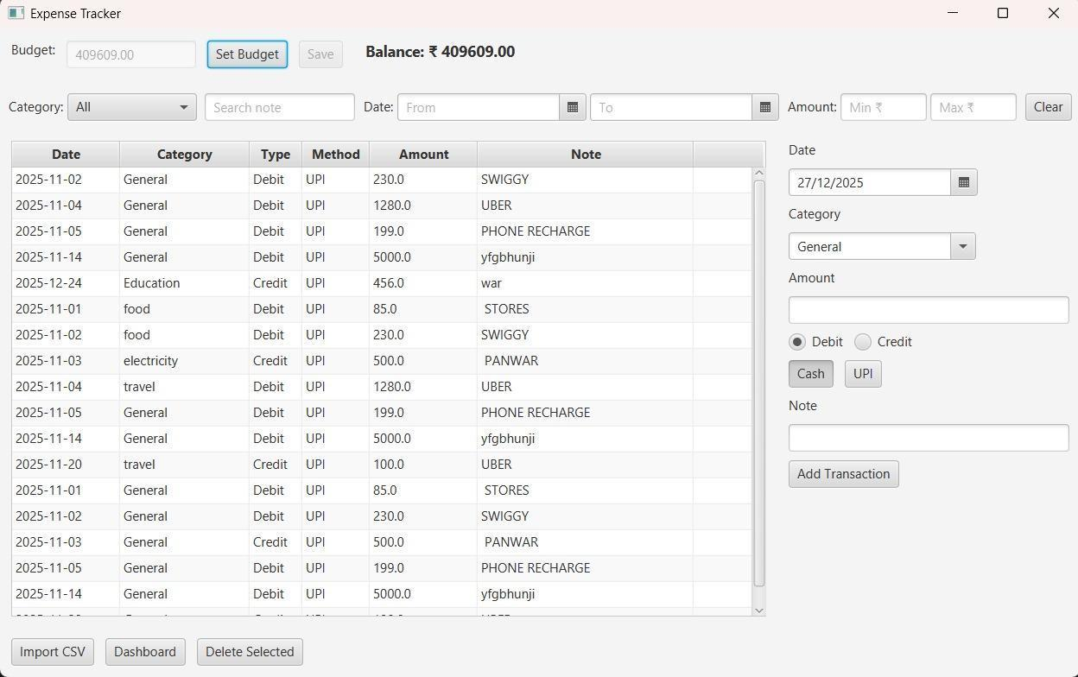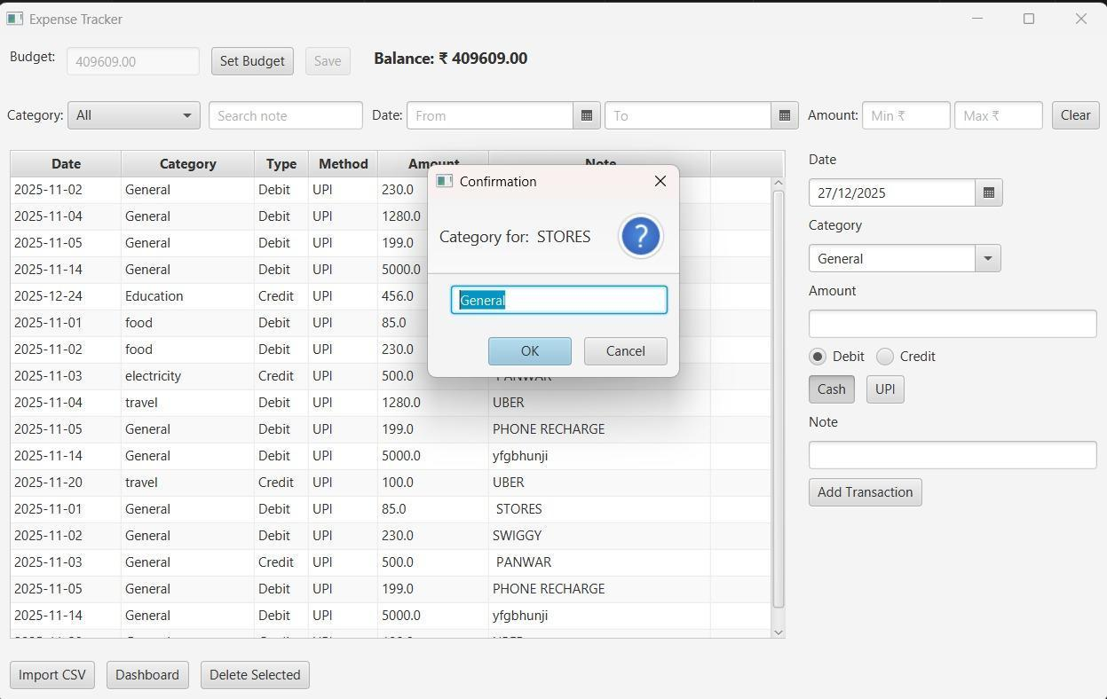

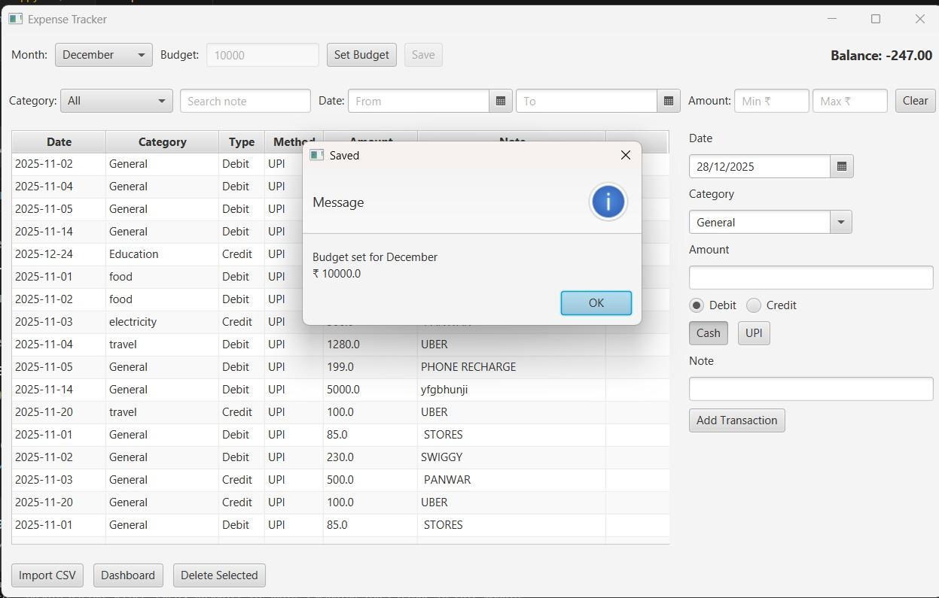

Dashboard window
- Shows the expenditure through a pie chart along with total amount spent in each category
- trends in expenditure are shown using a line chart comparing Weekly, Monthly and yearly expenditure in each category
JavaFX chart components (PieChart, LineChart) are used along with dynamic color mapping and tooltips for better visualization.
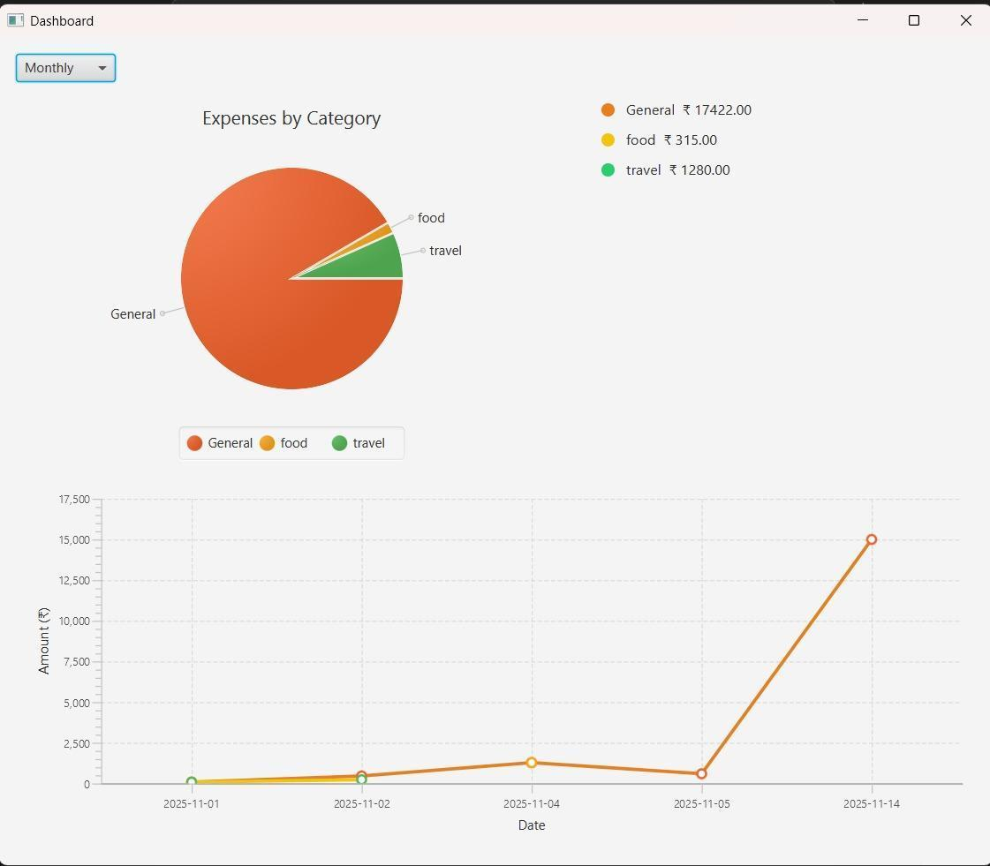
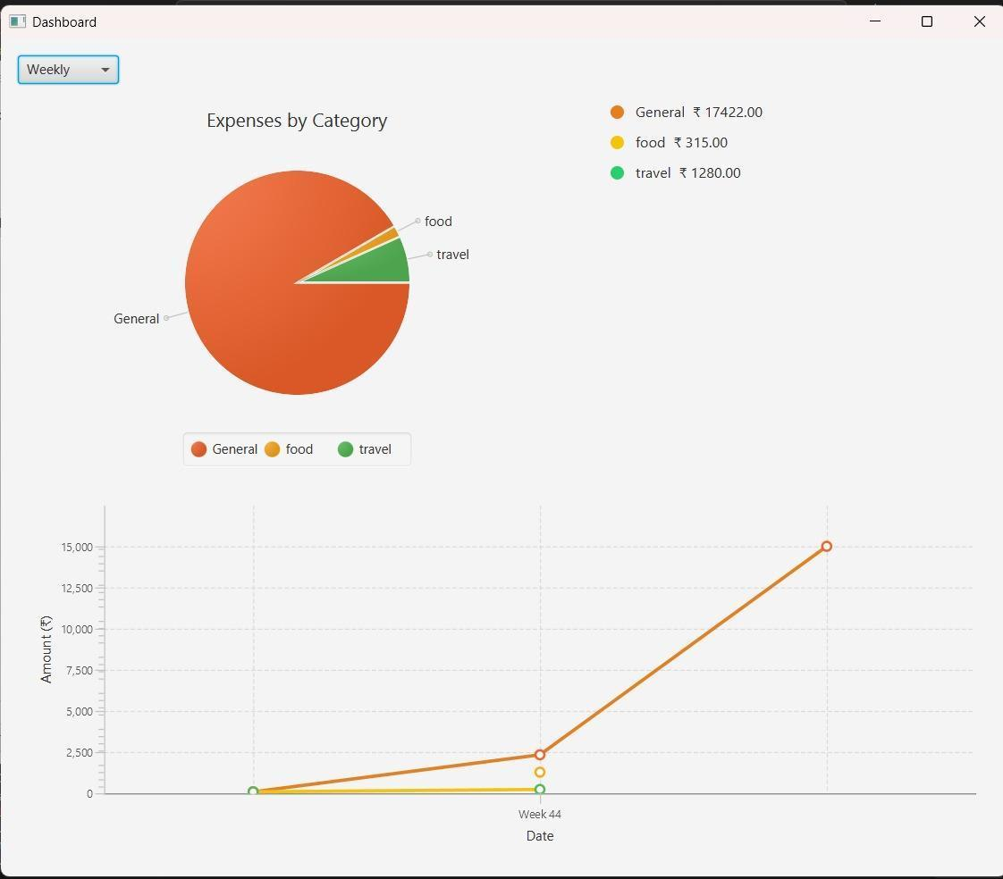

CSV Storage file
Stores all the transactions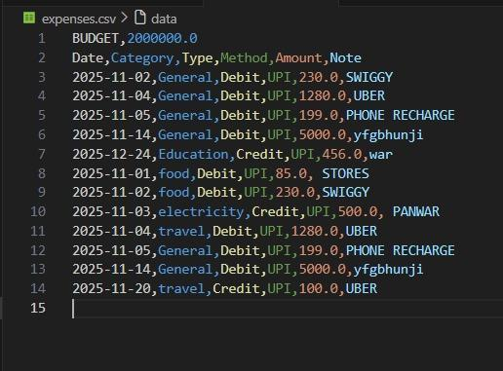

VI. CONCLUSION

The Expense Tracker Application successfully demonstrates how Java and JavaFX can be used to develop a practical, real‑world desktop application. The modular design, clean user interface, and use of object‑oriented principles make the application efficient and easy to maintain. This project not only fulfills its functional requirements but also serves as a strong learning experience in Java GUI programming and software design principles.

VII. FUTURE IMPROVEMENTS
The Expense Tracker can be developed as a web application for easier portability and global deployment. These changes would be required for the same:
- Database Integration
Replacing CSV file storage with a database such as SQLite or MySQL would improve data security and performance
- Multi‑User Support
Adding user authentication would allow multiple users to maintain separate and secure expense records.
- Budget Alerts
Users can be notified when their expenses exceed predefined budget limits using SMS or emails.
- Web application
This can be done using Springboot+HTML/CSS as code stack and deploying on Render/Netlify.

VII. REFERENCES

1.Oracle Corporation, Java Documentation,
https://docs.oracle.com/en/java/

2.Oracle Corporation, JavaFX Documentation,
https://openjfx.io/

3.Google Developers, JavaFX UI Controls,
https://openjfx.io/javadoc/

4.W3Schools, Java Tutorial,
https://www.w3schools.com/java/

5.TutorialsPoint, JavaFX Tutorial,
https://www.tutorialspoint.com/javafx/

6.GeeksforGeeks, Java Collections Framework,
https://www.geeksforgeeks.org/java-collections/

