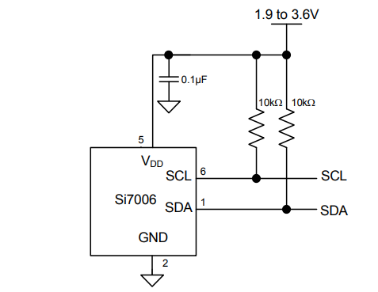
Shiva Pal
SCL
SDA
Pin 13 (built-in LED)
Pin 14
N.C. button
VCC
GND
Project 3
CSE 321
Adafruit M0 Feather WiFi

