**COMBAT Commander**C:\Users\AyyappaKumar\AppData\Local\Microsoft\Windows\Temporary Internet Files\Content.IE5\OW7O1GA0\MC900018512[1].wmf Mobile Game

Supervised By: Dr. Yugyung Lee Team:

Vishnu Gude Shiva Pothala Ayyappa Neerukonda

Akhilesh Vemparala

# First Increment

## Introduction

Advancements in the today's mobile technology created a huge scope to develop all kinds of user interactive applications. Multi player mobile games are more popular and fun to design by using motion sensor devices. This game allows multiple users to play and shoot each other and also it tracks user movements and acts according user simulation in the application.

## Project Goal and Objectives

* **Motivation**

The main motivation of this project comes from popularity of mobile games everywhere. From our childhood playing a game with friends always fun and we dreamt to have our own 3D game that everybody can play with our creatures and other 3D effects. After knowing about Sensor Tags and other user motion detective devices, we found a scope to develop this amazing application.

* **Objectives**

This collects data from different users through sensor tags and acts according to user motion in the shooting game. This would also rates a user in the game by giving performance based score. This kind of applications are designed to provide entertainment to users and show them how sensor tags can track their motion when they play around.

* **Significance**

There are plenty of mobile games available and this just one among them. But we are trying add few more features to it. This can be played on android or windows supporting devices like mobile phones or Tablets. With the animated 3D features user can have live play feeling when operating sensor tags.

## System Requirements:

* CC2541 TI Sensor Tag
* Android 4.3 and above OS
* Bluetooth 4.0 and above

## Technological and Architectural Requirements:

* Hadoop, Mahout, R and H Base
* Eclipse, Java, Android, Windows
* Data from sensor tag
* Unity 3D

## Activity Recognition Scenario and Data Collection:

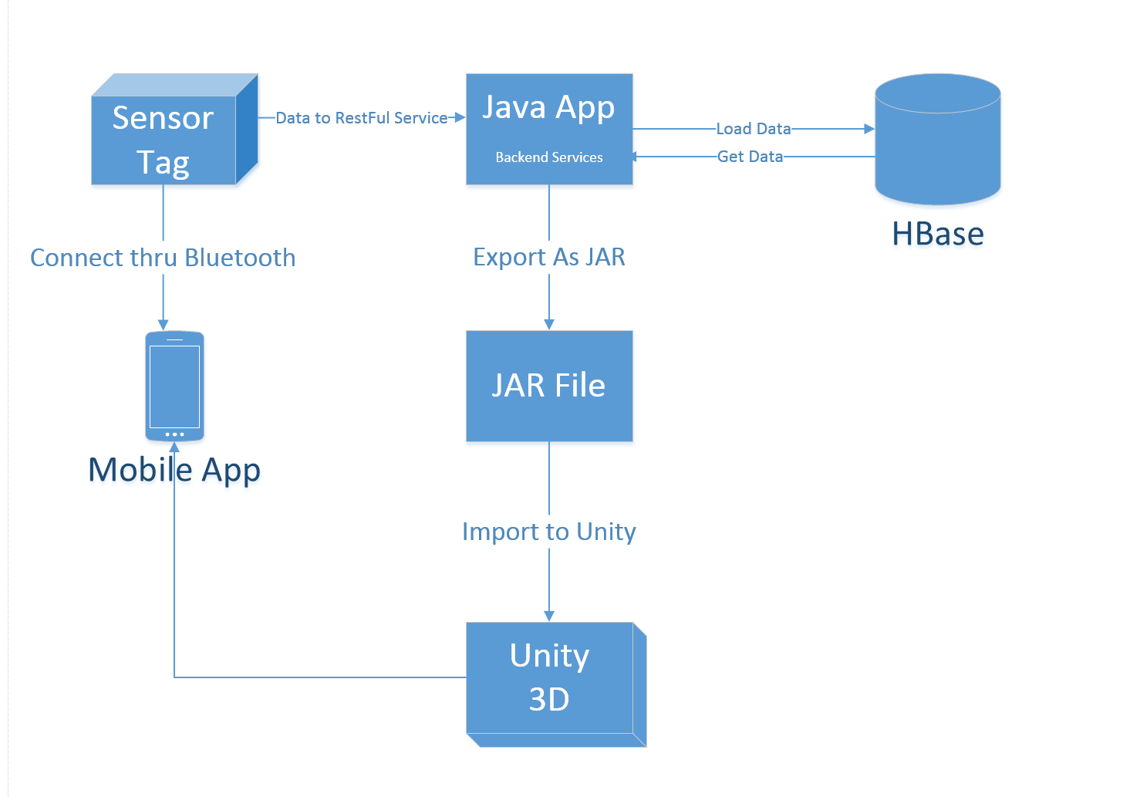

* **Devices/Sensors :**
* Android application
* Application using eclipse android ADT IDE
* Testing on Samsung Galaxy S4
* TI CC2541 Sensor Tag Development Kit
* temperature,
* humidity,
* pressure,
* accelerometer,
* gyroscope,
* Magnetometer.
* Using accelerometer, gyroscope and magnetometer
* Bluetooth connection with the device and transfers information
* **Data Collection**
* User movements as input from Sensor Tag
* HBase as Database
* Create a JAR file
* JAR file linked each user model
* Each User model integrated with mobile application to produce game environment
* Unity 3D framework to simulate user models
* **Motion/Activity Model**
* Android OS device with Bluetooth, to run application and a sensor tag.
* Sensor tag will be attached to each user
* User operates sensor tag
* Data is collected from sensor tag
* Shooting triggers based on User action
* Score will be given to each user
* **Analytical Tasks**
* Analytical task include
* Detection of users motion pattern
* User models transformed to game environment
* Shooting triggered based user motion simulation

## Design of Mobile Client:

Developing Android mobile app and Unity animations and integrating them, Here Mobile Client consumes Java RESTful Web service.

**Features:**

* Android or windows devices allowed to download this application
* multiple user models and components created
* This is an open source Web kit
* It is an amazing 3D application based Unity Framework

## Related Work:

**Combat Trigger: Modern Dead 3D**

It is a war game where user can select different weapons and fight in different battle fields.

**Features included:**

Exciting campaign with plenty of battles, futuristic weapon, big bang grenades, armor and health c ustomization, millions of enemies to kill, exotic planets and fallen human cities to fight in, battlefields on exotic planets, combat in fallen human cities

## Bibliography:

<https://play.google.com/store/apps/details?id=com.thunderbull_entertainment.callofdead&hl=en><https://play.google.com/store/apps/details?id=com.csshooter.roadshoot&hl=en>

<https://play.google.com/store/apps/details?id=com.fungame.wars&hl=en>

<https://play.google.com/store/apps/details?id=com.dseffects.StreetCombat&hl=en>

<https://play.google.com/store/apps/details?id=com.rubicon.dev.combatmonsters&hl=en>