# Report on Mobile Device

## Task1: Android application using TI sensor Tag

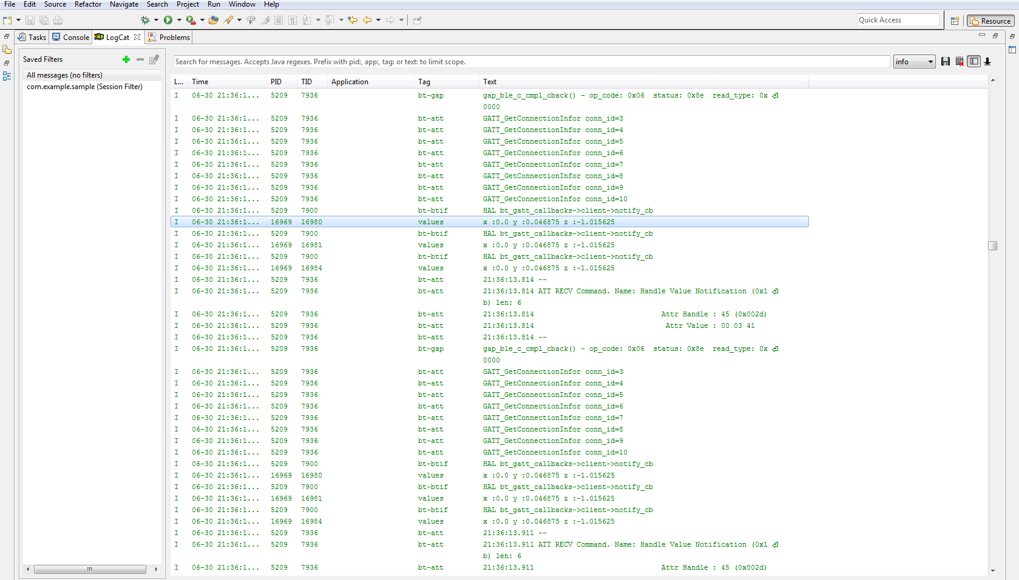

Result: After running sample code file for Sensor Tag, we can see co-ordinate values for X, Y and Z. (x: 0.0 y:0.046875 z:-1.015625)

## Task2: Mobile sensor with Android sensor app



Result: After running source code file for Android Sensor App, we can see the output as Green color and shows a message for switching the color

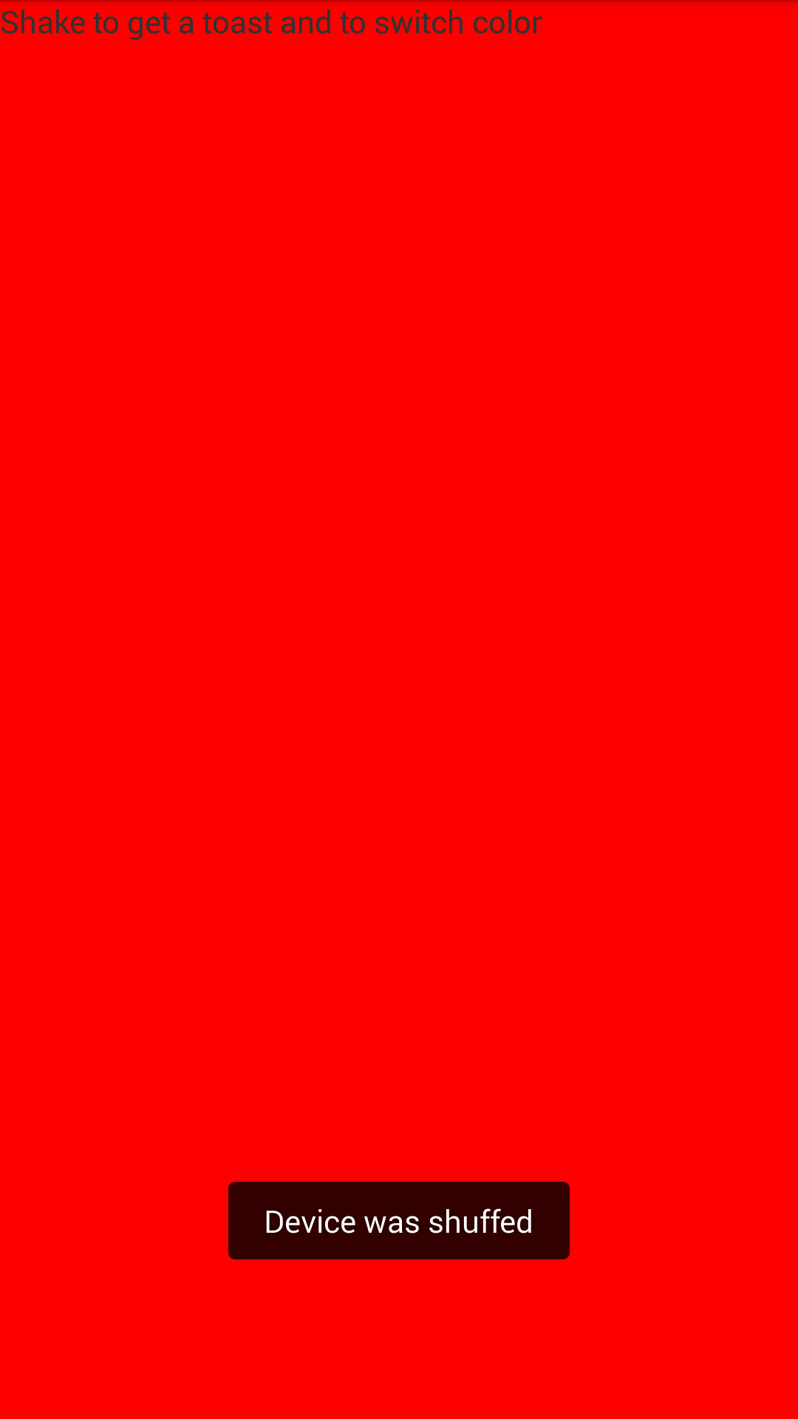

Result: When we shake the phone we get different color, here it is red and message shown as Device was shuffed.

## Task3: Geosensing android application

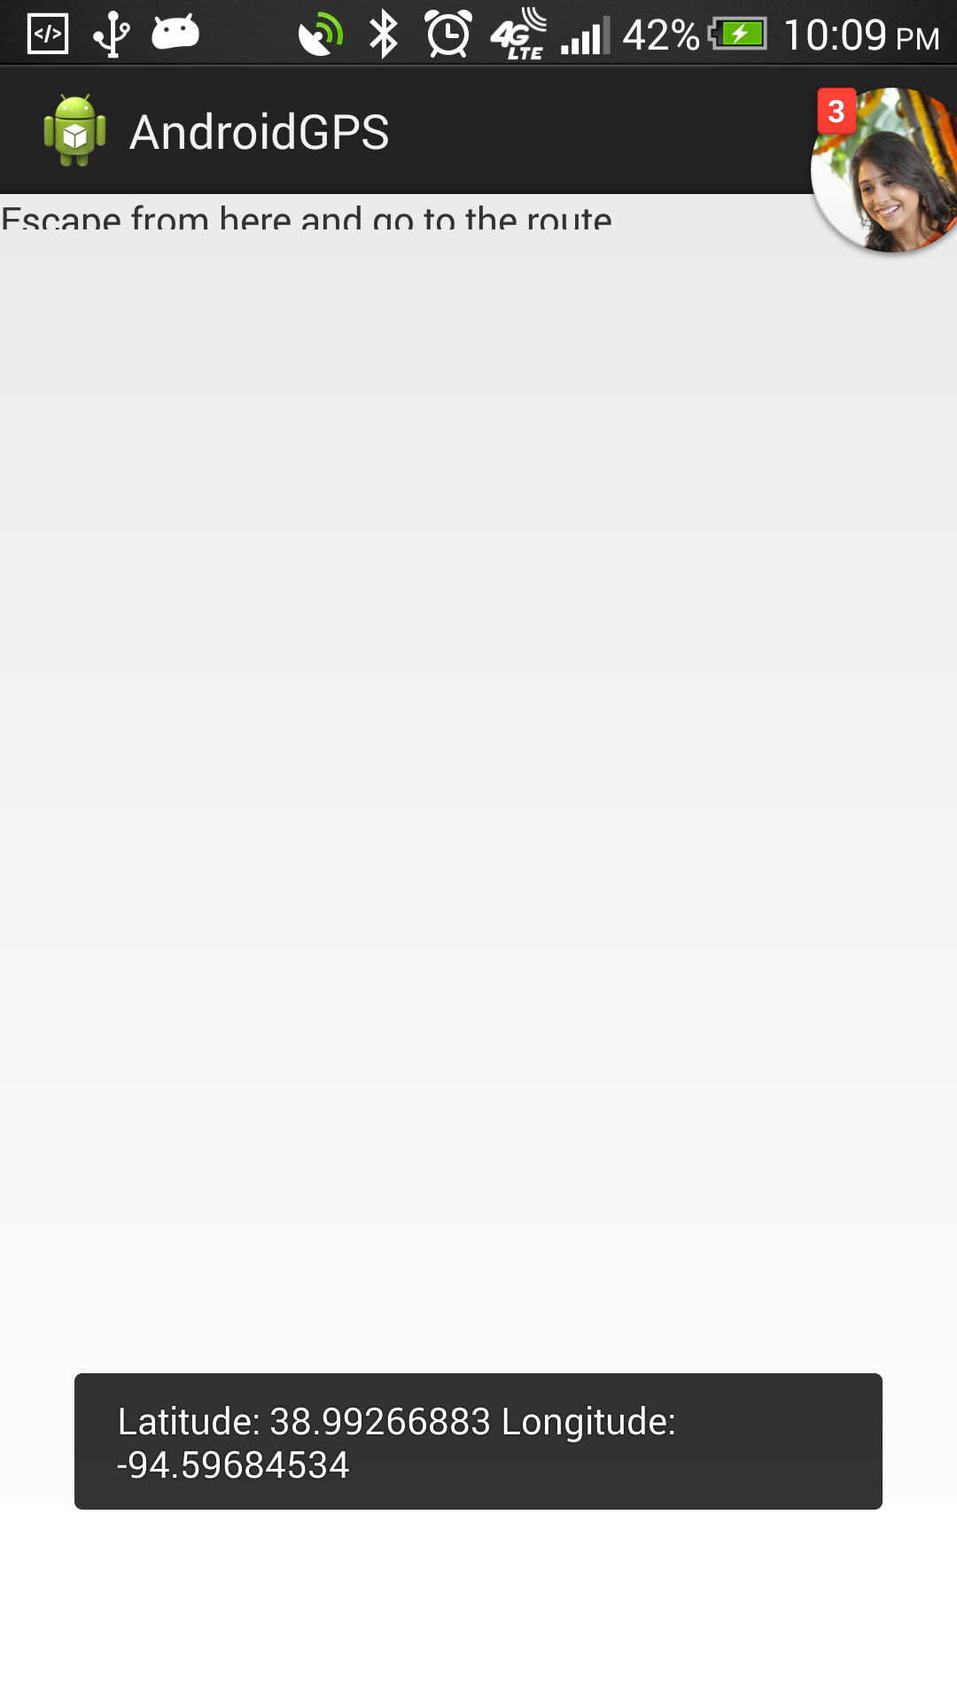

Result: After running sample code file for Geo sensing App, we can see the latitude and longitude values based on user location after turning on location services. Here above values shown for location Wornal road in Kansas City.

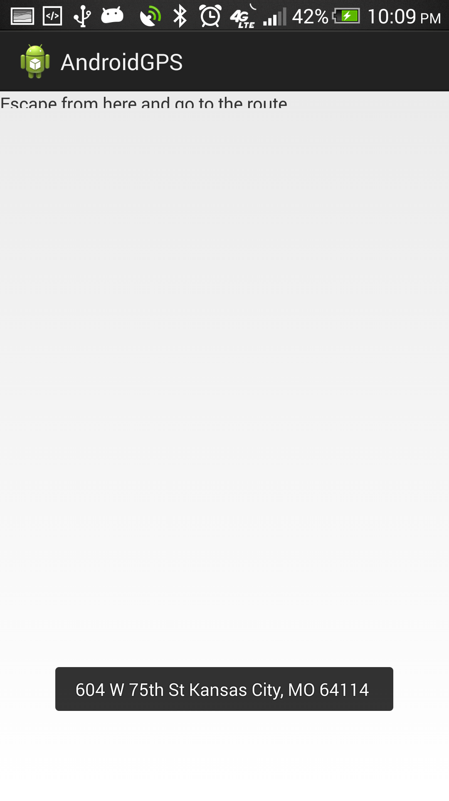

Result: This result is the location address for above latitude and longitude values.