# Report on Mobile Device

## Task1: Screenshots after ruuning Sensor Tag code

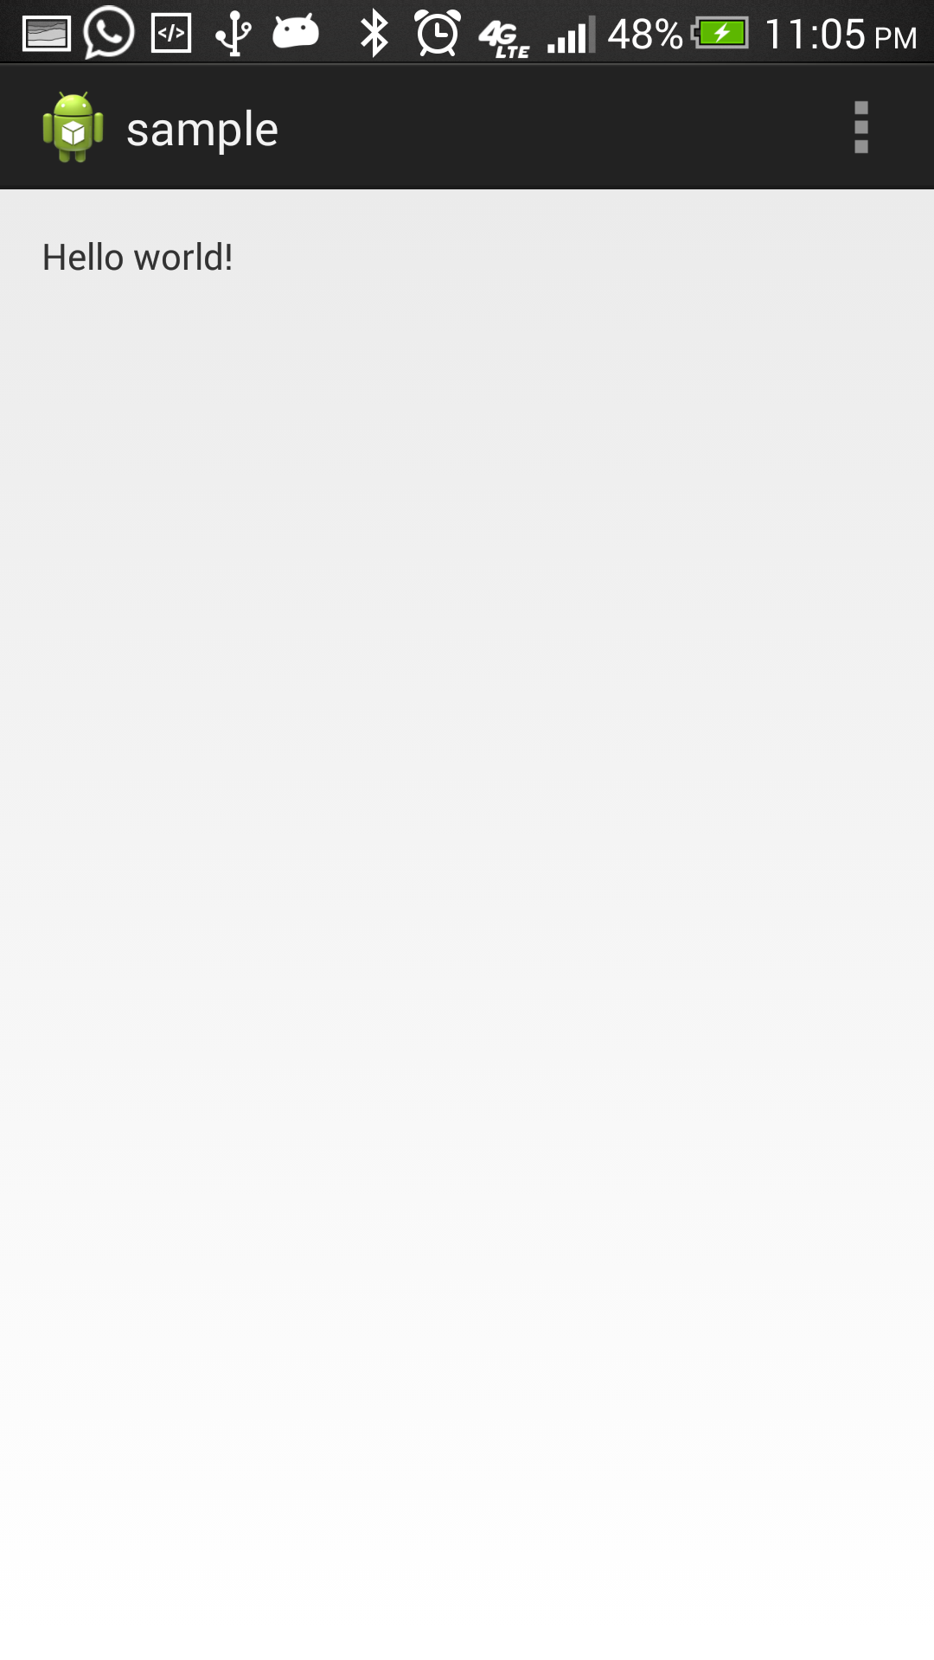

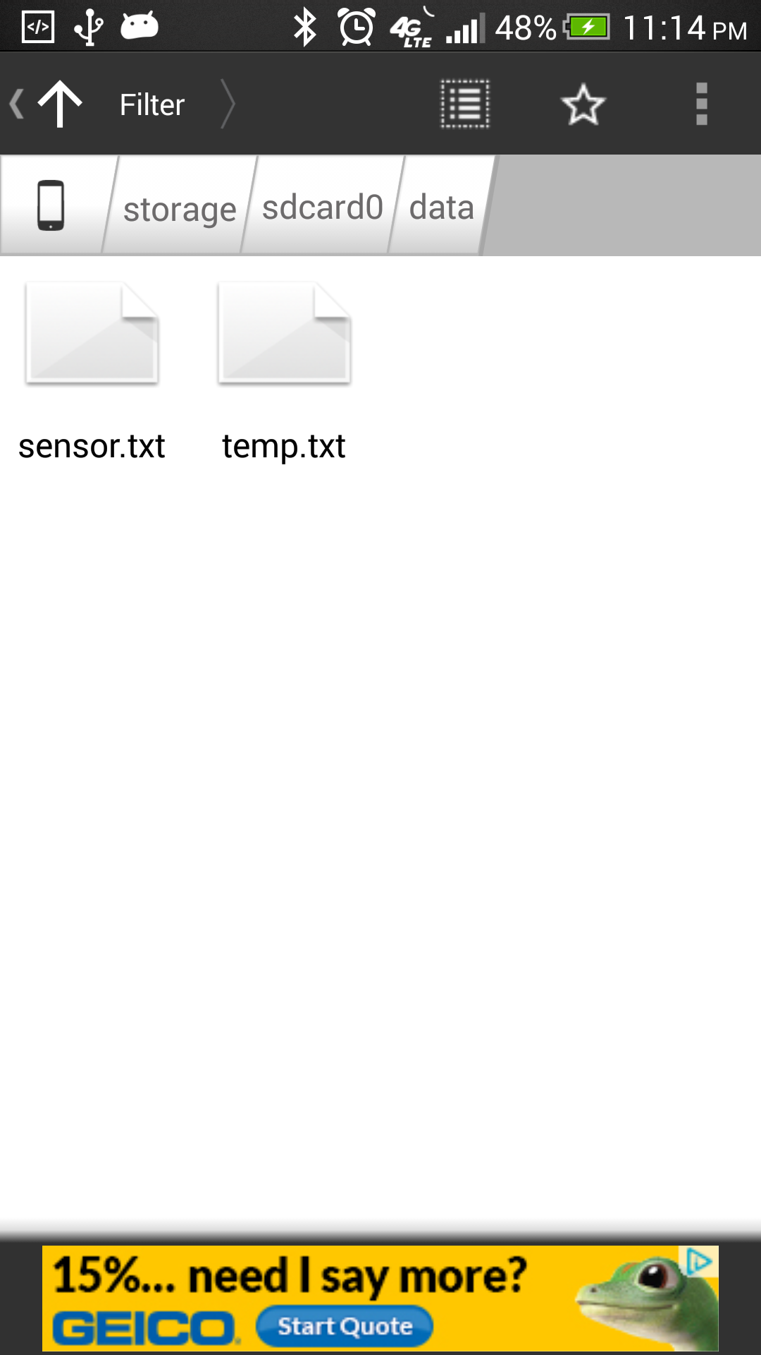

Result: After running sample code file for Sensor Tag, we can see the text files generated for Temparature and Humidity Values

