# Report on Mobile Device

## Task1: Screenshots after ruuning Sensor Tag code

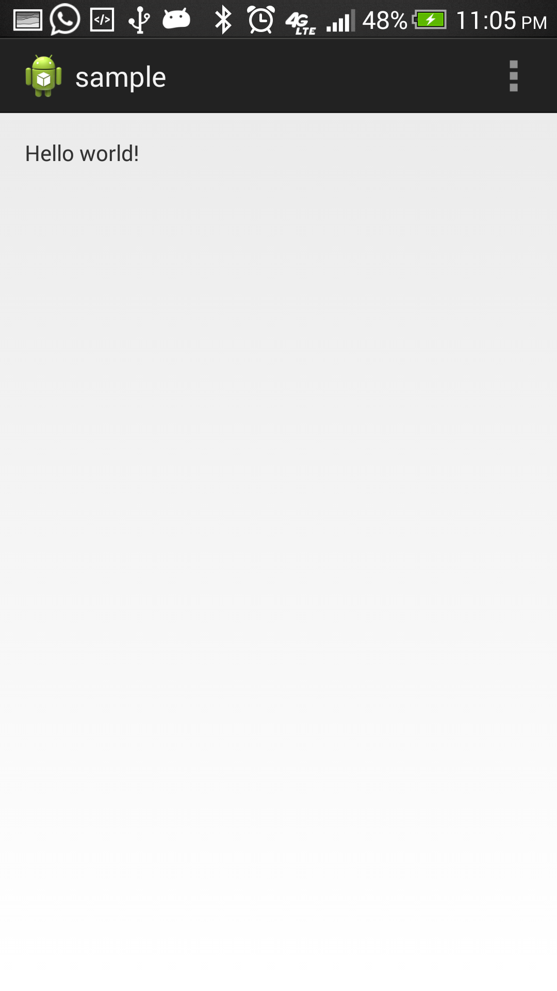

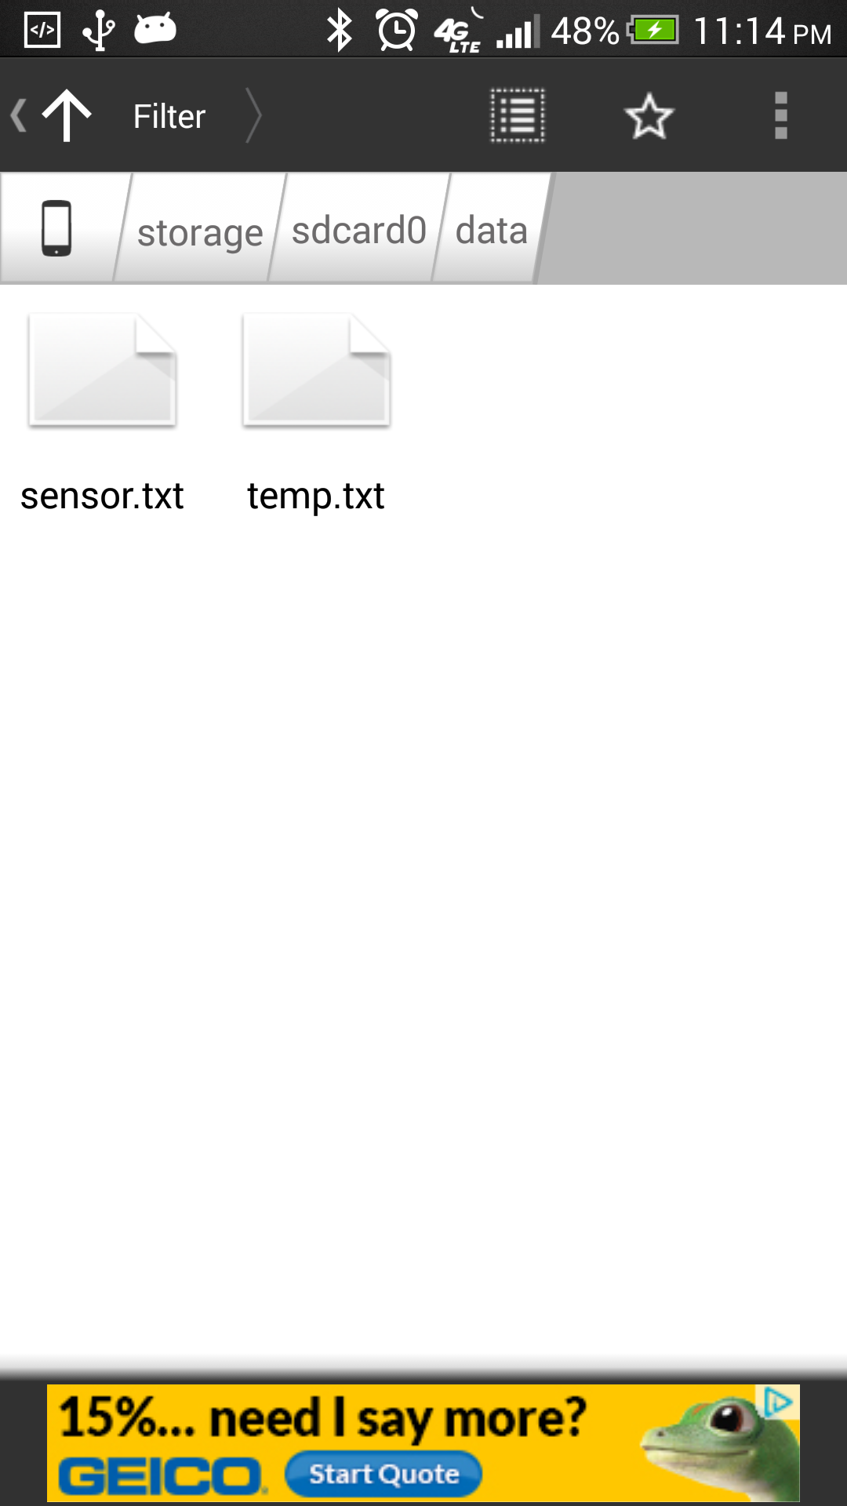

Result: After running sample code file for Sensor Tag, we can see the text files generated for Temparature and Humidity Values

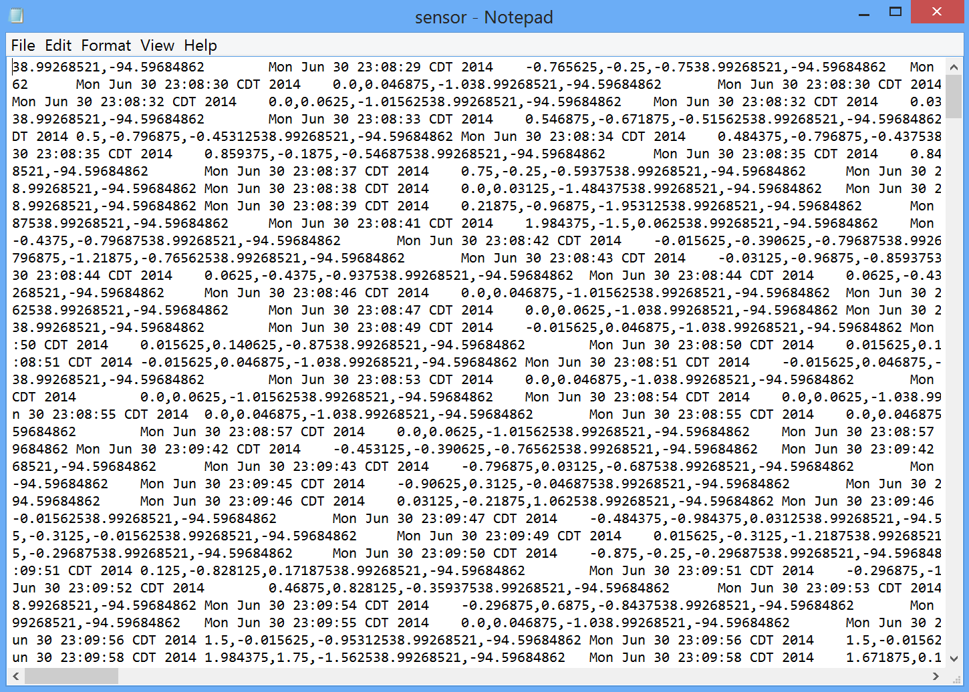

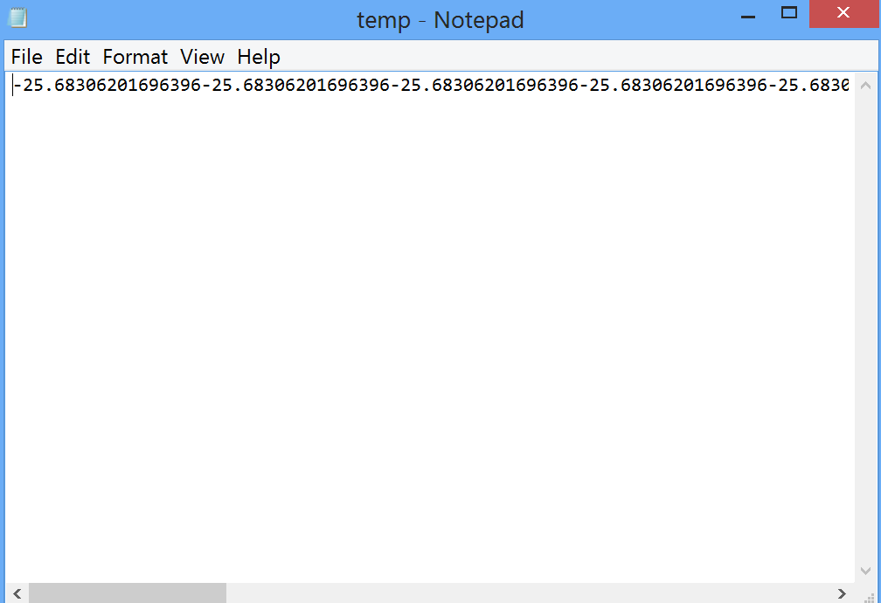

## Task2: HBase CRUD operations

1. Create table “shivapothala007”

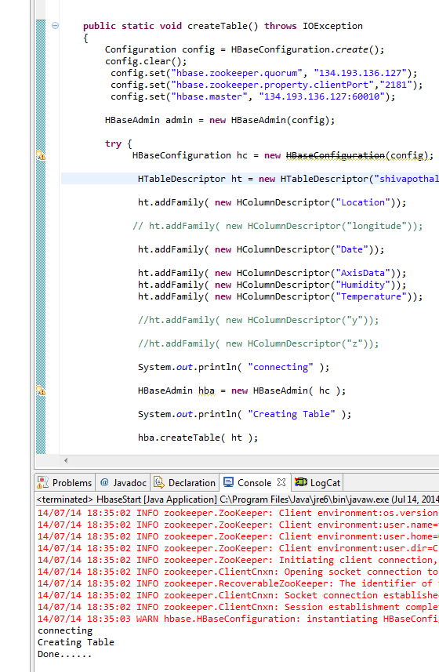

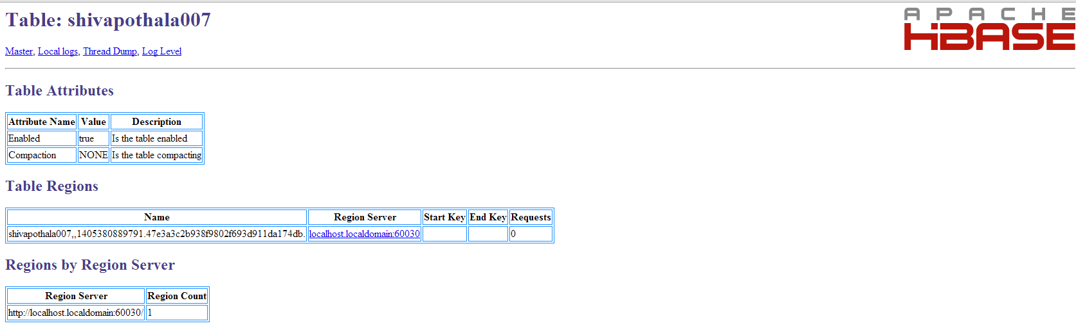

1. Insert sensor file data into table “shivapothala007”

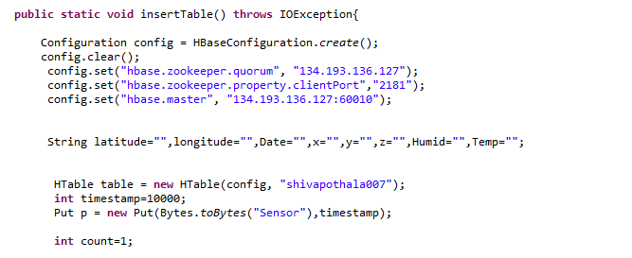

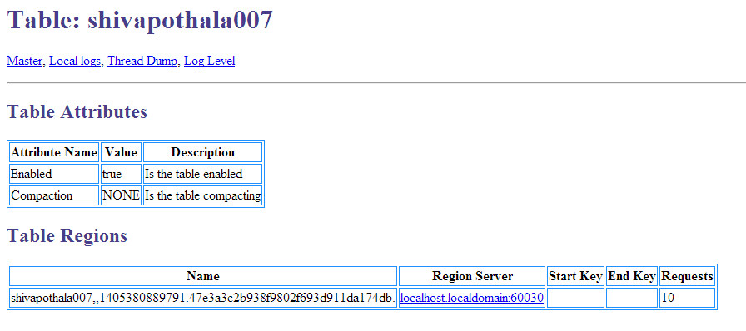

1. Retrieving data from table “shivapothala007”

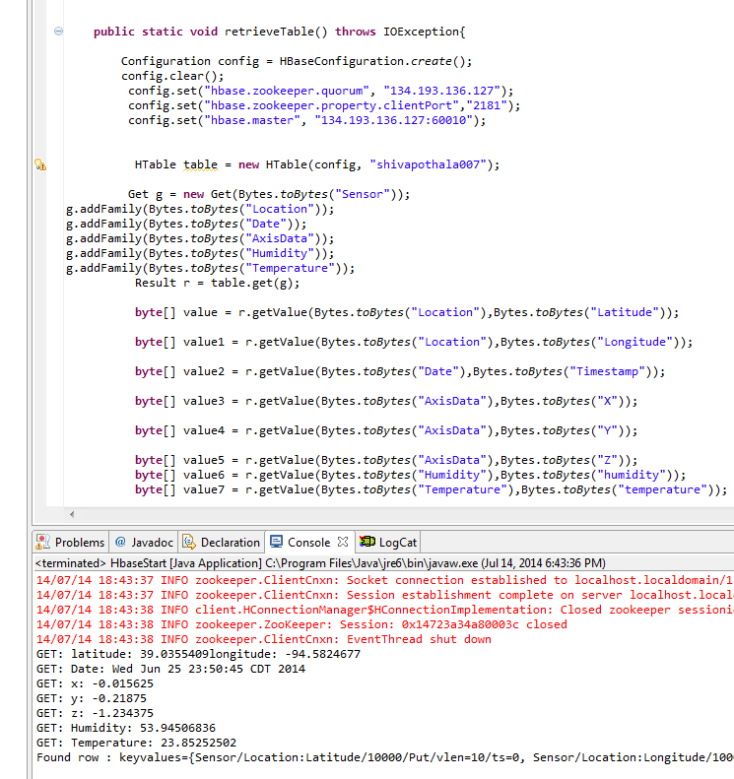

1. Delete table “shivapothala007”

