# LAB-3 Report

1. Developed an Android application and deployed

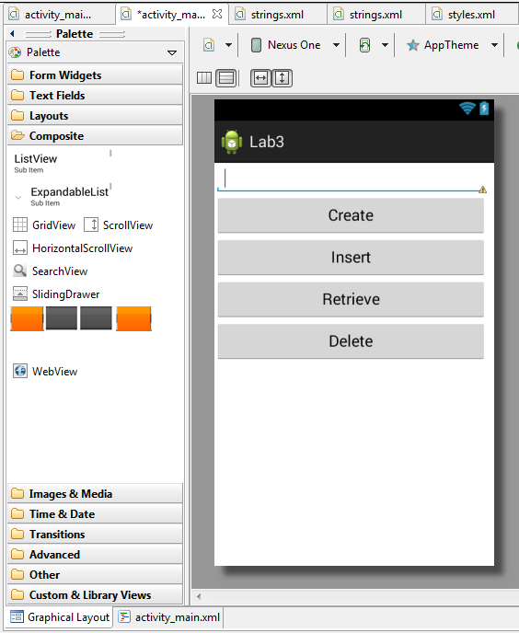

1. Android application for CRUD operations

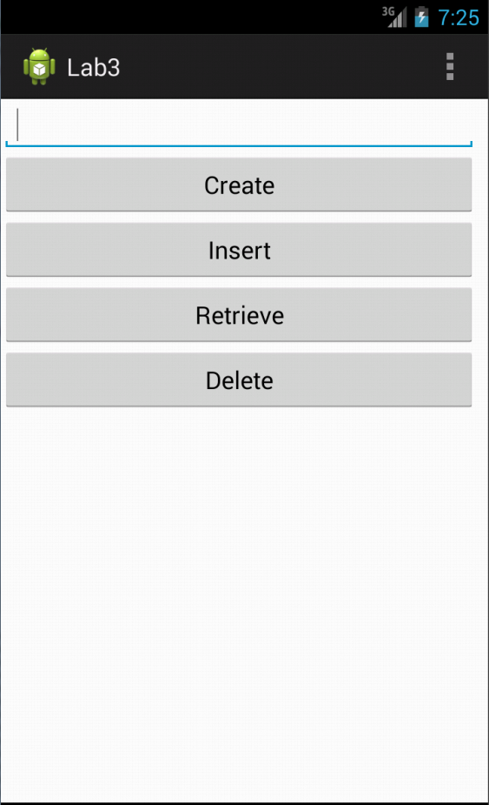

1. Created “sivakumar pothalaTable”

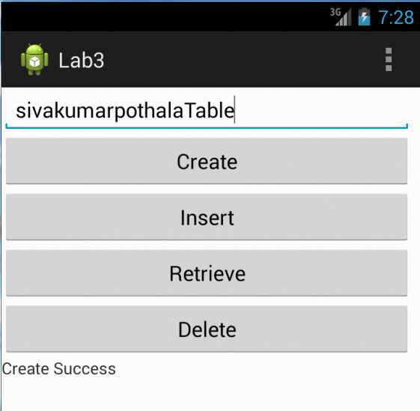

Result: Table created successfully

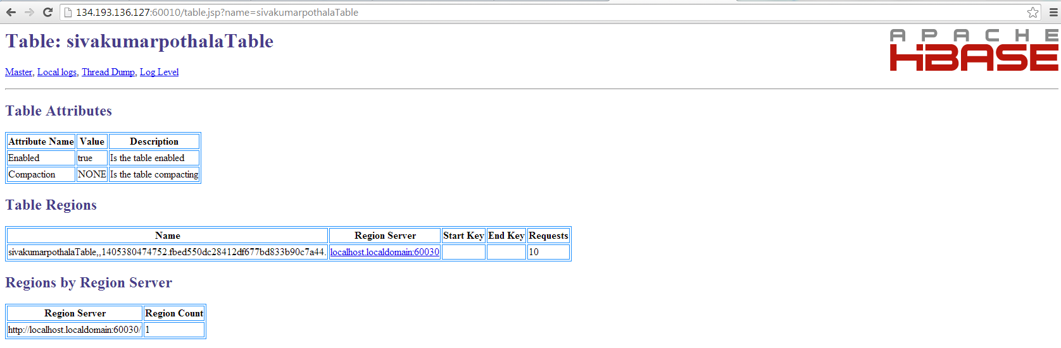

1. Insert operation on table “sivakumarpothalaTable”

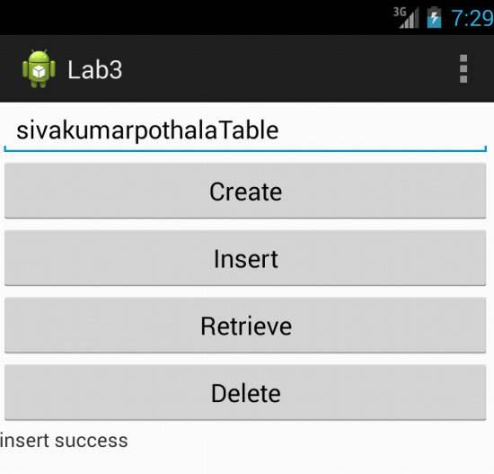

Result: Successfully inserted sensor.txt file data

1. Retrieving data from “sivakumarPothala” and successfully retrieved and shown

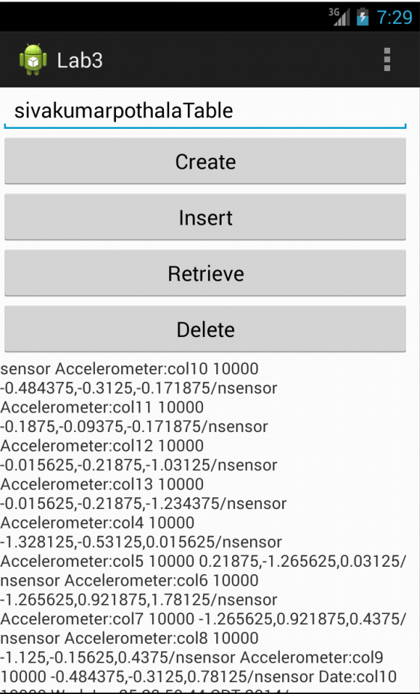

1. Delete Table “sivakumarpothalaTable”

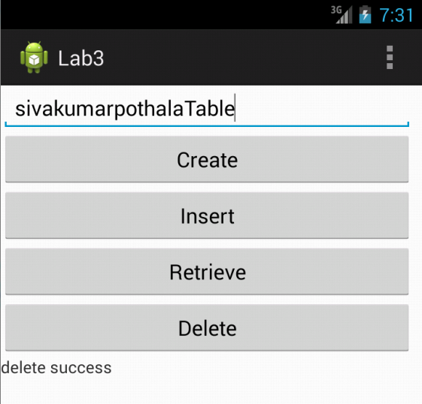

Result: successfully deleted the table