# Generate Sequence Files for Training data and Testing Activity Recognition

1. Punch Sequence training data

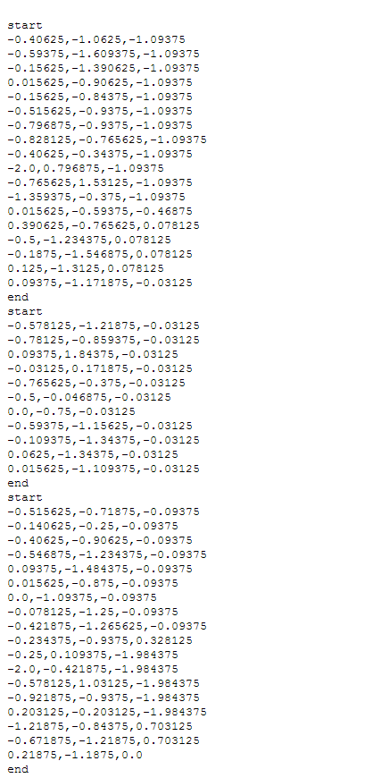

1. Right to Left training data

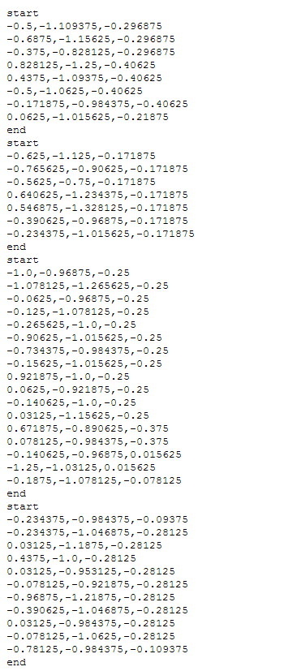

1. Left to Right training data

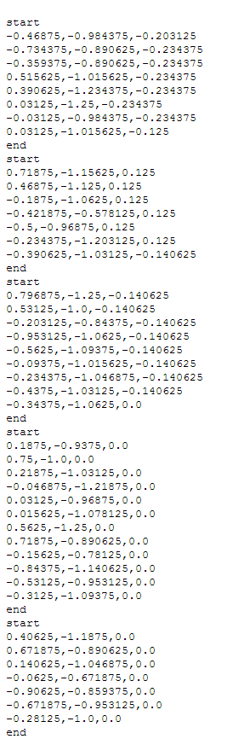

1. Combination training data for three different gestures

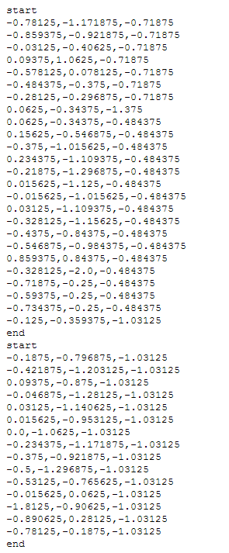

1. Testing the activity recognition data for three different gestures punch, left to right and right to left

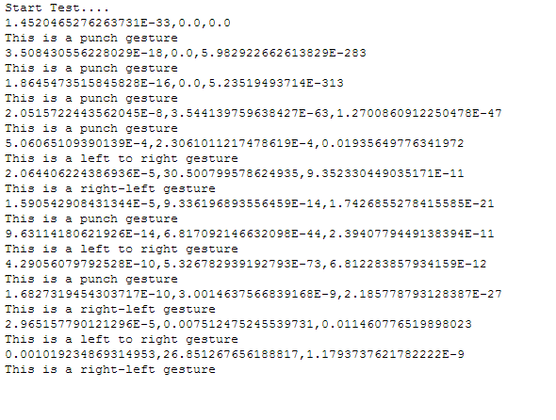

Result: We can see here different gestures data ‘punch’, ‘right-left’ and ‘left to right’ after testing with our third activity recognition web service.

1. Activity recognition for multiple motions as training data (fourth web service)

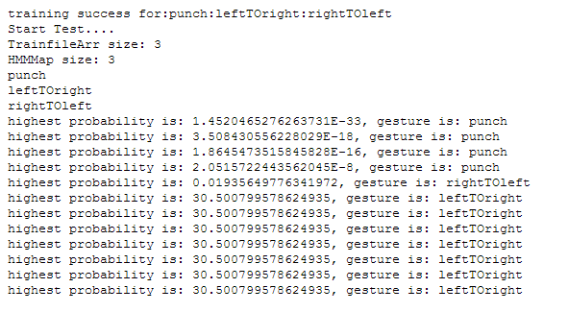

Result: We can see here different probabilities and type of gestures data ‘punch’, ‘right-left’ and ‘left to right’ after testing with our fourth activity recognition web service.