**COMBAT Commander**C:\Users\AyyappaKumar\AppData\Local\Microsoft\Windows\Temporary Internet Files\Content.IE5\OW7O1GA0\MC900018512[1].wmf Mobile Game

**Supervised By**: Dr Yugyung Lee **Team:**

Dr Shen Vishnu Gude Shiva Pothala Ayyappa Neerukonda

Akhilesh Vemparala

# Second Increment

## Introduction

Advancements in the today's mobile technology created a huge scope to develop all kinds of user interactive applications. Multi player mobile games are more popular and fun to design by using motion sensor devices. This game allows multiple users to play and shoot each other and also it tracks user movements and acts according user simulation in the application.

## Project Goal and Objectives

* **Motivation**

The main motivation of this project comes from popularity of mobile games everywhere. From our childhood playing a game with friends always fun and we dreamt to have our own 3D game that everybody can play with our creatures and other 3D effects. After knowing about Sensor Tags and other user motion detective devices, we found a scope to develop this amazing application.

* **Objectives**

This collects data from different users through sensor tags and acts according to user motion in the shooting game. This would also rates a user in the game by giving performance based score. This kind of applications are designed to provide entertainment to users and show them how sensor tags can track their motion when they play around.

* **Significance**

There are plenty of mobile games available and this just one among them. But we are trying add few more features to it. This can be played on android or windows supporting devices like mobile phones or Tablets. With the animated 3D features user can have live play feeling when operating sensor tags.

## System Features:

* **Activity Models:**

Four hand gestures Left, Up, Stomp, and Punch are used for determining Left, Right, walk and Punch activities. Our offline part is to generate sequence files for the trained data. Here each hand gesture is trained with ten samples. Now these data has been trained and the respective sequence files have been generated for each and every hand gesture.

* **Motion Models:**

We basically have four hand gestures to detect. Since we already have sequence files of the trained data. Now the new gesture data will be collected using the sensor tag and then a sequence file will be generated for these data. Now these sequence file will be compared with the trained sequence files and the appropriate gesture is detected.

## System Requirements:

* CC2541 TI Sensor Tag
* Android 4.3 and above OS
* Bluetooth 4.0 and above

## Technological and Architectural Requirements:

* Hadoop, H Base
* Eclipse, Java, Android
* Data from sensor tag
* Unity 3D

## Activity Recognition Scenario and Data Collection:

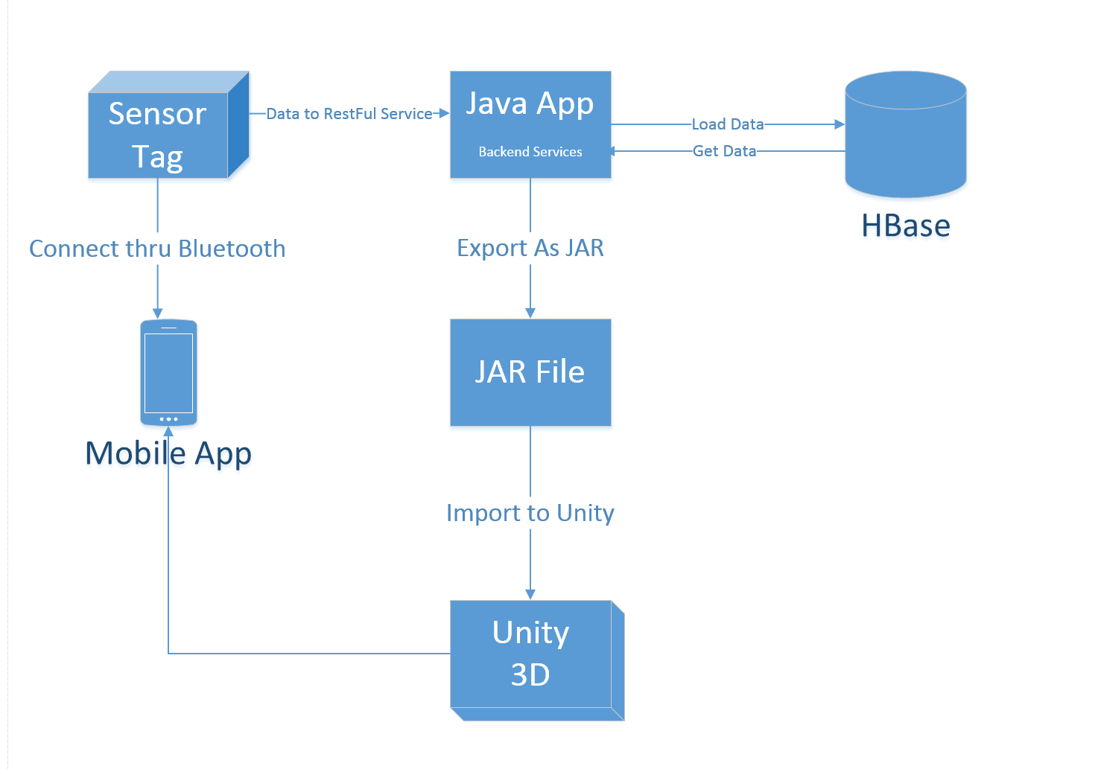

## Data Collection:

1. Data collected for the Left Gesture

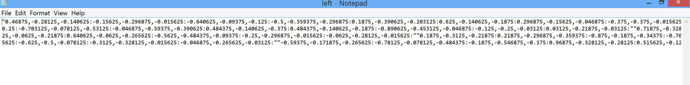

1. Data collected for the Right Gesture

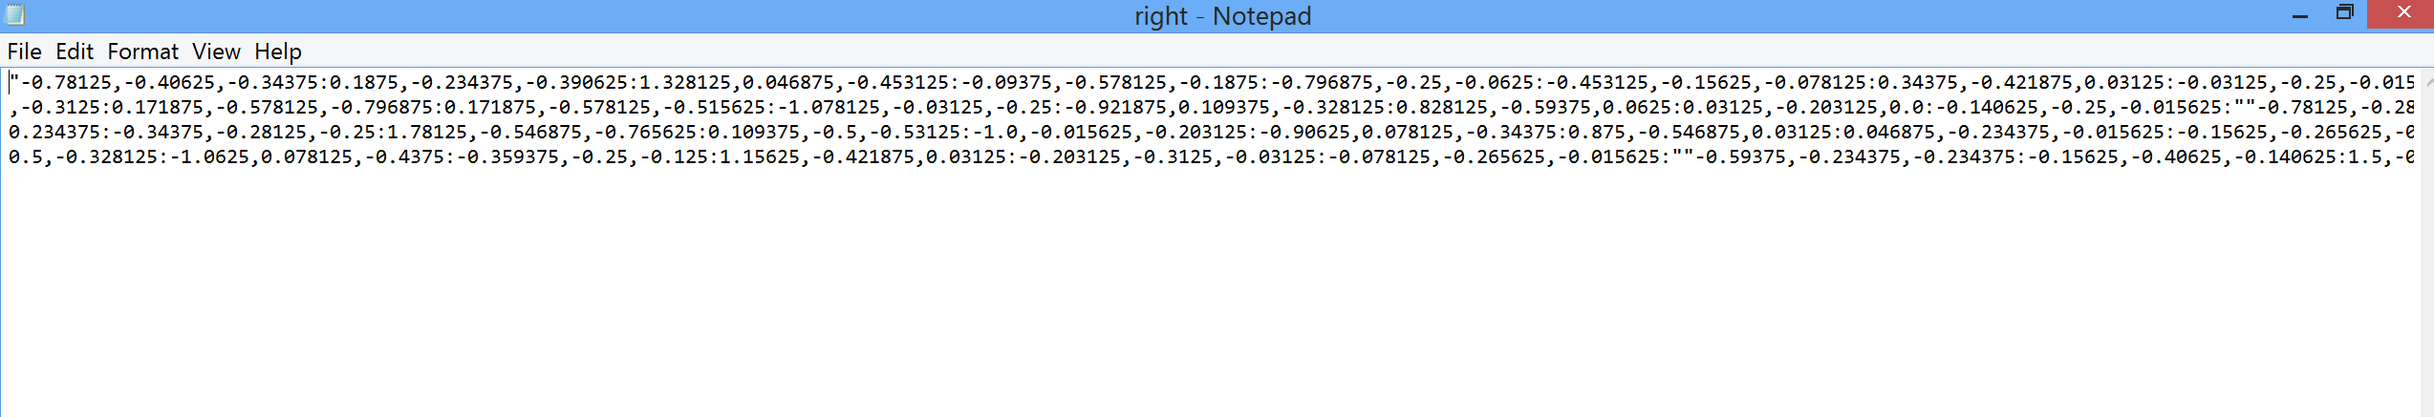

1. Data collected for the Walk (Stomp) Gesture

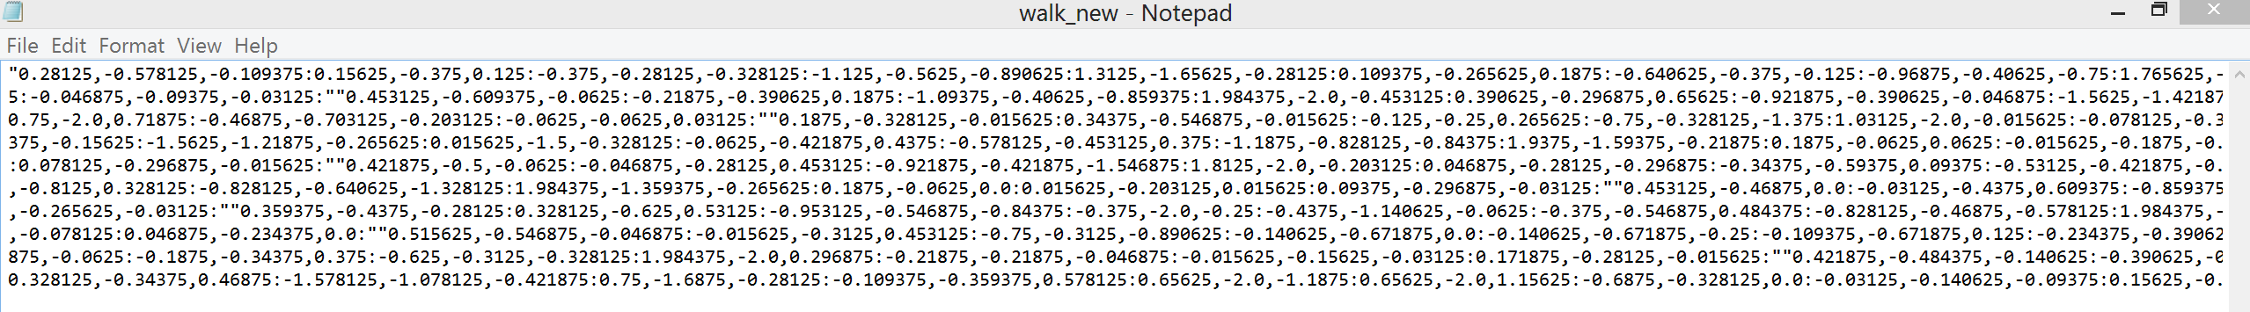

1. Data collected for the Stomp Gesture

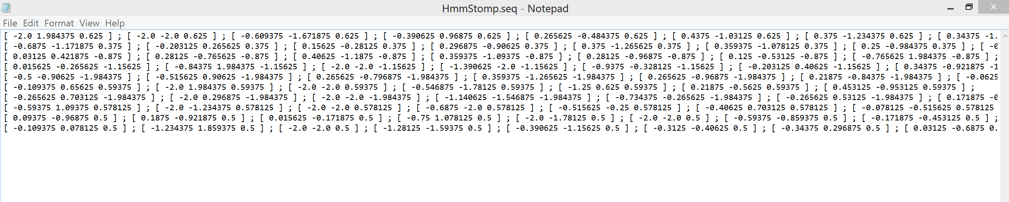

1. Data collected for the Punch(Shoot) Gesture

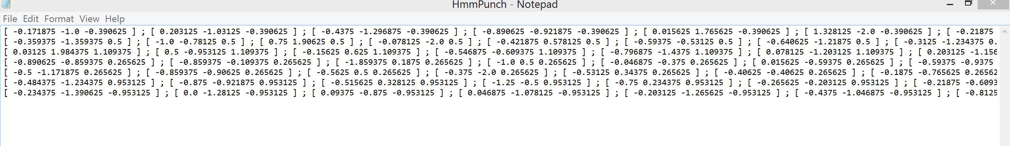

## Related Work:

**Combat Trigger: Modern Dead 3D**

It is a war game where user can select different weapons and fight in different battle fields.

**Features included:**

Exciting campaign with plenty of battles, futuristic weapon, big bang grenades, armor and health customization, millions of enemies to kill, exotic planets and fallen human cities to fight in, battlefields on exotic planets, combat in fallen human cities

## Bibliography:

<https://play.google.com/store/apps/details?id=com.thunderbull_entertainment.callofdead&hl=en><https://play.google.com/store/apps/details?id=com.csshooter.roadshoot&hl=en>

<https://play.google.com/store/apps/details?id=com.fungame.wars&hl=en>

<https://play.google.com/store/apps/details?id=com.dseffects.StreetCombat&hl=en>

<https://play.google.com/store/apps/details?id=com.rubicon.dev.combatmonsters&hl=en>