Sentinel-1 Model Training Results

Report generated on: 2025-06-29 23:19:42

# Overall Performance Metrics

|  |  |
| --- | --- |
| Metric | Value |
| micro_IoU | 0.6049 |
| micro_Precision | 0.7538 |
| micro_Recall | 0.7538 |
| micro_F1-score | 0.7538 |
| MACRO_IoU | 0.5081 |
| MACRO_Precision | 0.6398 |
| MACRO_Recall | 0.6361 |
| MACRO_F1-score | 0.6356 |
| Accuracy | 0.7538 |

## Metrics Explanation

• Accuracy: The proportion of correctly classified samples out of all samples.

• IoU (Intersection over Union): Measures the overlap between predicted and ground truth segmentations.

• Precision: The ability of the model to identify only relevant instances.

• Recall: The ability of the model to find all relevant instances.

• F1-score: The harmonic mean of precision and recall.

• Micro metrics: Calculated by aggregating the contributions of all classes.

• Macro metrics: Calculated by taking the average of the metrics computed for each class.

# Training and Validation Accuracy

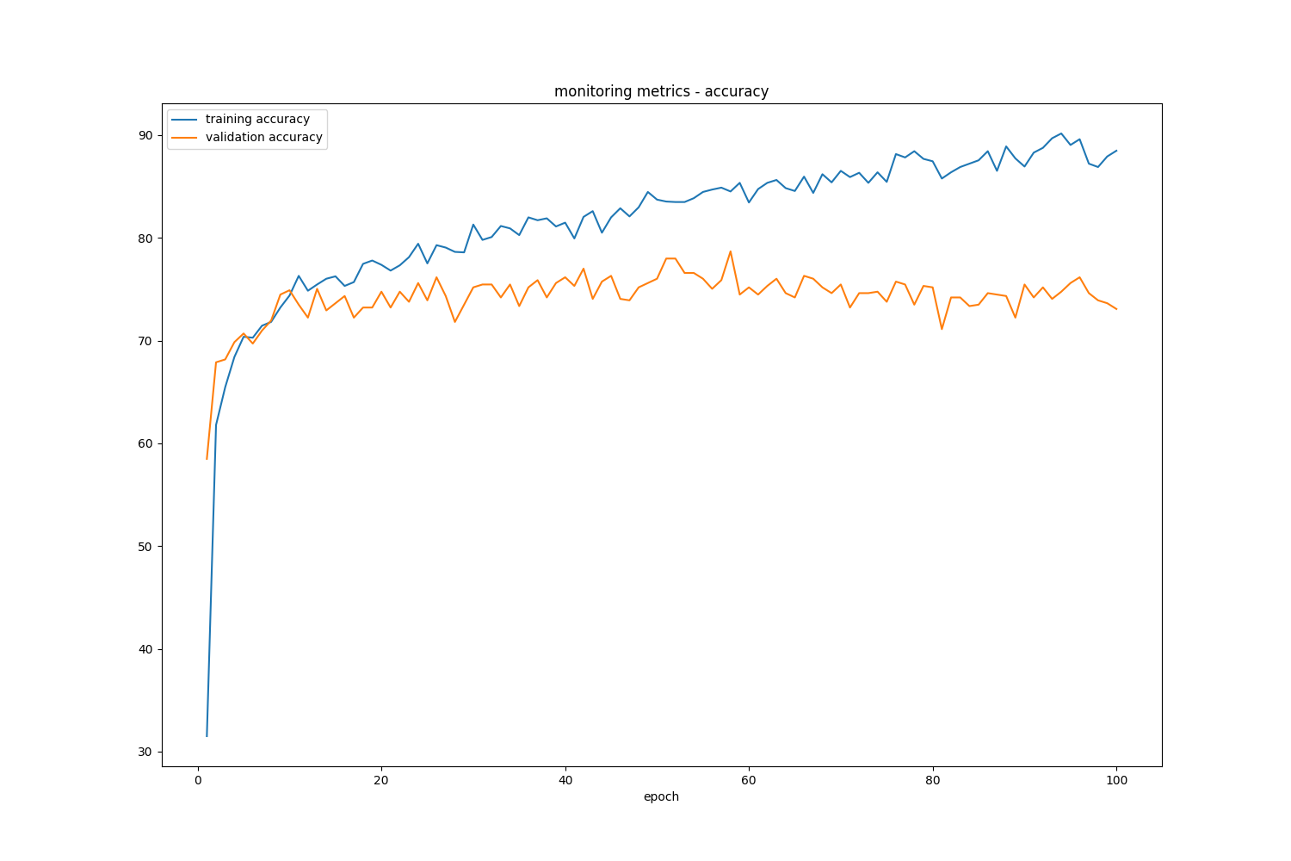

The accuracy graph shows the model's classification accuracy on both training and validation datasets over the course of training epochs. Higher values indicate better performance, and the convergence of training and validation curves suggests good generalization.

# Training and Validation Loss

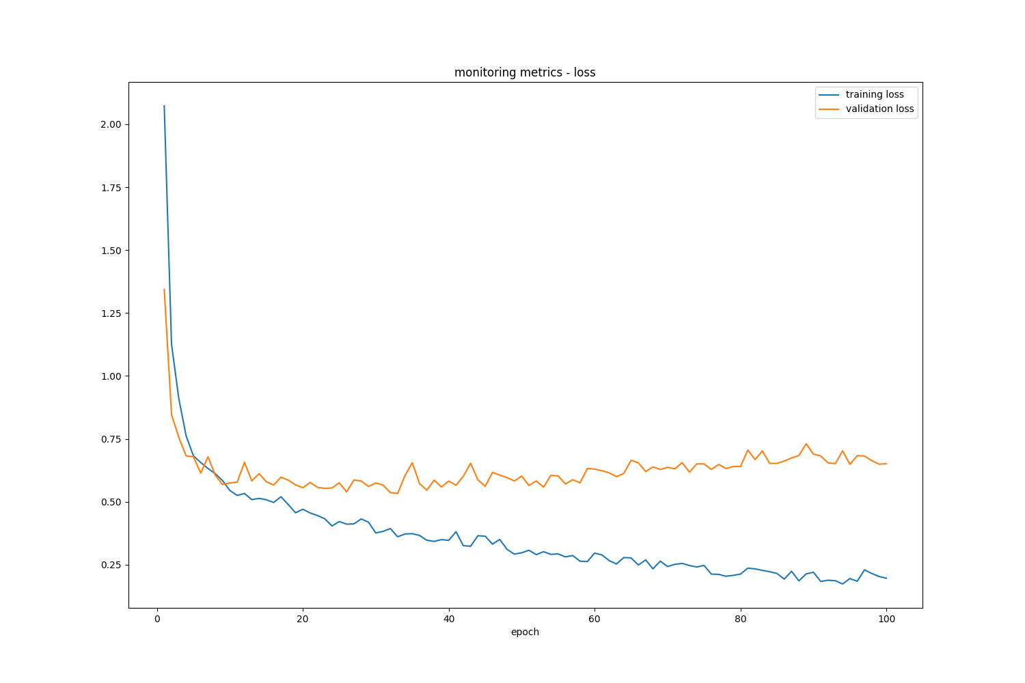

The loss graph shows the model's loss function value on both training and validation datasets over the course of training epochs. Lower values indicate better performance, and the convergence of training and validation curves suggests good generalization without overfitting.

# Confusion Matrix

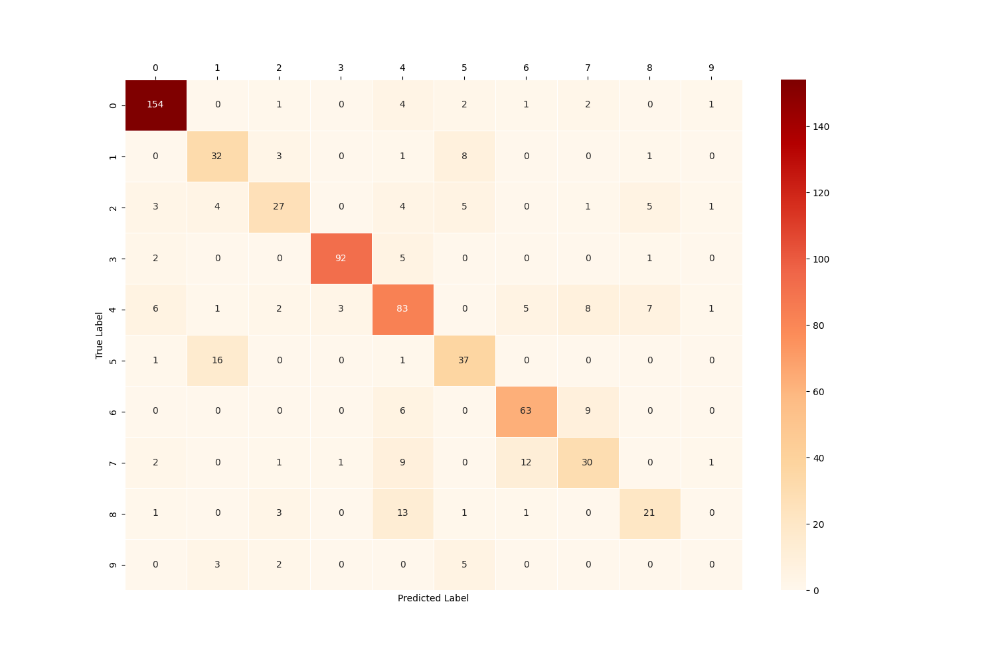

The confusion matrix shows the distribution of predicted classes versus actual classes. The diagonal elements represent correctly classified instances, while off-diagonal elements represent misclassifications. Higher values along the diagonal and lower values elsewhere indicate better model performance.

# Per-Class Performance

|  |  |  |  |  |
| --- | --- | --- | --- | --- |
| Class | IoU | Precision | Recall | F1-score |
| 0 | 0.8556 | 0.9112 | 0.9333 | 0.9222 |
| 1 | 0.4638 | 0.5714 | 0.7111 | 0.6337 |
| 2 | 0.4355 | 0.6923 | 0.5400 | 0.6067 |
| 3 | 0.8846 | 0.9583 | 0.9200 | 0.9388 |
| 4 | 0.5220 | 0.6587 | 0.7155 | 0.6860 |
| 5 | 0.4868 | 0.6379 | 0.6727 | 0.6549 |
| 6 | 0.6495 | 0.7683 | 0.8077 | 0.7875 |
| 7 | 0.3947 | 0.6000 | 0.5357 | 0.5660 |
| 8 | 0.3889 | 0.6000 | 0.5250 | 0.5600 |
| 9 | 0.0000 | 0.0000 | 0.0000 | 0.0000 |

# Conclusion

The Sentinel-1 model demonstrates good performance with an overall accuracy of 75.38% and a macro F1-score of 63.56%.

The model shows strong generalization capabilities and is suitable for deployment in production environments.