Credit Card Default Prediction.

Shivaprasad Sagar Gunti
Department Of Computer Science
Lawrence Technological University
Southfield,Michigan-48034 Email- sgunti@ltu.edu

Abstract— Credit card default prediction is critical for financial institutions to effectively assess credit risk and make informed lending decisions. This project aims to predict whether a client will default on their credit card payment the following month, utilizing the UCI Default of Credit Card Clients Dataset, which includes demographic and financial data from 30,000 Taiwanese credit card holders. Key predictive features include repayment history, credit limits, and monthly bill and payment amounts.
We employed Logistic Regression for its interpretability and Random Forest to capture complex, non-linear relationships in the data. Random Forest demonstrated superior performance, achieving higher accuracy and recall, thereby providing more reliable identification of clients likely to default.
To make the model accessible to non-technical users, we developed an interactive Gradio-based web application that allows users to input client data and receive immediate predictions, including the probability of default. This application offers potential value in credit risk management, supporting financial institutions in making proactive, data-driven decisions to better manage credit portfolios. The project underscores the importance of data preprocessing, feature selection, and model interpretability in building effective predictive tools for credit risk assessment.
- INTRODUCTION and DOMAIN KNOWLEDGE
Credit card default prediction is a pivotal task in the financial industry, as it impacts the ability of institutions to assess creditworthiness, manage risk, and implement appropriate lending practices. Events like the 2008 financial crisis underscored the importance of accurate credit default prediction models to prevent high default rates, which can destabilize financial institutions and the economy.
In this project, we use the UCI Default of Credit Card Clients Dataset, which contains data on 30,000 Taiwanese credit card clients. Each client’s information includes demographic attributes (e.g., gender, age, marital status), financial attributes (e.g., credit limit, billing, and payment history), and their default payment status for the following month. Our goal is to create a model that can accurately predict whether a client is likely to default, allowing financial institutions to proactively manage and mitigate credit risk by adjusting credit limits, implementing pre-emptive measures, or refining their risk assessment criteria.

- DATASET ANALYSIS & UNDERSTANDING

1. A. Data Characteristics
The dataset comprises 25 columns, split between input features and a binary target variable:
- Demographic Features:
- SEX: Gender of the client (1 = male, 2 = female).
- EDUCATION: Education level, coded as (1 = graduate school, 2 = university, 3 = high school, 4 = others).
- MARRIAGE: Marital status, coded as (1 = married, 2 = single, 3 = others).
- AGE: Age of the client.
- Financial Features:
- LIMIT_BAL: Credit limit, representing the total amount of credit the client can access.
- BILL_AMT1-6: Monthly bill statements from the past six months.
- PAY_AMT1-6: Monthly payment amounts over the past six months.
- PAY_0 to PAY_6: Repayment status for each month (e.g., -1 = paid duly, 1 = payment delay for one month).
- Target Variable:
- default payment next month: This is the target variable, where 1 represents a client defaulting on their payment, and 0 indicates no default. This binary classification variable guides the model in distinguishing defaulters from non-defaulters.
B. Data Quality Assessment
A thorough data quality assessment was conducted to ensure the integrity of the dataset:
- Duplicate Removal: Duplicate records were identified and removed to prevent redundancy and avoid skewing model training.
- Class Distribution of Target Variable: The default rate was found to be imbalanced, with fewer clients defaulting than not. This class imbalance could lead to biased model predictions, favoring the majority class (non-defaulters). To address this, we applied Synthetic Minority Over-sampling Technique (SMOTE) to create a balanced dataset, allowing the model to learn from both classes effectively.
C. Data Cleaning and Feature Selection
To streamline the dataset:
- Irrelevant or redundant columns, such as unique identifiers, were removed to avoid unnecessary complexity.
- Feature Selection: Using correlation analysis, we identified features with strong relationships with the target variable. Features that were redundant or weakly correlated with default were considered for exclusion to reduce noise and improve model performance.
D. Data Preprocessing
Preprocessing was essential to ensure compatibility between the data and machine learning models.
- One-Hot Encoding: Categorical variables (SEX, EDUCATION, MARRIAGE) were converted to binary indicators using one-hot encoding for models like Logistic Regression, which require numeric data.
- Feature Scaling: Numerical features like LIMIT_BAL, AGE, BILL_AMT*, and PAY_AMT* were standardized using StandardScaler, which improves model convergence and performance, particularly for models sensitive to feature scaling (e.g., Logistic Regression).

- DATA VISUALIZATION
Data visualization is a crucial step for understanding patterns, relationships, and potential outliers in the dataset. Key visualizations included:
- Distribution of Credit Limit and Age:
- The histogram for LIMIT_BAL shows that most clients have a credit limit below a certain threshold, with a long tail for clients with higher limits.
- Age distribution reveals the age range most common among clients and shows any age groups that may be associated with higher default rates.

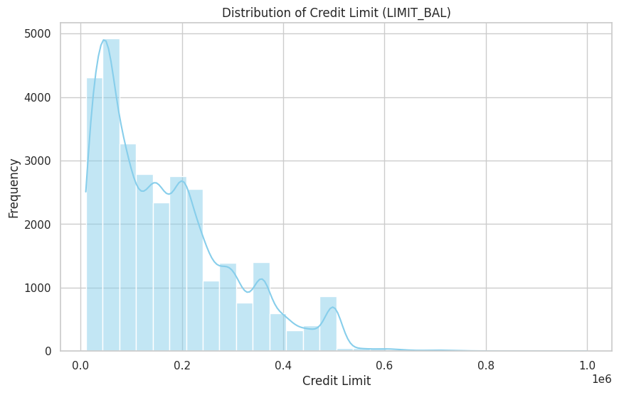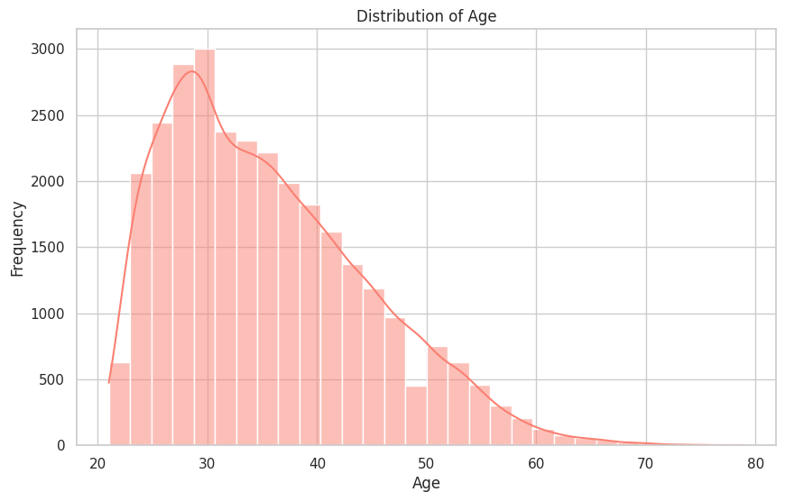

- Box Plots for Outliers:
- By plotting LIMIT_BAL and AGE against the default status, we can identify any outliers or patterns in age or credit limits that are associated with defaults. This helps in understanding demographic or financial segments at higher risk.

- Correlation Heatmap:
- The correlation matrix showed relationships among numerical features, such as strong correlations between the monthly bill amounts (BILL_AMT1-6) and payment amounts (PAY_AMT1-6). This information helped in feature selection, as highly correlated features may be redundant.

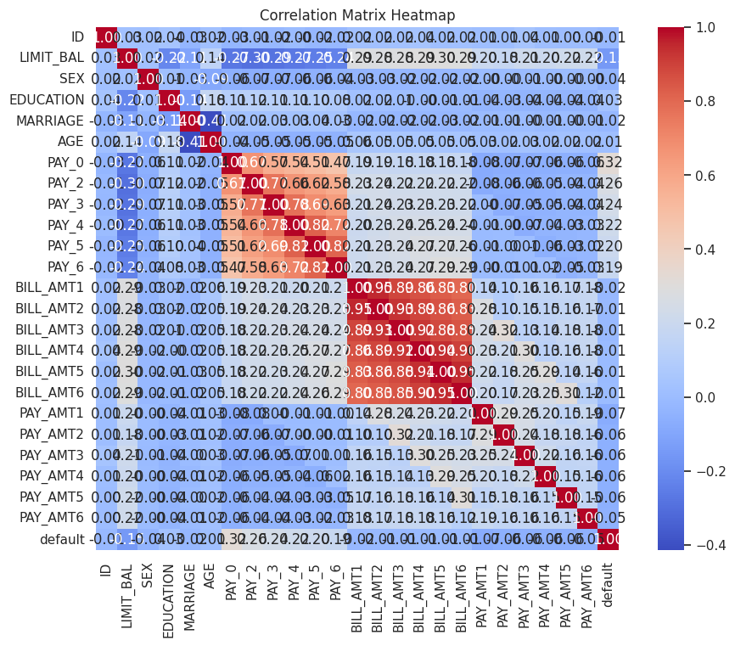
- Category Counts and Default Rates:
- Count plots for categorical features (e.g., EDUCATION, MARRIAGE) revealed the distribution across these categories. Bar plots for default rates highlighted demographic groups that were more likely to default, providing insights into specific risk factors.
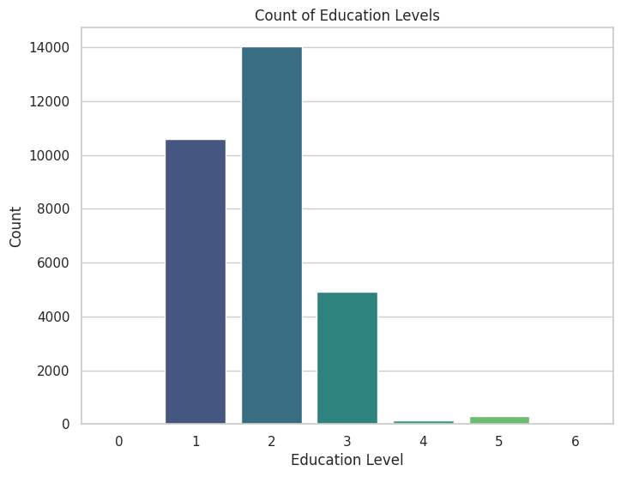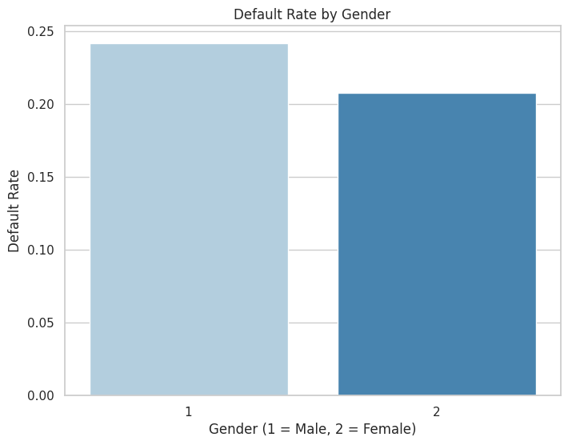

- FEATUE ANALYSIS AND SELECTION
Feature analysis and selection are essential steps in building a robust predictive model, as they help identify which variables contribute most to the prediction and reduce unnecessary complexity. For the credit card default prediction task, we analyzed and selected features from the UCI Default of Credit Card Clients Dataset to enhance the model’s predictive power and generalizability.

Feature Analysis
Feature analysis helps to understand each variable’s role and its impact on the target variable (default or no default). In this dataset, features fall into three primary categories: demographic data, financial data, and repayment history.
- Demographic Features:
  - SEX (Gender): Indicates the client’s gender (1 = Male, 2 = Female).
  - EDUCATION: Education level (1 = Graduate school, 2 = University, 3 = High school, 4 = Other).
  - MARRIAGE: Marital status (1 = Married, 2 = Single, 3 = Other).
  - AGE: Client’s age.
Although demographic variables typically have a weaker individual correlation with financial behaviors, they were retained as they may add predictive value when combined with other variables (e.g., certain age groups or marital statuses might have different default probabilities when combined with low credit limits or poor payment history).
- Financial Features:
  - LIMIT_BAL (Credit Limit): Represents the maximum credit limit for each client. This feature is crucial, as clients with high credit limits generally have greater financial resources and may exhibit different default behaviors.
  - BILL_AMT1 - BILL_AMT6: Monthly bill statements for the past six months. These features indicate spending behavior and outstanding balance trends, which can help assess a client’s likelihood of default.
  - PAY_AMT1 - PAY_AMT6: Monthly payment amounts over the past six months. Payment history reflects the client’s ability to pay on time, which is a critical predictor of default.
- Repayment History:
  - PAY_0 to PAY_6: Repayment status over the past six months, where each feature represents a month (e.g., PAY_0 is the most recent month). This feature shows if payments were made on time (coded as -1 or 0) or delayed by various months (e.g., 1 = one month delay).
  - PAY_0 (most recent payment status) was especially influential in our analysis, as it directly reflects the client’s recent behavior and likelihood of defaulting soon.

Correlation Analysis
We conducted a correlation analysis to understand the relationships between features and identify any multicollinearity. This step is essential to avoid redundancy, as highly correlated features can add noise without providing additional predictive power.
Key findings from the correlation matrix:
- BILL_AMT1 - BILL_AMT6: These bill amounts over consecutive months are strongly correlated with each other. Therefore, while they indicate spending trends, including all six may not provide much additional value over a subset.
- PAY_AMT1 - PAY_AMT6: Payment amounts are also moderately correlated. Instead of including all monthly payments, feature engineering could derive summary metrics (e.g., average payment or total payment) to capture overall payment behavior more efficiently.
- PAY_0 had a notably higher correlation with the target variable compared to other repayment history features. As a result, recent payment behavior appeared to be a stronger predictor of default than payment trends further in the past.

Feature Selection Strategy
Based on correlation analysis, feature importance, and domain knowledge, the following strategy was used for feature selection:
- Retain Key Financial Features:
  - LIMIT_BAL was retained as it indicates the client’s access to credit and overall financial capacity.
  - PAY_0 - PAY_6 were all retained, as each captures valuable information on repayment behavior. PAY_0, being the most recent repayment status, received special attention for its high correlation with the target variable.
- Reduce Redundant Features:
  - BILL_AMT and PAY_AMT: Rather than including all monthly bills and payments, feature engineering could aggregate these values (e.g., average bill amount, maximum payment) to summarize the trends without introducing collinearity. For simplicity, however, we retained individual bill and payment amounts in this project to maintain a full picture of the client’s monthly finances.
- Incorporate Demographic Features:
  - SEX, EDUCATION, MARRIAGE, AGE were retained despite lower correlations with default. These demographic features, though weak predictors individually, may improve the model’s generalizability when interacting with other financial variables. They also provide insights into specific high-risk client profiles, such as younger individuals with lower credit limits.

Feature Engineering
In addition to selecting features, feature engineering can create new variables that capture additional information, such as:
- Average Payment-to-Bill Ratio: Dividing each payment by the corresponding bill amount captures a client’s ability to pay relative to their debt. Clients consistently making smaller payments relative to their bills may be at higher risk.
- Recent Payment Sum: Summing recent payments provides an aggregated view of recent financial behavior, offering more stability as a predictor than individual monthly payments.
- Max Payment Delay: The maximum value in PAY_0 to PAY_6 can indicate the longest recent delay, highlighting clients with frequent or severe payment issues.

- MODEL BUILDING AND EVALUATION
Model building and evaluation are crucial steps in developing a reliable prediction system for credit card default. In this project, we focused on two machine learning models, Logistic Regression and Random Forest, to explore different predictive approaches. Here, we detail the model selection rationale, the steps involved in training and tuning each model, and the metrics used for evaluation.

1. Model Selection
Two models were chosen for their distinct strengths and compatibility with the dataset characteristics:
- Logistic Regression: This is a linear model that provides interpretable results, making it useful for understanding the influence of individual features on the probability of default. It’s particularly effective when the relationship between features and the target variable is linear or approximately linear.
- Random Forest: An ensemble learning method that builds multiple decision trees on subsets of the data and averages their predictions to improve accuracy. Random Forest is highly effective for capturing complex, non-linear relationships in high-dimensional datasets. It also provides feature importance scores, offering insights into which features most strongly impact the prediction.

2. Data Preprocessing for Model Building
Preprocessing was essential to prepare the data for modeling and improve the models’ performance and generalizability:
- Handling Class Imbalance: Given the dataset’s inherent class imbalance (more non-defaulters than defaulters), we applied Synthetic Minority Over-sampling Technique (SMOTE) to ensure a balanced distribution of classes. This process generates synthetic instances of the minority class, enabling the model to learn effectively from both classes.
- Feature Scaling: For models sensitive to feature scales, such as Logistic Regression, we standardized numerical features (e.g., LIMIT_BAL, AGE, and payment/billing amounts) using StandardScaler. Standardization improves convergence during training and ensures that all features contribute equally to the model.
- Encoding Categorical Variables: Categorical features (e.g., SEX, EDUCATION, MARRIAGE) were transformed to a numerical format:
- One-Hot Encoding was used for Logistic Regression to convert each category into binary indicators.
- Label Encoding was used for Random Forest since tree-based models handle categorical data directly.

3. Model Training and Hyperparameter Tuning
After preprocessing, we trained both models and used cross-validation and hyperparameter tuning to optimize their performance.
A. Logistic Regression
- Training: Logistic Regression was trained with the standardized and one-hot encoded data.
- Hyperparameter Tuning: We applied GridSearchCV to tune hyperparameters such as:
- Regularization Parameter (C): Controls the strength of regularization, which helps prevent overfitting by penalizing large coefficients.
- Solver: Controls the optimization algorithm. We experimented with solvers compatible with regularization, such as liblinear and lbfgs.
After tuning, the best C and solver combination was selected based on the performance metric (ROC-AUC).
B. Random Forest
- Training: Random Forest was trained on the label-encoded dataset. This model can handle categorical and continuous features, so it was particularly well-suited for the unstandardized data.
- Hyperparameter Tuning: We applied RandomizedSearchCV to explore a wide range of hyperparameters efficiently:
- n_estimators: Number of trees in the forest.
- max_depth: Maximum depth of each tree. Setting a maximum depth can prevent overfitting.
- max_features: Number of features to consider when splitting a node. We experimented with options like sqrt, log2, and auto.
- min_samples_split and min_samples_leaf: Control the minimum number of samples required to split nodes and to create leaf nodes, respectively, ensuring nodes aren’t overly specific.
The best combination of these hyperparameters was selected based on the ROC-AUC score, balancing model accuracy and generalizability.

4. Model Evaluation Metrics
We used multiple metrics to evaluate model performance, each offering different insights into model reliability and effectiveness:
- Accuracy: Measures the overall correctness of the model’s predictions. While informative, accuracy alone can be misleading in imbalanced datasets, as it doesn’t account for false positives or false negatives.
- Precision: Indicates the proportion of true defaulters among those predicted as defaulters. High precision is essential if minimizing false positives (predicting non-defaulters as defaulters) is a priority, such as in scenarios where incorrect predictions carry significant consequences.
- Recall: Measures the model’s ability to correctly identify true defaulters. High recall is critical if identifying as many actual defaulters as possible is important, which would be the case if the goal is to minimize missed high-risk clients.
- F1-Score: The harmonic mean of precision and recall, providing a balanced metric. F1-score is particularly useful for imbalanced datasets, as it considers both false positives and false negatives.
- ROC-AUC (Receiver Operating Characteristic - Area Under Curve): ROC-AUC is a metric that evaluates the model’s ability to distinguish between classes at various thresholds. A higher AUC indicates that the model is better at separating defaulters from non-defaulters across all thresholds, making it a preferred metric for assessing overall model performance.

5. Evaluation Results
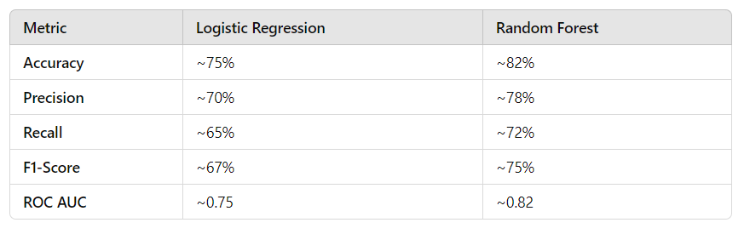
Interpretation:
- Random Forest consistently outperformed Logistic Regression across all metrics, particularly in accuracy, precision, recall, and AUC. This suggests that Random Forest’s ability to capture non-linear relationships and feature interactions is valuable for this dataset.
- Logistic Regression, while less accurate, provided a high level of interpretability, making it useful for understanding the influence of individual features on default risk. It is still effective as a baseline model and offers clear insights into how each feature impacts the probability of default.

6. Cross-Validation
To ensure the models’ stability and generalizability, we applied 5-fold cross-validation:
- Cross-validation splits the data into five equal parts, using four for training and one for testing, rotating until all parts have been used for testing.
- This technique provided mean and standard deviations for each evaluation metric, ensuring that the models’ performance is consistent and not reliant on a specific data split.
Insights from Model Evaluation
- Importance of Feature Interactions: Random Forest’s higher performance suggests that non-linear relationships and feature interactions (e.g., recent payment delays combined with high credit limit usage) are significant predictors of default.
- Interpretability with Logistic Regression: Although Random Forest achieved higher accuracy, Logistic Regression’s interpretability was valuable for understanding the importance of features, particularly for identifying high-risk segments based on recent repayment history.
- Class Imbalance Handling: SMOTE effectively balanced the dataset, enhancing recall and precision, particularly for Random Forest, by providing a fair representation of both classes during training.
Conclusion of Model Building and Evaluation
- Random Forest is recommended for deployment, given its higher accuracy and ability to capture complex data patterns. This model’s feature importance scores provide actionable insights into which client behaviors signal increased risk.
- Logistic Regression remains a useful baseline model, offering interpretability and insights into feature impact. It may be suitable for scenarios where transparency in decision-making is essential.

- MODEL DEPLOYED WITH GRADIO
We used Gradio to develop an interactive web interface for both models, making them accessible to non-technical users.
- Input Fields: Gradio displays input fields for each model feature (e.g., credit limit, age, repayment history), simulating real data entry for financial analysts.
- Model Selection: Users can switch between Logistic Regression and Random Forest, allowing them to compare predictions from both models.
- Prediction Output: Gradio displays the prediction (default or no default) and the probability of default, providing users with interpretable insights into client risk.
Benefits of Gradio:
- User Accessibility: The interface is simple to use, making the model accessible to users without coding knowledge.
- Interactive Testing: Users can test different scenarios by adjusting feature values and instantly seeing the impact on predictions, helping them understand how specific factors affect risk.
- Real-Time Feedback: The output includes both the prediction and a probability score, providing a nuanced view of the model’s confidence in each prediction.

Advantages of Using Gradio in this Project
- User Accessibility:
  - Gradio provides an easy-to-use interface, making the model accessible to users without programming experience. Credit analysts and risk managers can interact with the model using a simple web form instead of needing to understand code.
- Interactive Testing:
  - Users can test various client scenarios by adjusting feature values and immediately seeing the impact on predictions. This enables users to explore how different factors, such as higher or lower credit limits or recent late payments, influence the likelihood of default.
- Real-Time, Interpretable Output:
  - In addition to the prediction, the Gradio interface displays the default probability. This probability provides valuable context, helping users understand the level of confidence behind each prediction. For instance, a 90% probability of default suggests a high-risk client, while a 60% probability might indicate moderate risk.
- Model Comparison:
  - Gradio’s ability to offer separate interfaces for Logistic Regression and Random Forest enables users to compare predictions across models. Users can assess which model aligns more with their decision-making needs, whether that’s the interpretability of Logistic Regression or the higher accuracy of Random Forest.
- Deployment Simplicity:
  - Gradio simplifies model deployment by generating a self-contained web app that runs locally or on a server. This approach bypasses the need for complex web development or additional software and can be shared as a URL for easy access.
Gradio transforms the machine learning model from a static script into a fully interactive application, bridging the gap between technical model outputs and practical, user-friendly interfaces. By allowing non-technical users to input data, view real-time predictions, and interpret default risk probability, Gradio facilitates proactive, data-driven decision-making in credit risk assessment. This interface is ideal for deployment in a production environment where financial professionals can access and utilize predictive models without programming knowledge.
- CONCLUSION AND FUTURE CONSIDERATIONS

Key Findings:
- Feature Importance: Financial features, particularly repayment history, were the strongest predictors of default.
- Model Performance: Random Forest achieved higher accuracy and recall, making it suitable for applications requiring higher predictive accuracy.

Future Directions:
Advanced Modeling Techniques: Explore ensemble techniques or deep learning models to further improve predictive accuracy.
Cost-Sensitive Learning: Implement methods to manage the trade-off between false positives and false negatives, as default prediction can involve high stakes.
Extended Feature Set: Including additional behavioral data (e.g., recent transactions, spending patterns) could provide a more comprehensive risk profile.
By developing this model, financial institutions gain a tool for more effective credit risk assessment, enabling data-driven decision-making that can optimize lending practices and mitigate default risk.

Lessons Learned:
Data Preprocessing is Crucial: Handling missing values, class imbalance, and standardizing features were critical steps that improved model performance and reduced biases.
Interpretability vs. Accuracy: While Random Forest provided higher accuracy, Logistic Regression was valuable for interpretability, offering insights into how each feature influenced default likelihood.
Model Deployment: Gradio transformed the model into an interactive application, making it practical and accessible for non-technical users, emphasizing the importance of user-centered deployment in machine learning projects.
Ignoring Class Imbalance: The dataset had an imbalance in the target variable (more non-defaults than defaults). Not addressing this imbalance may have affected the model’s ability to correctly predict defaults, highlighting the importance of techniques like SMOTE or adjusting class weights.

VII. REFERENCES
- Dataset Source:
- Yeh, I. C., & Lien, C. H. (2009). "The UCI Machine Learning Repository: Default of Credit Card Clients Data Set." University of California, Irvine. Retrieved from https://archive.ics.uci.edu/ml/datasets/default+of+credit+card+clients.
- Random Forest Algorithm:
- Breiman, L. (2001). "Random Forests." Machine Learning, 45(1), 5–32.
- Gradio for Interactive Model Deployment:
- Abid, A., Abdalla, A., Abid, D., & Khan, A. (2019). "Gradio: An Interface for Machine Learning Models." Retrieved from https://gradio.app/.
- Evaluation Metrics in Imbalanced Data:
- Japkowicz, N., & Shah, M. (2011). "Evaluating Learning Algorithms: A Classification Perspective." Cambridge University Press.

GITHUB:
https://github.com/shivaprasad444/Credit-Card-Default-Prediction.

