Patient-Level Normalization for ECG-Based
Haemodynamic-Instability Classification
Frozen Results, Methodological Audit, and Implications for Patient Adaptation
Internal Collaborator Results Report
20-patient leave-one-subject-out validation
Analysis frozen | 31 July 2026

This report reconstructs and interprets the supplied frozen evidence. No model was retrained, tuned, or replaced, and no alternative result was introduced.

Prepared for internal scientific collaboration and manuscript development

Contents
1. Purpose and Intended Audience
2. Executive Summary
3. Clinical and Scientific Motivation
4. Study Objectives and Research Questions
5. Dataset and Analysis Unit
6. Experimental Design
7. Patient-Level Normalization Strategies
8. Leakage-Safe LOSO Validation Pipeline
9. Feature Domains and Fold-Specific Feature Selection
10. Classifiers and Model Fitting
11. Evaluation Populations and Performance Measures
12. Reproducibility and Audit Controls
13. Frozen Results
14. Patient-Level Heterogeneity
15. Calibration and IQR Fallback Findings
16. Main Scientific Interpretation
17. What the Study Does and Does Not Establish
18. Limitations
19. Implications for a Practical Monitoring System
20. Proposed Manuscript Story
21. Candidate Manuscript Contributions
22. Recommended Tables and Figures
23. Conclusions
24. Technical Appendix
In Microsoft Word, right-click this contents page and select Update Field if an automatic page-numbered table of contents is desired.

1. Purpose and Intended Audience
This report provides collaborators with a complete, auditable account of the frozen ECG-based haemodynamic-instability classification study. It reconstructs the analytical design, explains the normalization and validation pipeline, consolidates pooled and patient-level findings, and separates verified results from interpretation, limitations, and future work.
The report is written for biomedical researchers, clinicians, data scientists, and manuscript co-authors. Python implementation details are included only where they materially affect scientific validity, leakage control, or reproducibility.
The repository begins with an already constructed table of ECG-derived features. The upstream waveform retrieval, event labelling, segmentation, signal preprocessing, and feature-extraction pipeline are outside the minimal frozen repository and cannot be independently audited from this package.

2. Executive Summary
The study evaluated whether patient-level normalization improves ECG-based classification of haemodynamic instability in 20 patients. The frozen dataset contained 1,260 ECG-derived observations: 593 reference observations and 667 HI observations. Twenty-fold leave-one-subject-out validation compared four normalization methods, two feature domains, and three classifiers, producing 24 completed configurations.
The primary comparison used the same 1,060 non-calibration rows for every method. This common-row design holds patient composition, row identity, sample size, and prevalence constant, making it the most appropriate method-to-method evaluation.
- Without normalization, tree models often showed much stronger within-patient discrimination than pooled discrimination. Reduced-feature Random Forest had pooled AUC 0.639 but median patient AUC 0.849, suggesting cross-patient score misalignment.
- Retrospective jackknife normalization produced the strongest tree-model result: reduced-feature Random Forest AUC 0.866, average precision 0.889, Brier score 0.179, and median patient AUC 0.966. Sixteen patients improved relative to no normalization.
- Fixed 10-row labelled calibration recovered part of the retrospective benefit. The best calibration-median AUC was 0.728, while the best calibration median-IQR AUC was 0.769.
- For tree models, the retrospective-to-calibration AUC gap ranged from 0.064 to 0.169, depending on feature domain and calibration method.
- Median-IQR scaling improved pooled tree-model AUC over median centering by 0.032-0.052, but patient-level effects were mixed and fallback was required in 18% of eligible applications.
- Normalization effects were classifier-dependent: Extra Trees and Random Forest benefited substantially, whereas the fixed Logistic Regression implementation did not.
Central conclusion: Patient adaptation can materially improve ECG-based HI classification, but its apparent value depends on the quantity and timing of patient-specific information, the classifier, the feature representation, and whether evaluation is pooled or patient-level.

3. Clinical and Scientific Motivation
Continuous invasive blood-pressure monitoring is not available for every ICU patient or throughout every admission. ECG is among the most routinely acquired continuous physiological waveforms. Although ECG does not directly measure blood pressure or cardiac output, its morphology and dynamics are influenced by rhythm, conduction, autonomic regulation, myocardial function, medications, devices, and systemic stress. This motivates testing whether ECG-derived features contain information associated with haemodynamic instability.
Patient-independent ECG modelling is difficult because baseline feature distributions differ between patients. A classifier may distinguish reference and HI observations within one patient while assigning poorly aligned absolute scores across different patients. Patient normalization attempts to reduce these stable patient-specific offsets by representing each observation relative to a patient-specific reference centre or scale.
The scientific meaning of normalization depends on the information used. Retrospective use of a patient’s labelled reference record demonstrates potential under favourable information availability. Fixed limited calibration asks how much of that benefit remains when personalization is based on only 10 labelled reference observations.

4. Study Objectives and Research Questions
Primary objective: determine whether patient-level normalization improves subject-independent classification of ECG observations associated with haemodynamic instability under leave-one-subject-out validation.
- RQ1. How well do engineered ECG features discriminate reference and HI observations in unseen patients without personalization?
- RQ2. Does the difference between pooled and patient-level AUC indicate inter-patient score misalignment?
- RQ3. How much does retrospective jackknife median normalization improve classification?
- RQ4. How much of that benefit is retained using only 10 labelled calibration observations?
- RQ5. Does median-IQR scaling improve beyond median centering?
- RQ6. Do effects differ between Logistic Regression, Extra Trees, and Random Forest?
- RQ7. Do effects differ between the all-feature and reduced feature domains?
- RQ8. Are aggregate gains broadly distributed across patients?
- RQ9. How frequently does IQR scaling require training-derived fallback?
- RQ10. Do conclusions remain stable between common-row and native-row evaluation?

Table 1. Dataset and Study Design
Item | Frozen value
Patients | 20
ECG-derived observations | 1,260
Reference/Class 0 observations | 593
HI/Class 1 observations | 667
Validation | 20-fold LOSO
Normalization methods | 4
Feature domains | 2
Classifiers | 3
Configurations | 24
Calibration observations | 10 per patient
Random seed | 42

5. Dataset and Analysis Unit
The canonical modelling file was data/FullFeatureDataset_Clean.csv. It contained 35 candidate ECG features and three metadata columns: patient_id, segment_id, and Class. Every patient contributed both classes, allowing patient-level ROC AUC calculation in all 20 held-out folds.
The analysis unit was one ECG-derived observation represented by one feature-table row. The 1,260 rows are repeated observations nested within 20 patients; they are not 1,260 independent subjects. Holding out entire patients is therefore essential.
Audit checks found no exact duplicate rows, missing feature values, infinite feature values, or non-numeric candidate features. The patient_id + segment_id combination was not unique, so segment identifiers and deterministic row ordering cannot be treated as verified clinical chronology.
Canonical dataset SHA-256: ef5a8c73034afa0ff92da1a5c31d133c1d847fe1894ba8c559bfd2cdab440796.

6. Experimental Design
The factorial benchmark crossed four normalization methods with two feature domains and three classifiers. In each of 20 outer folds, all observations from one patient were held out, while all train-derived preprocessing and feature selection were fitted on the remaining 19 patients. No inner cross-validation or hyperparameter search was performed; the design is therefore LOSO validation with fold-internal preprocessing and feature selection, not nested cross-validation.
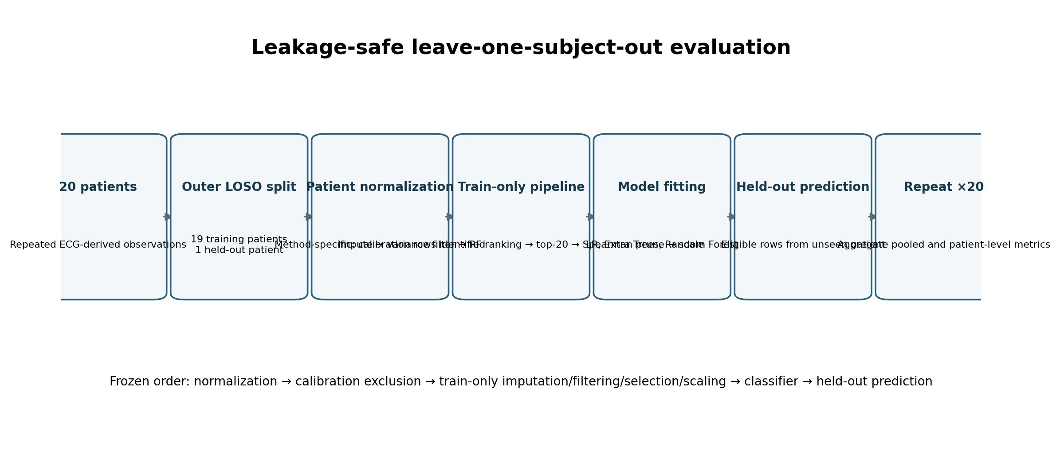
Figure 1. Leakage-safe LOSO pipeline. The held-out patient is excluded from train-derived preprocessing, feature selection, scaling, and model fitting.

7. Patient-Level Normalization Strategies

7.1 No normalization
Original feature values were retained. No information from the held-out patient was used to personalize the representation.

7.2 Retrospective jackknife median
Each observation was centred using labelled reference observations from the same patient. For a reference row, the current row was excluded from its centring median. This is a retrospective, optimistic comparator and is not a directly deployable initial-calibration method.

7.3 Fixed labelled calibration median
Ten labelled Class 0 observations per patient were used to estimate a fixed patient median. The 200 calibration observations were excluded from fitting and evaluation, leaving 1,060 common rows. Selection was deterministic but not verified as chronological.

7.4 Fixed labelled calibration median-IQR
The same 10 observations were used to estimate median and IQR. If the patient IQR was zero, non-finite, or below tolerance, the implementation used a training-derived fallback: median non-zero outer-training patient IQR, then pooled outer-training calibration IQR, then scale 1.0.
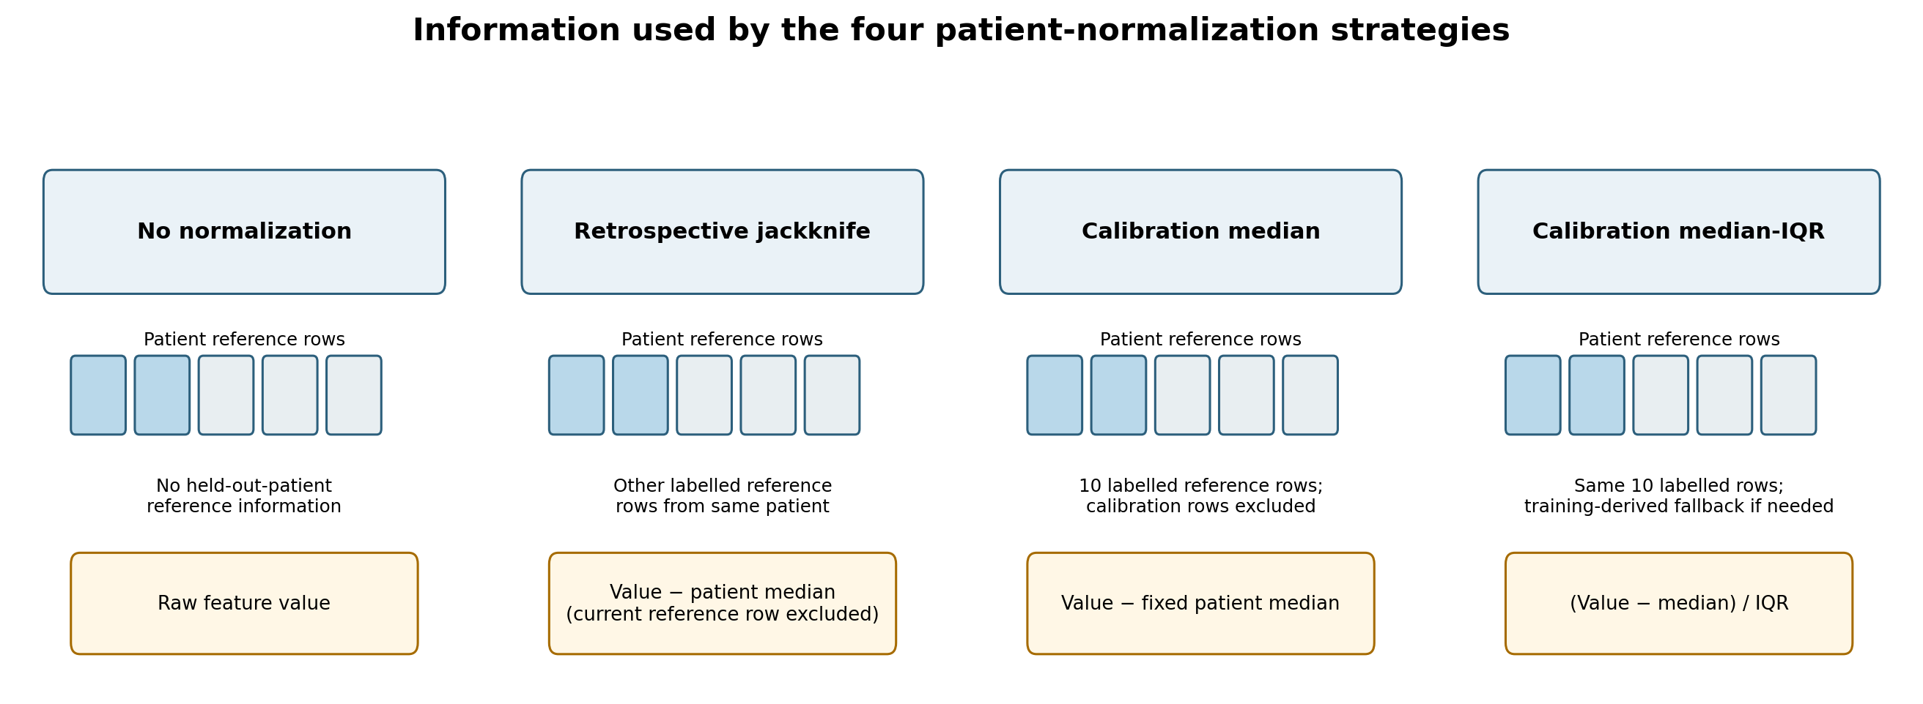
Figure 2. Conceptual comparison of the four normalization strategies and the amount of held-out-patient information used.

8. Leakage-Safe LOSO Validation Pipeline
The frozen order was preserved exactly: patient normalization → calibration-row exclusion → infinity handling → training-only median imputation → variance filtering → Random Forest feature ranking → top-20 selection → Spearman correlation pruning at 0.90 → training-only StandardScaler → classifier fitting → held-out-patient prediction.
The implementation includes checks for train-test row overlap, patient overlap, calibration-row exclusion, jackknife self-exclusion, held-out-patient contribution to IQR fallback, and consistency of common-row identities. Fold-level hashes of transformed train and test matrices were retained.

9. Feature Domains and Fold-Specific Feature Selection
The complete domain contained 35 features spanning time/amplitude/distribution, entropy, nonlinear complexity, fractal, and frequency-domain summaries. The reduced domain contained 10 features: mean absolute value, median, minimum, maximum, variance, standard deviation, skewness, kurtosis, positive-to-negative sample ratio, and number of zero crossings.
Feature selection was repeated independently inside every LOSO training fold. Features were ranked by a training-only Random Forest, restricted to the top 20, and pruned for Spearman correlation above 0.90. Consequently, the benchmark evaluates a fold-specific selection pipeline rather than one globally fixed biomarker set.

10. Classifiers and Model Fitting
Logistic Regression represented a linear classifier. Extra Trees and Random Forest represented nonlinear tree ensembles. Both ensembles used 500 trees, balanced class weighting, and seed 42. Model specifications were fixed; no hyperparameter tuning, threshold optimization, or inner model-selection loop was performed.

11. Evaluation Populations and Performance Measures
The primary common-row population contained the same 1,060 observations for all configurations: 393 reference and 667 HI observations. Native-row evaluation retained 1,260 rows for no normalization and jackknife, but 1,060 rows for the calibration methods. Native-row comparisons are secondary because row populations and positive prevalence differ.
Primary discrimination was assessed with pooled ROC AUC, complemented by average precision, Brier score, balanced accuracy, and patient-level ROC AUC. Patient direction categories identified correctly directed, near-random, and inverted discrimination. Pooled and patient-level metrics answer different questions: pooled AUC includes cross-patient score alignment, whereas patient AUC measures within-patient ranking.

12. Reproducibility and Audit Controls
The frozen package retained a manifest, row-level out-of-fold predictions, common and native pooled metrics, patient-level metrics, directionality summaries, calibration rows, fallback summaries, fold summaries, selected features, and transformed-matrix hashes. The OOF table contained 30,240 records, exactly 1,260 rows × 24 configurations. The 2,400 missing probabilities corresponded exactly to 200 excluded calibration rows × 12 calibration configurations.
The manifest recorded Python 3.13.9, NumPy 2.3.5, pandas 2.3.3, and scikit-learn 1.7.2. It also recorded a non-clean Git working tree. The archive did not include .git history, and a complete exact-environment numerical rerun was not performed during this report assembly.

Table 2. Complete Experimental Matrix
Normalization | Feature domain | Classifier | Folds | Common rows | Native rows
No normalization | All features | Logistic Regression | 20 | 1060 | 1260
No normalization | All features | Extra Trees | 20 | 1060 | 1260
No normalization | All features | Random Forest | 20 | 1060 | 1260
No normalization | Reduced features | Logistic Regression | 20 | 1060 | 1260
No normalization | Reduced features | Extra Trees | 20 | 1060 | 1260
No normalization | Reduced features | Random Forest | 20 | 1060 | 1260
Retrospective jackknife | All features | Logistic Regression | 20 | 1060 | 1260
Retrospective jackknife | All features | Extra Trees | 20 | 1060 | 1260
Retrospective jackknife | All features | Random Forest | 20 | 1060 | 1260
Retrospective jackknife | Reduced features | Logistic Regression | 20 | 1060 | 1260
Retrospective jackknife | Reduced features | Extra Trees | 20 | 1060 | 1260
Retrospective jackknife | Reduced features | Random Forest | 20 | 1060 | 1260
Calibration median | All features | Logistic Regression | 20 | 1060 | 1060
Calibration median | All features | Extra Trees | 20 | 1060 | 1060
Calibration median | All features | Random Forest | 20 | 1060 | 1060
Calibration median | Reduced features | Logistic Regression | 20 | 1060 | 1060
Calibration median | Reduced features | Extra Trees | 20 | 1060 | 1060
Calibration median | Reduced features | Random Forest | 20 | 1060 | 1060
Calibration median-IQR | All features | Logistic Regression | 20 | 1060 | 1060
Calibration median-IQR | All features | Extra Trees | 20 | 1060 | 1060
Calibration median-IQR | All features | Random Forest | 20 | 1060 | 1060
Calibration median-IQR | Reduced features | Logistic Regression | 20 | 1060 | 1060
Calibration median-IQR | Reduced features | Extra Trees | 20 | 1060 | 1060
Calibration median-IQR | Reduced features | Random Forest | 20 | 1060 | 1060

13. Frozen Results

13.1 Performance without normalization
Without normalization, Logistic Regression remained near chance (AUC 0.474 with all features; 0.515 with reduced features). Tree models performed better with the reduced domain: Extra Trees AUC 0.637 and Random Forest AUC 0.639. The most important finding was the pooled-versus-patient discrepancy: reduced-feature Random Forest had median patient AUC 0.849 despite pooled AUC 0.639, with six inverted patients.

13.2 Retrospective jackknife normalization
Jackknife centring substantially improved both tree ensembles. The best frozen configuration was reduced-feature Random Forest: AUC 0.866, average precision 0.889, Brier score 0.179, balanced accuracy 0.767, and median patient AUC 0.966. Sixteen patients improved, three worsened, and one was unchanged relative to no normalization. Logistic Regression did not improve.

13.3 Fixed calibration median
Fixed median calibration recovered part of the tree-model benefit. The strongest result was all-feature Random Forest with AUC 0.728. Patient responses were more heterogeneous: all-feature Random Forest improved 14 patients, worsened five, and left one unchanged; reduced-feature Random Forest split evenly, with 10 improving and 10 worsening.

13.4 Fixed calibration median-IQR
Median-IQR scaling improved pooled AUC over median centring for all four tree comparisons by 0.032-0.052. The strongest fixed-calibration AUC was 0.769 with all-feature Extra Trees; all-feature Random Forest achieved AUC 0.760, Brier score 0.200, and balanced accuracy 0.709. Patient-level effects remained mixed.

13.5 Classifier and feature-domain interactions
Normalization benefits were concentrated in Extra Trees and Random Forest. The reduced feature domain was stronger without normalization, whereas the complete domain was generally stronger under fixed calibration. No single feature domain or classifier dominated every evaluation objective.
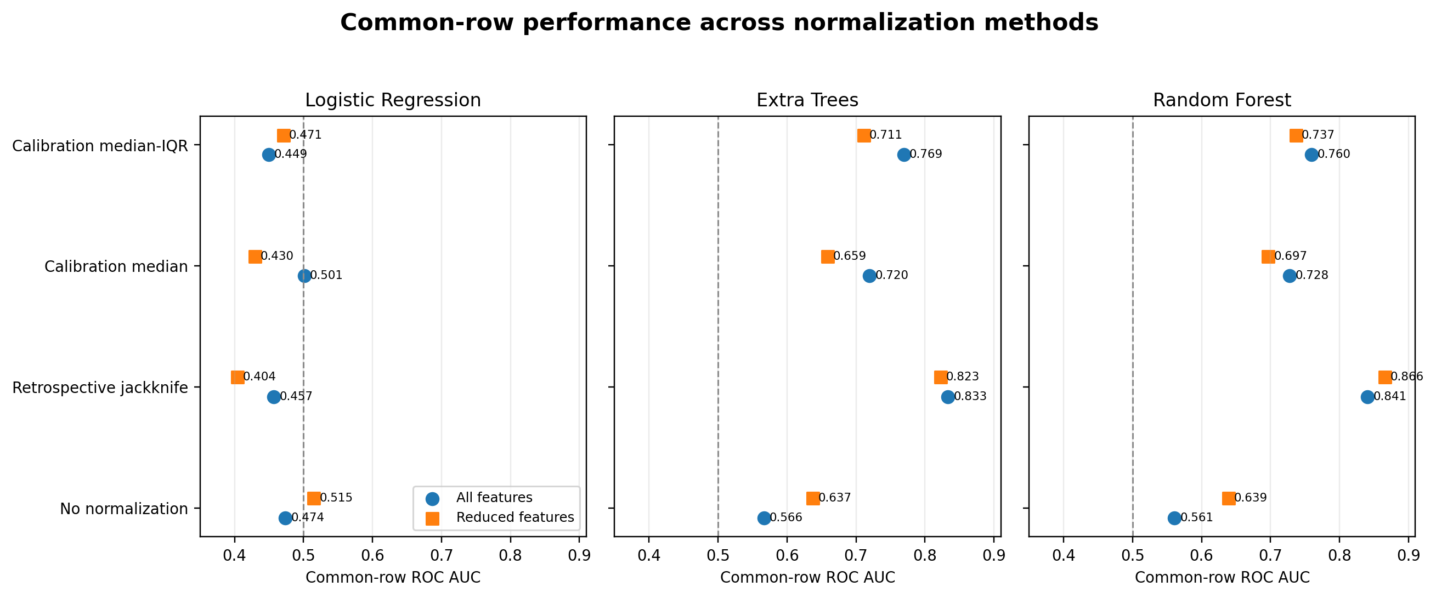
Figure 3. Primary common-row ROC AUC comparison across all 24 configurations. The dashed line marks chance-level ranking.

Table 3. Primary Common-Row Pooled Results
Normalization | Domain | Classifier | AUC | AP | Brier | Balanced acc. | Median patient AUC | Correct | Near | Inverted
Calibration median | All features | Extra Trees | 0.720 | 0.773 | 0.226 | 0.644 | 0.836 | 14 | 1 | 5
Calibration median | All features | Logistic Regression | 0.501 | 0.668 | 0.338 | 0.566 | 0.414 | 7 | 2 | 11
Calibration median | All features | Random Forest | 0.728 | 0.795 | 0.212 | 0.691 | 0.795 | 16 | 0 | 4
Calibration median | Reduced features | Extra Trees | 0.659 | 0.744 | 0.238 | 0.603 | 0.801 | 15 | 3 | 2
Calibration median | Reduced features | Logistic Regression | 0.430 | 0.600 | 0.304 | 0.482 | 0.381 | 8 | 0 | 12
Calibration median | Reduced features | Random Forest | 0.697 | 0.772 | 0.215 | 0.655 | 0.851 | 16 | 2 | 2
Calibration median-IQR | All features | Extra Trees | 0.769 | 0.825 | 0.211 | 0.665 | 0.922 | 18 | 1 | 1
Calibration median-IQR | All features | Logistic Regression | 0.449 | 0.652 | 0.349 | 0.528 | 0.362 | 8 | 0 | 12
Calibration median-IQR | All features | Random Forest | 0.760 | 0.819 | 0.200 | 0.709 | 0.845 | 16 | 2 | 2
Calibration median-IQR | Reduced features | Extra Trees | 0.711 | 0.762 | 0.216 | 0.693 | 0.873 | 15 | 3 | 2
Calibration median-IQR | Reduced features | Logistic Regression | 0.471 | 0.678 | 0.296 | 0.521 | 0.494 | 8 | 2 | 10
Calibration median-IQR | Reduced features | Random Forest | 0.737 | 0.810 | 0.203 | 0.687 | 0.890 | 17 | 2 | 1
Retrospective jackknife | All features | Extra Trees | 0.833 | 0.865 | 0.241 | 0.677 | 0.936 | 17 | 1 | 2
Retrospective jackknife | All features | Logistic Regression | 0.457 | 0.668 | 0.341 | 0.538 | 0.416 | 9 | 0 | 11
Retrospective jackknife | All features | Random Forest | 0.841 | 0.885 | 0.209 | 0.698 | 0.918 | 18 | 0 | 2
Retrospective jackknife | Reduced features | Extra Trees | 0.823 | 0.839 | 0.218 | 0.706 | 0.953 | 19 | 0 | 1
Retrospective jackknife | Reduced features | Logistic Regression | 0.404 | 0.610 | 0.313 | 0.472 | 0.427 | 8 | 1 | 11
Retrospective jackknife | Reduced features | Random Forest | 0.866 | 0.889 | 0.179 | 0.767 | 0.966 | 19 | 1 | 0
No normalization | All features | Extra Trees | 0.566 | 0.644 | 0.261 | 0.509 | 0.682 | 13 | 0 | 7
No normalization | All features | Logistic Regression | 0.474 | 0.619 | 0.302 | 0.475 | 0.495 | 9 | 3 | 8
No normalization | All features | Random Forest | 0.561 | 0.662 | 0.270 | 0.529 | 0.696 | 14 | 3 | 3
No normalization | Reduced features | Extra Trees | 0.637 | 0.746 | 0.236 | 0.600 | 0.831 | 15 | 0 | 5
No normalization | Reduced features | Logistic Regression | 0.515 | 0.675 | 0.267 | 0.489 | 0.471 | 9 | 1 | 10
No normalization | Reduced features | Random Forest | 0.639 | 0.740 | 0.242 | 0.605 | 0.849 | 14 | 0 | 6

Note: All 24 methods are evaluated on the same 1,060 rows. This is the primary like-for-like comparison.

Table 4. Native-Row Pooled Results
Normalization | Domain | Classifier | Rows | AUC | AP | Brier | Balanced acc.
Calibration median | All features | Extra Trees | 1060 | 0.720 | 0.773 | 0.226 | 0.644
Calibration median | All features | Logistic Regression | 1060 | 0.501 | 0.668 | 0.338 | 0.566
Calibration median | All features | Random Forest | 1060 | 0.728 | 0.795 | 0.212 | 0.691
Calibration median | Reduced features | Extra Trees | 1060 | 0.659 | 0.744 | 0.238 | 0.603
Calibration median | Reduced features | Logistic Regression | 1060 | 0.430 | 0.600 | 0.304 | 0.482
Calibration median | Reduced features | Random Forest | 1060 | 0.697 | 0.772 | 0.215 | 0.655
Calibration median-IQR | All features | Extra Trees | 1060 | 0.769 | 0.825 | 0.211 | 0.665
Calibration median-IQR | All features | Logistic Regression | 1060 | 0.449 | 0.652 | 0.349 | 0.528
Calibration median-IQR | All features | Random Forest | 1060 | 0.760 | 0.819 | 0.200 | 0.709
Calibration median-IQR | Reduced features | Extra Trees | 1060 | 0.711 | 0.762 | 0.216 | 0.693
Calibration median-IQR | Reduced features | Logistic Regression | 1060 | 0.471 | 0.678 | 0.296 | 0.521
Calibration median-IQR | Reduced features | Random Forest | 1060 | 0.737 | 0.810 | 0.203 | 0.687
Retrospective jackknife | All features | Extra Trees | 1260 | 0.812 | 0.781 | 0.219 | 0.673
Retrospective jackknife | All features | Logistic Regression | 1260 | 0.453 | 0.550 | 0.323 | 0.533
Retrospective jackknife | All features | Random Forest | 1260 | 0.827 | 0.823 | 0.194 | 0.698
Retrospective jackknife | Reduced features | Extra Trees | 1260 | 0.795 | 0.748 | 0.206 | 0.687
Retrospective jackknife | Reduced features | Logistic Regression | 1260 | 0.418 | 0.507 | 0.302 | 0.481
Retrospective jackknife | Reduced features | Random Forest | 1260 | 0.842 | 0.821 | 0.175 | 0.748
No normalization | All features | Extra Trees | 1260 | 0.559 | 0.542 | 0.259 | 0.503
No normalization | All features | Logistic Regression | 1260 | 0.482 | 0.522 | 0.301 | 0.487
No normalization | All features | Random Forest | 1260 | 0.556 | 0.563 | 0.265 | 0.517
No normalization | Reduced features | Extra Trees | 1260 | 0.655 | 0.687 | 0.232 | 0.612
No normalization | Reduced features | Logistic Regression | 1260 | 0.525 | 0.590 | 0.261 | 0.497
No normalization | Reduced features | Random Forest | 1260 | 0.654 | 0.681 | 0.235 | 0.617

Warning: Native-row populations differ between methods; these results are secondary to Table 3.

Table 5. Patient-Level Performance Summary
Normalization | Domain | Classifier | N | Median | Q1 | Q3 | Min | Max
Calibration median | All features | Extra Trees | 20 | 0.836 | 0.456 | 0.979 | 0.175 | 1.000
Calibration median | All features | Logistic Regression | 20 | 0.414 | 0.234 | 0.698 | 0.000 | 1.000
Calibration median | All features | Random Forest | 20 | 0.795 | 0.627 | 0.988 | 0.215 | 1.000
Calibration median | Reduced features | Extra Trees | 20 | 0.801 | 0.557 | 0.942 | 0.321 | 1.000
Calibration median | Reduced features | Logistic Regression | 20 | 0.381 | 0.144 | 0.649 | 0.000 | 0.989
Calibration median | Reduced features | Random Forest | 20 | 0.851 | 0.611 | 0.993 | 0.217 | 1.000
Calibration median-IQR | All features | Extra Trees | 20 | 0.922 | 0.685 | 1.000 | 0.277 | 1.000
Calibration median-IQR | All features | Logistic Regression | 20 | 0.362 | 0.166 | 0.671 | 0.000 | 0.952
Calibration median-IQR | All features | Random Forest | 20 | 0.845 | 0.615 | 1.000 | 0.337 | 1.000
Calibration median-IQR | Reduced features | Extra Trees | 20 | 0.873 | 0.640 | 0.968 | 0.279 | 1.000
Calibration median-IQR | Reduced features | Logistic Regression | 20 | 0.494 | 0.349 | 0.737 | 0.000 | 0.940
Calibration median-IQR | Reduced features | Random Forest | 20 | 0.890 | 0.635 | 0.973 | 0.331 | 1.000
Retrospective jackknife | All features | Extra Trees | 20 | 0.936 | 0.796 | 1.000 | 0.378 | 1.000
Retrospective jackknife | All features | Logistic Regression | 20 | 0.416 | 0.107 | 0.641 | 0.000 | 1.000
Retrospective jackknife | All features | Random Forest | 20 | 0.918 | 0.759 | 1.000 | 0.284 | 1.000
Retrospective jackknife | Reduced features | Extra Trees | 20 | 0.953 | 0.799 | 0.985 | 0.346 | 1.000
Retrospective jackknife | Reduced features | Logistic Regression | 20 | 0.427 | 0.198 | 0.663 | 0.000 | 1.000
Retrospective jackknife | Reduced features | Random Forest | 20 | 0.966 | 0.857 | 0.987 | 0.473 | 1.000
No normalization | All features | Extra Trees | 20 | 0.682 | 0.266 | 0.821 | 0.000 | 1.000
No normalization | All features | Logistic Regression | 20 | 0.495 | 0.342 | 0.738 | 0.002 | 1.000
No normalization | All features | Random Forest | 20 | 0.696 | 0.524 | 0.825 | 0.030 | 1.000
No normalization | Reduced features | Extra Trees | 20 | 0.831 | 0.658 | 0.912 | 0.043 | 1.000
No normalization | Reduced features | Logistic Regression | 20 | 0.471 | 0.207 | 0.725 | 0.000 | 0.958
No normalization | Reduced features | Random Forest | 20 | 0.849 | 0.433 | 0.925 | 0.087 | 1.000

Table 6. Directionality Relative to No Normalization
Domain | Classifier | Comparison | Improved | Worsened | Unchanged | Inverted→correct | Always inverted
All features | Extra Trees | Retrospective jackknife | 14 | 5 | 1 | 7 | 0
All features | Extra Trees | Calibration median | 12 | 7 | 1 | 5 | 0
All features | Extra Trees | Calibration median-IQR | 13 | 6 | 1 | 6 | 0
All features | Logistic Regression | Retrospective jackknife | 8 | 11 | 1 | 4 | 3
All features | Logistic Regression | Calibration median | 6 | 13 | 1 | 2 | 3
All features | Logistic Regression | Calibration median-IQR | 9 | 11 | 0 | 3 | 3
All features | Random Forest | Retrospective jackknife | 15 | 4 | 1 | 3 | 0
All features | Random Forest | Calibration median | 14 | 5 | 1 | 2 | 0
All features | Random Forest | Calibration median-IQR | 13 | 5 | 2 | 2 | 0
Reduced features | Extra Trees | Retrospective jackknife | 13 | 6 | 1 | 4 | 1
Reduced features | Extra Trees | Calibration median | 9 | 11 | 0 | 3 | 1
Reduced features | Extra Trees | Calibration median-IQR | 9 | 11 | 0 | 3 | 1
Reduced features | Logistic Regression | Retrospective jackknife | 8 | 12 | 0 | 1 | 5
Reduced features | Logistic Regression | Calibration median | 6 | 13 | 1 | 2 | 5
Reduced features | Logistic Regression | Calibration median-IQR | 9 | 10 | 1 | 3 | 5
Reduced features | Random Forest | Retrospective jackknife | 16 | 3 | 1 | 5 | 0
Reduced features | Random Forest | Calibration median | 10 | 10 | 0 | 3 | 0
Reduced features | Random Forest | Calibration median-IQR | 12 | 8 | 0 | 4 | 0

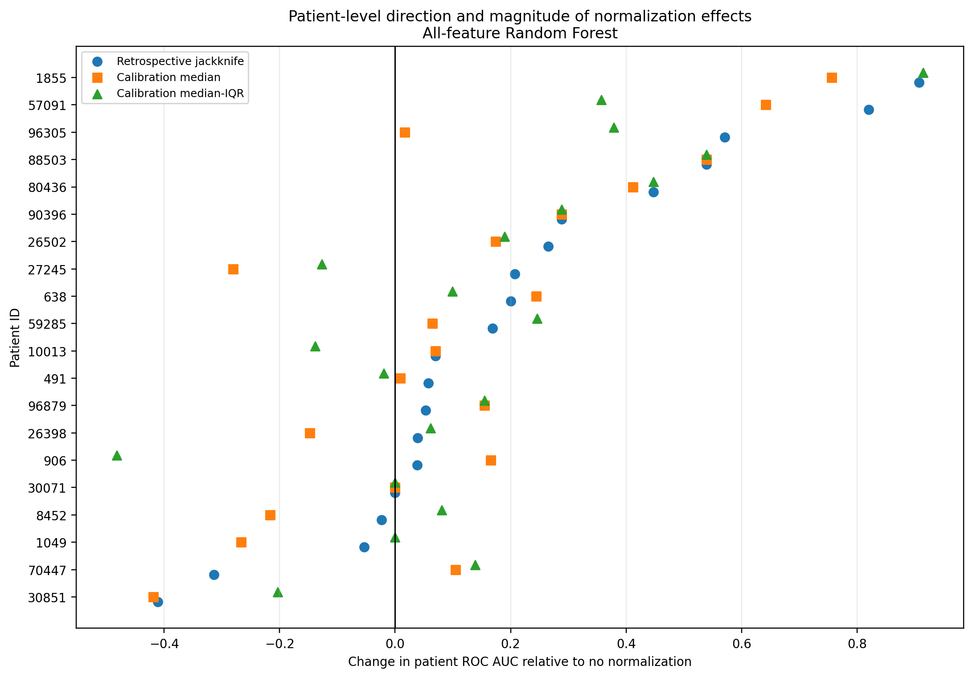
Figure 4. Per-patient change in ROC AUC relative to no normalization for all-feature Random Forest. Positive values indicate improvement.
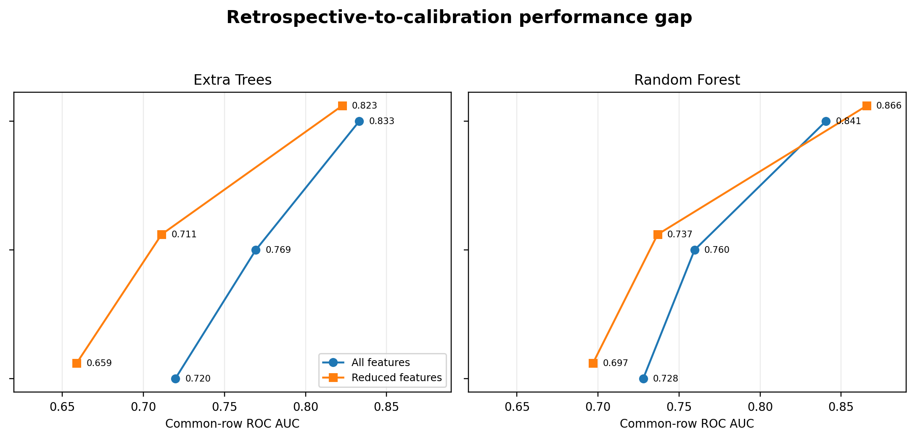
Figure 5. Retrospective-to-calibration gap for the two tree ensembles. Fixed calibration recovers only part of the retrospective normalization benefit.

14. Patient-Level Heterogeneity
Patient-level analysis is essential because pooled metrics combine within-patient ranking with cross-patient score alignment. Jackknife tree-model gains were broadly distributed, particularly for reduced-feature Random Forest, where 16 of 20 patients improved and no patient remained inverted. Fixed calibration was less uniform. A pooled improvement could occur even when a majority of patients did not improve, as observed when reduced-feature Random Forest moved from median to median-IQR scaling.
Clinical-context examples show that large gains occurred in clean-sinus, atrial-fibrillation, and mechanically supported patients, while some paced patients already had strong unnormalized discrimination and worsened after centring. These are descriptive observations only; the frozen evidence does not include a prespecified subgroup or interaction analysis.

15. Calibration and IQR Fallback Findings
The fixed calibration set contained 200 labelled reference observations: 10 per patient. After exclusion, 1,060 observations remained for evaluation. Because row ordering was deterministic but not clinically time-verified, the method is best described as fixed limited labelled calibration rather than prospective calibration.
Median-IQR scaling required 3,240 fallback applications among 18,000 eligible patient-feature-fold operations, an overall proportion of 18%. Fallback affected all 20 patients and 20 of 35 features. fd_bandPower required fallback in every eligible application, Petrosian fractal dimension in 85%, variance in 60%, mean absolute value in 55%, and median in 50%.
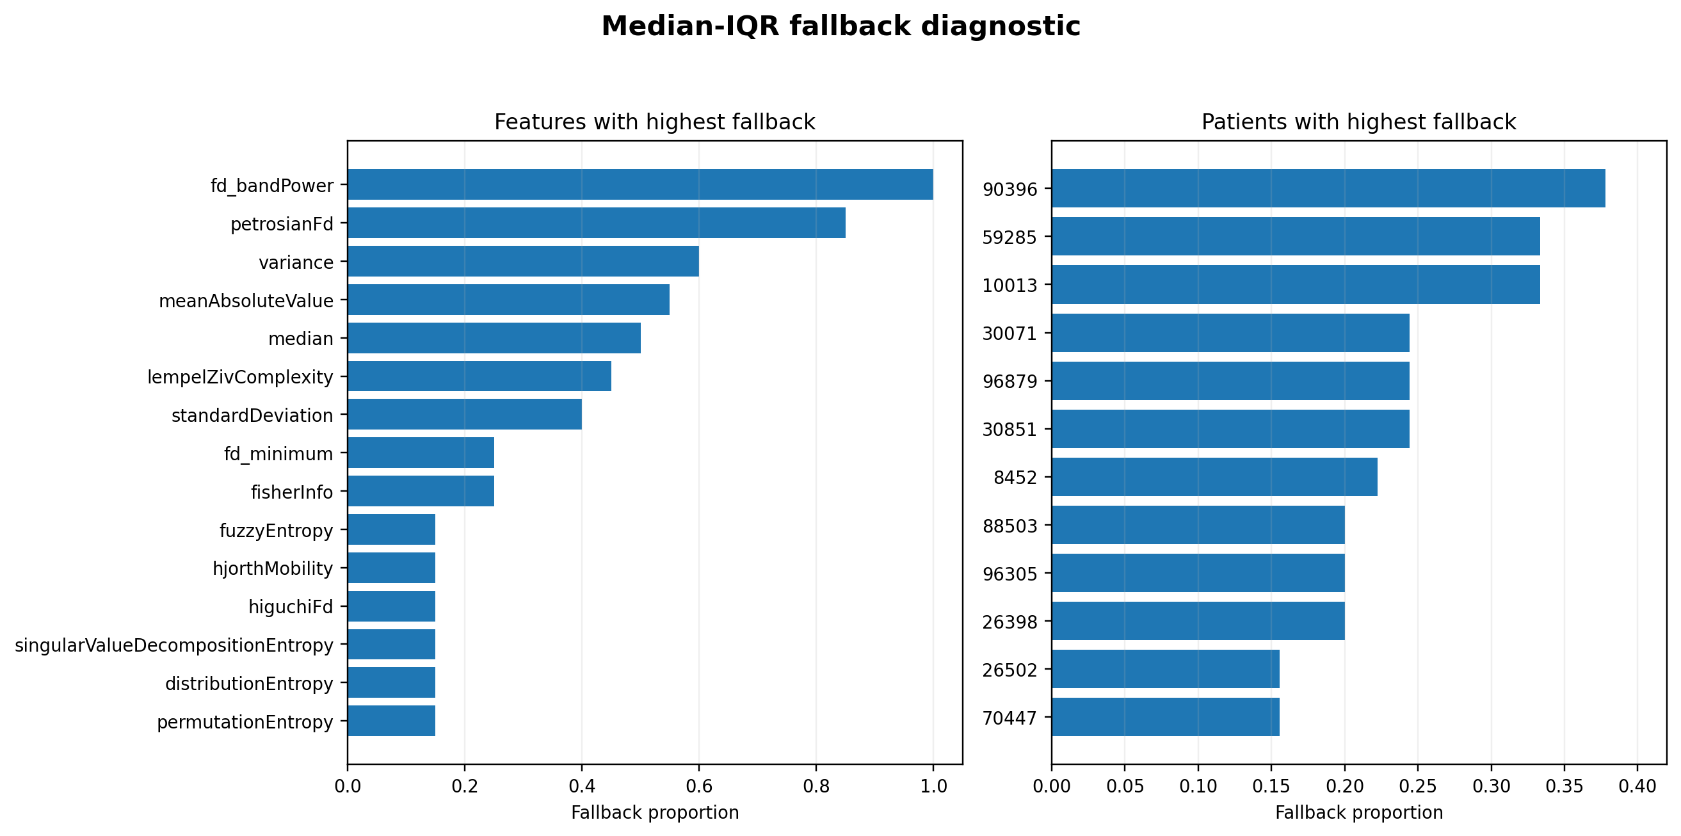
Figure 6. Feature-level and patient-level median-IQR fallback proportions. Rates are derived from the frozen aggregate fallback counts and the documented design denominators.

Table 7. Calibration and IQR Fallback Summary
Item | Frozen result
Calibration patients | 20
Rows per patient | 10 labelled reference rows
Total calibration rows | 200
Evaluation rows after exclusion | 1,060
Overall fallback applications | 3,240
Eligible applications | 18,000
Overall fallback proportion | 18.0%
Patients affected | 20 of 20
Features affected | 20 of 35
Highest feature fallback | fd_bandPower: 100%

Table 8. Clinical Cohort Context
Characteristic | Count or summary
Patients | 20
Median age | 69.5 years
Age IQR | 55.75-79 years
Men / women | 13 / 7
Any atrial fibrillation | 6
Pacing or ICD concern | 5
Bundle branch block | 4
Antiarrhythmic exposure | 5
Mechanical circulatory support | 3
Atypical/non-cardiogenic HI | 3
Clean-sinus candidates | 4
Outside strict HRV-valid subgroup | 8

Clinical characteristics are provided for cohort context. No frozen subgroup-performance analysis was available.

16. Main Scientific Interpretation
Patient-specific variation is a major part of the problem. High within-patient AUC but modest pooled AUC without normalization indicates that patient-specific feature offsets and scale differences impair cross-patient score alignment.
Patient adaptation can substantially improve nonlinear classifiers. Retrospective centring increased tree-model AUC by 0.185-0.280 and corrected directionality for many patients.
Retrospective normalization is optimistic. It uses extensive labelled information from the held-out patient and does not represent initial real-time calibration.
Limited calibration recovers only part of the benefit. The tree-model gap between jackknife and fixed calibration was 0.064-0.169.
Median-IQR scaling offers a trade-off. It improved pooled tree-model AUC but depended frequently on training-derived scale fallback and did not benefit every patient.
Aggregate performance is not patient-uniform. Pooled AUC and patient improvement counts must be reported together.

17. What the Study Does and Does Not Establish

17.1 Establishes
- Patient-specific variation materially changes pooled tree-model performance.
- Retrospective jackknife is an optimistic comparator of personalization potential.
- Fixed labelled calibration recovers part of the benefit.
- Patient responses are heterogeneous.
- IQR fallback is frequent under a 10-row calibration sample.

17.2 Does not establish
- Prospective real-time detection or future-event prediction.
- Clinical readiness or bedside utility.
- Performance using unlabelled calibration.
- Verified chronological calibration.
- External generalisability or formal statistical superiority.
- Causal effects of rhythm, devices, medications, or diagnosis.

18. Limitations
- Only 20 independent patients despite 1,260 repeated observations.
- Clinically heterogeneous, enriched cohort with several potential HI mechanisms.
- No external or prospective validation.
- Calibration required labelled reference observations.
- Calibration order was not verified as chronological.
- Only 10 calibration rows were used; scale estimation was frequently unstable.
- No frozen confidence intervals or paired statistical tests.
- Upstream waveform processing, segmentation, labelling, and feature extraction were not present in the minimal repository.
- The full feature set contains correlated or mathematically related quantities.
- Fixed classifier specifications were not optimized.
- Temporal dependence and possible window overlap could not be independently characterized.
- The manifest recorded a non-clean working tree, and exact-environment full rerun was not completed during report assembly.

19. Implications for a Practical Monitoring System
A practical system would require a clearly defined, chronological calibration period that precedes prediction and represents a stable patient state. It would also need a policy for uncertain calibration labels, baseline drift, rhythm conversion, electrode changes, insufficient feature variation, and reversion to a non-personalized model when calibration quality is poor.
Clinical translation would require external validation, prospective data collection, explicit lead-time or detection definitions, threshold selection, alarm-burden analysis, subgroup and failure-mode evaluation, clinician usability assessment, and demonstration of impact on decisions or outcomes.

20. Proposed Manuscript Story
Haemodynamic instability is clinically important, while continuous invasive blood-pressure monitoring is not universally available. ECG is a routinely acquired continuous signal, but patient-specific physiology and devices create substantial variation in engineered feature distributions. The study asks whether patient adaptation can reduce this cross-patient misalignment and, critically, whether the apparent benefit survives when patient information is restricted to a small calibration set.
Without normalization, tree models often discriminated well within patients but showed modest pooled performance. Retrospective jackknife centring substantially improved discrimination, whereas fixed 10-row labelled calibration recovered only part of that benefit. Median-IQR scaling improved pooled calibration performance but required frequent fallback and had mixed patient-level effects. The manuscript contribution is therefore a patient-aware evaluation framework that distinguishes retrospective personalization potential from limited-calibration performance.

21. Candidate Manuscript Contributions
- Leakage-safe LOSO comparison of four patient-normalization strategies.
- Explicit separation of retrospective adaptation from fixed limited calibration.
- Primary common-row evaluation holding row identity constant.
- Patient-level directionality analysis of improved, worsened, and inverted patients.
- Operational audit of median-IQR fallback under a small calibration sample.

22. Recommended Tables and Figures
The collaborator report includes eight tables and six figures. The main manuscript should retain the dataset/design table, primary common-row results, patient-level summary and directionality, plus Figures 1-5. Native-row details, the complete experimental matrix, detailed fallback diagnostics, and clinical-context overlays are better suited to supplementary material.

23. Conclusions
Patient adaptation can materially improve ECG-based classification of haemodynamic instability, but retrospective normalization should not be interpreted as prospective deployment performance.
The strongest evidence is the discrepancy between pooled and within-patient discrimination without normalization, the broad tree-model improvement under retrospective jackknife centring, and the incomplete recovery under fixed 10-row labelled calibration. Median-IQR scaling improved pooled tree-model discrimination but exposed an important practical limitation: reliable patient-specific dispersion could not always be estimated from a small calibration sample.
Future evaluation should prioritize chronologically acquired, minimally labelled or unlabelled calibration in independent and prospectively collected cohorts.

24. Technical Appendix

24.1 Authoritative artifacts
Artifact | Role
data/FullFeatureDataset_Clean.csv | Canonical modelling dataset
results/frozen/manifest.json | Configuration, environment, provenance
results/frozen/oof_predictions.csv | Row-level OOF predictions
results/frozen/common_row_metrics.csv | Primary pooled results
results/frozen/native_row_metrics.csv | Secondary pooled results
results/frozen/common_row_patient_metrics.csv | Patient-level common-row metrics
results/frozen/patient_directionality.csv | Improved/worsened counts
results/frozen/calibration_rows.csv | Calibration identities
results/frozen/iqr_fallback_counts.csv | Fallback diagnostics
results/frozen/fold_summary.csv | Fold counts, selected features, hashes

24.2 Frozen software and provenance
Field | Frozen value
Python | 3.13.9
NumPy | 2.3.5
pandas | 2.3.3
scikit-learn | 1.7.2
Git branch | audit/student-code-review
Git commit | a58aa971a26986fb7188bdb613ab4c133f3dfae8
Working tree clean | false
Run timestamp | 2026-07-30T15:56:50.169119+00:00

24.3 Selected checksums
File | SHA-256
FullFeatureDataset_Clean.csv | ef5a8c73034afa0ff92da1a5c31d133c1d847fe1894ba8c559bfd2cdab440796
calibration_rows.csv | 17ac6131288d7502b4ea0862a96ab1130acdc54a243ae634955f1b66b6ae32fa
common_row_metrics.csv | 4b9cd0c9f1ef9f62cd6f7c5c4f0f654c2860dfed311d46a21aa753c52049c38d
common_row_patient_metrics.csv | f871b2e40d9784af7cdfda2efa6eea1ecdae3c13e3271fce8a22fdf5885a283e
fold_summary.csv | fb5fe60fca087d4cb8e9ecd8adcd4c12bd737899a89c2b7c9e10b981d5f1cc13
iqr_fallback_counts.csv | 9b6fc6daa5e07ac0a687216330084eef5279fb874913dcdf0dab54573a981b98
manifest.json | 88c554a0498f06396992a50c5706f2771f9104b0251512e9ac6fe58238bfeec2
native_row_metrics.csv | 636d29e4503848288e43f2f450288774d1d98049bc58984f862d152825be6ade
native_row_patient_metrics.csv | ab37f2a699db2b2e9c02620b944785f82364596144d3fcfed7562a85d5738609
oof_predictions.csv | 091e69a66b3f0c731b3a0d964d2dece1a04d63d10b6d5f74d664b3e7ffc29d70
patient_directionality.csv | a9e1f698f869c849e610f5f66449ea124f21d8cbb708a6771d8b33d63eb2b4b1

24.4 Traceability matrix
Claim | Primary source
20 patients; 1,260 rows | Dataset, manifest
Common comparison used 1,060 identical rows | OOF predictions, common metrics
Best retrospective AUC 0.866 | Common metrics: jackknife/reduced/RF
Best fixed-calibration AUC 0.769 | Common metrics: median-IQR/all/ET
16 patients improved in best retrospective configuration | Directionality summary
Retrospective-to-calibration gap 0.064-0.169 | Matched common-metric subtraction
Fallback proportion 18% | IQR fallback counts
Calibration chronology unverified | Calibration rows + identifier audit
Clinical heterogeneity present | Clinical summary and flags

24.5 Audit qualification
The frozen evidence is sufficient to reconstruct the patient-normalization benchmark and its major numerical conclusions. It is not sufficient to independently audit the upstream waveform and event-labelling pipeline, establish prospective calibration, conduct formal clinical subgroup inference, or claim external clinical readiness.

