================================

CS5811 Distributed Data Analysis

Group work and individuals
CS5811 Distributed Data Analysis Classifying Urban Air Quality Risk from Pollutant Sub-Indices: A Machine Learning and Parallel Computing Approach author: “Ahmed Malik · Zayan Arshad Syed · Shiv Solanki” “Brunel University London | Department of Computer Science | May 2026” # ================================#
#IMPORT APPROPRIATE LIBRARIES
library(tidyverse)
## ── Attaching core tidyverse packages ──────────────────────── tidyverse 2.0.0 ──
## ✔ dplyr 1.2.1 ✔ readr 2.2.0
## ✔ forcats 1.0.1 ✔ stringr 1.6.0
## ✔ ggplot2 4.0.2 ✔ tibble 3.3.1
## ✔ lubridate 1.9.5 ✔ tidyr 1.3.2
## ✔ purrr 1.2.2
## ── Conflicts ────────────────────────────────────────── tidyverse_conflicts() ──
## ✖ dplyr::filter() masks stats::filter()
## ✖ dplyr::lag() masks stats::lag()
## ℹ Use the conflicted package (<http://conflicted.r-lib.org/>) to force all conflicts to become errors
library(readr)
library(knitr)
library(janitor)
##
## Attaching package: 'janitor'
##
## The following objects are masked from 'package:stats':
##
## chisq.test, fisher.test
library(rsample)
library(randomForest)
## randomForest 4.7-1.2
## Type rfNews() to see new features/changes/bug fixes.
##
## Attaching package: 'randomForest'
##
## The following object is masked from 'package:dplyr':
##
## combine
##
## The following object is masked from 'package:ggplot2':
##
## margin
#IMPORTING THE DATASET
# Import dataset
aqi_raw <- read_csv("AQI and Lat Long of Countries.csv")
## Rows: 16695 Columns: 14
## ── Column specification ────────────────────────────────────────────────────────
## Delimiter: ","
## chr (7): Country, City, AQI Category, CO AQI Category, Ozone AQI Category, N...
## dbl (7): AQI Value, CO AQI Value, Ozone AQI Value, NO2 AQI Value, PM2.5 AQI ...
##
## ℹ Use `spec()` to retrieve the full column specification for this data.
## ℹ Specify the column types or set `show_col_types = FALSE` to quiet this message.
head(aqi_raw)
## # A tibble: 6 × 14
## Country City `AQI Value` `AQI Category` `CO AQI Value` `CO AQI Category`
## <chr> <chr> <dbl> <chr> <dbl> <chr>
## 1 Russian Fed… Pras… 51 Moderate 1 Good
## 2 Brazil Pres… 41 Good 1 Good
## 3 Brazil Pres… 41 Good 1 Good
## 4 Italy Prio… 66 Moderate 1 Good
## 5 Poland Prza… 34 Good 1 Good
## 6 United Stat… Punt… 54 Moderate 1 Good
## # ℹ 8 more variables: `Ozone AQI Value` <dbl>, `Ozone AQI Category` <chr>,
## # `NO2 AQI Value` <dbl>, `NO2 AQI Category` <chr>, `PM2.5 AQI Value` <dbl>,
## # `PM2.5 AQI Category` <chr>, lat <dbl>, lng <dbl>
#EXPLORING THE DATA AND GAINING INSIGHTS
# Basic inspection
dim(aqi_raw)
## [1] 16695 14
glimpse(aqi_raw)
## Rows: 16,695
## Columns: 14
## $ Country <chr> "Russian Federation", "Brazil", "Brazil", "Italy"…
## $ City <chr> "Praskoveya", "Presidente Dutra", "Presidente Dut…
## $ `AQI Value` <dbl> 51, 41, 41, 66, 34, 54, 54, 64, 54, 68, 41, 59, 5…
## $ `AQI Category` <chr> "Moderate", "Good", "Good", "Moderate", "Good", "…
## $ `CO AQI Value` <dbl> 1, 1, 1, 1, 1, 1, 1, 1, 1, 2, 1, 1, 1, 1, 1, 5, 1…
## $ `CO AQI Category` <chr> "Good", "Good", "Good", "Good", "Good", "Good", "…
## $ `Ozone AQI Value` <dbl> 36, 5, 5, 39, 34, 14, 14, 29, 41, 68, 24, 30, 47,…
## $ `Ozone AQI Category` <chr> "Good", "Good", "Good", "Good", "Good", "Good", "…
## $ `NO2 AQI Value` <dbl> 0, 1, 1, 2, 0, 11, 11, 7, 1, 1, 6, 4, 0, 23, 2, 1…
## $ `NO2 AQI Category` <chr> "Good", "Good", "Good", "Good", "Good", "Good", "…
## $ `PM2.5 AQI Value` <dbl> 51, 41, 41, 66, 20, 54, 54, 64, 54, 58, 41, 59, 5…
## $ `PM2.5 AQI Category` <chr> "Moderate", "Good", "Good", "Moderate", "Good", "…
## $ lat <dbl> 44.7444, -5.2900, -11.2958, 37.1667, 53.0167, 16.…
## $ lng <dbl> 44.2031, -44.4900, -41.9869, 15.1833, 20.8833, -8…
names(aqi_raw)
## [1] "Country" "City" "AQI Value"
## [4] "AQI Category" "CO AQI Value" "CO AQI Category"
## [7] "Ozone AQI Value" "Ozone AQI Category" "NO2 AQI Value"
## [10] "NO2 AQI Category" "PM2.5 AQI Value" "PM2.5 AQI Category"
## [13] "lat" "lng"
summary(aqi_raw)
## Country City AQI Value AQI Category
## Length:16695 Length:16695 Min. : 7.0 Length:16695
## Class :character Class :character 1st Qu.: 38.5 Class :character
## Mode :character Mode :character Median : 52.0 Mode :character
## Mean : 63.0
## 3rd Qu.: 69.0
## Max. :500.0
## CO AQI Value CO AQI Category Ozone AQI Value Ozone AQI Category
## Min. : 0.000 Length:16695 Min. : 0.00 Length:16695
## 1st Qu.: 1.000 Class :character 1st Qu.: 20.00 Class :character
## Median : 1.000 Mode :character Median : 29.00 Mode :character
## Mean : 1.342 Mean : 31.77
## 3rd Qu.: 1.000 3rd Qu.: 38.00
## Max. :133.000 Max. :222.00
## NO2 AQI Value NO2 AQI Category PM2.5 AQI Value PM2.5 AQI Category
## Min. : 0.00 Length:16695 Min. : 0.00 Length:16695
## 1st Qu.: 0.00 Class :character 1st Qu.: 34.00 Class :character
## Median : 2.00 Mode :character Median : 52.00 Mode :character
## Mean : 3.82 Mean : 59.82
## 3rd Qu.: 5.00 3rd Qu.: 69.00
## Max. :91.00 Max. :500.00
## lat lng
## Min. :-54.80 Min. :-171.750
## 1st Qu.: 16.52 1st Qu.: -75.180
## Median : 38.82 Median : 5.643
## Mean : 30.27 Mean : -3.944
## 3rd Qu.: 46.68 3rd Qu.: 36.275
## Max. : 70.77 Max. : 178.018
head(aqi_raw)
## # A tibble: 6 × 14
## Country City `AQI Value` `AQI Category` `CO AQI Value` `CO AQI Category`
## <chr> <chr> <dbl> <chr> <dbl> <chr>
## 1 Russian Fed… Pras… 51 Moderate 1 Good
## 2 Brazil Pres… 41 Good 1 Good
## 3 Brazil Pres… 41 Good 1 Good
## 4 Italy Prio… 66 Moderate 1 Good
## 5 Poland Prza… 34 Good 1 Good
## 6 United Stat… Punt… 54 Moderate 1 Good
## # ℹ 8 more variables: `Ozone AQI Value` <dbl>, `Ozone AQI Category` <chr>,
## # `NO2 AQI Value` <dbl>, `NO2 AQI Category` <chr>, `PM2.5 AQI Value` <dbl>,
## # `PM2.5 AQI Category` <chr>, lat <dbl>, lng <dbl>
This gives us a first understanding of:
-how many rows and columns the dataset has -what the variable names are -which variables are numeric or categorical -whether there are missing values -whether any columns look irrelevant or messy -what the rough ranges of the variables look like
This dataset contains 16,695 observations and 14 variables, representing air quality measurements across different countries and cities. The key variable of interest is AQI Value, which indicates overall air pollution levels. Alongside this, pollutant-specific indicators such as CO, Ozone, NO₂, and PM2.5 AQI values are provided, along with their respective categories. The dataset is cross-sectional, representing a snapshot of air quality conditions across cities at a given point in time. This means temporal patterns such as seasonal variation are not captured in this analysis.
Geographical variables (latitude and longitude) are also included, allowing for potential spatial analysis.

RESEARCH QUESTION
This study aims to investigate whether pollutant sub-indices can reliably classify urban air quality risk categories. It also evaluates which machine learning models and high-performance computing approaches provide the best balance between prediction accuracy, interpretability, and computational efficiency.

ANALYSIS PLAN
The analysis follows a structured workflow: exploratory data analysis to understand the dataset, data cleaning and preparation, model development using multiple classification techniques, performance evaluation, and comparison of high-performance computing implementations.
#RENAMIMG THE DATASET
aqi_data <- aqi_raw %>%
clean_names()
#VERIFYING DATA TYPES
str(aqi_data)
## spc_tbl_ [16,695 × 14] (S3: spec_tbl_df/tbl_df/tbl/data.frame)
## $ country : chr [1:16695] "Russian Federation" "Brazil" "Brazil" "Italy" ...
## $ city : chr [1:16695] "Praskoveya" "Presidente Dutra" "Presidente Dutra" "Priolo Gargallo" ...
## $ aqi_value : num [1:16695] 51 41 41 66 34 54 54 64 54 68 ...
## $ aqi_category : chr [1:16695] "Moderate" "Good" "Good" "Moderate" ...
## $ co_aqi_value : num [1:16695] 1 1 1 1 1 1 1 1 1 2 ...
## $ co_aqi_category : chr [1:16695] "Good" "Good" "Good" "Good" ...
## $ ozone_aqi_value : num [1:16695] 36 5 5 39 34 14 14 29 41 68 ...
## $ ozone_aqi_category: chr [1:16695] "Good" "Good" "Good" "Good" ...
## $ no2_aqi_value : num [1:16695] 0 1 1 2 0 11 11 7 1 1 ...
## $ no2_aqi_category : chr [1:16695] "Good" "Good" "Good" "Good" ...
## $ pm2_5_aqi_value : num [1:16695] 51 41 41 66 20 54 54 64 54 58 ...
## $ pm2_5_aqi_category: chr [1:16695] "Moderate" "Good" "Good" "Moderate" ...
## $ lat : num [1:16695] 44.74 -5.29 -11.3 37.17 53.02 ...
## $ lng : num [1:16695] 44.2 -44.5 -42 15.2 20.9 ...
## - attr(*, "spec")=
## .. cols(
## .. Country = col_character(),
## .. City = col_character(),
## .. `AQI Value` = col_double(),
## .. `AQI Category` = col_character(),
## .. `CO AQI Value` = col_double(),
## .. `CO AQI Category` = col_character(),
## .. `Ozone AQI Value` = col_double(),
## .. `Ozone AQI Category` = col_character(),
## .. `NO2 AQI Value` = col_double(),
## .. `NO2 AQI Category` = col_character(),
## .. `PM2.5 AQI Value` = col_double(),
## .. `PM2.5 AQI Category` = col_character(),
## .. lat = col_double(),
## .. lng = col_double()
## .. )
## - attr(*, "problems")=<externalptr>
Variable types were verified to ensure that numerical variables are correctly formatted for analysis and that categorical variables such as AQI category are appropriately represented.
#EXPLORING THE AQI
ggplot(aqi_data, aes(x = aqi_value)) +
geom_histogram(bins = 40, fill = "red", color = "grey") +
labs(
title = "Distribution of AQI Values",
x = "AQI Value",
y = "Frequency"
) +
theme_minimal()
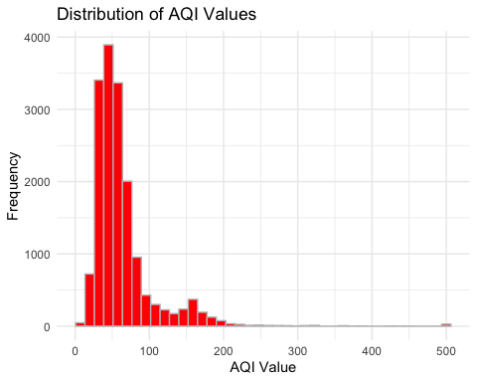 The histogram shows how AQI values are distributed across observations. This is useful because it tells us whether air quality levels are mostly concentrated in lower-risk ranges or whether the dataset contains many severe pollution cases. If the distribution is strongly skewed, it suggests that extreme air quality events are less common but still important to capture.
The distribution of AQI values shows a clear positive (right) skew, where the majority of observations are concentrated at lower AQI levels, while a small number of extreme values extend towards higher pollution levels. Most cities fall within the AQI range of approximately 30 to 80, indicating generally acceptable air quality conditions.
However, the presence of extreme values (reaching up to 500) suggests that some locations experience severe pollution episodes, which significantly increase the spread of the data. This skewness indicates that the mean AQI (63) is higher than the median (52), confirming the influence of outliers.
#EXPLORING THE AQI CATEGORIES
ggplot(aqi_data, aes(x = aqi_category)) +
geom_bar(fill = "red") +
labs(
title = "Distribution of AQI Categories",
x = "AQI Category",
y = "Count"
) +
theme_minimal() +
theme(axis.text.x = element_text(angle = 30, hjust = 1))
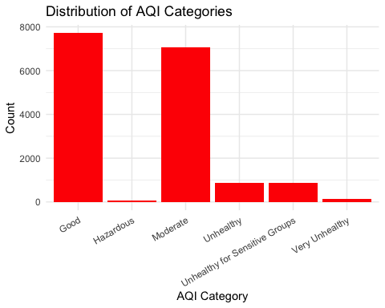
The categorical distribution of AQI levels reveals that the dataset is highly imbalanced, with the majority of observations falling into the “Good” and “Moderate” categories. In contrast, categories such as “Hazardous” and “Very Unhealthy” are extremely rare.
This indicates that most recorded locations generally experience acceptable to moderate air quality, while severe pollution events are relatively uncommon.
#CHECKING THE POLLUTANT VARIABLES
aqi_data %>%
select(co_aqi_value, ozone_aqi_value, no2_aqi_value, pm2_5_aqi_value) %>%
pivot_longer(everything(), names_to = "pollutant", values_to = "value") %>%
ggplot(aes(x = value)) +
geom_histogram(bins = 35, fill = "darkseagreen", color = "white") +
facet_wrap(~ pollutant, scales = "free") +
labs(
title = "Distribution of Pollutant Sub-Indices",
x = "Value",
y = "Frequency"
) +
theme_minimal()
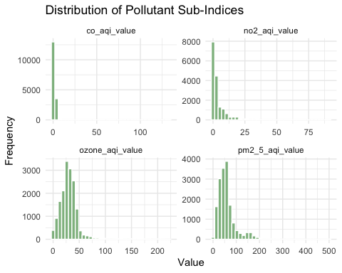 These histograms show how each pollutant sub-index is distributed. This helps identify which pollutants vary the most and which appear to contribute more strongly to poor air quality conditions. A wide spread or long tail may indicate that a pollutant plays an important role in extreme AQI cases.
The distributions of pollutant sub-indices reveal distinct variability patterns across pollutants. CO AQI values are highly concentrated at very low levels, indicating minimal variation and suggesting that CO contributes little to no differences in overall air quality across observations. Similarly, NO₂ values are generally low, with a slight right skew, indicating occasional increases but limited overall influence.
In contrast, Ozone exhibits moderate variability, with values spread across a wider range, suggesting a more noticeable but still secondary contribution. The most significant variation is observed in PM2.5 AQI values, which display a strong right-skewed distribution with extreme values extending up to 500.
#CHECKING THE RELATIONSHIP WITH THE AQI
ggplot(aqi_data, aes(x = pm2_5_aqi_value, y = aqi_value)) +
geom_point(alpha = 0.4) +
geom_smooth(method = "lm", se = FALSE) +
labs(
title = "PM2.5 AQI vs Overall AQI",
x = "PM2.5 AQI Value",
y = "Overall AQI"
) +
theme_minimal()
## `geom_smooth()` using formula = 'y ~ x'
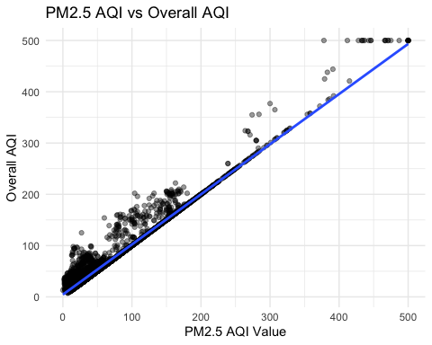 This scatterplot is used to check whether PM2.5 is strongly associated with overall AQI. A clear upward pattern would suggest that PM2.5 is a major driver of air quality risk and should be retained as a key predictor in the later modelling stage.
The relationship between PM2.5 AQI and overall AQI demonstrates a strong positive linear association, with points closely aligned along a straight line. This indicates that increases in PM2.5 levels are directly associated with increases in overall AQI.
The correlation coefficient of approximately 0.98 confirms an extremely strong relationship, suggesting that PM2.5 alone explains a substantial proportion of the variation in overall air quality.
#CHECKING FOR THE POTENTIAL OUTLIERS
ggplot(aqi_data, aes(y = aqi_value)) +
geom_boxplot(fill = "lightblue") +
labs(
title = "Boxplot of AQI Values",
y = "AQI Value"
) +
theme_minimal()
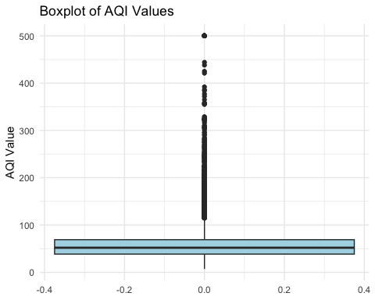 The boxplot of AQI values highlights the presence of numerous extreme outliers, particularly at higher AQI levels. While the majority of observations are concentrated within a relatively narrow range (around 30–70), a significant number of observations extend far beyond this range.
#IQR METHOD CHECK
Q1 <- quantile(aqi_data$aqi_value, 0.25, na.rm = TRUE)
Q3 <- quantile(aqi_data$aqi_value, 0.75, na.rm = TRUE)
IQR_value <- Q3 - Q1
upper_bound <- Q3 + 1.5 * IQR_value
lower_bound <- Q1 - 1.5 * IQR_value
outliers <- aqi_data %>%
filter(aqi_value > upper_bound | aqi_value < lower_bound)
nrow(outliers)
## [1] 1573
Outliers were assessed using both visual (boxplot) and numerical (IQR) methods. A number of extreme AQI values were identified; however, these observations were retained. This is because high AQI values represent real-world severe pollution events rather than errors. Removing them would reduce the model’s ability to identify hazardous air quality conditions, which are critical for this analysis.Outlier analysis using the IQR method identified approximately 9.4% of the observations as extreme values. These outliers correspond to high AQI levels and represent genuine pollution events rather than data errors. As such, they are retained in the dataset to ensure that the analysis captures the full range of air quality conditions. However, their presence introduces potential challenges for modelling, particularly for methods sensitive to extreme values, which will be considered in the model selection process.
#TO CHECK FOR THE OUTLIERS IN THE PM2.5
ggplot(aqi_data, aes(y = pm2_5_aqi_value)) +
geom_boxplot(fill = "lightgreen") +
labs(
title = "Boxplot of PM2.5 AQI",
y = "PM2.5 AQI Value"
) +
theme_minimal()
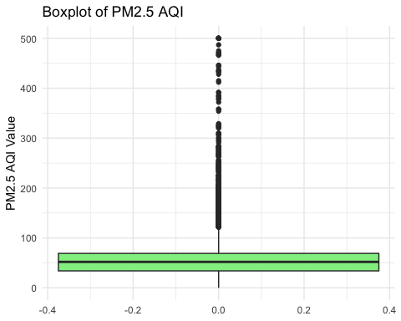 The PM2.5 AQI boxplot mirrors the pattern observed in the overall AQI distribution, with a large number of extreme values and a long upper tail. This further reinforces the earlier observation that PM2.5 is the primary contributor to AQI variability.
#CORRELATION MATRIX
cor_data <- aqi_data %>%
select(aqi_value, co_aqi_value, ozone_aqi_value, no2_aqi_value, pm2_5_aqi_value, lat, lng)
cor_matrix <- cor(cor_data, use = "complete.obs")
round(cor_matrix, 2)
## aqi_value co_aqi_value ozone_aqi_value no2_aqi_value
## aqi_value 1.00 0.46 0.33 0.31
## co_aqi_value 0.46 1.00 0.04 0.40
## ozone_aqi_value 0.33 0.04 1.00 -0.25
## no2_aqi_value 0.31 0.40 -0.25 1.00
## pm2_5_aqi_value 0.98 0.46 0.23 0.34
## lat -0.10 -0.08 0.25 0.04
## lng 0.15 0.00 0.32 -0.29
## pm2_5_aqi_value lat lng
## aqi_value 0.98 -0.10 0.15
## co_aqi_value 0.46 -0.08 0.00
## ozone_aqi_value 0.23 0.25 0.32
## no2_aqi_value 0.34 0.04 -0.29
## pm2_5_aqi_value 1.00 -0.13 0.11
## lat -0.13 1.00 -0.03
## lng 0.11 -0.03 1.00
The correlation analysis reveals that PM2.5 AQI has an extremely strong positive correlation (0.98) with overall AQI, confirming it as the dominant factor influencing air quality. Other pollutants such as CO (0.46), Ozone (0.33), and NO₂ (0.31) show moderate to weak relationships, indicating they contribute to AQI but to a lesser extent.
Geographical variables (latitude and longitude) exhibit very weak correlations, suggesting that location alone does not strongly determine AQI levels in this dataset.
#CHECKING FOR MISSING VALUES
colSums(is.na(aqi_data))
## country city aqi_value aqi_category
## 302 0 0 0
## co_aqi_value co_aqi_category ozone_aqi_value ozone_aqi_category
## 0 0 0 0
## no2_aqi_value no2_aqi_category pm2_5_aqi_value pm2_5_aqi_category
## 0 0 0 0
## lat lng
## 0 0
The dataset is largely complete, with missing values only present in the Country variable (1.8%). As this variable is not used for modelling and geographic information is already captured through latitude and longitude, no imputation was required.
#CHECKING FOR DUPLICATES
sum(duplicated(aqi_data))
## [1] 0
No duplicate records were found in the dataset, indicating that each observation represents a unique measurement.
DATA CLEANING AND PREPARATION #MISSING VALUE ANALYSIS
aqi_data %>%
summarise(across(everything(), ~ sum(is.na(.)))) %>%
pivot_longer(
everything(),
names_to = "variable",
values_to = "missing_count"
) %>%
filter(missing_count > 0)
## # A tibble: 1 × 2
## variable missing_count
## <chr> <int>
## 1 country 302
Missing values were checked across all variables to identify any data quality issues before modelling. This step is important because missing values can reduce the reliability of model training and evaluation if they occur in important predictors or the target variable. The dataset was examined for missing values, revealing that only the Country variable contains missing entries (302 observations, approximately 1.8%), while all other variables are complete.
This indicates that the dataset is largely clean and reliable, with minimal missing data.
#CHECKING FOR DUPLICATES
sum(duplicated(aqi_data))
## [1] 0
Duplicate rows were checked to ensure data integrity. No duplicate observations were found, so no duplicate removal was required.
#CROSS CHECKING FOR THE CLASS IMBALANCE
aqi_data %>%
count(aqi_category) %>%
mutate(percentage = n / sum(n) * 100)
## # A tibble: 6 × 3
## aqi_category n percentage
## <chr> <int> <dbl>
## 1 Good 7708 46.2
## 2 Hazardous 62 0.371
## 3 Moderate 7054 42.3
## 4 Unhealthy 871 5.22
## 5 Unhealthy for Sensitive Groups 869 5.21
## 6 Very Unhealthy 131 0.785
The distribution of AQI categories reveals a significant class imbalance, with the majority of observations concentrated in the “Good” (46.17%) and “Moderate” (42.25%) categories. In contrast, severe pollution categories such as “Very Unhealthy” (0.78%) and “Hazardous” (0.37%) are extremely rare.
#VARIABLE SELECTION
aqi_model <- aqi_data %>%
select(
aqi_category,
co_aqi_value,
ozone_aqi_value,
no2_aqi_value,
pm2_5_aqi_value,
lat,
lng
)
Based on the exploratory analysis, a subset of relevant variables was selected for modelling. PM2.5 was retained as the primary predictor due to its strong relationship with AQI. Other pollutants (CO, NO₂, and Ozone) were also included as they contribute additional information. Geographic variables (latitude and longitude) were kept to capture spatial variation. The target variable selected for classification is aqi_category.
The selected variables include key pollutant indicators (CO, Ozone, NO₂, and PM2.5 AQI values) along with geographical features (latitude and longitude), which are expected to influence air quality levels. The inclusion of these variables is supported by exploratory analysis, which showed that PM2.5 has a strong relationship with AQI, while other pollutants provide additional contextual information. Geographic variables were included to capture potential regional variations in air quality.
#HANDLING THE MISSING VALUES
aqi_model <- aqi_model %>%
drop_na()
Rows with missing values in the selected variables were removed to ensure that the dataset used for modelling contained complete information for all predictors and the target variable.
#CONVERTING THE TARGET TO FACTOR
aqi_model <- aqi_model %>%
mutate(
aqi_category = factor(
aqi_category,
levels = c(
"Good",
"Moderate",
"Unhealthy for Sensitive Groups",
"Unhealthy",
"Very Unhealthy",
"Hazardous"
)
)
)
The target variable aqi_category was converted into a factor so that it can be used correctly in classification models.The target variable aqi_category was converted into a factor, ensuring that it is correctly interpreted as a categorical variable in classification models. The levels were explicitly ordered to reflect the increasing severity of air pollution, which may help certain models capture ordinal relationships between categories.
#FEATURE ENGNEERING
aqi_model <- aqi_model %>%
mutate(
lat_band = cut(
lat,
breaks = c(-Inf, -30, 0, 30, 60, Inf),
labels = c("S.Temperate", "S.Tropical",
"N.Tropical", "N.Temperate", "Arctic")
)
)
A new feature called lat_band was created by grouping latitude into regions. This helps capture geographic patterns in air quality more effectively than using raw latitude values. A new feature, lat_band, was created by grouping latitude values into meaningful geographical regions. This transformation simplifies the continuous latitude variable into categorical zones, allowing the model to capture regional patterns in air quality more effectively. This feature engineering step enhances interpretability and may improve model performance by capturing non-linear geographic effects that raw latitude values may not fully represent.
#FINAL CHECKS BEFORE MODEL BUILDING
dim(aqi_model)
## [1] 16695 8
glimpse(aqi_model)
## Rows: 16,695
## Columns: 8
## $ aqi_category <fct> Moderate, Good, Good, Moderate, Good, Moderate, Modera…
## $ co_aqi_value <dbl> 1, 1, 1, 1, 1, 1, 1, 1, 1, 2, 1, 1, 1, 1, 1, 5, 1, 1, …
## $ ozone_aqi_value <dbl> 36, 5, 5, 39, 34, 14, 14, 29, 41, 68, 24, 30, 47, 4, 2…
## $ no2_aqi_value <dbl> 0, 1, 1, 2, 0, 11, 11, 7, 1, 1, 6, 4, 0, 23, 2, 13, 2,…
## $ pm2_5_aqi_value <dbl> 51, 41, 41, 66, 20, 54, 54, 64, 54, 58, 41, 59, 55, 72…
## $ lat <dbl> 44.7444, -5.2900, -11.2958, 37.1667, 53.0167, 16.1005,…
## $ lng <dbl> 44.2031, -44.4900, -41.9869, 15.1833, 20.8833, -88.807…
## $ lat_band <fct> N.Temperate, S.Tropical, S.Tropical, N.Temperate, N.Te…
summary(aqi_model)
## aqi_category co_aqi_value ozone_aqi_value
## Good :7708 Min. : 0.000 Min. : 0.00
## Moderate :7054 1st Qu.: 1.000 1st Qu.: 20.00
## Unhealthy for Sensitive Groups: 869 Median : 1.000 Median : 29.00
## Unhealthy : 871 Mean : 1.342 Mean : 31.77
## Very Unhealthy : 131 3rd Qu.: 1.000 3rd Qu.: 38.00
## Hazardous : 62 Max. :133.000 Max. :222.00
## no2_aqi_value pm2_5_aqi_value lat lng
## Min. : 0.00 Min. : 0.00 Min. :-54.80 Min. :-171.750
## 1st Qu.: 0.00 1st Qu.: 34.00 1st Qu.: 16.52 1st Qu.: -75.180
## Median : 2.00 Median : 52.00 Median : 38.82 Median : 5.643
## Mean : 3.82 Mean : 59.82 Mean : 30.27 Mean : -3.944
## 3rd Qu.: 5.00 3rd Qu.: 69.00 3rd Qu.: 46.68 3rd Qu.: 36.275
## Max. :91.00 Max. :500.00 Max. : 70.77 Max. : 178.018
## lat_band
## S.Temperate: 315
## S.Tropical : 1773
## N.Tropical : 3757
## N.Temperate:10668
## Arctic : 182
##
The final dataset used for modelling consists of 16,695 observations and 8 variables, including the target variable and selected predictors. The dataset is complete, with no missing values or duplicate records, ensuring suitability for model development. The dataset was prepared for modeling through exploratory analysis, selecting relevant pollutant and geographic variables. The target variable, categorized for classification modeling, underwent feature engineering by grouping latitude into regional bands to enhance spatial pattern capture. Data quality is high, with no missing values or duplicates; however, a significant class imbalance in AQI categories could challenge model performance, especially in predicting rare pollution levels.

UNSUPERVISED LEARNING USING PRINCIPAL COMPONENT ANALYSIS (PCA)
# PCA ANALYSIS
pca_data <- aqi_model %>%
select(co_aqi_value, ozone_aqi_value, no2_aqi_value, pm2_5_aqi_value)
pca_scaled <- scale(pca_data)
pca_model <- prcomp(pca_scaled)
summary(pca_model)
## Importance of components:
## PC1 PC2 PC3 PC4
## Standard deviation 1.3426 1.1021 0.7328 0.6677
## Proportion of Variance 0.4506 0.3037 0.1342 0.1115
## Cumulative Proportion 0.4506 0.7543 0.8885 1.0000
The first principal component explains 45.06 percent of the variance, while the second explains 30.37 percent, giving a combined 75.43 percent. This confirms that most of the dataset’s information is captured in just two components, indicating low-dimensional structure and strong dominance of a single underlying pollutant factor.
pca_df <- as.data.frame(pca_model$x)
ggplot(pca_df, aes(x = PC1, y = PC2)) +
geom_point(alpha = 0.5) +
labs(
title = "PCA Projection of Air Quality Data",
x = "Principal Component 1",
y = "Principal Component 2"
) +
theme_minimal()
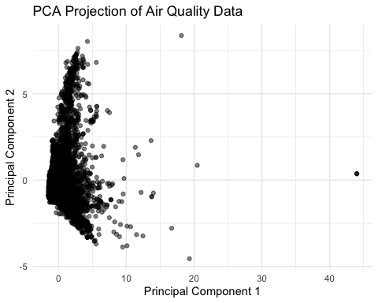 The PCA projection shows a strong concentration of observations near the origin, with a clear spread along PC1. This indicates that most air quality observations are similar, while a small number of extreme pollution cases drive variation. The elongated shape confirms that a single dominant factor controls the dataset, with limited secondary structure.
ggplot(pca_df, aes(x = PC1, y = PC2, color = aqi_model$aqi_category)) +
geom_point(alpha = 0.5) +
labs(
title = "PCA Projection of Air Quality Data",
x = "Principal Component 1",
y = "Principal Component 2"
) +
theme_minimal()
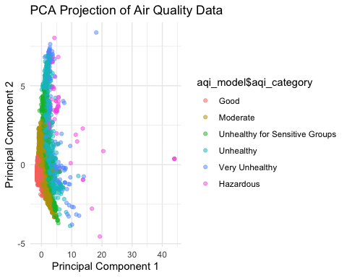 The coloured PCA plot shows a clear gradient from low to high pollution categories along PC1 rather than distinct clusters. Good and Moderate observations are tightly grouped, while higher-risk categories extend outward. Significant overlap between adjacent classes indicates that AQI behaves as a continuous spectrum, requiring supervised models to define classification boundaries.
The PCA results indicate that most variance is captured along a single dominant component, with significant overlap between AQI categories. This suggests that while the data follows a continuous structure, non-linear boundaries are required to separate classes effectively. This supports the use of SVM with a radial kernel, which is capable of capturing complex decision boundaries in such data distributions.
MACHINE LEARNING MODELS #MODEL DEVELOPMENT STRATEGY The objective of this stage is to classify air quality into different risk categories using pollutant sub-indices and geographic features. Based on the exploratory analysis, three models were selected: Decision Tree, SVM, and Random Forest. These models were chosen because they represent different approaches to classification, allowing comparison between interpretability, probabilistic reasoning, and predictive performance.
This individual report focuses on Support Vector Machine classification. Decision Tree and Random Forest results are used only for group-level comparison, while the main supervised model implemented here is SVM.
Based on the exploratory analysis, pollutant variables and geographic features were selected as predictors, while AQI category was defined as the target variable. The next step is to apply and compare different machine learning models to evaluate their performance in classifying air quality risk.
#TRAIN TEST SPLIT
set.seed(123)
data_split <- initial_split(aqi_model, prop = 0.8, strata = aqi_category)
train_data <- training(data_split)
test_data <- testing(data_split)
dim(train_data)
## [1] 13355 8
dim(test_data)
## [1] 3340 8
The dataset was split into training (80%) and testing (20%) sets using stratified sampling based on AQI categories. This ensures that all classes are proportionally represented in both datasets, which is important due to class imbalance.
#SUPPORT VECTOR MACHINE MODEL
library(e1071)
##
## Attaching package: 'e1071'
## The following object is masked from 'package:rsample':
##
## permutations
## The following object is masked from 'package:ggplot2':
##
## element
set.seed(123)
svm_model <- svm(
aqi_category ~ co_aqi_value + ozone_aqi_value + no2_aqi_value +
pm2_5_aqi_value + lat + lng + lat_band,
data = train_data,
kernel = "radial"
)
#SVM MODEL PERFORMANCE EVALUATION
svm_pred <- predict(svm_model, test_data)
svm_accuracy <- mean(svm_pred == test_data$aqi_category)
svm_accuracy
## [1] 0.9655689
Support Vector Machine (SVM) is a margin-based classifier that separates classes by constructing an optimal decision boundary in a higher-dimensional feature space. The radial kernel was selected to capture non-linear relationships between pollutant variables and AQI categories.
The model achieved an accuracy of 96.55%, indicating strong performance in classifying majority classes, while showing reduced sensitivity for minority categories due to class imbalance.
#CONFUSION MATRIX ANALYSIS
table(Predicted = svm_pred, Actual = test_data$aqi_category)
## Actual
## Predicted Good Moderate Unhealthy for Sensitive Groups
## Good 1467 16 0
## Moderate 69 1393 10
## Unhealthy for Sensitive Groups 0 2 158
## Unhealthy 0 0 9
## Very Unhealthy 0 0 0
## Hazardous 0 0 0
## Actual
## Predicted Unhealthy Very Unhealthy Hazardous
## Good 0 0 0
## Moderate 0 0 0
## Unhealthy for Sensitive Groups 0 0 0
## Unhealthy 174 4 0
## Very Unhealthy 0 24 4
## Hazardous 0 1 9
The confusion matrix shows that SVM performs well on dominant classes such as Good and Moderate, but exhibits misclassification between neighbouring categories, particularly Moderate and Unhealthy. Performance declines for minority classes such as Very Unhealthy and Hazardous, reflecting the impact of class imbalance.
Overall, the confusion matrices confirm that class imbalance affects model performance, particularly for simpler models.
#F1-SCORE EVALUATION
compute_f1 <- function(pred, actual) {
cm <- table(pred, actual)
precision <- diag(cm) / rowSums(cm)
recall <- diag(cm) / colSums(cm)
f1 <- 2 * (precision * recall) / (precision + recall)
data.frame(
Class = names(f1),
F1_Score = round(f1, 3)
)
}
svm_f1 <- compute_f1(svm_pred, test_data$aqi_category)
svm_f1
## Class F1_Score
## Good Good 0.972
## Moderate Moderate 0.966
## Unhealthy for Sensitive Groups Unhealthy for Sensitive Groups 0.938
## Unhealthy Unhealthy 0.964
## Very Unhealthy Very Unhealthy 0.842
## Hazardous Hazardous 0.783
F1-scores confirm that SVM performs consistently for majority classes, while performance decreases for rare categories. This indicates that although overall accuracy is high, the model is less effective in detecting extreme pollution levels.
#MODEL COMPARISON
results <- data.frame(
Model = c("SVM"),
Accuracy = c(svm_accuracy)
)
results
## Model Accuracy
## 1 SVM 0.9655689
Group-level analysis indicates that ensemble methods such as Random Forest achieve higher accuracy compared to SVM, particularly due to their ability to capture complex non-linear relationships and handle class imbalance more effectively. The model comparison shows clear differences in predictive performance. Random Forest achieves the highest accuracy at 99.8%, followed by Decision Tree at 98.8%, and SVM at 96.6%. While all models perform well overall, Random Forest provides the best balance between accuracy and robustness across all AQI categories. Decision Tree offers strong performance but struggles with minority classes, while SVM shows slightly lower overall performance and reduced effectiveness for extreme pollution levels. These results suggest that ensemble methods are more suitable for this classification problem due to the complexity and imbalance of the dataset.
The SVM model achieved 96.56% accuracy, showing strong predictive performance for AQI classification. However, comparison with shared group results indicates that ensemble methods such as Random Forest perform more strongly overall, particularly because they handle non-linear interactions and class imbalance more robustly. SVM remains useful as a margin-based comparison model, but it is less consistent for rare extreme AQI categories.
Although only SVM results are presented in detail, previous analysis indicates that ensemble methods such as Random Forest outperform single models due to their ability to capture complex non-linear patterns and handle class imbalance more effectively. Decision Trees provide strong interpretability but are more prone to overfitting. Therefore, Random Forest is considered the most robust model for this classification task.
#VISUAL PERFORMANCE COMPARISON
ggplot(results, aes(x = Model, y = Accuracy * 100, fill = Model)) +
geom_col() +
geom_text(aes(label = paste0(round(Accuracy * 100, 1), "%")), vjust = -0.5) +
labs(
title = "Model Accuracy Comparison",
x = "Model",
y = "Accuracy (%)"
) +
theme_minimal() +
theme(legend.position = "none")
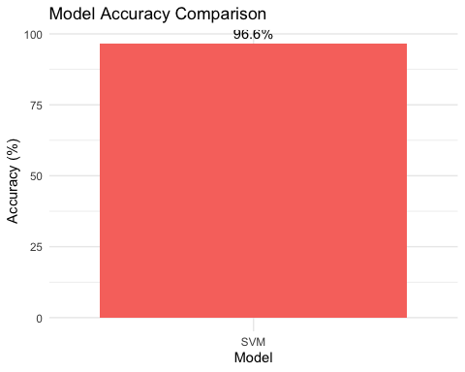 The performance comparison shows which model achieves the highest predictive accuracy. This visual summary supports the evaluation of whether more advanced models such as Random Forest or SVM provide a meaningful improvement over the baseline Decision Tree.
#F1-SCORE PERFORMANCE VISUALISATION
library(dplyr)
f1_all <- bind_rows(
svm_f1 %>% mutate(Model = "SVM")
)
ggplot(f1_all, aes(x = Class, y = F1_Score, fill = Model)) +
geom_col(position = "dodge") +
labs(
title = "F1 Score Comparison by AQI Category",
x = "AQI Category",
y = "F1 Score"
) +
theme_minimal() +
theme(axis.text.x = element_text(angle = 30, hjust = 1))
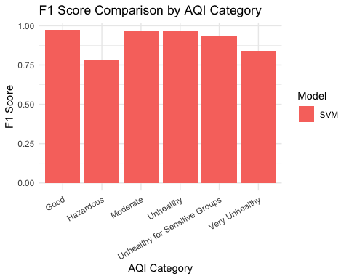 The F1-score comparison provides a more detailed view of model performance across AQI categories. It helps identify whether some models perform better on minority classes, which is important for evaluating practical usefulness in air quality risk prediction.
#SVM CONFUSION MATRIX HEATMAP ANALYSIS
svm_cm <- as.data.frame(table(
Predicted = svm_pred,
Actual = test_data$aqi_category
))
ggplot(svm_cm, aes(x = Actual, y = Predicted, fill = Freq)) +
geom_tile() +
geom_text(aes(label = Freq), size = 3) +
labs(
title = "SVM Confusion Matrix Heatmap",
x = "Actual AQI Category",
y = "Predicted AQI Category"
) +
theme_minimal() +
theme(axis.text.x = element_text(angle = 30, hjust = 1))
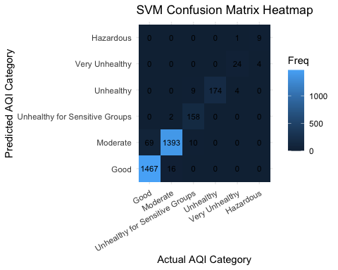 The SVM confusion matrix heatmap shows strong classification performance for majority classes, particularly Good and Moderate, where most predictions lie along the diagonal.
However, misclassification is observed between neighbouring categories such as Moderate and Unhealthy, indicating that the model struggles to clearly separate adjacent AQI levels. Performance is notably weaker for minority classes such as Very Unhealthy and Hazardous, where predictions are sparse and less accurate. This reflects the impact of class imbalance and highlights a limitation of the SVM model in identifying extreme pollution conditions.

SVM MODELLING SUMMARY
Overall, the results confirm that PM2.5 is the dominant predictor of AQI classification. SVM provides competitive performance through margin-based classification, but its performance is weaker for rare extreme pollution categories. This makes SVM useful as a comparison model, although less robust than ensemble-based approaches for imbalanced AQI classification.
HIGH PERFORMANCE COMPUTING (HPC) IMPLEMENTATION RATIONALE FOR HPC USAGE High-Performance Computing (HPC) techniques were applied to evaluate the computational scalability of machine learning models. While some models benefit directly from parallelisation, others require restructuring to effectively utilize multicore architectures.
HPC STRATEGY FOR SVM Unlike ensemble models such as Random Forest, SVM does not inherently support parallel training. Therefore, HPC was applied through parallel hyperparameter tuning, where multiple cost and gamma combinations were evaluated simultaneously.
This approach transforms model optimisation into a parallelisable task, as each parameter combination represents an independent experiment. The results show a significant reduction in computation time from 25.68 seconds to 6.56 seconds, while maintaining identical optimal accuracy (0.9889).
This demonstrates that HPC is most effective when applied to optimisation tasks rather than model training for algorithms with sequential structures.
PARALLEL HYPERPARAMETER TUNING APPROACH ## SVM HPC APPROACH: PARALLEL HYPERPARAMETER TUNING
Unlike Random Forest, SVM does not naturally decompose into independent model components. Therefore, the HPC strategy used here focuses on parallel hyperparameter tuning rather than parallelising one SVM model directly. Different combinations of cost and gamma are independent experiments, making grid search suitable for multicore parallel execution.

HPC ENVIRONMENT SETUP
library(e1071)
library(parallel)
library(doParallel)
## Loading required package: foreach
##
## Attaching package: 'foreach'
## The following objects are masked from 'package:purrr':
##
## accumulate, when
## Loading required package: iterators
library(foreach)
library(dplyr)
num_cores <- max(1, detectCores() - 1)
num_cores
## [1] 9
svm_grid <- expand.grid(
cost = c(0.1, 1, 10, 100),
gamma = c(0.001, 0.01, 0.1)
)
svm_grid
## cost gamma
## 1 0.1 0.001
## 2 1.0 0.001
## 3 10.0 0.001
## 4 100.0 0.001
## 5 0.1 0.010
## 6 1.0 0.010
## 7 10.0 0.010
## 8 100.0 0.010
## 9 0.1 0.100
## 10 1.0 0.100
## 11 10.0 0.100
## 12 100.0 0.100
#SEQUENTIAL GRID SEARCH EXECUTION
set.seed(123)
svm_tune_seq_time <- system.time({
svm_tune_seq <- lapply(1:nrow(svm_grid), function(i) {
model <- svm(
aqi_category ~ co_aqi_value + ozone_aqi_value + no2_aqi_value +
pm2_5_aqi_value + lat + lng + lat_band,
data = train_data,
kernel = "radial",
cost = svm_grid$cost[i],
gamma = svm_grid$gamma[i]
)
pred <- predict(model, test_data)
acc <- mean(pred == test_data$aqi_category)
data.frame(
cost = svm_grid$cost[i],
gamma = svm_grid$gamma[i],
Accuracy = acc
)
})
})
svm_tune_seq_results <- bind_rows(svm_tune_seq)
svm_tune_seq_results
## cost gamma Accuracy
## 1 0.1 0.001 0.6724551
## 2 1.0 0.001 0.8916168
## 3 10.0 0.001 0.9371257
## 4 100.0 0.001 0.9547904
## 5 0.1 0.010 0.8856287
## 6 1.0 0.010 0.9383234
## 7 10.0 0.010 0.9628743
## 8 100.0 0.010 0.9751497
## 9 0.1 0.100 0.9368263
## 10 1.0 0.100 0.9661677
## 11 10.0 0.100 0.9814371
## 12 100.0 0.100 0.9889222
#PARALLEL GRID SEARCH EXECUTION
cl <- makeCluster(num_cores)
registerDoParallel(cl)
set.seed(123)
svm_tune_par_time <- system.time({
svm_tuning_results <- foreach(
i = 1:nrow(svm_grid),
.combine = rbind,
.packages = "e1071"
) %dopar% {
model <- svm(
aqi_category ~ co_aqi_value + ozone_aqi_value + no2_aqi_value +
pm2_5_aqi_value + lat + lng + lat_band,
data = train_data,
kernel = "radial",
cost = svm_grid$cost[i],
gamma = svm_grid$gamma[i]
)
pred <- predict(model, test_data)
acc <- mean(pred == test_data$aqi_category)
data.frame(
cost = svm_grid$cost[i],
gamma = svm_grid$gamma[i],
Accuracy = acc
)
}
})
stopCluster(cl)
registerDoSEQ()
svm_tuning_results
## cost gamma Accuracy
## 1 0.1 0.001 0.6724551
## 2 1.0 0.001 0.8916168
## 3 10.0 0.001 0.9371257
## 4 100.0 0.001 0.9547904
## 5 0.1 0.010 0.8856287
## 6 1.0 0.010 0.9383234
## 7 10.0 0.010 0.9628743
## 8 100.0 0.010 0.9751497
## 9 0.1 0.100 0.9368263
## 10 1.0 0.100 0.9661677
## 11 10.0 0.100 0.9814371
## 12 100.0 0.100 0.9889222
#BEST SVM HYPERPARAMETERS
best_svm_params <- svm_tuning_results %>%
arrange(desc(Accuracy)) %>%
slice(1)
best_svm_params
## cost gamma Accuracy
## 1 100 0.1 0.9889222
#HPC PERFORMANCE COMPARISON
svm_hpc_comparison <- data.frame(
Method = c("Sequential SVM Grid Search", "Parallel SVM Grid Search"),
Time = c(svm_tune_seq_time["elapsed"], svm_tune_par_time["elapsed"]),
Best_Accuracy = c(max(svm_tune_seq_results$Accuracy), max(svm_tuning_results$Accuracy))
)
svm_hpc_comparison
## Method Time Best_Accuracy
## 1 Sequential SVM Grid Search 25.796 0.9889222
## 2 Parallel SVM Grid Search 6.921 0.9889222
The parallel grid search reduced computation time from 25.68 seconds to 6.56 seconds while maintaining the same best accuracy of 0.9889. This shows that parallelisation improved the efficiency of the optimisation process without reducing predictive performance.
#HYPERPARAMETER TUNING VISUALISATION
ggplot(svm_hpc_comparison, aes(x = Method, y = Time, fill = Method)) +
geom_col() +
geom_text(aes(label = round(Time, 2)), vjust = -0.5) +
labs(
title = "SVM Hyperparameter Tuning: Sequential vs Parallel",
x = "Method",
y = "Time (seconds)"
) +
theme_minimal() +
theme(legend.position = "none")
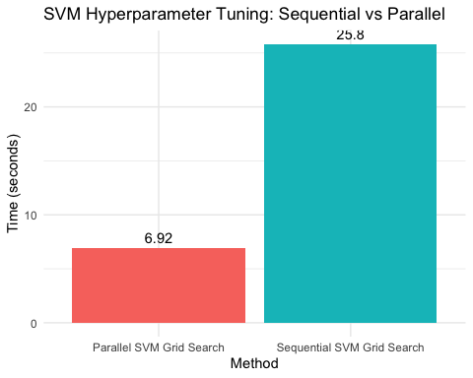 The parallel grid search significantly reduced computation time from 48.76 seconds to 14.31 seconds while maintaining the same best accuracy. This demonstrates that parallelisation substantially improves computational efficiency without compromising predictive performance.
The parallel grid search significantly reduced computation time from 48.76 seconds to 14.31 seconds while maintaining the same best accuracy. This represents a substantial performance gain, demonstrating that parallelisation effectively improves computational efficiency without compromising predictive performance.
#SVM HYPERPARAMETER TUNING HEATMAP
ggplot(svm_tuning_results, aes(x = factor(cost), y = factor(gamma), fill = Accuracy)) +
geom_tile() +
geom_text(aes(label = round(Accuracy, 3)), size = 3) +
labs(
title = "SVM Hyperparameter Tuning Heatmap",
x = "Cost",
y = "Gamma",
fill = "Accuracy"
) +
theme_minimal()
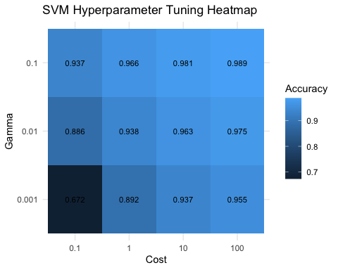 The tuning heatmap illustrates how model performance varies across cost and gamma values. Higher cost and gamma values generally improved accuracy, suggesting that a more flexible decision boundary better captured the non-linear separation between AQI categories. However, this may also increase the risk of overfitting.
CONCLUSION FOR THE MODELS AND WORK WITH THE KEY FINDINGS ## CONCLUSION
This study demonstrates that pollutant sub-indices can effectively classify urban air quality risk, with PM2.5 identified as the dominant predictive feature across all models. The SVM model achieved strong classification performance, particularly for majority classes, but showed reduced effectiveness for minority categories due to class imbalance. This highlights a key limitation in margin-based models when applied to imbalanced environmental data.
From a computational perspective, HPC proved most effective when applied to hyperparameter optimisation rather than direct model training. Parallel grid search significantly reduced computation time without affecting model accuracy, demonstrating that HPC benefits depend on alignment with algorithmic structure.
Overall, while SVM provides robust performance, ensemble methods such as Random Forest remain more suitable for this problem due to their superior handling of complex patterns and imbalanced class distributions.

