CS5803 Data Visualization
Global CO2 Policy Monitoring Dashboard
A Tableau-based Visual Analytics Project for Climate-Policy Prioritisation
Student: Shiv Solanki
Student ID: 2545809
May 2026

1. Introduction

1.1 Data
This project builds an interactive Tableau dashboard to support climate-policy prioritization using country-level CO2 emissions data. Climate-policy analysts must simultaneously compare emissions intensity, total emissions, direction of trend, fuel-source structure, population scale and economic context. A single table or ranking is not sufficient, because the decision is exploratory, comparative and multidimensional.
This analysis uses a preprocessed derivative of the CO2 and Greenhouse Gas Emissions dataset from Our World in Data. The file OWID_CO2_Policy.csv contains 7,509 country-year observations and 17 columns from 1990 to 2024. The primary cross-section year is 2022. The trend view encompasses the whole 1990-2024 period. As such, the dashboard should be interpreted as a decision support and screening tool rather than a causal model of policy impact.
Table 1. Data dictionary for variables used in the dashboard.
Field | Role | Dashboard use
country, iso_code | Identifier | Country labels, tooltips and filtering.
year | Temporal | Year filter and trend analysis.
population | Scale | Population threshold and bubble size.
gdp_per_capita | Economic context | X-axis for the complex scatter plot.
co2 | Measure | Annual CO2 emissions in the trend view.
co2_per_capita | Intensity | Ranking measure and scatter y-axis.
co2_growth_prct | Direction | Colour encoding for short-term growth.
coal_co2, oil_co2, gas_co2, cement_co2 | Composition | Stacked bar components in SQ3.
policy_cluster | Grouping | Interactive policy comparison filter.

1.2 Persona and Analytical Questions
It is aimed at the climate-policy analyst or decision-maker working within a multilateral organization, climate finance institution or government advisory team. It is for the user to decide where policy attention may be most urgent, where emissions are increasing and which source categories suggest the most appropriate type of intervention.
SQ1: Which countries with populations above five million have the highest per-capita CO2 emissions in 2022?
SQ2: How have annual CO2 emissions changed from 1990 to 2024 for the highest-emitting countries?
SQ3: How do coal, oil, gas and cement contributions differ across major emitters in 2022?
CQ: Which countries combine high per-capita emissions, positive short-term growth and large population scale?

1.3 Requirements
The requirements translate the analytical questions into visual and interaction choices, so the implementation can be checked against the intended user task.
Requirement | Specification
SQ1-R1 | Rank countries by CO2 per capita using a sorted horizontal bar chart.
SQ2-R2 | Show emissions change over time using a multi-line chart with year on the x-axis.
SQ3-R3 | Compare fuel and cement structure using a stacked bar chart.
CQ-R4 | Combine GDP per capita, CO2 per capita, population and growth in a bubble scatter plot.
NF-R5 | Keep the Tableau dashboard on one screen with visible filters and legends.
NF-R6 | Use labels and colour choices that a policy user can interpret without specialist Tableau knowledge.

2. Design

2.1 Paper Landscape Prototype
We started the design process with a paper landscape prototype and then built in Tableau. This helped to plan how the views would fit together on one screen and how the user would navigate from simple comparisons to the complex policy-priority question.
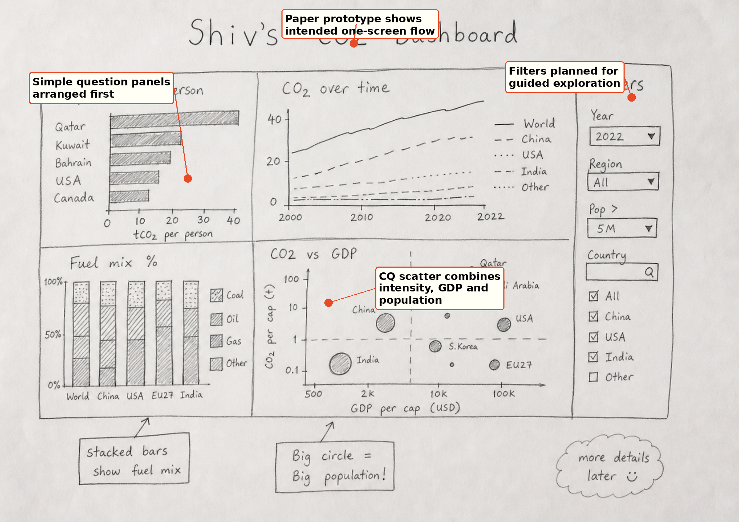
Figure 1. Paper landscape prototype sketch for the dashboard layout.
Annotation: The prototype identifies filters, simple-question panels and the final synthesis view before software constraints shaped the dashboard.
The prototype had the per-capita ranking and fuel mix views on the left, the trend chart on the upper center, the policy-priority scatter in the lower-center panel and filters on the right. This sequence provides a path of reading from high intensity countries, through emissions direction, to source structure, and then to combined policy evidence.

2.2 Tableau Design Rationale
The chart selections were correlated to the analytical relationships. We chose a horizontal bar chart for the ranking since it is possible to compare the lengths of the bars accurately. Temporal change was visualized with a line chart, source composition with a stacked bar chart, and the complex multivariate question with a bubble scatter plot. This is consistent with visualization guidelines that encodings should be selected to suit the comparison task rather than for the sake of variety (Cleveland and McGill, 1984; Munzner, 2015). The design also considers cognitive load. The simple views use familiar encodings so that the user can read them quickly, while the complex scatter uses multiple channels only where necessary - position for GDP and emissions intensity, size for population, and color for short term growth. The stacked bar chart is good for composition but is carefully interpreted. It is harder to compare small internal segments than the total height of the bar.
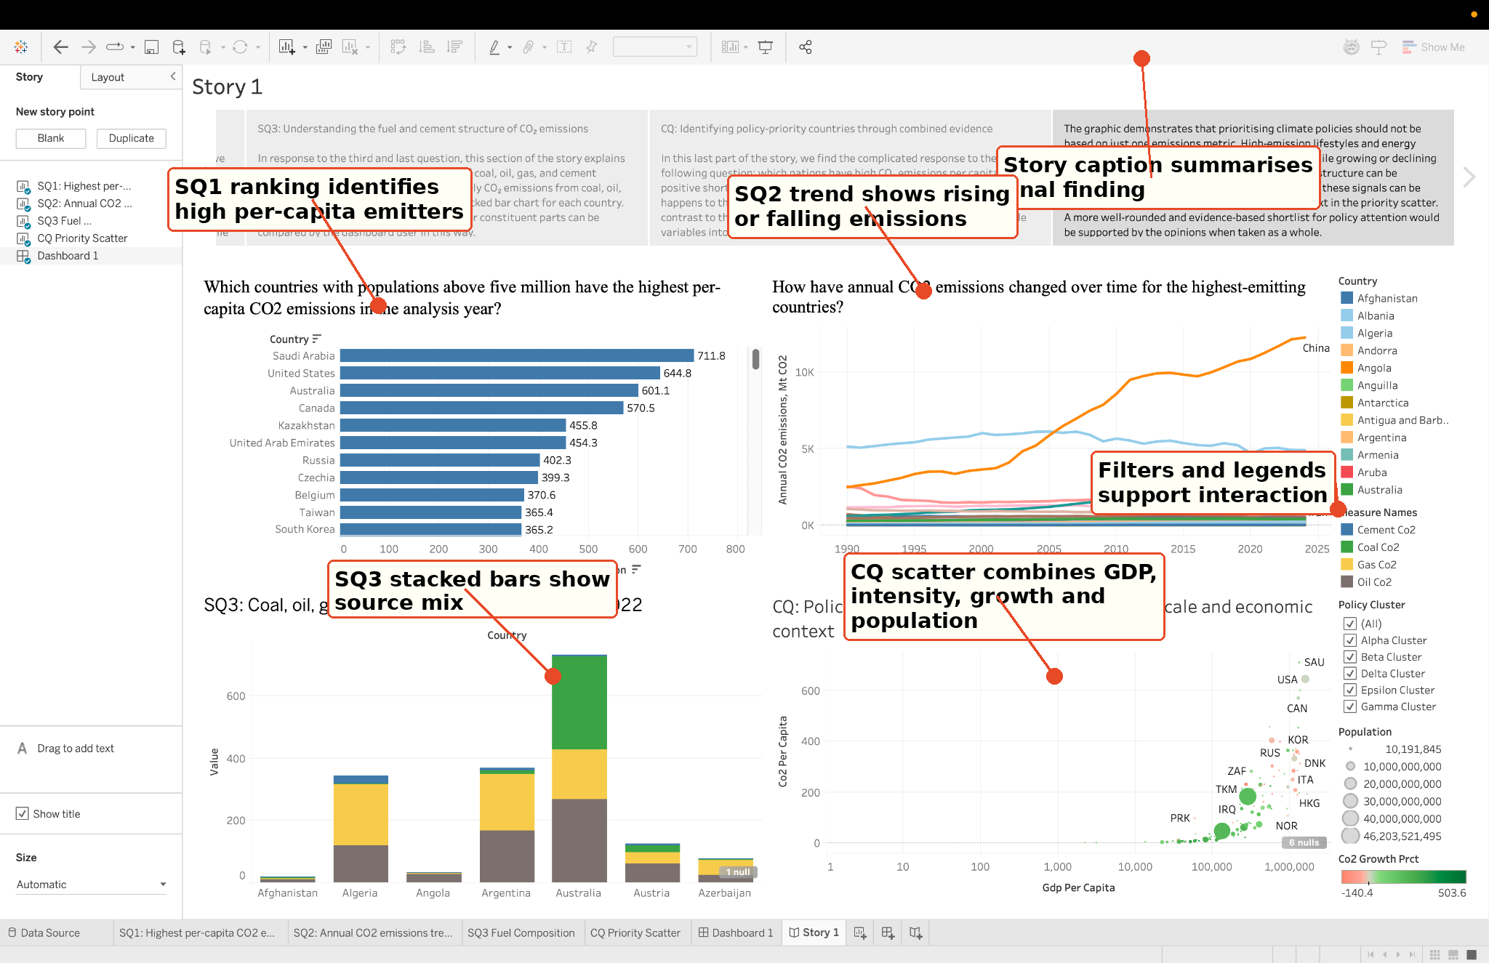
Figure 2. Final Tableau dashboard overview with coordinated charts and filters.
Annotation: Callouts show how SQ1, SQ2, SQ3 and CQ are visible together, supporting overview-first analysis and coordinated interpretation.
Some choices were changed during implementation to make it more readable. The ranking and composition charts were restricted to a few countries to keep the labels legible, and the scatter plot was made the primary synthesis view as it aggregates the largest number of variables in a single space. The final dashboard also had visible legends, country labels and filters that were only roughly sketched in the paper design.

3. Implementation

3.1 Tableau Worksheets and Dashboard
This summary outlines the implementation of the Tableau workbook using OWID_CO2_Policy.csv, noting that no complex joins were necessary due to the country-year structure. The main implementation work involved validating aggregation, building four worksheets, creating filters, developing a one-screen dashboard, and crafting a Story for interpretation. The analysis focused on the year 2022 for cross-sectional views and the period 1990-2024 for the trend view. The implementation meets the project requirements, with specified visualizations: SQ1-R1 is represented by a sorted bar chart, SQ2-R2 by a time-series line chart, SQ3-R3 by source-composition stacked bars, and CQ-R4 by a multivariate scatter plot. NF-R5 and NF-R6 are integrated into the single-screen Tableau dashboard featuring visible filters, labels, and legends.
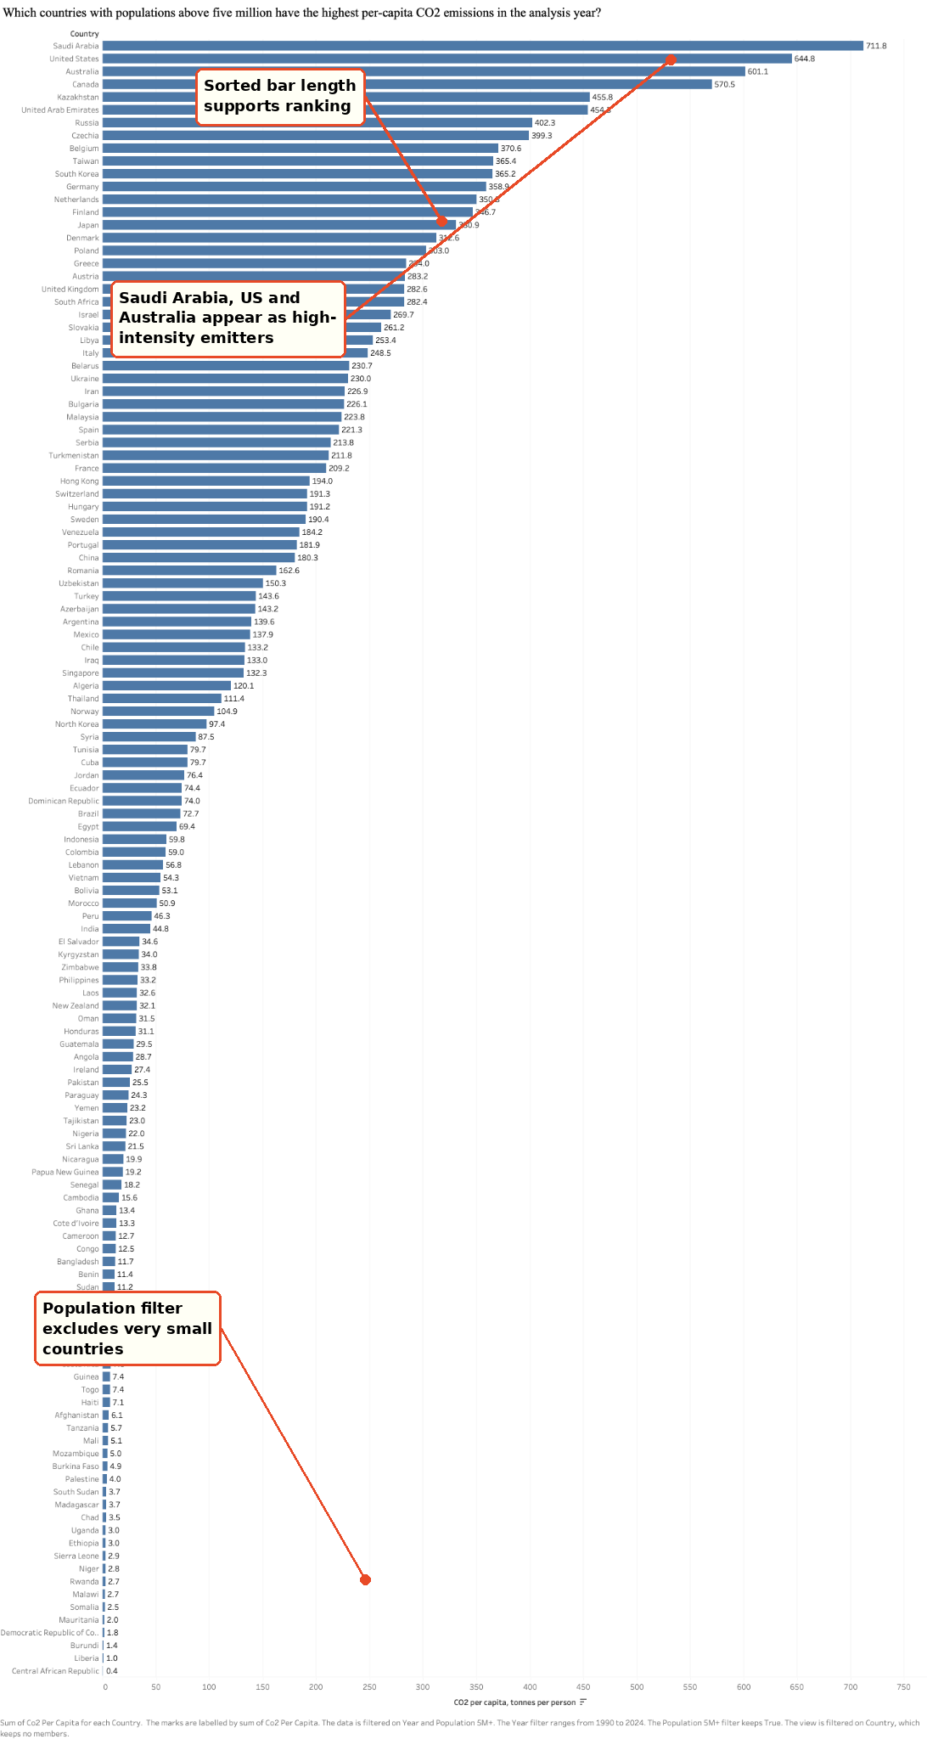
Figure 3. SQ1 worksheet showing per-capita CO2 ranking.
Annotation: The sorted horizontal bars reveal high-intensity emitters among countries above five million people. The population filter improves policy relevance.
SQ1 utilizes per capita CO2 filtered to nations with populations above five million. The visible rating for Saudi Arabia is highest at around 711.8, followed by the United States at about 644.8, Australia at about 601.1, and Canada at about 570.5. Instead, it is offering an intensity-based initial screen, not a total emissions score.
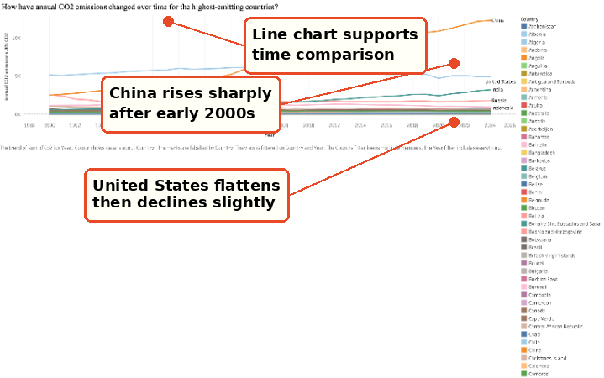
Figure 4. SQ2 worksheet showing annual CO2 emissions trends.
Annotation: The line chart highlights China’s strong rise, the United States flattening pattern and India’s steady growth from a lower base.
SQ2 is a multi-line chart with year on the x-axis and yearly CO2 emissions on the y-axis. It differentiates between nations with growing emissions and those with flatter or dropping emissions, which is an essential distinction since current intensity and future trajectory may indicate different policy responses.

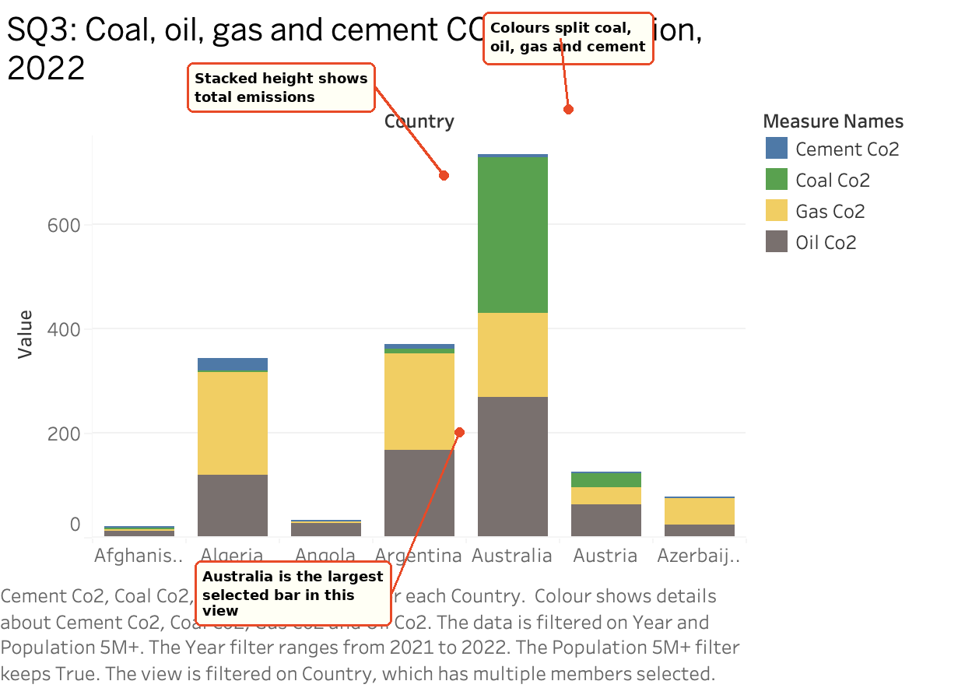
Figure 5. SQ3 worksheet showing fuel and cement composition.
Annotation: Stacked segments reveal whether emissions are mainly associated with coal, oil, gas or cement, helping connect the dashboard to intervention type.
SQ3 uses a stacked bar chart to compare total emissions and source composition. The height of each bar shows magnitude, while the coloured segments show the contribution of coal, oil, gas and cement. This changes the analysis from simply naming priority countries to understanding what type of policy response may be suitable.
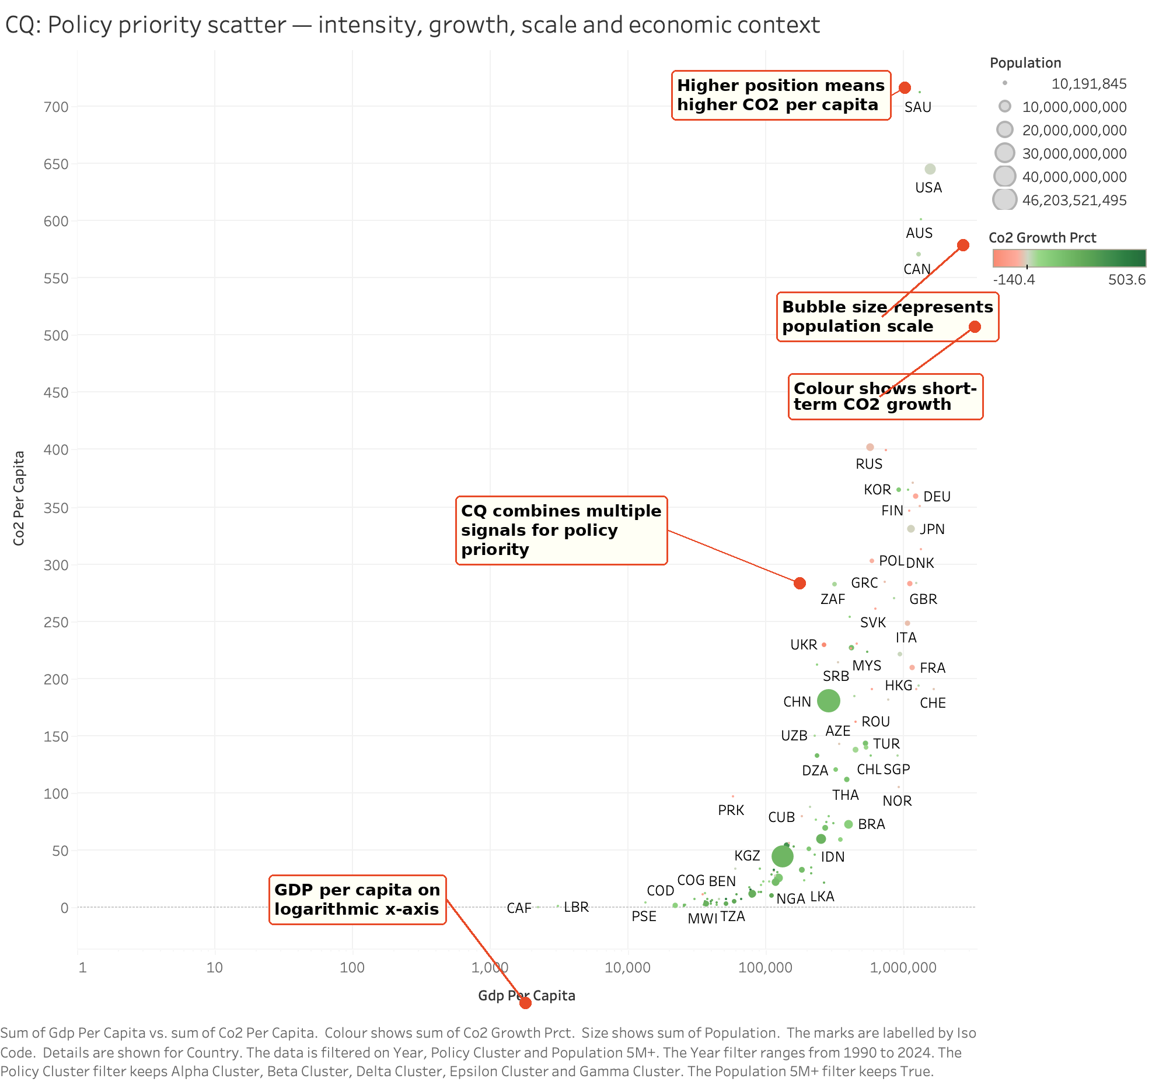
Figure 6. CQ worksheet showing the policy-priority scatter.
Annotation: The scatter integrates GDP per capita, CO2 per capita, population size and CO2 growth, making the complex question testable through filters.
The complex worksheet uses GDP per capita on the x-axis, CO2 per capita on the y-axis, population as bubble size and CO2 growth percentage as colour. Filters for year, policy cluster, country and population threshold allow the analyst to test whether a shortlist changes under different assumptions. This makes the complex question genuinely interactive rather than a static ranking.

3.2 Power BI Secondary Implementation
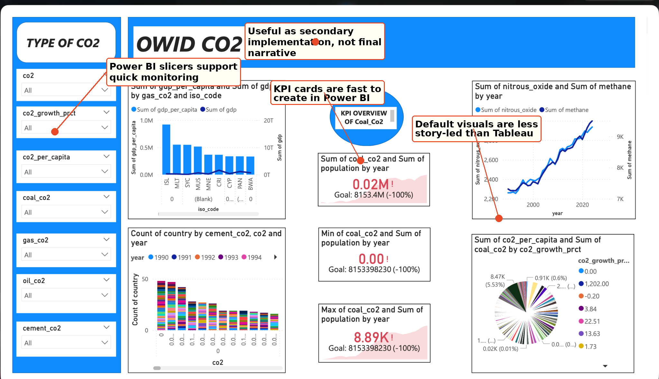
Figure 7. Power BI secondary implementation dashboard.
Annotation: Power BI demonstrates slicer-driven monitoring and KPI-style reporting, while Tableau remains stronger for the guided Story and coordinated analytical flow.

The second implementation was carried out in Power BI with the same prepared data set. Power BI was good for quick KPI cards, slicers and operational monitoring. The Power BI site is less useful as a narrative explanation however, since the views are more like dashboards and less linked to the tour question by question. This contrast is still useful since it demonstrates how the same dataset may take on different character when transferred from a story-led tableau design to a business intelligence interface. Future Power BI version should mimic Tableau layout more closely, retaining the same four analytical views, deleting irrelevant pie charts and decreasing KPI overload. This topic is freely debated since a second implementation needs to be provided with the same analytical aim and not just to prove that another tool can load the dataset.

4. Walkthrough Using Tableau Story
The walkthrough is based on five Tableau Story points: SQ1, SQ2, SQ3, CQ and a final conclusion point. Each Story point preserves a view state and interpretation, so the marker can reproduce the reasoning path from simple evidence to the final policy-priority judgement.

4.1 Story Point 1: SQ1 Per-Capita Emitters
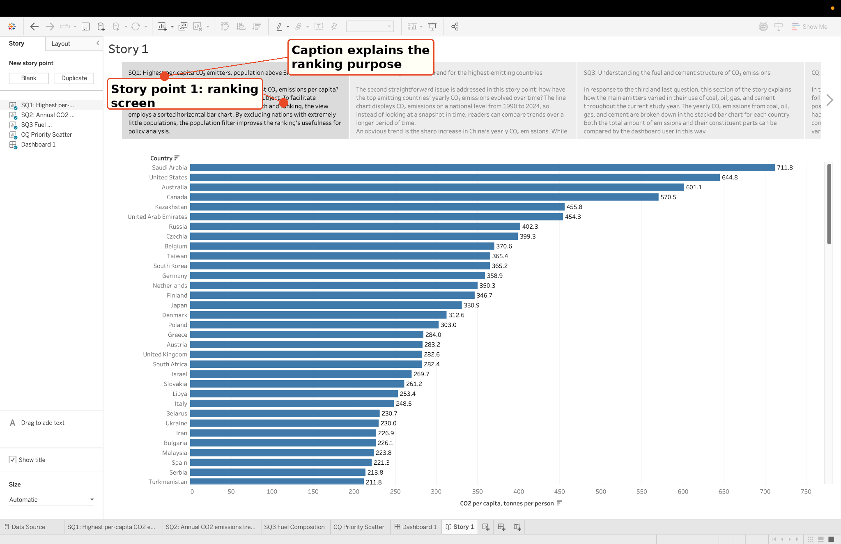
Figure 8. Tableau Story point 1 showing the SQ1 per-capita ranking.
Annotation: The Story caption explains why the ranking uses per-capita emissions, while the chart provides the evidence for SQ1.
This Story point answers which countries with populations above five million have the highest per-capita CO2 emissions in 2022. Saudi Arabia, the United States, Australia and Canada appear near the top. This is the first screening step because per-capita emissions show intensity rather than total national scale.

4.2 Story Point 2: SQ2 Emissions Trend
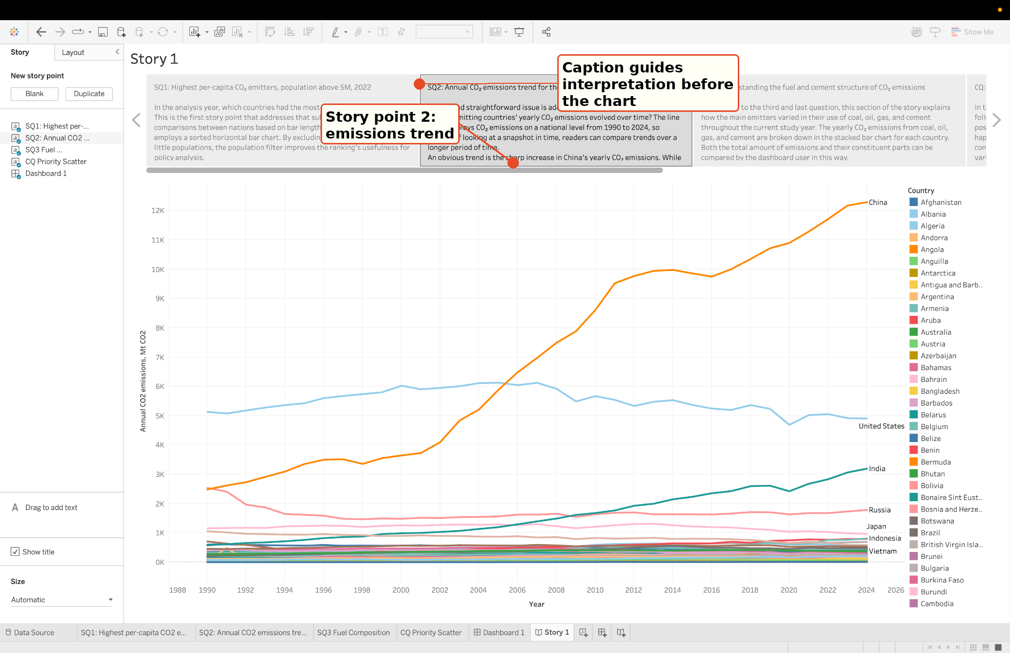
Figure 9. Tableau Story point 2 showing annual CO2 emissions trends.
Annotation: The Story links the line chart to trend interpretation, allowing the user to compare direction and pace of change.
This Story point answers how emissions changed over time for major emitters. China shows the sharpest increase, particularly after the early 2000s. The United States remains high but flattens and slightly declines after its peak, while India grows from a lower base. This trend context changes how the per-capita ranking should be interpreted.

4.3 Story Point 3: SQ3 Fuel and Cement Composition
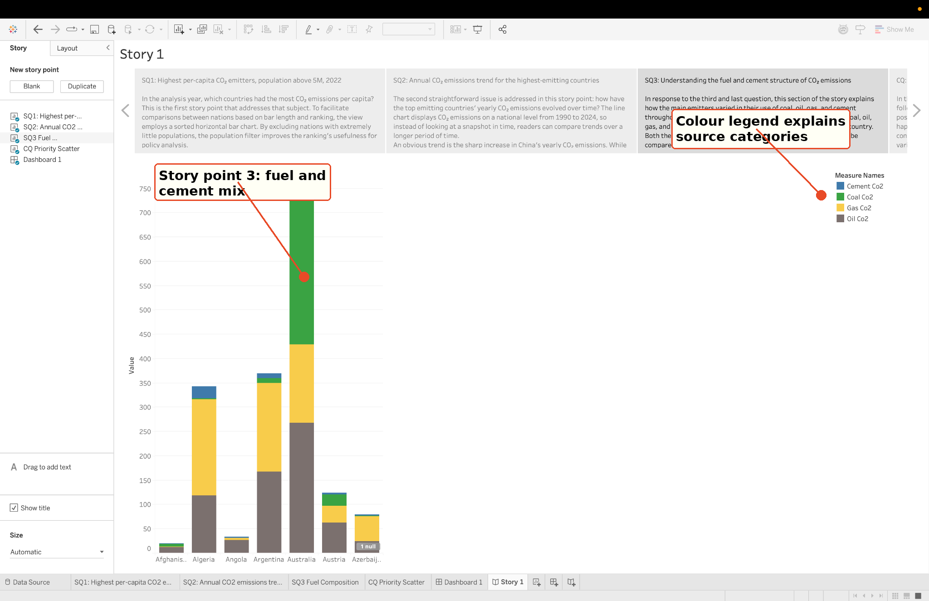
Figure 10. Tableau Story point 3 showing fuel and cement composition.
Annotation: The Story explains how stacked bars support source-structure interpretation rather than only magnitude comparison.
This Story point answers how coal, oil, gas and cement contribute to national emissions. A coal-heavy country may require electricity-sector transition and renewable energy policies, while an oil-heavy country may need greater attention to transport, refining or petroleum consumption. The view therefore connects descriptive comparison to possible policy action.

4.4 Story Point 4: Complex Policy-Priority Scatter
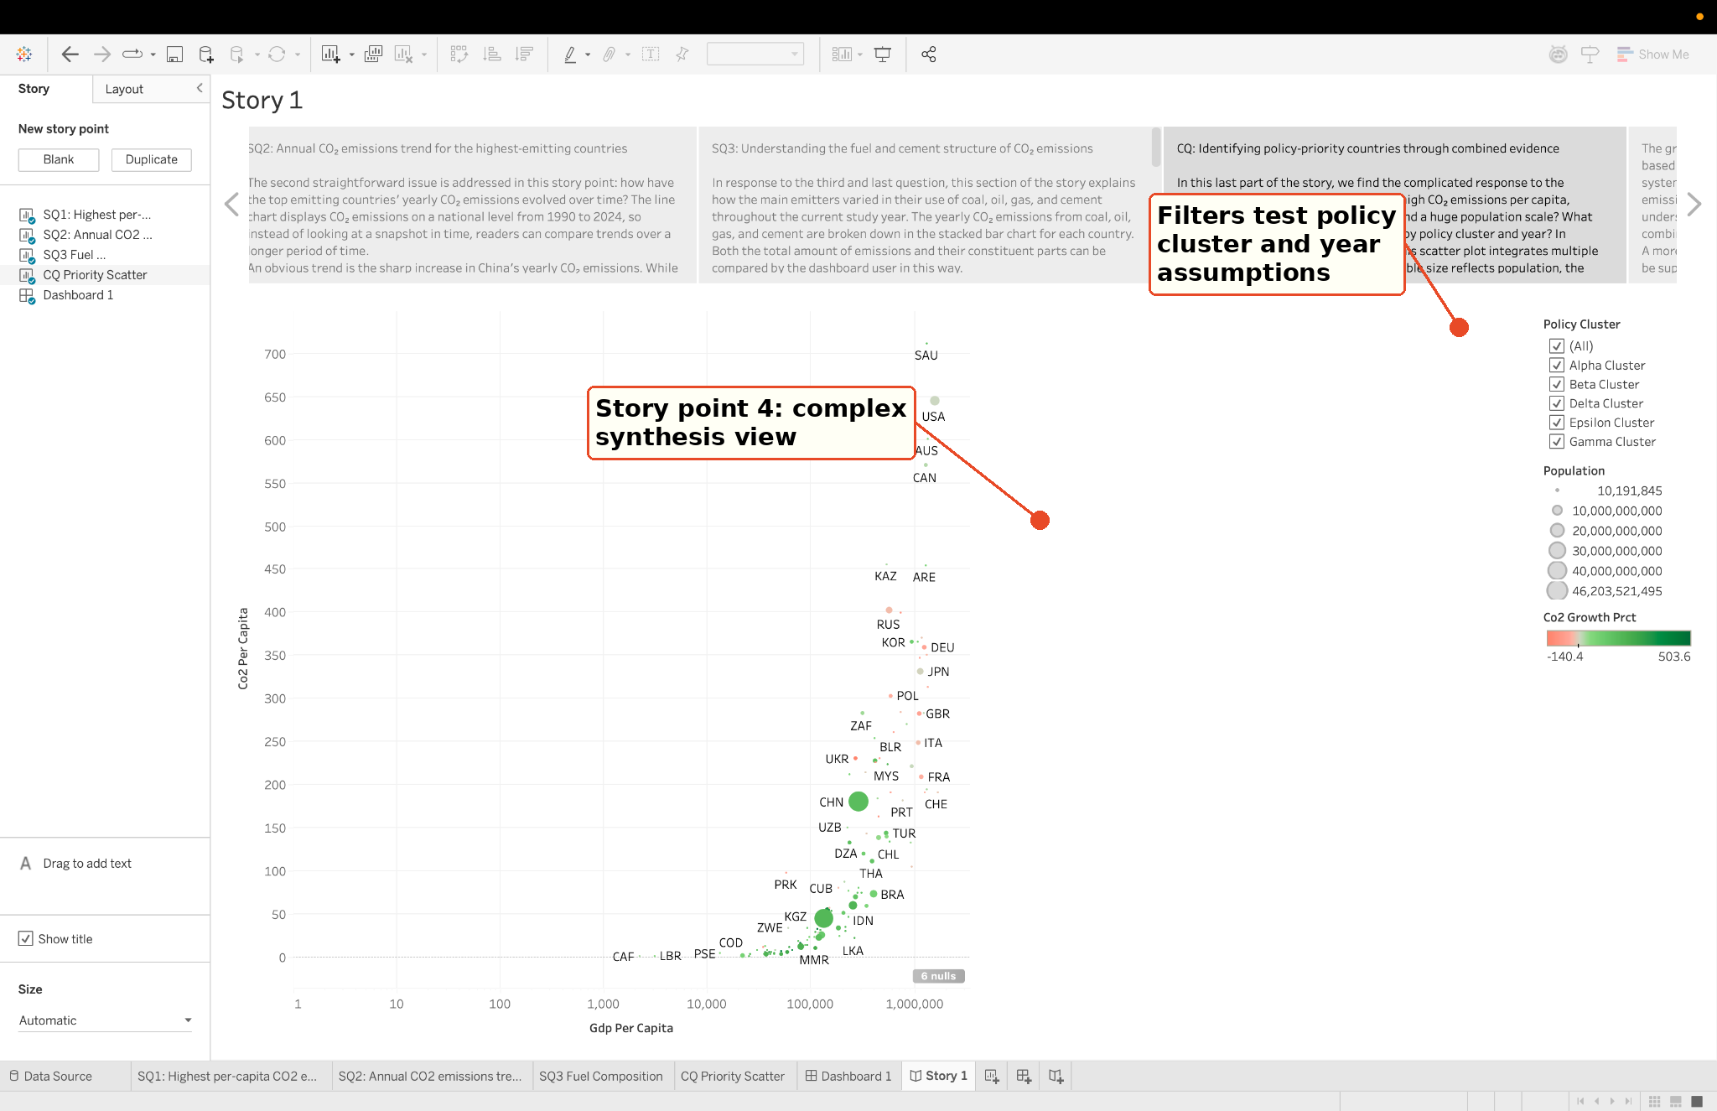
Figure 11. Tableau Story point 4 showing the complex policy-priority scatter.
Annotation: The complex view integrates intensity, growth, population and economic context, with filters available for testing assumptions.
This Story point answers the complex question by combining several signals. A country becomes more policy-relevant when high emissions intensity, large population, positive emissions growth and economic context are considered together. The scatter plot avoids relying on one metric alone and turns the dashboard into a decision-support tool.

4.5 Story Point 5: Combined Interpretation
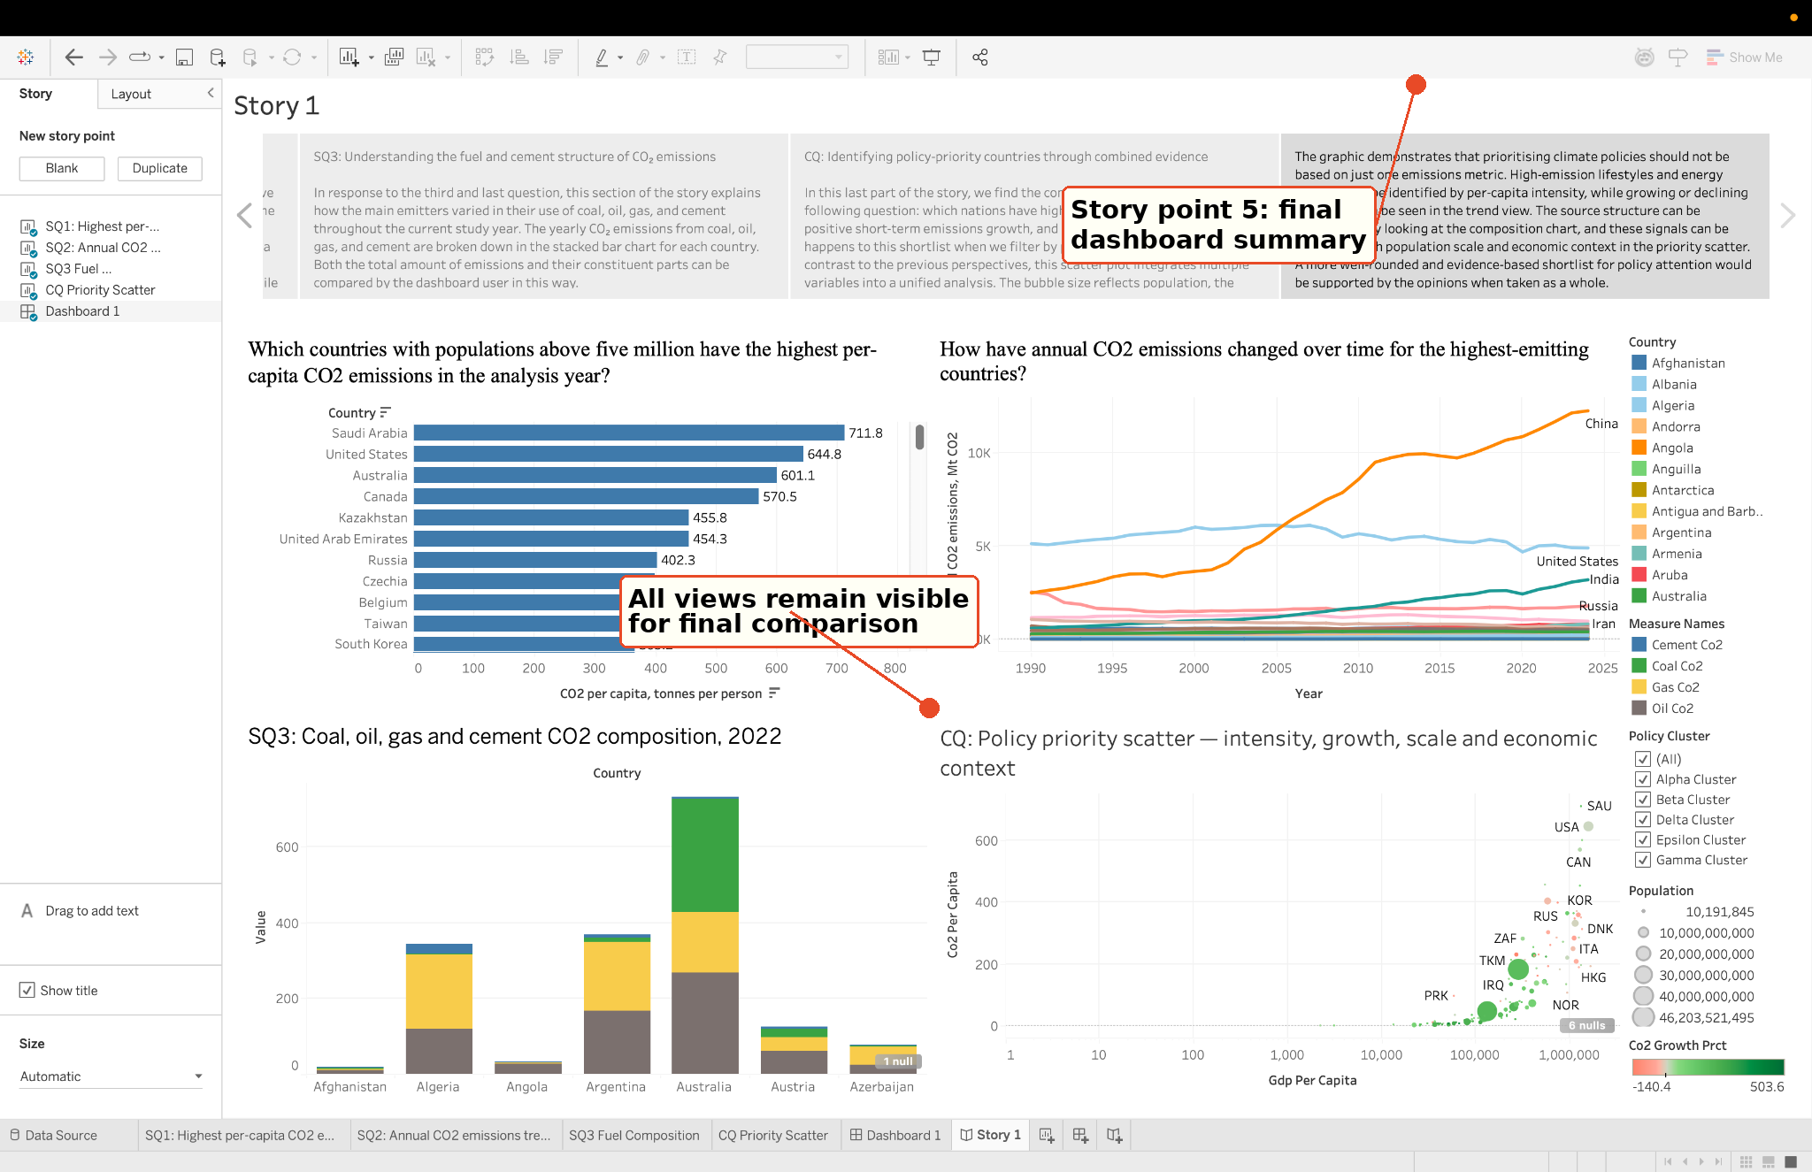
Figure 12. Tableau Story conclusion summarising the combined interpretation.
Annotation: The final Story point keeps all views visible and explains why climate-policy prioritisation should be based on combined evidence.
The final Story point concludes that climate-policy prioritisation should not rely on a single emissions metric. SQ1 identifies high per-capita emitters, SQ2 shows whether emissions are rising or falling, SQ3 explains the source structure and the CQ scatter combines intensity, population, growth and economic context. Together, these views support a more balanced shortlist for policy attention.

5. Discussion

5.1 Dashboard Evaluation

The fundamental strength of the initiative is that it does not depend on a single ranking of emissions. The dashboard enables a policy analyst to analyze emissions intensity, total trajectory, source structure and population size in a common visual context. The Story sheet offers a clear path through the evidence for users who may not know which perspective to look at first, while the dashboard remains for self-directed investigation. This balance crucial because climate-policy priority is not a mechanical ranking process. The user should be able to examine how the various pieces of evidence agree or disagree before compiling a selection.

5.2 Tableau and Power BI Comparison

Tableau did a better job guiding visual analytics. The Story sheet tied the analytical questions into a clear order. It also offered more direct control over the bubble dispersion, legends and coordinated filtering. Power BI was better for quick KPI-style monitoring and familiar slicer controls. The present Power BI version is less compelling as a narrative transfer since the graphics are more experimental. A beefier future port would more closely align the four Tableau views and cull the unconnected summary visualizations. Power BI is thus better used as an exploratory comparison and proof of transportable dashboard creation with Tableau being the stronger submitted artefact for the evaluation narrative.

5.3 HCI, Ethics and Data Limitations
In human-computer interaction terms, the design is overview-first: the user starts with views of the ranking, trends and composition, then moves on to the sophisticated scatter plot and filters. This supports the notion of overview, filter and details-on-demand (Heer & Shneiderman, 2012). Ethical care is also required. The dashboard should facilitate policy debate, not automatically rank nations for action, since climate responsibility relies on historical context, fairness, development requirements and data quality. A high per-capita figure may signal an urgent problem of emissions, but by itself it does not determine whether solution is fair or practicable. The dashboard should thus be seen as a starting point for analysis, not as a substitute for professional opinion.
There are constraints of data and aggregate. Short-term growth rates may be quite erratic, and some nations do not have full GDP or fuel-specific statistics. Per-capita variables also need to be aggregated properly to a particular year of investigation, rather than totalled across a larger time range. Future development may include a choropleth map, color-blind testing, a priority-score calculator and a clearer data-quality document. The new design relies on the analyst properly reading the colors and sizes combined in the scatter plot, thus you should review the tooltips and legends carefully in the final worksheet.

5.4 Personal Reflection and Future Learning
This project taught me the difference between dashboards and a bunch of charts. The most powerful takeaway is that the visual design should follow the user task: each basic inquiry accumulates evidence for the ultimate large question. Next, I want to strengthen my Power BI design discipline by more closely mimicking the Tableau style and testing both dashboards with a user not acquainted with the dataset. This will indicate if the Story sequence is clear for someone not involved in the project and whether the complicated scatter plot requires further explanation or simplification.

6. Conclusion
This research shows how interactive data visualization may enhance evidence-based thinking about climate policy. The dashboard reduces a difficult prioritization issue to easy analytical procedures, then recombines the information in a multivariate scatter plot. The key conclusion is that no single indicator is adequate for prioritizing climate-policy participation. Interpret in conjunction with per capita emissions, emissions trajectory, source mix, population size and economic environment. The Tableau dashboard and Story sheet provide an organized approach to communicating this combined information, and the Power BI plugin illustrates how the same dataset can be used to additionally assist operational monitoring.

7. References
Bertin, J. (1983) Semiology of Graphics: Diagrams, Networks, Maps. Madison: University of Wisconsin Press.
Cairo, A. (2016) The Truthful Art: Data, Charts, and Maps for Communication. San Francisco: New Riders.
Cleveland, W.S. and McGill, R. (1984) 'Graphical perception: Theory, experimentation, and application to the development of graphical methods', Journal of the American Statistical Association, 79(387), pp. 531-554.
Few, S. (2012) Show Me the Numbers: Designing Tables and Graphs to Enlighten. 2nd edn. Burlingame: Analytics Press.
Heer, J. and Shneiderman, B. (2012) 'Interactive dynamics for visual analysis', Communications of the ACM, 55(4), pp. 45-54.
Knaflic, C.N. (2015) Storytelling with Data: A Data Visualization Guide for Business Professionals. Hoboken: Wiley.
Munzner, T. (2015) Visualization Analysis and Design. Boca Raton: CRC Press.
Our World in Data (2026) CO2 and Greenhouse Gas Emissions dataset. Prepared as OWID_CO2_Policy.csv for this project.
OpenAI (2026) ChatGPT [Large language model]. Available at: https://chat.openai.com/ (Accessed: 4 May 2026). Used for language support and report refinement; final analysis choices and content were reviewed by the author.

