**Tackling chronic kidney disease in Nepal: from evidence to action**

Shiva Raj Mishra PhD1,2,3, Suresh Mehata PhD4, Vishnu Khanal PhD5, Nipun Shrestha PhD1*

1. NHMRC Clinical Trials Centre, University of Sydney, Australia
2. Westmead Applied Research Centre, University of Sydney, Australia
3. Nepal Development Society, Bharatpur-6, Chitwan, Nepal
4. Ministry of Health and Population, Government of Nepal, Kathmandu, Nepal
5. Menzies School of Health Research, Charles Darwin University, Alice Springs, NT, Australia

Corresponding author:

Nipun Shrestha, MBBS, MPH, PhD

NHMRC Clinical Trials Center,

Faculty of Medicine and Public Health,

University of Sydney

Email: drnipunsth@gmail.com

**Worlds**: 2800

**References**: 40

**Figures/Tables:** 5

Authors declare no conflict of interests.

**Abstract**

Chronic kidney disease (CKD) poses a significant burden in Nepal. We reviewed the epidemiology of CKD in Nepal and proposed strategies to mitigate its burden. We found that the age-standardised prevalence of chronic kidney disease was growing in Nepal by 0.11% (95% Uncertainty Interval: 0.10, 0.11) per annum between 1990 and 2021. Despite the high burden (10887.7 prevalent CKD per 100,000 population), the country only has 56 nephrologist and 60 HD centres, a majority of which is in country’s capital serving only 15% of population. CKD requires multicomponent interventions that address the diverse causes and pathological expressions of the disease. Integrating interventions across the care continuum, such as health education, screening programs, lifestyle modifications, and improved access to renal replacement therapies, can enhance effective coverage and scalability of care. Additionally, it is crucial to explore and address disparities in access to CKD treatment, including gender and socioeconomic disparities.

**Keywords:** chronic kidney disease, epidemiology, dialysis services, health systems, Nepal**Introduction**

Chronic kidney disease (CKD) is a condition characterized by a persistent injury to the renal parenchyma, resulting in the gradual deterioration of kidney function over time, which may eventually lead to end-stage renal disease (ESRD) (1). CKD burden has increased by staggering proportions in the last decade in low middle income countries (LMICs), reaching nearly four times higher than those observed in high income countries (2). According to the Global Burden of Disease study 2021, there were approximately 1.5 million deaths worldwide caused by CKD in 2021, ranking it amongst the top twenty causes of deaths and leading cause of years loss of life worldwide (3). Furthermore, the syndemics of high body-mass index, uncontrolled hypertension and diabetes in LMICs has contributed to rising burden and progression of CKD (4). The burden of CKD has led to an increased need for renal replacement therapy (RRT) worldwide, resulting in a strain on healthcare resources and catastrophic financial consequences for patients and their families (4, 5). It accounts for 1-2% of healthcare expenditures in high-income countries, however similar estimates are lacking for LMICs (5).

In Nepal, a lower-middle income country in South Asia, CKD is poorly understood. There is no comprehensive assessment of the drivers of CKD, burden at national level and socioeconomic impact of CKD is poorly understood. Given the unprecedented rise in risk factors for CKD, such as diabetes (6) and hypertension (7), a high burden of CKD is anticipated now and over the next decades . In fact, there has been a dramatic increase in end-stage renal disease patients requiring dialysis and transplantation services in Nepal (8, 9). The growth in CKD burden has been met with lack of early diagnosis services, poor awareness on consumers end, and lack of readiness on health services side. In many resources deprived districts, resources outstrip the demand for renal services, and many patients are compelled to seek these services in neighbouring countries like India (8, 10).

The progression of CKD into end-stage renal disease can be delayed or prevented by early identification and intervention (11). Hence, understanding the entire spectrum of CKD epidemiology including its drivers, socioeconomic impact on affected population and strategies for prevention, and management of CKD in a low resource setting, like Nepal might help in tackling the global burden of CKD. This estimate/study aims to discuss the epidemiology of CKD and health system challenges in providing dialysis services in Nepal.

**Changing disease epidemiology**

Changing burden of CKD is closely tied with increasing life expectancy, reflecting improvements in healthcare, nutrition, and socio-economic conditions in Nepal.(12) On an average, Nepalese have added 10 to 15 years so life expectancy in last 30 years (Figure 1). This added life is marred by multi-morbidity, and significant clustering of vascular risk factors (e.g., hypertension, diabetes, obesity, cardiovascular disease) which can be attributed to a steep incline in burden of chronic kidney disease. Thus, risk factor management is undoubtedly the single most important strategy for halting progression of CKD in Nepal (13).

Among vascular risk factors, Nepal has witnessed a rising prevalence of hypertension. According to a recent study, the prevalence of hypertension in Nepal increased from 26% in 2000 to 32% in 2020, indicating a growing public health concern. Of those hypertensives in 2020, only 27% were currently treated and 38% of the treated hypertensives were able to had their blood pressure under control. (14)

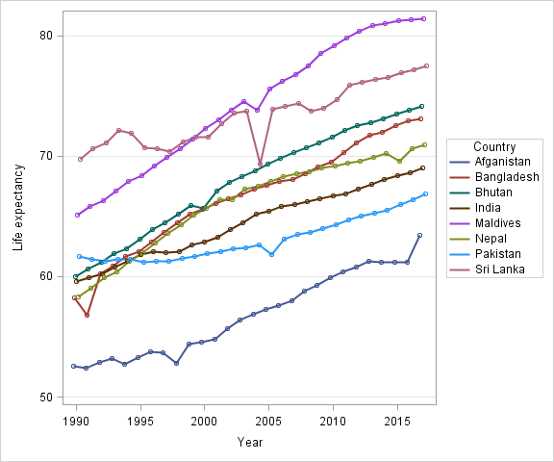

*Figure 1. Changing life expectancy in Nepal over past 40 years compared to South Asian countries. Data from World Bank (*[*https://data.worldbank.org/*](https://data.worldbank.org/)*) is used to create this visualization.*

There is a marked heterogeneity in risk factor burden across geographic region in Nepal, suggesting a similar pattern for CKD burden across geographic regions.

Besides hypertension, the prevalence of diabetes has also been on the rise in Nepal and South Asia as a whole. According to World Health Organisation, Nepal had an estimated 436,000 adults living with diabetes in 2021, representing approximately 8.5% (95% CI 6.9–10.4%) of the adult population (6). The increase can be attributed to factors such as urbanization, sedentary lifestyles, and unhealthy diets, including a shift towards a more westernized diet.(6, 15)

**Chronic kidney disease epidemiology**

The 2021 Burden of Disease estimation conducted by Global Burden of Disease (GBD) showed that prevalence of CKD in Nepal was 10887.7 (95% UI: 10177.4, 11883.1 per 100,000 population) (Table 1). The burden of CKD was found to be growing by 0.11% (95% UI: 0.10, 0.11) per annum between 1990 and 2021, with higher burden and growth rate among female compared to their male counterparts (Table 1). Similarly average annual percentage change in Deaths, DALYS, years lived with disability, years of life lost were also increased by 1.17 (95% UI: 1.13, 1.19), 0.57 (95% UI: 0.55, 0.60), 0.12 (95% UI: 0.08, 0.17) and 0.78 (95% UI: 0.73, 0.81) respectively. Chronic kidney disease is ranked amongst the top twenty causes of deaths in South Asia including Nepal (e-supplementary figure 1).

A nationwide survey of non-communicable diseases in Nepal conducted in the year 2019 (17, 18) reported somewhat lower but comparable , CKD prevalence of 6.2% (95% CI: 5.7,6.6) (Figure 2), while that of reduced GFR (<60 ml/min) and albuminuria was 0.75% (95%CI: 0.56,0.94) and 5.97% (95%CI: 5.47,6.47), respectively.(17) The severity of CKD according to KIDGO classification indicated that 0.3% (95% CI: 0.2, 0.4) of the participants were at very high risk, 0.9% (95% CI: 0.7, 1.0) were at high risk, and 4.9% (95%CI: 4.5, 5.3) were at moderate risk (Figure 2). Around 93.8% (95% CI: 93.4,94.2%) had an eGFR ≥60ml/min/1.73m2 and an ACR <30 mg/g (3mg/mmol) and therefore, in the absence of other markers of kidney injury, this presents as a low-risk prognosis. (17)

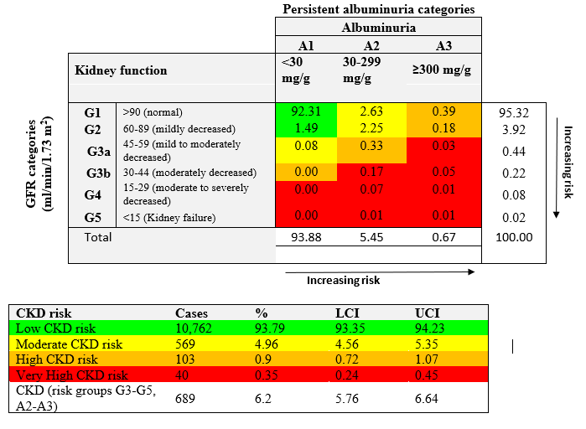 *Figure 2. Distribution of participants based on glomerular filtration rate (GFR) and*

*albuminuria with prevalence estimates according to the KDIGO chronic kidney disease guidelines (further texts in eSupplementary Table 1 describes GFR calculation and eSupplementary Table 2 describes CKD staging)* (17, 19)

In Nepal, CKD risk groups G1–G2 and A2–A3, defined as stage 1 or 2 CKD in some studies (20-22) presents as the predominant forms of CKD. This is comparable to an earlier study from India, which showed nearly 92% of participants in this risk category. It is vital to reduce the risk of progression and cardiovascular disease in people with CKD through active lifestyle management and pharmaceutical intervention (23). A large meta-analysis of 105,872 participants showed 1.18-, 1.57- and 3.14-times higher risk of all-cause mortality associated with GFR at 60, 45 and 15 ml/min/1.73 m2 compared to GFR 95 ml/min/1.73 m2 (24, 25). Albuminuria is further associated with 1.2, 1.63 and 2.22 folds risk of all-cause mortality at 1.1, 3.4 and 33.9 mg/mmol of albuminuria compared with 0.6 mg/mmol (24). As recommended by KIDGO guidelines (26), stringent blood pressure control is must for management of CKD as high proportion of CKD patients are hypertensive (23).

Of the risk factors contributing to CKD burden, hypertension (42.1%; 95%CI: 35.8, 47.9), diabetes (33.9%; 95%CI: 26.6, 40.5), and obesity (19.6%; 95%CI: 9.7, 31.3) are the top three leading risk factors contributing to the rising burden of CKD.(16). Non-optimal temperature, inadequate sanitation and clean water sources can increase the risk of kidney infections and subsequent damage; combined together these environmental risk factors contributed to nearly 13% (95%CI: 6.4, 22.1) of CKD burden in Nepal. (16)Regarding the role of vascular risk factors, a nationwide study of non-communicable diseases in Nepal showed that more than three-fourth (76.6%) of all CKD cases had at least one of the three NCDs risk factors, i.e., obesity, hypertension, and diabetes (17). Hypertension was the most prevalent risk factor (65%), followed by overweight/obesity (35%) and diabetes (28%) among CKD patients (e-supplementary Figure 2).

*Table 1. Age-standardised rates and 95% Uncertainty Interval (UI)* of chronic kidney disease in Nepal from 1990 and 2021.*

|  |  |  |  |  |
| --- | --- | --- | --- | --- |
|  | | **Male** | **Female** | **Both** |
| **Prevalence (UI)** | Age-standardised rate (2021) | 10593.5 (9919.2, 11399) | 11134.9 (10349.6, 12469.8) | 10887.7 (10177.4, 11883.1) |
| AAPC in age-standardised rates between 1990 and 2021 | 0.07 (0.06, 0.08) | 0.13 (0.13, 0.14) | 0.11 (0.10,0.11) |
| **Deaths (UI)** | Age-standardised rate (2021) | 24.21 (16.82, 33.34) | 14.88 (10.39, 20.81) | 19.19 (14.07, 25.14) |
| AAPC in age-standardised rates between 1990 and 2021 | 1.28 (1.23, 1.33) | 1.1 (1.07, 1.13) | 1.17 (1.13,1.19) |
| **DALY (UI)** | Age-standardised rate (2021) | 753.2 (572.3, 992.4) | 565.2 (425.9, 745.2) | 652.7 (513.5, 826.0) |
| AAPC in age-standardised rates between 1990 and 2021 | 0.75 (0.72,0.78) | 0.42 (0.39, 0.44) | 0.57 (0.55, 0.60) |
| **YLD (UI)** | Age-standardised rate (2021) | 202.20 (140.94, 272.33) | 200.48 (144.83, 275.40) | 201.20 (145.17, 267.93) |
| AAPC in age-standardised rates between 1990 and 2021 | 0.19 (0.14, 0.24) | 0.08 (0.05, 0.12) | 0.12 (0.08, 0.17) |
| **YLL (UI)** | Age-standardised rate (2021) | 550.98 (381.96, 764.84) | 364.68 (242.71, 532.29) | 451.50 (328.20, 609.59) |
| AAPC in age-standardised rates between 1990 and 2021 | 0.97 (0.92, 1.02) | 0.62 (0.58, 0.65) | 0.78 (0.73, 0.81) |

*Methods for calculating Age-standardised rates and 95% UI are shown in eSupplementary Table 2. Abbreviations: DALY: disability adjusted life years; YLD: years lived with disability; YLL: years of life lost; APCC: Average annual percentage change; *aged-standardised rates are presented per 100000 population; UI: Uncertainty Interval.*

**Distribution of dialysis services and workforce**

Dialysis care in Nepal faces significant challenges due to limited resources and infrastructure. A recent study reported that there were 60 haemodialysis (HD) centres, 570 HD machines serving a total of 3775 patients in Nepal in 2021 (27). Of 56 nephrologist registered in the Nepal Society of Nephrology in 2021; of which a majority (46 of 56) practice in country’s capital. This scarcity both in terms of haemodialysis centers and trained nephrologist has resulted in long waiting lists and inadequate access to life-sustaining treatment for patients with end-stage renal disease. Although continuous ambulatory peritoneal dialysis may be a viable option, challenges in obtaining peritoneal dialysis fluid and the high transportation costs to remote areas make this treatment less practical for patients (28). Extrapolating the 6% prevalence of CKD to Nepal’s 150 million adult’s population (aged ≥20 years) estimates that 0.9-1.9 million of are at risk of some forms of kidney damage and of those 0.14 million would require treatment for ESKD (29). This indicates that the existing infrastructure and available human resources for dialysis services in Nepal is not sufficient to cater the needs of growing burden of CKD in Nepal.

Further, there is inadequate focus on training axillary renal health workers such as nurses, mid-level health workers, diabetes educators/diabetes nurse educators who could provide specialised services with some training. Educational models like credited courses in partnership with medical schools (e.g. 6-month nursing residency (30)) and on-the-job training could be used to develop next generation of nephrology workforce (30).

The cost of dialysis sessions can be burdensome for many Nepalese, hindering their ability to receive regular treatment. Given the financial burden on families, Nepalese government started free HD services in public hospitals, dialysis centres as well as selected private hospitals from 2016. To curb out of pocket expenses, government provides annual sum of US$483 for haemodialysis (31), and US$40/month for medication expenses (27, 32).Efforts are being made to support dialysis facilities and improve affordability, but further investments and collaborations are necessary to enhance dialysis care and ensure its availability to a larger portion of the population (27, 32).

**Evolution of dialysis and renal transplantation services**

The development of dialysis care in Nepal has progressed in several steps. In 1987, the first haemodialysis was conducted in Nepal, marking a significant milestone (Figure 3). Over the years, the number of dialysis centers has gradually increased, with approximately 60 centers across the country as of 2021. Nearly 50% of the dialysis centers are located in the country’s capital which only accounts for the 15% of Nepal’s population (27).The government has also taken steps to provide subsidized dialysis services, making it more accessible to those in need. Dialysis services currently cost US$6.7 million (US$2300 per dialysis patient) per annum which roughly accounts for 2.1% of health budget. Additionally, efforts have been made to train healthcare professionals in nephrology and dialysis management. Despite these advancements, challenges persist due to limited resources and the growing demand for services. Continued investment, infrastructure development, and capacity-building initiatives are necessary to further enhance dialysis care in Nepal (33).

With the Human Body Transplantation Act was first introduced in 1998, Nepal also paved the way for solid organ transplantation. However, it was not until August 2008, the first solid organ transplantation which was kidney transplantation was successfully performed in one of the premier health institutes in Nepal, the Tribhuvan University Teaching Hospital (Figure3) (31). The Government of Nepal has setup the Disadvantaged Citizens Medical Treatment Fund to cover some of the costs of kidney transplantation (approximately USD 5,000 per patient) and one year of immunosuppressive medication in government hospitals. In addition, national health insurance policy provides up to USD 900 per year to cover the cost of post-transplantation medications (31). Out of 2,040 kidney transplantations that were performed between August 2008 to December 2022 in Nepal, 99% of Kidney transplantation were performed in hospitals in Baghmati province (mainly in the capital of Nepal, Kathmandu), with the majority of recipients (32.52%) from Baghmati province itself (31, 32). Majority of these transplantation happen through live donor with the first deceased donor transplantation conducted in 2017(32). Important to note, there is a strong gender bias in kidney transplantation with 75% of kidney donors being women and 84% of recipient being men(32).

Nepal has witnessed steady growth in the number of nephrologists and dialysis centers, along with advancements in nephrology training (e-supplementary Figure 3). As of 2021, there were around 56 practicing nephrologists in the country; this a four fold increase compared to only 12 trained nephrologist in 2010 (27). This increase is a positive sign for specialised care in kidney diseases. Also, the number of dialysis centers has increased three folds from 13 HD centers in 2010 to 42 centers in 2021. The government and medical institutions have been actively collaborating to provide specialized training opportunities for healthcare professionals in nephrology, contributing to the improvement of kidney care services in the country. Given that nurses effectively manage many diseases in primary care, nurse-led renal care—providing individualized information and engaging patients in decision-making—holds promise as an equally effective approach to nephrologist-led care in the community.

**Tackling CKD burden**

The complex nature of CKD requires multicomponent interventions, similar to other non-communicable diseases (NCDs). However, many existing NCD interventions are often standalone and may not adequately address the diverse causes and pathological expressions of CKD (34, 35). Exploring disparities in access to CKD treatment, particularly by gender and socioeconomic status (SES), is another important aspect. Existing socioeconomic disparities and health system challenges can exacerbate inequities in accessing adequate care.

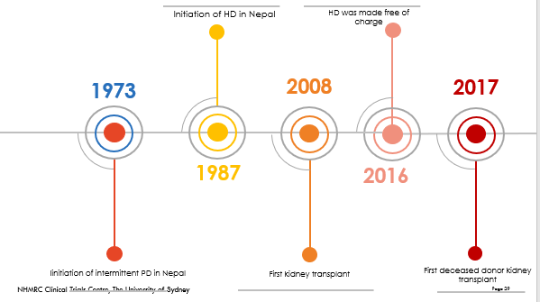

*Figure 3. Development of dialysis care in Nepal. HD: haemodialysis*

To overcome this challenge, packaging interventions that address various factors contributing to CKD development and progression is necessary. This approach could include a combination of health education and awareness campaigns, screening programs, lifestyle modifications, comorbidity management, and improved access to renal replacement therapies. By packaging and scaling up these interventions, the effective coverage can be increased, leading to improved outcomes for individuals with CKD (35).

Furthermore, strengthening the healthcare system's capacity to manage CKD comprehensively is crucial. This includes investing in nephrology training programs, expanding the number of nephrologists, training generalist clinicians on CKD so they can play crucial role to provide clinical support at grass root level and establishing more dialysis centers in LMICs such as Nepal. It is also essential to move focus beyond just ‘doctors’ to other workforce which play crucial roles and are more readily available. This includes training nurses in the screening, management, and care of patients with CKD, building their capacity, and empowering them to lead telehealth and other digital health solutions, enabling them to support patients within their own communities. Leaving home for dialysis and managing the travelling in and out of the center is stressful for the patients, their carers, and families. Holistic care model to support social, and spiritual wellbeing also essential. The learning can at least be considered to adapt in the LMIC’s context. One such example is ‘purple houses’ in Central Australia which provides support to patients with CKD living in remote and rural communities (36). Purple house was born out of the need of *Pintupi* people in Western desert of central Australia by providing mobile dialysis services (36).

There are other types of health workers including CHWs, and mid-level workforces which are untapped resources within the current health system. Their contribution can make significant impact on holistic care of patients with CKD. The training process should also focus on making it easier for them and reducing their travel to attend the trainings. The tertiary hospital in each province/region can work as centre of excellence to build the capacity of the workforce. Such model has been used to upskill capacity of existing workforce in the past. Therefore, careful planning, and inclusive capacity building of health professionals will improve the quality and availability of kidney care services, ensuring timely and appropriate management of CKD cases(34, 35).

Further, the multifactorial nature of chronic kidney disease (CKD) development and progression poses significant challenges in understanding its aetiologies and implementing effective interventions (34, 35, 37). One key challenge is the limited number of longitudinal studies conducted in low- and middle-income like Nepal, which hampers our ability to draw robust conclusions on causal factors. To address this, increased investment in longitudinal studies and surveillance programs specifically focused on CKD in LMICs is essential. These studies would provide crucial insights into the risk factors, progression patterns, and outcomes of CKD in these populations, enabling more targeted preventive strategies and interventions.

Finally, collaborative efforts between the government, healthcare providers, researchers, and international organizations, is crucial for effective program implementation, resource allocation, and policy development. By working together, it is possible to create an enabling environment for CKD care and improve health outcomes for individuals living with CKD in LMICs.

**CONCLUSIONS**

CKD burden is increasing in Nepal primarily contributed by growth in vascular risk factors. Health system’s capacity for risk factor screening and dialysis services is largely inadequate. A comprehensive approach is needed to address the challenges posed by CKD, requiring multicomponent interventions, as well as training and expansion of nephrology services. Longitudinal surveillance programs are essential to gain critical insights into CKD aetiologies.

Data availability

Data used in this paper are publicly available from GBDx Results Tool. https://vizhub.healthdata.org/gbd-results/

Conflict of interest

Authors declare no conflicts of interest.

Authors contribution

SRM and NS conceptualised the study. SRM created the first draft of the paper with support from NS, SM and VK. All the authors participated in the literature reviews, manuscript drafting and revision.

**REFERENCES**

1. Akchurin OM. Chronic Kidney Disease and Dietary Measures to Improve Outcomes. Pediatr Clin North Am. 2019;66(1):247-67.

2. Kovesdy CP. Epidemiology of chronic kidney disease: an update 2022. Kidney Int Suppl (2011). 2022;12(1):7-11.

3. Ward ZJ, Goldie SJ. Global Burden of Disease Study 2021 estimates: implications for health policy and research. The Lancet. 2024;403(10440):1958-9.

4. Ke C, Liang J, Liu M, Liu S, Wang C. Burden of chronic kidney disease and its risk-attributable burden in 137 low-and middle-income countries, 1990-2019: results from the global burden of disease study 2019. BMC Nephrol. 2022;23(1):17.

5. Mushi L, Marschall P, Flessa S. The cost of dialysis in low and middle-income countries: a systematic review. BMC Health Serv Res. 2015;15:506.

6. Shrestha N, Mishra SR, Ghimire S, Gyawali B, Mehata S. Burden of Diabetes and Prediabetes in Nepal: A Systematic Review and Meta-Analysis. Diabetes Ther. 2020;11(9):1935-46.

7. Mehata S, Shrestha N, Mehta R, Vaidya A, Rawal LB, Bhattarai N, et al. Prevalence, awareness, treatment and control of hypertension in Nepal: data from nationally representative population-based cross-sectional study. J Hypertens. 2018;36(8):1680-8.

8. Abraham G, Varughese S, Thandavan T, Iyengar A, Fernando E, Naqvi SA, et al. Chronic kidney disease hotspots in developing countries in South Asia. Clin Kidney J. 2016;9(1):135-41.

9. Hada R, Khakurel S, Agrawal RK, Kafle RK, Bajracharya SB, Raut KB. Incidence of end stage renal disease on renal replacement therapy in Nepal. Kathmandu Univ Med J (KUMJ). 2009;7(27):301-5.

10. Hirachan P, Kharel T, Shah DS, Ball J. Renal replacement therapy in Nepal. Hemodial Int. 2010;14(4):383-6.

11. Go AS, Chertow GM, Fan D, McCulloch CE, Hsu CY. Chronic kidney disease and the risks of death, cardiovascular events, and hospitalization. N Engl J Med. 2004;351(13):1296-305.

12. Mishra SR, Neupane D, Bhandari PM, Khanal V, Kallestrup P. Burgeoning burden of non-communicable diseases in Nepal: a scoping review. Globalization and health. 2015;11:1-10.

13. Gyawali B, Khanal P, Mishra SR, van Teijlingen E, Wolf Meyrowitsch DJGHA. Building strong primary health care to tackle the growing burden of non-communicable diseases in Nepal. 2020;13(1):1788262.

14. Dhungana RR, Pandey AR, Shrestha N. Trends in the prevalence, awareness, treatment, and control of hypertension in Nepal between 2000 and 2025: a systematic review and meta-analysis. 2021;2021:1-11.

15. Gyawali B, Sharma R, Neupane D, Mishra SR, van Teijlingen E, Kallestrup P. Prevalence of type 2 diabetes in Nepal: a systematic review and meta-analysis from 2000 to 2014. 2015;8(1):29088.

16. Murray CJ, Aravkin AY, Zheng P, Abbafati C, Abbas KM, Abbasi-Kangevari M, et al. Global burden of 87 risk factors in 204 countries and territories, 1990–2019: a systematic analysis for the Global Burden of Disease Study 2019. 2020;396(10258):1223-49.

17. Poudyal A, Karki KB, Shrestha N, Aryal KK, Mahato NK, Bista B, et al. Prevalence and risk factors associated with chronic kidney disease in Nepal: evidence from a nationally representative population-based cross-sectional study. 2022;12(3):e057509.

18. Dhimal M, Karki KB, Sharma SK, Aryal KK, Shrestha N, Poudyal A, et al. Prevalence of Selected Chronic Non-Communicable Diseases in Nepal. Journal of Nepal Health Research Council. 2019;17(3):394-401.

19. Stevens PE, Ahmed SB, Carrero JJ, Foster B, Francis A, Hall RK, et al. KDIGO 2024 clinical practice guideline for the evaluation and management of chronic kidney disease. Kidney international. 2024;105(4):S117-S314.

20. Bikbov B, Purcell CA, Levey AS, Smith M, Abdoli A, Abebe M, et al. Global, regional, and national burden of chronic kidney disease, 1990&#x2013;2017: a systematic analysis for the Global Burden of Disease Study 2017. The Lancet.

21. Zhang L, Wang F, Wang L, Wang W, Liu B, Liu J, et al. Prevalence of chronic kidney disease in China: a cross-sectional survey. 2012;379(9818):815-22.

22. Anand S, Shivashankar R, Ali MK, Kondal D, Binukumar B, Montez-Rath ME, et al. Prevalence of chronic kidney disease in two major Indian cities and projections for associated cardiovascular disease. 2015;88(1):178-85.

23. Fraser SD, Blakeman T. Chronic kidney disease: identification and management in primary care. Pragmat Obs Res. 2016;7:21-32.

24. Lancet CKD Collaboration. Association of estimated glomerular filtration rate and albuminuria with all-cause and cardiovascular mortality in general population cohorts: a collaborative meta-analysis. 2010;375(9731):2073-81.

25. Coresh J, Turin TC, Matsushita K, Sang Y, Ballew SH, Appel LJ, et al. Decline in estimated glomerular filtration rate and subsequent risk of end-stage renal disease and mortality. 2014;311(24):2518-31.

26. National Kidney Foundation: Kidney Disease: Improving Global Outcomes (KDIGO) 2012 Clinical Practice Guideline for the Evaluation and Management of Chronic Kidney Disease. Kidney International. 2013;3:1–150.

27. Mcgee J, Pandey B, Maskey A, Frazer T, Mackinney T. Free dialysis in Nepal: Logistical challenges explored. 2018;22(3):283-9.

28. Thaweethamcharoen T, Sritippayawan S, Noparatayaporn P, Aiyasanon N. Cost-Utility Analysis of Continuous Ambulatory Peritoneal Dialysis and Automated Peritoneal Dialysis for Thai Patients With End-Stage Renal Disease. Value in health regional issues. 2020;21:181-7.

29. PopulationPyramid.net. Population pyramid-Nepal 2019 [Available from: <https://www.populationpyramid.net/nepal/2019/>.

30. Boyle SM, Washington R, McCann P, Koul S, McLarney B, Gadegbeku CA. The nephrology nursing shortage: insights from a pandemic. American Journal of Kidney Diseases. 2022;79(1):113-6.

31. Singh Shah D, Shrestha M, Khatri B, Chhetri S, Shrestha K, Sedhai S, et al. Equity in Transplantation Access in Nepal: An Analysis of Gender, Geographic, and Caste-Based Disparities in Transplants. Transplant international : official journal of the European Society for Organ Transplantation. 2023;36:11635.

32. Sharma I, Bhattarai M, Sigdel MR. Global Dialysis Perspective: Nepal. 2022;3(7):1269.

33. Thaweethamcharoen T, Sritippayawan S, Noparatayaporn P, Aiyasanon N. Cost-utility analysis of continuous ambulatory peritoneal dialysis and automated peritoneal dialysis for Thai patients with end-stage renal disease. Value in health regional issues. 2020;21:181-7.

34. Ameh OI, Ekrikpo UE, Kengne A-PJKir. Preventing CKD in low-and middle-income countries: a call for urgent action. 2020;5(3):255-62.

35. Stanifer JW, Muiru A, Jafar TH, Patel U. Chronic kidney disease in low-and middle-income countries. 2016;31(6):868-74.

36. National Indigenous Times. Purple House provides model of what 'yes' could achieve 2023 [Available from: <https://nit.com.au/09-10-2023/8021/purple-house-provides-model-of-what-yes-could-achieve>.

37. Shrestha N, Gautam S, Mishra SR, Virani SS, Dhungana R. Burden of chronic kidney disease in the general population and high-risk groups in South Asia: A systematic review and meta-analysis. 2021;16(10):e0258494.

38. Delanghe JR, Speeckaert MM. Creatinine determination according to Jaffe-what does it stand for? NDT Plus. 2011;4(2):83-6.

39. Chapter 1: Definition and classification of CKD. Kidney Int Suppl (2011). 2013;3(1):19-62.

40. Levey AS, Coresh J, Greene T, Marsh J, Stevens LA, Kusek JW, et al. Expressing the Modification of Diet in Renal Disease Study equation for estimating glomerular filtration rate with standardized serum creatinine values. Clin Chem. 2007;53(4):766-72.

41. Levey AS, Coresh J. Chronic kidney disease. The Lancet. 2012;379(9811):165-80.

42. Levey AS, Atkins R, Coresh J, Cohen EP, Collins AJ, Eckardt KU, et al. Chronic kidney disease as a global public health problem: approaches and initiatives - a position statement from Kidney Disease Improving Global Outcomes. Kidney Int. 2007;72(3):247-59.

**Supplementary Appendix**

eSupplementary Table 1. Urinary albumin and creatine excretion assessment

eSupplementary Table 2. Methods texts for construction of CKD staging as well as quantification of CKD burden in Nepal.

eSupplementary Figure 1. Ranking based on deaths rates per 100,000 in Nepal

eSupplementary Figure 2. Venn diagram for the interaction between chronic kidney disease and other non-communicable diseases risk factors

eSupplementary Figure 3. Nephrology human resources in Nepal (adapted (27, 32)).

**eSupplementary Table 1.** Urinary albumin and creatine excretion assessment in nationwide non communicable disease survey (17)

Urinary albumin and creatinine were measured from a spot urine sample collected from single voided specimens using a semi-automatic biochemistry analyzer (Analyticon Biolyzer® 100 Clinical Chemistry Analyzer, Germany). Albumin and creatinine, in the urine sample, were quantified by immunoturbidimetric tests and Jaﬀe’s kinetic method (38); subsequently, urinary albumin to creatinine ratio was computed.

Albuminuria is defined as the urinary loss of 30 mg or more of albumin in 24 hours, which is considered to be approximately equivalent to an albumin creatinine ratio of ≥30 mg/g in a random urine sample (39). For measuring glomerular filtration rate (GFR), fasting blood samples (an overnight fast of at least ten hours) was used. Serum creatinine (SCreat) was measured by the same methods as urinary creatinine. Glomerular filtration rate was calculated using the Modiﬁcation of Diet in Renal Disease (MDRD) equation as follows (40).

*GFR = 175 x (SCreat)-1:154 x (age)-0:203 x (0.742 if female)*

GFR <60 ml/min/1.73 m2 was considered as reduced GFR; otherwise it was considered as normal.

**eSupplementary Table 2.** Methods texts for construction of CKD staging as well as quantification of CKD burden in Nepal.

CKD staging proposed by the KDIGO 2012 Clinical Practice Guidelines (KDIGO) (26, 41) was used for CDK staging using the estimates reported for CKD and it’s severity published elsewhere (16). According to KDIGO guidelines, CKD was defined based on the urinary albumin to creatinine ratio and/or the estimated GFR. To distinguish CKD from acute kidney diseases, such as acute glomerulonephritis or acute kidney injury, participants who had albumin creatinine ratio ≥30 mg/dl at baseline were followed up after three months of the baseline and a repeated measurement of albumin and creatinine in urine and serum creatinine were taken during the follow up. A participant was said to have CKD if the urinary albumin to creatinine ratio is greater than or equal to 30 mg/g and/or the Glomerular Filtration Rate (GFR) is less than 60 ml/min/1.73 m2 at both baseline and in follow up (39).

Further, the severity of CKD was classified as low, moderate, high, and very high risk. The higher KDIGO risk groups are more likely to develop the major complications of CKD, such as all-cause mortality, cardiovascular mortality, end-stage renal disease, acute kidney injury, and progression of CKD (26, 41, 42).

Prevalence, deaths, DALYs, YLDs and YLLs for CKD in Nepal were estimated using data were obtained from the GBD 2021 study, obtained from the Institute for Health Metrics and Evaluation (IHME) GBD utilizes all appropriate data and advanced statistical methods to obtain for estimates for disease burden for countries and years with very little or no primary data sources. Detailed methods of GBD 2021 have been published elsewhere. (3) We computed age-standardized rates (per 100,000) for prevalence, deaths, years lived with disability (YLDs), years of life lost (YLLs) and disability-adjusted life-years (DALYs) to quantify the burden of CKD. Age-standardized rates (per 100,000) were standardized by the global age-standard population. Joinpoint Regression Program (Version 4.9.0.0. March 2021) was used to calculate average annual percent change (AAPC) to show trends of disease burden between 1990 and 2019. For all the calculated estimates 95% uncertainty interval (UI) are reported. The 95% uncertainty interval (UI) was determined by generating 1,000 samples from the posterior distribution for each quantity and selecting the 25th and 75th values from this set to represent the boundaries of the uncertainty range.

**eSupplementary *Figure 1.*** *Ranking based on deaths rates per 100,000 in Nepal. Data from the Global Burden of Disease 2019 is used to create this visualisation* (3)*. 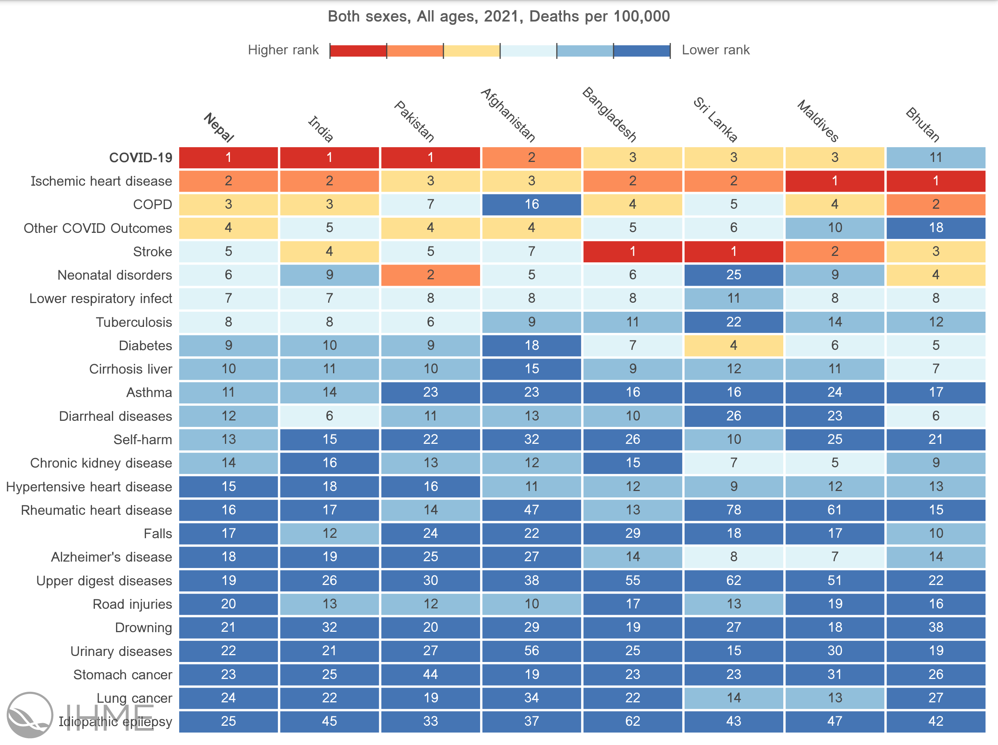*

**eSupplementary *Figure 2.***Venn diagram for the interaction between chronic kidney disease and other non-communicable diseases risk factors (17)



**eSupplementary *Figure 3.*** *Nephrology human resources in Nepal (*adapted (27, 32)).

