FPGA-BASED INTELLIGENT SENSOR

MONITORING AND FAULT DETECTION SYSTEM
A Modular Verilog HDL Design and Vivado Simulation Project

Submitted by | Shivaram Gollapalli
Roll number | BT24ECE111
Department / Program | ECE
Institution | IIIT Nagpur
SUBJECT | HDL

Abstract

This project presents a modular FPGA-oriented sensor monitoring system written in Verilog HDL. An 8-bit digital sensor reading is classified immediately on a raw path and also passed through a four-sample moving-average filter. A finite-state machine (FSM) applies warning and fault thresholds with hysteresis, requires repeated high readings before confirming a fault, and latches the confirmed fault until a safe acknowledgement. A separate counter records confirmed fault events. When the alarm state changes, a status reporter packages the state, filtered value, and event count for transmission by a UART transmitter. The Vivado project includes unit-level and system-level testbenches, expected data files, and a 100 MHz timing constraint. The design is intended as a simulation and RTL-learning project; physical sensor interfacing and board pin constraints are outside its current scope.
Keywords: Verilog HDL, FPGA, moving average, finite-state machine, fault detection, UART, Vivado
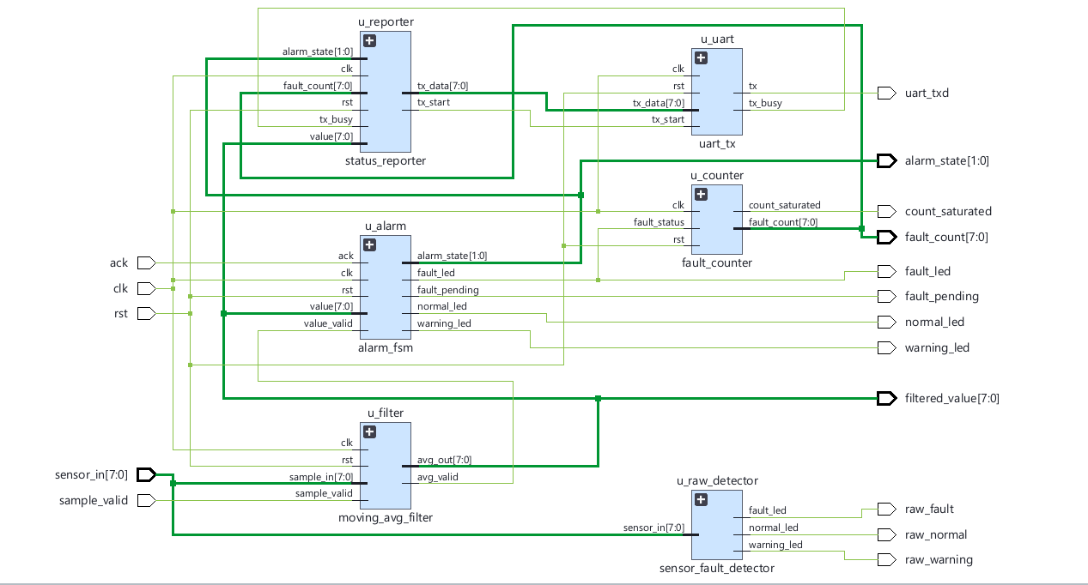

1. Introduction and System Overview
Industrial monitoring systems must interpret changing sensor readings, tolerate measurement noise, identify persistent abnormal conditions, and communicate status. This project models those functions in synchronous digital logic. The input is an already-digitized 8-bit unsigned value; analog sensing and ADC conversion are not implemented.

1.1 Objectives
- Classify the current unfiltered reading into normal, warning, or fault ranges.
- Reduce short-term fluctuations by averaging the latest four valid samples.
- Use hysteresis and consecutive-sample confirmation to avoid alarm flicker and reject brief spikes.
- Latch confirmed faults, support operator acknowledgement, and count distinct fault events.
- Transmit alarm state and useful measurements as a UART status packet.
- Verify individual modules and the integrated system using Vivado behavioral simulation.

1.2 Top-Level Architecture
The design top is sensor_monitor_top.v. It instantiates and connects the processing modules. sample_valid is a one-clock strobe indicating a new sensor sample; all sequential design blocks share clk and a synchronous active-high rst.
sensor_in ?????> Raw threshold detector ??> raw status outputs
???> 4-sample average ??> Alarm FSM ??> LEDs / fault counter
???> Status reporter ??> UART TX ??> uart_txd
The raw detector is a parallel diagnostic view. The official alarm state uses the filtered value, so brief raw spikes need not cause an alarm. The filtered path also produces filtered_valid, allowing the FSM to update only when a new average is available.

1.3 Default Design Parameters
Parameter | Default | Purpose
DATA_WIDTH | 8 bits | Unsigned sensor reading range 0?255
LOG2_TAPS | 2 | 2? = 4 samples in the moving-average window
WARN_ON / WARN_OFF | 60 / 55 | Warning enter / exit thresholds
FAULT_ON / FAULT_OFF | 80 / 75 | Fault trigger / safe-clear thresholds
CONFIRM_COUNT | 4 | Consecutive filtered samples required to confirm fault
CLKS_PER_BIT | 868 | Approx. 115200 baud with 100 MHz clock

These are Verilog parameters, so many behaviors can be changed at elaboration without editing the algorithm. Parameter combinations must still obey the ordering and width assumptions documented in the RTL.

2. Sensor Processing and Alarm Logic

2.1 Raw Threshold Detector
sensor_fault_detector.v is combinational logic: its outputs respond to the current sensor_in without waiting for a clock. With default thresholds, values 0?59 are Normal, 60?79 are Warning, and 80?255 are Fault. Default assignments set every output low before the if/else chain selects exactly one output, preventing unintended latch inference. These raw outputs are provided for comparison and are not the confirmed alarm outputs.

2.2 Moving-Average Filter
moving_avg_filter.v is sequential logic. A history array stores four samples, with history[0] newest and history[TAPS-1] oldest. Instead of re-adding the entire history each time, the running sum is updated as:
new_sum = old_sum + incoming_sample ? oldest_sample
When sample_valid is asserted, the history shifts, the incoming sample enters the window, and avg_out is updated. Since the window size is four, dividing the sum by four is implemented by selecting bits equivalent to a two-bit right shift. avg_valid pulses for one clock to mark the new output. After reset the history is zero-filled, so initial averages are biased low until the window fills.
Incoming sample | Four-sample window after update | Average
100 | 100, 0, 0, 0 | 25
100 | 100, 100, 0, 0 | 50
100 | 100, 100, 100, 0 | 75
100 | 100, 100, 100, 100 | 100
20 | 20, 100, 100, 100 | 80
20 | 20, 20, 100, 100 | 60

This example shows smoothing: one sudden 20 does not immediately make the output 20 because earlier readings remain in the window.

2.3 Alarm Finite-State Machine
alarm_fsm.v contains a state register and combinational next-state logic. The four states are NORMAL (00), WARNING (01), FAULT_PENDING (10), and FAULT (11). The LEDs are decoded from the current state; pending is shown as warning_led plus fault_pending, while fault_led is reserved for a confirmed fault.
Warning enters at value ? 60 and clears below 55. A value ? 80 enters FAULT_PENDING. The FSM counts consecutive valid filtered samples at or above 80; the fourth confirms FAULT by default. If a sample falls below 80 during confirmation, the pending count resets and the FSM returns to warning or normal. Hysteresis avoids rapid switching near thresholds. A confirmed fault remains latched until ack is asserted while value is below 75; it then returns to Normal or Warning based on the lower threshold.
Coding pattern: state/confirm_cnt are clocked registers updated with nonblocking assignments at posedge clk. A separate always @(*) block defaults next_state and next_cnt to their current values, then overrides them for transitions. This separation is a common FSM implementation style.

3. Fault Logging and UART Communication

3.1 Fault Event Counter
fault_counter.v counts a confirmed fault event, not every clock cycle in which the fault remains active. It stores the previous fault_status in prev_fault and detects a new event using:
new_fault_event = fault_status AND NOT prev_fault
Thus only a 0-to-1 transition increments fault_count. A sustained high level counts once; a later fault counts again after fault_status has returned low. The counter is 8 bits and saturates at 255 rather than wrapping. count_saturated indicates the maximum has been reached. The FSM confirmation counter and this event counter serve different purposes: one confirms consecutive samples, the other records separate confirmed events.

3.2 Status Reporter
status_reporter.v detects when alarm_state differs from last_state. It snapshots the state, filtered value, and fault count, then sends three bytes through a request/busy handshake. Its small control FSM moves through idle, snapshot, load-byte, wait-for-accept, and wait-for-completion states. It sends a one-cycle tx_start pulse and waits for tx_busy to rise and then fall before advancing to the next byte. If state changes during a packet, it completes the current packet and later reports the latest state; it does not maintain a packet FIFO.
Byte index | Contents | Example meaning
0 | 0xA0 OR alarm_state | A1 = Warning
1 | Filtered sensor value | 44 hex = 68 decimal
2 | Fault event count | 02 hex = 2 events

The tag nibble A identifies the status packet; the lower two bits of byte 0 encode the four alarm states. Example packet A1 44 02 means Warning, filtered value 68, and fault count 2.

3.3 UART Transmitter
uart_tx.v serializes each byte using 8N1 framing: one low start bit, eight data bits least-significant bit first, and one high stop bit. The line idles high. A clock counter holds each bit for CLKS_PER_BIT system-clock cycles; tx_busy is high while a frame is being transmitted. With a 100 MHz clock and 868 clocks per bit, the nominal bit rate is approximately 115200 baud. Testbenches use smaller values to shorten simulation time; those values are simulation-only overrides.
The complete communication path is: alarm state change ? three-byte snapshot ? UART frames ? uart_txd. uart_rx_monitor.v is a simulation-only receiver used to decode this line and allow tests to compare received bytes; it is not part of synthesizable hardware.

4. Verification, Vivado Project, and Conclusion

4.1 Testbench Strategy
Testbenches are simulation-only Verilog modules. They generate clock/reset and input stimulus, compare actual outputs against expected values or a reference model, and report mismatches. They can be selected and run individually in Vivado; the full-system test is a separate integration test.
Testbench | Main verification focus
tb_sensor_fault_detector | Threshold boundaries, one-hot outputs, parameter overrides, exhaustive 8-bit sweep
tb_moving_avg_filter | Known sequences, output-valid behavior, random samples vs reference model, reset
tb_alarm_fsm | Hysteresis, rejected spikes, confirmation, latch/ack, reset and state invariants
tb_fault_counter | Rising-edge event counting, sustained faults, reset and saturation at 255
tb_uart_reporter | UART byte decode, bit timing, busy handshake, packet snapshot and framing
tb_sensor_monitor_top | Integrated trace, expected filtered/state/count data, UART packets and reset during fault

The integration test reads sensor_trace.mem and expected result files using $readmemh. expected_samples.mem supplies golden per-sample values, expected_packets.mem supplies expected UART packets, and trace_info.mem supplies the dataset sizes. The testbench includes checks for one-hot outputs, unknown values, framing errors, and unexpected counter changes. Test results should be confirmed by running the selected simulation to completion and checking the Tcl Console summary; this report describes coverage and does not claim a fresh simulation run.

4.2 Main Vivado Files and Flow
- sensor_monitor.xpr: Vivado project file; records the target part and source/file-set configuration.
- sensor_monitor.srcs/sources_1/new: synthesizable RTL; design top is sensor_monitor_top.
- sensor_monitor.srcs/sim_1/new: testbenches, UART monitor, and memory-based test data.
- timing.xdc: defines a 10 ns (100 MHz) clock for timing analysis; it does not assign FPGA pins.
- rebuild_project.tcl: fallback script for recreating the project if the XPR cannot be opened.
To simulate, open the XPR, choose a tb_ module under Simulation Sources as the simulation top, run Behavioral Simulation, then Run All. For RTL synthesis exploration, synthesize sensor_monitor_top and inspect utilization/timing reports. The project targets xc7a35tcpg236-1, but no package pins or I/O standards are assigned, so it is not currently a complete board-programming project; do not generate a bitstream until board-specific constraints and physical interfaces are added.

5. Conclusion and Future Work
The project demonstrates a complete modular RTL workflow: sample conditioning, threshold classification, state-machine alarm handling, event logging, and serial reporting. The separation into small modules makes the design easier to explain, test, and extend. Possible next steps include connecting a real ADC and board-level inputs, synchronizing/debouncing a physical acknowledgement button, adding configurable packet checksums or a queue, and validating the design on a selected FPGA board with correct pin and I/O constraints.
Project source: sensor_monitor.srcs/sources_1/new and sensor_monitor.srcs/sim_1/new. All threshold, timing, protocol, and test descriptions in this report are based on the supplied Verilog and Vivado project files.

