Project Charter
Date: 05/17/2021

Project Title: Dining Scheduler
Project Start Date: 05-17-2021 Projected Finish Date: 06-03-2021
Budget Information: The project would cost around 12,000 dollars for completion.
Project Manager: Hema Sree Rathnam Machha, +1 (763) 222 -4811, S542270@nwmissouri.edu
Project Objectives:
Creation of a software Application which helps in scheduling the working hours of an employee
Success Criteria:
- Client requirements should be fulfilled.
- Project should adhere to the deadlines.
- Project should be completed within the assigned budget.
- Before the deadline finish our website should be live without any errors and with user-friendly design
- Project should fulfill all the requirements defined in the scope.

Approach: Agile Approach
Roles and Responsibilities
Name and Signature | Role | Position | Contact Information
Alekya Billakanti  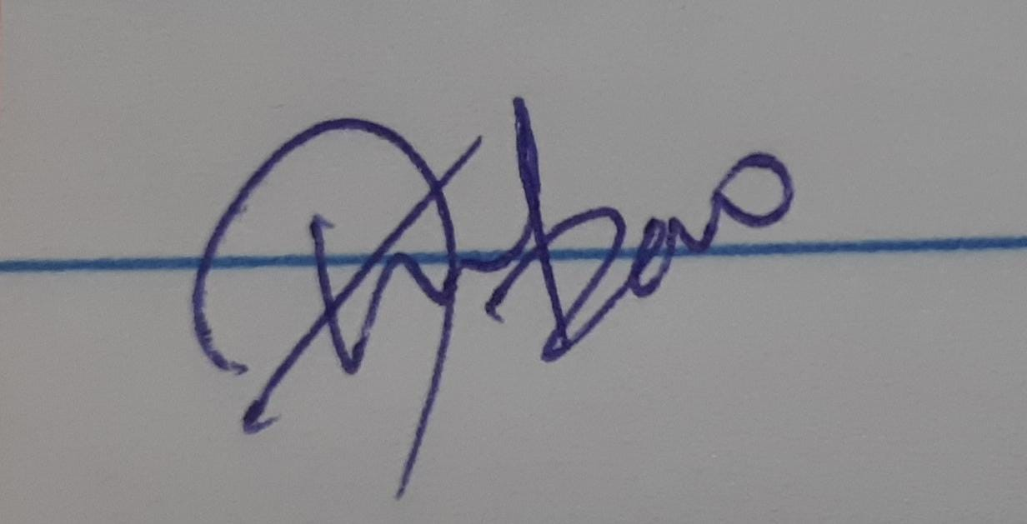 | Team Member | Tester | S542388@nwmissouri.edu
Hema Sree Rathnam Machha  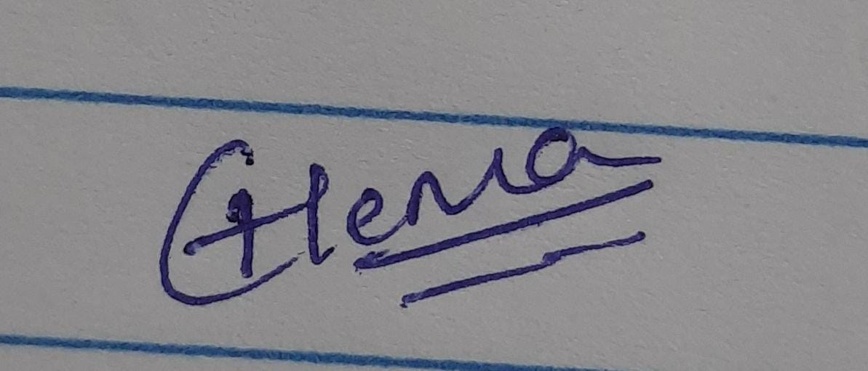 | Project Manager | Manager | S542270@nwmissouri.edu
Hemanth Venkata Reddy Telluri  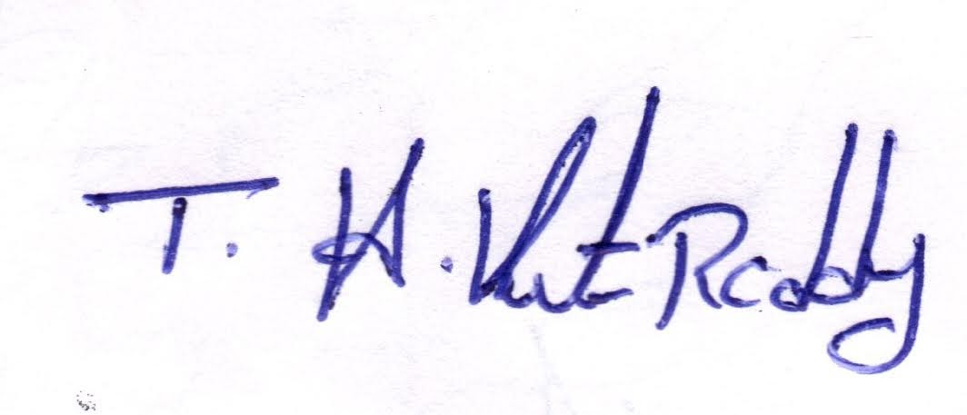 | Team Member | Application Developer | S542393@nwmissouri.edu
Jaya Kumar Saga  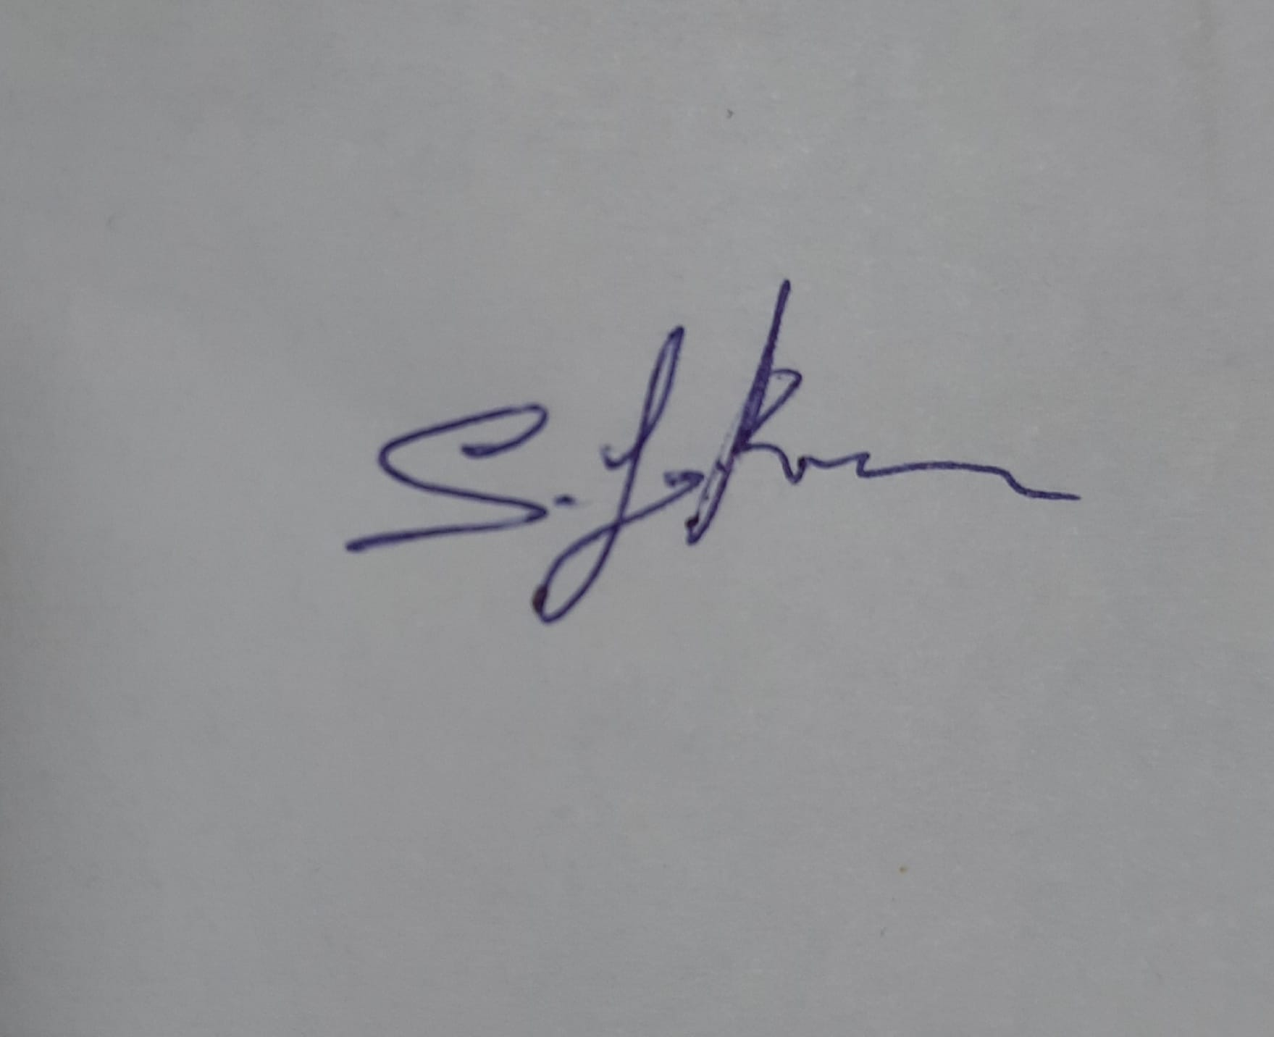 | Team Lead | Full Stack Developer | S542392@nwmissouri.edu
Shiva Ram Kothapally  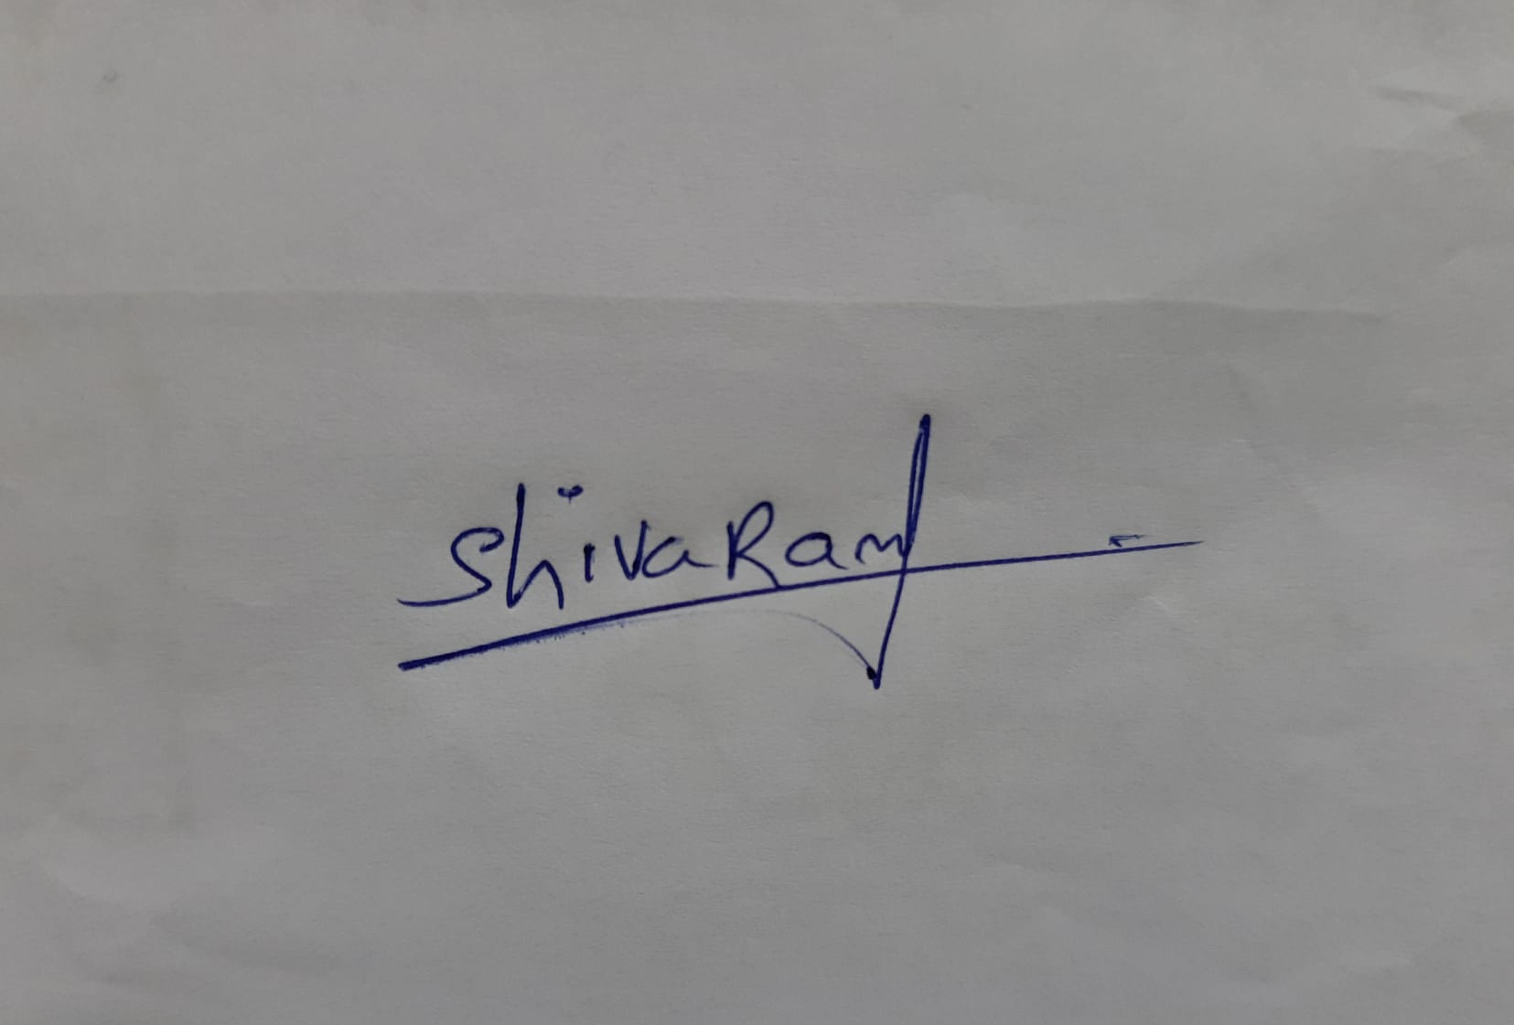 | Team Member | Web application developer | S542269@nwmissouri.edu
Comments: (Handwritten or typed comments from above stakeholders, if applicable)

Team Name: Incredibles

Team Logo:



Stakeholder Register for Project Name

Prepared by: Hema Sree Rathnam Machha Date: 05/07/2021

Name | Position | Internal/External | Project Role | Contact Information
Alekya Billakanti | Tester | Internal | Team Member | S542388@nwmissouri.edu
Hema Sree Rathnam Machha | Manager | Internal | Project Manager | S542270@nwmissouri.edu
Hemanth Venkata Reddy Telluri | Application Developer | Internal | Team member | S542393@nwmissouri.edu
Jaya Kumar Saga | Full Stack Developer | Internal | Team Lead | S542392@nwmissouri.edu
Shiva Ram Kothapally | Web application developer | Internal | Team member | S542269@nwmissouri.edu
Dr. Aziz Fellah | End User | External | Client | AFELLAH@nwmissouri.edu

