**Azure End-To-End Data Engineering Project (From Scratch!)**

**Architecture**

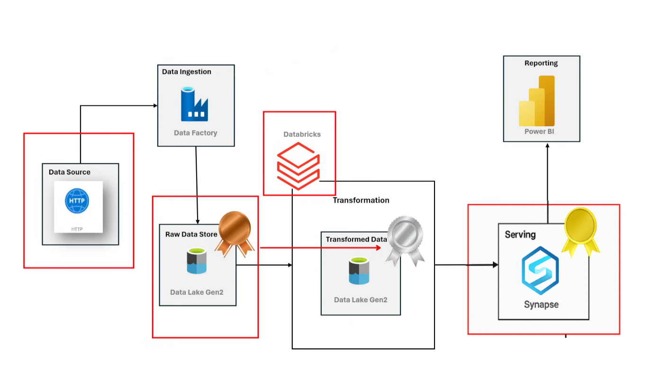

**Created an resource group and Datalake in storage account.**

**Created azure datafactory for aw project.**

**Created three containers in Data lake storing data.**

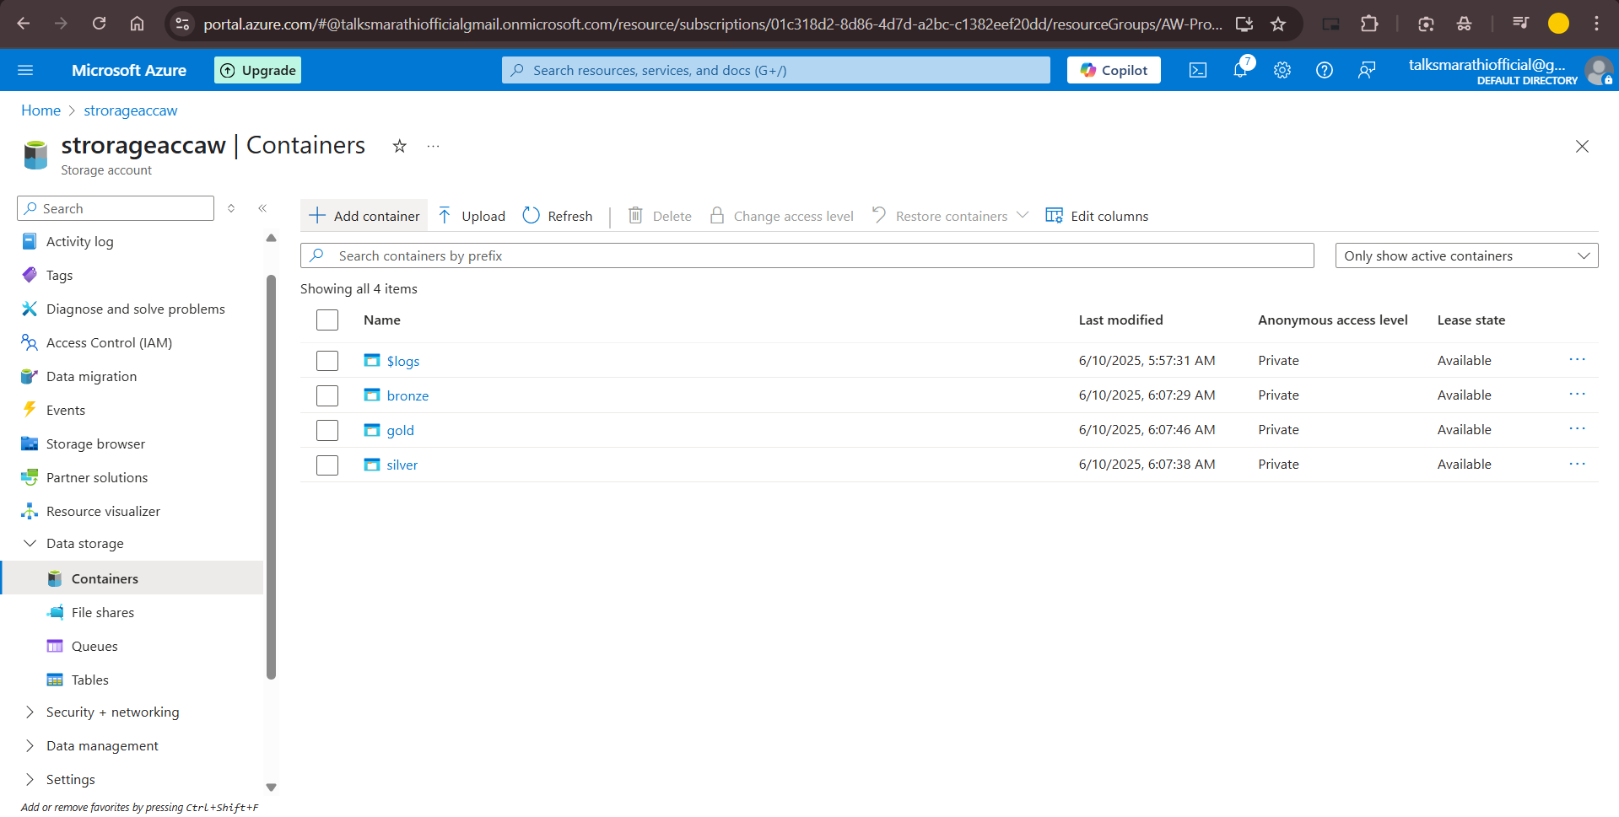

Created a static pipeline for Getting data from Github to Data Lake.

**Created a json file for parameters.**

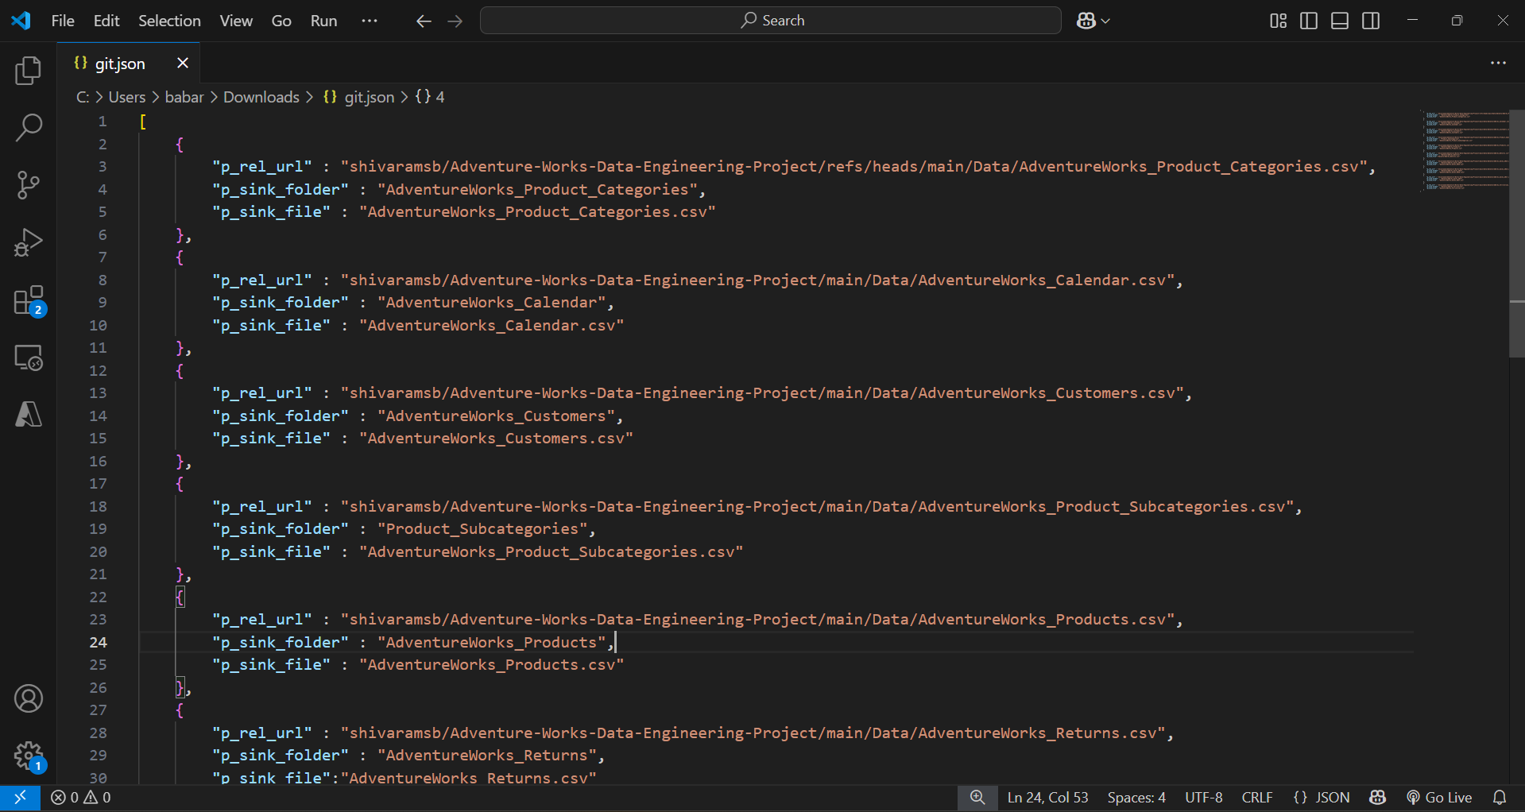

**Created a dynamic pipeline for copy all files from source folder and copy in Data lake in each folder and file.**

Copied data in bronze layer data lake.

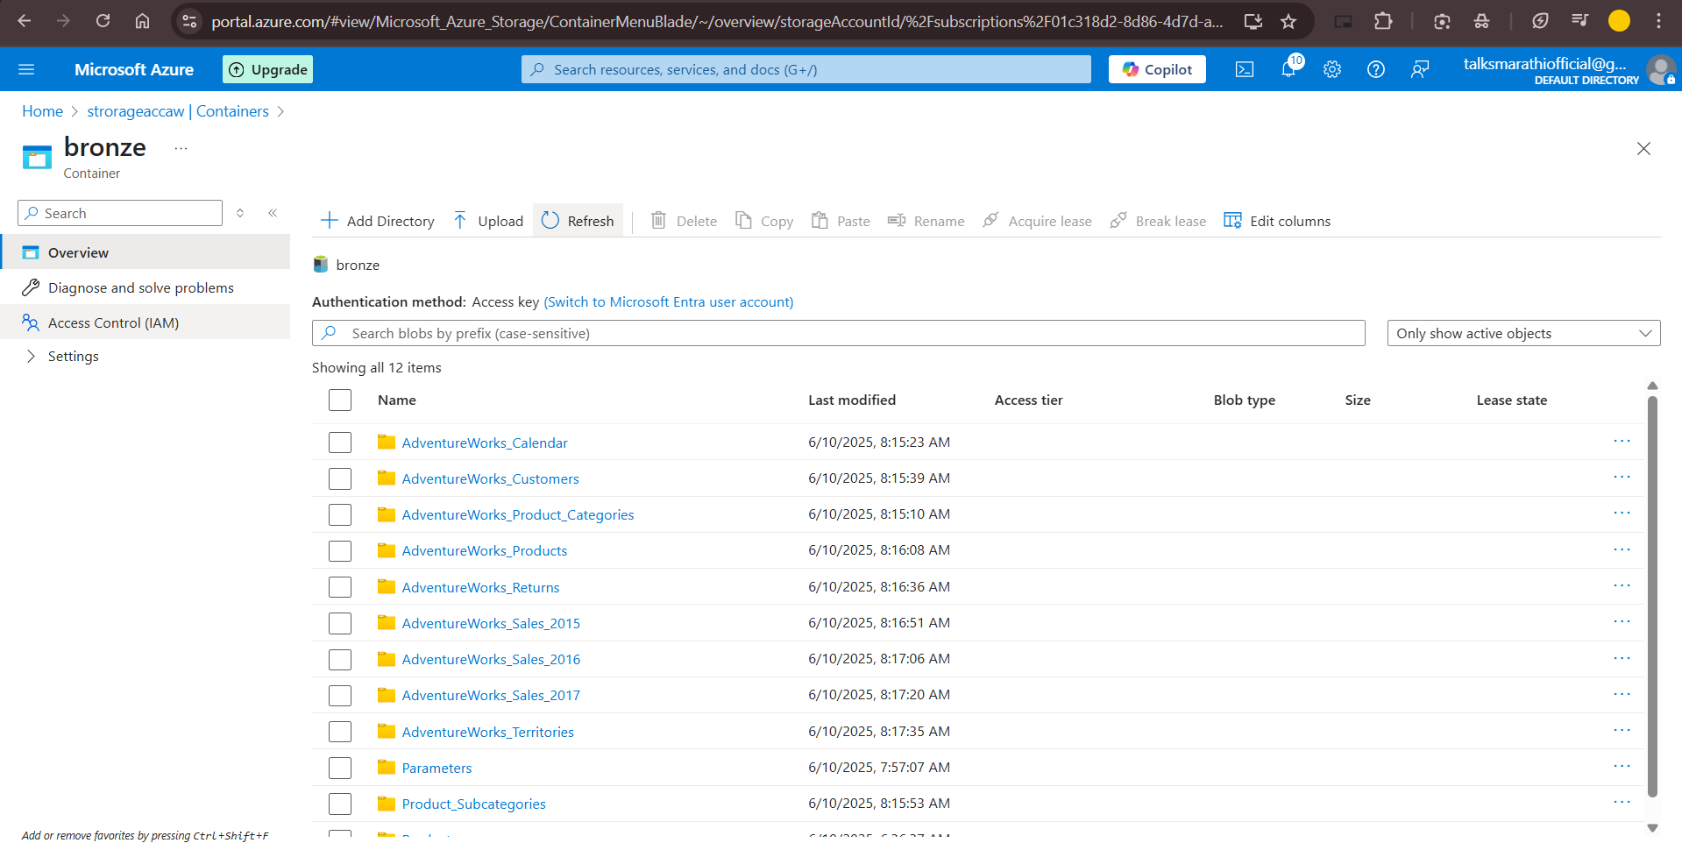

Created a Azure Databricks (aw-databricks-ws) Workspace.

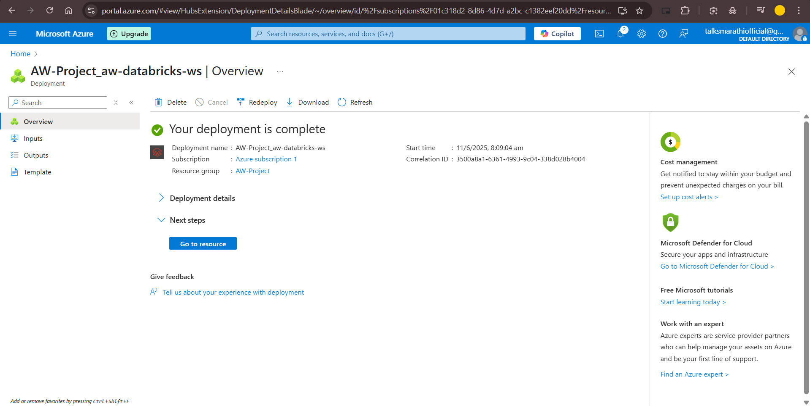

Service Level Application : Created an app registration, secrets and added role assignment for Blob Data Contributor.

Created an Databricks compute cluster for sparks jobs.

Created Databricks workspace and created a notebook for silver layer transformation.

Created Synapse Workspace and attached assignment role of data lake.

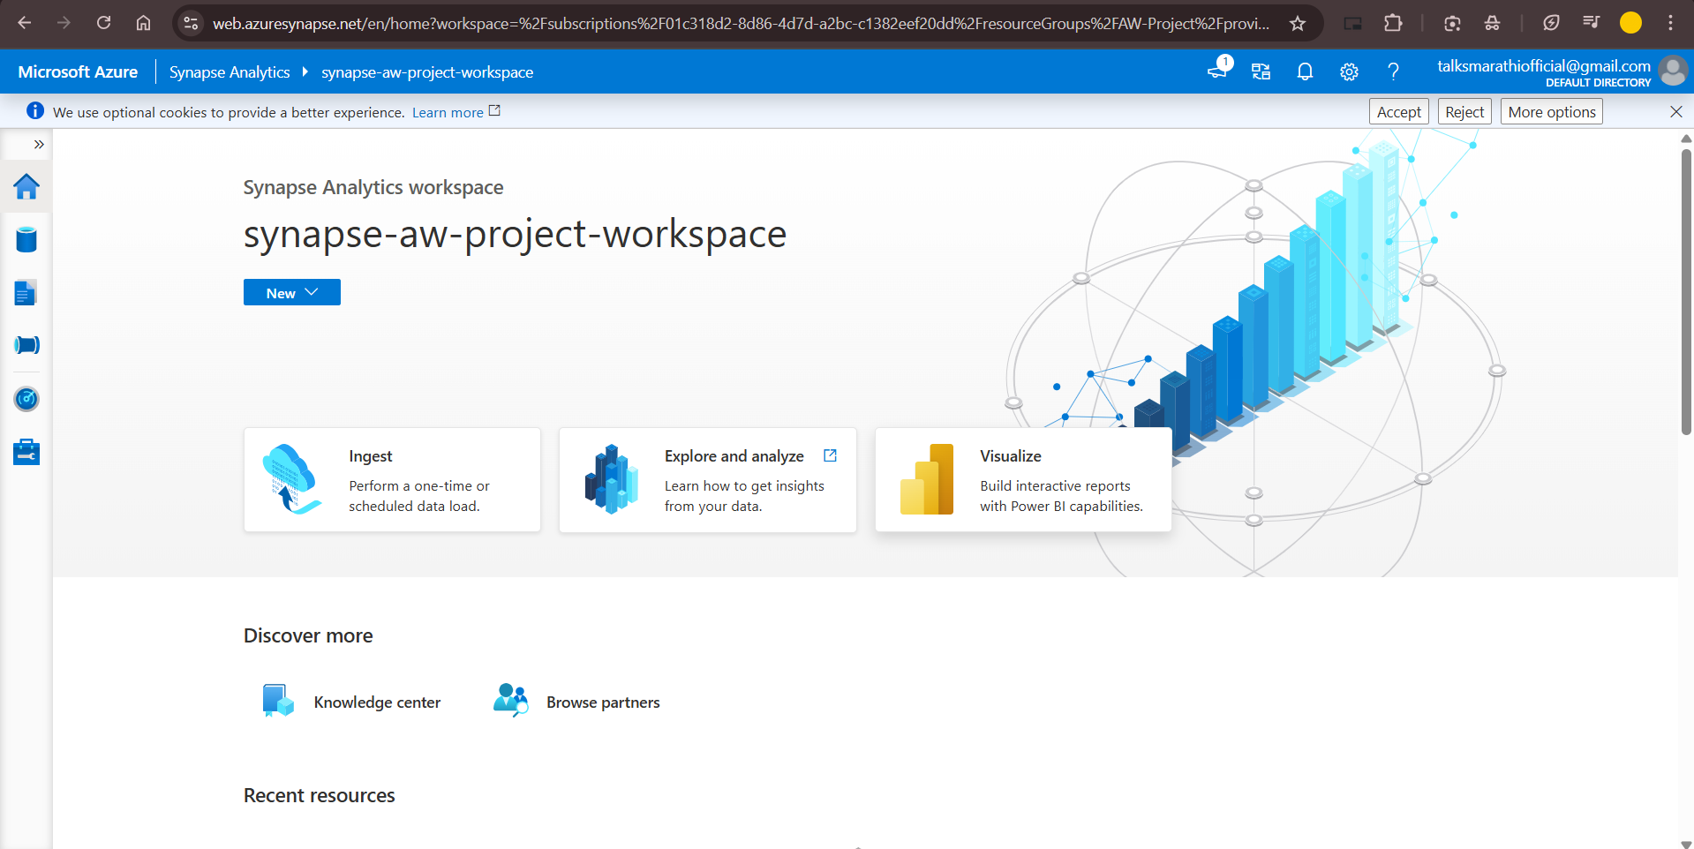

Created an SQL database in Synapse and created view for all data stored in silver layer.

On the top of sales view created an External Table and this table stored in Gold layer.

Connected Powerbi desktop to the Azure synapse sql

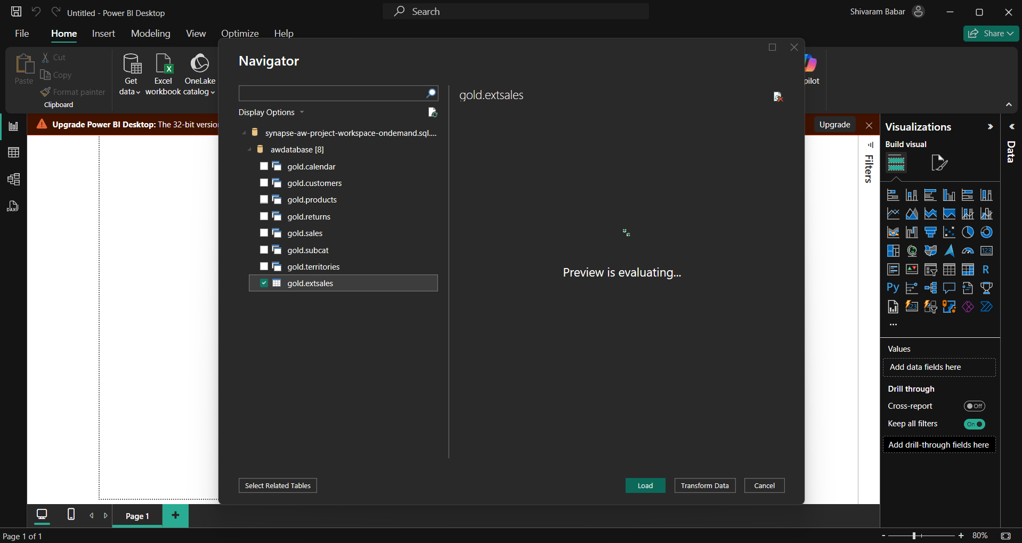

Created a powerbi dashboard

