CO-1 ASSESSMENT TOO1-01
COURSE:DAA
CODE:CSA0613
NAME:A.Shiva Shankar Reddy
REG NO:192425174
SLOT :A

Q1. Application: Online Video Streaming Platform
Problem Statement
A video streaming platform processes user data using the recurrence:
$$T\left(n\right)=2T\left(n/2\right)+n$$
Determine the time complexity using the Master Theorem.

Python Program
Python
Run
def streaming_platform(n):
if n <= 1:
return 1

left = streaming_platform(n // 2)
right = streaming_platform(n // 2)

return left + right + n
n = 16
result = streaming_platform(n)
print("Input Size:", n)
print("Result:", result)

Sample Output
Input Size: 16
Result: 80
Master Theorem Analysis
Given:
$$T\left(n\right)=2T\left(n/2\right)+n$$
Compare with standard form:
$$T\left(n\right)=aT\left(n/b\right)+f\left(n\right)$$
Parameters
- a = 2
- b = 2
- f(n) = n
Calculate
$$n^{\log_{b}a} \\ n^{\log_{2}2} \\ n^{1}=n$$
Thus,
$$f\left(n\right)=Θ\left(n\right)$$
and
$$n^{\log_{b}a}=Θ\left(n\right)$$
Master Theorem Case
Since
$$f\left(n\right)=Θ\left(n^{\log_{b}a}\right)$$
it satisfies Case 2.
Therefore,
$$T\left(n\right)=Θ\left(n\log{n}\right)$$
Asymptotic Interpretation
- Big-O: O(n log n)
- Big-Theta: Θ(n log n)
- Big-Omega: Ω(n log n)

Scalability Analysis
As the number of users increases:
Users (n) | Time Complexity
100 | 100 log 100
1000 | 1000 log 1000
10000 | 10000 log 10000
Growth is slower than O(n²), making the algorithm efficient for large-scale streaming platforms.
Conclusion
Using the Master Theorem, the recurrence
$$T\left(n\right)=2T\left(n/2\right)+n$$
belongs to Case 2, giving:
$$\boxed{T\left(n\right)=Θ\left(n\log{n}\right)}$$
The algorithm scales efficiently and is suitable for processing large numbers of users.
Output:
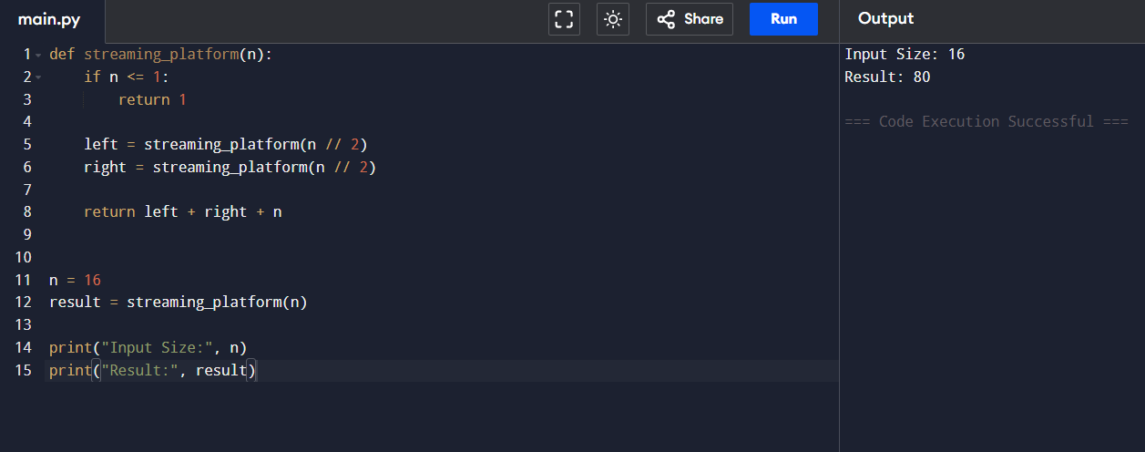
Q2. Application: Social Media Feed Processing
Problem Statement
A social media platform processes posts using:
$$T\left(n\right)=T\left(n-1\right)+n$$
Solve using the Substitution Method.
Python Program
Python
Run
def social_media_feed(n):
if n == 1:
return 1

return social_media_feed(n - 1) + n
n = 10
result = social_media_feed(n)
print("Input Size:", n)
print("Result:", result)
Sample Output:
Input Size: 10
Result: 55
Substitution Method Analysis
Given:
$$T\left(n\right)=T\left(n-1\right)+n$$
Expand repeatedly:
$$T\left(n\right)=T\left(n-1\right)+n \\ =T\left(n-2\right)+\left(n-1\right)+n \\ =T\left(n-3\right)+\left(n-2\right)+\left(n-1\right)+n \\ =T\left(n-4\right)+\left(n-3\right)+\left(n-2\right)+\left(n-1\right)+n$$
Continuing:
$$=T\left(1\right)+2+3+4+⋯+n$$
Assume:
$$T\left(1\right)=1$$
Then
$$T\left(n\right)=1+\sum_{i=2}^{n}{i}$$
Using the sum formula:
$$1+\frac{n\left(n+1\right)}{2}-1 \\ =\frac{n\left(n+1\right)}{2} \\ =\frac{n^{2}+n}{2}$$
Final Complexity
Dominant term:
$$\frac{n^{2}}{2}$$
Therefore,
$$T\left(n\right)=Θ\left(n^{2}\right)$$

Asymptotic Interpretation
- Big-O: O(n²)
- Big-Theta: Θ(n²)
- Big-Omega: Ω(n²)

Performance Analysis
Number of Posts (n) | Operations
100 | 10,000
1,000 | 1,000,000
10,000 | 100,000,000
The running time increases quadratically, causing significant performance degradation for very large social media datasets.

Conclusion
By applying the Substitution Method:
$$T\left(n\right)=T\left(n-1\right)+n$$
expands to
$$T\left(n\right)=\frac{n\left(n+1\right)}{2}$$
Hence,
$$\boxed{T\left(n\right)=Θ\left(n^{2}\right)}$$
The algorithm becomes less efficient as input size grows because execution time increases quadratically.
Output:
