CO-1 ASSESSMENT TOO1-03
COURS:DAA
CODE:CSA0613
NAME:A.Shiva Shankar Reddy
REG NO:192425174
SLOT :A

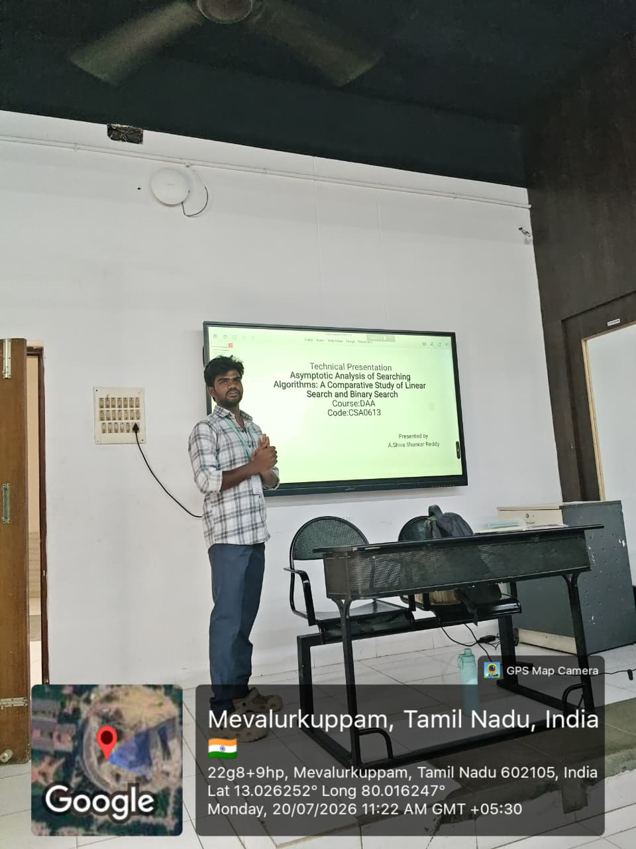

Title: Asymptotic Analysis and Performance Comparison of Linear Search and Binary Search Algorithms
Description:
This presentation focuses on the asymptotic analysis of two fundamental searching algorithms: Linear Search and Binary Search. It evaluates their performance using the three standard asymptotic notations—Big-O (O) for worst-case complexity, Big-Theta (Θ) for average-case complexity, and Big-Omega (Ω) for best-case complexity. The presentation explains how each algorithm searches for an element, compares their time complexities, and demonstrates how the search space is reduced during execution. Using tables, diagrams, and Python implementations, it highlights the efficiency of both algorithms across datasets of different sizes. The analysis concludes by showing why Binary Search, with its logarithmic time complexity, is significantly more efficient than Linear Search for large sorted datasets, while Linear Search remains suitable for small or unsorted datasets.

