SIMATS ENGINEERING
SAVEETHA INSTITUTE OF MEDICAL AND TECHNICAL SCIENCES
NAME: A Shiva Shankar Reddy
DATE:08/10/2026
LAB EXP: 13
Reg Mo: 192425174
Course Code/ Name: DSA0601 / Data Handling and Visualization
Set:13
Dataset: Geographic Data
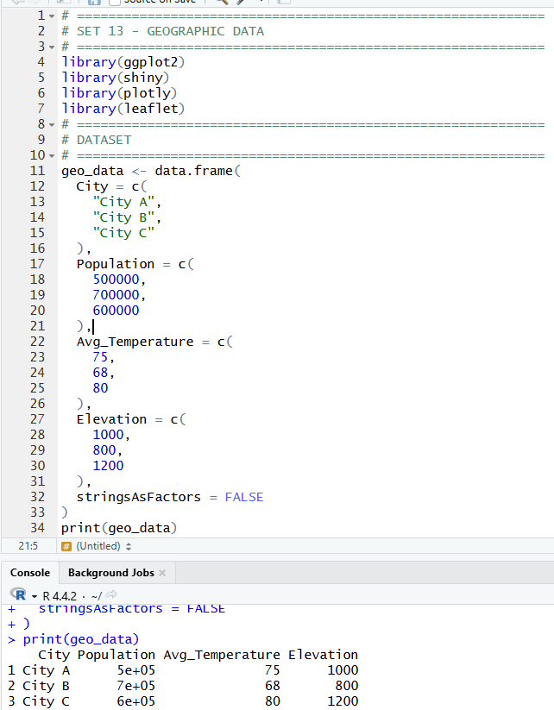
1. Create a map chart to visualize the distribution of cities on a geographic map. Label the map elements.
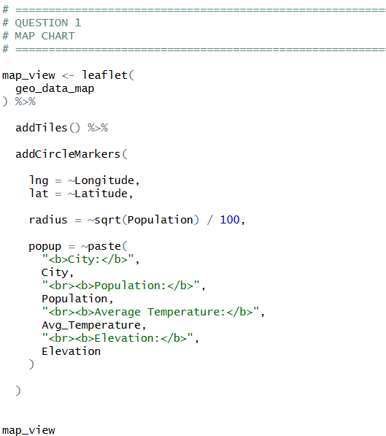
OUTPUT:
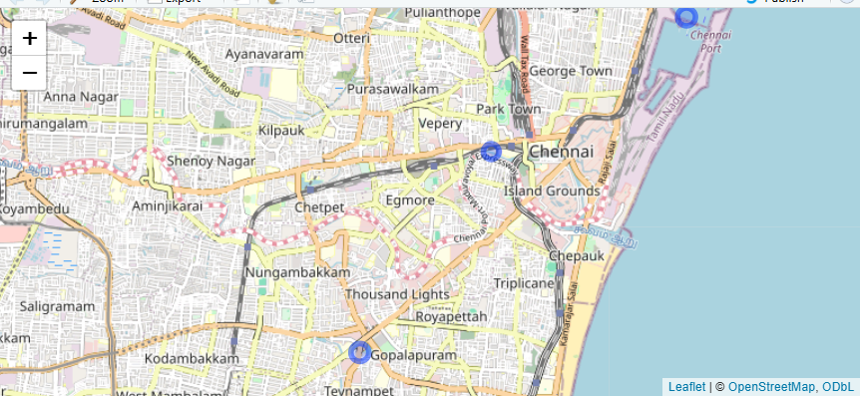

2. Generate a scatter plot to explore the relationship between average temperature and population size Explain any insights.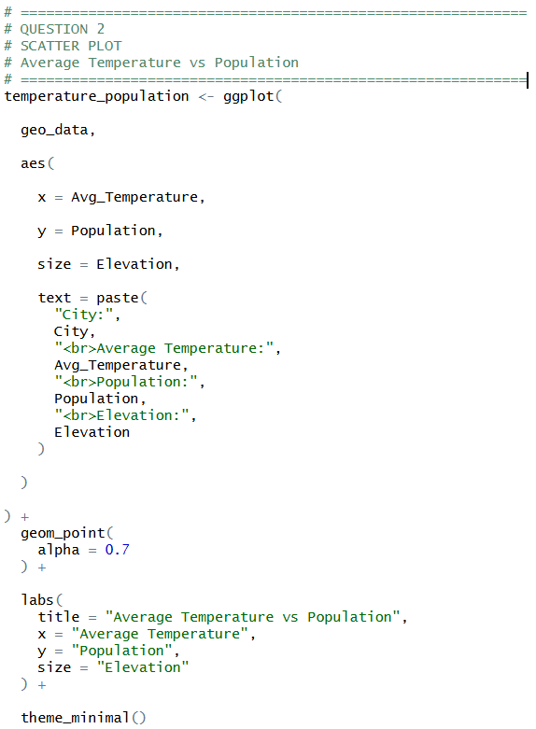
OUTPUT:
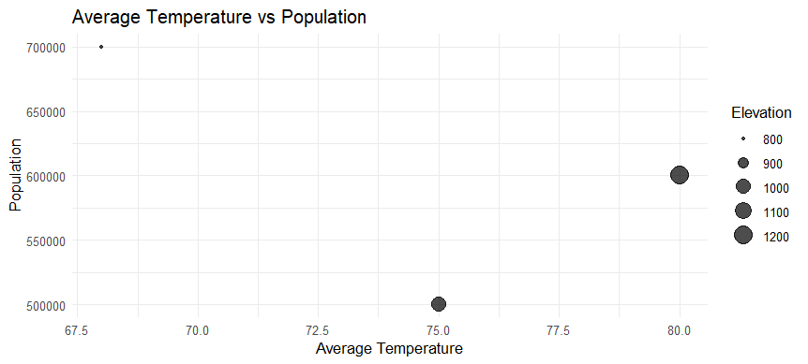
3. Build a table to display the geographic data for each city. Label the table elements.
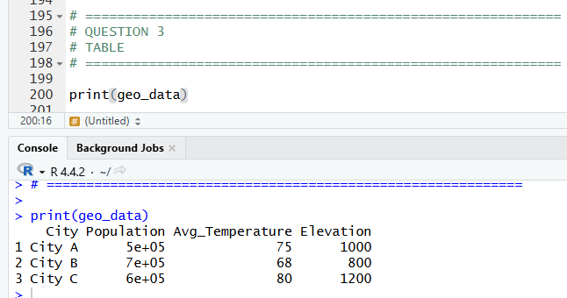

4.Develop a Tableau dashboard combining the map chart, scatter plot, and the table for interactive exploration of geographic data.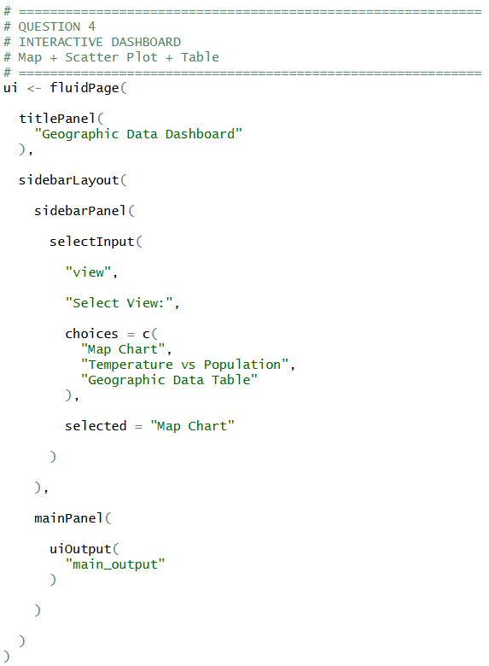
OUTPUT:
