SIMATS ENGINEERING
SAVEETHA INSTITUTE OF MEDICAL AND TECHNICAL SCIENCES
NAME: A Shiva Shankar Reddy
DATE:13/10/2026
LAB EXP: 21
Reg Mo: 192425174
Course Code/ Name: DSA0601 / Data Handling and Visualization
Set 21
Dataset: Energy_Consumption_Data.csv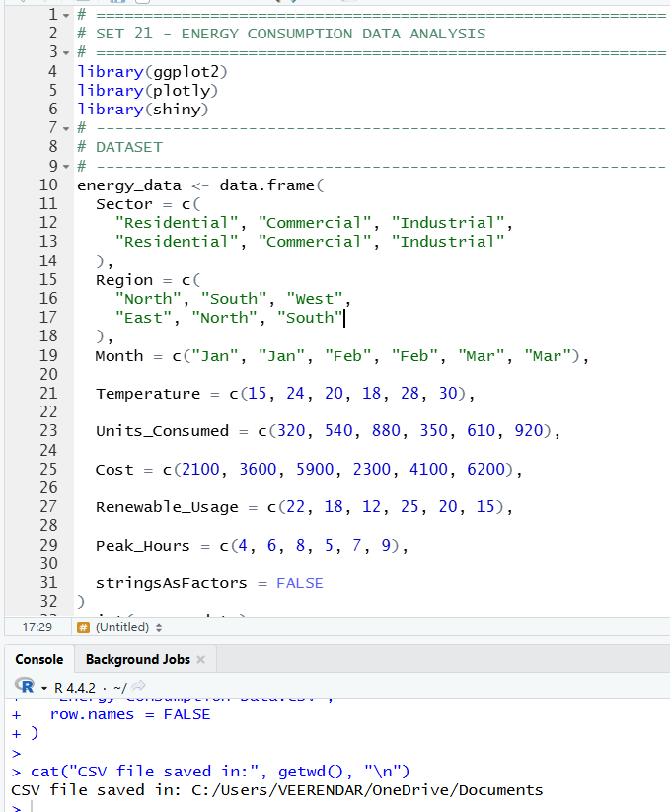
1. Import the dataset in R. Plot a histogram and density plot for Units_Consumed. Compare consumption patterns.
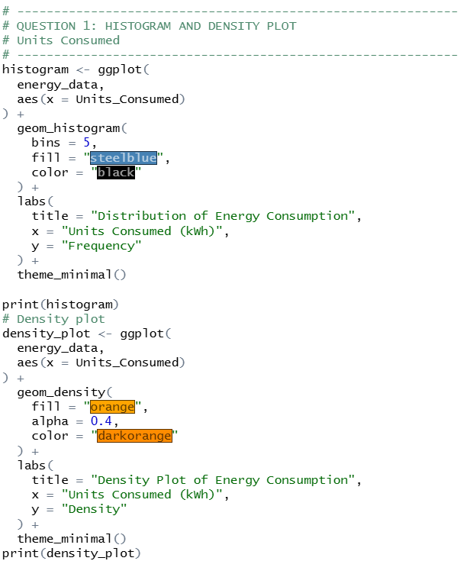
OUTPUT:
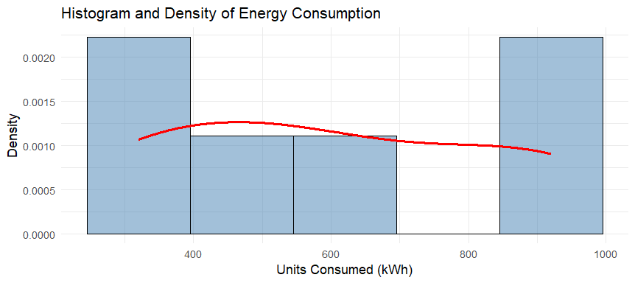
2. Using R programming, create a scatter plot between Temperature and Units_Consumed. Represent Peak_Hours using bubble size. Apply transparency.
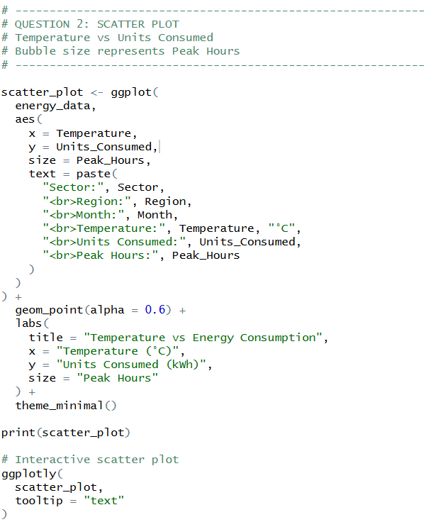
OUTPUT:
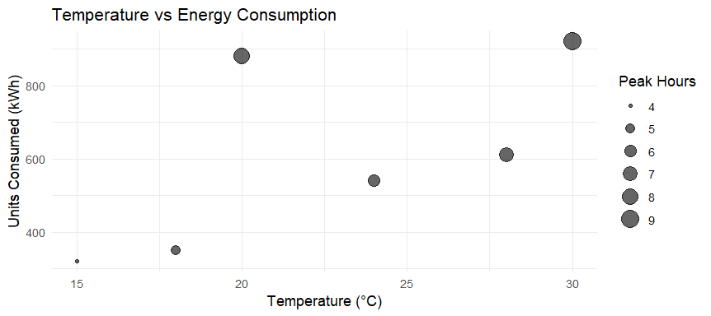
3. Using R, calculate average Renewable_Usage for each Sector. Create a bar chart. Interpret renewable energy adoption.
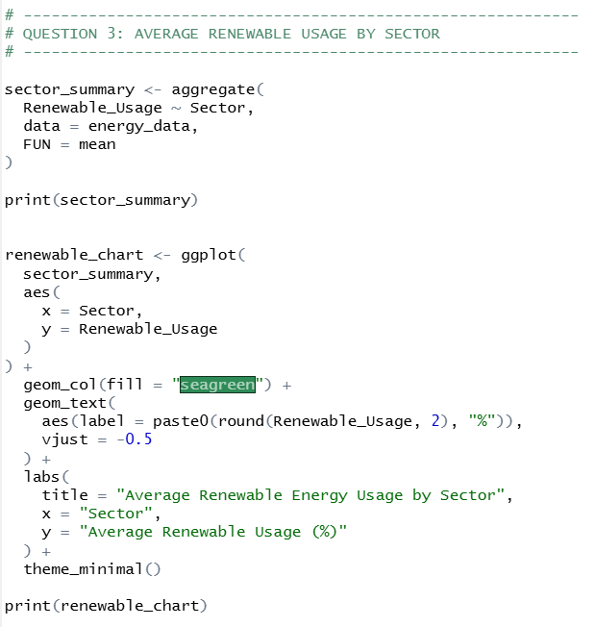
OUTPUT:
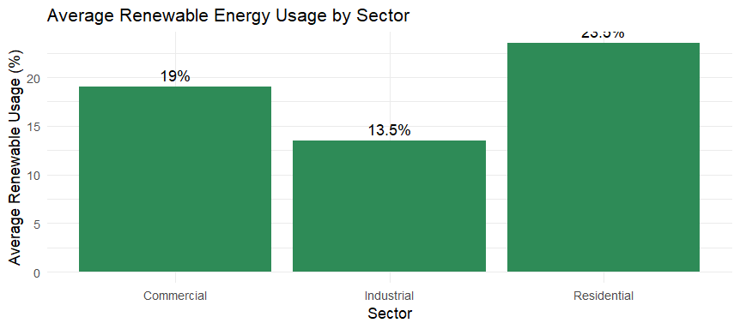

4. Import Energy_Consumption_Data.csv into Tableau. Create a line chart for monthly energy usage trends. Create a heatmap (Sector vs Region vs Units). Add filters for Month and Sector. Design an interactive dashboard.
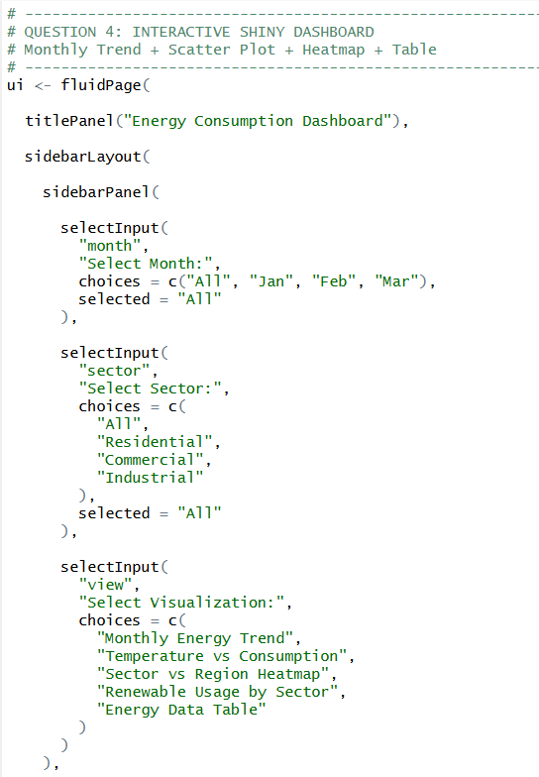
OUTPUT:
