LAB EXPERIMENT RECORD
 | 22-10-2026---Set 28: Website Traffic Analysis
Department |  | AIML
Course Code / Course Name |  | DSA0601 / Data Handling and Visualization
Experiment |  | Data Visualization using R and Tableau
Name |  | A Shiva Shankar Reddy
Register Number |  | 192425174
Date |  | 22 OCTOBER 2026
Day |  | THURSDAY

Aim
To analyze website traffic data in R and Tableau using a line chart, bar chart, stacked area chart and an interactive dashboard.
Dataset: Website Traffic
Date | Page Views | Click-through Rate
2023-01-01 | 1500 | 2.3%
2023-01-02 | 1600 | 2.7%
2023-01-03 | 1400 | 2.0%
2023-01-04 | 1650 | 2.4%
2023-01-05 | 1800 | 2.6%

Question 1: Line Chart of Page Views (Tableau)
Question: In Tableau, create a line chart to visualize the trend in page views over time. Label the axes and title the chart.
Aim: To visualize the trend in daily page views using a Tableau line chart with labelled axes and a title.
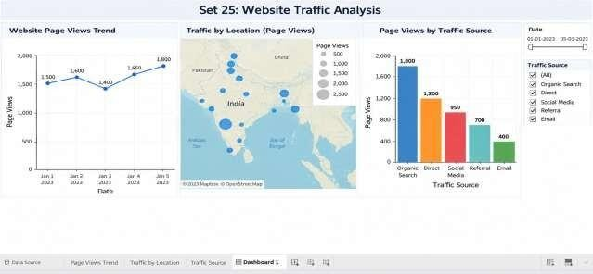

Result: Page views rise from 1500 to 1600, dip to 1400 on 2023-01-03, and then climb to 1650 and a peak of 1800 on 2023-01-05, so the overall trend is upward.

Question 2: Bar Chart of Top N Days by Click-through Rate (R)
Question: In R, generate a bar chart to show the top N days with the highest click-through rates.
Label the chart elements.
Aim: To identify the top N days with the highest click-through rates using a labelled bar chart.
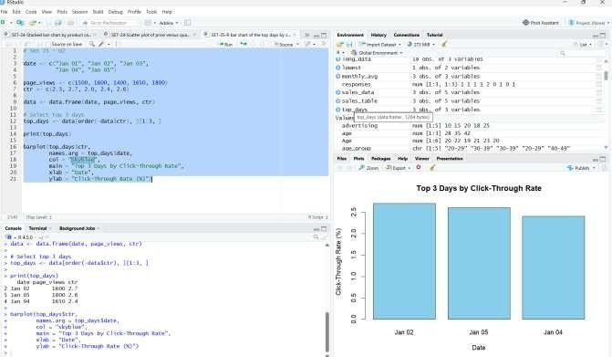
Result: For N = 3, 2023-01-02 ranks first (2.7%), followed by 2023-01-05 (2.6%) and 2023-01-04 (2.4%).

Question 3: Stacked Area Chart of User Interactions (R)
Question: In R, build a stacked area chart to display the distribution of user interactions (likes, shares, comments) on the website.
Aim: To display how likes, shares and comments add up to total user interactions over time using a stacked area chart.
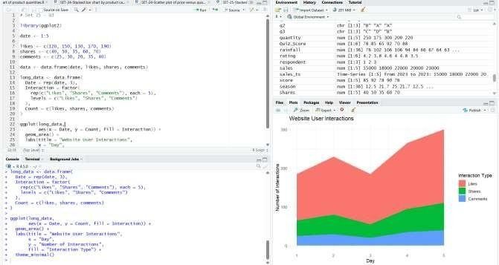
Result: The chart shows each interaction type as a layer stacked over the days; the dataset has no likes, shares or comments columns, so these values must be supplied.

Question 4: Tableau Dashboard with Map and Bar Chart
Question: In Tableau, create a dashboard with an interactive map showing traffic sources and a bar chart displaying page views by source.
Aim: To build an interactive Tableau dashboard that shows traffic sources on a map and page views by source in a bar chart.
Result: The map and bar chart are linked, so selecting a source on the map highlights its page views in the bar chart; the dataset has no source or location column, so these must be supplied.
Overall Result
Observation: The average page views are 1590 per day and the average click-through rate is 2.4%, with the most views on 2023-01-05 (1800) and the best click-through rate on 2023-01-02 (2.7%).

