**44-642 - App Design: Patterns and Frameworks Reading Excel Data**

**Creating a Maven Project in NetBeans IDE 12.0:**

1. Choose “New Project” from the menu.
2. Under “Java with Maven”, find and select “Project from Archetype” and click “Next”.

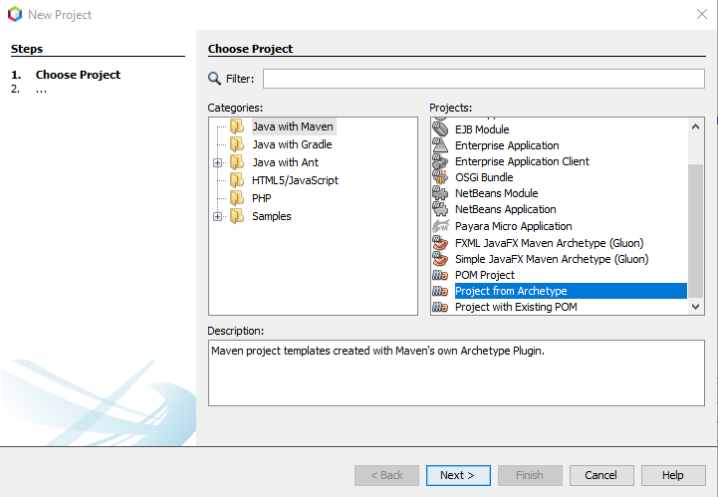

1. For this project we will use **Artifact ID**: maven-archetype-quickstart. To get this, type “org.apache.maven.archetypes” in Search. Select the Artifact ID referenced above and click “Next”.

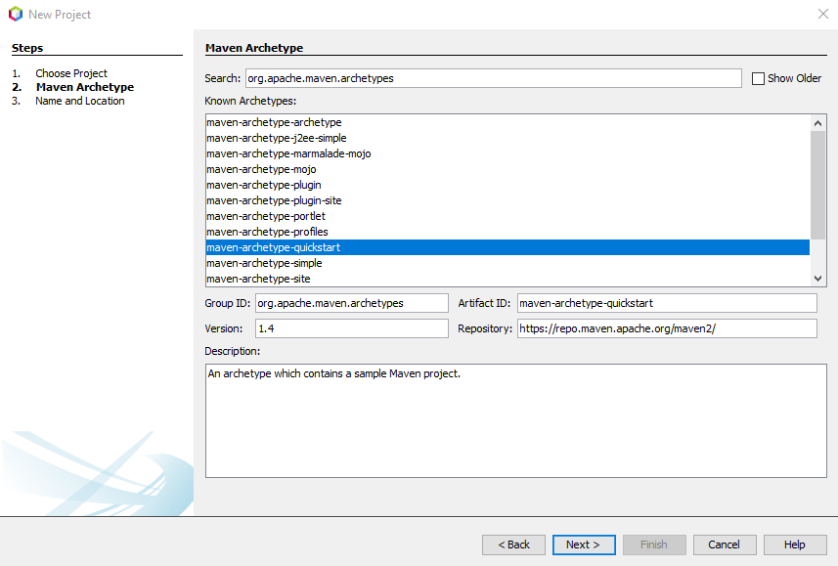

1. Now you need to enter the **Group Id** and **Artifact Id.**
   1. **Group Id:** com.buildtools
   2. **Artifact Id (enter in Project Name field):** demo
   3. Click “Finish”.

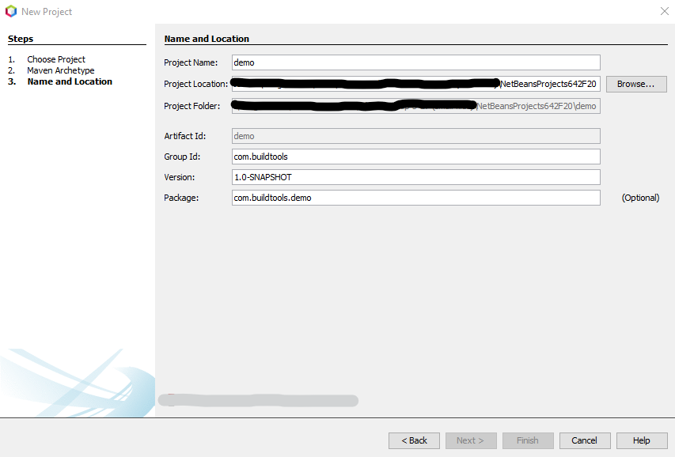

1. Create an excel file named “SampleExcel.xls” with some sample data as given below.
2. Add the file in the root folder of your project. Use Excel 97-2003 format i.e. .xls (not .xlsx) since the code we use below is complaint only with that specific format.
3. Excel data:



1. It should look like this:

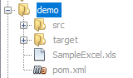

1. To read Excel data and print it in the console, replace the main method in App.java, which is an auto-generated class, with the following code:

public static void main(String[] args) throws FileNotFoundException, IOException {

//Create POI file system object.

POIFSFileSystem objPOIFileSystem = new POIFSFileSystem(new FileInputStream("SampleExcel.xls"));

//Create a data extractor using file system object.

ExcelExtractor datExtractor = new ExcelExtractor(objPOIFileSystem);

//Extract data using extractor and print

System.out.println(datExtractor.getText());

}

1. You get errors for which we need to add a dependency:

<dependency>

<groupId>org.apache.poi</groupId>

<artifactId>poi</artifactId>

<version>3.17</version>

</dependency>

1. Paste this in pom.xml under the dependencies tag as shown below and build the project.

**Note**: If your file does not contain the tag, add <dependencies> </dependencies> below the <packaging> tag and above the <properties> tag.

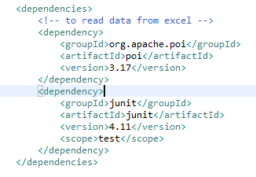

1. Make necessary imports and run the application.