**44-642 - App Design: Patterns and Frameworks Vector Math with Matrix3d**

**Creating a Maven Project in NetBeans IDE 12.0:**

1. Choose “New Project” from the menu.
2. Under “Java with Maven”, find and select “Project from Archetype” and click “Next”.

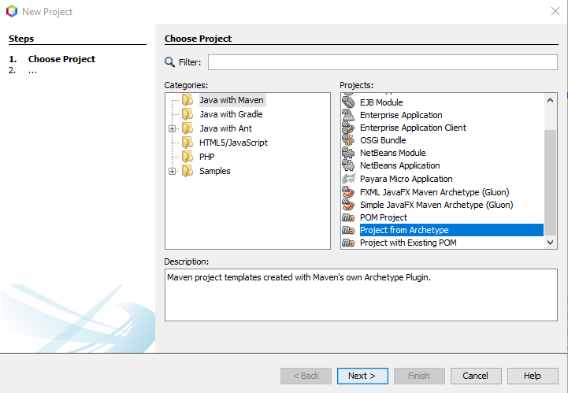

1. For this project we will use **Artifact ID**: maven-archetype-quickstart. To get this, type “org.apache.maven.archetypes” in Search. Select the Artifact ID referenced above and click “Next”.

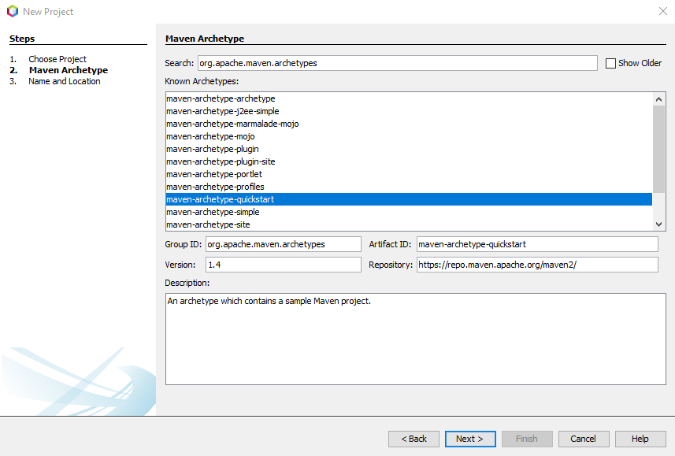

1. Now you need to enter the **Group Id** and **Artifact Id.**
   1. **Group Id:** com.vectmath
   2. **Artifact Id (enter in Project Name field):** VecmathDemo
   3. Click “Finish”.

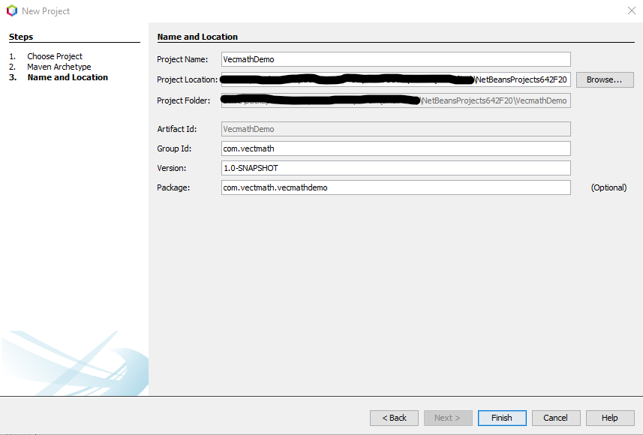

1. In App.java we will be doing matrix operations using Matrix3d.
2. To read a matrix from the keyboard add the following code blocks to App.java

**private** **static** Matrix3d readMatrix() {

// Create a scanner object.

Scanner scanner = **new** Scanner(System.***in***);

// Read input elements for matrix from user.

**double**[] matrixElements = **new** **double**[3 * 3];

**for** (**int** index = 0; index < matrixElements.length; index++)

{

matrixElements[index] = scanner.nextDouble();

}

// Create and return the matrix.

**return** **new** Matrix3d(matrixElements);

}

**public** **static** **void** main(String[] args) {

// Declare two matrix variables

Matrix3d matrix1, matrix2;

// Read input for matrix1

System.***out***.println("Enter input elements for 3X3 matrix#1: ");

matrix1 = *readMatrix*();

// Read input for matrix2

System.***out***.println("Enter input elements for 3X3 matrix#2: ");

matrix2 = *readMatrix*();

Matrix3d resultMatrix = **new** Matrix3d();

// Matrix addition

System.***out***.println("The addition of two matrices is:");

resultMatrix.add(matrix1, matrix2);

System.***out***.println(resultMatrix);

// Matrix multiplication

System.***out***.println("The multiplication of two matrices is:");

resultMatrix.mul(matrix1, matrix2);

System.***out***.println(resultMatrix);

}

**Adding the dependency for vecmath in pom.xml**

1. Open pom.xml file and add the following code inside the <dependencies> tag. Once you add the dependency to file, build the project.
2. **Note**: If your file does not contain the tag, add <dependencies> </ dependencies> below the <packaging> tag and above the <properties> tag.

<dependency>

<groupId>javax.vecmath</groupId>

<artifactId>vecmath</artifactId>

<version>1.5.2</version>

</dependency>

1. Make necessary imports and run the application.