44-642 Application Design: Patterns and Frameworks
Trees

Objective This worksheet will give you practice in working with trees.

- Use the following binary search tree to complete the remainder of this problem.

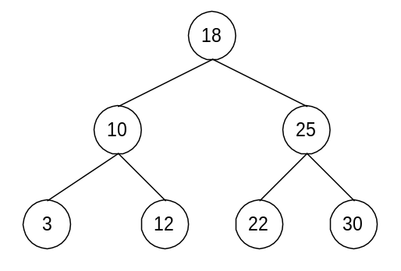

  - What is the root node of the tree?
  - List the leaves of the tree:
  - List the nodes at level 1:
  - What is the height of the tree?
  - List the children of 18:
  - List the descendents of 18:
  - List the ancestors of 22:
  - What is the left child of 25?
  - What is the right child of 10?
  - What is the parent node of 30?
  - List the siblings of 3:
  - Draw the right subtree of 18:
  - Draw the left subtree of 10.
  - How many probes are necessary to find 18?
  - How many probes are necessary to find 3?
  - How many probes are necessary to discover that 27 is not in the tree?
  - List the values probed to find 3 (list probes in the order in which they occur):

- Use the following binary search tree to complete the remainder of this problem.
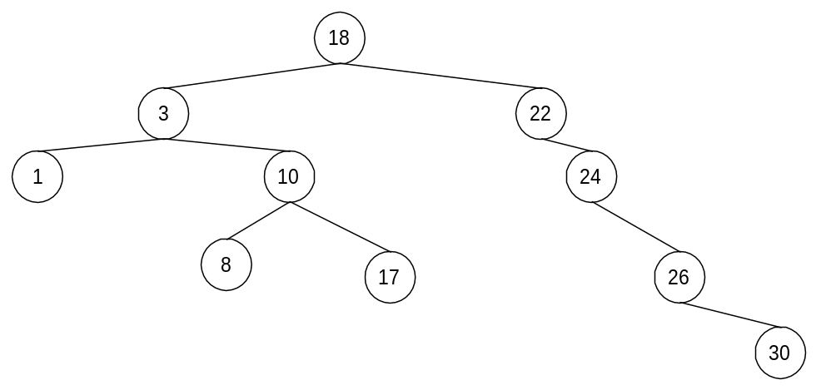
  - What is the root node of the tree?
  - List the leaves of the tree:
  - List the nodes at level 1:
  - What is the height of the tree?
  - List the children of 24:
  - List the descendents of 18:
  - List the ancestors of 8:
  - What is the left child of 26?
  - What is the right child of 10?
  - What is the parent node of 30?
  - List the siblings of 26:
  - Draw the right subtree of 18:
  - Draw the left subtree of 10.
  - How many probes are necessary to find 30?
  - How many probes are necessary to find 3?
  - How many probes are necessary to discover that 27 is not in the tree?
  - List the values probed to discover that 27 is not in the tree (list probes in the order in which they occur):
- For each of the following lists, draw the binary search tree that results when the values are inserted in the order given:
  - 18, 25, 22, 10, 3, 30, 12
  - 18, 10, 12, 3, 25, 22, 30
  - 18, 3, 22, 10, 12, 25, 30
  - 3, 10, 12, 18, 22, 25, 30
  - 30, 25, 22, 18, 12, 10, 3

