44-642 Application Design: Patterns and Frameworks
Trees KEY

Objective This worksheet will give you practice in working with trees.

- Use the following binary search tree to complete the remainder of this problem.

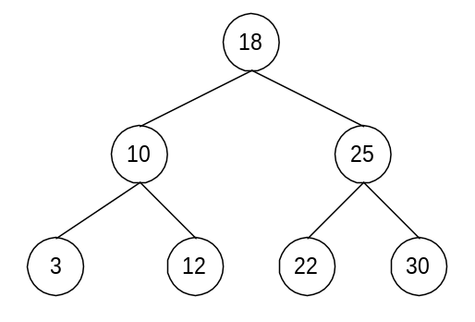

  - What is the root node of the tree? 18
  - List the leaves of the tree: 3, 12, 22, 30
  - List the nodes at level 1: 10, 25
  - What is the height of the tree? 2
  - List the children of 18: 10, 25
  - List the descendents of 18: 3, 10, 12 22, 25, 30
  - List the ancestors of 22: 18, 25
  - What is the left child of 25? 22
  - What is the right child of 10? 12
  - What is the parent node of 30? 25
  - List the siblings of 3: 12
  - Draw the right subtree of 18:
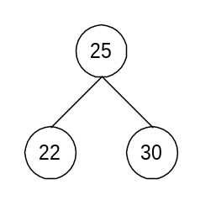

  - Draw the left subtree of 10.
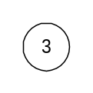
  - How many probes are necessary to find 18? 1
  - How many probes are necessary to find 3? 3
  - How many probes are necessary to discover that 27 is not in the tree? 4 (18, 25, 30, then you must probe the left child of 30 to discover that 27 is not in the tree)
  - List the values probed to find 3 (list probes in the order in which they occur): 18, 10, 3
- Use the following binary search tree to complete the remainder of this problem.
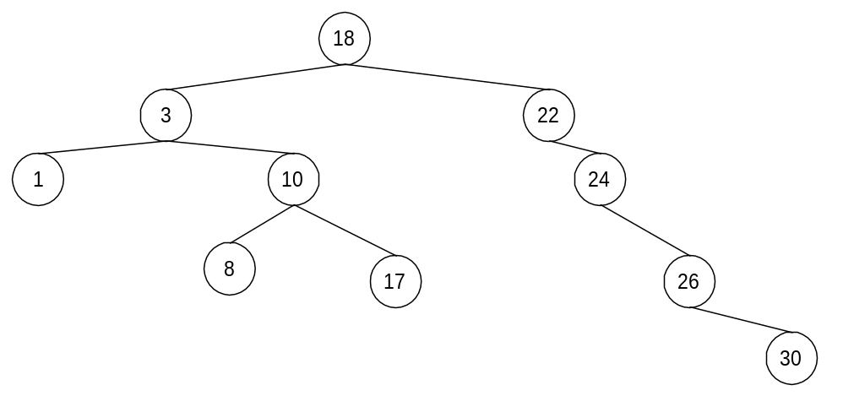

  - What is the root node of the tree? 18
  - List the leaves of the tree: 1, 8, 17, 30
  - List the nodes at level 1: 3, 22
  - What is the height of the tree? 4
  - List the children of 24: 26
  - List the descendents of 18: 1, 3, 8, 10, 17, 22, 24, 26, 30
  - List the ancestors of 8: 3, 10, 18
  - What is the left child of 26? 26 has no left child
  - What is the right child of 10? 17
  - What is the parent node of 30? 26
  - List the siblings of 26: 26 has no siblings
  - Draw the right subtree of 18:
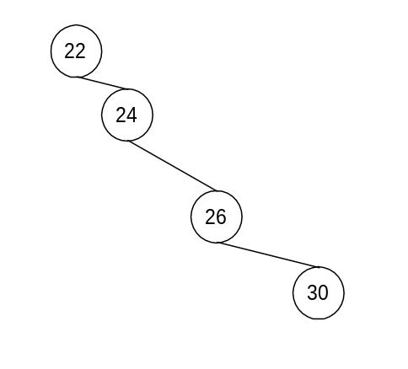
  - Draw the left subtree of 10.
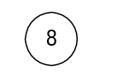
  - How many probes are necessary to find 30? 5
  - How many probes are necessary to find 3? 2
  - How many probes are necessary to discover that 27 is not in the tree? 6
  - List the values probed to discover that 27 is not in the tree (list probes in the order in which they occur): 18, 22, 24, 26, 30, null probe to discover that 30 has no left child

- For each of the following lists, draw the binary search tree that results when the values are inserted in the order given:
  - 18, 25, 22, 10, 3, 30, 12
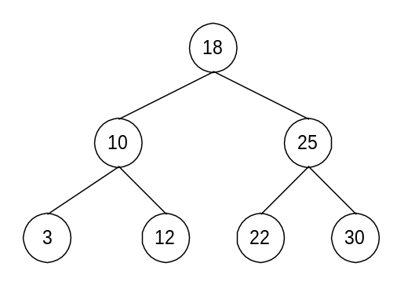

  - 18, 10, 12, 3, 25, 22, 30
  - 18, 3, 22, 10, 12, 25, 30
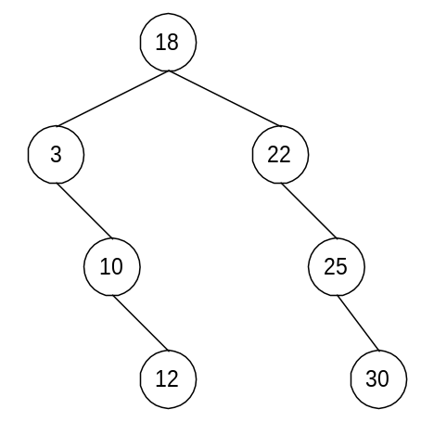

  - 3, 10, 12, 18, 22, 25, 30
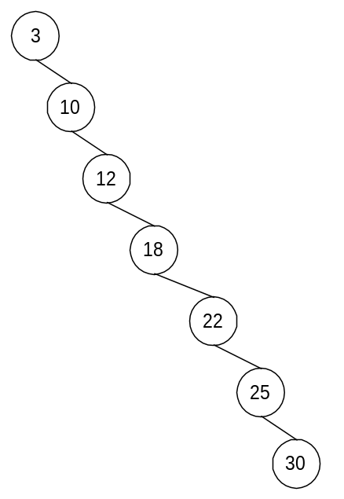

  - 30, 25, 22, 18, 12, 10, 3

