Agents and MMM: Guide and Technical Reference
The investigation agents and every MMM page: how to use them, and how every number is computed

Retail Intelligence Platform · branch Merge-1
Part 1 — Guide: the Promotion Investigation agents and every MMM page (Data Connections, Insights Hub, Calendar,
Budget Optimizer, Budget Allocator, Revenue Forecast, Reports, Settings), with screenshots and workflows.
Part 2 — Technical reference: every filter, chart and number, with the algorithms, theory, worked examples
and the reasons behind each method; validation, limitations and the API index.
Worked examples use the platform's reference data (4,291 days, 1 Jan 2015 – 30 Sep 2026, 22 channels).
Written for: business users, marketing managers, analysts and engineers who use or maintain the platform

Contents
PART 1 — GUIDE
1. What this document covers
2. Promotion Investigation agents
2.1 How to start an investigation
2.2 The four agents
2.3 What happens when you press Investigate
2.4 Reading the results
3. The MMM module at a glance
4. Data Connections
5. Insights Hub
5.1 Filters
5.2 What is on the page
6. Calendar
7. Budget Optimizer
7.1 Controls
7.2 What is on the page
8. Budget Allocator
9. Revenue Forecast
9.1 The file
9.2 What is on the page
10. Reports and Settings
10.1 Reports
10.2 Settings
11. Typical workflows
Review last year
Re-plan a past quarter
Set next year’s budget
12. Glossary
PART 2 — TECHNICAL REFERENCE
Part A — Foundations
A.1 The daily dataset (data contract)
A.2 Money, units and currency
A.3 Scope: how filters select days (Insights Hub, Calendar, Reports)
Part B — Insights Hub
B.1 Filters and controls
B.2 The baseline: what the days would earn without ads
B.3 KPI cards
B.4 Ad Spend & ROAS Trend
B.5 Revenue Decomposition (donut)
B.6 Channel card: Revenue / Ad Spend / ROAS by Channel
B.7 Revenue by Promotion Type
B.8 Performance Comparison
B.9 Days With vs Without Events
B.10 Caching
Part C — Calendar
Part D — The response model (planning pages)
D.1 Carryover (adstock)
D.2 Diminishing returns (Hill curve)
D.3 The baseline features (26 columns)
D.4 How the model is fitted
D.5 Uncertainty: the block bootstrap
D.6 Validation and the fitted parameters
D.7 Why this model, and its limits
Part E — Budget Optimizer
E.1 Controls
E.2 How a plan is scored
E.3 The optimizer
E.4 From a plan to moves
E.5 Every panel and number
Part F — Budget Allocator
F.1 Inputs
F.2 The three plans and the two effects
F.3 Net profit at every budget (frontier)
F.4 Optimal spend by channel
Part G — Revenue Forecast
G.1 The uploaded plan
G.2 The sample plans
G.3 How revenue is predicted
G.4 Every panel and number
G.5 Planning the forecast
Part H — Reports, Data Connections and Settings
H.1 Reports
H.2 Data Connections
H.3 Settings
Part I — Investigation agents (TPO)
I.1 Promotion economics the agents use
I.2 The four agents in detail
I.3 The pipeline
I.4 Guarding the numbers
I.5 Confidence and contribution
I.6 Runs, storage and configuration
Part J — Validation, limitations and API index
J.1 Automated tests
J.2 Limitations to keep in mind
J.3 API index (all under /api)

PART 1 — GUIDE
How to use the investigation agents and each MMM page. Sections 1–12.

1. What this document covers
The platform has two modules. TPO (Trade Promotion Optimisation) analyses promotions; its Investigations page uses four AI agents to explain why a promotion under-performed. MMM (Marketing Mix Modelling) analyses advertising: how much revenue each ad channel drives, how the budget should be split, and what a future plan will earn.
Part 1 (sections 1–12) explains, page by page, what you see, what each part means and how to use it, with light maths. Part 2 (Parts A–J) explains every filter, chart and number in depth: formulas, theory, algorithms, worked calculations and why each method was chosen.
Area | Page | What it answers
TPO | Investigations | Why did this promotion, channel or region under-perform, and what should we do?
MMM | Data Connections | Which daily file is loaded, and is it valid?
MMM | Insights Hub | How much did we spend, what did it return, and how does it compare with last year?
MMM | Calendar | When was each channel on air, month by month and day by day?
MMM | Budget Optimizer | Keeping the same budget, how should it be moved between channels and weeks for more profit?
MMM | Budget Allocator | If my budget is X, what is the best split, and is X the right size?
MMM | Revenue Forecast | What will a future ad plan earn? Then optimise that plan.
MMM | Reports | Download the Insights Hub as Excel or PDF.
MMM | Settings | Where the data lives and who is signed in.

2. Promotion Investigation agents
The Investigations page (TPO → Investigations) answers a question in plain English, such as “Why did South Modern Trade Push under-perform despite increased trade spend?”. Four specialist agents each examine one side of the problem, using the promotion data. Their findings are weighed and combined into ranked root causes, with one recommended action for each.
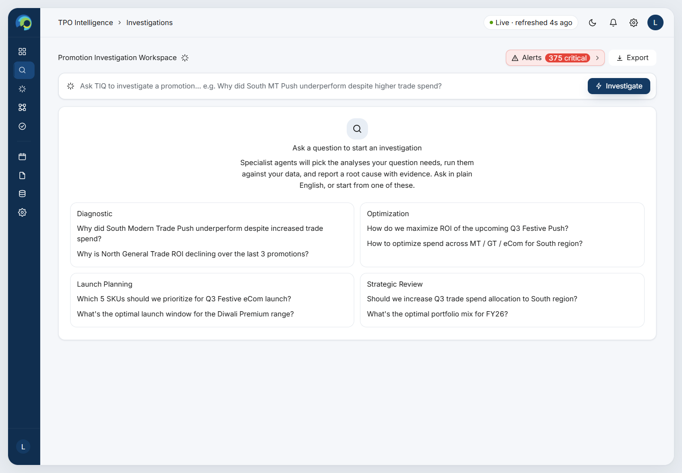
Figure 2.1 – The Investigations page before a question is asked: the question bar and four example archetypes.

2.1 How to start an investigation
- Type a question in the bar and press Investigate. Questions that only look something up (“what is”, “show me”, “top …”) are sent to the Insights Hub Analyst instead. Questions with “why”, “cause”, “decline”, “despite” and similar words start an investigation.
- Pick an example from the four archetype cards: Diagnostic, Optimisation, Launch Planning and Strategic Review.
- Start from an alert. The Alerts button lists promotion events below the 1.50x ROI target. Choosing one writes the question for you, scoped to that promotion, product, channel and week, and runs it.
There are no filter controls on this page. The period, channel, region and the rest are read from the question, or from the alert you chose.

2.2 The four agents
Every investigation runs all four agents, in parallel. Each one answers one question in a chain of reasoning: is it really under-performing → which offers lost money → where → was the lift real?
Agent | Question it answers | What it looks at | What it reports
Performance Agent | Does this segment really under-perform the business, its peers and over time? | Segment KPIs vs the whole business; ROI by channel and by region; the monthly trend | Whether the segment is abnormal or average, by how much, and which month carried or dragged it
Promotion Design Agent | Which mechanics and events made or lost money? | ROI per promotion mechanic, in the segment and across the business; spend mix by offer; events by severity; the worst events by money at stake | The failing mechanic (a design problem if it fails everywhere, an execution problem if only here), its share of spend, and the worst events
Market & Portfolio Agent | Where does it break: region, state, retailer, category or brand? | ROI broken down by region, state, retailer, category and brand inside the segment | The smallest place that explains the problem, or that performance is even everywhere
Cannibalization Agent | Was the lift real, or taken from sister products? | Sales of other products in the same brand form during the promotion weeks, against their normal weeks | How much neighbours’ units and sales changed (potential cannibalization, not proven cause)

2.3 What happens when you press Investigate
1. Plan (≈ 9 s). An AI planner reads the question, decides whether the data can answer it, works out the scope (period, channel, region, product…) and writes a one-line brief for each agent. Off-topic questions are declined with a reason. If no rows match the scope, the run stops and says so.
2. Investigate (≈ 30 s). The four agents fetch their data from the platform’s KPI engine (they do no arithmetic themselves) and each writes a finding: a headline, a short explanation, the evidence numbers and a small bar chart.
3. Check and score (instant, no AI). The platform checks every number an agent quotes against the data it was given. Numbers that cannot be traced are flagged and their chart bars removed. Each finding gets a confidence score, and a share of the problem.
4. Synthesise (≈ 12 s). A final AI step writes one root cause and one specific recommendation per agent and a 3–4 sentence summary. The causes are ranked by their share of the problem.
A run makes 6 AI calls (1 plan, 4 agents, 1 synthesis), using the OpenAI-compatible model set in backend/.env (default gpt-4o-mini). Without an API key the run stops with a clear message; there is no offline fallback.

2.4 Reading the results
Section | What it shows
Investigation scope | The subject, period, channel, region, trade spend and promotion ROI, with a standing badge: Critical (ROI ≤ 1.00), High (below 1.25), Medium (below 1.50) or On target.
Agent findings | “Combined root cause” (the summary), then the numbered root causes, each with its share of the problem as a % bar and the agents behind it, then Recommended actions, one per root cause.
Specialist agents | A list of the four agents, sorted by contribution. Selecting one shows its status, confidence, contribution, what it found, a verified bar chart, its evidence and its own root cause and action.
Progress strip | Investigation progress, insights identified, rows analysed, and a link to the Promotion Intelligence summary.

How to read the scores. Confidence (60–95) is an evidence score, not a probability. It rises with the number of rows behind a finding, how much of the spend the agent could see, how complete the data was, and how many of its quoted numbers could be traced. Share of the problem weights each finding by its confidence and its kind: a loss counts fully (1.0), a risk 0.9, a moderate issue 0.6, a data gap 0.4 and a strength 0.3. The shares always add up to 100%.

3. The MMM module at a glance
MMM works on one daily file: one row per day with the day’s Revenue, the spend on each ad channel (22 in the reference data, such as TV, Meta Ads and Google Search) and optional Festival / Seasonal / Promotion flags, discount and promotion type. Everything else is computed from it.
The module has two kinds of page:
- Looking back: Insights Hub and Calendar use direct, transparent arithmetic on the days in the file. Examples: revenue on days with ads against days without, and spend by channel.
- Planning: Budget Optimizer, Budget Allocator and Revenue Forecast use a fitted response model. For each channel it learns how long an ad keeps working (carryover) and how quickly extra spend stops paying (diminishing returns). It is fitted 41 times (one central fit and 40 refits) to give a P10 – P90 range for every number.
Menu item | Route | Needs a dataset?
Insights Hub | #/mmm/insights | Yes
Budget Optimizer | #/mmm/budget | Yes
Budget Allocator | #/mmm/allocator | Yes
Revenue Forecast | #/mmm/forecast | Yes
Calendar | #/mmm/calendar | Yes
Reports | #/mmm/reports | Yes
Data Connections | #/mmm/connections | No: this is where you load it
Settings | #/mmm/settings | No

All money is stored in rupees. The ₹ INR / $ USD switch on each page only changes how figures are shown. Amounts use Indian units: 1 L (lakh) = ₹1,00,000 and 1 Cr (crore) = ₹1,00,00,000.

4. Data Connections
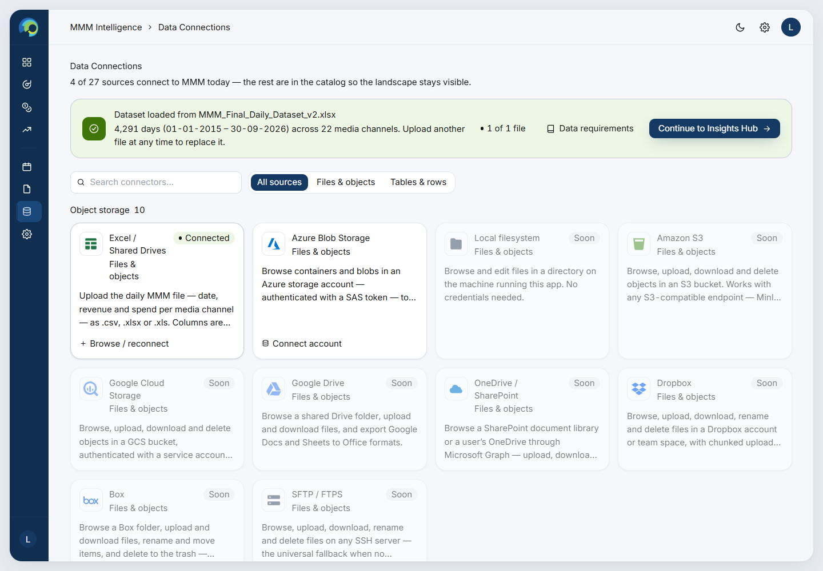
Figure 4.1 – Data Connections: the loaded dataset strip and the source catalogue.
Purpose. Load, replace, view or remove the MMM daily file. MMM’s data is kept apart from TPO’s, so loading or removing it never touches the promotion data.
- Upload a .csv, .xlsx or .xls file (up to 64 MB) from the Excel / CSV tile. The column checklist shows what was found: Date & Revenue, media spend (x of 22 reference channels), channel totals, promotions & events, and calendar fields.
- Required: Date, Revenue and at least one *_Spend column. Optional: Festival_Flag, Seasonal_Flag, Promotion_Flag, Discount_Percentage, Promotion_Type, and Month / Quarter / Week / Year (derived from the date if missing).
- Problems are listed together with row numbers: an unreadable date, a duplicate day, negative spend, or a flag that is not 0 or 1. A blank spend cell is read as 0, with a warning.
- What do I upload? opens the requirements guide, with Copy headers and Download template.
- A new upload replaces the old file in one step. The Insights Hub and the model are refreshed; the response model retrains once (about a minute) and is then cached.

5. Insights Hub
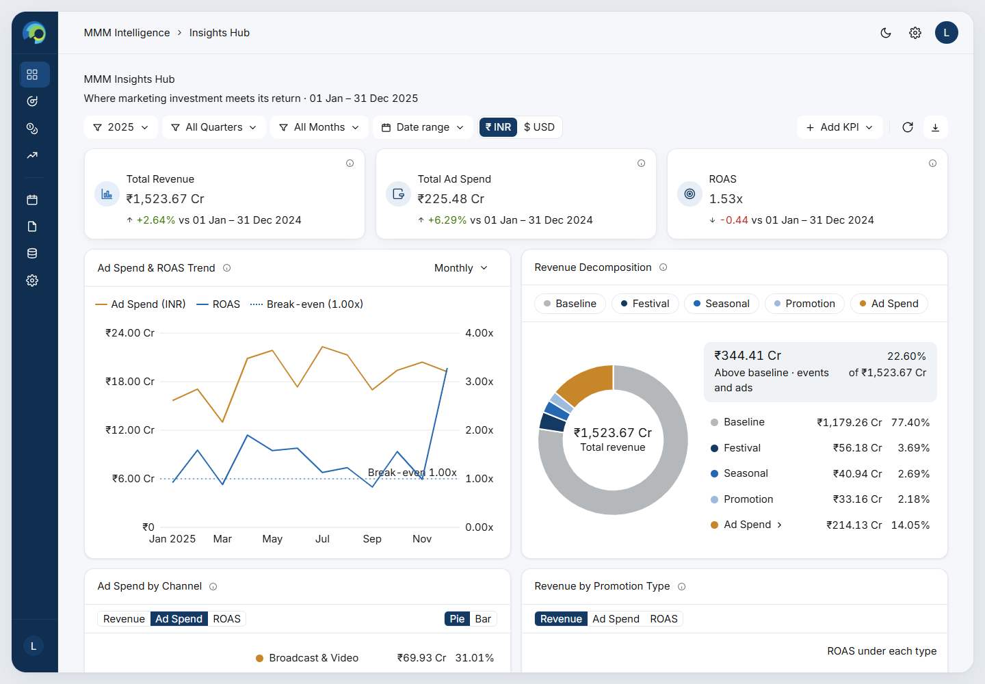
Figure 5.1 – Insights Hub for 2025: headline KPIs, the ad spend & ROAS trend and the revenue decomposition.
Purpose. A one-screen view of how much was spent on ads, what it returned and how that compares with earlier periods.

5.1 Filters
Control | What it does
Year | “All Years” or one year. It opens on the most recent completed year.
Quarter / Month | Narrow the year. The month list follows the quarter chosen.
Date range | Any From – To range. It replaces year, quarter and month while active.
₹ INR / $ USD | Display only.
+ Add KPI | Add more KPI cards beside the three headline cards. Your choice is remembered.
Refresh / Export | Reload the data, or create an Excel + PDF report of the current view (see Reports).

5.2 What is on the page
Card | What it shows | 2025 example
Total Revenue | All revenue on the days in scope, with % change vs the year before | ₹1,523.67 Cr, +2.64%
Total Ad Spend | Spend on all channels | ₹225.48 Cr, +6.29%
ROAS | Revenue above the baseline ÷ ad spend. 1.00x means the ads paid back their cost | 1.53x, −0.44 vs 2024
Baseline Revenue (add-on) | What the days would have earned without ads | ₹1,179.26 Cr
Incremental Revenue (add-on) | Revenue − baseline | ₹344.41 Cr
Avg Daily Baseline / Revenue, Ad Revenue Lift / Day, Days With Ad Spend (add-ons) | Per-day versions and counts | ₹3.23 Cr / ₹4.17 Cr, ₹1.09 Cr, 180 days
Ad Spend & ROAS Trend | Monthly or weekly ad spend (left axis) and ROAS (right axis), with a dotted break-even line at 1.00x | ROAS 0.92x in Jan, 1.59x in Feb
Revenue Decomposition | A donut splitting revenue into Baseline, Festival, Seasonal, Promotion and Ad Spend. Ad Spend drills into channel families, then channels | Baseline 77.4%, Ad Spend 14.05%
Ad Spend / Revenue / ROAS by Channel | Pie or bar by channel family; click a family for its channels | Broadcast & Video 31.01% of spend
Revenue by Promotion Type | Revenue, spend or ROAS per promotion type, with ROAS under each bar | 15% Discount ROAS 2.14x
Performance Comparison | Any KPI against Year Ago, Period Ago, Month Ago or year-to-date
Days With vs Without Events | Average daily revenue on days with each event vs days without | Ad days +31.33%

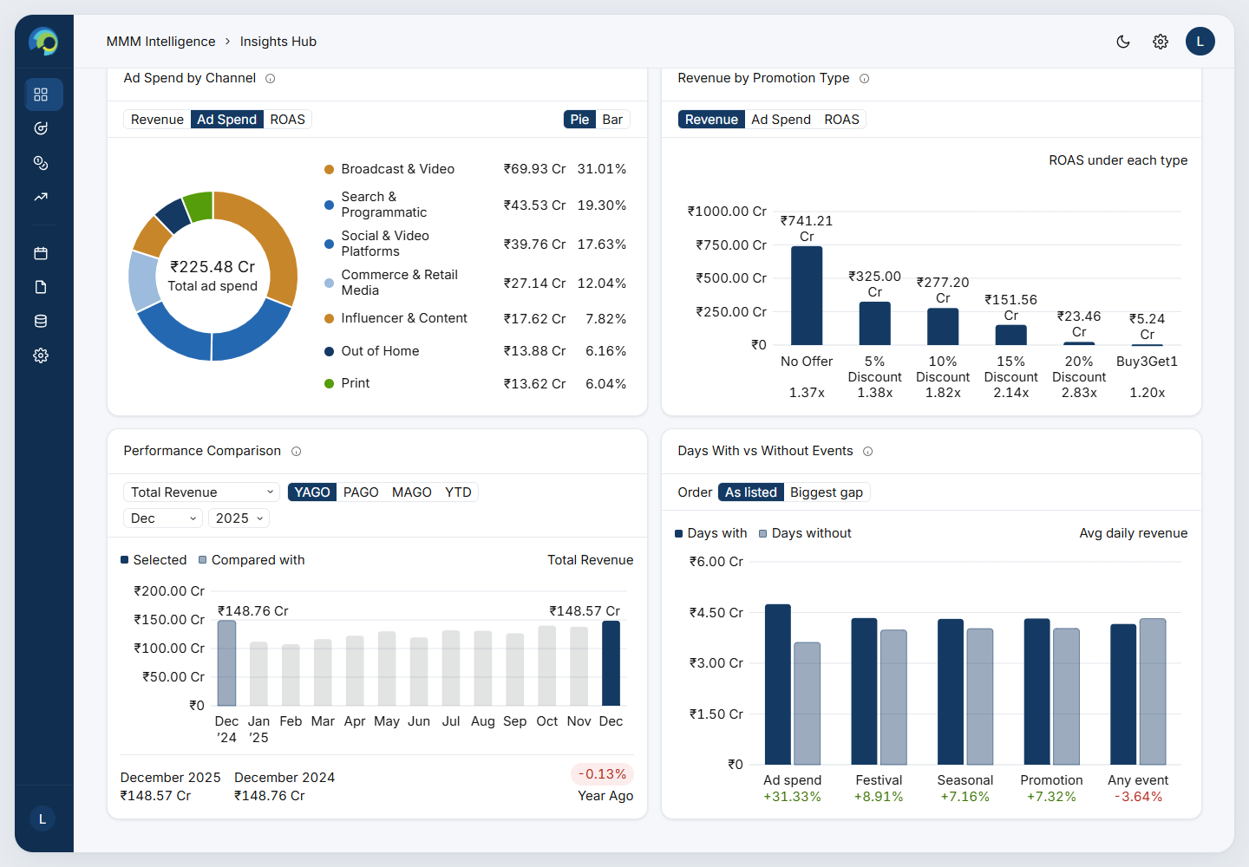
Figure 5.2 – Channel mix, promotion types, performance comparison and days with vs without events.
Two kinds of ROAS. The Insights Hub ROAS is a direct, look-back measure: revenue above the baseline on the days in scope. The planning pages use the fitted response model, which also accounts for carryover and diminishing returns. The two answer different questions, so their channel ROAS values differ (for example TV: 3.24x on the hub for 2025, 1.52x average in the model). Part 2, section B.6, explains why.

6. Calendar
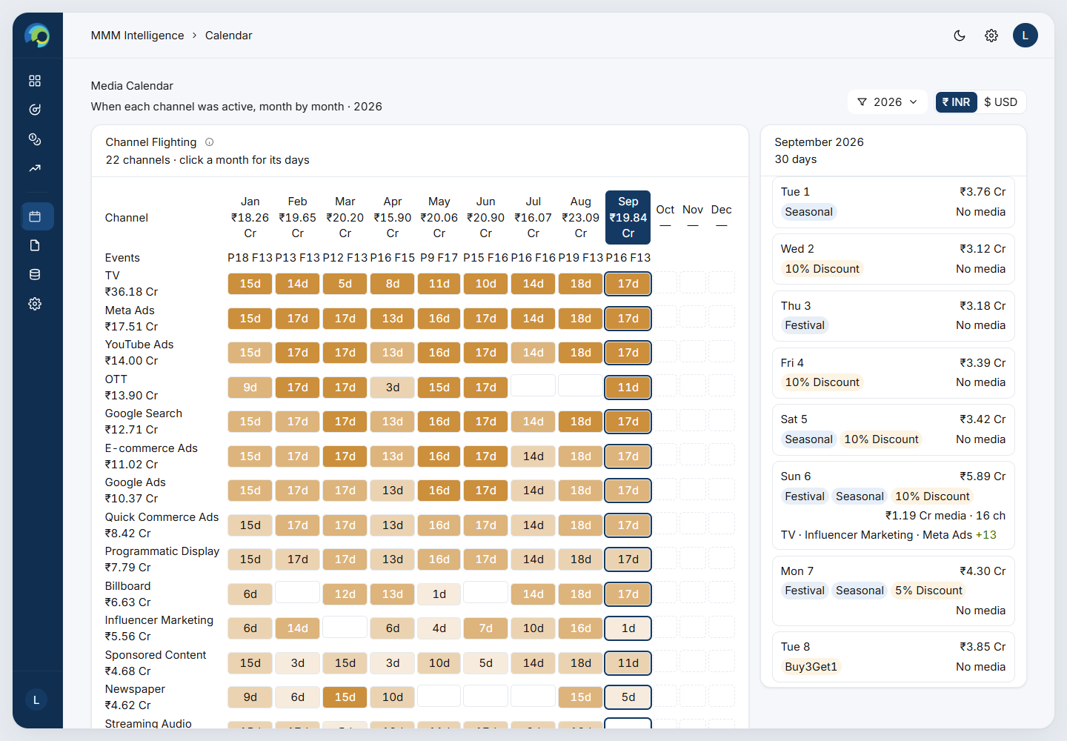
Figure 6.1 – Media Calendar: channel flighting by month (left) and the selected month day by day (right).
- Channel Flighting shows one row per channel and one column per month. Each cell shows the number of days on air (e.g. “17d”), shaded by spend: Off air, Low, Medium, High or Heaviest (the year’s spend quartiles).
- Month headers show the month’s spend and its promotion (P) and festival (F) days.
- Click a month to list its days: revenue, festival / seasonal / promotion tags, total media spend, the number of channels, and the top three channels.
- Use it to see bursts, dark periods and which channels always run together.

7. Budget Optimizer
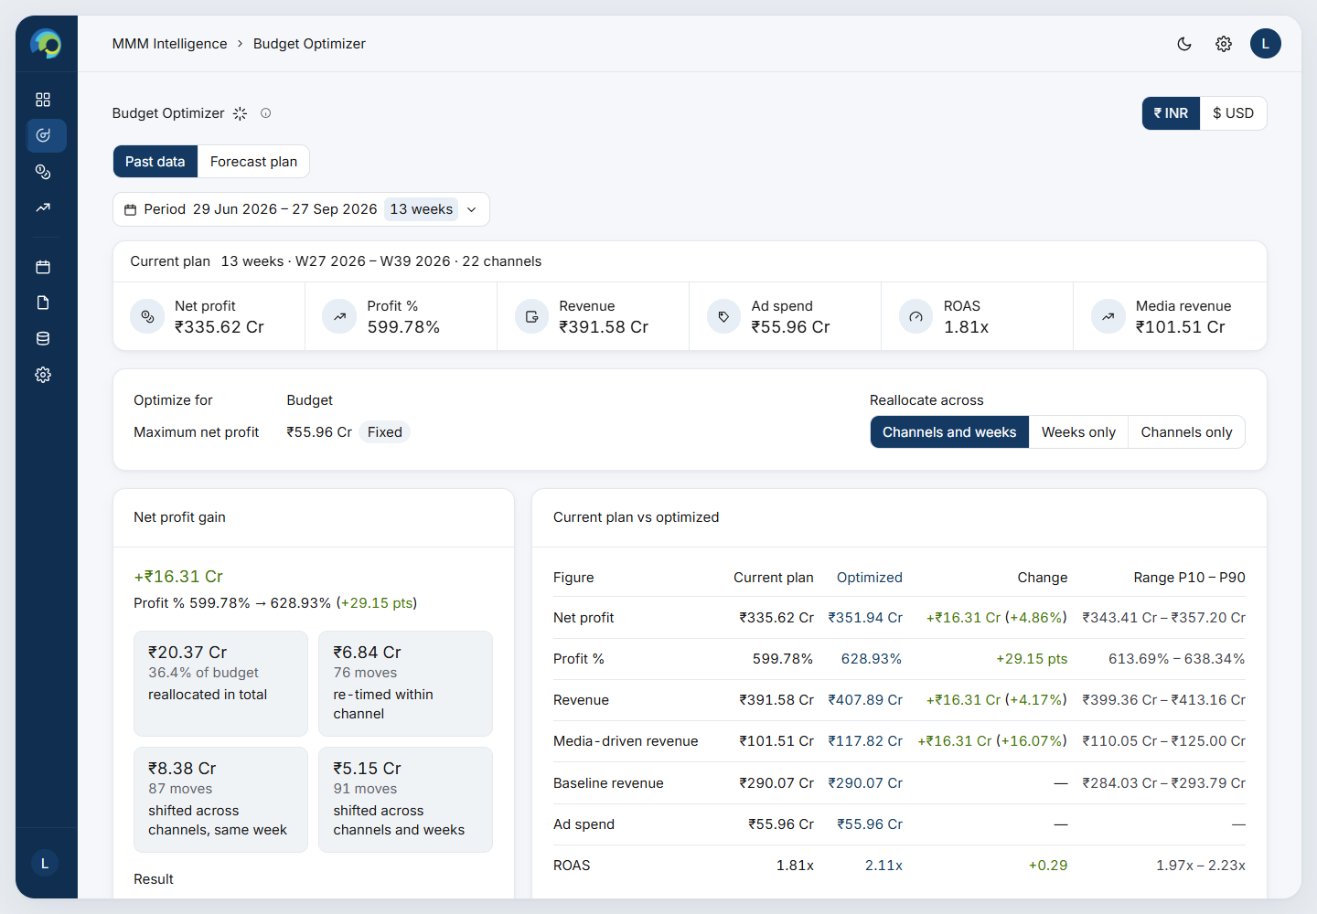
Figure 7.1 – Budget Optimizer: period, current plan, rules, net profit gain and current vs optimized.
Question it answers: with the same total budget in a period, how should money move between channels and weeks to make the most net profit (revenue − ad spend)?

7.1 Controls
Control | What it does
Past data / Forecast plan | Plan past weeks, or the weeks of an uploaded future plan (appears once a plan is uploaded).
Period | Any run of whole weeks, picked by dates or months. It opens on the latest 13 weeks.
Reallocate across | Channels and weeks: money may move anywhere. Weeks only: each channel keeps its total and is only re-timed. Channels only: each week keeps its total and is only re-split between channels.
₹ / $ | Display currency.

7.2 What is on the page
- Current plan strip: net profit, profit %, revenue, ad spend, ROAS and media revenue of the plan as it ran.
- Net profit gain: the extra net profit of the optimized plan, profit % before → after, how much money is moved (in total and by kind of move), and How sure: the P10 – P90 range of the gain and the share of the 40 refits in which the plan gains.
- Current plan vs optimized: every figure side by side, with the change and its P10 – P90 range.
- Week by week: profit or revenue per week for both plans, with the range. Hover for ad spend before → after.
- Spend response: for all channels together or one channel, how media revenue grows with budget. The dots mark each plan’s budget, and the dashed line marks break-even.
- Budget reallocations: every move of money, e.g. “TV · W38 → W36 · ₹78.29 L”. Filter by kind of move, view by where money leaves or arrives, and search.
- Channel budgets: each channel’s current and optimized budget, change, money moved out and in, and its change in media revenue.
Example (reference data)
Period W27 – W39 2026 (13 weeks), budget ₹55.96 Cr, kept fixed.
Current plan: net profit ₹335.62 Cr, ROAS 1.81x. Optimized: net profit ₹351.94 Cr, ROAS 2.11x.
Gain +₹16.31 Cr (likely between +₹10.12 Cr and +₹18.49 Cr; the plan gains in 100% of refits).
₹20.37 Cr (36.4% of the budget) moves: ₹6.84 Cr re-timed within channels, ₹8.38 Cr across channels in the same week and ₹5.15 Cr across both.

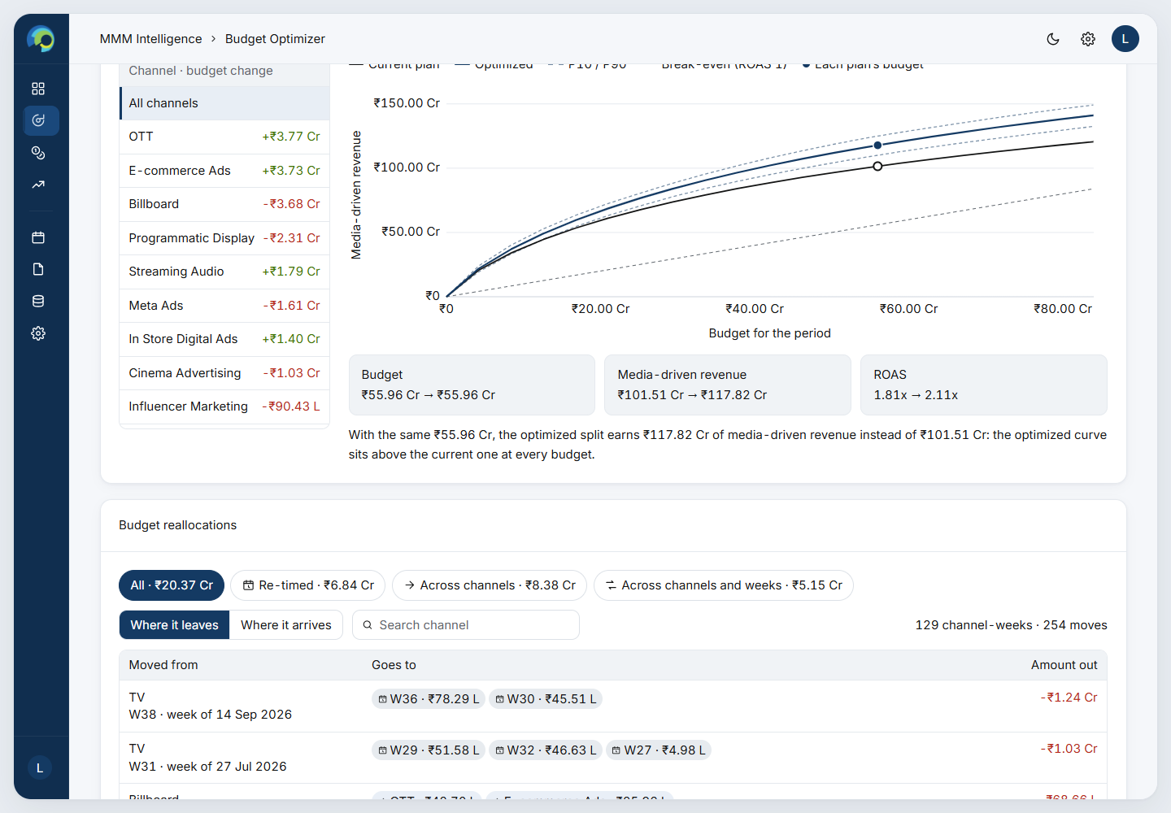
Figure 7.2 – Week by week, spend response and the start of the reallocation table.

8. Budget Allocator
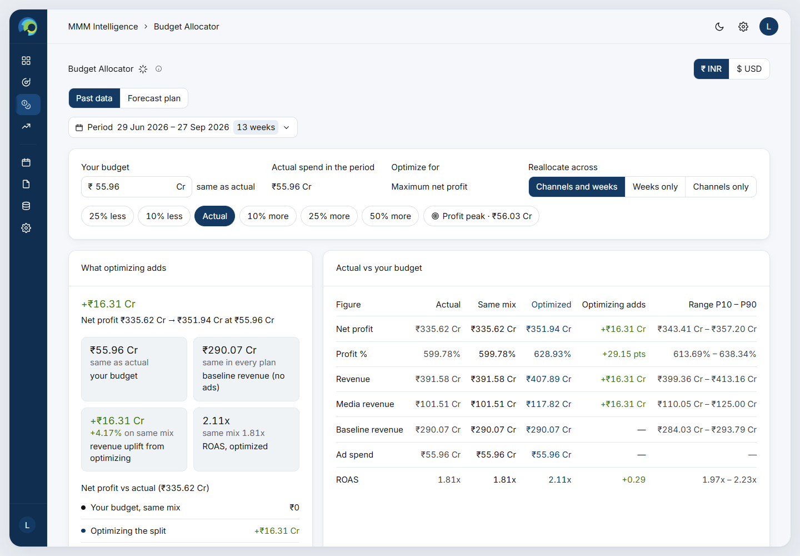
Figure 8.1 – Budget Allocator: your budget, what optimizing adds, and actual vs your budget.
Question it answers: “If my budget for this period is X, what is the best split across channels, what will it earn, and is X the right size?”
- Your budget: type an amount (₹ Cr or $ M), or use the quick buttons: 25% / 10% less, Actual, 10% / 25% / 50% more, or Profit peak (the budget that earns the most profit).
- Same Period, Reallocate across and Past data / Forecast plan controls as the Optimizer. No per-channel limits: only the total is fixed.
- Three plans are compared: Actual (what was spent), Same mix (your budget, split like the actual plan) and Optimized (your budget, split for the most profit). The baseline (revenue without ads) is the same in all three.
- What optimizing adds: the extra net profit of the optimized split over the same mix. It is broken down into the effect of the budget change and the effect of a better split.
- Net profit at every budget: a curve from ₹0 to 3× the actual budget, re-optimized at every point, with the profit peak marked.
- Optimal spend by channel: actual, same-mix and optimized spend, share of budget, change, media revenue and what the next ₹1 returns. ⚠ marks spend above anything seen in the data.
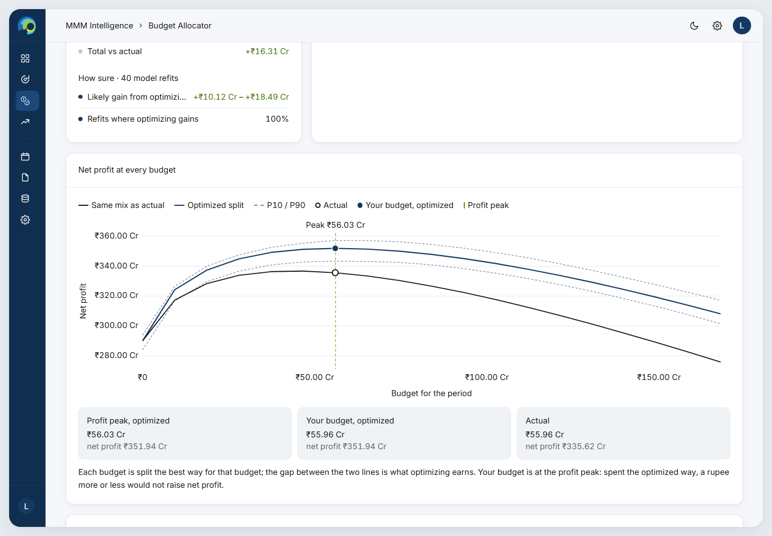
Figure 8.2 – Net profit at every budget, and the optimal spend by channel.
Example (reference data)
Period W27 – W39 2026, actual spend ₹55.96 Cr.
At the same ₹55.96 Cr, optimizing adds +₹16.31 Cr of net profit.
At 25% more (₹69.95 Cr), the same mix would earn ₹3.62 Cr *less* than actual (extra spend past the point of return), but the optimized split earns ₹350.81 Cr, +₹18.80 Cr over the same mix.
The profit peak is about ₹56.03 Cr: the budget was already close to the right size, so the gain comes from the split.

9. Revenue Forecast
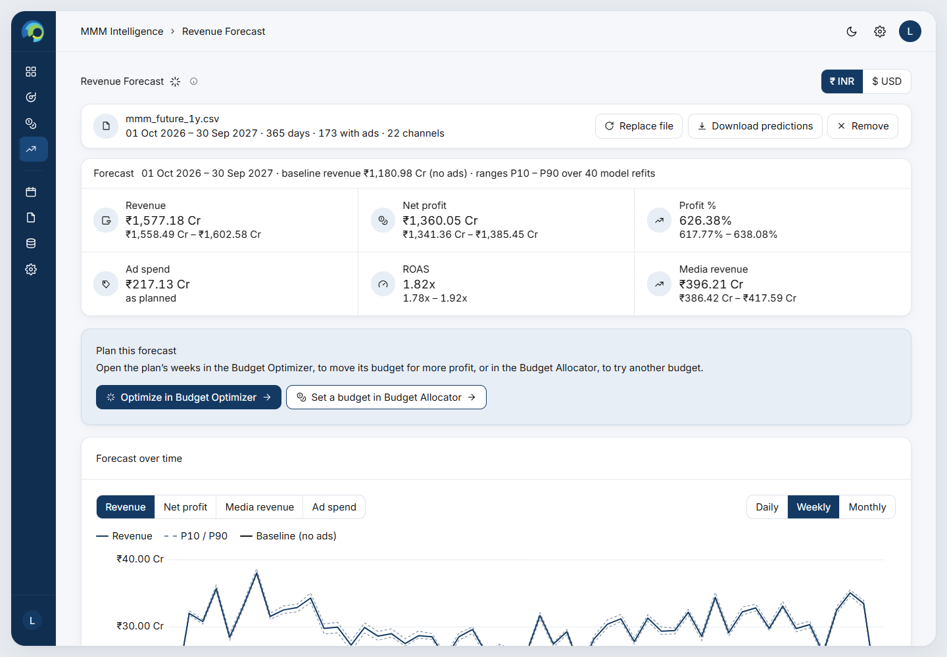
Figure 9.1 – Revenue Forecast with a 1-year plan: KPIs with ranges and the link to planning.
Purpose. Upload a daily ad plan for future dates without a Revenue column. The page predicts each day’s revenue, net profit and KPIs, and lets you open the plan in the Optimizer or Allocator.

9.1 The file
- One row per day, starting after the last day of the data (30 Sep 2026). It uses the same columns as the data, without Revenue: Date, each channel’s spend (0 on days without ads), and the flags, discount and promotion type.
- Sample plans of 1–5 years can be downloaded from the page (also in Data/mmm/future/). Each future week copies the same week from one of the last four years, so the samples keep real patterns: about half the days have no ads, festival and promotion days recur, and spend grows about 3% a year.
- Unusable files are refused with a reason: dates not after the data, duplicate days, negative spend, or text in a number column. Assumptions are listed on screen, such as a missing channel taken as zero or a Revenue column ignored.

9.2 What is on the page
- The plan bar with the file name, dates, days, ad days and channels, plus Replace file, Download predictions (the file with predicted revenue, P10/P90, baseline, media revenue and net profit added) and Remove.
- Forecast KPIs: revenue, net profit, profit %, ad spend, ROAS and media revenue, each with a P10 – P90 range.
- Plan this forecast: opens the plan’s weeks in the Budget Optimizer or Budget Allocator.
- Forecast over time: revenue (with the baseline line), net profit, media revenue or ad spend, daily, weekly or monthly.
- Year by year and Channels in the plan tables.
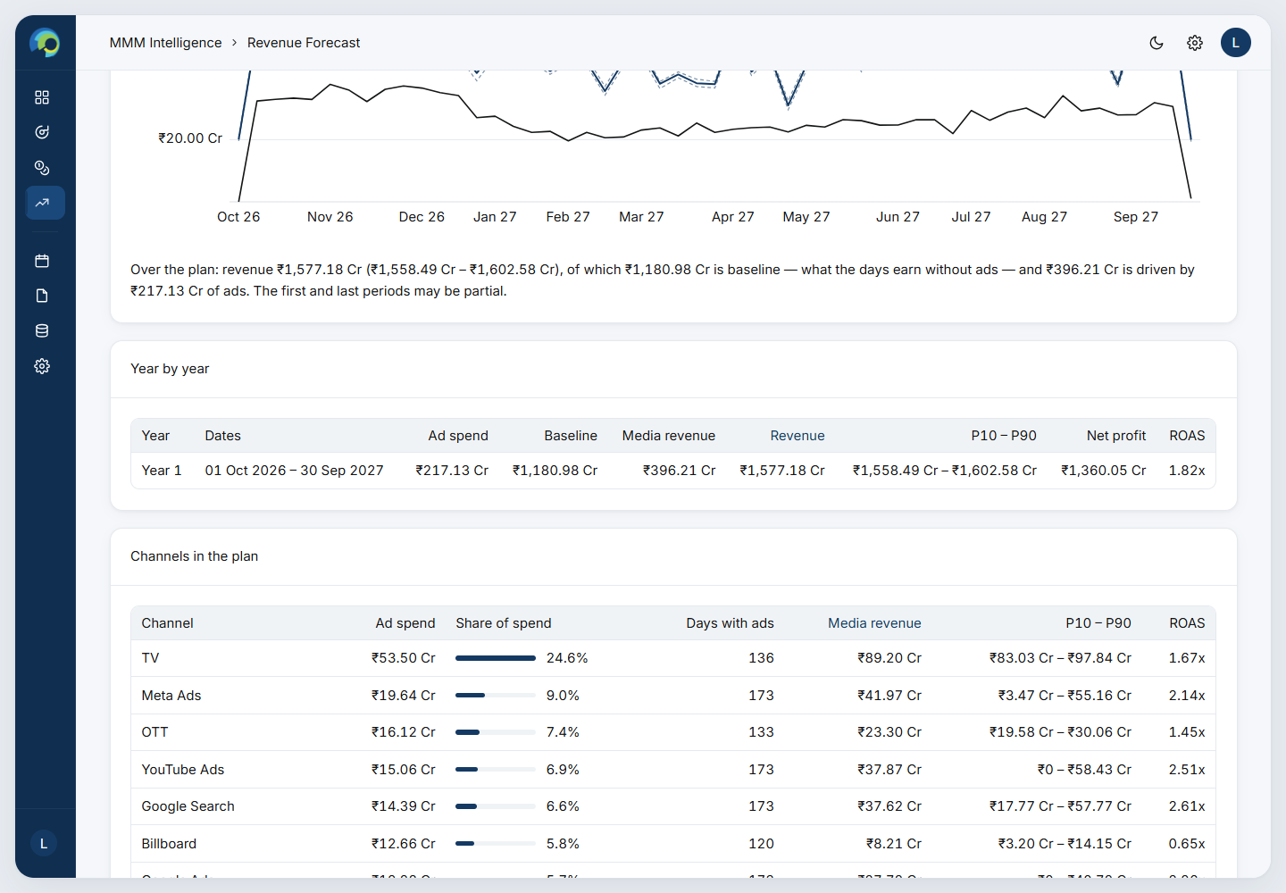
Figure 9.2 – Forecast over time and the year-by-year table.
Example (sample plans)
1-year sample (1 Oct 2026 – 30 Sep 2027, ₹217.13 Cr of ads on 173 days): revenue ₹1,577.18 Cr (₹1,558.49 – 1,602.58 Cr), of which ₹1,180.98 Cr is baseline. Net profit ₹1,360.05 Cr, ROAS 1.82x.
5-year sample: revenue ₹8,401.78 Cr from ₹1,222.33 Cr of ads (ROAS 1.74x), rising from ₹1,577 Cr in year 1 to ₹1,798 Cr in year 5.
Opened in the Optimizer, the first 13 forecast weeks gain +₹14.04 Cr of net profit at the same budget.

10. Reports and Settings

10.1 Reports
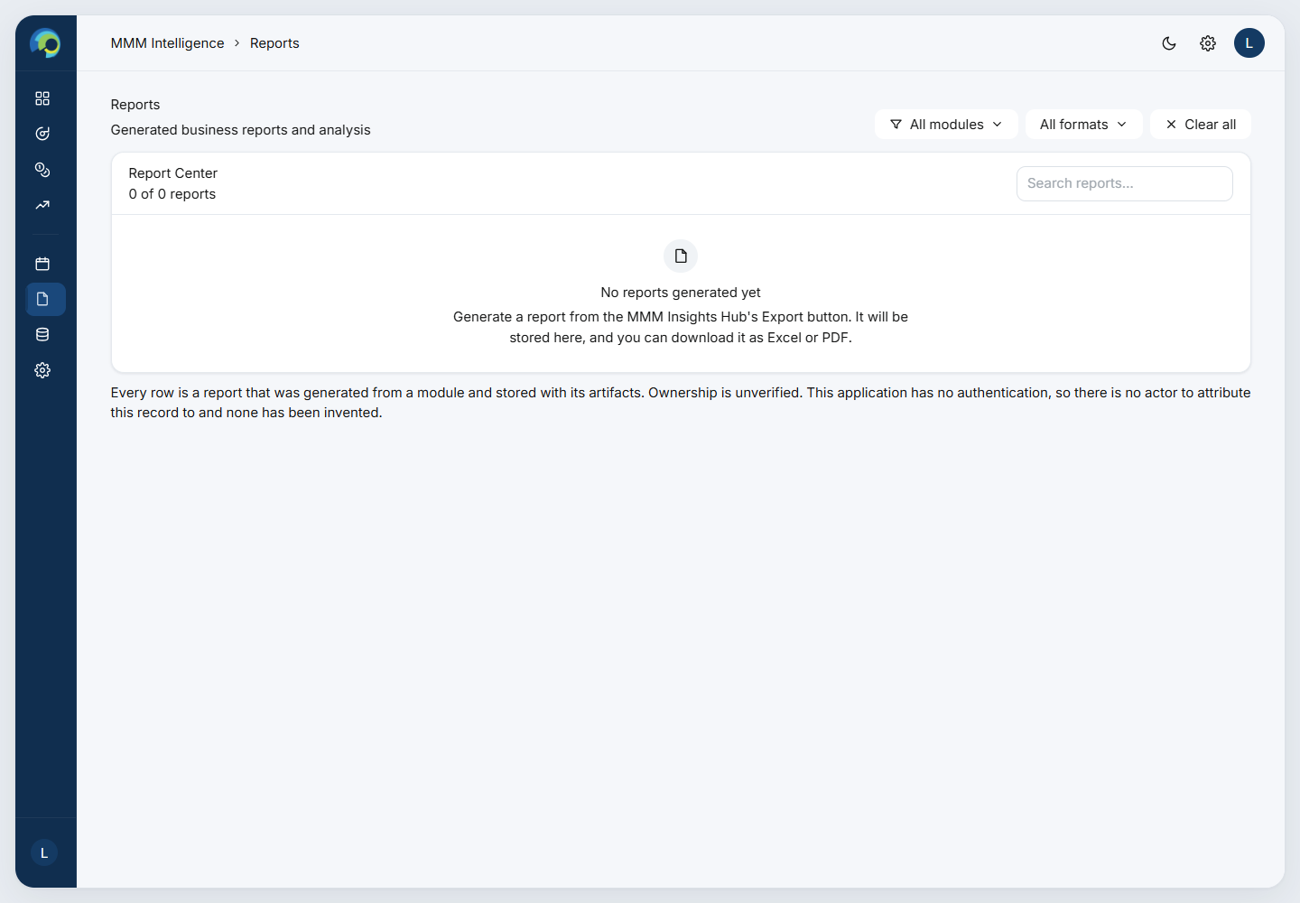
Figure 10.1 – Reports: the MMM report library.
Each Export on the Insights Hub creates a report in Excel and PDF from the current view. It contains the headline figures with their comparisons, the scope, the baseline calculation, media spend by channel, the monthly trend, promotions and days with vs without events. On the Reports page you can filter, search, preview, download or delete reports.

10.2 Settings
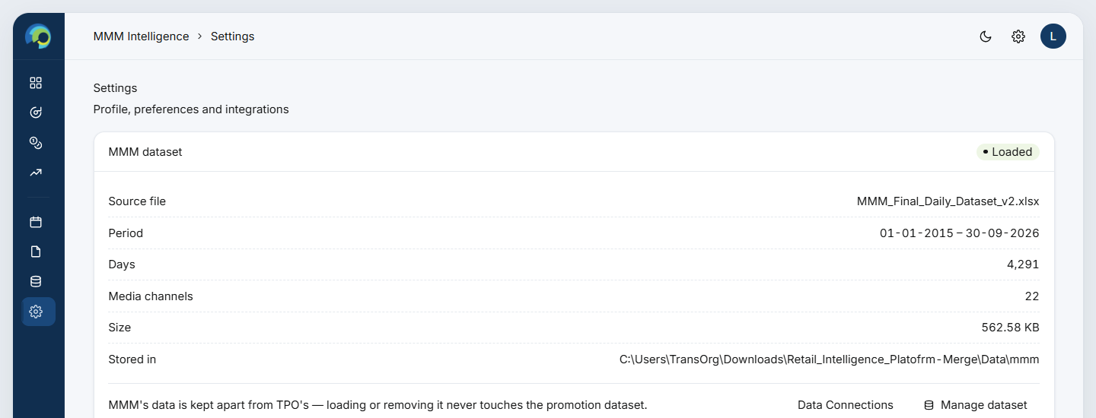
Figure 10.2 – Settings: the MMM dataset card.
Shows whether a dataset is loaded, its source file, period, days, channels, size and where it is stored, with shortcuts to Data Connections and to upload a file. Profile and preferences are shared with the rest of the platform.

11. Typical workflows

Review last year
1. Insights Hub → Year = last year. Read Revenue, Spend and ROAS against last year.
2. Open the Revenue Decomposition and click Ad Spend to see which families drove revenue.
3. Check Days With vs Without Events and the promotion-type ROAS.
4. Export the view for the team.

Re-plan a past quarter
1. Budget Optimizer → pick the quarter.
2. Try Weeks only (timing) and Channels only (mix) to see which matters more.
3. Read the reallocation table for the concrete moves.

Set next year’s budget
1. Prepare next year’s daily plan (or start from a sample) → Revenue Forecast → upload.
2. Read the forecast and the yearly table.
3. Set a budget in Budget Allocator → try amounts → use Profit peak to see the best-sized budget.
4. Optimize in Budget Optimizer for the week-by-week moves.

12. Glossary
Term | Meaning
Baseline revenue | Revenue the days would earn with no advertising (season, weekday, festivals, promotions, trend).
Media (incremental) revenue | Revenue above the baseline, caused by ads.
ROAS | Return on ad spend = media revenue ÷ ad spend. 1.00x means the ads returned their cost.
Net profit | Revenue − ad spend. The data has no product cost, so this is before the cost of goods.
Profit % | Net profit ÷ ad spend × 100.
Carryover (adstock) | An ad keeps working on the following days; a share of each day’s pressure carries to the next.
Diminishing returns | Each extra rupee in a channel earns less than the one before.
Marginal return (next ₹1 returns) | What one more rupee in a channel would earn now.
P10 – P90 | The range in which 8 of every 10 model refits fall: a measure of how sure the model is.
Same mix | A new budget spread across channels and weeks in the same proportions as the actual plan.
Profit peak | The budget at which net profit is highest; past it, the next rupee returns less than a rupee.
ROI (TPO) | Incremental sales ÷ trade spend for a promotion; 1.50x is the target hurdle.

PART 2 — TECHNICAL REFERENCE
Every filter, chart and number in depth, Parts A–J. Code paths are given so each statement can be checked against the source.

Part A — Foundations

A.1 The daily dataset (data contract)
MMM reads one table, Data/mmm/mmm_daily.csv, with one row per day (backend/app/mmm/schema.py, dataset.py, loader.py).
Column(s) | Required | Meaning and rules
Date | Yes | One format for the whole column; the parser picks the format that reads the most rows from DD-MM-YYYY, DD/MM/YYYY, YYYY-MM-DD, DD-MM-YY, DD/MM/YY. Unreadable dates are errors. Exactly one row per day.
Revenue | Yes | Numeric, not negative, not blank. Commas are stripped.
*_Spend | ≥ 1 | One column per channel. The 22 reference channels are grouped into 7 families: Broadcast & Video, Social & Video Platforms, Search & Programmatic, Out of Home, Print, Commerce & Retail Media, and Influencer & Content. Any other *_Spend column joins Other Media. A blank cell is read as 0, with a warning; non-numeric or negative values are errors.
Channel_*_Spend, Total_Spend | No | Roll-ups. They are checked against the sum of their channels (a warning when off by more than max(0.1%, ₹1)), but never stored or counted, so spend is never double-counted.
Festival_Flag, Seasonal_Flag, Promotion_Flag | No* | 0 or 1. (*The Insights Hub baseline needs all three; legacy names Holiday_Flag and Trending_Flag are accepted.)
Discount_Percentage, Promotion_Type | No | A blank Promotion_Type becomes “No Offer”.
Month, Quarter, Week_of_Year, Year | No | Derived from Date (ISO week) when missing; uploaded values win, with a warning.

Why one file, daily. Advertising effects last days, not months, and festivals and promotions are daily events. A daily grain is the finest level at which the data is reliable, and it gives 4,291 observations instead of about 140 months: enough to estimate 22 channel curves.
Install. The file is written to .mmm_daily.csv.incoming and then atomically renamed, so the dataset is never half-written. Every install or reset clears every cache (loader.reset_cache), including the response model.
About the reference data. The reference file originally had no advertising effect at all: days with spend averaged ₹2.720 Cr of revenue against ₹2.719 Cr on days without. An optimizer on that data could only rank noise. scripts/inject_mmm_media_effects.py therefore rebuilt Revenue as the original revenue plus a known, channel-by-channel effect (carryover + diminishing returns with chosen ROAS), and wrote the true parameters to scripts/mmm_media_truth.json. This lets the model be checked against a known truth (section J.1).

A.2 Money, units and currency
- Every amount is computed and stored in rupees. The ₹ / $ switch changes only presentation: the backend sends the display string and an exchange_rate (display units per rupee), and chart axes multiply by it.
- Indian steps: K = 10³, L (lakh) = 10⁵, Cr (crore) = 10⁷, with 2 decimals. Dollar steps: K, M, B.
- Multiples print as “1.53x”; a difference of multiples as “+0.20”; percentages to 2 decimals; a difference of percentages as “+28.96 pts”.
- Any signed figure (+ / −) is shown green or red on every page (lib/signColor.ts).

A.3 Scope: how filters select days (Insights Hub, Calendar, Reports)
A scope has time fields (year, quarter, month, week, or a date range) and day filters (promotion types, events) plus a media filter (channels) (backend/app/mmm/scope.py).
- Time fields choose the PERIOD. Year, quarter, month and week are combined with AND. A date range replaces all four.
- Day filters narrow the days inside the period. A promotion-type filter keeps rows of those types; an event filter keeps days that are festival OR seasonal OR promotion OR “none” (no flag).
- Channels choose which spend columns count as ad spend; they drop no days.
- Why time and day filters are kept apart. The baseline is estimated over the whole period and then applied to however many days the day filters leave. Estimating it only on, say, festival days would mix the festival effect into the baseline.
Comparison windows (comparison_window):
Comparison | Period made of whole calendar months | Any other period
YAGO — Year Ago | Same months, 12 months earlier | Same dates, one year earlier
PAGO — Period Ago | The same number of months immediately before | An equal-length window ending the day before
MAGO — Month Ago | Shifted back 1 month | Same dates, one month earlier

A comparison is unavailable, with the reason shown, when the scope is not one unbroken range (for example, every January across all years), when the window falls outside the data, or when no days match.

Part B — Insights Hub
Figure B.1 – Insights Hub, 2025.

B.1 Filters and controls
Control | Options and default | Effect on the numbers
Year | All Years, or each year (newest first). Default: the most recent completed year (2025) | Sets the period. Picking a year clears a custom range.
Quarter | All Quarters, Q1–Q4 | Narrows the period; clears a month outside the quarter.
Month | All Months, or months of the chosen quarter | Narrows the period.
Date range | From / To, bounded by the data (1 Jan 2015 – 30 Sep 2026) | Replaces year / quarter / month; they dim while it is active.
₹ INR / $ USD | INR | Display only.
+ Add KPI | Headline three only, plus up to 6 more | Adds cards; remembered in the browser (mmm-insights-hub.kpis.added).
Refresh | — | Re-fetches every MMM query.
Export | — | Builds an Excel + PDF report of the current scope (Part H).

Implementation note. The backend also supports channel, week, promotion-type and event filters and a daily trend, but this page sends them empty and offers Weekly / Monthly only. They remain available through the API and reports.

B.2 The baseline: what the days would earn without ads
Every Insights Hub ROAS and incremental figure rests on a baseline per day (backend/app/mmm/baseline.py). The method is a matched-difference (difference-in-means) estimator over three kinds of day:
Day class | Definition | 2025: mean revenue / day | Days
X | Ad spend > 0 and Festival = Seasonal = Promotion = 1 | ₹5.24 Cr | 39
Y | No ad spend and all three flags = 1 | ₹4.15 Cr | 22
R | Ad spend > 0 and all three flags = 0 | ₹4.32 Cr | 30

Z (ad lift per day) = mean(X) − mean(Y)
Baseline per day = mean(R) − Z
Baseline revenue = Baseline per day × days in scope
Incremental revenue = Total revenue − Baseline revenue
ROAS = Incremental revenue ÷ Total ad spend

Theory. X and Y are identical in their events (all three on) and differ only in advertising, so X − Y isolates what ads add on a day: the ad lift Z. R is an ad day with no events; removing Z from it leaves what an ordinary day earns with neither ads nor events, which is the baseline. This is the same idea as a controlled comparison: hold the other factors fixed and difference out the one you want.
Worked example
2025: Z = ₹5.24 Cr − ₹4.15 Cr = ₹1.09 Cr a day (Ad Revenue Lift / Day).
Baseline per day = ₹4.32 Cr − ₹1.09 Cr = ₹3.23 Cr (Avg Daily Baseline).
Baseline revenue = ₹3.23 Cr × 365 = ₹1,179.26 Cr; incremental = ₹1,523.67 Cr − ₹1,179.26 Cr = ₹344.41 Cr.
ROAS = ₹344.41 Cr ÷ ₹225.48 Cr = 1.53x (2024: 1.97x, so the card shows −0.44).

Widening. If the period lacks a day of X, Y or R (common for one month), the window is widened symmetrically by ±7 days, then ±14, and so on, until each class has at least one day. The estimate is then marked widened and the tooltip says so. If the whole file lacks a class, or a flag column is missing, the baseline is shown as unavailable with the reason; it is never shown as zero.
Why this method. It is transparent (three averages), needs no fitting, can be re-run instantly for any scope, comparison window, trend bucket or channel, and can be explained on one line of a report. Limitations: it uses only days where all three flags are on or all are off; it ignores carryover (an ad on Monday also lifts Tuesday) and diminishing returns; and with few X or Y days it is noisy. For planning, the platform therefore uses the fitted response model (Part D), not this estimator.

B.3 KPI cards
Each card shows the value, its change against the Year Ago window and a sub-label “vs <period>”. Currency and count changes are % changes, (now − before) ÷ |before| × 100; ROAS changes are differences of multiples, now − before. Ad spend is marked neither good nor bad; for every other card, up is good.
Card | Formula | 2025 value | vs 2024
Total Revenue | Σ Revenue over the days in scope | ₹1,523.67 Cr | +2.64%
Total Ad Spend | Σ of every channel’s spend (the sub-channels; roll-ups never counted) | ₹225.48 Cr | +6.29%
ROAS | Incremental revenue ÷ ad spend | 1.53x | −0.44
Baseline Revenue | Baseline per day × days | ₹1,179.26 Cr | +10.51%
Incremental Revenue | Revenue − baseline revenue | ₹344.41 Cr | −17.48%
Avg Daily Baseline | mean(R) − (mean(X) − mean(Y)) | ₹3.23 Cr | +10.81%
Avg Daily Revenue | Revenue ÷ days | ₹4.17 Cr | +2.92%
Ad Revenue Lift / Day | mean(X) − mean(Y) | ₹1.09 Cr | −14.39%
Days With Ad Spend | Count of days with spend > 0 | 180 | +4.05%

Reading the example. Revenue rose 2.6% while spend rose 6.3%, but the baseline rose 10.5%, so less of the revenue is credited to ads (incremental −17.5%) and ROAS fell from 1.97x to 1.53x.

B.4 Ad Spend & ROAS Trend
- Buckets: Monthly (default) or Weekly (weeks start Monday, labelled by their first day).
- Per bucket: spend = Σ spend; revenue = Σ revenue; baseline = baseline per day re-estimated inside the bucket × its days; ROAS = (revenue − baseline) ÷ spend.
- Axes: ad spend on the left (₹), ROAS on the right (x); the dotted line is break-even at 1.00x. A month with no spend leaves a gap in the ROAS line.
- Tooltip: spend, ROAS (a red “Below break-even” badge under 1.00x), the number of ad days, and the event mix of those days (e.g. “Festival + Seasonal + 5% Discount · 2 days · 15%”), plus a note if the baseline was widened.
Worked example
Jan 2025: spend ₹15.66 Cr, revenue ₹111.81 Cr, baseline ₹97.44 Cr → ROAS = (111.81 − 97.44) ÷ 15.66 = 0.92x (below break-even). Feb 2025: 1.59x.

B.5 Revenue Decomposition (donut)
The identity behind the donut (backend/app/mmm/decomposition.py):
Revenue = Baseline + Festival + Seasonal + Promotion + Σ channel contributions

Step 1 – a regression on every day of the file:
Revenue_t = b0 + b_trend·t + b_media·Spend_t + b_fest·Festival_t + b_seas·Seasonal_t + b_promo·Promotion_t + e_t

It is fitted by ordinary least squares with non-negativity on the media and event coefficients, using an active-set loop: refit, drop the most negative coefficient, and repeat until none is negative. The trend is left free. The fit is cached per channel selection; its R² is reported (0.75 on the reference data).
Step 2 – the split for the scope:
- Baseline = the hub’s baseline revenue (B.2), clamped to [0, revenue]. If it is unavailable, the model’s Σ(b0 + b_trend·t) is used and labelled as such.
- Incremental = revenue − baseline. It is divided among the drivers in proportion to their weights over the scope: media = b_media × Σ spend; each event = b_event × Σ flag-days.
- The media slice is divided among channels in proportion to spend, then summed into families. Each slice’s share is value ÷ revenue × 100.
Worked example
2025: revenue ₹1,523.67 Cr; Baseline ₹1,179.26 Cr (77.40%), Festival ₹56.18 Cr (3.69%), Seasonal ₹40.94 Cr (2.69%), Promotion ₹33.16 Cr (2.18%), Ad Spend ₹214.13 Cr (14.05%).
Ad Spend drills into Broadcast & Video ₹66.41 Cr (TV ₹36.97 Cr, OTT ₹18.55 Cr, …), Search & Programmatic ₹41.34 Cr, and so on.

Interaction: the driver chips can be combined; the summary then shows the selected total and its % of revenue. With none selected it shows “Above baseline · events and ads” = revenue − baseline (₹344.41 Cr, 22.60%). Click Ad Spend → a family → its channels; “All drivers” and “Ad Spend” go back up.
Why this design. The regression gives each driver a weight learned from all 11 years; the scope’s own baseline keeps the donut consistent with the KPI cards; proportional splitting guarantees the slices add up exactly to revenue. Limitation: splitting channels by spend assumes equal efficiency within the media slice. For channel efficiency use the channel card (B.6) or, better, the response model (Part D).

B.6 Channel card: Revenue / Ad Spend / ROAS by Channel
- Measure: Revenue, Ad Spend (default) or ROAS. Chart: Pie (default) or Bar; ROAS always uses bars. Rows: Top 10 / All.
- It opens on families; click one for its channels. Rows are sorted by the measure, with empty values last.
Figure | Formula
Spend | Σ the channel’s spend in scope; share = spend ÷ total spend
Active days | Days with the channel’s spend > 0
Revenue (attributed) | On each ad day, that day’s revenue is shared among the channels on air in proportion to their spend that day: Σ_days (spend_c ÷ day spend) × revenue
ROAS | (revenue on the channel’s active days − the channel’s own baseline per day × active days) ÷ spend. The baseline is re-estimated (B.2) treating only this channel as “ad spend”
Family ROAS | The same, over days when any member spent, with the family as “ad spend”

Worked example
TV, 2025: spend ₹38.93 Cr (17.26% of spend) on 115 days; attributed revenue ₹146.87 Cr; ROAS 3.24x. Broadcast & Video family: spend ₹69.93 Cr (31.01%), ROAS 3.91x.

Why hub ROAS is higher than model ROAS. Hub channel ROAS compares ad days with that channel’s own baseline; it does not separate channels that run on the same days. Seven digital channels switch on and off together, so each one is credited with their combined lift. That is why TV reads 3.24x here but 1.52x in the response model (Part D), which fits all channels jointly with carryover and diminishing returns. Use the hub for description and the model for decisions.

B.7 Revenue by Promotion Type
Per promotion type, over the days in scope:
days, revenue = Σ Revenue, average revenue = revenue ÷ days, spend = Σ ad spend
ROAS = (revenue − scope baseline per day × days) ÷ spend
share of days, share of revenue

Worked example
2025: 15% Discount — 33 days, ₹151.56 Cr, ROAS 2.14x; 5% Discount — 76 days, ROAS 1.38x; No Offer — 184 days, ROAS 1.37x. The ROAS under each bar is green at ≥ 1.00x and red below.

B.8 Performance Comparison
- Measure: Total Revenue, Total Ad Spend, ROAS, Baseline Revenue, Incremental Revenue or Days With Ad Spend.
- Against: YAGO, PAGO, MAGO, or YTD (hidden for a custom range). Month / Year selectors pick the period; it opens on the latest month with data.
- Charts: columns for the selected period against each comparison (click one to switch); with one month picked, 13 months of context with the two months highlighted; for YTD, running totals this year vs last year (dashed).
- Each comparison window gets its own full computation, including its own baseline, so the deltas are like for like.

B.9 Days With vs Without Events
Difference = (mean revenue on days WITH the event − mean on days WITHOUT) ÷ mean WITHOUT × 100

Event | Days with / without | Avg revenue with / without | Difference
Ad spend | 180 / 185 | ₹4.75 Cr / ₹3.62 Cr | +31.33%
Festival | 197 / 168 | ₹4.34 Cr / ₹3.98 Cr | +8.91%
Seasonal | 191 / 174 | ₹4.31 Cr / ₹4.02 Cr | +7.16%
Promotion | 181 / 184 | ₹4.32 Cr / ₹4.03 Cr | +7.32%
Any event | 335 / 30 | ₹4.16 Cr / ₹4.32 Cr | −3.64%

Why it is useful, and its limit. It is the simplest possible evidence that ads move revenue (+31% on ad days). It is a raw comparison: events overlap, so “Any event” can even be negative because almost every day has some event. Order: As listed, or Biggest gap.

B.10 Caching
Hub payloads (64 scopes), filter options, decomposition fits (16) and calendar views are cached in memory and cleared whenever a dataset is installed or removed.

Part C — Calendar
Figure C.1 – Channel flighting and month detail.
- Matrix: for each channel and month, spend = Σ spend and active days = days with spend > 0. Rows are sorted by the channel’s yearly spend.
- Shade level: 0 when off air, otherwise 1 + the number of the year’s quartile cuts (25/50/75% of all non-zero channel-month spends) that the cell exceeds, giving Low, Medium, High or Heaviest. Opacity steps are 0, 16, 36, 62 and 92% of the spend colour.
- Why quartiles of the year: the shading adapts to each year’s scale, so a heavy month always reads heavy.
- Month header: spend, days with any media, promotion days (P) and festival days (F).
- Month detail: per day, the revenue, Festival / Seasonal / promotion-type tags, total media and the number of channels, and the top three channels (the rest as “+N”).

Part D — The response model (planning pages)
The Budget Optimizer, Budget Allocator and Revenue Forecast share one fitted model (backend/app/mmm/budget_model.py). It describes a day’s revenue as:
revenue_t = baseline_t + Σ_c β_c · hill( adstock_c,t )

adstock_c,t = spend_c,t + decay_c · adstock_c,t−1 (carryover)
hill(x) = x^α_c ÷ ( x^α_c + κ_c^α_c ) (diminishing returns)
baseline_t = w · features_t (no ads)

D.1 Carryover (adstock)
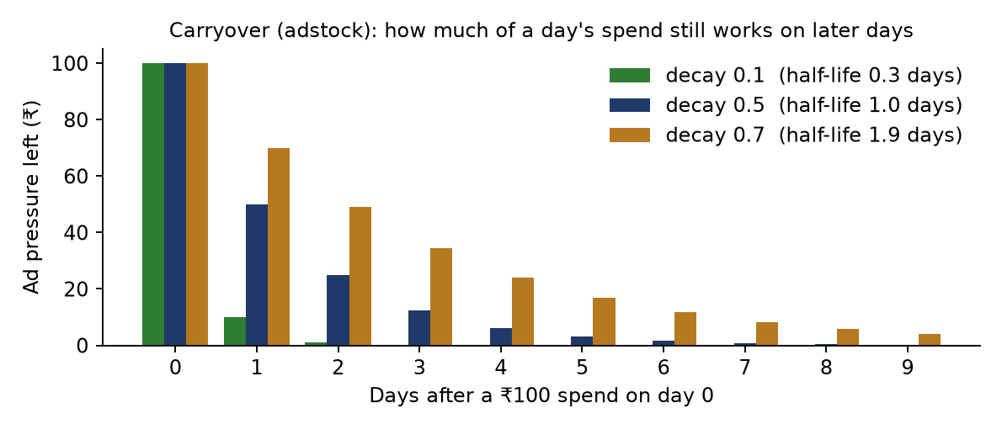
Figure D.1 – A ₹100 spend on day 0: the pressure left on later days, for three decays.
Advertising keeps working after the day it runs: viewers remember, search later and buy later. Geometric adstock keeps a fixed share (decay) of yesterday’s pressure. Half-life = ln 0.5 ÷ ln decay: decay 0.5 → 1 day, 0.7 → 1.9 days. The model tries decay ∈ {0, 0.1, …, 0.7} per channel.

D.2 Diminishing returns (Hill curve)
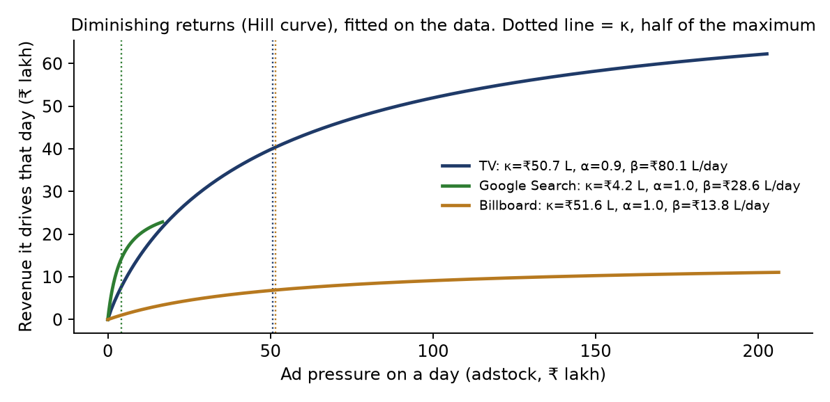
Figure D.2 – Fitted response curves for three channels.
Each extra rupee in a channel reaches people who have already seen the ad, so it earns less. The Hill function rises from 0 towards a ceiling β (rupees a day at full saturation). κ (kappa) is the pressure at which the channel gives half its maximum; α (alpha) sets the shape. The model tries κ ∈ {0.5, 0.75, 1, 1.5, 2} × the channel’s average pressure on active days, and α ∈ {0.8, 0.9, 1.0}.
Why these shapes. Adstock and Hill saturation are the standard building blocks of modern MMM (used by Google’s Meridian and LightweightMMM and Meta’s Robyn). They express the two facts any budget decision depends on — timing and saturation — with three numbers per channel that can be read and checked.

D.3 The baseline features (26 columns)
Group | Columns | Captures
Intercept | 1 | Average level
Trend | t, t² (t in decades since the first day) | Long-run growth (~3.5% a year in the data)
Yearly season | sin and cos of 2πk·day-of-year ÷ 365.25, k = 1…4 (8 columns) | Smooth annual cycle
Day of week | 6 weekday dummies | Weekly pattern
Events | Festival, Seasonal, Promotion flags; Discount % | Event lifts
Promotion type | One dummy per type except the first (5 columns) | Offer-specific lifts

Columns are standardised (mean 0, sd 1) with the history’s statistics. For future dates (Part G) the same statistics are reused, and past the data’s last day the quadratic trend continues along its tangent: straight on at its latest rate, instead of bending.

D.4 How the model is fitted
- Joint fit. The baseline and all 22 media curves are fitted together on every day. Ad days and no-ad days alternate in runs of about two days, so most no-ad days still carry earlier ads; fitting jointly credits that carryover to the spend that caused it.
- Coordinate search over curves. For each channel in turn, every candidate (8 decays × 5 kappas × 3 alphas = 120) is scored by how much it improves the fit. Everything else is projected out once with a QR decomposition, so each candidate is scored exactly without refitting. 3 sweeps over the 22 channels.
- Pooled channel effects. Seven digital channels switch on and off on the same days (spend correlation ≈ 0.95), so the data fixes their combined effect but not the split. Each channel’s ROAS gets a hierarchical prior ROAS_c ~ N(mean ROAS, 0.75²), with the mean itself estimated, and is kept ≥ 0. A channel moves away from the shared mean only as far as its own data supports.
- Ridge (penalty 1.0) on the standardised baseline coefficients for stability.
- Solved with bounded linear least squares (scipy.optimize.lsq_linear).

D.5 Uncertainty: the block bootstrap
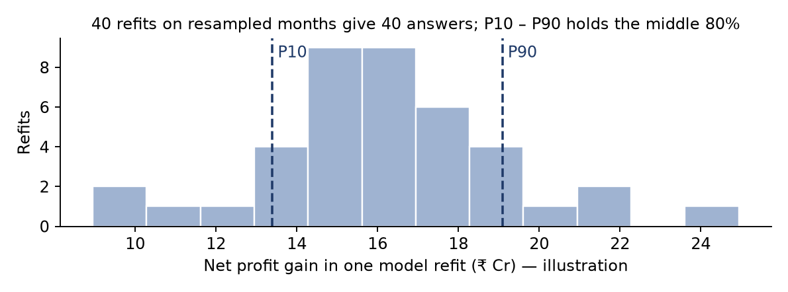
Figure D.3 – Illustration: 40 refits give 40 answers; P10 – P90 is the middle 80%.
The whole fit, curves included, is repeated 40 times on resamples of the calendar months (months drawn with replacement). Months, not days, are resampled so carryover and seasonality stay intact. Every plan is scored on all 41 fits (central + 40). That is where every P10 – P90 range and every “refits where the plan gains” share come from.

D.6 Validation and the fitted parameters
Refitted without the last 365 days and then predicting them unseen, daily revenue is off by 4.78% on average (MAPE), with R² 0.905. Media explains 27.86% of revenue.
Channel | Decay | α | κ | ROAS (fit) | P10 – P90 | True ROAS
TV | 0.5 | 0.9 | ₹50.7 L | 1.52x | 1.43 – 1.66 | 1.40x
OTT | 0.5 | 1.0 | ₹21.4 L | 1.49x | 1.25 – 1.93 | 1.60x
Streaming Audio | 0.7 | 1.0 | ₹13.9 L | 2.08x | 1.22 – 2.65 | 0.90x
Cinema Advertising | 0.4 | 0.8 | ₹6.0 L | 0.79x | 0.36 – 1.28 | 0.70x
Meta Ads | 0.1 | 0.8 | ₹5.5 L | 2.21x | 0.19 – 2.88 | 1.90x
YouTube Ads | 0.1 | 0.8 | ₹4.2 L | 2.60x | 0.00 – 4.01 | 1.70x
Google Ads | 0.1 | 0.8 | ₹3.8 L | 2.20x | 0.00 – 3.23 | 2.20x
TikTok Ads | 0.1 | 1.0 | ₹2.9 L | 0.58x | 0.00 – 1.23 | 1.10x
Billboard | 0.7 | 1.0 | ₹51.6 L | 0.60x | 0.23 – 1.02 | 0.80x
Transit Advertising | 0.3 | 1.0 | ₹3.3 L | 0.09x | 0.00 – 0.63 | 0.60x
Airport Advertising | 0.7 | 1.0 | ₹9.5 L | 1.01x | 0.63 – 2.02 | 0.50x
Newspaper | 0.4 | 1.0 | ₹23.7 L | 0.60x | 0.53 – 0.81 | 0.70x
Magazine | 0.7 | 1.0 | ₹37.8 L | 0.78x | 0.43 – 1.22 | 0.50x
Google Search | 0.1 | 1.0 | ₹4.2 L | 2.62x | 1.24 – 4.03 | 2.80x
Programmatic Display | 0.6 | 1.0 | ₹12.0 L | 0.00x | 0.00 – 2.19 | 1.00x
Native Advertising | 0.1 | 0.8 | ₹0.9 L | 1.92x | 0.81 – 2.53 | 1.20x
E-commerce Ads | 0.2 | 1.0 | ₹11.7 L | 3.20x | 2.68 – 4.13 | 3.00x
Quick Commerce Ads | 0.6 | 0.8 | ₹4.1 L | 4.01x | 2.98 – 5.07 | 2.40x
In Store Digital Ads | 0.0 | 1.0 | ₹4.0 L | 2.22x | 1.83 – 3.15 | 2.00x
Influencer Marketing | 0.7 | 0.8 | ₹5.9 L | 1.56x | 0.78 – 2.17 | 1.30x
Creator Content | 0.1 | 1.0 | ₹12.3 L | 1.16x | 0.84 – 1.98 | 1.10x
Sponsored Content | 0.7 | 0.8 | ₹4.3 L | 2.39x | 1.37 – 3.08 | 0.90x

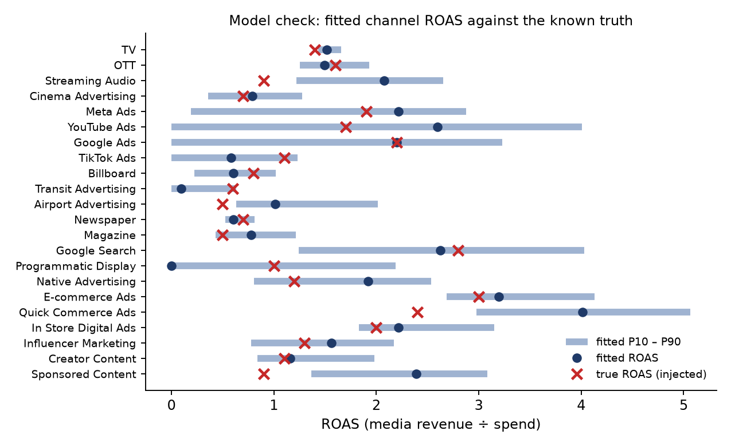
Figure D.4 – Fitted ROAS (dot, with P10–P90 bar) against the injected truth (×).
Reading the check. The large, independent channels are recovered closely (TV 1.52x vs 1.40x true; E-commerce Ads 3.20x vs 3.00x; Google Ads 2.20x vs 2.20x). The correlated digital channels have wide ranges (YouTube 0.00 – 4.01x): the data cannot separate them, and the ranges say so honestly. The model is conservative where it is unsure, which is the right behaviour for budget moves.

D.7 Why this model, and its limits
- Why not a full Bayesian MMM (Meridian, Robyn, PyMC)? The deployment can load only numpy, pandas and scipy (no native ML packages), and the page must answer in about a second. The model keeps the same structure (adstock, Hill, priors and uncertainty) with fast linear algebra, and a bootstrap in place of MCMC.
- Fitted once per dataset (about a minute), then cached on disk as plain arrays (never pickle) and reused.
- Limits: effects are assumed stable over time; channels are assumed additive (no synergy); spend far outside what the data saw is extrapolated (the pages flag it); net profit excludes the cost of goods because the data has none.

Part E — Budget Optimizer
Figure E.1 – Budget Optimizer.

E.1 Controls
Control | Detail
Past data / Forecast plan | source=history or source=forecast (Part G). Shown once a forecast plan is uploaded; kept in the URL.
Period | Whole ISO weeks (Monday – Sunday), keyed year×100 + week (e.g. 202627). Default: the latest 13 whole weeks.
Reallocate across | anywhere (Channels and weeks), within_channel (Weeks only), across_channels (Channels only).
Currency | Display only.

E.2 How a plan is scored
A plan is a matrix of channel × week spend. To score it (budget.score):
- Each week’s spend is spread over its days in that channel’s own daily pattern for that week (evenly if the channel was dark that week), so a plan keeps the real on/off rhythm.
- The model runs over a window from 90 days before the period (to set the starting carryover) to 28 days after it (to credit late spend with what it earns after the period ends).
- Incremental revenue = media revenue with the plan − media revenue with the period’s spend set to zero, over the period and the 28-day tail.
Revenue = baseline over the period’s days + incremental revenue
Net profit = Revenue − ad spend
Profit % = Net profit ÷ ad spend × 100
ROAS = incremental revenue ÷ ad spend

Every figure is computed on the central fit and the 40 refits. Ranges are the 10th and 90th percentiles; ad spend is chosen, not estimated, so it has no range.

E.3 The optimizer
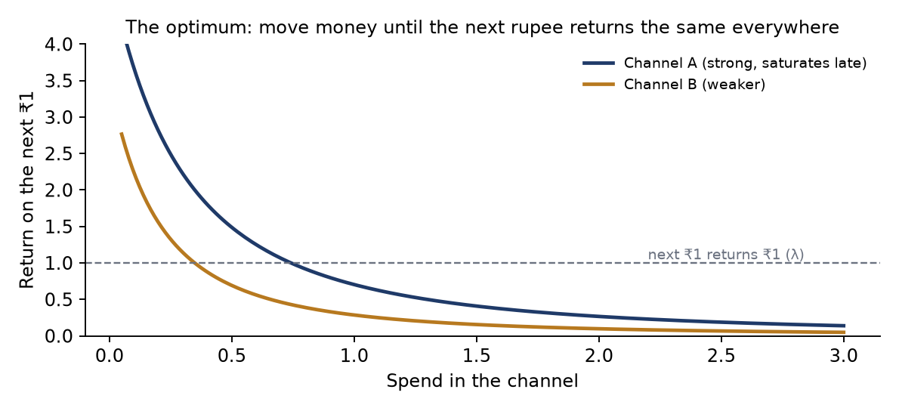
Figure E.2 – The optimality condition: equal return on the next rupee.
Goal: maximise net profit with the total budget fixed. Spend is fixed, so this is the same as maximising incremental revenue.
- Method: projected gradient ascent with an Armijo backtracking line search, up to 400 iterations, on the central fit.
- Exact gradient through carryover: the return of one more rupee on day t includes its effect on every later day τ, weighted decay^(τ−t). This is computed with one reverse-time filter per channel.
- Projection onto the allowed plans: {x ≥ 0, Σ x = budget} for anywhere; one such constraint per channel for Weeks only; one per week for Channels only. The exact Euclidean projection onto the simplex is used.
- One best plan exists: every response curve is concave, so the optimum is unique, and the search finds it.
- Optimality condition (theory): at the optimum, every channel-week that receives money has the same marginal return (the next rupee returns the same everywhere). Otherwise, moving a rupee from a low-return cell to a high-return cell would add profit. This is why the optimized plan shows “next ₹1 returns” nearly equal across channels.

E.4 From a plan to moves
The difference between the optimized and current plans is turned into moves of money, matched largest first in three passes: re-timed (same channel, other weeks), across channels (same week, other channels) and, in the anywhere mode only, across channels and weeks for what is left. Amounts below 0.01% of the budget are not listed.

E.5 Every panel and number
Panel | Number | Definition
Current plan strip | Net profit, Profit %, Revenue, Ad spend, ROAS, Media revenue | E.2 on the plan as it ran
Net profit gain | Hero figure | Optimized − current net profit
 | Profit % a → b (+pts) | Current and optimized profit %, and the difference in points
 | Reallocated in total | Σ moves; % of budget
 | Per kind tiles | Σ and count of moves of each kind (or channels touched in single-kind modes)
 | Result | Revenue change, ROAS before → after, ad spend unchanged
 | How sure | P10 – P90 of the gain over refits; % of refits in which the plan gains
Current vs optimized | Each figure | Current, optimized, change (and %), P10 – P90 of the optimized figure
Week by week | Profit / Revenue / Profit change | Per week, both plans, with the plan’s P10 – P90; the 28-day carryover is noted below the chart and counted in the totals
Spend response | Curves | Media revenue as the period budget goes 0 → 1.5×, spread as today and as the plan spreads it, with P10 / P90
 | Stat tiles | Budget, media revenue and ROAS, before → after
 | Next ₹1 returns | Spend-weighted marginal return of the channel (or of all channels)
Budget reallocations | Rows | One per channel-week money leaves (or arrives), with its moves as chips; filter by kind, search, 10 per page
Channel budgets | Columns | Current, optimized, change, moved out, moved in, change in media revenue

Worked example
Period W27 – W39 2026 (29 Jun – 27 Sep 2026), budget ₹55.96 Cr.
Current: revenue ₹391.58 Cr (baseline ₹290.07 Cr + media ₹101.51 Cr), net profit ₹335.62 Cr, ROAS 1.81x.
Optimized: media ₹117.82 Cr, net profit ₹351.94 Cr, ROAS 2.11x. Gain +₹16.31 Cr (P10 – P90: +₹10.12 – 18.49 Cr), positive in 100% of refits.
Moves: ₹20.37 Cr (36.4%), of which ₹6.84 Cr is re-timed (76 moves), ₹8.38 Cr crosses channels in the same week (87) and ₹5.15 Cr crosses both (91). The largest: TV W38 → TV W36, ₹78.29 L.
All channels: the next ₹1 returned ₹0.82 in the current plan and ₹1.00 in the optimized plan; returns are now equal across channels (E.3). TV: ₹13.94 Cr → ₹13.59 Cr, its next rupee ₹0.91 → ₹1.00.

Part F — Budget Allocator
Figure F.1 – Budget Allocator.

F.1 Inputs
- Your budget (₹ Cr or $ M; converted to rupees with the exchange rate). Quick buttons: 0.75×, 0.9×, actual, 1.1×, 1.25×, 1.5× the actual spend, and Profit peak.
- Period, Reallocate across and Past data / Forecast plan, exactly as in the Optimizer. No per-channel limits: only the total is fixed (as requested).

F.2 The three plans and the two effects
Actual A = the period’s spend as it ran
Same mix B = A × (your budget ÷ actual budget) every channel-week scaled
Optimized C = argmax net profit, Σ C = your budget (E.3; modes are measured against B)

Budget effect = profit(B) − profit(A) what the new budget does alone
Mix effect = profit(C) − profit(B) what a better split adds
Total = profit(C) − profit(A) = budget effect + mix effect

The baseline is identical in A, B and C: it is the period’s own revenue without ads. With the total fixed, the most net profit is also the most revenue. The panel “What optimizing adds” shows the mix effect as the hero figure, its P10 – P90 range, and the % of refits in which C beats B.

F.3 Net profit at every budget (frontier)
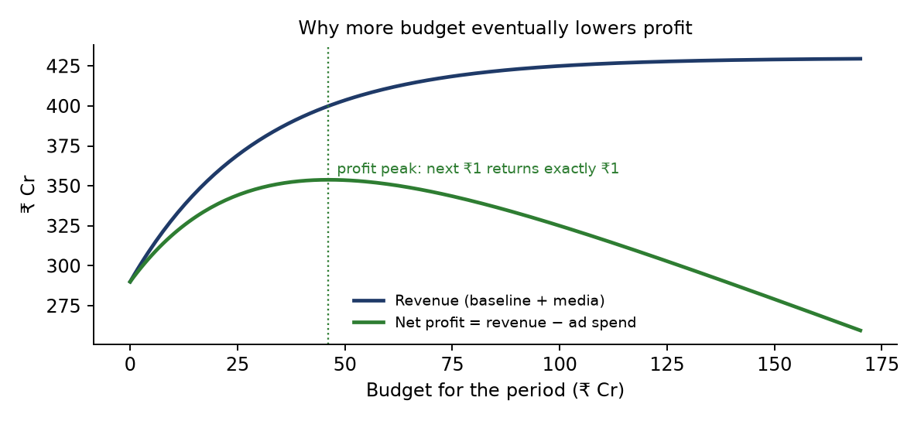
Figure F.2 – Illustration: revenue keeps rising with budget, but profit peaks.
- 19 budgets from ₹0 to 3× the actual. At each one, the same mix (B-style) and the best split (the optimizer run at that budget, warm-started from the previous one) are scored on all 41 fits.
- Profit peak: a golden-section search (8 steps) between the grid neighbours of the best grid point. Net profit is concave in the budget, so the search is valid. At the peak, the next rupee of ads returns exactly ₹1.
- The curve does not depend on the entered budget, so it is cached per period and mode.

F.4 Optimal spend by channel
Column | Definition
Actual / Same mix / Optimized | Σ over the weeks of each plan’s spend in the channel
Share of budget | Actual share → optimized share (bars: grey actual, navy optimized)
Change | Optimized − same mix
Media revenue | Same mix → optimized, from the central fit
Next ₹1 returns | The channel’s marginal return in the optimized plan; equal (≈ λ) for every funded channel
⚠ | A week of the optimized plan exceeds the channel’s highest weekly spend in the observed data

Worked example
Same period, actual ₹55.96 Cr. At 25% more (₹69.95 Cr): same mix net profit ₹332.01 Cr (−₹3.62 Cr vs actual); optimized ₹350.81 Cr, a mix effect of +₹18.80 Cr (P10 – P90 +₹12.22 – 20.88 Cr), +₹15.19 Cr in total.
Profit peak ≈ ₹56.03 Cr (net profit ₹351.94 Cr). The actual budget was already right-sized; the money is in the split. At the actual budget, every funded channel’s next ₹1 returns ₹1.00, which is exactly the peak condition.

Part G — Revenue Forecast
Figure G.1 – Revenue Forecast.

G.1 The uploaded plan
A daily CSV for dates after the data, without Revenue (backend/app/mmm/forecast.py, read_plan):
- Date (DD-MM-YYYY, YYYY-MM-DD or DD/MM/YYYY), one row per day, starting after 30 Sep 2026, and at most about six years.
- Channel spend columns with the data’s names. A missing channel is taken as zero, and unknown *_Spend columns are ignored (both listed as notes). Negative or non-numeric spend is refused.
- Flags, discount and promotion type: missing ones are taken as none; an unknown promotion type is read as No Offer.
- A Revenue column is ignored, with a note. Missing days inside the plan, and any gap from the data’s end, are filled as days without ads or offers.

G.2 The sample plans
scripts/make_mmm_future.py writes Data/mmm/future/mmm_future_{1..5}y.csv. Each future ISO week copies the same week and weekdays from a random one of the last 4 whole years (2022 – 2025). Each channel’s spend in that week is multiplied by a log-normal factor (σ = 0.12) and by 3% yearly growth. The generator is seeded, and the five files are prefixes of one 5-year plan, so they agree where they overlap.
File | Days | Dates | Ad spend | Days without ads
mmm_future_1y.csv | 365 | 01-10-2026 – 30-09-2027 | ₹217.13 Cr | 192
mmm_future_2y.csv | 731 | … – 30-09-2028 | ₹436.43 Cr | 388
mmm_future_3y.csv | 1,096 | … – 30-09-2029 | ₹676.66 Cr | 574
mmm_future_4y.csv | 1,461 | … – 30-09-2030 | ₹937.70 Cr | 752
mmm_future_5y.csv | 1,826 | … – 30-09-2031 | ₹1,222.33 Cr | 924

G.3 How revenue is predicted
- The extended model: the history with the plan’s days appended (spend, plus baseline features standardised with the history’s statistics, and the trend continued along its tangent, D.3). This is an ordinary model, so every planning function works on it unchanged.
- Per day and per fit: baseline = features · w; media = Σ β·hill(adstock), run over history and plan together, so the plan’s first days still carry the last real ads.
- Revenue = baseline + media; net profit = revenue − spend; ROAS = media ÷ spend. Totals, daily / weekly / monthly series and plan years are summed within each fit first, and the percentiles are taken afterwards, so every range is the range of that total.

G.4 Every panel and number
Panel | Content
Plan bar | File name, first – last date, days, days with ads, channels; Replace file, Download predictions, Remove
Notes | Everything assumed or ignored while reading the file
Forecast KPIs | Revenue, Net profit, Profit %, Ad spend (as planned), ROAS, Media revenue, each with P10 – P90; header with the baseline
Plan this forecast | Opens #/mmm/budget?source=forecast or #/mmm/allocator?source=forecast on the plan’s first 13 whole weeks
Forecast over time | Revenue (with baseline line), net profit, media revenue (lines + P10/P90) or ad spend (bars); daily, weekly or monthly (monthly by default above 400 days)
Year by year | Twelve-month plan years from the first day: spend, baseline, media, revenue (P10 – P90), net profit, ROAS
Channels in the plan | Spend, share, days with ads, media revenue (P10 – P90), ROAS
Download | The plan + Ad_Spend_Total, Predicted_Revenue, Revenue_P10, Revenue_P90, Baseline_Revenue, Media_Revenue, Net_Profit (rupees)

Worked example
1-year plan: revenue ₹1,577.18 Cr (P10 – P90 ₹1,558.49 – 1,602.58 Cr) = baseline ₹1,180.98 Cr + media ₹396.21 Cr; spend ₹217.13 Cr; net profit ₹1,360.05 Cr; ROAS 1.82x.
5-year plan: revenue ₹8,401.78 Cr; yearly revenue rises ₹1,577 → 1,620 → 1,670 → 1,738 → 1,798 Cr with the trend and spend growth, while ROAS falls 1.82x → 1.64x as more spend meets diminishing returns.

G.5 Planning the forecast
With source=forecast, the Optimizer and Allocator calendars show only the plan’s weeks after the data, and the default period is the plan’s first 13 whole weeks. The “highest weekly spend seen” warning still uses observed weeks only. Example: the first 13 weeks of the 5-year plan (W41 – W53 2026, ₹48.46 Cr) gain +₹14.04 Cr of net profit at the same budget.
Accuracy check. Validated in the automated tests on synthetic data whose true formula is known: the forecast total is within 4% of the true revenue of the plan.

Part H — Reports, Data Connections and Settings

H.1 Reports
Export on the Insights Hub creates one report document, written as Excel and PDF (module mmm-insights, file MMM_Insights_Hub_<year | All_years | Custom_range>). It is built from the same hub payload, so nothing is recomputed and the report always matches the screen.
Section | Content
Headline figures | All 9 KPIs: value, previous value, change, “vs …”
Scope | Period, days, media channels n of N, comparison
Baseline | X, Y, Z = X − Y, R, baseline per day = R − Z, baseline revenue, window (and whether widened)
Media spend by channel | Channel, family, spend, share, days on air, average spend per day on air
Monthly trend | Period, revenue, ad spend, baseline revenue, ROAS
Promotions | Type, days, share of days, revenue, average daily revenue
Days with and without events | Event, days with and without, average revenue with and without, difference

H.2 Data Connections
Upload, replace, view (the first 100 rows) or remove the dataset; rules as in A.1. Excel files are checked with a header-only preflight on the server; CSV headers are checked in the browser before upload. All problems are reported together, with row numbers (up to five per kind).

H.3 Settings
The MMM dataset card (loaded or not, source file, period, days, channels, size, storage folder) plus the shared profile and preferences. TPO’s period and channel preferences are hidden here.

Part I — Investigation agents (TPO)
Code: backend/app/agents/ (roster, star_pipeline, star_tools, pipeline, confidence, figures, client), backend/app/routers/investigations.py, frontend/src/pages/Investigations.tsx.

I.1 Promotion economics the agents use
ROI = incremental sales ÷ trade spend (a multiple; 1.00 = break-even)
Target ROI = 1.50
Severity Critical: ROI ≤ 1.00 · High: 1.00 – 1.25 · Medium: 1.25 – 1.50
At stake = max(trade spend × 1.50 − incremental sales, 0)
Event rank = at stake ↓, then trade spend ↓, then ROI ↑

Primary cause of a weak event (first rule that matches): incremental sales ≤ 0 → “No measurable uplift over baseline”; brand-form cannibalization > 25% → “High cannibalization within the Brand Form”; ROI < 1 → “Trade spend exceeds the revenue it returned”; otherwise “Uplift below the level the spend requires”.

I.2 The four agents in detail
Agent | Data fetched (all from the TPO KPI engine) | Instruction (focus)
Performance | Segment vs whole-business KPIs; ROI by channel and region (whole business); monthly trend of ROI, incremental sales, trade spend and target | Calibration: is the segment abnormal or merely average, by how much, and which month carried or dragged it. “Nothing unusual” is a valid finding.
Promotion Design | Mechanic ROI in the segment and across the business (with share of spend); spend mix by offer (discount + promotion cost); events by severity; 6 worst events by money at stake; 6 weakest events with their primary cause | Compare each mechanic here vs everywhere (fails everywhere = design; fails only here = execution); always give its share of spend; name the worst events
Market & Portfolio | ROI by region, state, retailer, category and brand inside the segment | Localisation: the smallest place that explains it, or that performance is even everywhere
Cannibalization | Neighbour analysis (below); segment cannibalization rate; incremental units by brand and category | Lead with the neighbours’ change; a negative change is potential cannibalization; never claim causation

Neighbour (cannibalization) algorithm. (1) In the scope, find the promoted products and their promotion weeks per brand form. (2) Widen the scope to the whole brand form, dropping the promotion and week filters. (3) For every other product of the same brand form: baseline per week = mean units (and sales) over weeks when it was not promoted and the promotion was not running; expected = baseline × promotion weeks; actual = Σ during the promotion weeks.
units_change_pct = (actual − expected) ÷ expected × 100 (also for sales; aggregated per brand form and overall)

If no ordinary weeks exist, the result is reported as not computable, with the reason.

I.3 The pipeline
Step | What happens | AI?
0 | Schema summary and whole-business KPIs, in parallel | No
1 Plan | Answerable? Scope filters (year, month, week, channel, region, state, city, retailer, category, brand, promotion type, promotion, product), investigation type, focus label, one brief per agent. Refuses off-topic questions; stops if no rows match | 1 call, temperature 0.1
2 Agents | 4 in parallel (≈ 6.3 s vs 12 s serial); each fetch off the event loop; data memoised | 4 calls, temperature 0.2
3 Check & score | Number tracing, delta arithmetic, confidence, contribution | No
4 Synthesis | One root cause (12–20 words) and one specific recommendation per agent; 3–4 sentence summary | 1 call, temperature 0.3
5 Assemble | Scope chips, agent board, progress (rows in scope) | No

I.4 Guarding the numbers
- Agents must return strict JSON (a headline of 15–25 words, a body, evidence, a metric, a delta basis, an impact and 2–4 chart bars). They are told: never invent figures, do no arithmetic, ROI to two decimals, ₹ not $, groups are a ranking not a composition.
- Deltas are computed by Python, never by the model: relative change (value − compared) ÷ |compared| × 100 → “+x.x%”; a multiple gap → “+0.00”; otherwise percentage points → “+x.x pp”. Both operands must be traceable to the agent’s own data (within 0.05 absolute or 0.01% relative).
- Chart bars that cannot be traced are removed. Numbers in the text are checked (0.5% tolerance; ×1, ×100, thousand, lakh and crore scales allowed) and untraceable ones are flagged.

I.5 Confidence and contribution
support = o ÷ (o + 5) o = rows in scope ÷ comparison groups
breadth = resolved trade spend ÷ scope trade spend (worst breakdown)
completeness = defined ÷ (defined + missing)
traceability = traceable citations ÷ checkable citations
evidence e = geometric mean of the four
confidence = round((0.60 + 0.35 · e) × 100) → 60 … 95; a failed agent scores 0

unit_i = max(confidence_i ÷ 100, 0.05) × impact weight_i
impact weight = negative 1.0 · risk 0.9 · moderate 0.6 · data 0.4 · strong 0.3
share_i = unit_i ÷ Σ unit (rounded by largest remainder to total exactly 100%)

Why a geometric mean. One weak dimension (for example, numbers that cannot be traced) should pull the score down strongly; an arithmetic mean would hide it. Why the 60–95 band: it is an evidence score, not a probability, so it never claims certainty or worthlessness.
Synthesis grounding. The model’s causes are matched to agents; an agent the model left out gets its own headline as its cause. Each cause’s share = its agent’s contribution; the overall root cause = the largest; the insight count = the number of findings (the model’s own count is ignored).

I.6 Runs, storage and configuration
- POST /api/investigations/run starts a run in the background; the page polls GET /api/investigations/runs/{id} every 1.5 s. Stages: planning → analyzing → complete.
- Runs are stored in backend/app/data/investigation-runs.json (the last 50), per owner.
- LLM: OpenAI-compatible chat completions with strict JSON schema; OPENAI_MODEL (default gpt-4o-mini), OPENAI_BASE_URL and OPENAI_API_KEY in backend/.env. Rate-limit retries are capped at 240 s.
- Without a key: the run fails with a clear message (no offline fallback). One failed agent does not stop the run; if all four fail, it errors.

Part J — Validation, limitations and API index

J.1 Automated tests
Suite | What it proves
test_mmm_budget.py | On synthetic data with known effects: the fit recovers each channel’s ROAS within 35%; holdout error < 6%; the gradient matches a finite difference; weekly points add up to the totals; each mode keeps its totals; the optimizer keeps the budget and raises profit; moves account for every change; the cache round-trips without pickle
test_mmm_allocator.py | At the actual budget, same mix = actual; a new budget is spent in full on the same baseline; budget + mix effect = total; Weeks only keeps every channel’s share; the frontier starts at the baseline and its peak matches allocating at the peak
test_mmm_forecast.py | Baseline features reproduce the fitted ones; forecast within 4% of the known truth; series add up; bad plans are refused with a reason; the optimizer plans only forecast weeks; routes report a missing plan

59 MMM tests pass.

J.2 Limitations to keep in mind
- Net profit excludes the cost of goods (the data has none). It measures returns on advertising, not business profit.
- Correlated channels (the digital group) cannot be separated well; trust their ranges and their combined effect.
- Effects are assumed stable over time and additive across channels.
- Spend far beyond what the data saw is extrapolated (flagged ⚠); estimates tend to be optimistic.
- The Insights Hub uses a descriptive baseline; the planning pages use the fitted model. Their ROAS values answer different questions and will differ.
- Investigation agents depend on an external LLM; their numbers are verified, but their wording is model-written.

J.3 API index (all under /api)
Method | Path | Purpose
GET/POST/DELETE | /mmm/dataset | Status, upload, remove the MMM dataset
POST | /mmm/dataset/inspect | Header preflight for Excel
GET | /mmm/dataset/preview | Rows, paged
GET | /mmm/filters, /mmm/hub | Insights Hub options and payload
GET | /mmm/calendar, /mmm/calendar/month | Calendar matrix and month detail
GET | /mmm/budget/status, /mmm/budget/options | Model training state; weeks and channels (source=history|forecast)
GET | /mmm/budget/summary | A period’s current plan
POST | /mmm/budget/optimize | Best fixed-budget plan
POST | /mmm/budget/allocate | Three plans for an entered budget
GET | /mmm/budget/frontier | Net profit at every budget and the profit peak
GET/POST/DELETE | /mmm/forecast | Forecast plan status, upload, remove
GET | /mmm/forecast/summary, /download, /sample/{n} | Forecast payload, predictions CSV, sample plans
POST | /investigations/run | Start an investigation
GET | /investigations/runs, /investigations/runs/{id} | Run list and run detail
POST | /analyst/route | Route a question to the Analyst or an investigation

