TRANSORG ANALYTICS · TRADE PROMOTION OPTIMIZATION
Simulation Studio, explained with one example
One five-week window with Dussehra and Diwali in it, followed from raw sales rows to every number and curve on the three tabs: What-if discount, Profit target and Best plan
The example | 29 Sep – 2 Nov 2025 (business weeks W40–W44). All products, stores and channels. Dussehra runs in W40, Diwali in W43, with regular 5%, 10% and 15% offers in between.
Who it is for | Beginners and technical readers. Every step has a green In plain words box and a blue For the technical reader box. Read only the ones you need.
Where the numbers come from | Every figure was produced by running the platform's own engine (backend/app/tpo/planner.py and planner_model.py) on this window, on the reference dataset loaded today, 21 October 2026. Nothing is illustrative. Rupee amounts on your screen will match if the same data is loaded.
How to read it | Section 1 sets up the example. Section 2 builds the engine that all three tabs share. Sections 3, 4 and 5 are the three tabs, each one using the engine from Section 2 on the same example.

0. Ten words you need first 3
1. The example we picked 4
1.1 The period: five weeks, two festivals 4
1.2 What the selection contains 4
1.3 The Current plan strip: what actually happened 4
1.4 Our microscope: one product-store 5
2. The engine all three tabs share 6
2.1 Step 1–2: the slot table and the baseline 6
2.2 Step 3: the fitting table 6
2.3 Step 4: the response model 7
2.4 Step 5: from the model to one slot's lift 8
2.5 Step 6: from lift to rupees (the economics of one slot) 8
2.6 Step 7: the delta rule 9
2.7 Step 8: the Monte Carlo (where every range comes from) 9
2.8 How we know the model is right 9
3. Tab 1: What-if discount 11
3.1 The lever and its limits 11
3.2 The algorithm, step by step: move the lever by −5 points 11
3.3 The comparison table the page shows 11
3.4 How the range and the chance are made 12
3.5 The "Week by week" chart: how it is built 12
3.6 The "Every discount level" curve: from data to chart 13
3.7 The opposite move, +5 points 14
4. Tab 2: Profit target 16
4.1 Turning "+1 point" into rupees 16
4.2 The answer the page shows: re-plan the fewest product-stores 16
4.3 When the target is out of reach: +3 points 17
4.4 The other answer (computed, not shown): one discount for everything 17
5. Tab 3: Best plan 18
5.1 The planning rules, read from the data 18
5.2 Step A: a gain table for each product-store 18
5.3 Step B: dynamic programming over the weeks 18
5.4 Example 2: a product-store that does change 19
5.5 Step C: every product-store, then the totals 19
5.6 How the two rule toggles change the answer 20
5.7 Why the What-if says "cut" and the Best plan says "deeper" 21
6. The whole example on one page 22
Limits worth knowing 22
Where this lives in the code 22

0. Ten words you need first
Word | Meaning, in one line
Slot | One product in one store in one business week. The smallest unit the studio prices. Our window has 11,700 of them.
Product-store | One product in one store, across all weeks. It is the unit a calendar is re-planned for. Our window has 2,340.
Baseline units | What a slot would have sold with no promotion. Every "extra" is measured against it.
Uplift (u) | Extra sales from a promotion, as a share of baseline. Selling 604 units against a baseline of 151 is an uplift of 300%.
Depth (d) | The discount as a fraction of the shelf (list) price: 1 − price paid ÷ list price. ₹210 paid on a ₹280 list price is a 25% depth.
Run | Consecutive weeks of the same offer on one product-store. The studio counts runs as "promotions".
Posterior draw | One plausible version of the model's parameters. The model keeps 1,000 of them, and that is where every range comes from.
P10 – P90 | The range the result lands in 8 times out of 10. P50 is the middle value.
Delta rule | New figure = what actually happened + (model's view of the new plan − model's view of today's plan).
CP / SP | Cost price (cost of goods + promotion cost) and selling price (revenue at the price actually paid). Profit % = (SP − CP) ÷ CP.

1. The example we picked

1.1 The period: five weeks, two festivals
In the studio's period picker we choose 29 Sep 2025 to 2 Nov 2025. The data is weekly, so the studio snaps the choice to whole business weeks, here W40 to W44. We leave Product, Store, Channel and Region empty, which means "everything".
Week | Starts | Month | Festival week? | Product-stores promoted
W40 | Mon 29 Sep 2025 | September* | Dussehra Deal | 625 (535 Dussehra + 90 on 15% off)
W41 | Mon 6 Oct 2025 | October | — | 545 (5%, 10%, 15% offers, plus 80 Diwali on month-booked channels)
W42 | Mon 13 Oct 2025 | October | — | 545 (mostly 15% and 5% off)
W43 | Mon 20 Oct 2025 | October | Diwali Special | 545 (485 Diwali + 60 on 5% off)
W44 | Mon 27 Oct 2025 | October | — | 140
* A week belongs to the month of its first day, so W40 counts as September. Modern Trade and B2B book whole months, which is why their Diwali offer also appears in W41, W42 and W44.
In plain words
A festival week is shaded on the charts when its offer runs in at least half as many product-stores as in that festival's busiest week. That is why Diwali is marked only in W43, even though month-booked channels run it all of October.

1.2 What the selection contains
Products × stores | 36 products × 65 stores = 2,340 product-stores, in 6 channels (E-commerce, Modern Trade, General Trade, Travel & Hospitality, B2B, Q-Commerce)
Slots | 2,340 × 5 weeks = 11,700 slots, of which 2,400 are promoted
Promotions (runs) | 1,980

The offer chips under the current plan strip list each offer that ran in the window, measured from the data:
Offer | Type | Depth | Runs = product-stores | ROI | Profit | Trade spend
Dussehra Deal 25 | Seasonal | 25% | 535 | 1.63x | ₹6.98 Cr | ₹7.23 Cr
Diwali Special 25 | Seasonal | 25% | 485 | 1.76x | ₹8.18 Cr | ₹8.48 Cr
5% Discount | Regular | 5% | 240 | 1.88x | ₹4.63 Cr | ₹79.06 L
10% Discount | Regular | 10% | 180 | 2.64x | ₹43.66 L | ₹13.55 L
15% Discount | Regular | 15% | 540 | 1.44x | ₹95.05 L | ₹46.25 L

1.3 The Current plan strip: what actually happened
These six tiles are measured, not modelled: they are added up straight from the fact rows of the 11,700 slots. They carry no range, because they already happened.
Tile | Value | How it is computed from the rows
Revenue (SP) | ₹128.08 Cr | Σ units × price actually paid
Cost (CP) | ₹66.48 Cr | Σ Total_Cost (₹64.39 Cr cost of goods) + Σ Promotion_Cost (₹2.09 Cr)
Profit | ₹61.60 Cr | SP − CP = 128.08 − 66.48
Profit % | 92.67% | Profit ÷ CP = 61.60 ÷ 66.48
Trade spend | ₹17.09 Cr | Discount given (Σ units × (list − paid) = ₹15.01 Cr) + promotion cost ₹2.09 Cr
Incremental sales | ₹29.25 Cr | Σ over promoted slots of (units − baseline units) × price paid
ROI | 1.71x | Incremental sales ÷ trade spend = 29.25 ÷ 17.09. Same function as the Insights Hub.
Avg discount | 21.57% | Σ discount given ÷ Σ list value, over promoted slots only (units-weighted)

Every tab also shows a Baseline column: the same 11,700 slots with no promotion at all, every slot at list price and baseline units. For our window it reads revenue ₹104.69 Cr, cost ₹47.11 Cr and profit ₹57.58 Cr. So the promotions as they ran added about ₹4.0 Cr of profit over doing nothing (61.60 − 57.58), and ₹23.4 Cr of revenue.
Why the Baseline shows a higher Profit % (122.22%) than today (92.67%)
Profit % divides by cost. With no promotions both profit and cost are lower, and cost falls further (₹47.11 Cr against ₹66.48 Cr). Absolute profit is what matters: ₹57.58 Cr against ₹61.60 Cr.

1.4 Our microscope: one product-store
An aggregate of 11,700 slots is hard to follow. So alongside the totals we follow one product-store through every step: Sensitive Baby Wipes 72 ct (brand Baby Wipes) at store S220, Flipkart, Hyderabad, in the E-commerce channel. Its list price is ₹280 and its unit cost ₹126. It ran Dussehra in W40 and Diwali in W43, which is typical for E-commerce in this window.
Week | Offer | Units | Base | List ₹ | Paid ₹ | Depth | Revenue ₹ | COGS ₹ | Profit ₹
W40 | Dussehra Deal 25 | 604 | 151 | 280 | 210 | 25% | 1,26,840 | 76,104 | 45,662
W41 | No promotion | 136 | 136 | 280 | 280 | 0% | 38,080 | 17,136 | 20,944
W42 | No promotion | 161 | 161 | 280 | 280 | 0% | 45,080 | 20,286 | 24,794
W43 | Diwali Special 25 | 620 | 155 | 280 | 210 | 25% | 1,30,200 | 78,120 | 46,872
W44 | No promotion | 157 | 157 | 280 | 280 | 0% | 43,960 | 19,782 | 24,178
Measured profit = revenue − COGS − promotion cost. W40: 1,26,840 − 76,104 − 5,074 = ₹45,662. Both festival weeks sold exactly 4× baseline, an uplift of 300%.

2. The engine all three tabs share
All three tabs run on the same eight steps. Steps 1–4 happen once per dataset and are cached. Steps 5–8 run every time you change the period, a filter or a slider, and only on the slots of your selection.
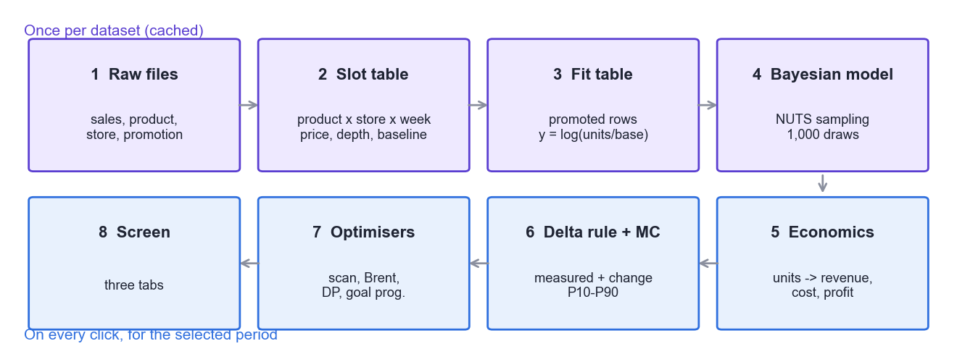
Figure 1. The eight stages. Top row: built once from all history. Bottom row: run on our five weeks at every click.
One important point before we start
The response model (step 4) is learned from all 139 weeks of history (Jan 2024 to Aug 2026, 55,590 promoted product-store-weeks), not just from our five weeks. Your period does not retrain anything. It decides which slots get priced.
Why: five weeks is far too little evidence to learn how discount drives volume. And if the model changed with every filter, the same promotion would get a different answer in two different views.

2.1 Step 1–2: the slot table and the baseline
Each fact row becomes one slot with a few derived columns. For our W40 Baby Wipes slot:
list price = Base_Revenue ÷ units = ₹280 (shelf price before discount)
price paid = Actual_Price = ₹210
depth d = 1 − 210 ÷ 280 = 0.25 (25%)
baseline = Base_Quantity from the file = 151 units
uplift u = 604 ÷ 151 − 1 = 3.00 (300%)
run position: week 1 of a Dussehra run
In plain words
The baseline is the one number nobody can record: what W40 would have sold without Dussehra. This dataset carries it in a column (Base_Quantity), so the studio uses it directly. A client file without it falls back to the average of the nearest 4 ordinary weeks either side for the same product-store.
Every slot has its own baseline, seasonality included. So if a plan moves a promotion from W42 to W43, it lands on W43's baseline, not W42's.
For the technical reader
build_slots() turns the fact table into numpy columns, indexes 2,340 cells (product × store) and 139 chronological weeks, and builds slot_of[cell, week], an O(1) lookup used by every filter and re-plan.
Depth is clipped to [0, 0.95]; a zero-unit slot borrows its cell's units-weighted list price so a promotion moved onto it can still be priced.

2.2 Step 3: the fitting table
Single product-store weeks are noisy, so the model is fitted on totals at product × channel × week × offer. For Baby Wipes in E-commerce, our five weeks contribute these rows (each one sums 10 product-stores):
Week | Offer | Depth | Units | Baseline | Uplift | Target y = log(units ÷ base)
W40 | Dussehra | 25.00% | 5,928 | 1,512 | +292.1% | 1.3663
W41 | regular | 9.79% | 2,368 | 1,231 | +92.4% | 0.6542
W42 | regular | 14.55% | 2,772 | 1,310 | +111.6% | 0.7495
W43 | Diwali | 25.00% | 6,133 | 1,551 | +295.4% | 1.3748
Across all history the full fitting table has 5,172 rows: 3,774 regular-offer rows and 1,398 festival rows. A row that sums more stores gets more weight, because it is less noisy.
For the technical reader
Depth in a fit row is list-value weighted: Σ units·(list − paid) ÷ Σ units·list. Weight w = slots in the row ÷ mean slots per row, and the noise term is Normal(0, σ/√w).

2.3 Step 4: the response model
The model answers one question: "If this product, in this store, ran this offer in that week, how many extra units would it sell?"
log(1 + u) = β1[g]·d + β2[g]·d² + γ[festival] + noise

d = discount depth g = brand × channel group (54 groups)
γ = a festival's extra lift over a regular week at the same depth (0 on a regular week)
In plain words
β1 and β2 shape the curve. β1 is how fast extra sales grow as the discount deepens; a negative β2 makes the curve bend, so each extra point of discount adds a little less.
Pooling. Each brand × channel group has its own curve, but it is pulled towards its brand's curve, and each brand towards the whole business. A group with lots of promotions keeps its own shape; a thin group borrows from its brand. That is the "hierarchical" part.
Festivals shift, they don't bend. Regular offers ran at 5, 10 and 15%, so they teach the shape. Each festival ran at one depth (25%), so it can only teach its own level. With no discount on a regular week, lift is exactly zero.
What the model learned for our group, Baby Wipes × E-commerce (mean and P10–P90 over the 1,000 draws), with the whole business for comparison:
Parameter | Baby Wipes × E-commerce | P10 – P90 | Whole business
β1 (slope) | 6.149 | 5.924 – 6.368 | 3.552
β2 (bend) | −4.292 | −5.388 – −3.164 | 0.243
γ Dussehra Deal | +0.039 (≈ +4.0% extra lift) | 0.030 – 0.048 | —
γ Diwali Special | +0.219 (≈ +24.5% extra lift) | 0.209 – 0.229 | —
σ (noise) | 0.070 | — | —
Baby Wipes in E-commerce responds to discount almost twice as strongly as the average group, with a curve that bends. Diwali is worth about six times as much extra lift as Dussehra.
For the technical reader
Priors: β[g] ~ N(β_brand, s_g); β_brand = β_global + τ·z (non-centred, 9 brands); γ[e] ~ N(μ_fest, s_e); τ, s_g, s_e ~ HalfNormal(0.5); σ ~ HalfNormal(1). In total 141 parameters.
Re-parameterised for sampling: x = d/10% and the basis (x, x² − k·x) with k = Σw·x³/Σw·x², which makes the two coefficients nearly uncorrelated. The Gaussian likelihood uses sufficient statistics (XᵀWX, XᵀWy), so a gradient costs the parameter count, not 5,172 rows.
Sampled with an in-house NUTS (No-U-Turn Sampler; Hoffman & Gelman 2014) with dual-averaging step size and a windowed diagonal mass matrix: 4 chains × 1,000 warm-up × 1,000 draws. Diagnostics: max split R-hat 1.0046, min ESS 676, 0 divergences. 1,000 evenly thinned draws are kept for the Monte Carlo, and the posterior is cached on disk by a hash of the fit table.

2.4 Step 5: from the model to one slot's lift
Here is the model turned into a number, by hand, for our product-store:
15% regular offer:
η = 6.149 × 0.15 − 4.292 × 0.15² = 0.922 − 0.097 = 0.826
u = e^(η + σ²/2) − 1 = e^(0.826 + 0.0025) − 1 = 128.9% (P10–P90 126.2% – 131.7%)

Dussehra at 25%:
η = 6.149 × 0.25 − 4.292 × 0.25² + 0.039 = 1.537 − 0.268 + 0.039 = 1.308
u = e^1.310 − 1 = 270.9%

Diwali at 25%:
η = 1.537 − 0.268 + 0.219 = 1.488
u = e^1.490 − 1 = 343% → capped at 300%, the largest lift anywhere in the data
In plain words
Why add σ²/2? The model works in logs, and e^η is the *typical* (median) lift. The *average* lift is a little higher, and an average is what a total of many slots needs.
Why a cap? The studio never predicts a lift bigger than any it has seen. Diwali at 25% hits that cap, and this matters later in the What-if tab.
In practice this calculation is done once for each of the 1,000 draws, and the answer shown is their average. The spread of the 1,000 answers is the range.
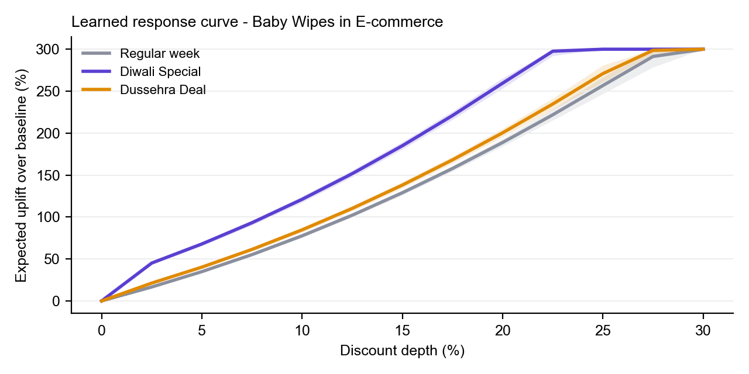
Figure 2. The learned curve for Baby Wipes in E-commerce: regular week, Dussehra and Diwali (shaded = P10–P90). Every curve starts at zero, Diwali sits well above, and all three flatten at the 300% cap.

2.5 Step 6: from lift to rupees (the economics of one slot)
Once the lift is known, every money figure follows from the units. For W40 Dussehra on our Baby Wipes slot:
units = baseline × (1 + u) = 151 × 3.709 = 560.07
revenue = units × list × (1 − d) = 560.07 × 210 = ₹1,17,615
cost of goods = units × unit cost = 560.07 × 126 = ₹70,569
promotion cost = 3.0% × units × list = 0.03 × 560.07 × 280 = ₹4,705
sister-pack = rate × extra units × margin
= 10.47% × 409.07 × (280 − 126) = ₹6,593
profit = 1,17,615 − 70,569 − 4,705 − 6,593 = ₹35,749

Same slot with NO promotion: 151 × 280 − 151 × 126 = ₹23,254
In plain words
3.0% promotion cost is read from the data: total Promotion_Cost ÷ total list value over all promoted slots.
Sister-pack loss is the margin a promotion takes from the same brand's other pack sizes. The 10.47% rate for Baby Wipes is calibrated so that, on history, the studio's promotion profit equals the Insights Hub's Net Incremental Profit. It is the Hub's own figure, not a second estimate.
Week | Offer | Model lift | Model profit | Profit if not promoted | Measured profit
W40 | Dussehra 25% | 270.9% | ₹35,749 | ₹23,254 | ₹45,662
W43 | Diwali 25% | 300.0% (cap) | ₹39,378 | ₹23,870 | ₹46,872
W41/42/44 | none | 0% | = measured | = measured | ₹20,944 / 24,794 / 24,178
The model's profit is lower than the measured one for two reasons. Measured profit does not book the sister-pack loss, and the actual week sold 604 units where the model expected 560. The next step makes sure this gap never leaks into a recommendation.

2.6 Step 7: the delta rule
new figure = measured figure + model(new option) − model(current option) (slot by slot)
In plain words
If nothing changes, the two model terms cancel and you get exactly what happened. W40 stays ₹45,662, to the rupee.
If something changes, only the *difference the model expects* is added. Say W40 had been lucky and sold 10% above expectation. Moving that promotion away loses only its *expected* sales, not its luck. So the optimisers cannot "discover" profit by running away from unlucky weeks or chasing lucky ones.
This also answers a common question: the measured-vs-model gap across our window's promoted slots is ₹2.37 Cr. ₹2.42 Cr of that is the sister-pack loss that measured profit does not book; actual units differ from the model's by only 0.4%.

2.7 Step 8: the Monte Carlo (where every range comes from)
- Price the plan under each of the 1,000 posterior draws (1,000 plausible versions of β1, β2, γ and σ). Each draw gives a slightly different lift, so a slightly different total.
- Add noise for the slots that change: each product × channel × week gets its own random error, sized by the model's σ and by how many stores it sums.
- Apply the delta rule draw by draw: plan_k = measured + model_k(new) − model_k(current) + noise_k.
- Read off P10, P50 and P90, plus the chance of a gain: the share of draws in which profit beats today by more than ₹0.50.
For the technical reader
Every metric is linear in the lift (units = base·(1+u)), so a total over N slots is Σa + Σc·u, and slots sharing a (group, depth, festival) share u. One small matrix product per request then prices all 1,000 draws. Noise variance per group = exp(σ²/(n/n̄)) − 1, signed so revenue and cost move with units. The seed is fixed (4242), so the same plan always shows the same range.

2.8 How we know the model is right
Check | Result | Reading
Time hold-out: train on first 80% of weeks, predict the rest (1,027 rows) | Units WAPE 5.04% | Total predicted units within 5% of actual
Same, on the promotion effect only | Incremental WAPE 12.39% | The harder number; slight over-prediction (+3.7%)
Share of actuals inside P10–P90 | 84.4% | Nominal 80%, so the ranges are honest, slightly wide
Hold out Diwali 2025, refit, predict it | 195.4% actual vs 196.4% predicted | Inside its band
Hold out Dussehra 2025, refit, predict it | 144.4% actual vs 138.9% predicted | 0.2 pts above P90: a festival that grows year on year is slightly under-predicted

3. Tab 1: What-if discount
The question
"If every promotion in my five weeks ran at a different average discount, in the same weeks, what would happen to profit, revenue and ROI?"

3.1 The lever and its limits
Setting | Value | Where it comes from
Opens at (blue ▲) | 21.57% | Today's units-weighted average discount of the window's promoted slots
Data limit (grey line) | 25.45% | The deepest depth anywhere in the data. Beyond it the page warns "Deeper than the data — an estimate".
Slider maximum | 30% | Data limit + 5 points, rounded down to a 0.5 step
Chips | −15 … +15, Reset, Best x% | Move by that many points; jump back to today; jump to the most profitable average

3.2 The algorithm, step by step: move the lever by −5 points
Click −5. The lever goes from 21.57% to 16.57%. The page waits 150 ms for the slider to settle, then calls /api/planner/whatif.
- Shift = 16.57 − 21.57 = −5 points. Every promoted slot moves by the same 5 points and keeps its week and its festival identity: 25% festival offers go to 20%, 15% goes to 10%, 10% goes to 5%.
- Clip at zero. A 5% offer whose measured depth is a shade under 5% (for example 4.98%) goes below zero. It is clipped to 0 and stops being a promotion. Here 80 promotions stop (1,980 → 1,900), and the page shows "Some promotions reach 0% and stop".
- Price every changed slot at its new depth with the model (§2.4–2.5).
- Delta rule (§2.6): measured + model(new) − model(today), slot by slot, then add up.
- Monte Carlo (§2.7) for the ranges and the chance of a gain, and a separate one per week for the weekly chart.
Our Baby Wipes slots under −5:
Week | Offer | Depth | Model units | Model profit: today → new | Change | Result (measured + change)
W40 | Dussehra | 25% → 20% | 560 → 454 | ₹35,749 → ₹35,760 | +₹11 | ₹45,662 → ₹45,673
W43 | Diwali | 25% → 20% | 620 → 557 | ₹39,378 → ₹43,448 | +₹4,070 | ₹46,872 → ₹50,942
In plain words
Dussehra: a 5-point cut loses about 106 units but saves ₹14 of margin on every unit sold. The two almost cancel: +₹11.
Diwali: at 25% the lift was already stuck at the 300% cap. At 20% the model still expects 259.5%, so the cut gives up only 63 units while saving margin on all 557. That makes it +₹4,070: Diwali was being over-discounted.

3.3 The comparison table the page shows
Row | Baseline (none) | Current plan | Scenario −5 | Change | Range P10–P90
Profit | ₹57.58 Cr | ₹61.60 Cr | ₹62.10 Cr | +₹49.80 L | ₹61.86 – 62.37 Cr
Profit % | 122.22% | 92.67% | 93.42% | +0.75 pts | 93.06 – 93.82%
Gross margin | 55.00% | 49.73% | 51.40% | +1.67 pts | 51.35 – 51.44%
Trade spend | ₹0 | ₹17.09 Cr | ₹11.53 Cr | −₹5.57 Cr | ₹11.31 – 11.76 Cr
Incremental sales | ₹0 | ₹29.25 Cr | ₹22.44 Cr | −₹6.81 Cr | ₹21.71 – 23.26 Cr
ROI | — | 1.71x | 1.95x | +0.24 | 1.92 – 1.98x
Revenue | ₹104.69 Cr | ₹128.08 Cr | ₹122.83 Cr | −₹5.25 Cr | ₹122.10 – 123.65 Cr
Units | 32,77,206 | 41,77,694 | 39,18,390 | −2,59,304
Average discount | — | 21.57% | 17.42% | −4.15 pts | exact
Promotions | 0 | 1,980 | 1,900 | −80 | exact
At a glance panel: Profit change +₹49.80 L · Likely +₹25.54 L to +₹76.24 L · Chance profit rises 99.5%.
Why the average discount reads 17.42%, not the 16.57% you set
The lever sets the shift; the table reports what results. The average is units-weighted, and units change with the discount. The 80 promotions clipped to 0% also drop out of the average. Average discount and Promotions are decisions, not outcomes, so every draw sees the same value: they show "exact" instead of a range.
Profit % in a scenario is divided by today's cost (₹66.48 Cr), not the scenario's own. Otherwise a plan could "improve" Profit % just by selling fewer units, because a smaller cost raises the ratio. Holding cost fixed means more profit always reads as a higher Profit %.

3.4 How the range and the chance are made
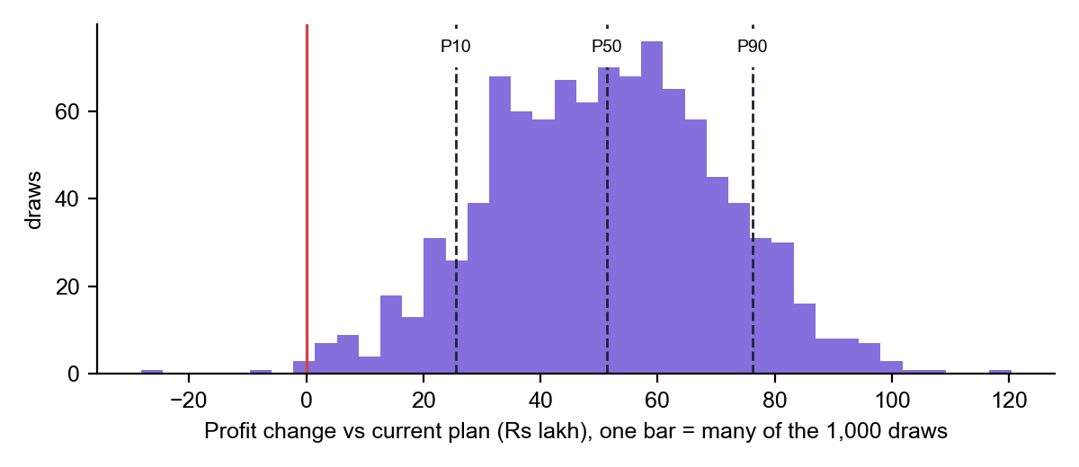
Figure 3. The 1,000 Monte Carlo outcomes for the −5 scenario. P10 = +₹25.5 L, P50 = +₹51.3 L, P90 = +₹76.2 L. Only 5 of 1,000 draws fall left of the red zero line, so the chance profit rises is 99.5%.

3.5 The "Week by week" chart: how it is built
- Current plan line: the measured profit of each week, added up from the fact rows.
- Scenario line: current + the model's change for that week only (model(new) − model(today) over that week's changed slots).
- Dashed P10/P90 lines: a Monte Carlo per week. Each week draws its own noise, so the weeks are independent.
- Shading: a festival's own week (its offer in at least half as many product-stores as at its peak).
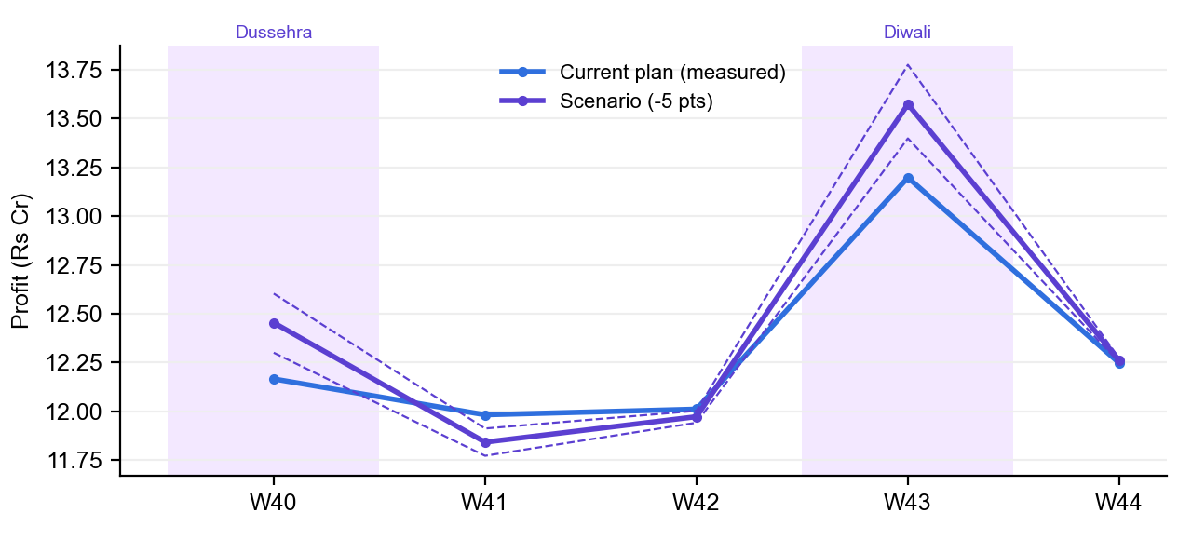
Figure 4. Week by week for the −5 scenario. The gain sits almost entirely in the two festival weeks. The ordinary weeks lose a little, because cutting 10% and 15% offers costs more units there than it saves.
Week | Festival | Profit today | Scenario | Scenario P10–P90 | Promoted: today → plan
W40 | Dussehra | ₹12.17 Cr | ₹12.45 Cr | ₹12.30 – 12.60 Cr | 625 → 625
W41 | — | ₹11.98 Cr | ₹11.84 Cr | ₹11.77 – 11.91 Cr | 545 → 495
W42 | — | ₹12.01 Cr | ₹11.97 Cr | ₹11.94 – 12.00 Cr | 545 → 495
W43 | Diwali | ₹13.20 Cr | ₹13.57 Cr | ₹13.40 – 13.78 Cr | 545 → 525
W44 | — | ₹12.25 Cr | ₹12.26 Cr | ₹12.25 – 12.27 Cr | 140 → 120
Measure toggle: Profit, Revenue, or Profit change (scenario − current, against a zero line). The weekly scenario values add up to the window total.

3.6 The "Every discount level" curve: from data to chart
This chart is the What-if algorithm run 61 times, once for every average discount from 0% to 30% in 0.5-point steps, each with the full 1,000-draw Monte Carlo. It is computed once per selection (about 3 seconds) and cached, so dragging the slider only moves a dot along it.
- For d = 0.0, 0.5, 1.0 … 30.0: shift every promotion by (d − 21.57) points, clip, price, apply the delta rule (§3.2).
- Store the posterior-mean profit and revenue (the violet line) and their P10/P90 (the shading).
- Best = the point with the highest median profit, searching only up to the data limit (25.45%). Optimisation never leaves the data, although a what-if may.
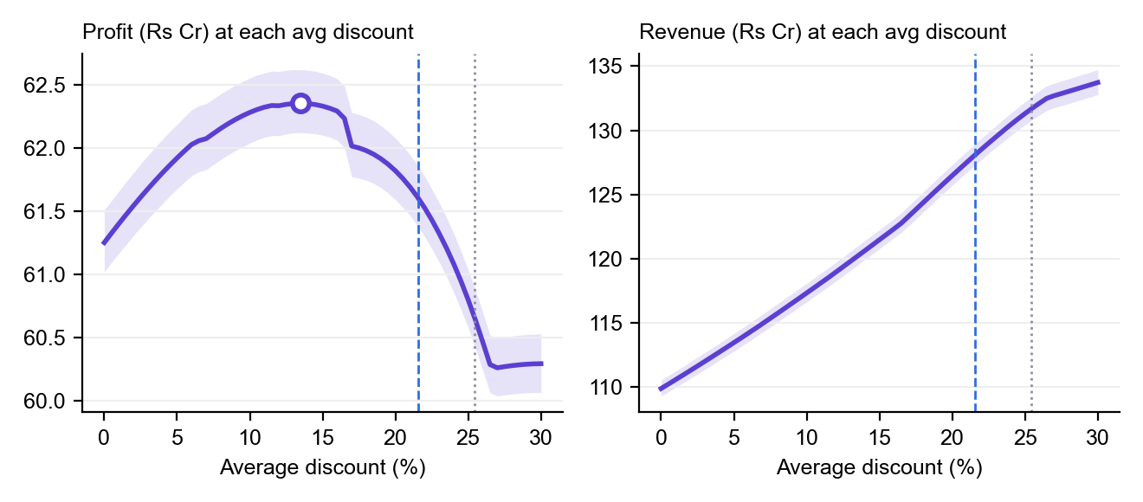
Figure 5. Profit and revenue at every average discount for our window. Blue dashed = today (21.57%), grey dotted = data limit (25.45%), ring = most profitable (13.5%).
Avg discount | Profit | Profit P10–P90 | Revenue | ROI | Note
0% | ₹61.25 Cr | ₹61.02 – 61.51 Cr | ₹109.87 Cr | 3.44x | see box below
5% | ₹61.92 Cr | ₹61.68 – 62.19 Cr | ₹113.45 Cr | 2.87x
10% | ₹62.28 Cr | ₹62.04 – 62.56 Cr | ₹117.32 Cr | 2.41x
13.5% | ₹62.36 Cr | ₹62.12 – 62.62 Cr | ₹120.20 Cr | 2.16x | Best
15% | ₹62.33 Cr | ₹62.10 – 62.60 Cr | ₹121.47 Cr | 2.07x
20% | ₹61.82 Cr | ₹61.59 – 62.08 Cr | ₹126.47 Cr | 1.78x
21.5% | ₹61.62 Cr | ₹61.39 – 61.87 Cr | ₹128.01 Cr | 1.71x | ≈ today
25% | ₹60.80 Cr | ₹60.58 – 61.03 Cr | ₹131.31 Cr | 1.56x
27.5% | ₹60.27 Cr | ₹60.05 – 60.50 Cr | ₹132.87 Cr | 1.49x | beyond data
Reading it: revenue keeps climbing as the discount deepens, but profit peaks at 13.5% and falls after. A deeper discount buys extra units, but it gives margin away on all the units that would have sold anyway. That is why revenue alone is the wrong objective. Moving to 13.5% earns +₹75.09 L (range +₹51.85 L to +₹1.02 Cr, positive in 99.9% of draws), with revenue −₹7.88 Cr and ROI 2.16x.
Why the curve has kinks and flat parts
Drop near 16.5%: the shift reaches −5.02 points, every 5% offer hits 0% and stops, and its lift, cost and discount vanish together. The same happens near 11.5% (10% offers stop) and 6.5% (15% offers stop).
Flat beyond about 26.5%: festival offers pushed past 25% are already at the 300% lift cap, so more discount adds no units, only cost.
The 0% end is not "no promotion". Every promotion moves by the same 21.57 points, so a 25% festival offer still runs at about 3.4%. 1,020 promotions remain, and the average discount reads 3.46%. The true no-promotion figure is the Baseline column (₹57.58 Cr).

3.7 The opposite move, +5 points
 | Current plan | Scenario +5 (26.57%) | Change
Profit | ₹61.60 Cr | ₹60.26 Cr | −₹1.34 Cr (range −₹1.57 to −₹1.11 Cr)
Revenue | ₹128.08 Cr | ₹132.54 Cr | +₹4.46 Cr
ROI | 1.71x | 1.49x | −0.22
Chance profit rises |  |  | 0%
Deeper discounting buys ₹4.46 Cr of revenue and costs ₹1.34 Cr of profit, and not one of the 1,000 draws disagrees. Festival slots are past the lift cap and gain no units.
+ Decision Center (shown once the lever has moved) snapshots the scenario's display figures into the Decision Center, which holds up to three.

4. Tab 2: Profit target
The question
"I want Profit % to rise by X points. What is the smallest change to the calendar that gets there? And if it can't be done, what is the most that can?"

4.1 Turning "+1 point" into rupees
CP (today) = ₹66.48 Cr Profit % today = 92.67%
needed = 1% × CP = ₹66.48 L
goal profit = 61.60 Cr + 66.48 L = ₹62.27 Cr → target Profit % 93.67%
In plain words
Cost is held at today's value. "+1 point" therefore means a fixed amount of extra profit (₹66.48 L), and a plan cannot hit the target simply by selling less.

4.2 The answer the page shows: re-plan the fewest product-stores
- For every product-store, find its best calendar under the chosen rules (Flexible / Same count by default). This is exactly the Best plan optimiser, explained step by step in Section 5. It gives each product-store a known gain: best calendar − today's calendar.
- Goal programme. Priority 1: minimise the shortfall s in Σ gain·x + s ≥ needed. Priority 2: at that shortfall, use the fewest product-stores. Product-stores share no constraint, so the exact answer is to take the largest gains first until they cover the need.
- Price the chosen product-stores' new calendars by the delta rule and run the Monte Carlo, now also counting the share of draws that reach the target.
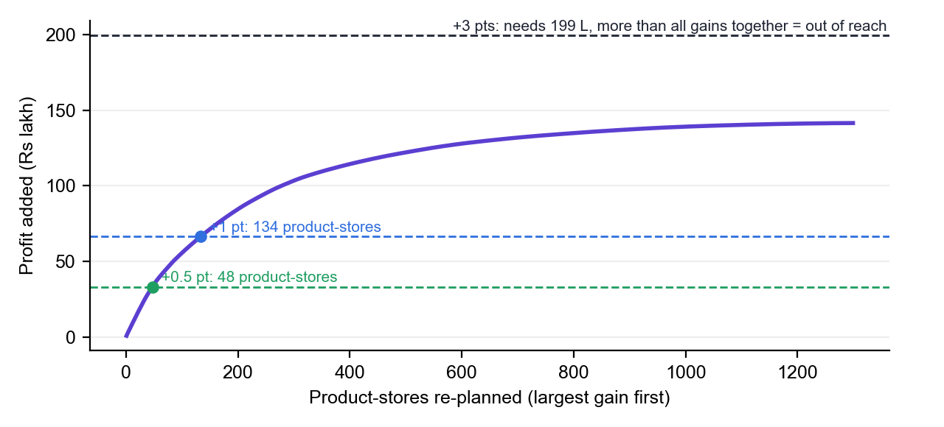
Figure 6. The goal programme for our window. The curve adds up the product-store gains, largest first. A target is reached where the curve crosses its line: +0.5 pt needs 48 product-stores and +1 pt needs 134. +3 pts sits above everything that can be gained.
Target | Needed | Verdict | Product-stores changed | Profit added P10–P90 | Chance of hitting it
+0.25 pt | ₹16.62 L | Reachable | 22 of 1,755 | +₹12.84 – 21.11 L | 55.1%
+0.5 pt | ₹33.24 L | Reachable | 48 of 1,755 | +₹23.27 – 45.11 L | 55.0%
+1 pt | ₹66.48 L | Reachable | 134 of 1,755 | +₹53.68 – 80.88 L | 53.3%
+3 pts | ₹1.99 Cr | Out of reach | all 1,299 that gain | +₹1.21 – 1.63 Cr | 0%
In plain words
Why only about 53%? The programme picks the fewest changes whose *expected* gain just covers the target. By construction it lands on the target, so about half the simulated outcomes fall either side. If you need more confidence, ask for a slightly higher target, or relax a rule to build headroom.
What the page shows for +1 pt: a verdict card ("Growing Profit % by +1% is reachable"), four tiles (Profit % now 92.67%, Target 93.67%, Profit needed ₹66.48 L, Most reachable +2.13 pts), a bar showing that the target uses about half of what is reachable, and the re-plan card with its table and timelines.

4.3 When the target is out of reach: +3 points
- Needed ₹1.99 Cr, but every product-store at its best calendar adds only ₹1.42 Cr (+2.13 pts). Shortfall: ₹57.89 L.
- Diagnose the blocker: re-run the optimiser with each rule relaxed in turn. "Allow dropping promotions that lose money" reaches +2.36 pts. "Allow more promotions per product-store" also reaches +2.36 pts.
- Neither reaches +3, so the page names the limit: "The response itself: no offer the data supports earns more on these product-stores."

4.4 The other answer (computed, not shown): one discount for everything
The API also answers the target with a single uniform discount, using the curve from §3.6:
- Find the first grid point (shallowest discount) whose profit reaches the goal. For +1 pt that is 10% (₹62.28 Cr against a goal of ₹62.27 Cr); 7.5% gives only ₹62.12 Cr.
- Between that grid point and the one before it (9.5%), solve profit(d) = goal exactly with Brent's method (scipy brentq, tolerance 0.0001 pt). Each trial is a full delta-rule pricing. Answer: 10.00% (−11.57 pts). The shallowest is chosen because it gives the least discount away.
- Per draw, read where that draw's profit curve crosses the goal: the required discount is 5.28%–10.83%, and 67.8% of draws reach the goal at some depth.
For +3 pts no single discount gets there. The best is 13.5% (+1.13 pts), and the blocker reads "Profit peaks at a 13.50% average discount…". The page displays the re-plan answer; the What-if tab's Best chip shows the same single-discount calculation.

5. Tab 3: Best plan
The question
"Under these rules, which offer in which week for every product-store earns the most profit?"

5.1 The planning rules, read from the data
Nothing is typed in by hand. Each channel's rules are learned from its own history:
Channel | Books by |  | Min gap | Max share | Offer menu
E-commerce, General Trade, Travel & Hospitality, Q-Commerce | week |  | 2 weeks | 23–25% | 5%, 10%, 15% (measured 5.02, 10.03, 14.98%)
Modern Trade, B2B | month |  | 1 month | 31–34% | 5%, 10%, 15%
Festival offers (all channels) | — |  | — | — | Only in a period where that festival actually ran in the channel. Here: Dussehra in W40, Diwali in W43 (for weekly channels).
Books by |  | Median promotion run of 3+ weeks → the channel books whole months; otherwise weeks
Min gap |  | The smallest gap seen between two promotions on one product-store
Max share |  | 90th percentile of "share of periods promoted" across the channel's product-stores. Used only by "Allow more".
Evidence |  | A product-store the data has never seen promoted is never promoted. In our window, 585 product-stores are frozen and 1,755 are eligible.

5.2 Step A: a gain table for each product-store
For every period and every offer on the menu, price the product-store with the economics of §2.5:
gain[offer, week] = profit(slot with that offer) − profit(same slot with no promotion)
Example 1: our Baby Wipes at Flipkart Hyderabad (rupees per week):
Offer | W40 | W41 | W42 | W43 | W44
5% Discount | 2,716 | 2,446 | 2,896 | 2,788 | 2,824
10% Discount | 6,422 | 5,784 | 6,847 | 6,592 | 6,677
15% Discount | 9,411 | 8,476 | 10,034 | 9,660 | 9,784
Dussehra Deal 25 | 12,493 | — not allowed | — | — | —
Diwali Special 25 | — | — | — | 15,513 | —
Best in the week | Dussehra 12,493 | 15%: 8,476 | 15%: 10,034 | Diwali 15,513 | 15%: 9,784
In plain words
Gains differ by week because each week has its own baseline (W42 sells more than W41 anyway). A festival offer is "−∞" (not allowed) outside its own week.

5.3 Step B: dynamic programming over the weeks
Today this product-store runs 2 promotions (K = 2), and E-commerce needs a 2-week gap between them. The Same count rule requires exactly 2. The question becomes: which 2 weeks, at least 2 empty weeks apart, give the largest total gain?
F[p][k] = best total using the first p weeks with exactly k promotions

F[p][k] = max( F[p−1][k] ← skip week p
F[p−1−gap][k−1] + best[p] ) ← promote week p (last one ≥ gap weeks earlier)
After week | k = 0 | k = 1 | k = 2
start | 0 | — | —
W40 | 0 | 12,493 (take Dussehra) | —
W41 | 0 | 12,493 (skip: 8,476 is less) | — (no room for 2)
W42 | 0 | 12,493 | — (W40 + W42 breaks the gap)
W43 | 0 | 15,513 (take Diwali alone) | 28,006 (W40 Dussehra + W43 Diwali)
W44 | 0 | 15,513 | 28,006 (W40 + W44 = 22,277 is less)
Answer: F[W44][2] = ₹28,006. Tracing the "take" decisions back gives Dussehra in W40 and Diwali in W43, which is exactly today's calendar. The new calendar does not beat today's by more than ₹1, so this product-store is left unchanged. Today's plan was already optimal.
In plain words
The 2-week gap is what makes this pairing possible. After promoting W40, the earliest next promotion is W43, and W43 happens to be Diwali, the most valuable week of all.

5.4 Example 2: a product-store that does change
Complete Manual Toothbrush Soft 2 ct at Amazon, Chennai (store S217, E-commerce) runs one promotion today: 15% off in W42, worth ₹379 over not promoting. Its gain table:
Offer | W40 | W41 | W42 | W43 | W44
5% Discount | −123 | −117 | −123 | −127 | −121
10% Discount | 131 | 124 | 131 | 135 | 129
15% Discount | 401 | 382 | 401 (today) | 417 | 398
Dussehra Deal 25 | 1,117 | — | — | — | —
Diwali Special 25 | — | — | — | 2,594 | —
With K = 1 the DP simply picks the single best cell: Diwali in W43, ₹2,594. The gain is +₹2,215, so the page shows the action "Moved: W42 → W43 · 15% Discount → Diwali Special 25". (Today's 15% is worth ₹379 in the model on its actual depth; the menu's 15% is priced at the channel's measured 14.98%.)
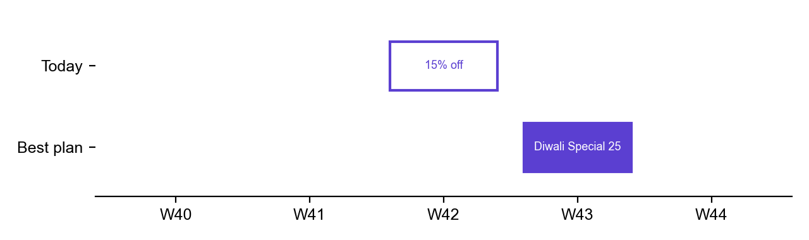
Figure 7. The timeline that opens when you click this row: today's promotion on the top lane (outlined), the proposed one below (filled).

5.5 Step C: every product-store, then the totals
- Run Steps A and B for every eligible product-store, vectorised per channel (under a second for all 2,340).
- Keep a new calendar only if it beats today's by more than ₹1.
- Apply all kept calendars with the delta rule and run the Monte Carlo.
- Pair what changed into actions per product-store: Moved (left one week, arrived in another), Re-priced (same week, different offer), Dropped / Added (only when the count rule allows).
Best plan, Flexible + Same count | Current plan | Best plan | Change
Profit | ₹61.60 Cr | ₹63.02 Cr | +₹1.42 Cr (P10–P90 +₹1.21 to +₹1.63 Cr)
Profit % | 92.67% | 94.80% | +2.13 pts
Revenue | ₹128.08 Cr | ₹133.36 Cr | +₹5.28 Cr
ROI | 1.71x | 1.81x | +0.10
Average discount | 21.57% | 22.66% | +1.09 pts
Promotions | 1,980 | 1,980 | same count
Chance of a gain |  |  | 100% of draws
Impact tiles: 1,299 of 2,340 product-stores change. 1,008 promotions move week, 1,204 get a new discount, and 867 do both. Nothing is stopped or added, because the count stays the same.
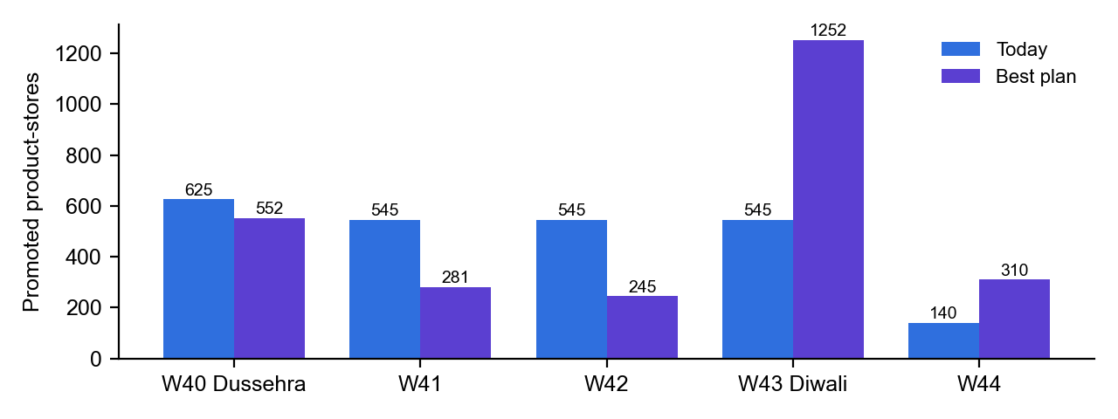
Figure 8. Where the Best plan puts promotions: W43 (Diwali) goes from 545 to 1,252 promoted product-stores, pulled mostly out of W41 and W42.
Largest changes (top of the table) | Store | Gain | Action
Cruisers Diapers Size 4 98 ct | GT172, Bhopal | ₹87.31 K | Moved W41 → W43: 5% Discount → Diwali Special 25
Cruisers Diapers Size 4 98 ct | GT171, Bhopal | ₹85.90 K | Same move
Cruisers Diapers Size 4 98 ct | GT051, Chandigarh | ₹79.85 K | Same move
Outdoor Fresh Dryer Sheets 160 ct | GT173, Bhopal | ₹77.35 K | Same move
In plain words
The pattern is the model's Diwali effect (+24.5% extra lift) at work: a promotion in an ordinary week earns more if it moves into Diwali week, as long as the gap rule allows it.

5.6 How the two rule toggles change the answer
Timing / count | Profit gain | Profit % | Product-stores | Moved | Re-priced | Dropped | Promotions after
Flexible / Same | +₹1.42 Cr | +2.13 pts | 1,299 | 1,008 | 337 | 0 | 1,980
Flexible / Fewer | +₹1.57 Cr | +2.36 pts | 1,314 | 756 | 83 | 565 | 1,415
Flexible / More | +₹1.57 Cr | +2.36 pts | 1,314 | 756 | 83 | 565 | 1,415
Fixed / Same | +₹66.90 L | +1.01 pts | 990 | 0 | 1,035 | 0 | 1,980
Fixed / Fewer | +₹91.94 L | +1.38 pts | 1,065 | 0 | 440 | 715 | 1,265
Fixed / More | +₹91.94 L | +1.38 pts | 1,065 | 0 | 440 | 715 | 1,265
- Flexible vs Fixed: letting promotions change week more than doubles the gain (₹1.42 Cr vs ₹66.90 L). In a window with Diwali in it, *timing* matters a lot.
- Allow fewer: 565 promotions earn less than not promoting at all. Dropping them adds about ₹15 L more.
- Allow more = Allow fewer here: with a 2-week gap and a 25% maximum share, a five-week window has no room for an extra promotion on any product-store.
- Fixed + More cannot add promotions (they would need new weeks), so it equals Fixed + Fewer.

5.7 Why the What-if says "cut" and the Best plan says "deeper"
The What-if's best single discount is 13.5% (+₹75 L). The Best plan raises the average discount to 22.66% (+₹1.42 Cr). They answer different questions:
- The What-if moves every promotion by the same points in the same weeks. The over-discounted festival slots dominate, so the overall answer is "cut".
- The Best plan chooses offer and week per product-store. It moves ordinary-week promotions into Diwali, where a 25% offer pays far better, so more of the plan runs at 25% and the average rises.
Both are right. The plan is worth almost twice as much because it uses timing, not just depth.

6. The whole example on one page
Tab | Algorithm | Answer for 29 Sep – 2 Nov 2025
All tabs | Measured current plan; no-promotion baseline (model at depth 0) | Today: profit ₹61.60 Cr, ROI 1.71x, average discount 21.57%. Without promotions: ₹57.58 Cr.
What-if −5 pts | Uniform shift → delta rule → 1,000-draw Monte Carlo | +₹49.80 L profit, −₹5.25 Cr revenue, ROI 1.95x, 99.5% chance of a gain. Driven by Diwali being past the lift cap.
What-if curve | 61-point scan, best = highest median profit within data | Best average discount 13.5%: +₹75.09 L. Revenue keeps rising, profit does not.
Profit target +1 pt | Per-product-store DP → goal programme (largest gains first) → Monte Carlo | Needs ₹66.48 L. Re-plan 134 of 1,755 product-stores; 53.3% chance of hitting it. +3 pts is out of reach (max +2.13 pts).
Best plan | Channel rules from data → gain table → exact DP per product-store → delta rule | +₹1.42 Cr (+2.13 pts), 100% chance. 1,299 product-stores change, mostly moving into Diwali week.

Limits worth knowing
- The model learns from all history; your period only selects the slots it prices.
- Same-week effect only: there is no post-promotion dip, pull-forward or competitor response.
- The lift is capped at the largest seen in the data (300%), which is why deep festival offers stop gaining units.
- Sister-pack loss is a brand-level average rate, calibrated to the Insights Hub.
- Festival commitment is off by default (TPO_COMMIT_FESTIVALS=0), so the Best plan may drop or move a festival offer that is contractually committed. Turn it on for clients with joint business plans.
- One level per festival: a festival that grows year on year is slightly under-predicted (Dussehra 2025 landed 0.2 pts above P90).
- The re-plan works within the selected period and within each product-store. Moving budget between products is the MMM Budget Optimizer's job.

Where this lives in the code
File | Responsibility
backend/app/tpo/planner_model.py | Slot table, baseline, fit table, hierarchical model, lift, validation, disk cache
backend/app/tpo/nuts.py | No-U-Turn Sampler, adaptation, R-hat, ESS
backend/app/tpo/planner.py | Selection, economics, delta rule, Monte Carlo, what-if, curve, Brent target, channel rules, calendar DP, goal programme
backend/app/routers/planner.py | The six /api/planner/* endpoints (options, summary, whatif, curve, target, best)
frontend/src/pages/PromotionPlanner.tsx | The page. It formats what the API returns and computes nothing itself.

