TRANSORG ANALYTICS
Trade Promotion Optimization
What's new since the demo video

The demo video showed the idea — five screens and a story. The product has those same five screens, and underneath them it now does real work. Here is what was added, how the interface improved, and what the platform can actually do.
1. New features
Things the product does that the video could not.
- Load your own data. Upload your sales, product and store files. The platform reads them and maps the columns for you.
- Ask in plain English. Type a question about a promotion and get an answer back, not just another chart.
- Automatic alerts. Every promotion falling short of its target is flagged for you — you don't have to go looking.
- Plan before you spend. Test a change to a promotion and see the effect before any money is committed.
- Set a target. Tell it the profit you want and it finds the discount that gets there.
- Compare scenarios. Put plans side by side and pick the one you want to take forward.
- Rupees or dollars. Switch currency with one click, anywhere in the product.
- Any time period. Not a fixed quarter — choose whatever window you need.
- Export. Take any view out as a report to share.
2. Interface improvements
How it looks and feels to use.
- One consistent design. Same fonts, colours, buttons and spacing across all five modules, so it feels like one product.
- More room for the data. The side menu collapses to icons when you want the charts to breathe.
- Dark mode. One toggle, respected across every screen.
- Every figure explains itself. Hover the small info mark beside any number or chart to see exactly how it is worked out.
- Clean charts. No shading, gradients or decoration competing with the data.
- Helpful empty screens. Instead of a blank page, each screen tells you what to do next and gives you a way to start.
- The same controls everywhere. Filters sit in the same place and behave the same way on every screen.
- Works on a smaller screen. The layout adapts rather than breaking.
3. What it can do now
The thinking that happens behind the screens.
- It works out a baseline. What would have sold anyway, without the promotion — so “incremental” finally means something.
- A team of specialists, not one view. Several agents each examine a different angle, then their findings are weighed into a single answer with a confidence score.
- It spots cannibalization. When a promoted product quietly steals sales from your own neighbouring products.
- It ranks the causes. Each root cause is shown with how much of the problem it explains, so you know what to fix first.
- It recommends actions. Not just what went wrong, but what to do about it.
- It handles the whole history. The full book of promotions, not a sample.
- The simulation is modelled, not guessed. It learns how discount drives volume from your own data, so the forecast reflects your business.

In one line
The video showed what TPO would look like. This is TPO working — on the client's own data, answering the client's own questions.
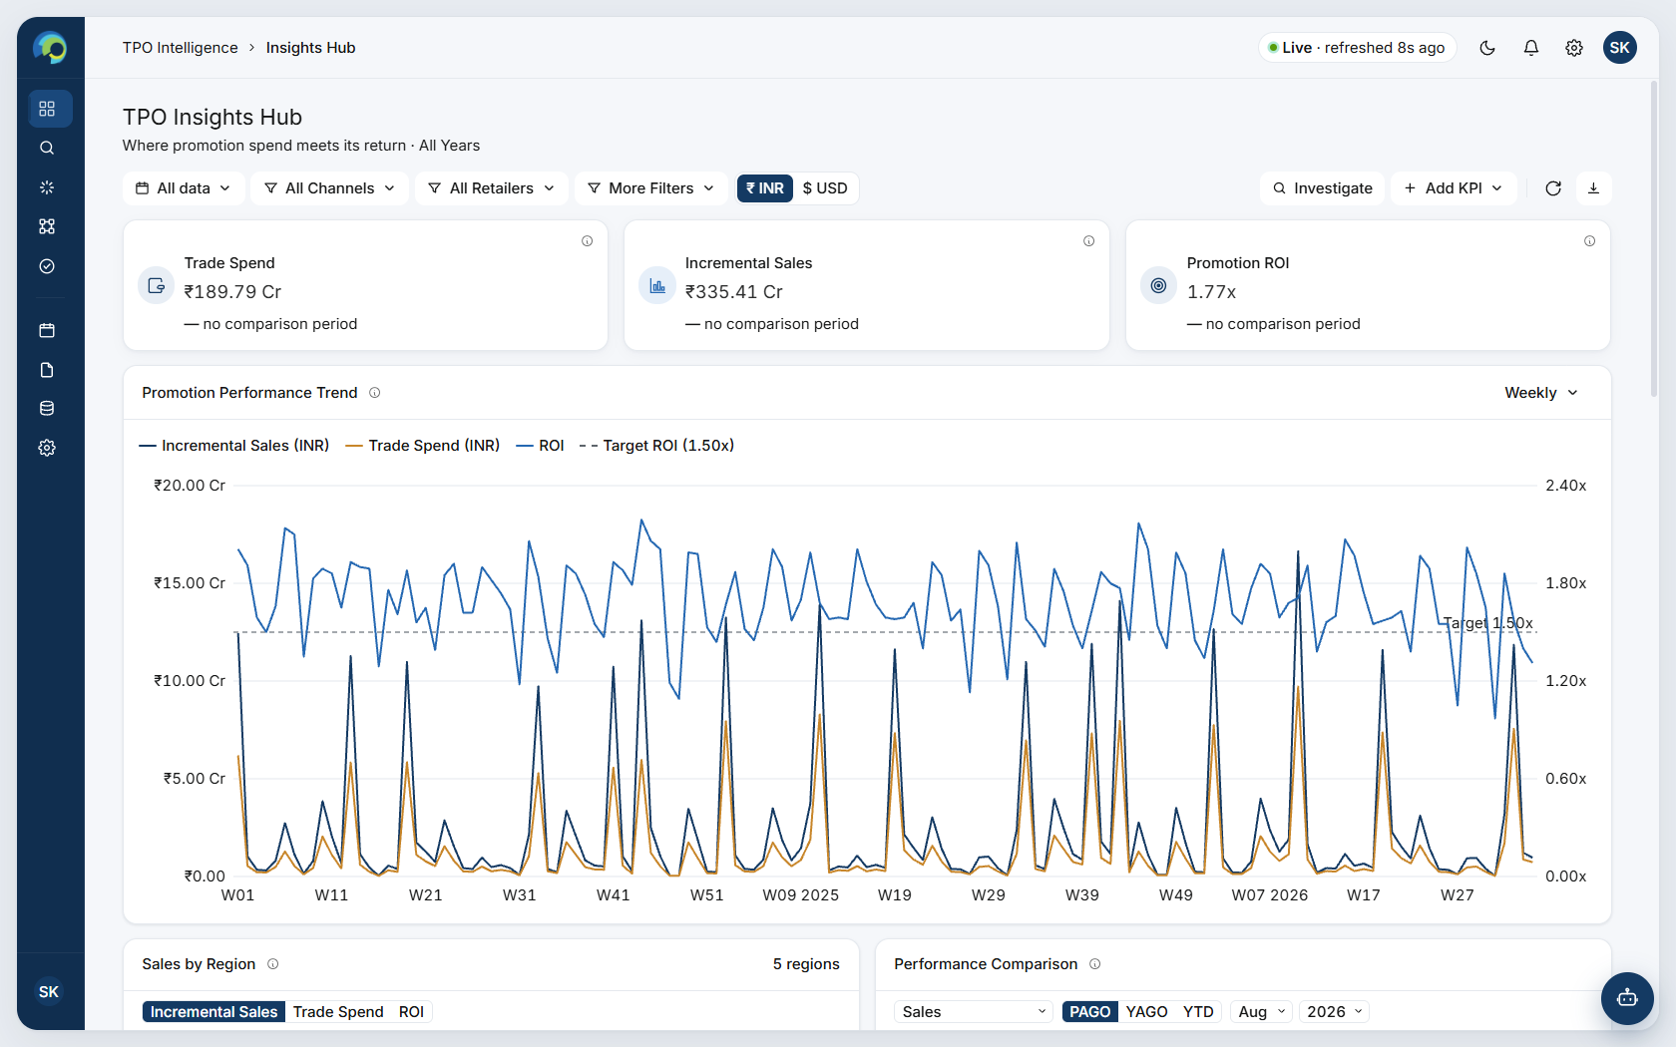
The product today, running on a client dataset.

