Project Name: **Toy Store E-commerce Application**

**Description**:

The toy store e-commerce application's database is designed to efficiently manage various aspects of the platform. It includes tables for customers, products, carts, orders, order details, payment methods, Wishlist, employees, and administrators. The Customer table stores user credentials and registration details, allowing seamless access to the platform. Product information, such as name, description, price, category, and age range, is stored in the Product table, facilitating organized browsing and shopping experiences. The Cart table tracks items added by customers for purchase, while the Order table records customer orders, including details like total amount, status, and payment methods. Order details are stored separately in the Order Detail table, capturing individual items within each order along with their quantities and prices.

Additionally, the database manages payment methods through the Payment Method table, enabling customers to securely store and reuse their preferred payment options. Wishlist, stored in the Wishlist table, allow customers to create lists of desired items for events, enhancing gift-giving experiences. Employee information, including usernames, emails, passwords, and roles, is stored in the Employee table, while administrators overseeing the platform are managed through the admin table. By efficiently organizing and storing data related to users, products, orders, payments, Wishlist, and staff, the database ensures smooth operation and enhanced user experiences within the toy store e-commerce application.

**Business Rules:**

1. Guest Browsing: Users can freely browse available toys without needing to create an account or log in. They can view product details, images, descriptions, and prices.
2. Login Prompt on Cart Addition: Users attempting to add items to their cart are prompted to log in if they haven't already done so. They are redirected to the login page to either log in or register as a new user.
3. User Authentication: Users can log in using their username or email and password. New users can register for an account, while existing users can log in using their credentials. Password reset functionality is available via email.
4. Product Management: Only administrators can add, edit, or delete products from the inventory. Products must include essential details such as name, description, price, category, and age range.
5. Cart Operations: Customers can add products to their carts for later purchase. The quantity of each item in the cart must be greater than zero.
6. Order Placement: Customers can place orders containing items from their carts. Orders must have a valid payment method and shipping address. The total amount of the order must be calculated accurately.
7. Order Processing: Employees are responsible for processing orders. Each order must be assigned to an employee for fulfillment. Orders must transition through different statuses, such as "pending," "processing," "shipped," and "delivered."
8. Payment Methods: Customers can save their payment methods for future use. Saved payment methods must be securely stored and accessible only to the respective customer.
9. Wishlist Management: Customers can create wishlists for special events, such as birthdays or holidays. Each wishlist must have a unique name and event date. Customers can add or remove products from their wishlists.
10. Employee Management: Administrators can manage employee accounts, including creating new accounts, updating information, and assigning roles and permissions. Employee usernames and emails must be unique.

**Database Tables Description**

|  |  |
| --- | --- |
| Table | Description |
| Customer | Stores information about registered users, including their username, email, password, and timestamps for creation and updates. |
| Products | Contains details of products available in the store, such as name, description, price, category, age range, availability, and timestamps for creation and updates |
| Cart | Tracks items added to the shopping cart by customers, including the customer ID, product ID, quantity, and timestamp of addition. |
| Wishlist | Tracks wishlists created by customers for events, storing the wishlist ID, customer ID, event name, event date, product IDs array, and timestamps for creation and updatesPayment |
| Order | Records details of customer orders, including the customer ID, total amount, status, order date, payment method ID, employee ID, and order ID. |
| Order Details | Stores individual items within each order, including the order detail ID, order ID, customer ID, product ID, quantity, and unit price. |
| Payment_method | Manages payment methods associated with each customer, storing the customer ID, payment method ID, method name, and a flag indicating if the method is saved for future use. |
| Employee | Stores information about employees involved in managing the store, including their username, email, password, role, and timestamps for creation and updates. |
| admin | Contains details of administrators overseeing the platform, including their username, email, password, and timestamps for creation and updates. |

**Database Model**

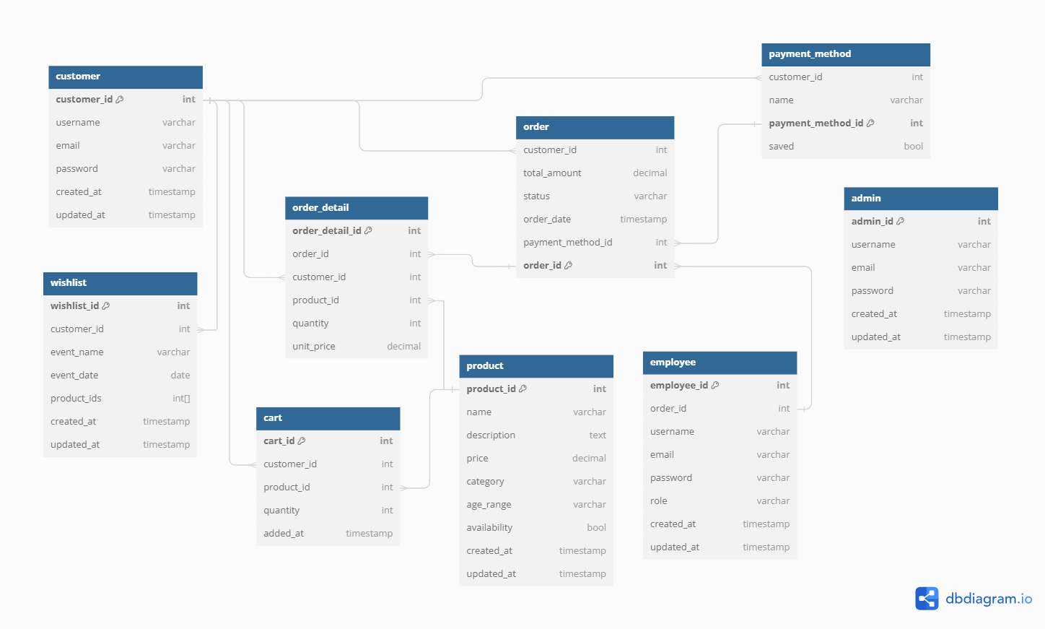

**Sample Data:**

