Shiva Sai Thakur
2303A54025
Batch 48
AI Assisted Coding
ASS NO – 6.3
Task Description #1: Classes (Student Class)
Task : Use an AI tool (GitHub Copilot / Cursor AI / Gemini) to complete a Student class.
Expected Output #1
• A Python class with a constructor (__init__) and a display_details() method.
• Sample object creation and output displayed on the console.
• Brief analysis of AI-generated code
Prompt:
Create a simple Python program that defines a Student class with details like name, roll number, and branch. Add a method to display the student’s details and show how the class works by creating sample student objects.
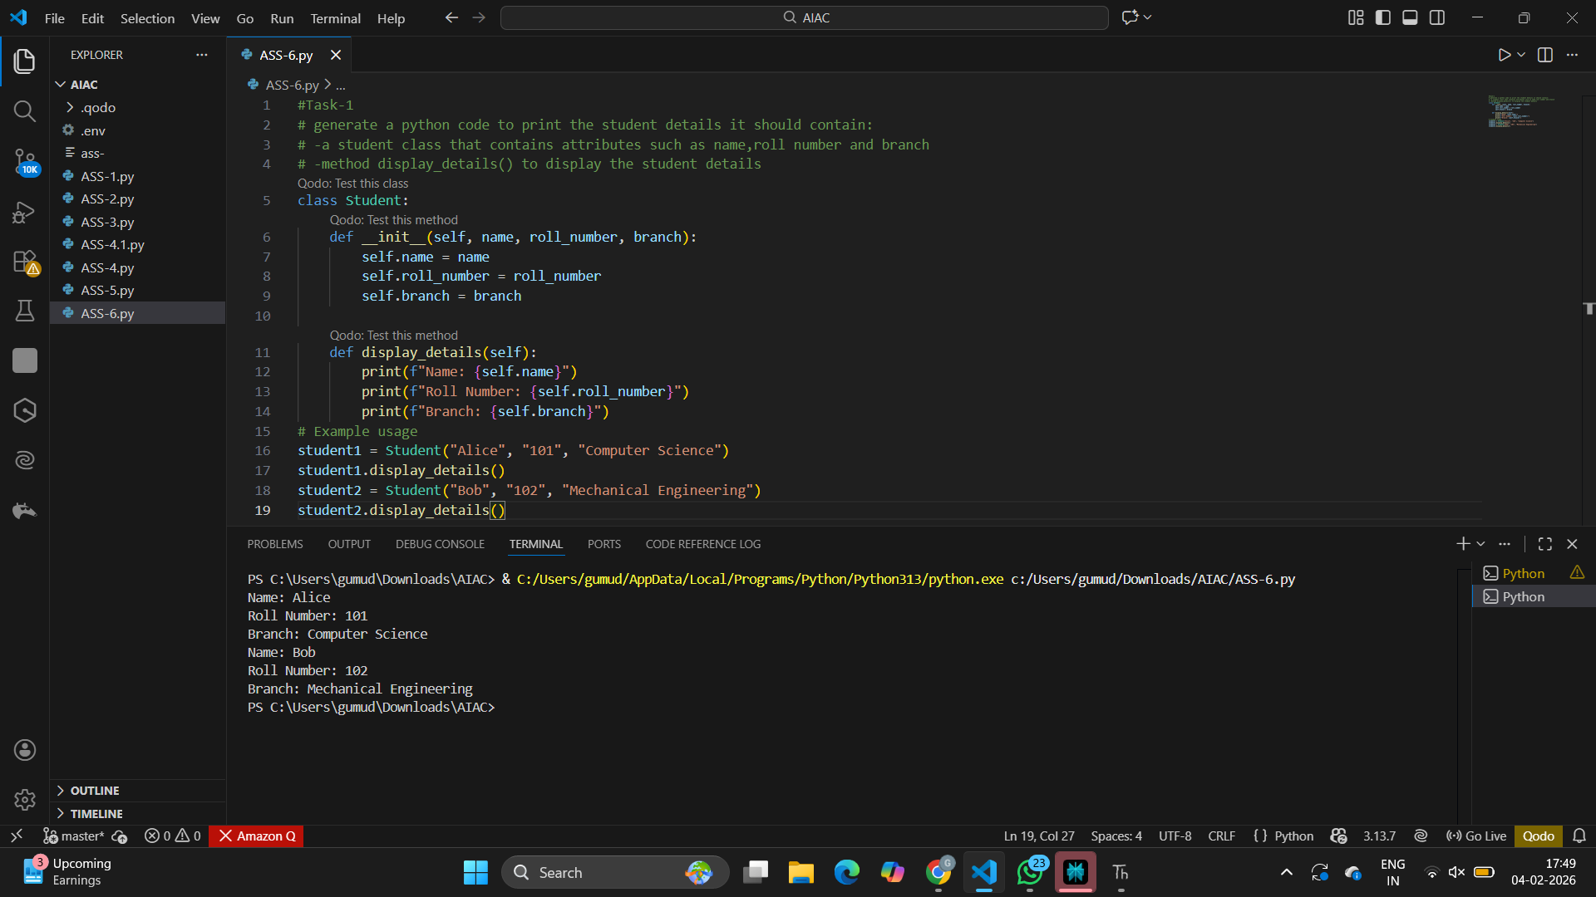
EXPLANATION: The code defines a Student class with attributes for name, roll number, and branch. It includes a method display_details() that prints the student's details. Two instances of the Student class are created to demonstrate its functionality.
Task Description #2: Loops (Multiples of a Number)
Task:Prompt the AI tool to generate a function that prints the first 10 multiples of a given number using a loop. Analyze the generated loop logic.Ask the AI to generate the same functionality using another controlled looping structure (e.g.,while instead of for).Expected Output: Identified privacy risks.Revised version with encrypted password storage (e.g., hashing).
Prompt : generate a function that prints the first 10 multiples of a given number using a both loops and compare and analyze of different looping approaches.
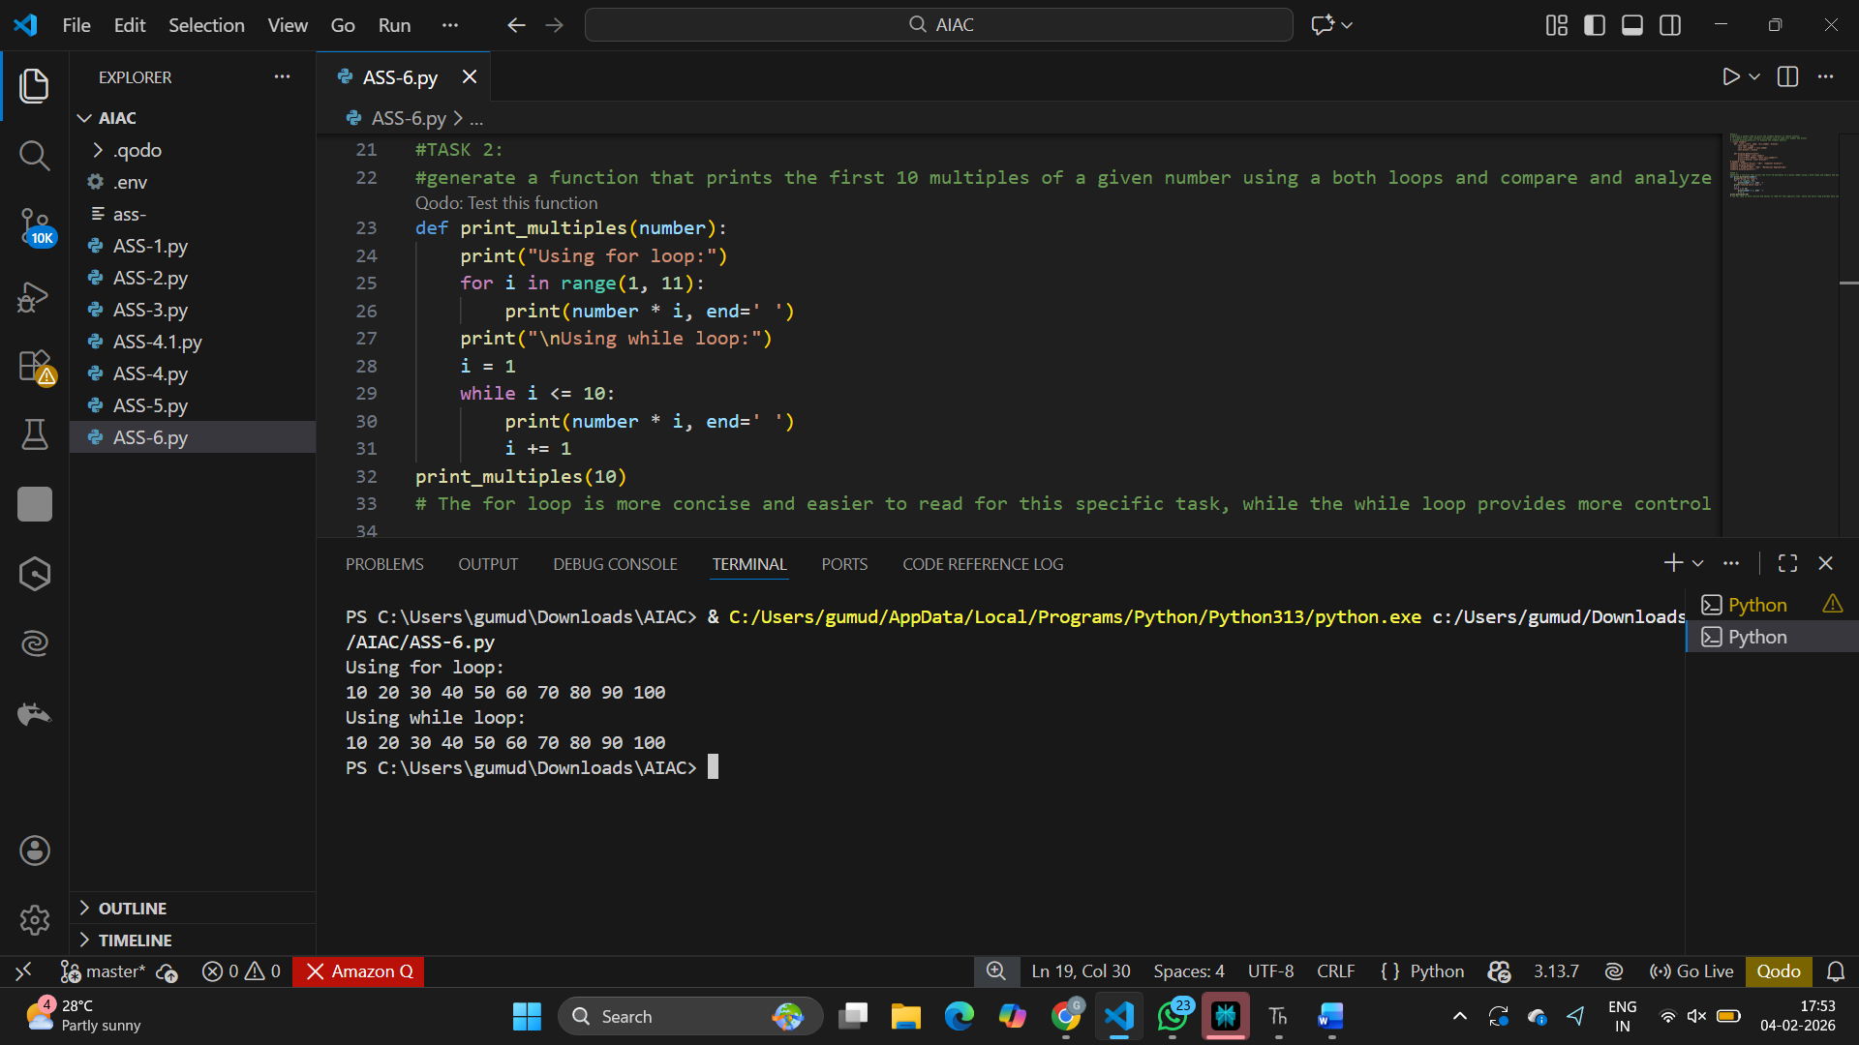
Explanation : In the for loop, we directly iterate over a range of numbers from 1 to 10, which makes it straightforward to generate the multiples.In the while loop, we manually control the loop variable 'i', which requires initialization and incrementing, making it slightly more verbose.
Task Description #3: Conditional Statements (Age Classification)
Task: Ask the AI tool to generate nested if-elif-else conditional statements to classify age groups(e.g., child, teenager, adult, senior).
• Analyze the generated conditions and logic.
• Ask the AI to generate the same classification using alternative conditional structures (e.g.,simplified conditions or dictionary-based logic).
Expected Output : A Python function that classifies age into appropriate groups
• Clear and correct conditional logic Explanation of how the conditions work.
Prompt : Create a Python program to classify age groups using if-elif-else conditions.
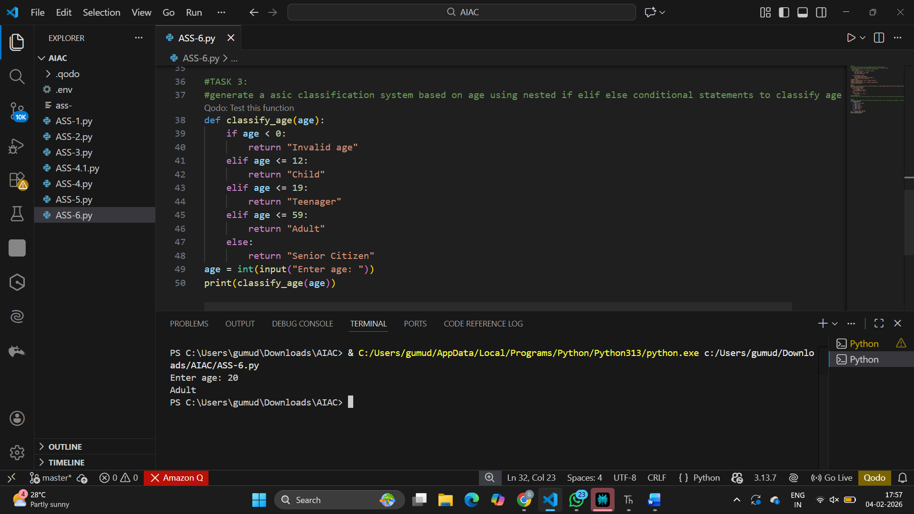
Explanation:
The function classify_age uses nested if-elif-else statements to classify the age into different groups: Child, Teenager, Adult, and Senior Citizen. It also checks for invalid age input.
Task Description #4: For and While Loops (Sum of First n Numbers)
Task:Use AI assistance to generate a sum_to_n() function using a for loop.
• Analyze the generated code.
• Ask the AI to suggest an alternative implementation using a while loop or a mathematical formula.
Expected Output : Python function to compute the sum of first n numbers. Correct output for sample inputs.Explanation and comparison of different approaches
Prompt:
Write a function to find the sum of the first n natural numbers using a loop and a formula.
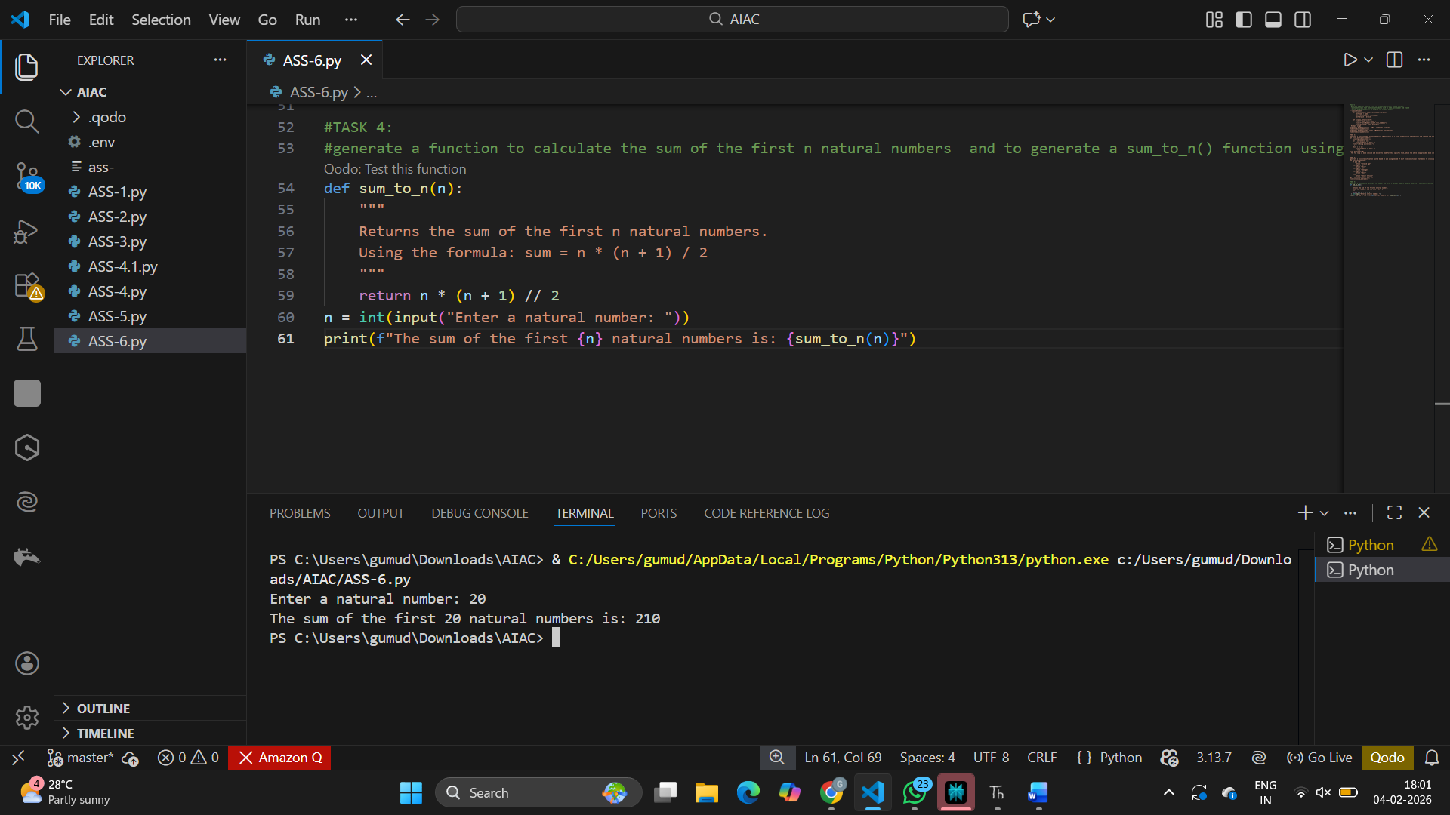
Explanation: The formula n * (n + 1) / 2 provides a direct way to calculate the sum of the first n natural numbers without needing to iterate through each number, making it more efficient.
Task Description #5: Classes (Bank Account Class)
Task:Use AI tools to generate a Bank Account class with methods such as deposit(), withdraw(),and check_balance().
• Analyze the AI-generated class structure and logic. Add meaningful comments and explain the working of the code.
Expected Output :Complete Python Bank Account class.Demonstration of deposit and withdrawal operations with updated balance.Well-commented code with a clear explanation.
Prompt : Create a Python BankAccount class with deposit, withdraw, and check balance methods.
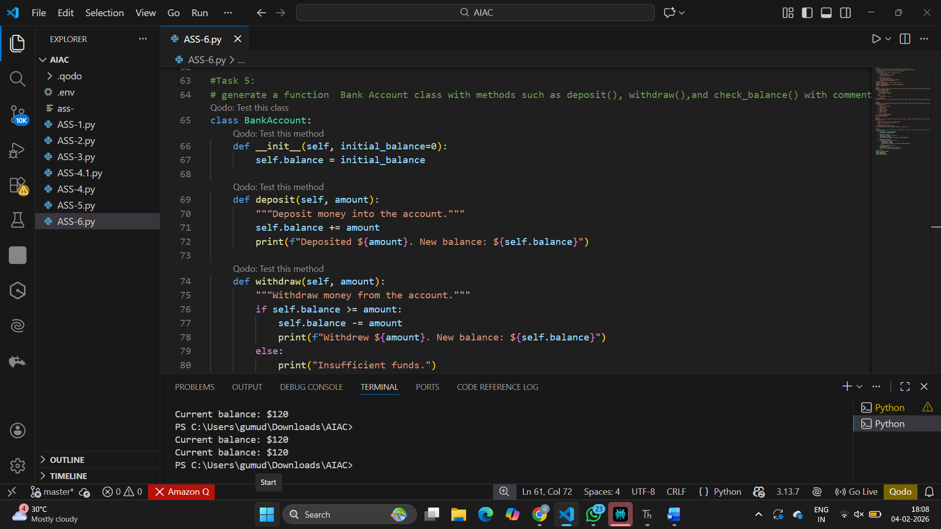
Explanation:
-The BankAccount class simulates a simple bank account with an initial balance.
-The deposit() method allows adding money to the account.
-The withdraw() method allows taking money out of the account, checking for sufficient funds.
-The check_balance() method displays the current balance of the account.

