SCHOOL OF COMPUTER SCIENCE AND ARTIFICIAL INTELLIGENCE |  |  |  |  |  |  | DEPARTMENT OF COMPUTER SCIENCE ENGINEERING
Program Name: B. Tech |  |  |  |  |  | Assignment Type: Lab |  |  |  | Academic Year:2025-2026
Course Code |  |  |  | 23CS002PC304 |  | Course Title |  |  | AI Assisted Coding
Year/Sem |  |  | III/II |  | Regulation |  |  | R23
Date and Day  of Assignment |  |  |  | Week3 – Wednesday |  | Batch No |  |  | 23CSBTB47B
Name |  |  |  | T Shiva Sai |  | Hall Ticket No |  |  | 2303A54025
AssignmentNumber:6.3
 | Q.No. | Question
 | 1 | Lab 6: AI-Based Code Completion – Classes, Loops, and Conditionals  Lab Objectives  • To explore AI-powered auto-completion features for core Python constructs such as classes, loops, and conditional statements.  • To analyze how AI tools suggest logic for object-oriented programming and control structures.  • To evaluate the correctness, readability, and completeness of AI-generated Python code.  Lab Outcomes (LOs)  After completing this lab, students will be able to:  • Use AI tools to generate and complete Python class definitions and methods.  • Understand and assess AI-suggested loop constructs for iterative tasks.  • Generate and evaluate conditional statements using AI-driven prompts.  • Critically analyze AI-assisted code for correctness, clarity, and efficiency.  Task Description #1: Classes (Student Class)  Scenario  You are developing a simple student information management module.  Task  • Use an AI tool (GitHub Copilot / Cursor AI / Gemini) to complete a Student class.  • The class should include attributes such as name, roll number, and branch.  • Add a method display_details() to print student information.  • Execute the code and verify the output.  • Analyze the code generated by the AI tool for correctness and clarity.  Expected Output #1  • A Python class with a constructor (__init__) and a display_details() method.  • Sample object creation and output displayed on the console.  • Brief analysis of AI-generated code.  Prompt :  Create simple Python Student class with name, roll number, branch in init. Add display_details to print all info. Include sample object and output.  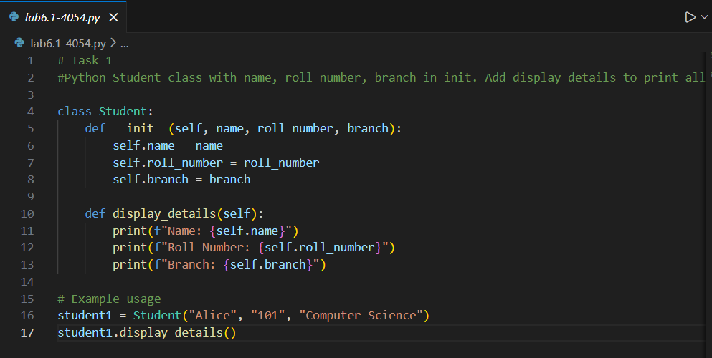  Output :  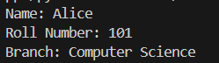  Explanation:  The Student class is defined with an __init__ method that initializes the name, roll number, and branch attributes.  The display_details method prints out the student's information in a formatted manner.  Task Description #2: Loops (Multiples of a Number)  Scenario  You are writing a utility function to display multiples of a given number.  Task  • Prompt the AI tool to generate a function that prints the first 10 multiples of a given number using a loop.  • Analyze the generated loop logic.  • Ask the AI to generate the same functionality using another controlled looping structure (e.g., while instead of for).  Expected Output #2  • Correct loop-based Python implementation.  • Output showing the first 10 multiples of a number.  • Comparison and analysis of different looping approaches.  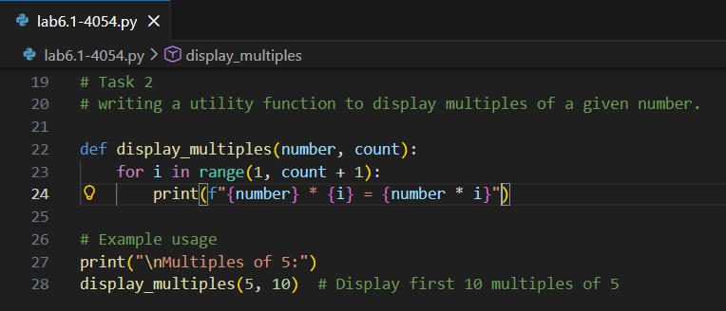  Output :  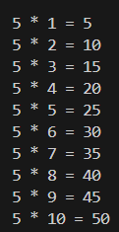  Explanation :  The function display_multiples takes two parameters: number and count.  It uses a for loop to iterate from 1 to count (inclusive) and prints the multiples of the given number.  Task Description #3: Conditional Statements (Age Classification)  Scenario  You are building a basic classification system based on age.  Task  • Ask the AI tool to generate nested if-elif-else conditional statements to classify age groups (e.g., child, teenager, adult, senior).  • Analyze the generated conditions and logic.  • Ask the AI to generate the same classification using alternative conditional structures (e.g., simplified conditions or dictionary-based logic).  Expected Output #3  • A Python function that classifies age into appropriate groups.  • Clear and correct conditional logic.  • Explanation of how the conditions work.  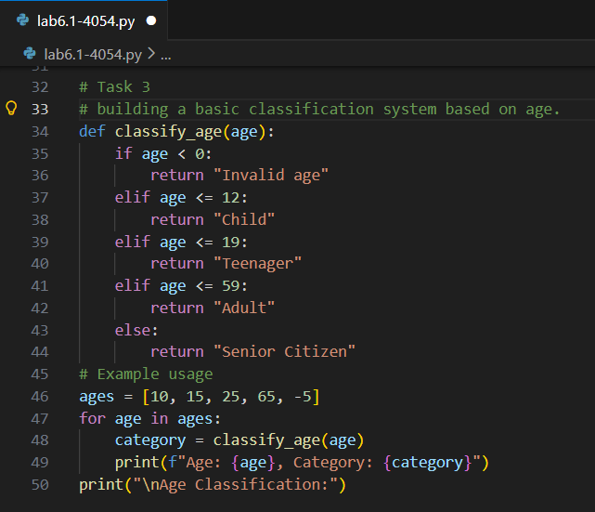  Output :  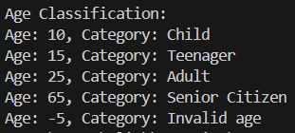  Explanation:  The classify_age function takes an age as input and classifies it into categories: Child.  eenager, Adult, and Senior Citizen based on the specified age ranges. It also handles invalid ages.  Task Description #4: For and While Loops (Sum of First n Numbers)  Scenario  You need to calculate the sum of the first n natural numbers.  Task  • Use AI assistance to generate a sum_to_n() function using a for loop.  • Analyze the generated code.  • Ask the AI to suggest an alternative implementation using a while loop or a mathematical formula.  Expected Output #4  • Python function to compute the sum of first n numbers.  • Correct output for sample inputs.  • Explanation and comparison of different approaches.  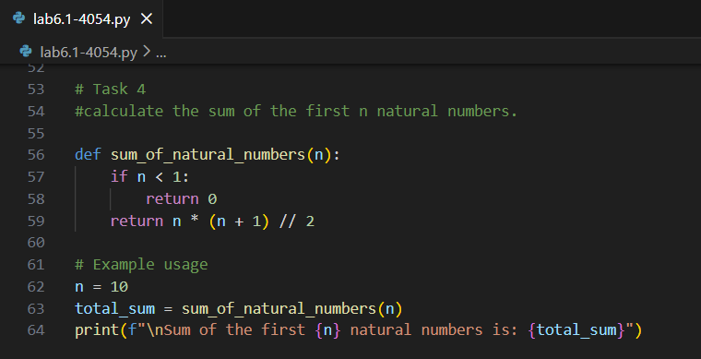  Output :  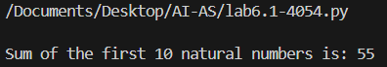  Explanation:  The formula n(n+1)/2 is used to calculate the sum of the first n natural numbers efficiently.  Task Description #5: Classes (Bank Account Class)  Scenario  You are designing a basic banking application.  Task  • Use AI tools to generate a Bank Account class with methods such as deposit(), withdraw(), and check_balance().  • Analyze the AI-generated class structure and logic.  • Add meaningful comments and explain the working of the code.  Expected Output #5  • Complete Python Bank Account class.  • Demonstration of deposit and withdrawal operations with updated balance.  • Well-commented code with a clear explanation.  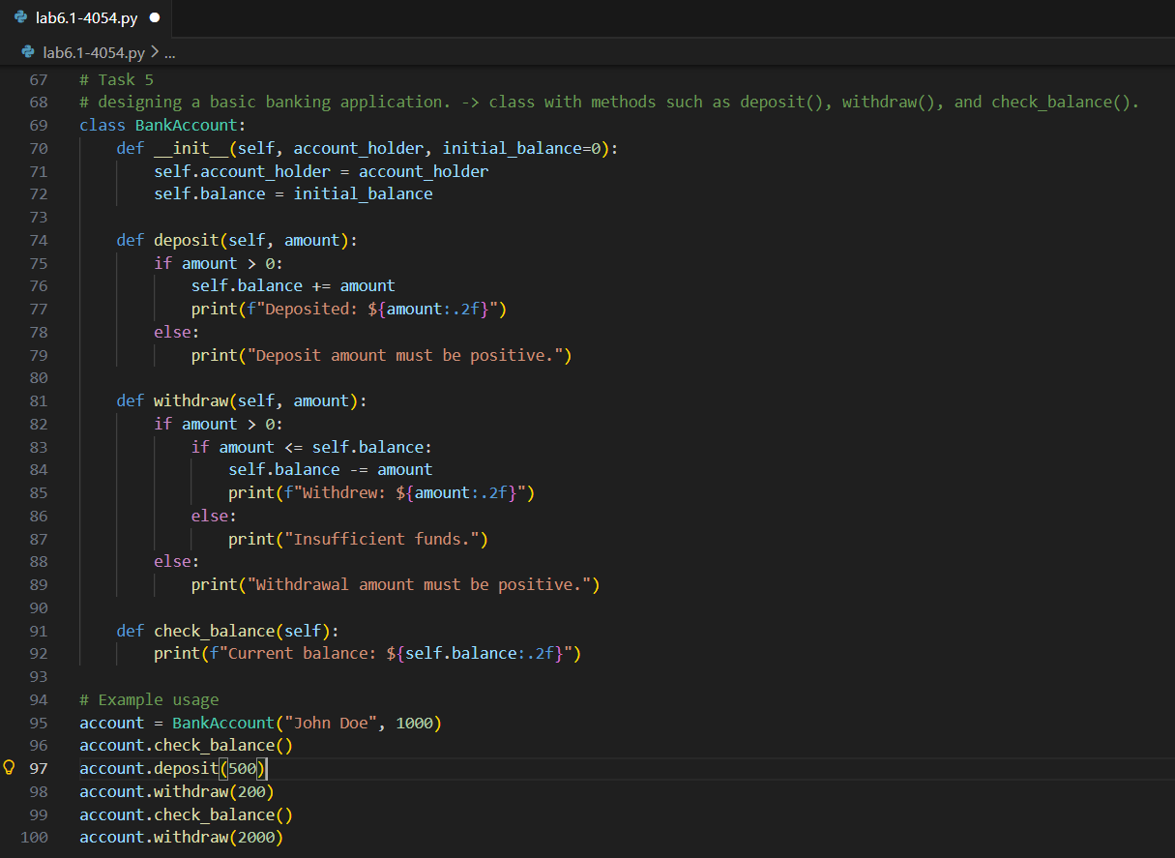  Output :  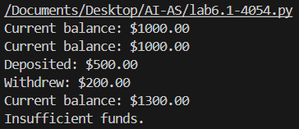  Explanation:  The BankAccount class represents a simple banking system. It has an initializer that sets the account holder's name and initial balance.  The deposit() method allows adding money to the account, while the withdraw() method allows taking money out, provided there are sufficient funds. The check_balance() method displays the current balance of the account.


