ASSIGNMENT_5.1_AI_ASSISTED_CODING

Task Description #1 (Privacy in API Usage)
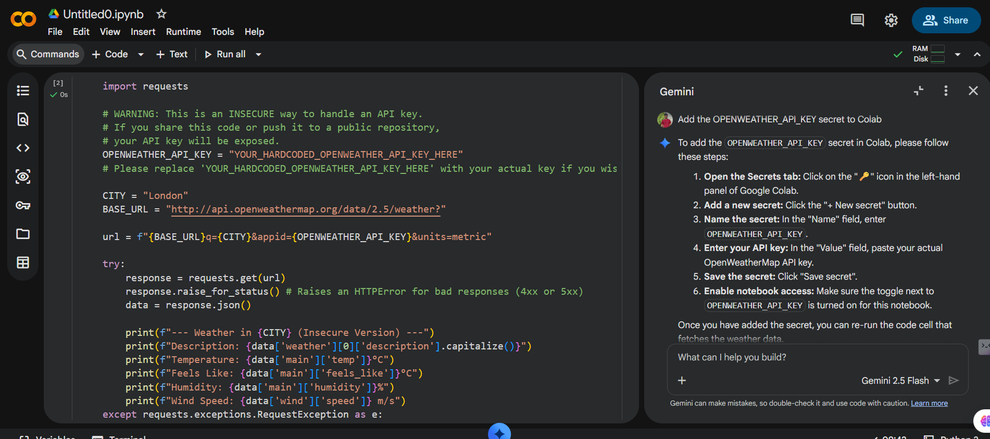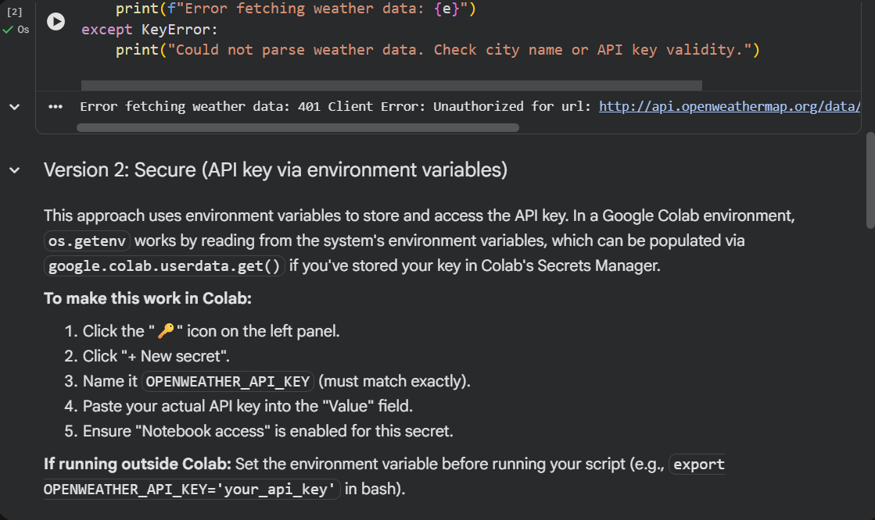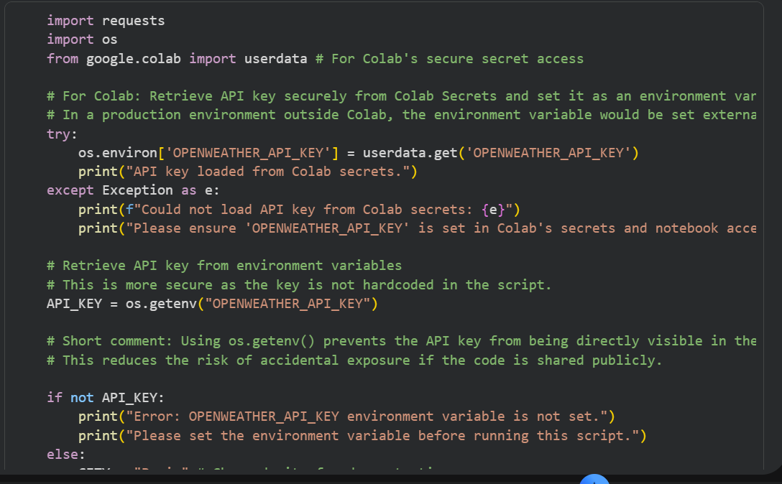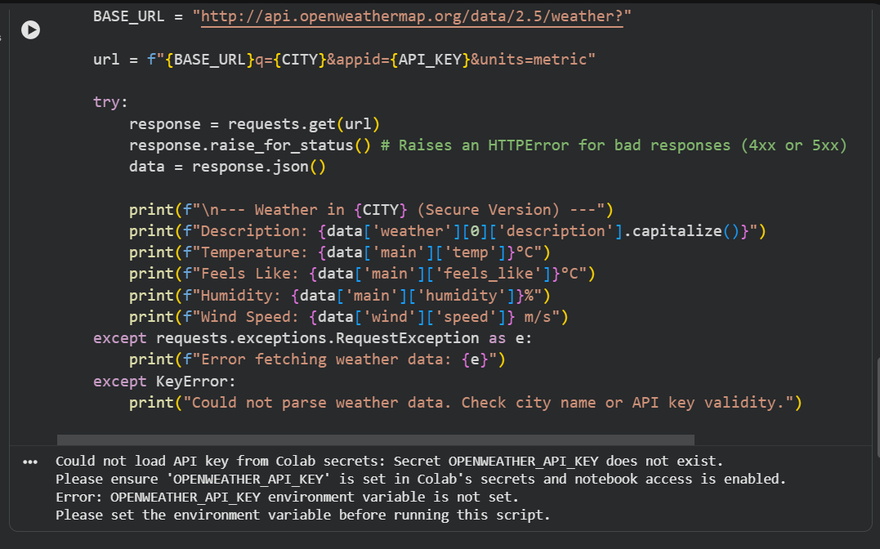

Task Description #2 (Privacy & Security in File Handling)
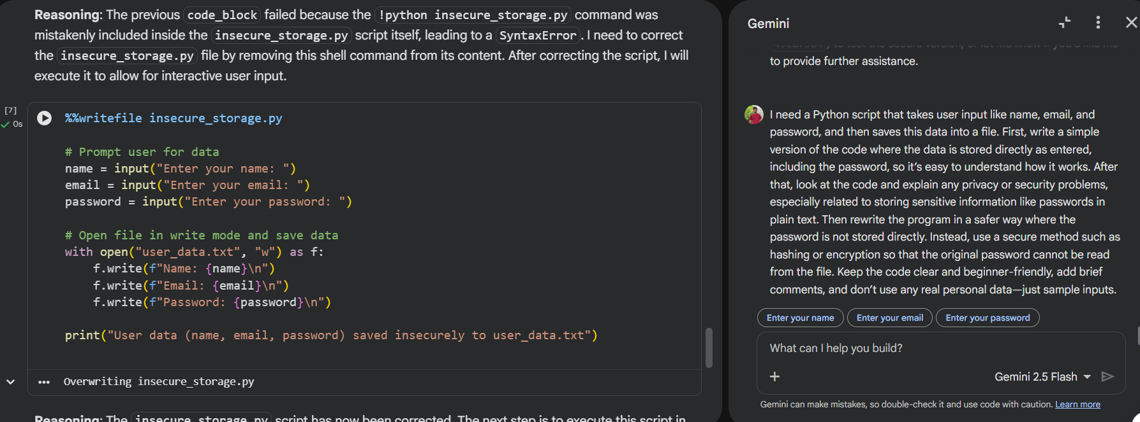
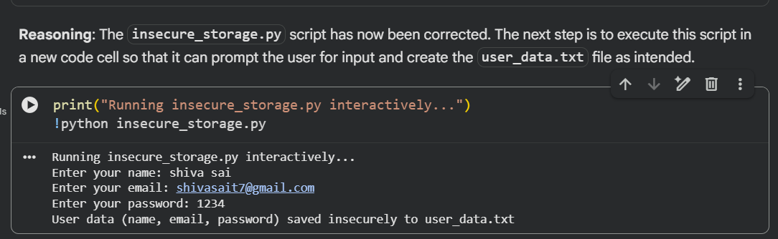
- Generate Insecure User Data Storage Code: Create a Python script that prompts the user for name, email, and password, and then saves this information directly into a file in plain text. This will serve as an example of an insecure approach.
- Explain Security Vulnerabilities: Provide a detailed explanation of the privacy and security problems associated with the insecure code generated in the previous step, specifically highlighting the risks of storing passwords in plain text.
- Generate Secure User Data Storage Code: Rewrite the Python script to securely handle the password. This version will prompt for user data, hash the password using a secure hashing algorithm (like hashlib.sha256), and then store the hashed password (along with name and email) in a file, ensuring the original password cannot be read directly.
- Final Task: Provide a summary of the differences between the insecure and secure approaches, emphasizing the importance of secure password handling in real-world applications.

Task Description #3 (Transparency in Algorithm Design)
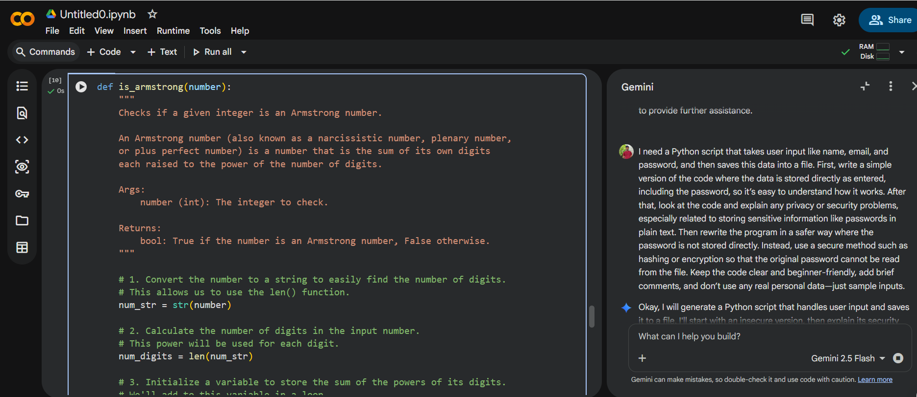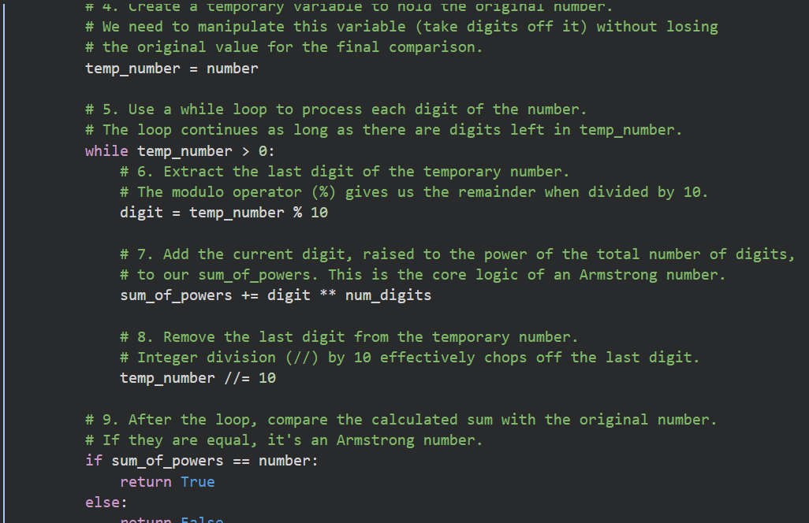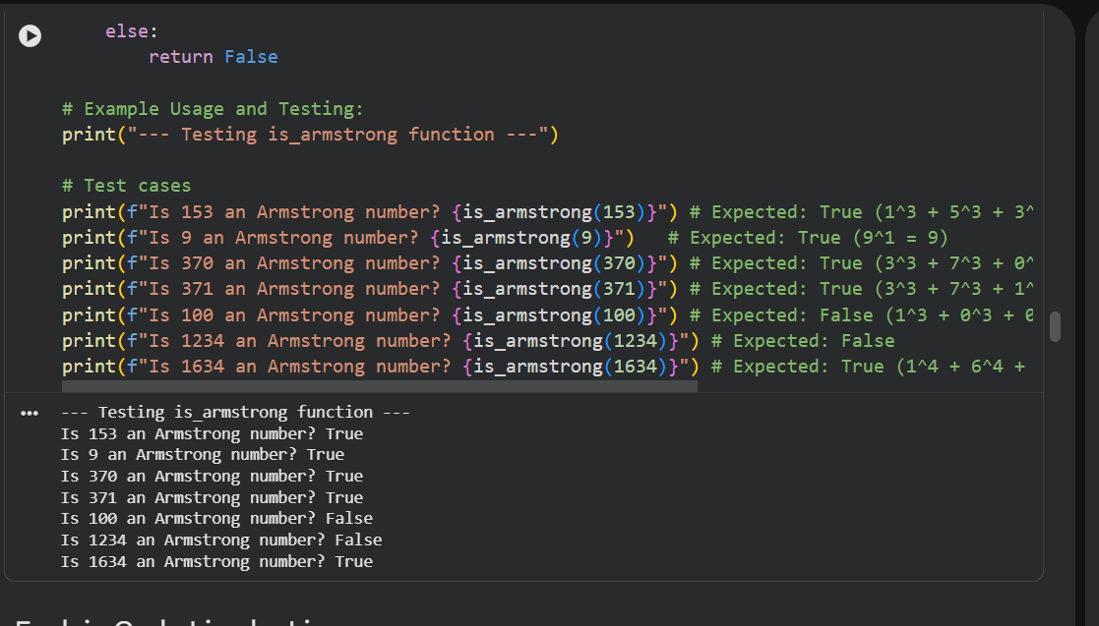
- Generate Insecure User Data Storage Code: Create a Python script that prompts the user for name, email, and password, and then saves this information directly into a file in plain text. This will serve as an example of an insecure approach.
- Explain Security Vulnerabilities: Provide a detailed explanation of the privacy and security problems associated with the insecure code generated in the previous step, specifically highlighting the risks of storing passwords in plain text.
- Generate Secure User Data Storage Code: Rewrite the Python script to securely handle the password. This version will prompt for user data, hash the password using a secure hashing algorithm (like hashlib.sha256), and then store the hashed password (along with name and email) in a file, ensuring the original password cannot be read directly.
- Final Task: Provide a summary of the differences between the insecure and secure approaches, emphasizing the importance of secure password handling in real-world applications.

Task Description #4 (Transparency in Algorithm Comparison)
Task
Implement the BubbleSort algorithm in Python, ensuring the code is clear, well-commented, and includes a step-by-step explanation of its logic.

Implement BubbleSort Algorithm
Subtask:
Generate Python code for the BubbleSort algorithm. The code will be simple, clear, and include step-by-step comments to explain its logic.

Reasoning: I will generate a Python function for the Bubble Sort algorithm, including comments and example usage, as specified in the subtask instructions.
Code:
def bubble_sort(arr):
"""
Sorts a list of numbers using the Bubble Sort algorithm.

Bubble Sort repeatedly steps through the list, compares adjacent elements
and swaps them if they are in the wrong order. The pass through the list
is repeated until no swaps are needed, which indicates that the list is sorted.

Args:
arr (list): A list of comparable elements to be sorted.

Returns:
list: The sorted list.
"""
n = len(arr)
# Outer loop for number of passes. Each pass places the largest
# unsorted element at its correct position at the end of the unsorted part.
for i in range(n):
# Initialize a flag to check if any swaps occurred in this pass.
# If no swaps occur, the list is already sorted, and we can stop early.
swapped = False

# Inner loop for comparisons and swaps. It iterates through the unsorted
# portion of the array. The '-i' part ensures we don't re-check elements
# that are already in their correct sorted position at the end.
for j in range(0, n - i - 1):
# Compare adjacent elements.
# If the element found is greater than the next element,
# swap them.
if arr[j] > arr[j + 1]:
arr[j], arr[j + 1] = arr[j + 1], arr[j] # Perform swap
swapped = True # Set flag to True as a swap occurred

# If no two elements were swapped by the inner loop, then the list is sorted.
if not swapped:
break
return arr

# Example Usage:
print("--- Demonstrating Bubble Sort ---")
my_list = [64, 34, 25, 12, 22, 11, 90]
print(f"Original list: {my_list}")

sorted_list = bubble_sort(my_list.copy()) # Use .copy() to keep original list unchanged
print(f"Sorted list: {sorted_list}")

my_list_2 = [5, 1, 4, 2, 8]
print(f"Original list 2: {my_list_2}")
sorted_list_2 = bubble_sort(my_list_2.copy())
print(f"Sorted list 2: {sorted_list_2}")

my_list_3 = [1, 2, 3, 4, 5] # Already sorted list to test optimization
print(f"Original list 3 (already sorted): {my_list_3}")
sorted_list_3 = bubble_sort(my_list_3.copy())
print(f"Sorted list 3: {sorted_list_3}")
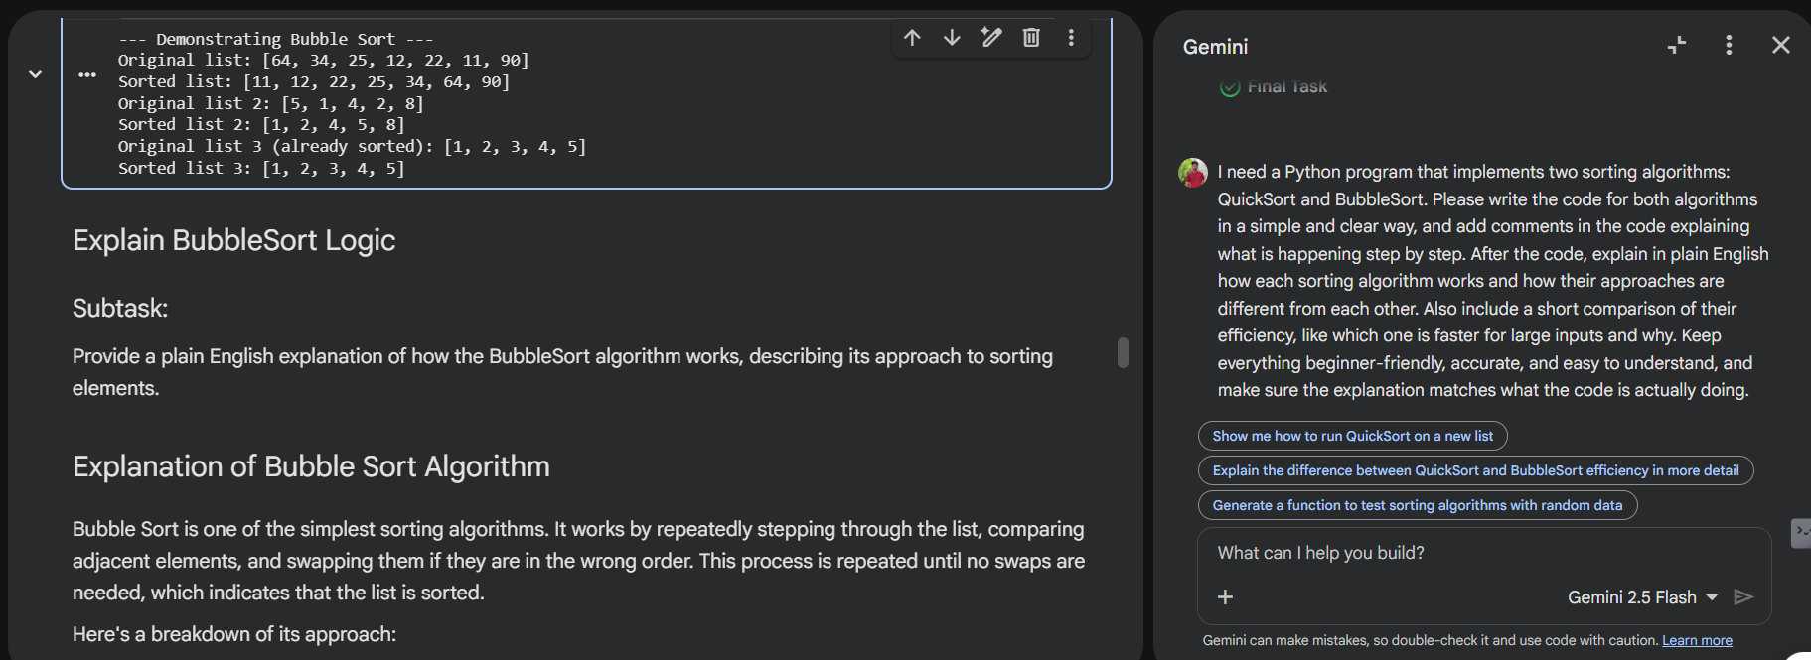

QuickSort: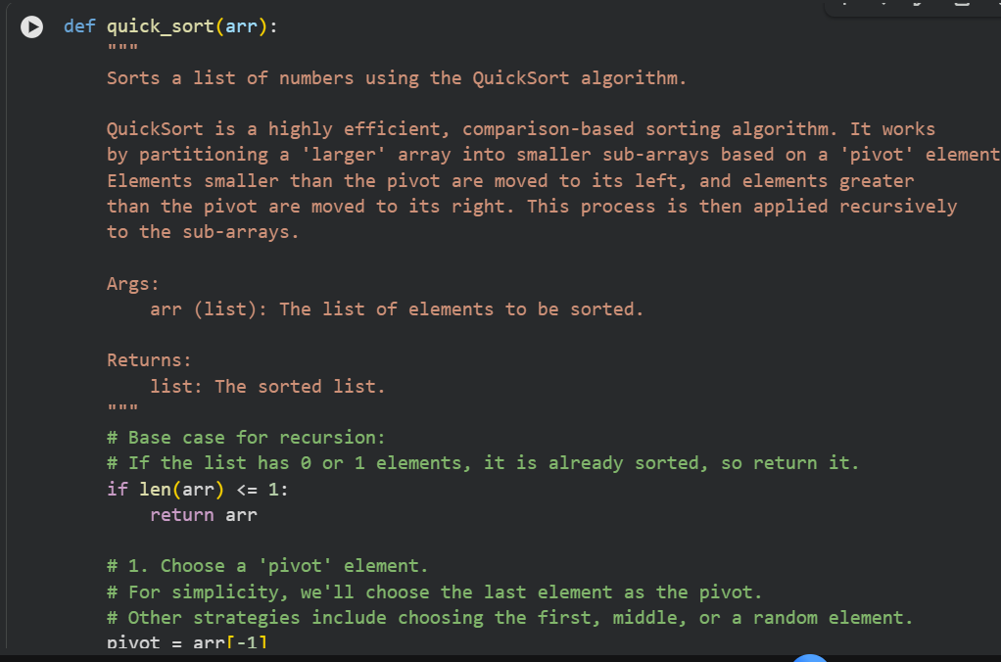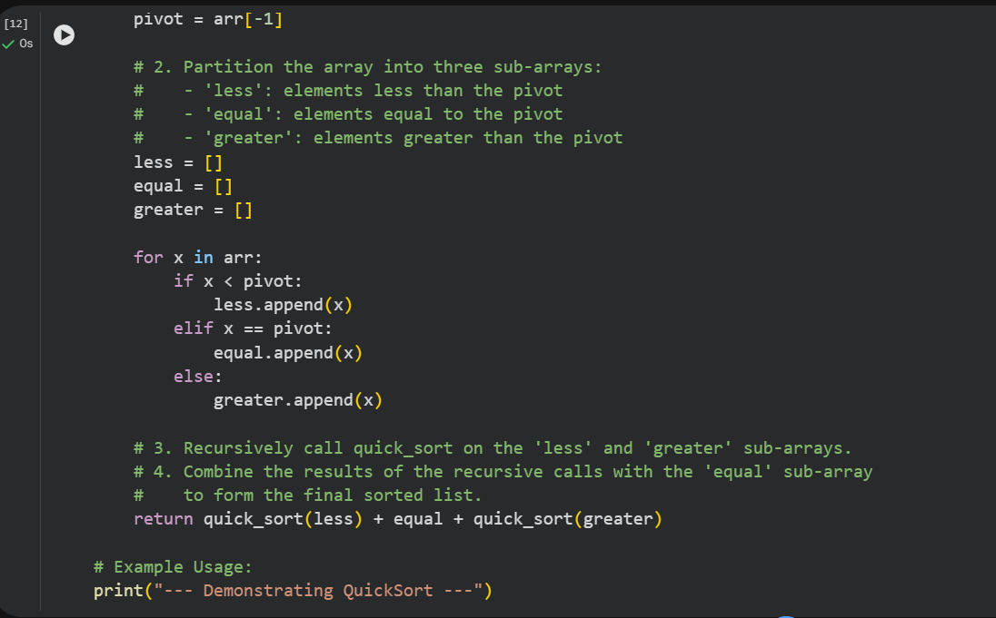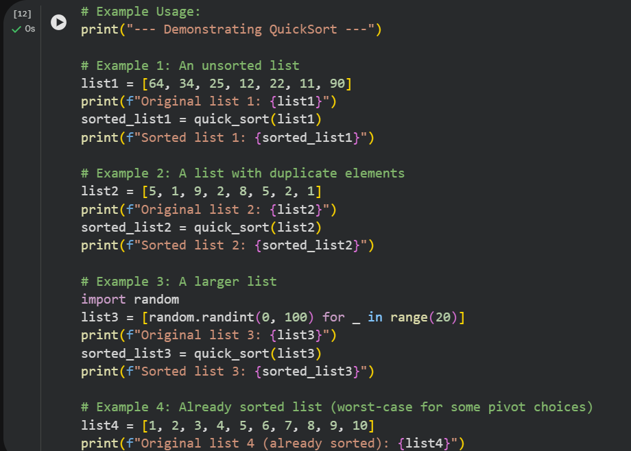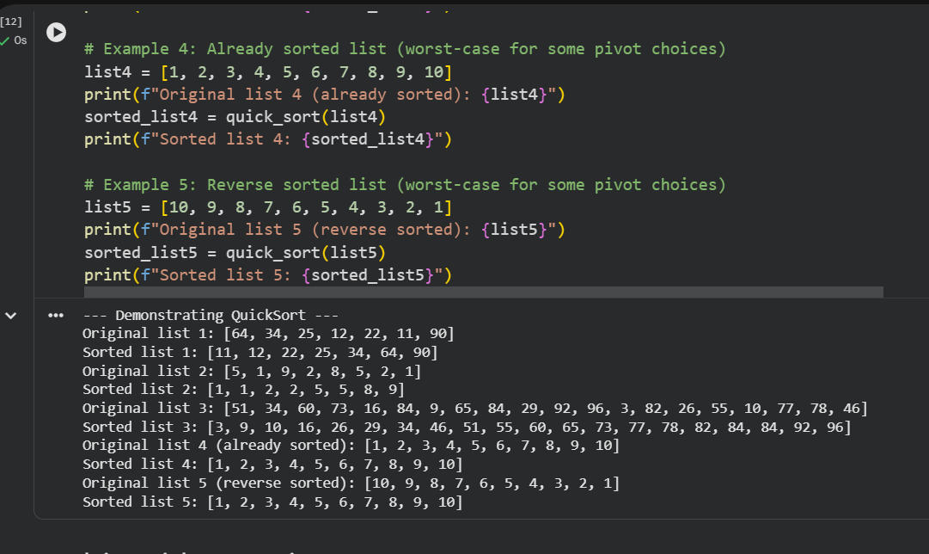

COMPARISION :-

Here's a concise summary of the comparison between Bubble Sort and Quick Sort:
- Bubble Sort is a simple, iterative algorithm that repeatedly steps through the list, compares adjacent elements, and swaps them if they are in the wrong order. Its time complexity is generally O(n^2) for average and worst cases, making it very inefficient for large inputs. Its space complexity is O(1).
- Quick Sort is a highly efficient, recursive divide-and-conquer algorithm. It works by selecting a pivot, partitioning the array around it, and then recursively sorting the sub-arrays. Its average-case time complexity is O(n log n), which is significantly faster than Bubble Sort for large datasets. Its space complexity is O(log n) on average (due to recursion stack), though it can be O(n) in the worst case.
Preference for Large Inputs: Quick Sort is generally preferred for larger inputs because its average-case O(n log n) performance scales much better than Bubble Sort's O(n^2) as the number of elements n grows. The difference in execution time becomes astronomical for large datasets.

Task Description #5 (Transparency in AI Recommendations)
Task
Implement a simple product recommendation system in Python. The system should define sample product data (e.g., name, category, tags) and user preferences. It should then recommend products based on these, with each recommendation accompanied by a clear, beginner-friendly explanation for why it was chosen (e.g., "because it's in the 'Electronics' category which you like," or "it matches your interest in 'Gaming'"). The code should be well-commented and use no real user data.

Implement Simple Product Recommendation System
Subtask:
Generate Python code for a simple product recommendation system. The code will define sample product data and user preferences, then recommend products based on these. Crucially, each recommendation will come with a clear, beginner-friendly explanation of why it was chosen (e.g., similar category, matching tags, user's past interests). The code should be well-commented and use no real user data.

Generate Simple Product Recommendation System Code
Subtask:
Generate Python code for a simple product recommendation system. The code will define sample product data and user preferences, then recommend products based on these. Crucially, each recommendation will come with a clear, beginner-friendly explanation of why it was chosen (e.g., similar category, matching tags, user's past interests). The code should be well-commented and use no real user data.
Reasoning:
I will now define sample product data and user preferences as dictionaries and lists, which will serve as the foundation for our recommendation system. This directly addresses the first two instructions of the subtask.

Reasoning: I will generate Python code to define sample product data and user preferences, which are the foundational inputs for the recommendation system, as per the first two instructions of the subtask.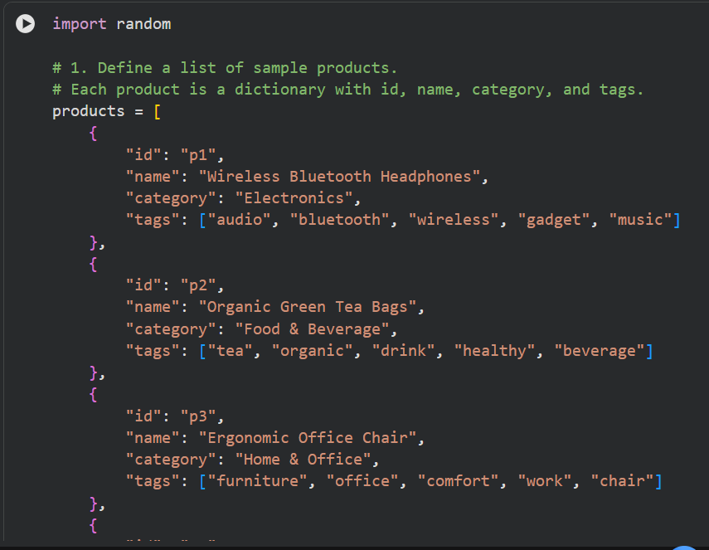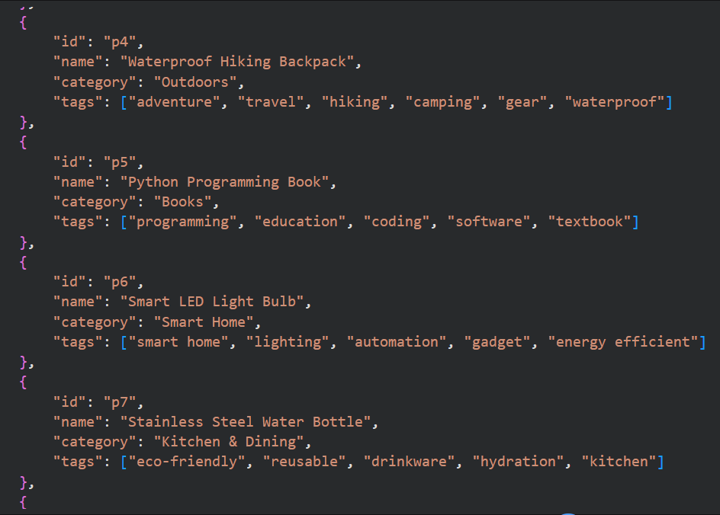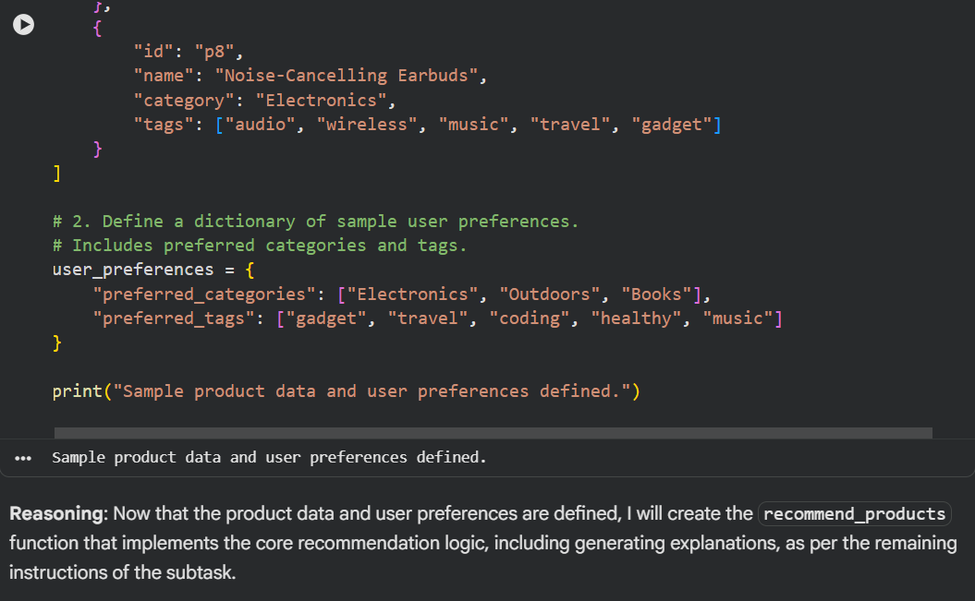
Reasoning: Now that the product data and user preferences are defined, I will create the recommend_products function that implements the core recommendation logic, including generating explanations, as per the remaining instructions of the subtask. 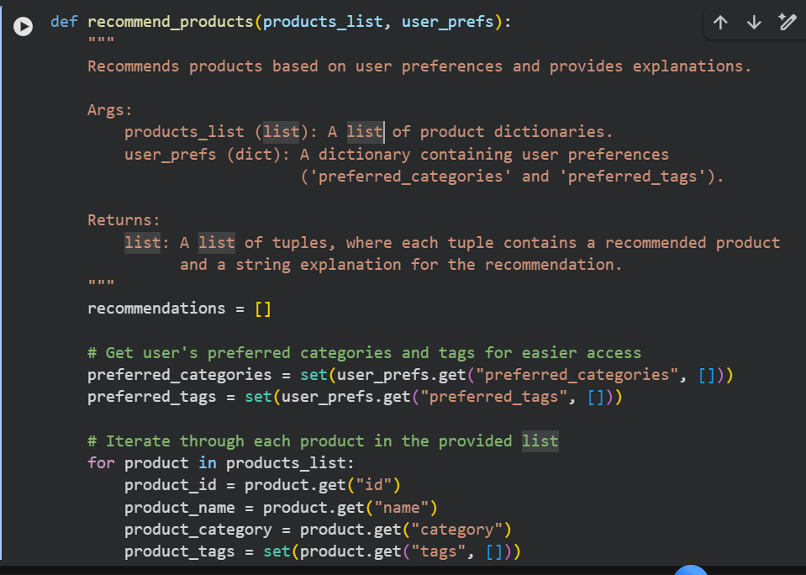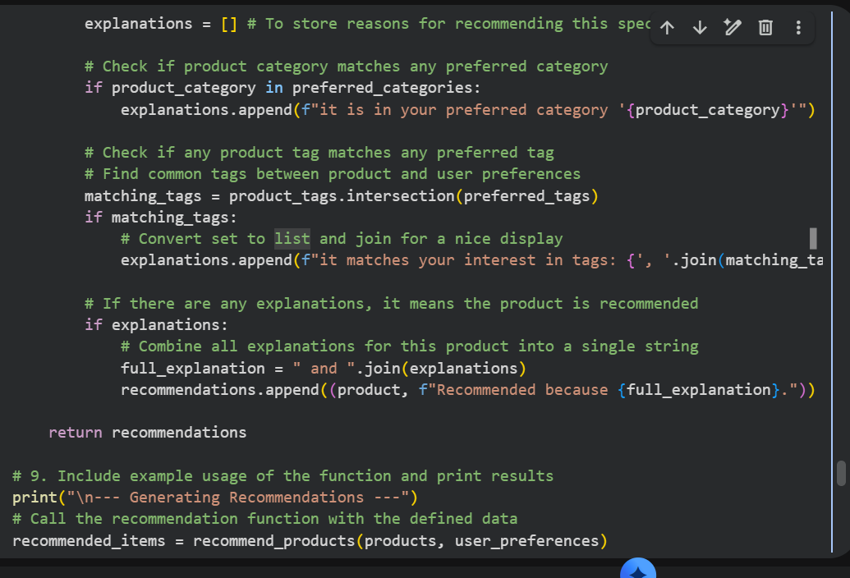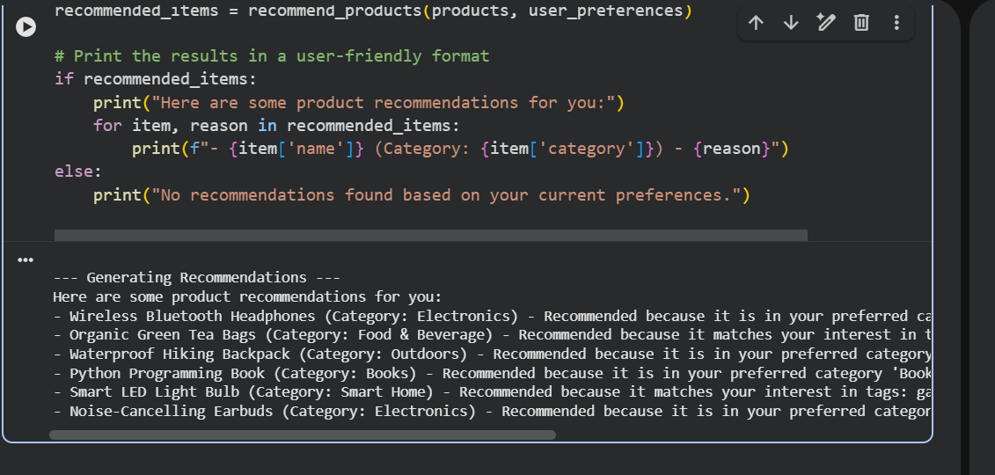

Final Task
Subtask:
Summarize the developed product recommendation system, its logic, and the effectiveness of its explanations.

Summary:
Q&A
The developed product recommendation system is a content-based filtering system that recommends products by matching their categories and tags with the user's defined preferences. Its logic involves iterating through a list of products, comparing each product's category and tags against the user's preferred categories and tags, and generating a recommendation if a match is found. The explanations provided are clear, readable, and informative, explicitly stating why a product was recommended (e.g., "because it's in your preferred category 'Electronics' and it matches your interest in tags: gadget, music").
Data Analysis Key Findings
- The system successfully defined sample product data, including product IDs, names, categories, and tags for 8 distinct products.
- User preferences were clearly defined, consisting of preferred_categories (e.g., 'Electronics', 'Outdoors', 'Books') and preferred_tags (e.g., 'gadget', 'travel', 'coding').
- The recommend_products function accurately identified recommended products by matching user preferences to product attributes. For example, "Wireless Bluetooth Headphones" was recommended because it was in the 'Electronics' category and matched 'gadget, music' tags.
- The system provided specific, beginner-friendly explanations for each recommendation, combining multiple reasons with "and" where applicable, such as:
  - "Wireless Bluetooth Headphones (Category: Electronics) - Recommended because it is in your preferred category 'Electronics' and it matches your interest in tags: gadget, music."
  - "Python Programming Book (Category: Books) - Recommended because it is in your preferred category 'Books' and it matches your interest in tags: coding."
- The explanations were assessed as clear, readable, and informative, effectively communicating the rationale behind each recommendation to a normal user.
Insights or Next Steps
- The current system provides effective and transparent recommendations based on direct content matching. To enhance complexity and personalization, future iterations could integrate user interaction data (e.g., purchase history, ratings) to build more sophisticated collaborative filtering or hybrid models.
- The established method of generating clear, combined explanations is highly effective for user trust and understanding. This approach should be maintained and scaled when developing more complex recommendation algorithms to ensure transparency remains a core feature.

