Task1
You are developing a simple student information management module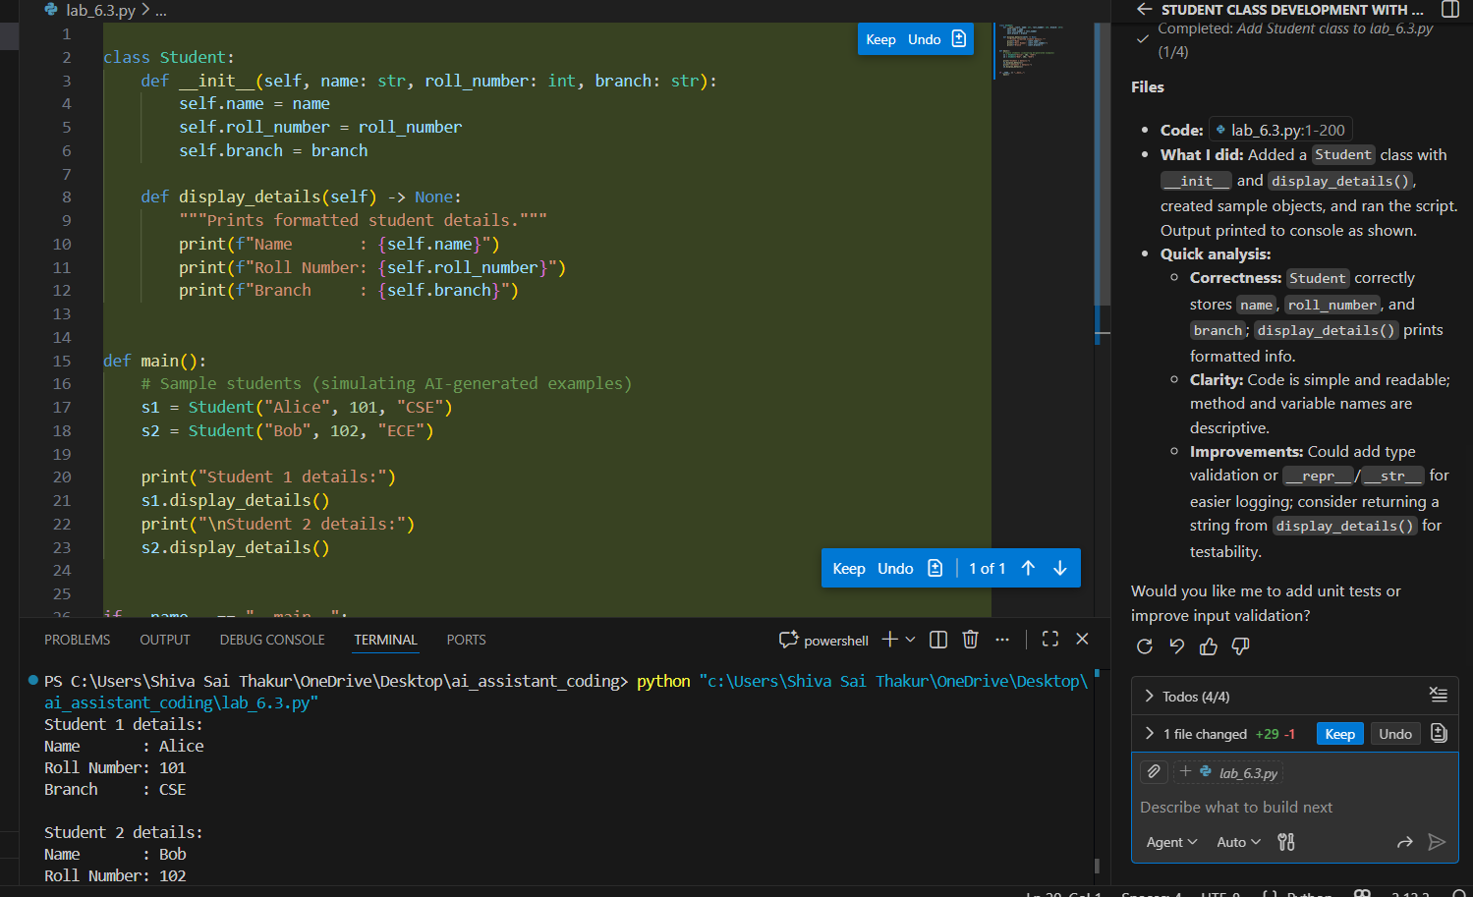

Task2
You are writing a utility function to display multiples of a given number
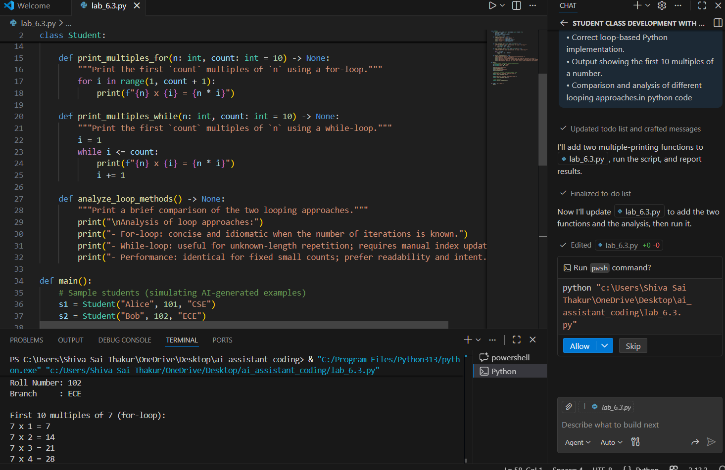
Task3
You are building a basic classification system based on age.

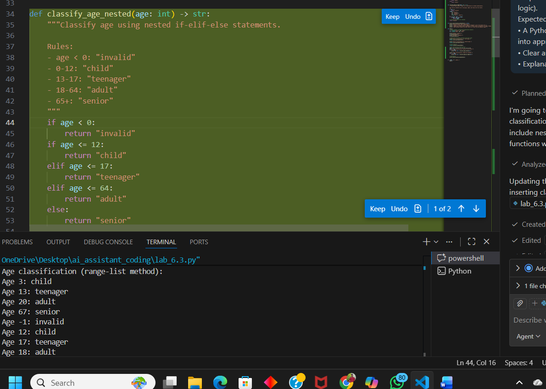

Task4
You need to calculate the sum of the first n natural numbers
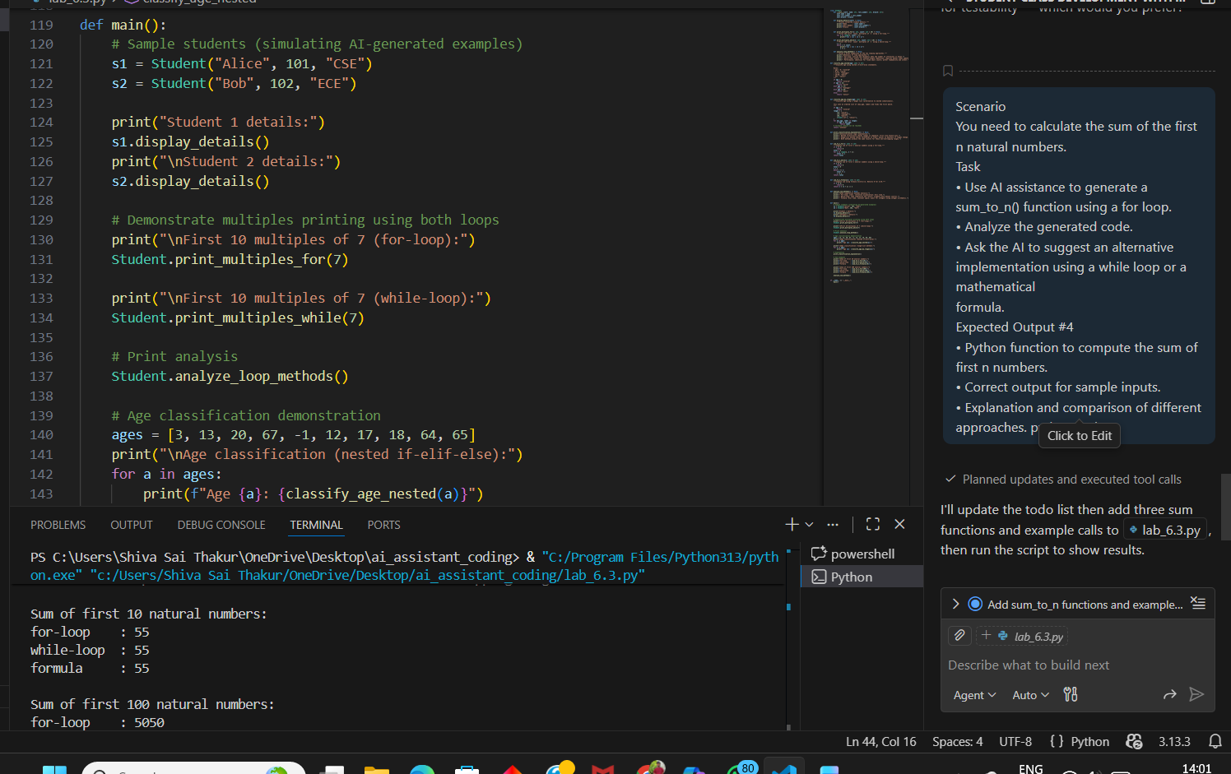
Task5
You are designing a basic banking application
