Sample Project Approach (Roadmap)
Title: Machine Learning-Based Predictive Analytics for Supply Chain Optimization
Domain
- Supply Chain Analytics • Predictive Modeling • Data Science
This project falls under Data Science and Big Data Analytics specialization, aligned with Supply Chain 4.0 and Industry 4.0.
Dataset
I recommend using three benchmark datasets together:
- 1. DataCo Smart Supply Chain Dataset (logistics, orders, shipments, products, customers, delivery delay)
https://www.kaggle.com/datasets/shashwatwork/dataco-smart-supply-chain-for-big-data-analysis
- 2. Store Item Demand Forecasting Dataset (store-item daily sales, 5 years, time-series forecasting)
https://www.kaggle.com/datasets/briandiem/store-item-demand-forecasting
- 3. UCI Online Retail II Dataset (UK e-commerce, 1M+ transactions, high SKU cardinality)
https://archive.ics.uci.edu/dataset/502/online+retail+ii
- All the 3 are famous Valid Datasets. All are to be considered in the Project.

Abstract
Global supply chains generate large volumes of sales, inventory, supplier and logistics data that can be utilized to forecast demand and optimize operations. However, conventional forecasting models such as ARIMA and exponential smoothing often function as limited linear systems, providing point forecasts without capturing non-linear dependencies, promotions, seasonality and disruptions. This lack of adaptability limits the confidence of supply chain planners and managers in adopting data-driven decision-making.
To address this challenge, this project proposes a comprehensive Machine Learning-Based Predictive Analytics framework for Supply Chain Optimization by integrating Exploratory Data Analysis (EDA), machine learning / deep learning and prescriptive optimization with explainability techniques.
The proposed framework utilizes three widely recognized benchmark datasets: the DataCo Smart Supply Chain Dataset, Store Item Demand Forecasting Dataset and the UCI Online Retail II Dataset. Initially, the datasets undergo data preprocessing, including missing value handling, categorical data encoding and normalization to improve data quality and consistency. A detailed Exploratory Data Analysis (EDA) is then performed to gain meaningful insights through dataset overview, data quality assessment, descriptive statistics, missing value analysis, duplicate record detection, outlier detection, univariate, bivariate and multivariate analyses, correlation analysis, feature engineering and feature selection.
Following preprocessing and EDA, multiple machine learning algorithms, namely XGBoost, LightGBM, LSTM and Temporal Fusion Transformer (TFT) as a weighted ensemble, are trained and evaluated for multi-horizon (7/30/90-day) demand forecasting, along with a delay-risk classifier for shipment lead-time prediction. The performance of these models is assessed using standard evaluation metrics, including MAE, RMSE, MAPE, R², Precision, Recall, F1-Score and ROC analysis. To enhance transparency and interpretability, the framework incorporates SHAP (SHapley Additive exPlanations) and TFT attention-based interpretability, enabling both global and local explanations of model predictions. These techniques help identify the most influential features affecting demand and delay risk, thereby making the prediction process understandable to planners and stakeholders.
Furthermore, the forecasted demand distribution is fed into a prescriptive optimization layer that computes dynamic Safety Stock, Reorder Point (ROP) and Economic Order Quantity (EOQ) and generates reorder alerts. The analytical results are presented through interactive visualizations such as forecast vs. actual charts, heatmaps, inventory recommendation tables, risk heatmaps, SHAP plots and a Streamlit dashboard with FastAPI backend, facilitating effective interpretation of the data and model outcomes. Finally, a comparative analysis is conducted across all models (ARIMA vs. RF vs. XGBoost vs. LightGBM vs. LSTM vs. TFT vs. Ensemble) to determine the most effective and explainable approach for supply chain optimization.
The proposed research framework combines supply chain data mining, time-series forecasting, operations research and explainable AI into a unified analytical pipeline. The project aims not only to achieve high predictive performance (expected 25%+ improvement over ARIMA, 15–20% holding-cost reduction) but also to provide transparent and deployable insights that support evidence-based procurement, inventory and logistics decisions.
Approach:
- Data Analytics
➔ EDA Flow Diagram:

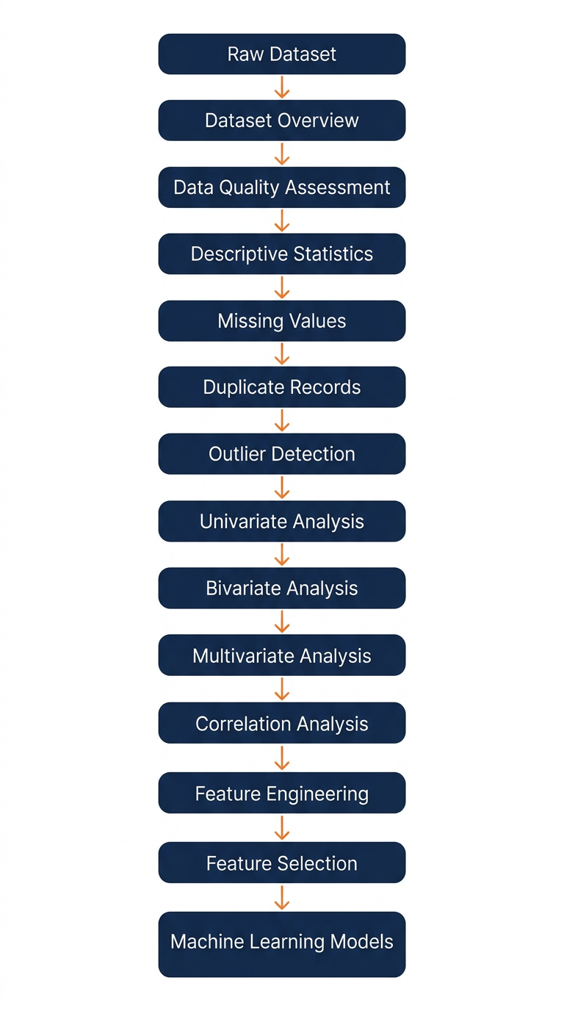
Raw Dataset
│
▼
Dataset Overview
│
▼
Data Quality Assessment
│
▼
Descriptive Statistics
│
▼
Missing Values
│
▼
Duplicate Records
│
▼
Outlier Detection
│
▼
Univariate Analysis
│
▼
Bivariate Analysis
│
▼
Multivariate Analysis
│
▼
Correlation Analysis
│
▼
Feature Engineering
│
▼
Feature Selection
│
▼
Machine Learning Models
I recommend, EDA section to include at least 10–12 analytical techniques rather than limiting it to basic plots. This encourages a deeper understanding of the data and aligns more closely with the analytical workflows. For Supply Chain, add ABC analysis and STL seasonality decomposition.
Preprocessing
- • Missing values
- • Encoding
- • Normalization
- • Outlier handling (IQR capping)
ML Models
- • XGBoost
- • LightGBM
- • LSTM
- • Temporal Fusion Transformer (TFT) — Ensemble
- • Delay-Risk Classifier (Random Forest / XGBoost)
Explainability
- • SHAP
- • TFT Attention (Interpretable Multi-Head Attention)
- • What-If Simulator
Visualization
- • Forecast vs. Actual Chart (Plotly)
- • Heatmap (Demand × Warehouse / Risk)
- • Boxplot / SHAP Beeswarm
- • Feature Importance Graph
- • Dashboard (Streamlit + FastAPI)
Comparative Analysis
- Compare
- ARIMA
- Random Forest
- XGBoost
- LightGBM
- LSTM
- TFT
- Ensemble (Weighted)
Metrics
- Accuracy (for delay) / MAE / RMSE
- Precision
- Recall
- F1
- ROC / R² / MAPE
Recommended Research Pipeline:
Benchmark Dataset
│
▼
Data Cleaning
│
▼
EDA
│
▼
Feature Engineering
│
▼
Feature Selection
│
▼
Train-Test Split (TimeSeriesSplit)
│
▼
ML Models
(XGBoost / LightGBM / LSTM / TFT / Ensemble)
│
▼
Performance Evaluation
(MAE / RMSE / MAPE / F1 / ROC)
│
▼
Optimization Layer
(Safety Stock / ROP / EOQ / Delay Risk)
│
▼
Explainable AI
(SHAP + TFT Attention + What-If)
│
▼
Visualization Dashboard
│
▼
Comparative Analysis
│
▼
Research Conclusions & Deployment
(Docker / FastAPI / Cloud)
Figure — Complete Flow Architecture (One Picture)
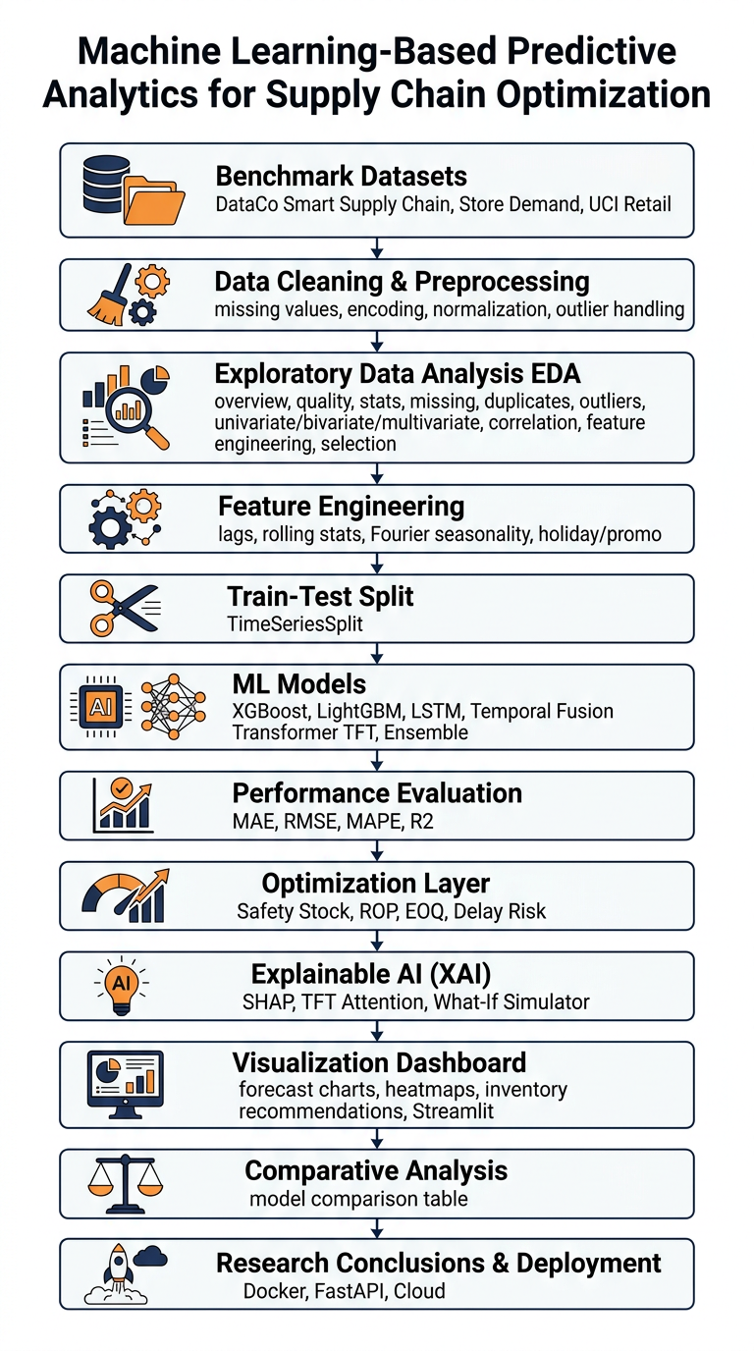
Note: These datasets combination is particularly strong because it covers logistics, demand time-series and e-commerce retail. It also enables meaningful comparisons across different supply chain environments and is well aligned with current Supply Chain 4.0, Predictive Analytics and Explainable AI research.
Dear students, This will be Perfect Project for your resume for specialization in Data Science and Supply Chain Analytics.

