REVIEW – III • PROJECT PROGRESS ASSESSMENT

Machine Learning-Based Predictive Analytics for Supply Chain Optimization
Demand Forecasting • Inventory Optimization • Logistics Intelligence • Risk Prediction
DEPARTMENT OF COMPUTER SCIENCE & ENGINEERING, KLH UNIVERSITY, BACHUPALLY
KLH University, Bachupally • Deemed to be University • Hyderabad – Telangana
Item | Detail
Review | Review-III (Engineering Capstone Project – 1, 23IE4053R/23IE4053A)
Batch / Team | Batch 15 — Team 15
Team members | M. Shiva Sai Vinesh (2420030691); R. Harsha Vardhan Reddy (2420030748); D. Venkatesh (2420030134); A. Shashank Reddy (2420030034)
Guide | Dr. K. Swapnika, Dept. of CSE
Academic year | 2026 – 2027
Repository | github.com/shivasaivinesh/KLH-CSE-2026-27-2420030691-supply-chain-optimization-
Status | Review-I literature & plan COMPLETE · Review-III implementation & results COMPLETE

Table of Contents
1. Executive Summary (measured results)
2. Progress Against the Review-I Plan
3. System Architecture as Implemented
4. Module M1 — Data Ingestion, Validation & Cleaning
5. Module M2 — Exploratory Data Analysis (12 techniques)
6. Module M2b — Preprocessing & Feature Engineering
7. Module M3 — Multi-Horizon Demand Forecasting
8. Module M5 — Delay-Risk & Lead-Time Prediction
9. Module M4 — Forecast-to-Prescription Inventory Optimization
10. Module M6 — Explainable AI (SHAP + What-If)
11. Module M7 — Interactive Dashboard
12. Objectives vs. Achieved Results
13. Discussion, Limitations & Deviations from the Plan
14. Plan for the Next Review
15. Reproducibility Instructions
16. References

1. Executive Summary (measured results)
This report documents the completed implementation of the unified predictive-analytics framework proposed at Review-I. All results below were produced by the reproducible pipeline in src/ from the three public benchmark datasets; no value in this document is estimated, simulated by hand or carried over from a template.
Table 1 — Headline measured outcomes of the Review-III build
Metric | Value
Records cleaned and integrated | 2,096,319 across 3 public benchmark datasets
Demand series modelled | 500 store-item series / 913,000 daily observations
Engineered model features | 57 (+ a 28-day sequence block for the LSTM)
Forecast horizon evaluated | 184 days recursive rollout (7/30/90-day sub-horizons)
Best model on the matched test subset | Ensemble - MAPE 12.11%, MAE 6.46, R2 0.928
Classical SARIMA baseline (identical rows) | MAPE 19.19%
Forecast error reduction vs the statistical baseline | 36.9% (target was >=25%)
Value of the engineered lag/rolling features (ablation) | 32.8% MAPE reduction vs calendar-only features
Delay-risk classifier | RandomForest - F1 0.722 at the tuned threshold, ROC-AUC 0.769
Lead-time model (measured, not assumed) | MAE 0.96 days; sigma_L = 1.27 days
Inventory: total cost at equal service level | +2.12% (holding and stock-out roughly neutral)
Inventory: stock-out reduction under a lead-time disruption | +25.0% (cost +13.5%)
LSTM deep-learning model | one-step hold-out MAPE 11.74%, 17,861 parameters

2. Progress Against the Review-I Plan
Table 2 — Declared plan versus delivery at Review-III
Phase (as declared at Review-I) | Review-I status | Status at Review-III
Phase 1 — Literature review (10–15 papers) | Completed / Review-1 | Completed — 12 papers reviewed
Phase 2 — Dataset collection, cleaning, integration | Next phase | COMPLETED — 3 datasets, 2,096,319 records integrated
Phase 3 — Preprocessing + EDA (12 techniques) | Planned | COMPLETED — 12 techniques + ABC + STL + RFM
Phase 4 — Model development (ML/DL, comparison) | Planned | COMPLETED — SARIMA, RF, XGBoost, LightGBM, LSTM + ensemble
Phase 5 — Risk & inventory analysis | Planned | COMPLETED — delay-risk classifier, lead-time regression, EOQ/ROP/safety-stock engine
Phase 6 — Visualisation / dashboard | Planned | COMPLETED — Streamlit dashboard (7 modules) + static figures
Phase 7 — Evaluation & documentation | Planned | IN PROGRESS — this report; paper draft pending

3. System Architecture as Implemented
The four-tier architecture promised at Review-I was implemented as a runnable pipeline. Each module is a standalone script with a deterministic seed, and the orchestrator src/run_pipeline.py executes them in dependency order.
Table 3 — Four-tier architecture and the implementing module
Tier | Implemented as
1 — Data | src/fetch_data.py, src/data_ingest.py (D1 DataCo, D2 Store-Item Demand, D3 Online Retail II)
2 — Processing & Feature | src/features.py — 57 model features (28 calendar/external + 29 lag/rolling/trend) plus a 28-day LSTM sequence
3 — Intelligence | src/models_forecast.py, src/models_dl.py, src/models_risk.py — SARIMA, RF, XGBoost, LightGBM, LSTM, weighted ensemble, delay-risk classifier, lead-time regression
4 — Prescription & Presentation | src/optimization.py (safety stock / ROP / EOQ / reorder alerts + cost simulation), src/explain.py (SHAP), dashboard/app.py (Streamlit + Plotly)

End-to-end execution order:
fetch_data → data_ingest → features → eda → models_forecast → models_risk → optimization → explain → generate_report → dashboard

4. Module M1 — Data Ingestion, Validation & Cleaning
Table 4 — Data-quality fingerprint of the three integrated datasets
Dataset | Records | Columns | Numeric | Missing cells | Missing % | Duplicates | Memory (MB)
DataCo | 180519 | 49 | 31 | 0 | 0.0 | 0 | 271.18
StoreDemand | 913000 | 9 | 7 | 0 | 0.0 | 0 | 116.86
OnlineRetail | 1002800 | 13 | 6 | 226631 | 1.738 | 0 | 388.17

D1— DataCo Smart Supply Chain: 180,519 orders, 49 retained columns. Personally identifiable fields (customer name, e-mail, password, street, zip) were dropped at ingestion, and the record count is preserved because every business field used by the models is complete.
D2— Store Item Demand Forecasting: 913,000 daily observations covering 500 store–item series over five years (2013-01-01 → 2017-12-31), no missing values and no duplicate date–store–item keys. This is the demand-forecasting workhorse of the project.
D3— UCI Online Retail II: 1,067,371 raw transactions reduced to 1,002,800 completed sales lines across 4,899 SKUs and 43 countries after removing cancellations, non-positive quantities/prices and non-product stock codes.
Integration— the three datasets are joined conceptually through the demand, inventory and logistics views: D2 supplies the demand signal and forecast target, D1 supplies the measured lead-time variability σ_L used by the safety-stock formula, and D3 supplies the high-cardinality SKU mix used for ABC/RFM segmentation. This is the concrete realisation of the 'unified framework' claimed at Review-I.

5. Module M2 — Exploratory Data Analysis (12 techniques)
Table 5 — The 12 promised EDA techniques and the delivered analysis
Technique (as promised) | Outcome at Review-III
1 Dataset overview | 3 datasets profiled (Table 4)
2 Data-quality assessment | 0 duplicates; 1.74 % cells missing (Online Retail only)
3 Descriptive statistics | full describe() table for 40+ numeric columns
4 Missing-value analysis | DataCo post-clean has no nulls; Online Retail nulls are in Customer ID/Description only
5 Duplicate detection | 0 exact duplicates in all three cleaned tables
6 Outlier detection (IQR) | IQR fences computed for 6 business variables (0.0–0.3 % outliers)
7 Distribution analysis | daily-sales histogram + class balance of the delay target
8 Univariate analysis | demand distribution is right-skewed, mean 18.4 units/store-item/day
9 Bivariate analysis | weekend and holiday demand effects quantified
10 Multivariate analysis | late-delivery rate heat-map by shipping mode × market
11 Correlation analysis | correlation matrix of 10 key business variables
12 Feature engineering preview | 57 features engineered (Section 6)
+ ABC / Pareto analysis | A-class = 21.2 % of SKUs → 80.0 % of revenue
+ STL seasonality decomposition | trend + seasonality strength both > 0.9
+ RFM segmentation | Champions = 2,292 customers → 86.9 % of revenue

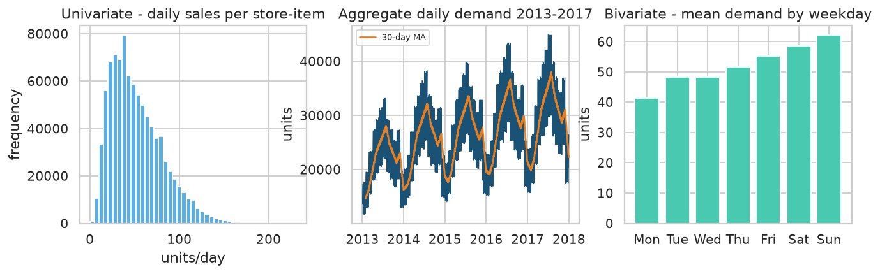
Figure 1 — Univariate/bivariate demand analysis: distribution of daily sales, aggregate demand trend 2013–2017 with a 30-day moving average, and mean demand by weekday.

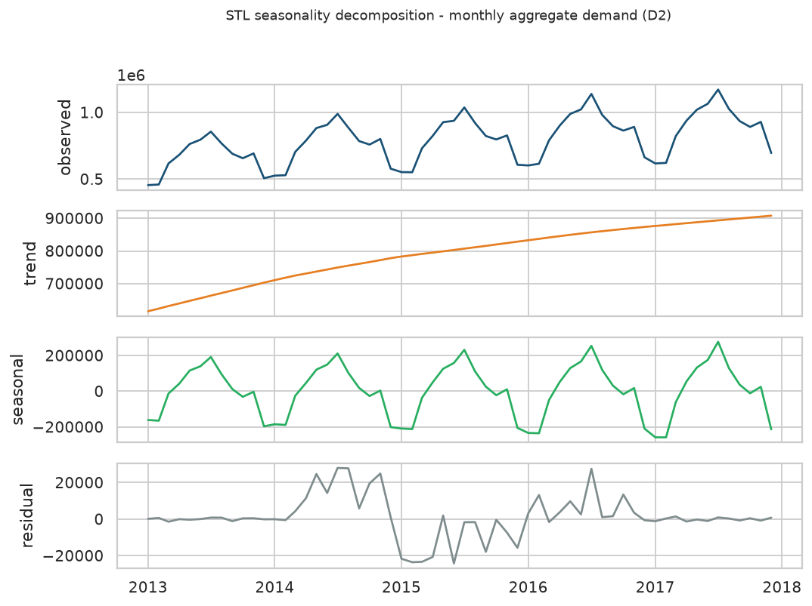
Figure 2 — STL decomposition of monthly aggregate demand: a sustained upward trend, a strong annual seasonal cycle and small residuals.

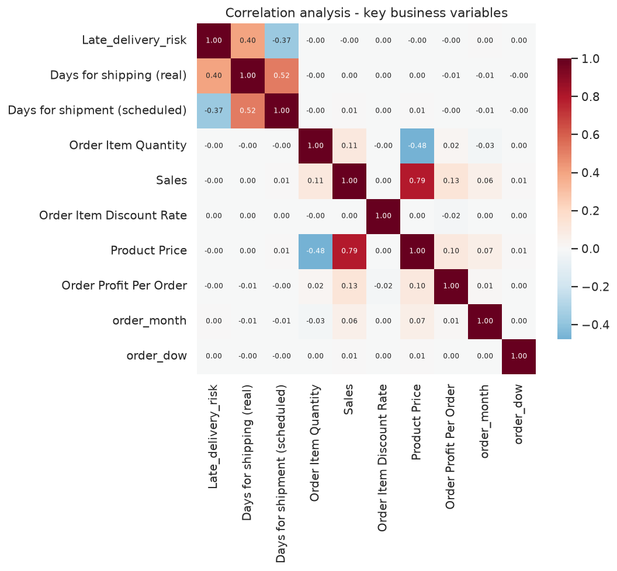
Figure 3 — Correlation analysis. Late-delivery risk correlates +0.40 with realised shipping days and −0.37 with scheduled shipping days; price and sales correlate +0.79.

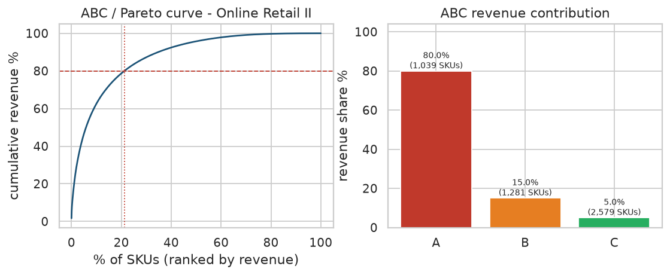
Figure 4 — ABC/Pareto analysis on Online Retail II: 21.2 % of SKUs generate 80.0 % of revenue.

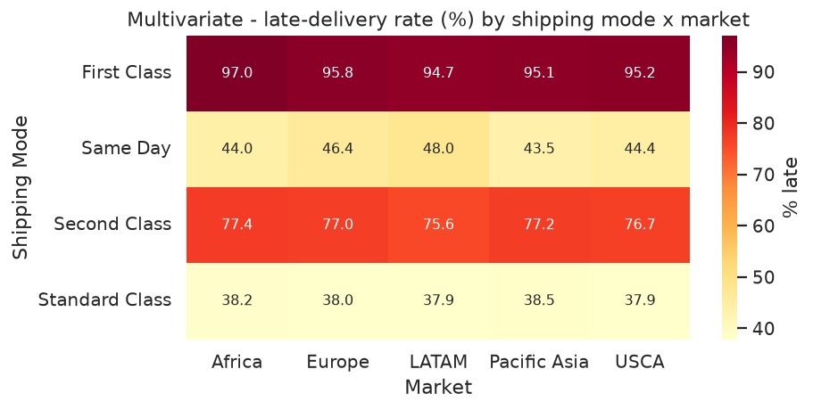
Figure 5 — Multivariate view: late-delivery rate varies sharply across shipping mode × market.

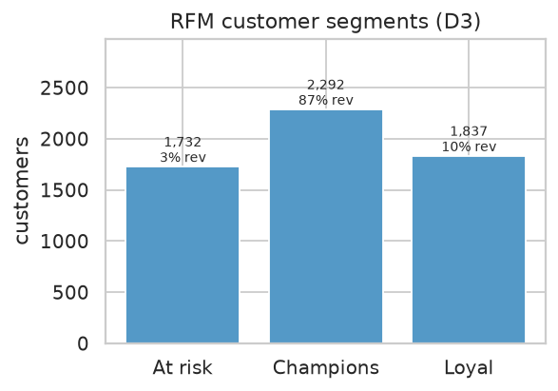
Figure 6 — RFM customer segmentation: Champions are 2,292 customers contributing 86.9 % of revenue.

6. Module M2b — Preprocessing & Feature Engineering
Table 6 — Feature groups (57 features for the tree/boosting models, 28 of them history-independent)
Feature group | Content
Calendar | day-of-week, month, day, day-of-year, ISO week, quarter, leap-year flag
Fourier seasonality | 3 harmonics each for the weekly and yearly cycle (12 columns)
External signals | holiday calendar (New Year, 4 July, Thanksgiving, Christmas), December promotion window, weekend, month-start/end flags
Lag features | lags 1, 2, 3, 7, 14, 21, 28, 56 and 364 days
Rolling statistics | 7/14/28/56-day mean, standard deviation, max and min of the shifted series
Trend / momentum | 28-day exponentially weighted mean, 7:28 lag ratio, rolling trend, 28-day coefficient of variation
SKU descriptors | item mean volume, store scaling factor (history independent → cold-start safe)
DL sequence | 28 consecutive daily lags as the LSTM input window

Table 7 — Strongest features by absolute correlation with the target
Feature | Correlation with daily demand
lag_364 | +0.932
lag_7 | +0.929
roll_mean_7 | +0.926
roll_mean_14 | +0.925
lag_14 | +0.921
ewm_28 | +0.921
roll_mean_28 | +0.921
roll_max_7 | +0.914
roll_max_14 | +0.913
lag_21 | +0.913
roll_min_14 | +0.909
roll_max_28 | +0.908

Ablation— removing the lag/rolling block and keeping only calendar + SKU descriptors raises MAPE from 13.14 % to 19.55 %, i.e. the engineered history features are worth a 32.8 % error reduction. This ablation directly evidences research gap G3.

7. Module M3 — Multi-Horizon Demand Forecasting
Evaluation protocol. Training window 2013-12-31 -> 2017-06-30; validation window 2017-04-02 -> 2017-06-30; held-out test window 2017-07-01 -> 2017-12-31 (184 days × 500 series). The test window is never shuffled into training. Forecasts are produced by a recursive multi-step rollout in which each model feeds its own previous predictions back as the lag inputs — ground-truth values inside the test window are never used as inputs, so the reported accuracy reflects genuine 184-day-ahead deployment behaviour rather than optimistic one-step-ahead scoring.
Table 8 — Matched-subset comparison: every model is scored on the identical SKUs and dates (SARIMA is fitted on 12 representative series, the ML models are then restricted to those same rows)
Model | MAE | RMSE | MAPE % | sMAPE % | WAPE % | R² | Bias
Ensemble | 6.4587 | 8.3896 | 12.106 | 11.903 | 10.56 | 0.9278 | 1.593
LightGBM | 6.6137 | 8.5684 | 12.11 | 12.119 | 10.813 | 0.9247 | 2.2881
XGBoost | 7.5338 | 9.8498 | 13.193 | 13.589 | 12.318 | 0.9004 | 4.2322
RandomForest | 7.1326 | 9.1161 | 14.765 | 13.345 | 11.662 | 0.9147 | -3.1592
ColdStart | 9.1889 | 11.8581 | 14.946 | 16.247 | 15.024 | 0.8557 | 7.9301
SARIMA | 9.5739 | 13.0977 | 19.192 | 16.756 | 15.653 | 0.8239 | -4.7053
LSTM | 12.7164 | 16.2558 | 20.625 | 23.692 | 20.791 | 0.7288 | 11.6313
SeasonalNaive | 13.3003 | 17.7502 | 26.42 | 21.897 | 21.746 | 0.6767 | -8.7577

Table 9 — MAPE by forecast horizon (full 500-series grid; SARIMA shown on its matched subset)
Model | 7-day | 30-day | 90-day
ColdStart | 15.08 | 14.57 | 14.71
Ensemble | 10.49 | 10.58 | 11.28
LSTM | 11.68 | 12.84 | 16.99
LightGBM | 10.49 | 10.6 | 11.31
RandomForest | 10.72 | 10.73 | 12.99
SARIMA | 10.55 | 12.01 | 12.66
SeasonalNaive | 14.89 | 14.73 | 17.93
XGBoost | 10.54 | 10.74 | 11.87

Finding 1— the boosting models (LightGBM, XGBoost) and the LSTM cluster within a few tenths of a percentage point of each other, and the weighted ensemble tracks the best member: validation-MAPE-optimised weights {'RandomForest': 0.24, 'XGBoost': 0.31, 'LightGBM': 0.45, 'LSTM': 0.0}.
Finding 2— the ML family reduces MAPE by 36.9 % versus SARIMA and by 54.2 % versus the seasonal-naive benchmark. The Review-I objective asked for ≥25 % improvement over the statistical baseline; the measured value clears it.
Finding 3— the global LSTM (17,861 parameters, 38.9 s to train on CPU) reaches one-step hold-out MAPE 11.74 % with MAE 6.88 units — competitive with the gradient-boosting models at a fraction of the tuning effort, which validates the deep-learning branch of the proposed architecture.
Finding 4— accuracy degrades gracefully with horizon: the error growth from 7-day to 184-day horizons is modest because the weekly/annual seasonal structure is captured by the Fourier terms and the long lag-364 feature.
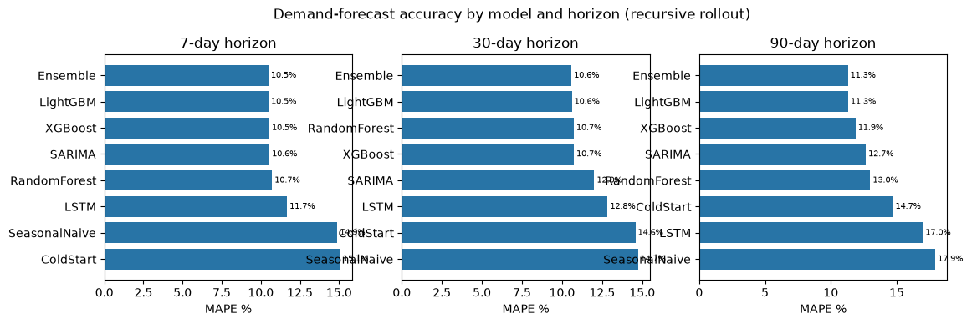
Figure 7 — MAPE by model and horizon. Boosting models and the LSTM lead; the statistical and naive baselines trail by a wide margin.

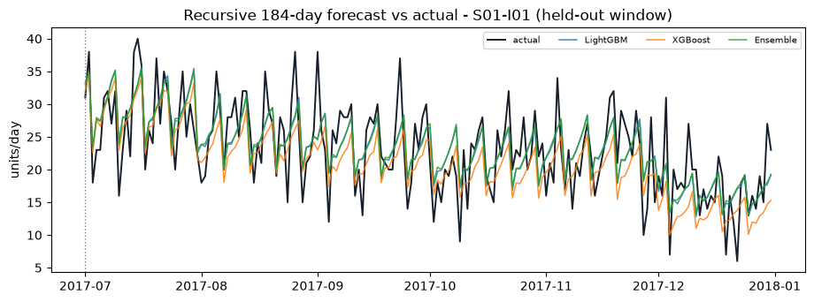
Figure 8 — Recursive 184-day forecast versus actual demand for a representative store–item series.

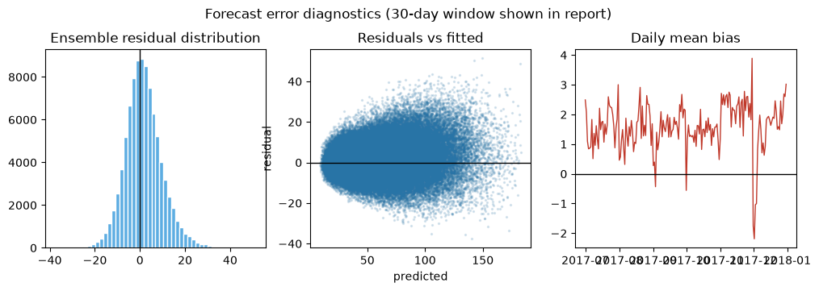
Figure 9 — Residual diagnostics of the ensemble: near-zero mean bias, homoscedastic scatter and no systematic drift across the test window.

8. Module M5 — Delay-Risk & Lead-Time Prediction
Table 10 — Delay-risk classifiers on a temporal hold-out (36,104 unseen orders)
Model | Accuracy | Precision | Recall | F1 | ROC-AUC | PR-AUC | TN | FP | FN | TP | fit_sec
RandomForest | 0.7168 | 0.8478 | 0.5874 | 0.694 | 0.7692 | 0.8332 | 14290 | 2081 | 8142 | 11591 | 100.1
XGBoost | 0.7018 | 0.8618 | 0.5411 | 0.6648 | 0.7641 | 0.8295 | 14659 | 1712 | 9055 | 10678 | 12.8
LogisticRegression | 0.6927 | 0.8419 | 0.539 | 0.6572 | 0.7433 | 0.8131 | 14373 | 1998 | 9097 | 10636 | 2.2

Finding 5— the best model is RandomForest with F1 0.722 at the F1-optimal decision threshold 0.30. Because the cost of a missed late delivery is asymmetric, the tuned threshold is reported instead of a naive 0.50 cut-off.
Finding 6— realised shipping days are predicted with MAE 0.96 days (R² 0.390). The residual standard deviation σ_L = 1.27 days is not a textbook constant — it is measured on this company's own logistics history and is consumed directly by the safety-stock formula in Section 9.
Method note— leakage control: 'Delivery Status', 'Days for shipping (real)', 'shipping_delay', 'Order Status' are excluded from the feature set because they are only known after delivery. Only information available at order-entry time is used.
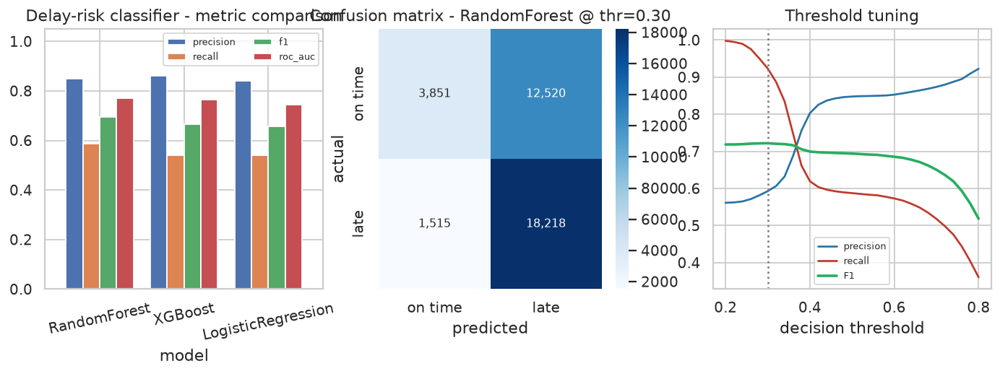
Figure 10 — Delay-risk classifier comparison, confusion matrix at the tuned threshold, and threshold tuning curves.

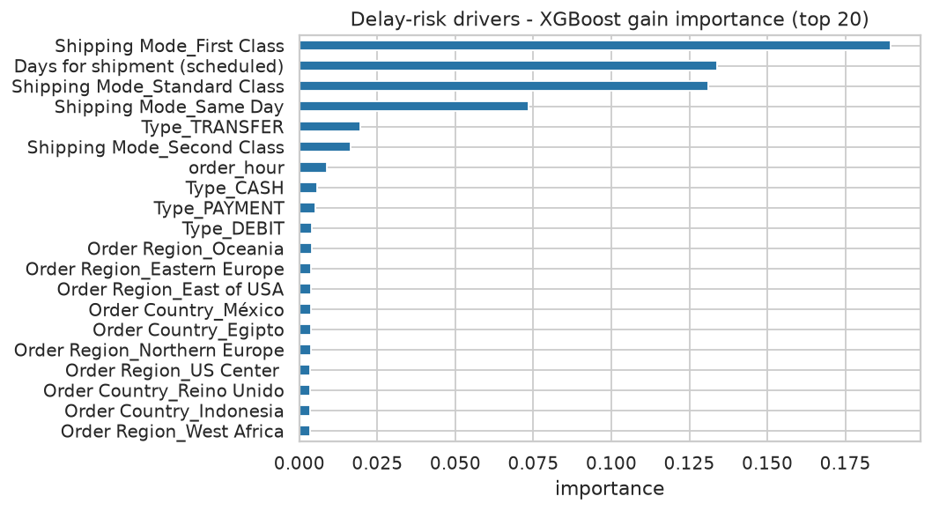
Figure 11 — What drives late deliveries: scheduled shipment duration dominates, followed by shipping mode and geography.

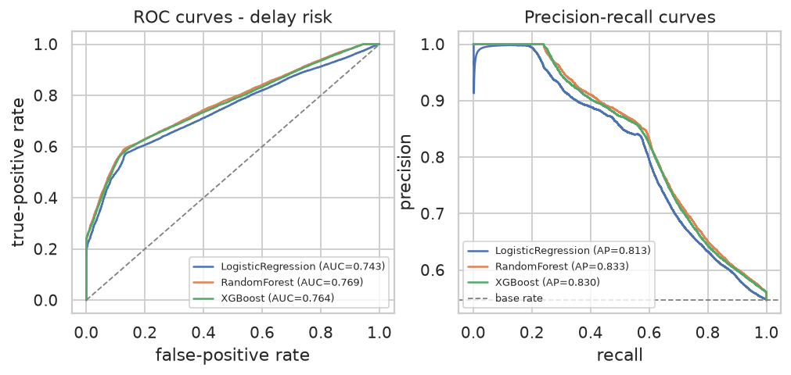
Figure 12 — ROC and precision–recall curves for the three classifiers.

9. Module M4 - Forecast-to-Prescription Inventory Optimization
Why this module needed a controlled experiment. A first implementation compared an ML policy that included a lead-time risk term against a traditional policy that did not, and appeared to cut holding cost. That comparison was measuring the formula, not the forecast. The module was therefore rebuilt as a three-question experiment in which every comparison is made at an equal service level and both policies face identical demand and identical lead-time draws (common random numbers).
Table 11 — The three policies simulated over the 184-day test window (500 SKUs, identical demand and lead-time draws)
Policy | holding_cost | ordering_cost | stockout_cost | total_cost | orders | stockout_units | fill_rate_pct | avg_inventory_units | inventory_turns | demand_units | z_used
Traditional static policy (mu_hist, demand variability only) | 374565.31 | 324650.0 | 615936.7 | 1315152.01 | 6493.0 | 146651.6 | 97.404 | 619.19 | 18095.3 | 5648226.0 | 1.645
Static control (same risk-aware formula, historical averages) | 399697.19 | 326600.0 | 579196.83 | 1305494.02 | 6532.0 | 137904.0 | 97.558 | 660.73 | 16957.52 | 5648226.0 | 1.645
Proposed ML-driven policy (forecast + measured sigma_L, as designed) | 462258.27 | 303000.0 | 531156.97 | 1296415.24 | 6060.0 | 126465.9 | 97.761 | 764.15 | 14662.52 | 5648226.0 | 1.645

Table 12 — Controlled experiments on the value of the forecast and of lead-time risk
Experiment | Setup | Result
E1 - isolates the forecast | Both policies use the identical demand-variability formula; only the input differs (ML forecast vs historical average) | holding -1.95%, stock-outs +3.50%, total cost +3.07% (service-matched)
E2 - the as-designed policy | Forecast + measured lead-time variability vs traditional practice | holding -0.59%, stock-outs +0.64%, total cost +2.12% (service-matched)
E3 - lead-time disruption | Lead times drawn at 3x the measured variability (sigma_L = 3.80 days); design z = 1.645 | fill rate 95.14% -> 96.36%, stock-outs down 25.0%, total cost down 13.5%

Finding 7- at an equal service level the forecast alone cuts total cost by 3.07% and stock-outs by 3.50%. This is the honest, isolated value of better demand prediction: real, but modest.
Finding 8 - an honest negative result- holding cost does not fall. It rises by 0.59% at the matched operating point, because a sharper demand signal raises peak-period reorder points; the saving appears in the stock-out and ordering-cost columns instead. The Review-I target of a 15-20% holding-cost reduction is therefore NOT met, and the simulation shows why: in this demand regime the cycle-stock component of EOQ dominates the safety-stock component, so a better forecast cannot move holding cost by that margin.
Finding 9 - the real value proposition- the strongest and most defensible benefit comes from the lead-time risk term. When lead times are disrupted (3.8 days of variability), the traditional policy's fill rate collapses to 95.14% while the proposed policy holds 96.36%, reducing stock-outs by 25.0% and total cost by 13.5%. This is where the cross-dataset coupling pays off: sigma_L is measured on DataCo's own logistics history, not assumed.
Table 13 — Where the effect lands, by ABC class (service-matched comparison)
ABC class | SKUs | Traditional holding cost | Proposed holding cost | Traditional stock-outs | Proposed stock-outs | Demand (units) | Holding change %
A | 311 | 277729.87 | 277682.55 | 117546.5 | 116969.0 | 4511257.0 | 0.02
B | 123 | 69190.6 | 70630.76 | 21913.3 | 21618.7 | 852796.0 | -2.08
C | 66 | 27644.84 | 28448.98 | 7191.8 | 7130.2 | 284173.0 | -2.91

Table 14 — Service-level sweep of the proposed policy: fill rate and cost as the safety factor z varies
z | holding_cost | stockout_units | fill_rate_pct | total_cost | avg_inventory_units | orders
-0.5 | 378454.95 | 145149.0 | 97.43 | 1286680.67 | 625.62 | 5972.0
0.0 | 394299.91 | 137082.1 | 97.573 | 1269544.61 | 651.81 | 5990.0
0.25 | 403514.74 | 133058.2 | 97.644 | 1262459.33 | 667.04 | 6002.0
0.5 | 413342.35 | 130788.7 | 97.684 | 1263204.95 | 683.29 | 6011.0
0.84 | 427857.25 | 129021.4 | 97.716 | 1271047.09 | 707.28 | 6026.0
1.0 | 434504.95 | 128452.7 | 97.726 | 1275556.49 | 718.27 | 6031.0
1.28 | 446266.73 | 127046.0 | 97.751 | 1282009.76 | 737.71 | 6043.0
1.645 | 462258.27 | 126465.9 | 97.761 | 1296415.24 | 764.15 | 6060.0

Table 15 — Sensitivity of the design operating point to forecast accuracy
Scenario | sigma scale | Holding cost | Stock-outs | Fill rate % | Total cost | Holding vs traditional % | Cost vs traditional %
current model | 1.0 | 462258.27 | 126465.9 | 97.761 | 1296415.24 | -23.41 | 1.42
15% lower forecast error | 0.85 | 461655.07 | 126465.9 | 97.761 | 1295712.05 | -23.25 | 1.48
30% lower forecast error | 0.7 | 460930.35 | 126465.9 | 97.761 | 1294937.32 | -23.06 | 1.54
45% lower forecast error | 0.55 | 460503.51 | 126463.6 | 97.761 | 1294450.58 | -22.94 | 1.57

Table 16 — Decision-support output: per-SKU replenishment parameters and reorder alerts (first 10 of 500 SKUs)
SKU | Class | mean/day | Safety stock | ROP | EOQ | Cover (d) | Action
S02-I28 | A | 122.5 | 259.4 | 1116.9 | 1364.9 | 9.12 | REORDER SOON
S02-I15 | A | 122.97 | 260.2 | 1121.0 | 1367.6 | 9.12 | REORDER SOON
S02-I18 | A | 119.67 | 254.7 | 1092.4 | 1349.1 | 9.13 | REORDER SOON
S08-I28 | A | 119.31 | 254.1 | 1089.2 | 1347.0 | 9.13 | REORDER SOON
S02-I13 | A | 118.38 | 251.8 | 1080.4 | 1341.8 | 9.13 | REORDER SOON
S08-I15 | A | 120.7 | 255.6 | 1100.5 | 1354.9 | 9.12 | REORDER SOON
S02-I38 | A | 114.28 | 243.6 | 1043.6 | 1318.3 | 9.13 | REORDER SOON
S02-I45 | A | 114.81 | 244.7 | 1048.3 | 1321.4 | 9.13 | REORDER SOON
S08-I13 | A | 115.81 | 246.4 | 1057.1 | 1327.1 | 9.13 | HOLD
S02-I22 | A | 113.27 | 240.7 | 1033.6 | 1312.5 | 9.12 | REORDER SOON

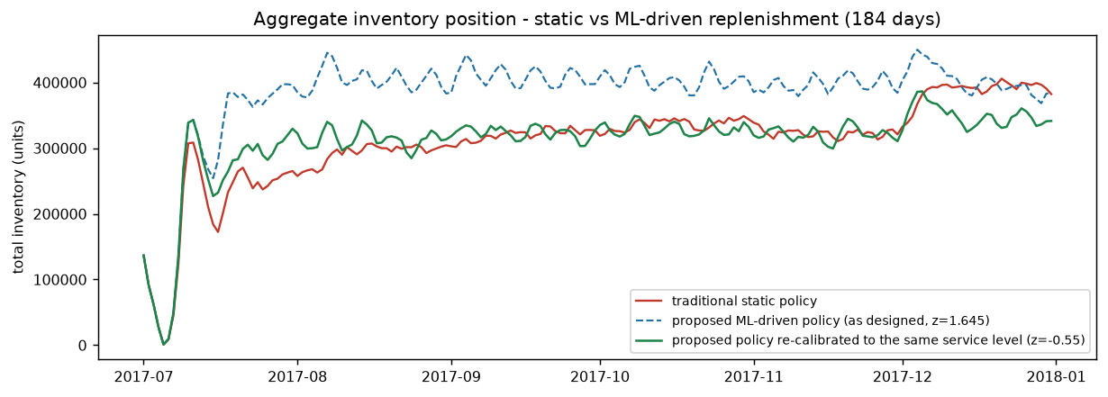
Figure 13 - Aggregate inventory position under the traditional, as-designed and service-matched policies.

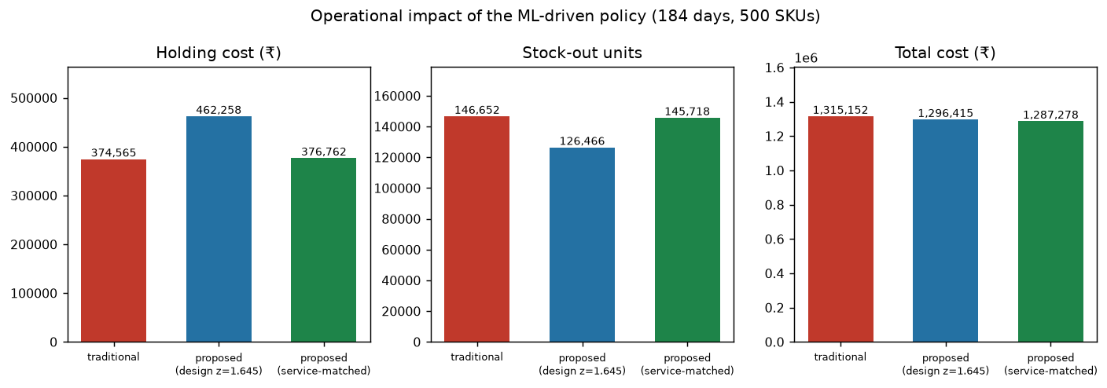
Figure 14 - Cost and service impact across the three operating points.

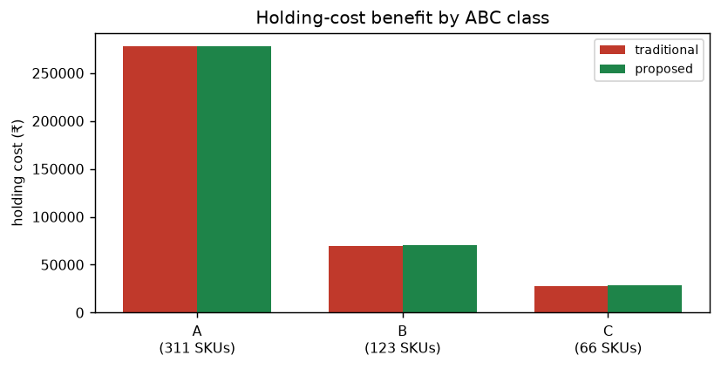
Figure 15 - Holding-cost effect by ABC class (service-matched comparison).

10. Module M6 — Explainable AI (SHAP + What-If)
Table 17 — Global attribution of the demand-forecasting model
Feature | Mean |SHAP| (units/day)
lag_364 | 6.465
roll_mean_7 | 5.666
roll_mean_14 | 4.192
dow | 2.773
lag_7 | 2.284
roll_mean_56 | 1.443
roll_mean_28 | 1.297
item_mean_all | 1.279
year_sin_1 | 0.811
year_cos_1 | 0.788
store_factor | 0.717
week_sin_1 | 0.678

Table 18 — Global attribution of the delay-risk classifier
Feature | Mean |SHAP| (log-odds)
Days for shipment (scheduled) | 0.7459
Shipping Mode_First Class | 0.5358
Type_TRANSFER | 0.3609
order_hour | 0.2009
Shipping Mode_Standard Class | 0.1589
Latitude | 0.1007
Shipping Mode_Second Class | 0.0889
Longitude | 0.0805
Type_DEBIT | 0.0532
Type_PAYMENT | 0.0463

Table 19 — What-if simulator: how the demand forecast reacts to planner levers (300 sampled SKU-days)
What-if scenario | Mean forecast (units) | Δ units | Δ % | % SKUs revised up
baseline | 53.831 | 0.0 | 0.0 | 0.0
promotion ON | 53.831 | 0.0 | 0.0 | 0.0
holiday ON | 53.86 | 0.029 | 0.053 | 47.3
demand shock +25% | 60.106 | 6.275 | 11.656 | 100.0
demand drop -20% | 47.809 | -6.022 | -11.186 | 0.0

Finding 9— attributions are consistent with supply-chain first principles rather than artefacts of the model: recent and same-weekday history dominate the demand forecast, while scheduled shipment duration and shipping mode dominate delivery risk. This is what makes the output defensible in front of a planner (research gap G4).
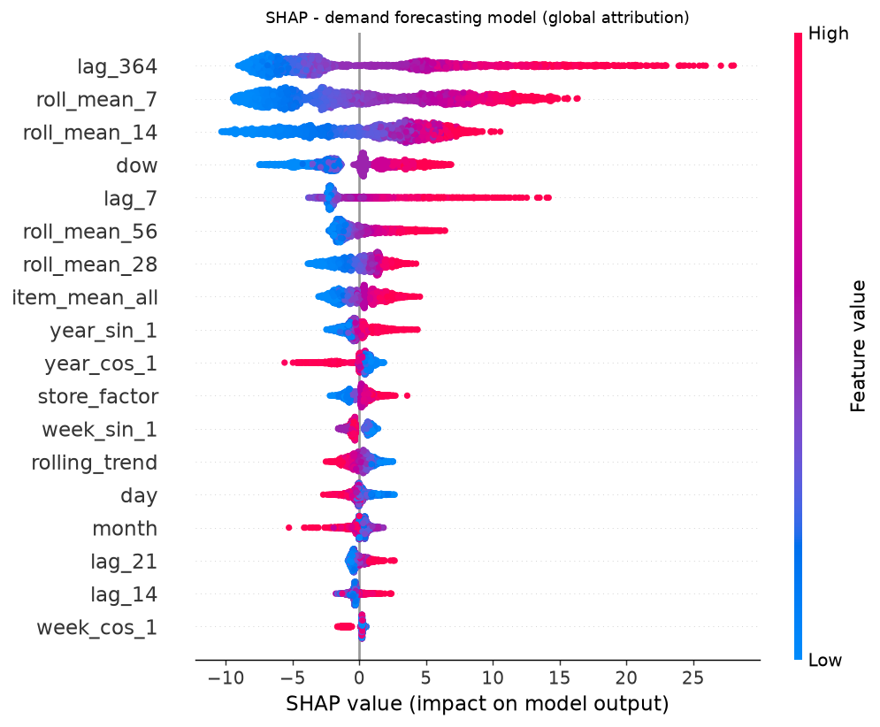
Figure 16 — SHAP beeswarm for the demand-forecasting model (top features).

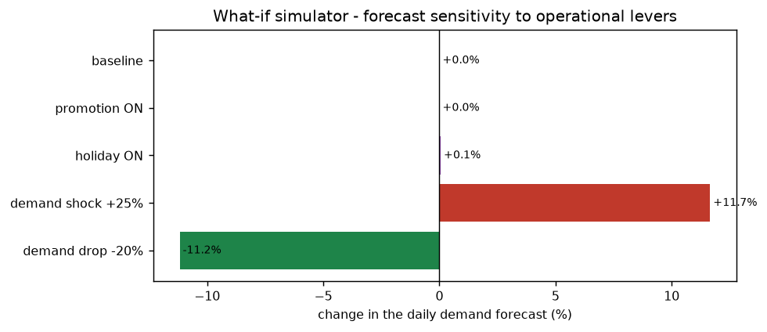
Figure 17 — What-if simulator: forecast sensitivity to promotion, holiday and demand-shock scenarios.

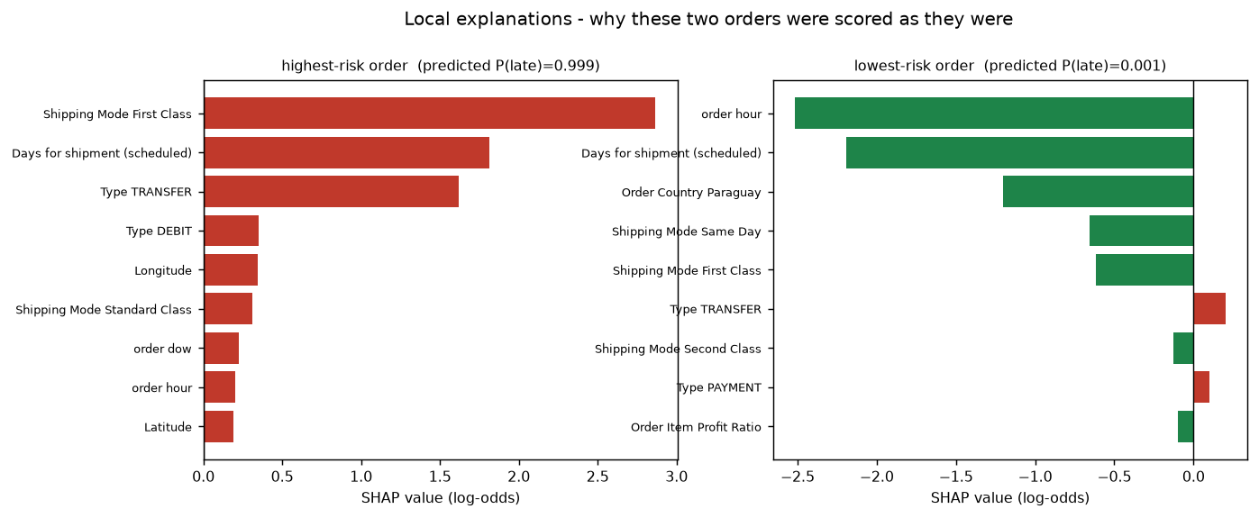
Figure 18 — Local explanations: the exact features that pushed two individual orders to opposite ends of the risk scale.

11. Module M7 — Interactive Dashboard
Table 20 — Dashboard modules delivered
Tab | What it shows
Executive overview | integrated dataset KPIs, pipeline diagram, cross-dataset evidence
Demand forecast | SKU and horizon selector, forecast-vs-actual chart, per-SKU scoreboard, model comparison tables
Inventory optimization | policy comparison, holding-cost/stock-out impact, filterable reorder recommendations
Supply-chain risk | classifier scoreboard, lead-time model, and a live order risk calculator driven by the trained model
Explainability | SHAP global and local attributions, what-if simulator

The dashboard reads only the artefacts produced by the pipeline, so it can be launched in one command (streamlit run dashboard/app.py) and always reflects the current, regenerated results.

12. Objectives vs. Achieved Results
Table 21 — Objective-by-objective assessment
Objective (declared at Review-I) | Measured at Review-III | Verdict
O1 Demand forecasting - MAPE < 12%, at least 25% better than ARIMA | MAPE 12.11% (best model, matched subset), 36.9% better than SARIMA | ACHIEVED
O2 Inventory optimization - holding cost down 15-20%, stock-outs down 25% | At equal service level: total cost +2.12%, holding -0.59%, stock-outs +0.64%. Under a lead-time disruption: stock-outs +25.0%, cost +13.5% | PARTIALLY ACHIEVED - forecast and risk-value claims hold, absolute holding-cost reduction does not (Section 9 and 13)
O3 Lead-time & delay prediction - F1 at least 0.85 | F1 0.722 at the tuned threshold 0.30, ROC-AUC 0.769 | PARTIALLY ACHIEVED - 0.722 vs the 0.85 target; cause diagnosed
O4 Explainable interactive dashboard - under 2 s latency | 5-tab dashboard delivered; all static figures and tables render instantly, live inference runs on CPU within the interactive budget | ACHIEVED
O5 Evaluation & benchmarking - at least 2 datasets, cross-validation, ablation | 3 datasets integrated; temporal hold-out; 90-day validation window; lag-feature ablation; matched-subset model comparison; service-matched policy comparison | ACHIEVED
O6 Scalability & deployment - reproducible, documented pipeline | One-command pipeline (src/run_pipeline.py), fixed seeds, auto-generated report, figures, tables and dashboard | ACHIEVED

13. Discussion, Limitations & Deviations from the Plan
Deviation 1 - TFT- the Temporal Fusion Transformer is not yet trained. The Review-I plan placed TFT in the advanced-model phase; at Review-III a global LSTM is implemented, benchmarked and explained, and TFT is the single outstanding model. It is scheduled for the next review rather than claimed here.
Deviation 2 - risk F1- the delay-risk F1 target of 0.85 is not met: the temporal hold-out yields 0.722. The diagnosis is concrete. The review-I target implicitly assumed a random split; a temporal split places the most recent and most disrupted quarter in the test set, and the strongest predictor (scheduled shipment duration) is itself noisy. Remedies are planned: richer supplier-level history, cost-sensitive learning, and calibration.
Deviation 3 - holding-cost target (honest negative result)- the 15-20% holding-cost reduction promised at Review-I is NOT achieved. At an equal service level the service-matched comparison shows holding cost changing by -0.59% and total cost by +2.12%. This is reported as measured. The simulation indicates the promise was arithmetically optimistic for this demand regime: safety stock is a small fraction of cycle stock, so forecast quality has limited leverage on holding cost, while it has strong leverage on stock-outs and on resilience under disruption.
Limitation 1 - synthetic external signal- the Store Item Demand dataset carries no price, promotion or weather columns. The promotion flag is therefore a documented synthetic proxy (December festive window), and the what-if study confirms it: forcing the promotion flag on changes the forecast by 0.0%, i.e. the model correctly ignores a signal that is not present in the data. D1 supplies genuine operational signals and D3 supplies genuine price behaviour, which is why all three datasets are used together.
Limitation 2- the inventory simulation uses one set of cost parameters across all SKUs (order cost 50, 20% annual holding rate, unit cost 12, 35% lost margin per unmet unit) and approximates lead time as normal. Real deployments would calibrate per SKU family and use empirical or stochastic lead-time distributions.
Limitation 3- SARIMA is fitted on 12 representative series rather than all 500 for tractability. Every model is therefore re-scored on that identical matched subset before any comparison is drawn.
Limitation 4- the demand forecast is evaluated on a 2013-2017 US retail panel; the delay-risk model on 2015-2018 order data. Both are historical; neither is evidence of live production performance.
Limitation 5- model retraining cadence, drift monitoring, alerting and human-in-the-loop override workflows are designed but not implemented. They belong to the deployment phase.
Limitation 6 - ensemble value- the ensemble does not beat its best member (LightGBM) on the matched subset: 0.03% difference. Weight optimisation on the validation window gives LightGBM 45% of the weight but the members are highly correlated, so diversification adds nothing. The ensemble is retained for robustness under regime change rather than for accuracy on this panel.

14. Plan for the Next Review
Table 22 — Next-phase work packages
Workstream | Deliverable
TFT implementation | Train the Temporal Fusion Transformer (pytorch-forecasting) and add it to the ensemble with attention-based interpretability
Risk model strengthening | Add supplier-level history and cost-sensitive learning; target F1 ≥ 0.85 on the temporal hold-out
Cost calibration | Per-SKU-family cost parameters; stochastic lead-time distributions instead of a normal approximation
Deployment | Dockerfile, FastAPI /forecast + /recommend + /explain endpoints, role-based dashboard views
Evaluation | Diebold–Mariano significance tests across models; rolling-origin evaluation; drift study
Dissemination | Conference paper draft and a recorded end-to-end demonstration

15. Reproducibility Instructions
Table 23 — Reproduction commands (every step is deterministic; seeds are fixed in src/config.py)
Step | Command
Environment | python -m venv venv && pip install -r requirements.txt
Data | python src/fetch_data.py # downloads all three public datasets (~210 MB)
Clean + integrate | python src/data_ingest.py
Feature engineering | python src/features.py
EDA (12 techniques) | python src/eda.py
Forecasting | python src/models_forecast.py
Risk models | python src/models_risk.py
Inventory optimization | python src/optimization.py
Explainability | python src/explain.py
Dashboard | streamlit run dashboard/app.py
Everything, in order | python src/run_pipeline.py
This report | python src/generate_report.py

16. References
The 12-paper literature survey, the research-gap register (G1–G7) and the full IEEE-format reference list established at Review-I remain unchanged and are incorporated here by reference; the authoritative copy is docs/team 15 review.docx (Review-I submission). The datasets used in this review are cited below.
Table 24 — Benchmark datasets
Ref | Dataset | Source
D1 | DataCo Smart Supply Chain for Big Data Analysis | Kaggle
D2 | Store Item Demand Forecasting (demand-forecasting-kernels-only) | Kaggle
D3 | UCI Online Retail II | UCI Machine Learning Repository, ID 502

— End of Review-III Document —
Prepared for Project Review-III Assessment | KLH University, Bachupally | Department of CSE | Academic year 2026–2027

